**CS 1632 – DELIVERABLE 3: Automated System Testing of a Web Application**

Aliyah Flores

**Github:** aliflooo

<https://github.com/aliflooo/D3>

**Description of Issues:**

Alongside writing the code and tests, my initial issues arose with figuring how to put together my logic; I had difficulties figuring out which parts I could separate into erb files, and which parts should be included in my main file, truth.rb. Ultimately, I realized that I could put all my errors separate from truth.rb, the latter which could contain logic about producing the correct output from AND, OR, NOR, and NAND.

The next issue I had was trying to figure out how to produce the correct table output. In the end, I gave specific values to AND and OR, and then set the values of NAND to !(AND) and NOR to !(OR) respectively.

**Katalon:**

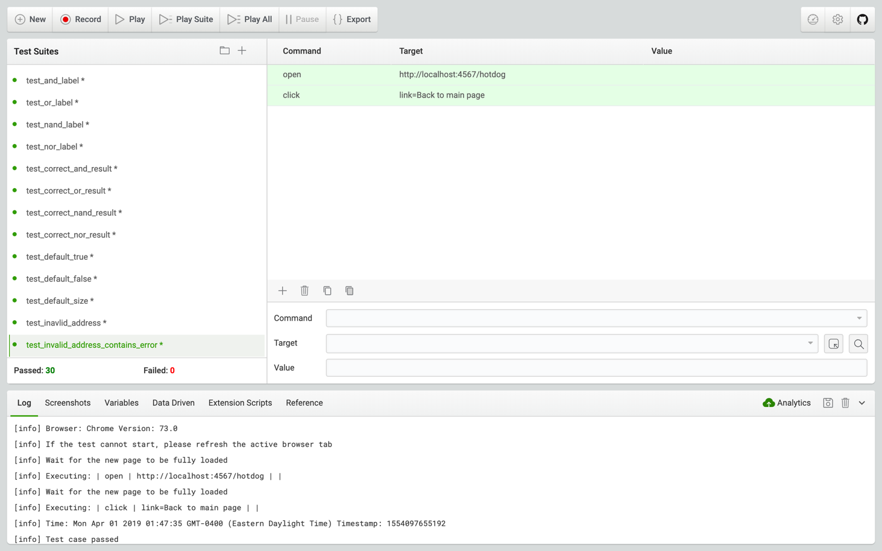

**Traceability Matrix:**

|  |  |
| --- | --- |
| **Requirement** | **Test Cases** |
| 1 | test_show_boxes, test_submit_button, test_correct_labels |
| 2 | test_invalid_param_link_to_main, test_invalid_address_link_to_main, test_table_link_to_main |
| 3 | test_invalid_param_page, test_invalid_param_error_msg, test_invalid_param_required_txt, test_invalid_param_contains_rules |
| 4 | test_single_char_value_true, test_single_char_value_false, test_same_true_false, test_size_greater_two |
| 5 | test_construct_truth_table, test_specified_symbols, test_descending_bit_values, test_and_label, test_or_label, test_nand_label, test_nor_label |
| 6 | test_correct_and_label, test_correct_or_label, test_correct_nand_label, test_correct_nor_label, |
| 7 | test_default_true, test_default_false, test_default_size |
| 8 | test_invalid_address, test_invalid_address_contains_error |