1. Install mysql . The scenario is that as an instructor in ITI, you have grade-keeping responsibilities. You want to convert the grading process from a manual operation using a gradebook to an electronic representation using database. In this case: • For each student, you keep track his name, contact info (email, address), and multiple phone numbers. • Each student study different subjects such as (C, CPP, HTML, …), there some students study (C,CPP only), and the other students study (HTML,JS only), and so on • For each subject, you need to define the name and the description and max score. • The students achieve score in subject by exam result. • For each exam which taken by student you must store Exam date, score in exam. • Keep track of subjects which will studied by each student

2. Design ERD and write down the mapping schema.

3. Create your mapped tables with their columns.
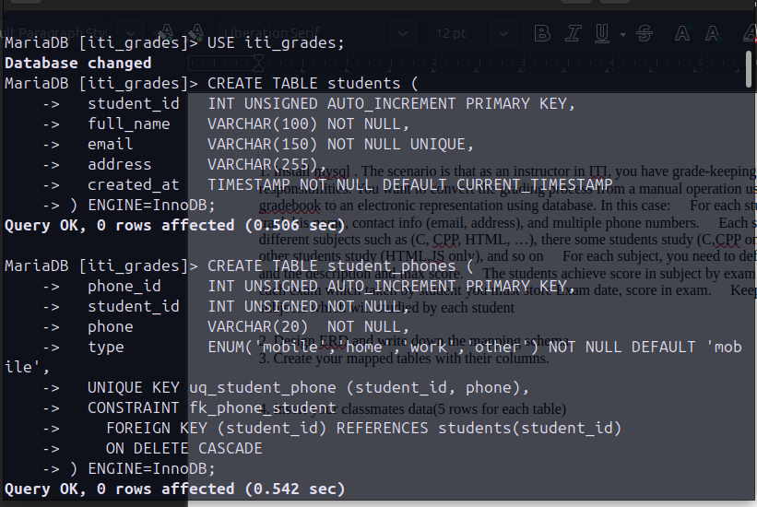
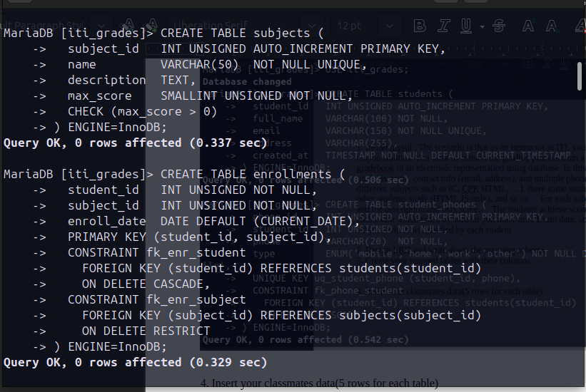
4. Insert your classmates data(5 rows for each table)

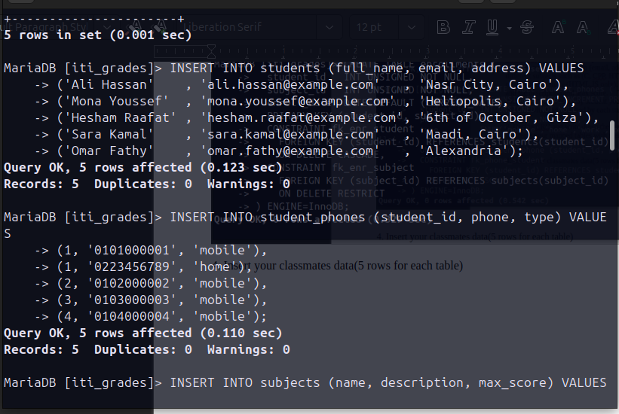

Add gender column for the student table. It holds two value (male or female).
2. Add birth date column for the student table.
3. Delete the name column and replace it with two colums first name and last name.
4. Delete the address and email column and replace it with contact info (Address, email) as object Data type.
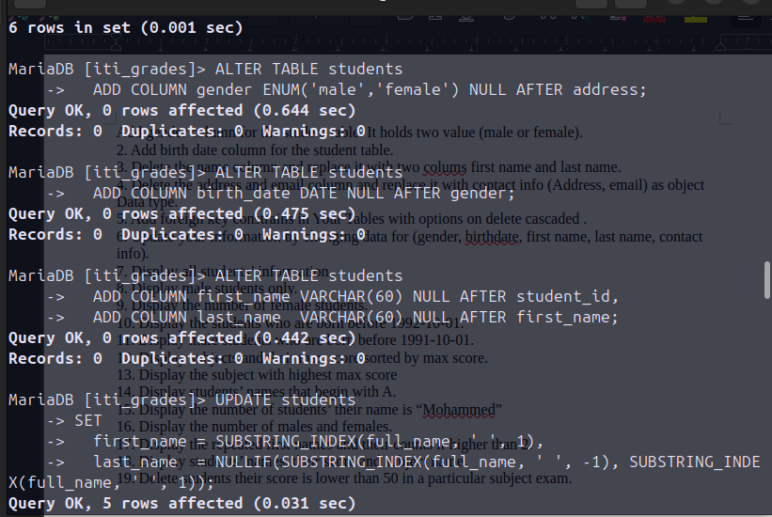
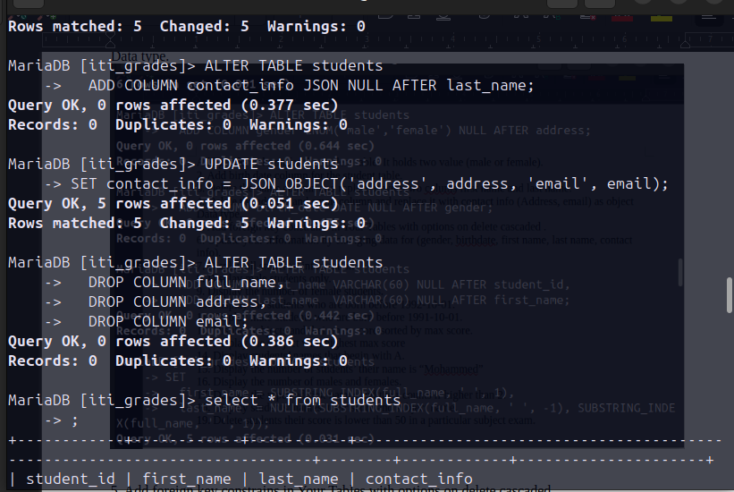
5. Add foreign key constrains in Your Tables with options on delete cascaded .
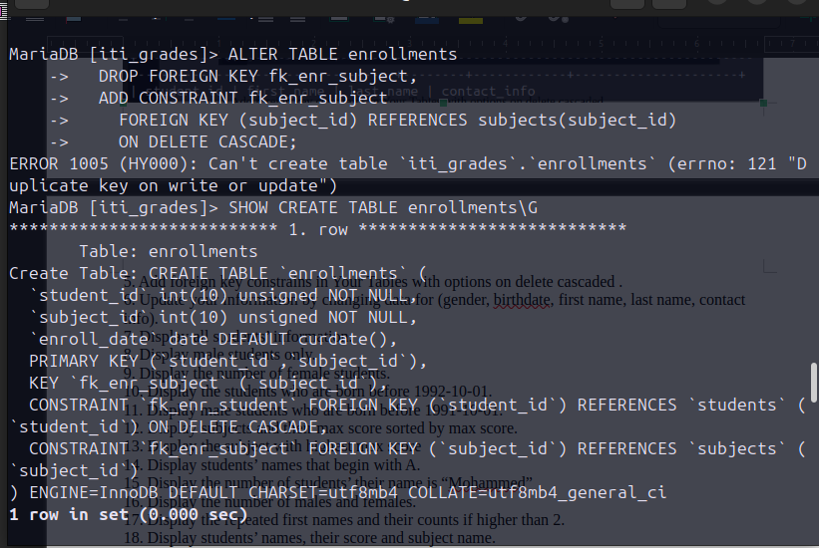
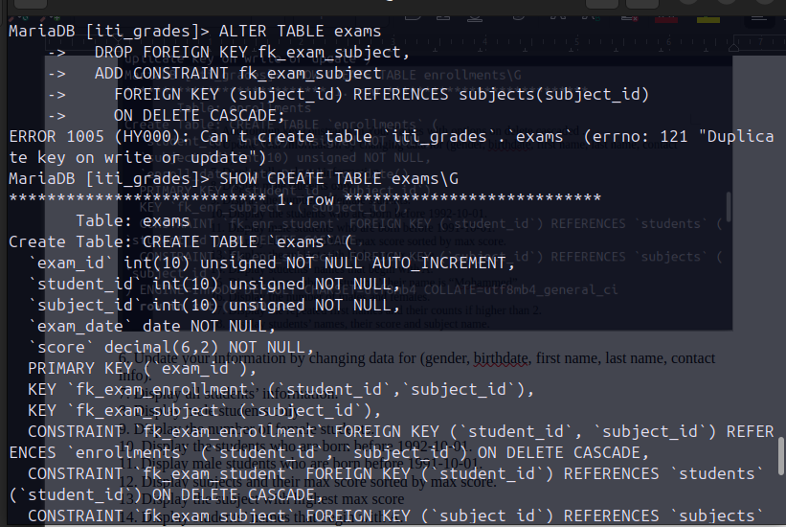
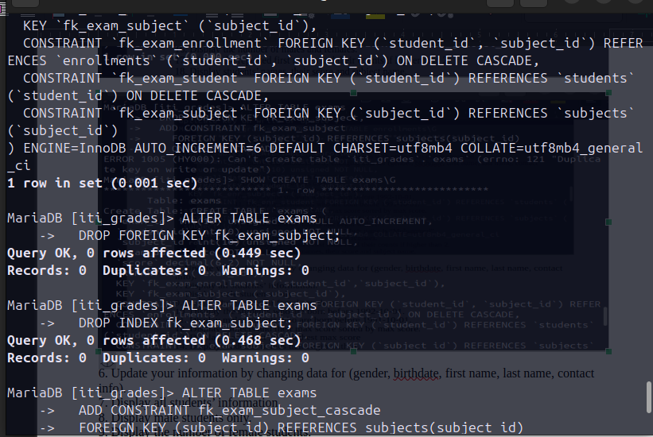
6. Update your information by changing data for (gender, birthdate, first name, last name, contact info).
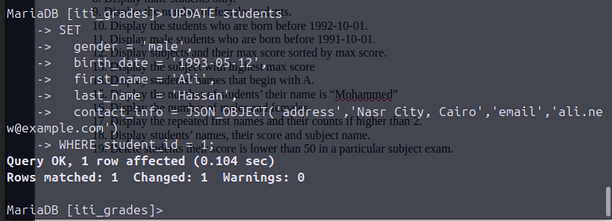
7. Display all students’ information.
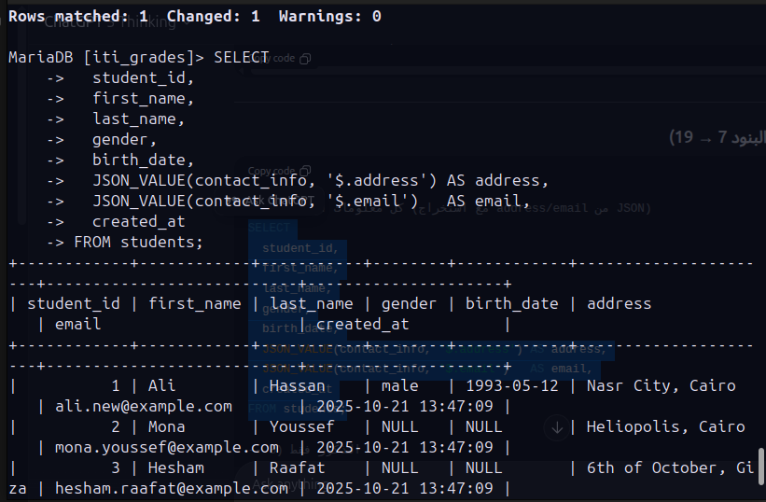
8. Display male students only.
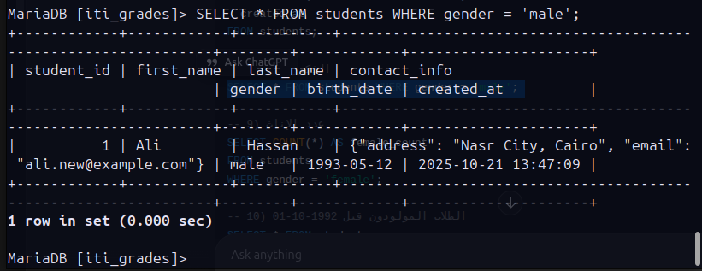
9. Display the number of female students.
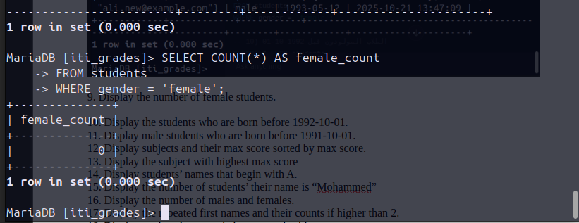
10. Display the students who are born before 1992-10-01.
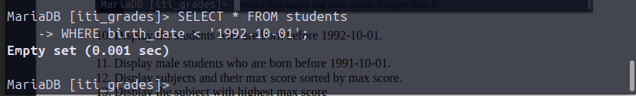
11. Display male students who are born before 1991-10-01.
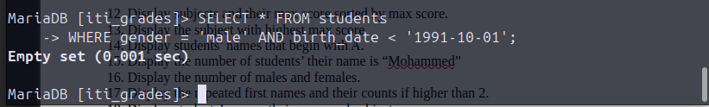

12. Display subjects and their max score sorted by max score.
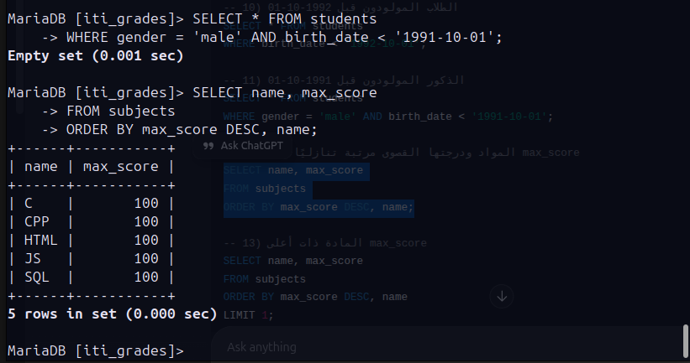
13. Display the subject with highest max score
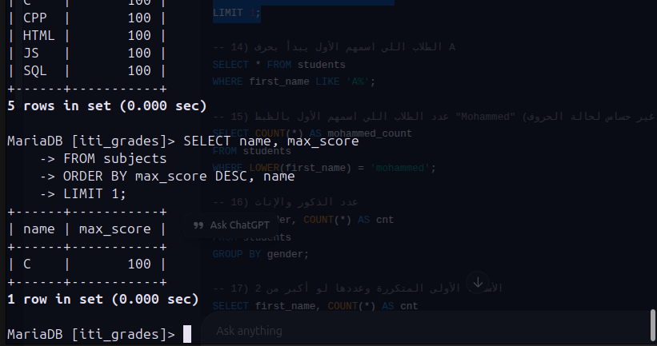
14. Display students’ names that begin with A.
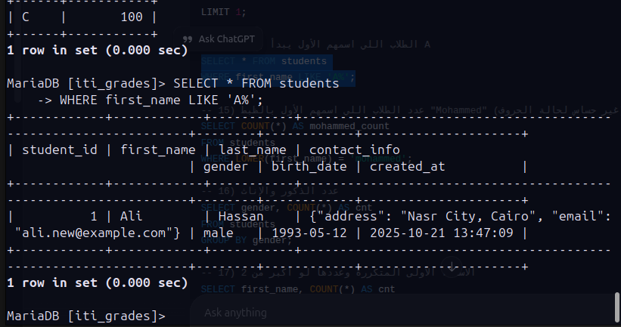
15. Display the number of students’ their name is “Mohammed”
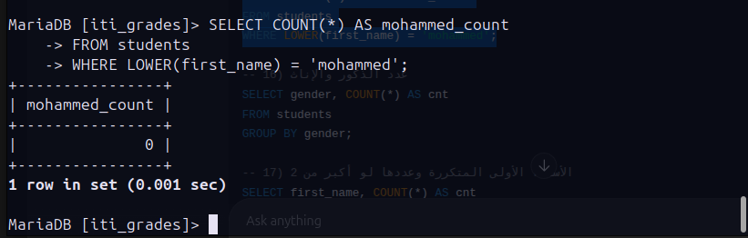
16. Display the number of males and females.
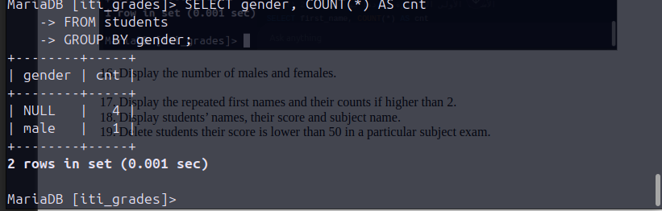
17. Display the repeated first names and their counts if higher than 2.
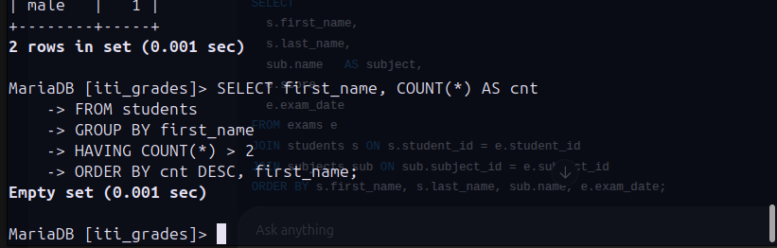

18. Display students’ names, their score and subject name.
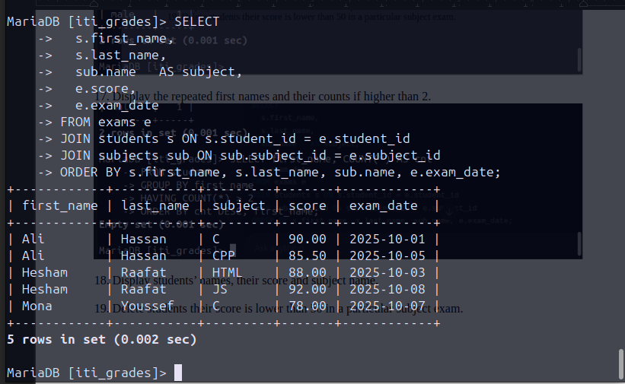

19. Delete students their score is lower than 50 in a particular subject exam.

