**TeleHealth Test Instruction**

**Date: 12/4/2017**

Since the website is still in development and there might be some changes or updates in later days. I used Selenium to run a few test cases and saved them as HTML files. These cases basically covered all the functions and link in the website right now. In the future, if anyone needs to do a regression test to make sure the original functions work well. He can follow the instructions below and run test case file from Selenium directly.

**Step 1: Install Firefox**

Download the suitable Firefox 42.0 from the link. <https://ftp.mozilla.org/pub/firefox/releases/42.0/>

The firefox after 50.0 can’t extend the Selenium IDE, so I suggest install firefox 42.0. Chrome also can’t extend Selenium IDE. If you use Selenium server, which requires PHP web driver and some other installations , then the latest Chrome and Firefox both can work with it.

**Step 2: Extend Selenium**

Open firefox and go to the link below. Add Selenium IDE to firefox.

<https://addons.mozilla.org/en-US/firefox/addon/selenium-ide/>

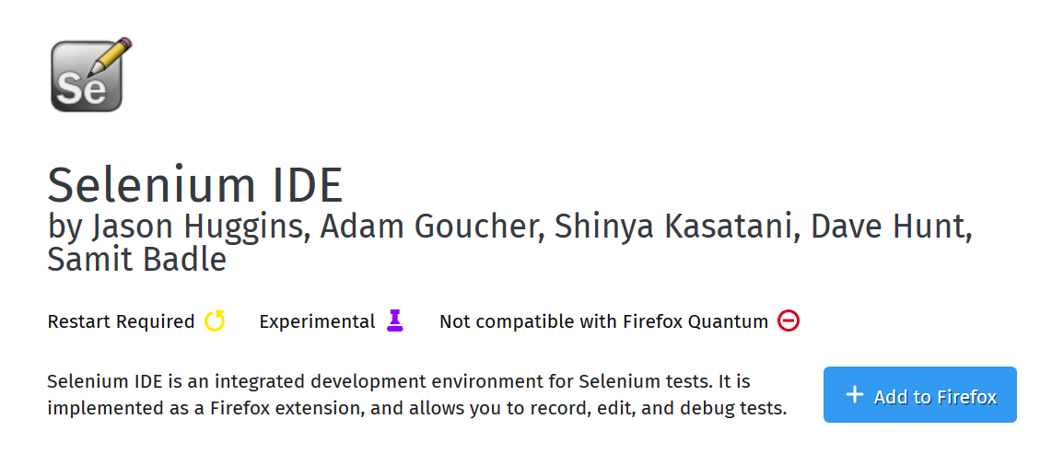

**Step 3: Open web page and Selenium**

After installation, Selenium icon will show up on the right top of the browser or you can find it from the menu -> developer.



Open Selenium IDE and input the web page URL for recording. (The red button is used for recording the test procedure).

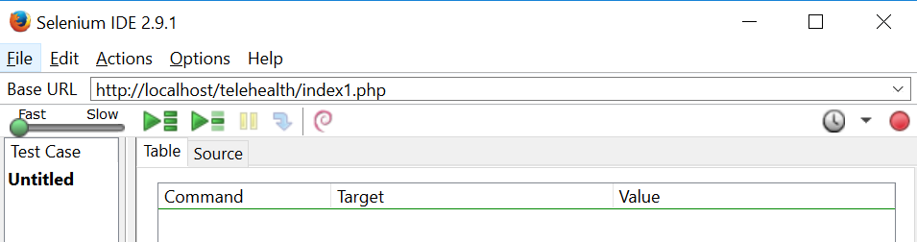

**Step 4: Import test HTML file and start testing.**

File 🡪 Open.. 🡪 TelehealthTest.html. The test file will be imported to the IDE.

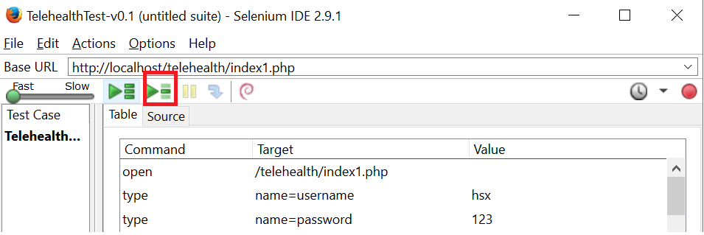

Make sure the testing URL is already open in firefox browser. Click the green button on the right to start testing. The green button on the left is used for running test cases if you have multiple test files to run. If there is no error, the log will run successfully and the bar on the left side is green. If there is error happens, then the bar on the left side is going to be red and it’s time to check if there are any problems on the button or input.

