————————————questions——————————————————————

1

1. how many players are inducted into the hall of fame?

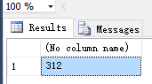

SELECT COUNT(playerID) FROM HallOfFame

WHERE inducted='Y'

b)how many distinct players in the batting data set are in the hall of fame?

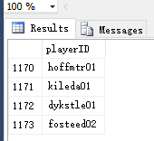

SELECT DISTINCT Batting.playerID FROM Batting

INTERSECT

--use INTERSECT to get the common players in both tables

SELECT HallOfFame.playerID FROM HallOfFame

2

a)what player has exactly 3000 hits total for his career?

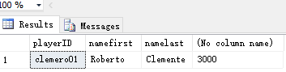

SELECT Batting.playerID,namefirst,namelast,SUM(Hits) FROM Batting,Players

WHERE Batting.playerID=Players.playerid

--use playerID to connect 2 tables

GROUP BY Batting.playerID,namefirst,namelast

Having SUM(Hits)=3000

b)what year was he inducted into the hall of fame?

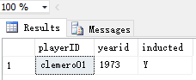

SELECT playerID,yearid,inducted FROM HallOfFame

WHERE playerID='clemero01'

3

what player had the highest number of homeruns in 1919?

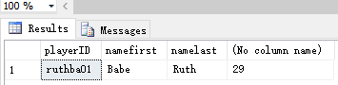

SELECT TOP 1 Batting.playerID,namefirst,namelast,SUM(Homeruns) FROM Batting,Players

--use top 1 to choose the first row from result

WHERE yearid=1919 AND Batting.playerID=Players.playerid

GROUP BY Batting.playerID,namefirst,namelast

ORDER BY SUM(Homeruns) DESC

4

what team has had the most hits after the year 2000, how many?

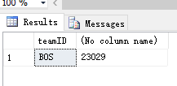

SELECT TOP 1 teamID,SUM(Hits) FROM Batting

WHERE yearID>2000

--choose teams' sum of hits after year 2000

GROUP BY teamID

ORDER BY SUM(Hits) DESC

5

a)what player has the most cumulative hits?

b)how many does he have?

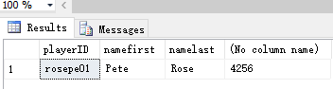

SELECT TOP 1 Batting.playerID,namefirst,namelast,SUM(Hits) FROM Batting,Players

WHERE Batting.playerID=Players.playerid

Group by Batting.playerID,namefirst,namelast

Order by SUM(Hits) DESC

c)is he in the hall of fame?

d)how many votes has he received total?

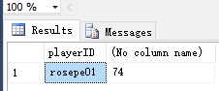

SELECT playerID,SUM(votes) FROM HallOfFame

WHERE playerID='rosepe01'

Group by playerID

6

a)what 3 players have the highest number of cumulative strikeouts over their career that have been inducted into the hall of fame?

b)how many total strikeouts do they each have?

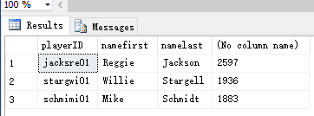

SELECT TOP 3 HallOfFame.playerID,namefirst,namelast,SUM(strikeOuts) FROM Batting,HallOfFame,Players

WHERE HallOfFame.playerID=Batting.playerID AND HallOfFame.playerID=Players.playerid AND inducted='Y'

--connect 3 tables with playerID and set inducted value as Y

Group by HallOfFame.playerID,namefirst,namelast

ORDER BY SUM(strikeOuts) DESC

7

a)what 3 players have the highest cumulative total number of homeruns and have been inducted into the hall of fame?

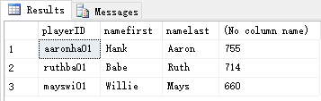

SELECT TOP 3 HallOfFame.playerID,namefirst,namelast,SUM(Homeruns) FROM Batting,HallOfFame,Players

WHERE HallOfFame.playerID=Batting.playerID AND HallOfFame.playerID=Players.playerid AND inducted='Y'

--connect 3 tables with playerID and set inducted value as Y

Group by HallOfFame.playerID,namefirst,namelast

ORDER BY SUM(Homeruns) DESC

b)what 3 players have the highest cumulative total number of homeruns and have NOT been inducted into the hall of fame?

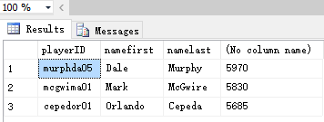

SELECT TOP 3 HallOfFame.playerID,namefirst,namelast,SUM(Homeruns) FROM Batting,HallOfFame,Players

WHERE HallOfFame.playerID=Batting.playerID AND HallOfFame.playerID=Players.playerid AND inducted='N'

--connect 3 tables with playerID and set inducted value as N

Group by HallOfFame.playerID,namefirst,namelast

ORDER BY SUM(Homeruns) DESC

8)

what player had the highest batting average from 1930 to 1940 with a cumulative total of hits over 1800 and

has NOT been elected into the hall of fame? batting average = hits/atbats

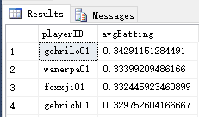

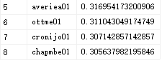

SELECT Batting.playerID,SUM(Hits) as sh,SUM(Atbats) as sab into Answ81

--Caculate the sum of Hits and sum of Atbats and save as sh and sab in table Answ81

FROM Batting

WHERE yearID between 1930 AND 1940

GROUP BY playerID

--Caculate the sum of Hits and sum of Atbats by players

SELECT Answ81.playerID,cast(Answ81.sh as float)/Answ81.sab as avgBatting

--use cast to get the average of Hits/Atbats

--use float to preserve decimals

FROM Answ81

WHERE Answ81.sab>0 AND Answ81.sh>1800 AND Answ81.playerID IN

--Get the average of Hits/Atbats only if the sum of Atbats>0 and Hits over 1800

(SELECT HallOfFame.playerID

--choose the players not inducted in the hall of fame, nesting query

FROM HallOfFame

WHERE HallOfFame.inducted='N')

ORDER BY avgBatting DESC

9)

what player averaged the highest number of walks from 1900-1920 with over 500 atbats?

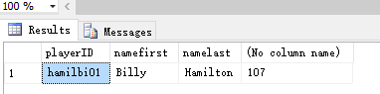

SELECT TOP 1 Batting.playerID,namefirst,namelast,AVG(Walks) FROM Batting,Players

WHERE Batting.playerID=Players.playerid AND Atbats>500 AND yearID BETWEEN '1900' AND '1920'

Group by Batting.playerID,namefirst,namelast

Order by AVG(Walks) DESC