1. In this section, we’ll connect a LED and a simple push button to the KL25Z.

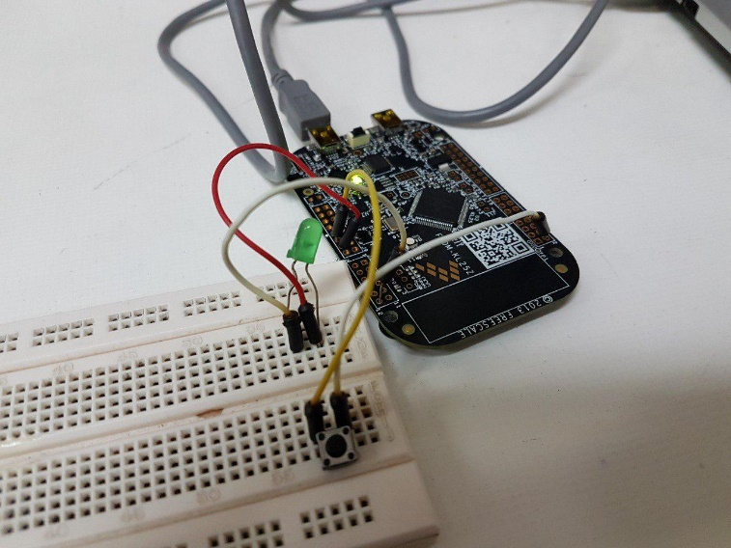

The code for evaluating the connection between the led and the board is given below.



1. In this section, we’ll use the PWM module to periodically assign different values to the output. The code is given below:



1. In this section, we employ a two simple variables to control the low and high periods of our artificial PWM module. The code is given below:

