Suggestions for using the iUltimate (iOS) or UltiAnalytics (Android) app to record AUDL Games

1. Practice! It can be challenging to record a game. Try and get comfortable with the app BEFORE the first game. We recommend recording a practice session as a way of getting comfortable.
2. Set the **Game To** property to **Time**.

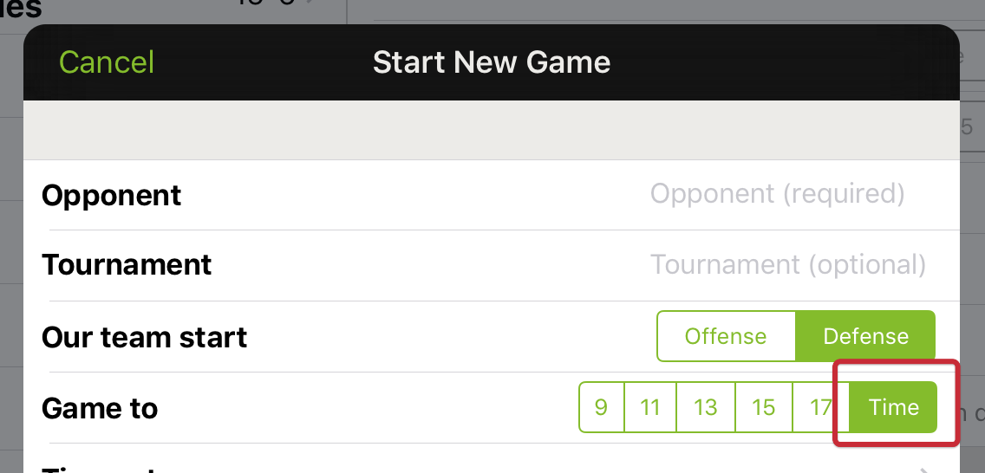

Time based games allow you to indicate the end of each period. The *Game Over* button will change to reflect the next period end. For instance, while playing the first quarter the button will say “End 1st Quarter”. Tapping it will record the quarter end and switch the receiving team for the next point. The app handles overtime as well.

1. Upload often. Your fans are watching! The ESPN announcers need the stats for announcing the game!   
   If you are using the iOS version turn on **Auto** Game Uploading. Auto Game Uploading will cause game stats to be uploaded frequently during the game. See notes below about connectivity. To make sure everything is working OK, try this before the game and record a few events to see the upload working (undo the events before the game starts).  
   If using the Android version upload your game after each point.

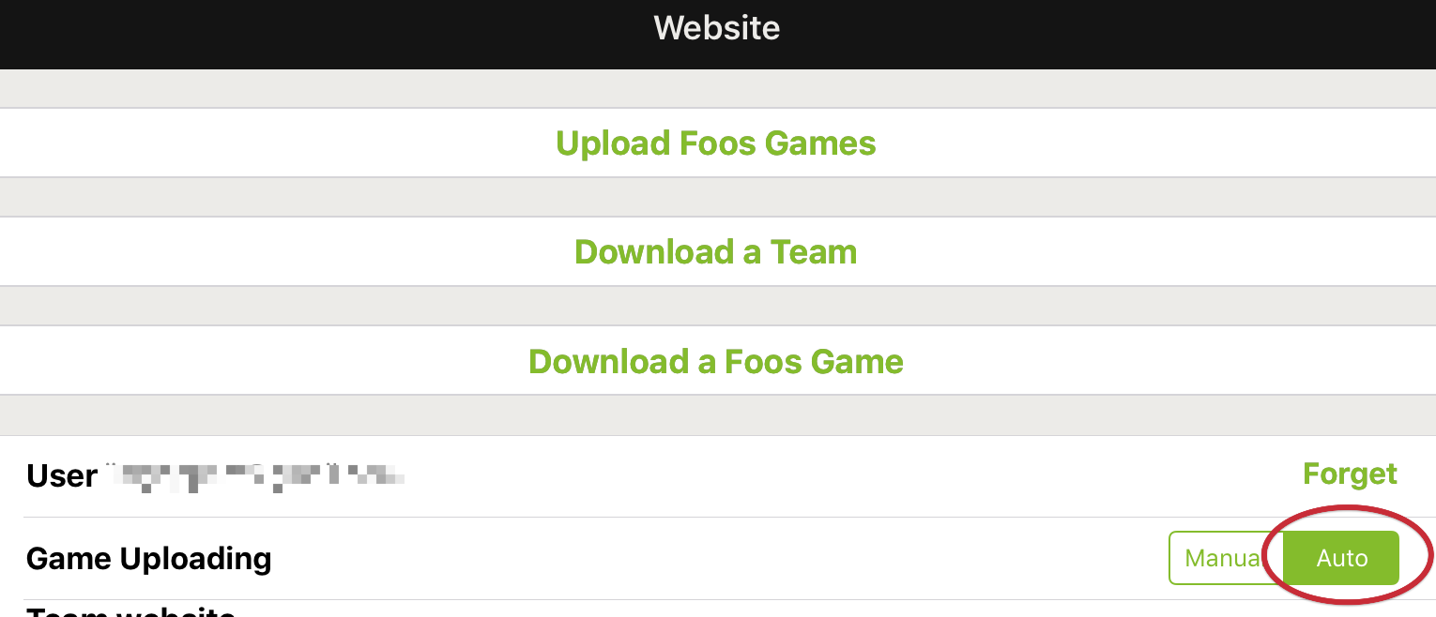

**iPhone/iPad connectivity during the game**

In order to upload data to the website during the game it it necessary to have cellular or WIFI availability. If you are using an iPhone (or iPad with cellular) this is probably not an issue. If you are using an iPad without cellular and there is no WIFI access at the stadium you can also tether your iPad to an iPhone for connectivity. There are many online articles on how to do tethering. Here is one: <http://www.imore.com/how-to-tether-ipad-wi-fi-iphone-personal-hotspot>