WiFi GeoLocator

Jonathan Mellor, Craig Weir

User Stories:

1. Jim wants to have a list of unsecured access points in his area. He can use the map to find their location.
2. Jane wants to do a site survey around her house to know what channel to put her access point on. She can use the analyze screen to see what channels other networks are on in her area.
3. Joe wants to do some statistics on the types of security wireless networks use. He can use the search screen to run a query on the database.
4. Bob works for a structured cabling company, he is testing locations for access points. He can walk around using the analyze screen to measure signal strength in different areas.

Requirements:

1. WiFi capable android device to scan for access points
   1. Local storage to store scanned access points into
   2. Offsite SQL Server to store scanned access points into
   3. GPS to get the users current location
   4. Google Maps to display locations of access points
2. IOS Device
   1. Can not be used for scanning as of IOS 4
   2. Offsite SQL Server to pull scanned access points to
   3. Google Maps to display locations of access points
3. Server
   1. SQL and Webserver
   2. Large amount of storage
   3. 24/7 365 uptime
   4. Website to promote the application
   5. Web interface to many mobile application components
   6. PHP processing

Screenshots of current progress:

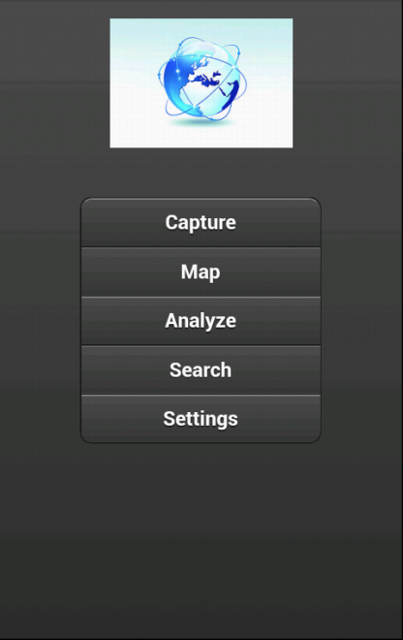 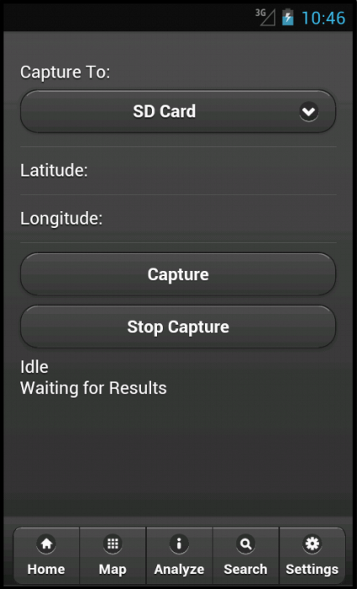 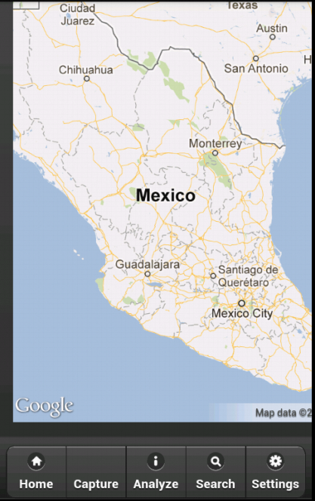

Progress:

1. Currently Working Pieces:
   1. Wifi Scanning works.
      1. Some minor hiccups, discussed below (Item 2d)
   2. Using the GPS works
   3. The google map loads properly
   4. A home page that may or may not be used, we are still discussing it.
2. Pieces Left To Do With Estimated Difficulty:
   1. Push scan results to the web or to local storage (medium)
   2. Configure website and database (easy)
   3. Google maps needs to place makers based on locally stored or cloud stored scan results. (medium)
   4. Fix occasional errors with the scanning plugin (unknown)
   5. Add user decision to activate wifi radio (medium)
   6. Add search screen (medium)
      1. Search local and/or web storage
   7. Add analyze screen (hard)
      1. Analyze access points in current scanning range
   8. Extensive Testing (unknown)
3. Stumbling blocks
   1. The only current stumbling block is the design of the scanner plugin
      1. When used, it turns on the wifi radio and then scans. This can cause some errors
      2. Needs to be redesigned to let the user decide when to turn on the wifi radio.