**Installation manual**

1. Import existing project into eclipse.

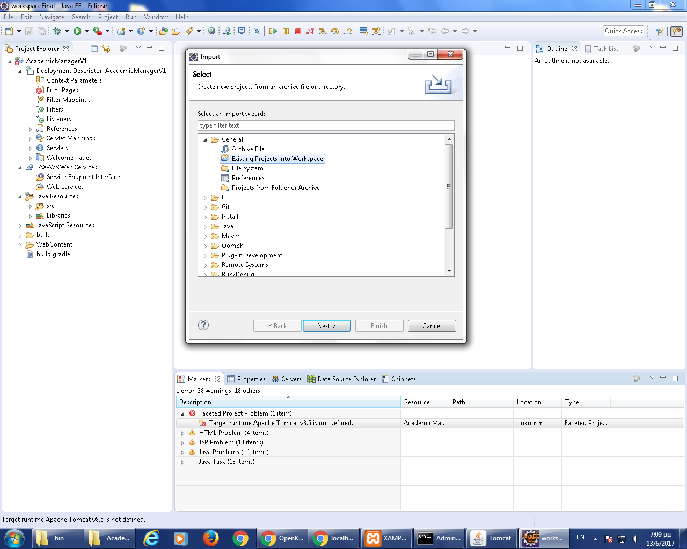

1. Create mysql database with name academicmanager and username manager with password 123456  
   2.1 Before import the datafile to the created database change the datafile encoding to utf-8

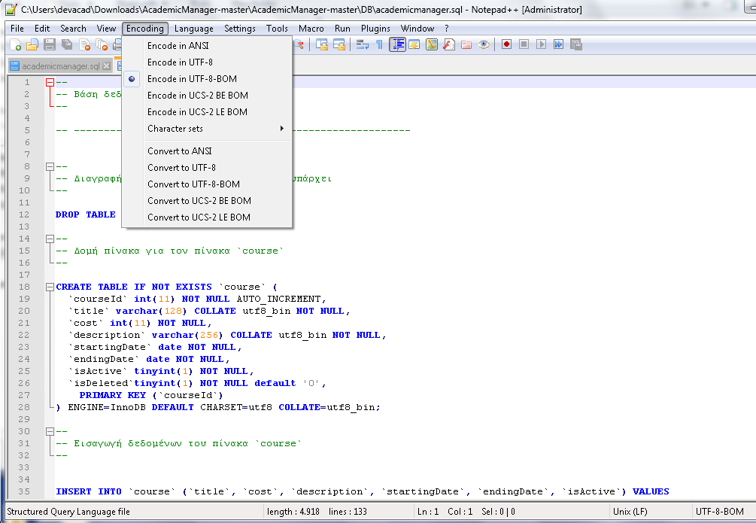

1. Add tomcat 8.5 server to the imported project in eclipse

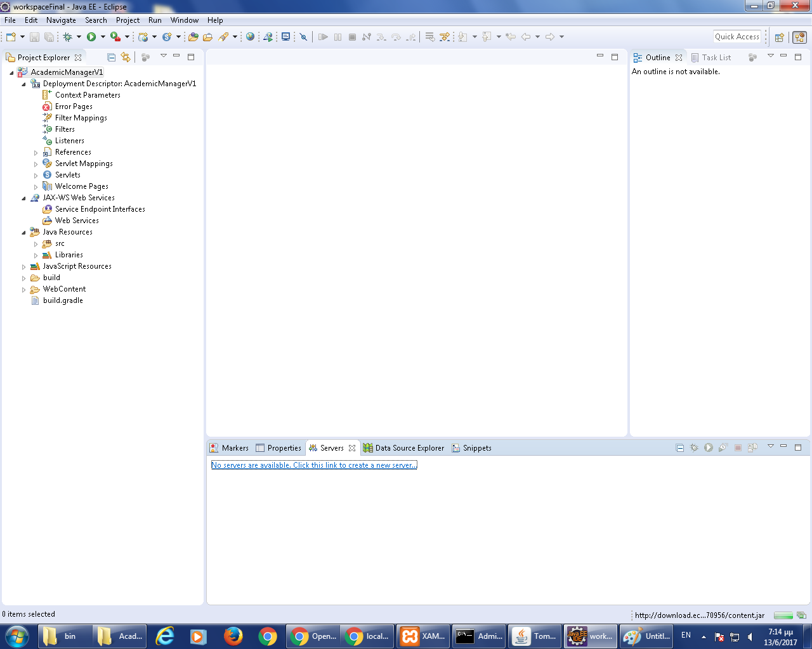

3.1 From the server tab create a new server in eclipse

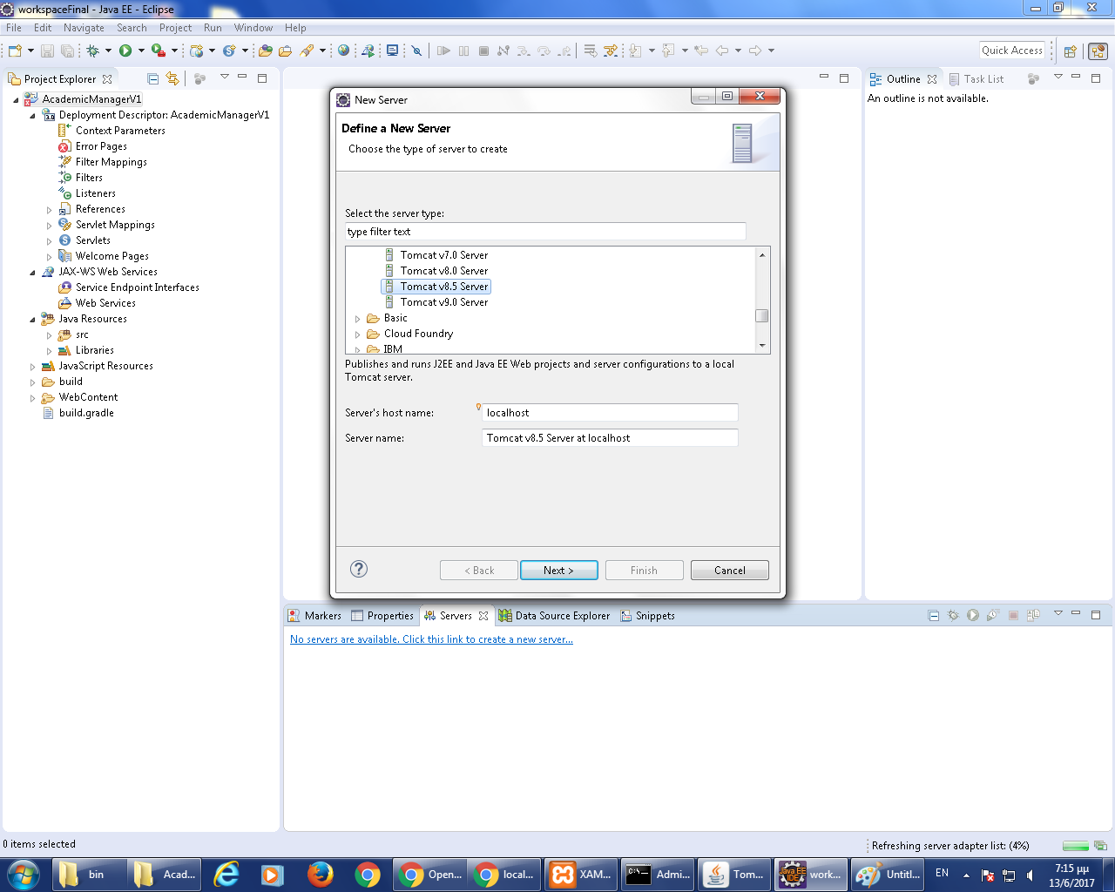

* 1. Give installation path to new tomcat server

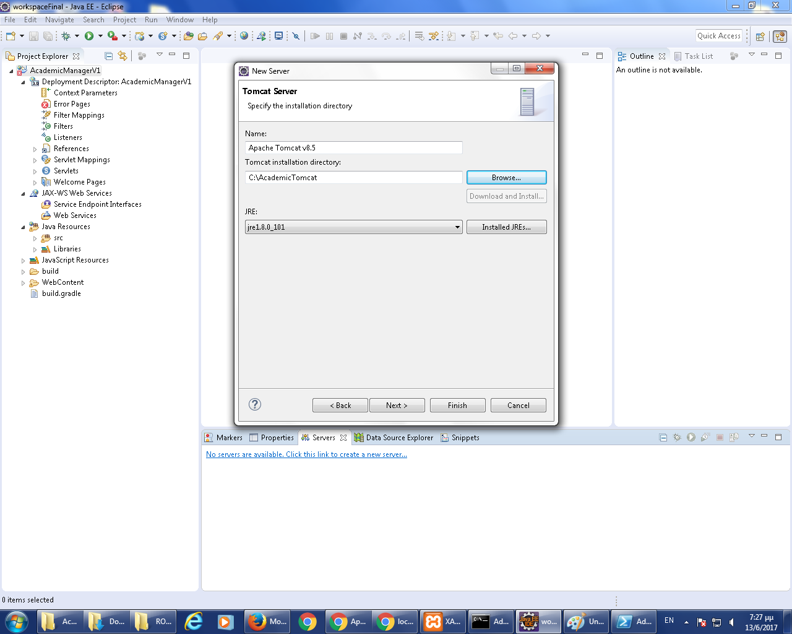

* 1. Add JAVA_HOME parameter in catalina.bat

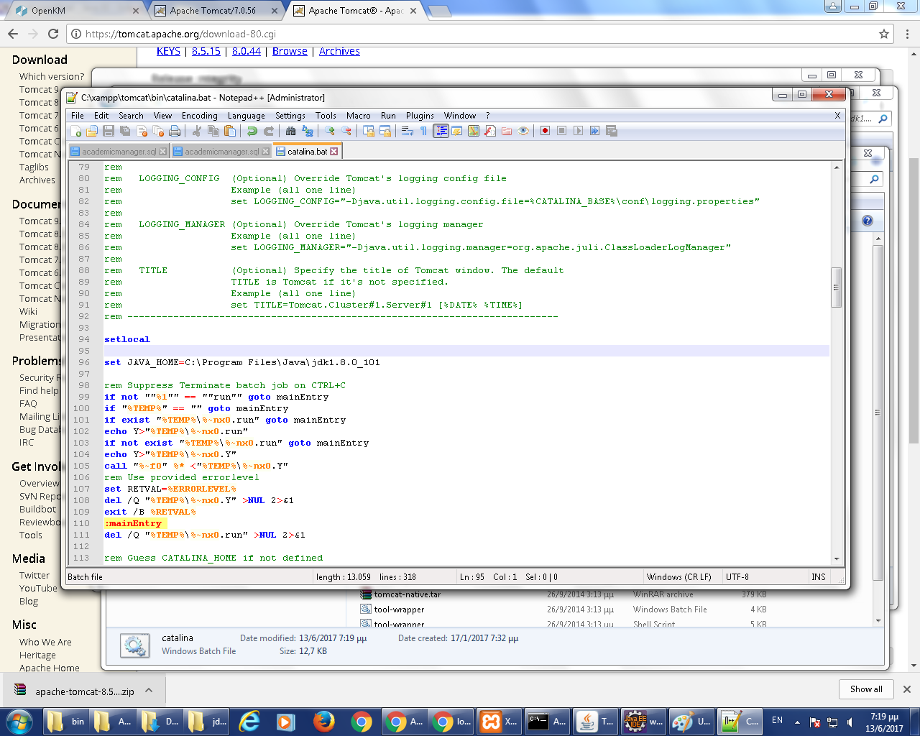

* 1. Configure context.xml with the resources of mariadb connector

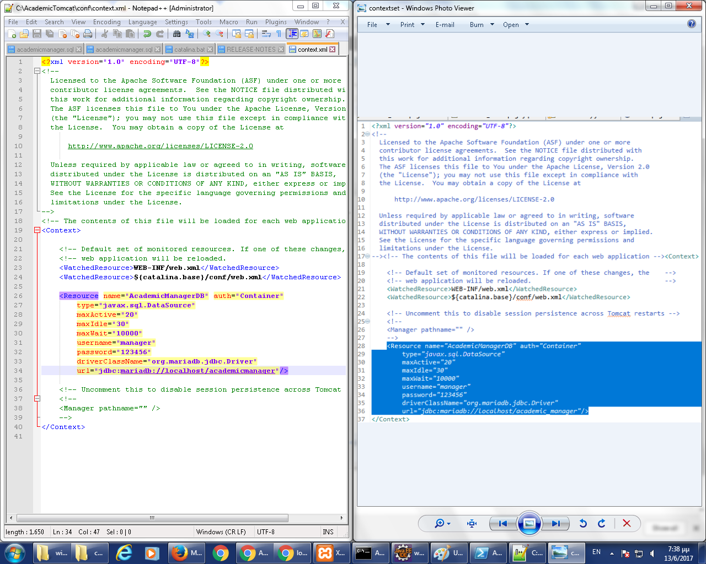

**User manual**

1. Build project in eclipse. If build is successful toy should see the following in the browser

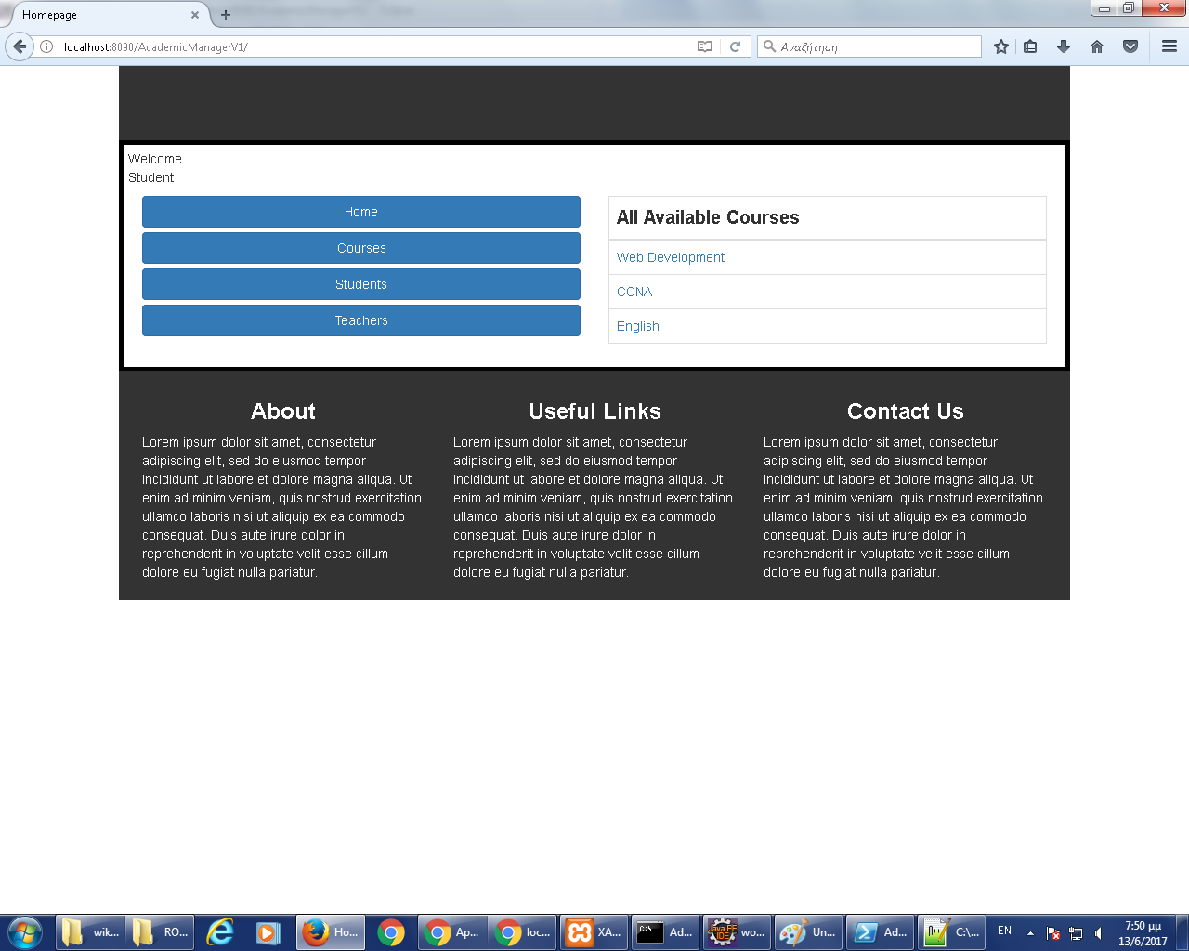

1. Click on the menu to view course details.

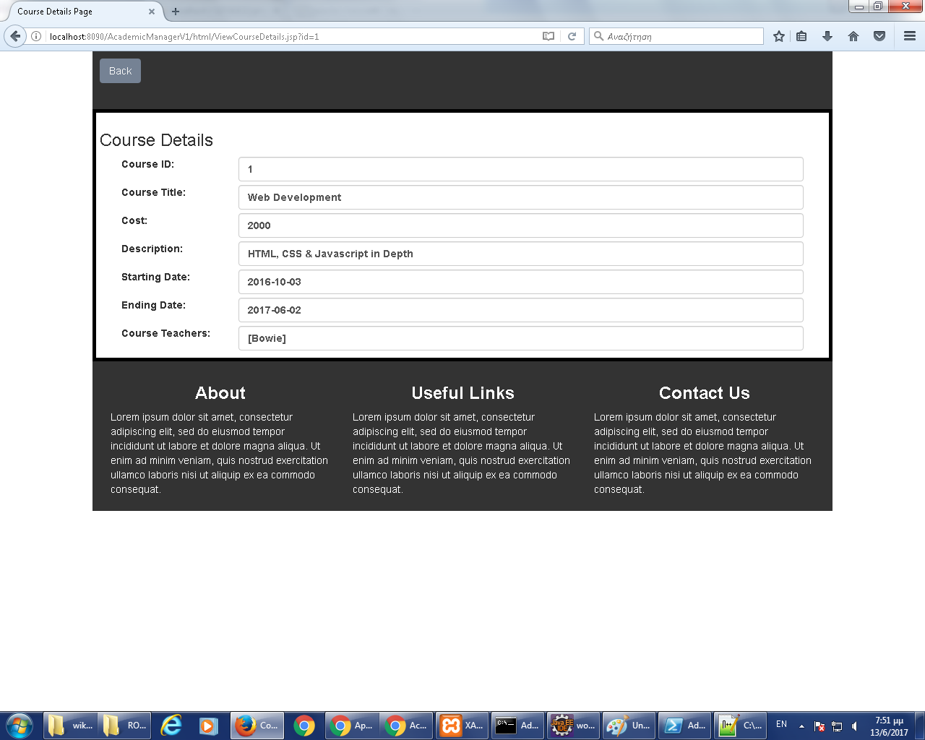

1. Use of the restful api :

Endpoint: …/rs/courses -> courses details

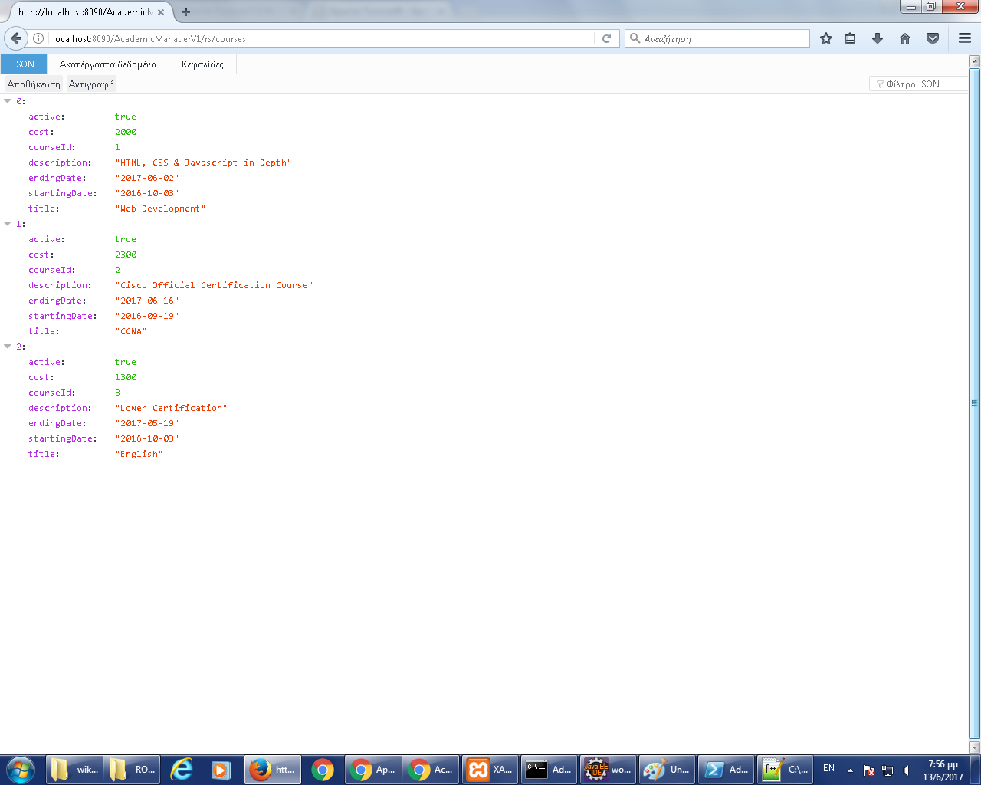

Endpoint: …/rs/teachers -> teachers details

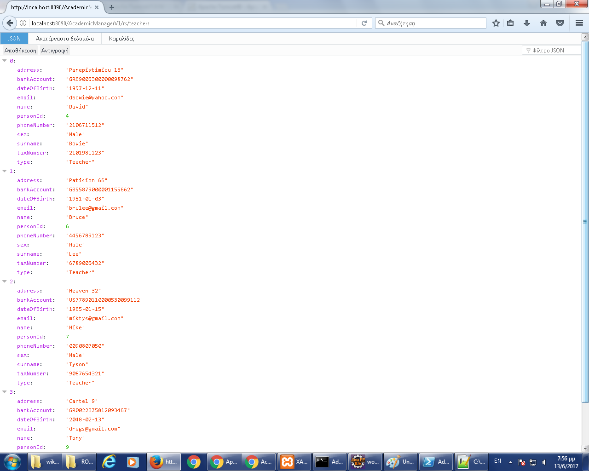

Endpoint: …/rs/teachers/<id> -> teacher details

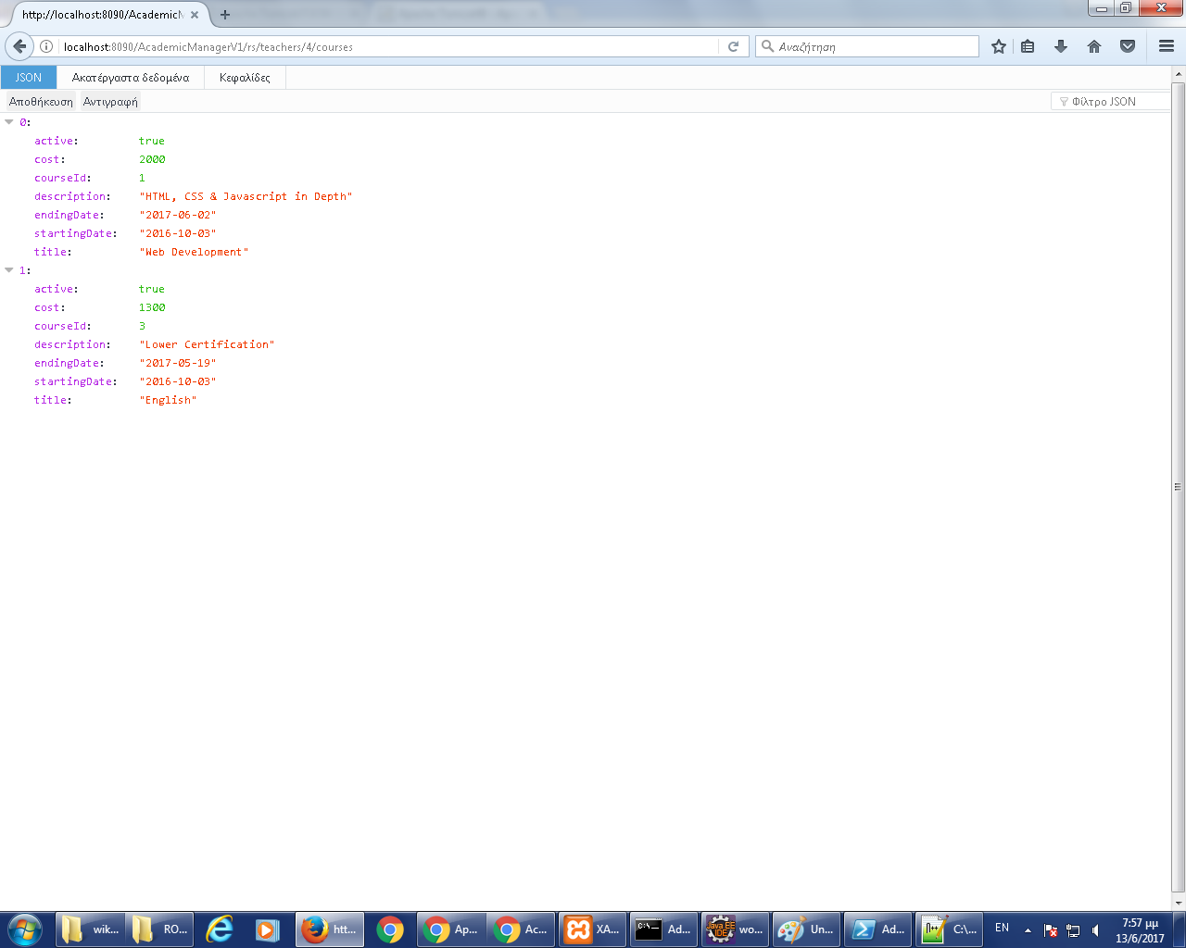

Endpoint: …/rs/teachers/<id>/courses -> teacher courses

