**User manual**

Contents

1. Prerequisites 1

2. Pages 1

3. Web Services 1

# Prerequisites

1. Use a web Browser of your choice. (Google Chrome or Mozilla Firefox etc.)

# Pages

1. Login page  
   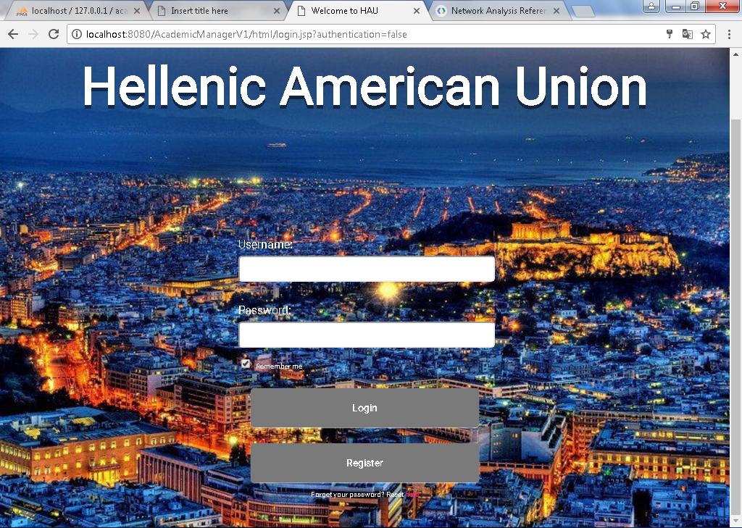
2. Students
   1. Student Home page  
      Student can choose a course from a list if of courses.  
      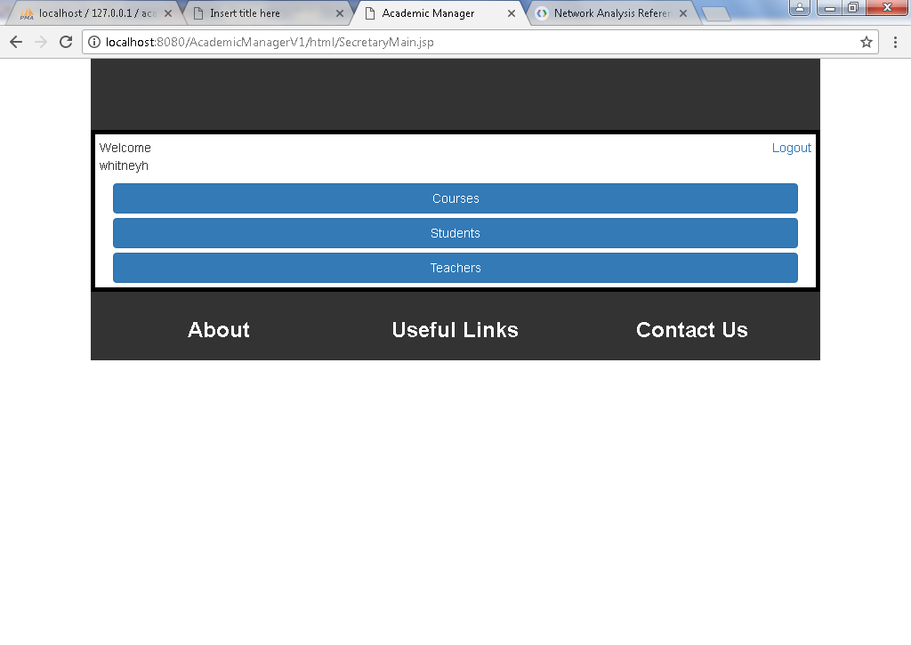
   2. Course Details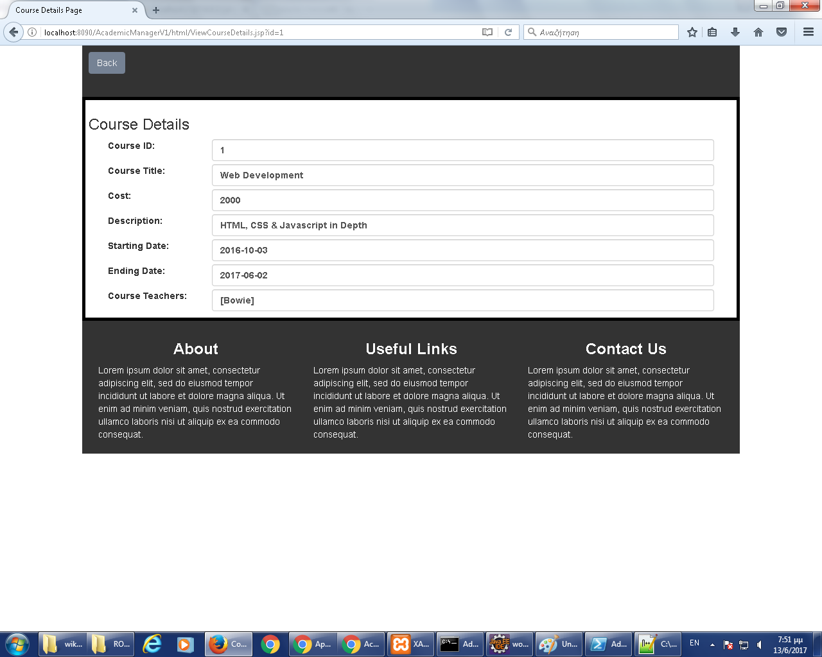

# Web Services

The application exposes a RESTFul API with the following endpoints:

1. Course Details :

Endpoint: …/rs/courses

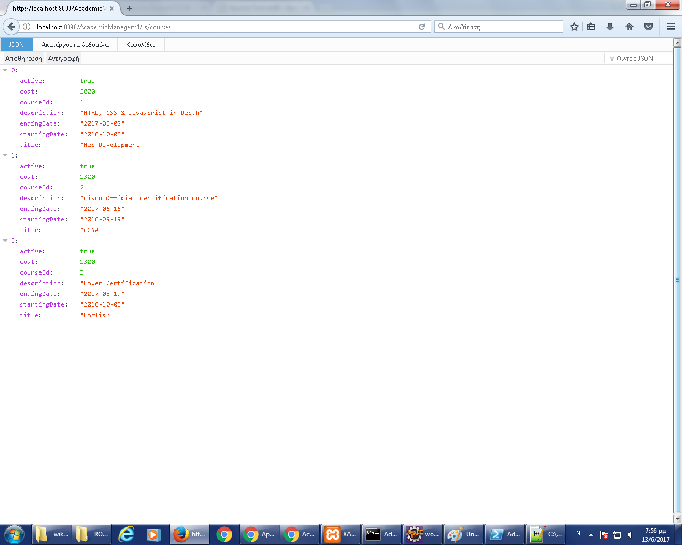

1. Teachers List:

Endpoint: …/rs/teachers

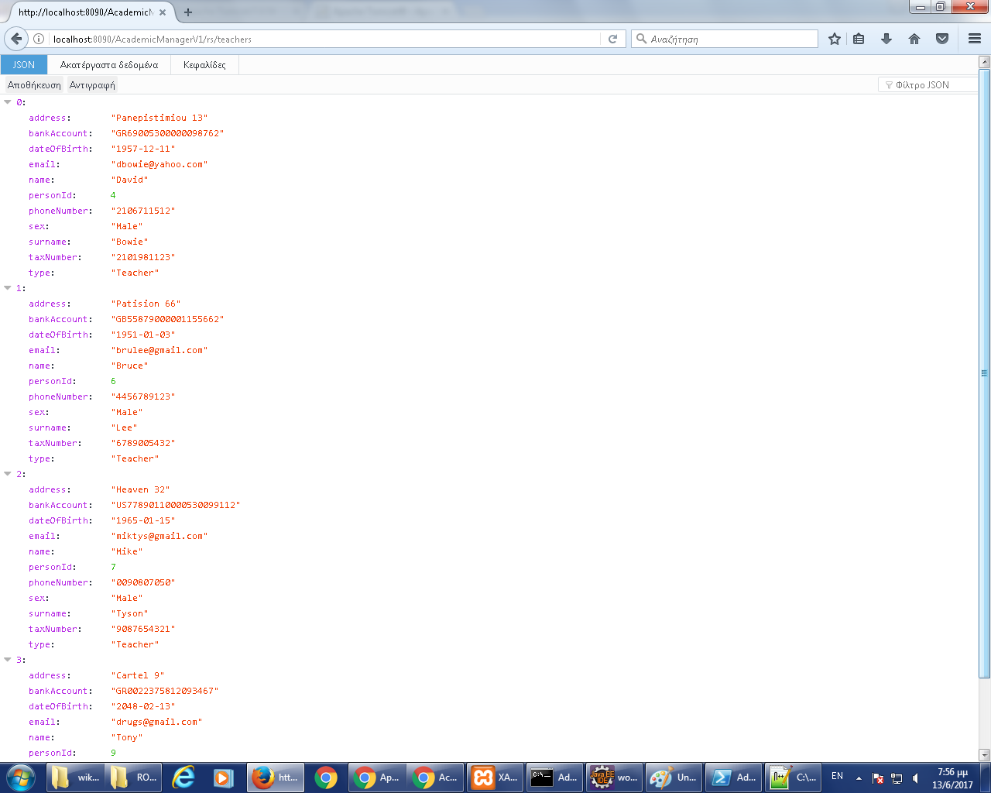

1. Teacher Courses :

Endpoint: …/rs/teachers/<id>/courses

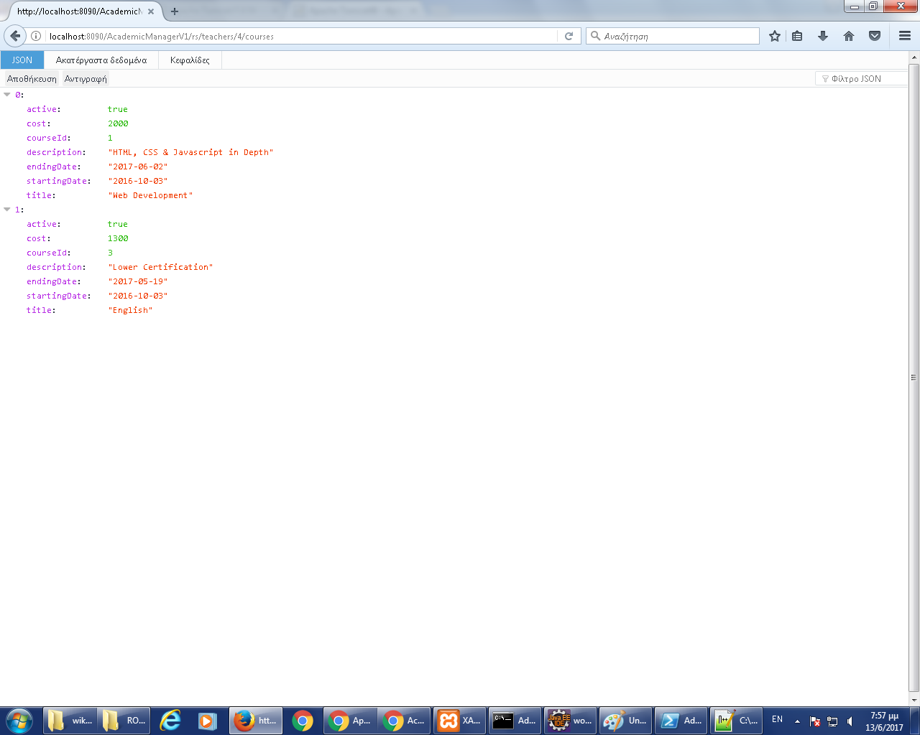

1. Teacher Details:

Endpoint: …/rs/teachers/<id>

