**Installation manual**

Contents

1. Prerequisites 1

2. Create Database 1

3. Import Project 3

# Prerequisites

The current manual assumes that you have already installed the following software on a Windows client:

* JDK 1.8
* Eclipse Neon IDE
* Apache Tomcat v.8.5
* MariaDB Ver 15.1 Distrib 10.1.16-MariaDB
* Apache httpd v.2.4.23
* PHPMyAdmin v.4.5.1.0

# Create Database

The Database DDL file is located at: %AcademicManager%/DB/academicmanager.sql

1. Change the encoding of academicmanager.sql from UTF8-BOM to UTF8 using Notepad++.

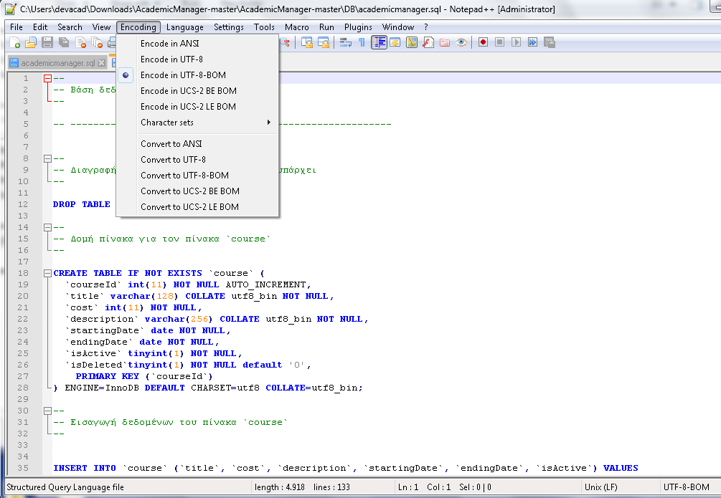

1. Open PHPMyAdmin (hosted on Apache httpd – example URL: http://localhost/phpmyadmin/)
2. Create a mysql database named *academicmanager*
3. Create a new user for this database with username *manager* and password 123456

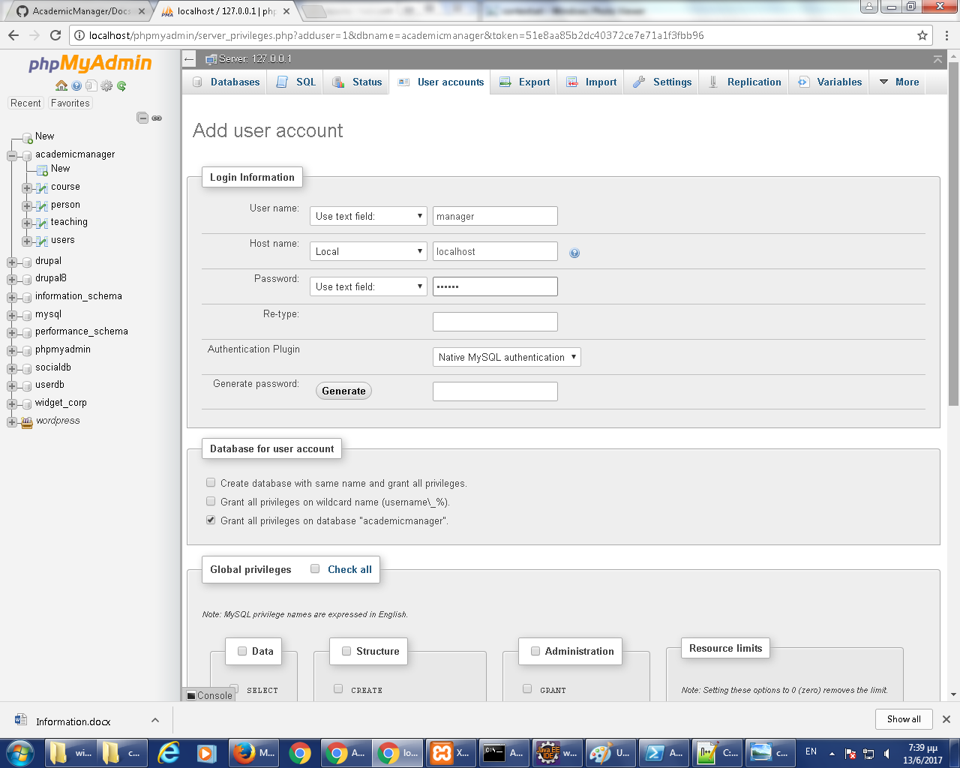

# Import Project

The project’s source code can be found in:

<https://github.com/dalexo/AcademicManager/>

To get the source code, download it as a .zip file.

To import the project in Eclipse, go to File->Import as shown in the following screenshot:

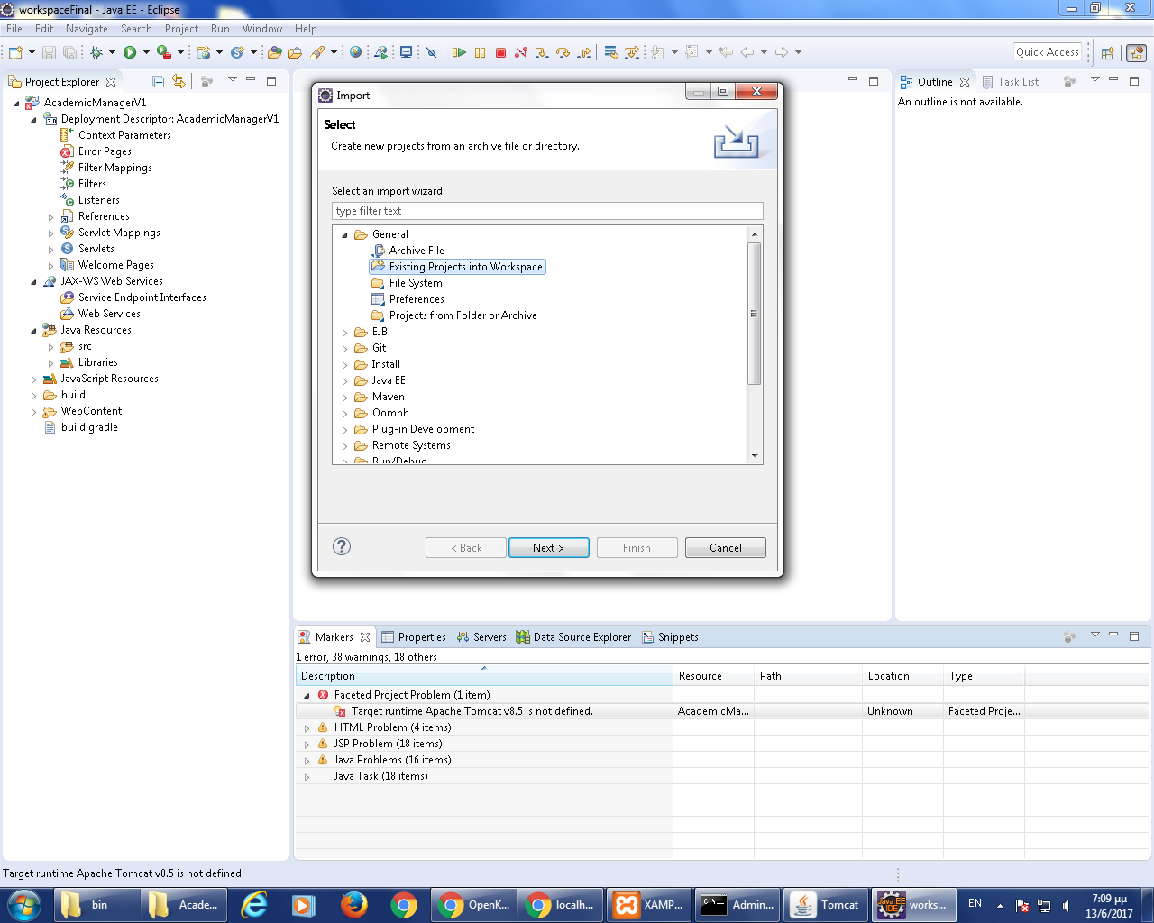

Add Tomcat v8.5 server (from the server tab) to the imported project in eclipse:

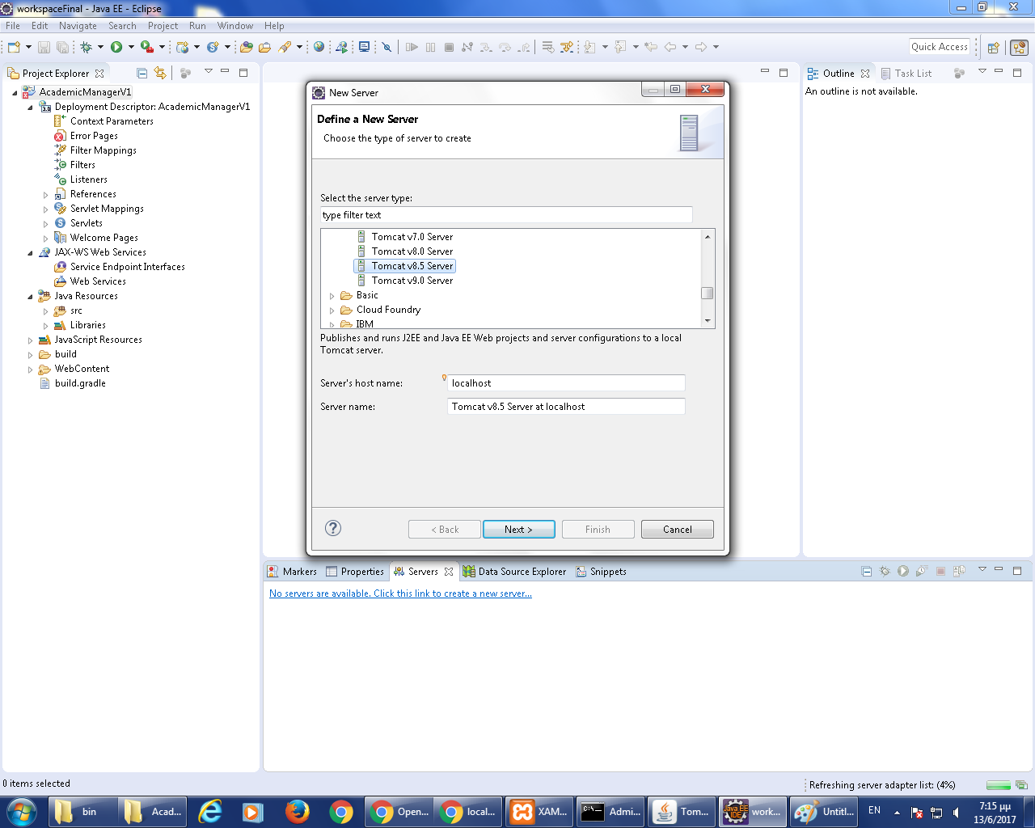

* 1. Give the installation path of the new tomcat server:

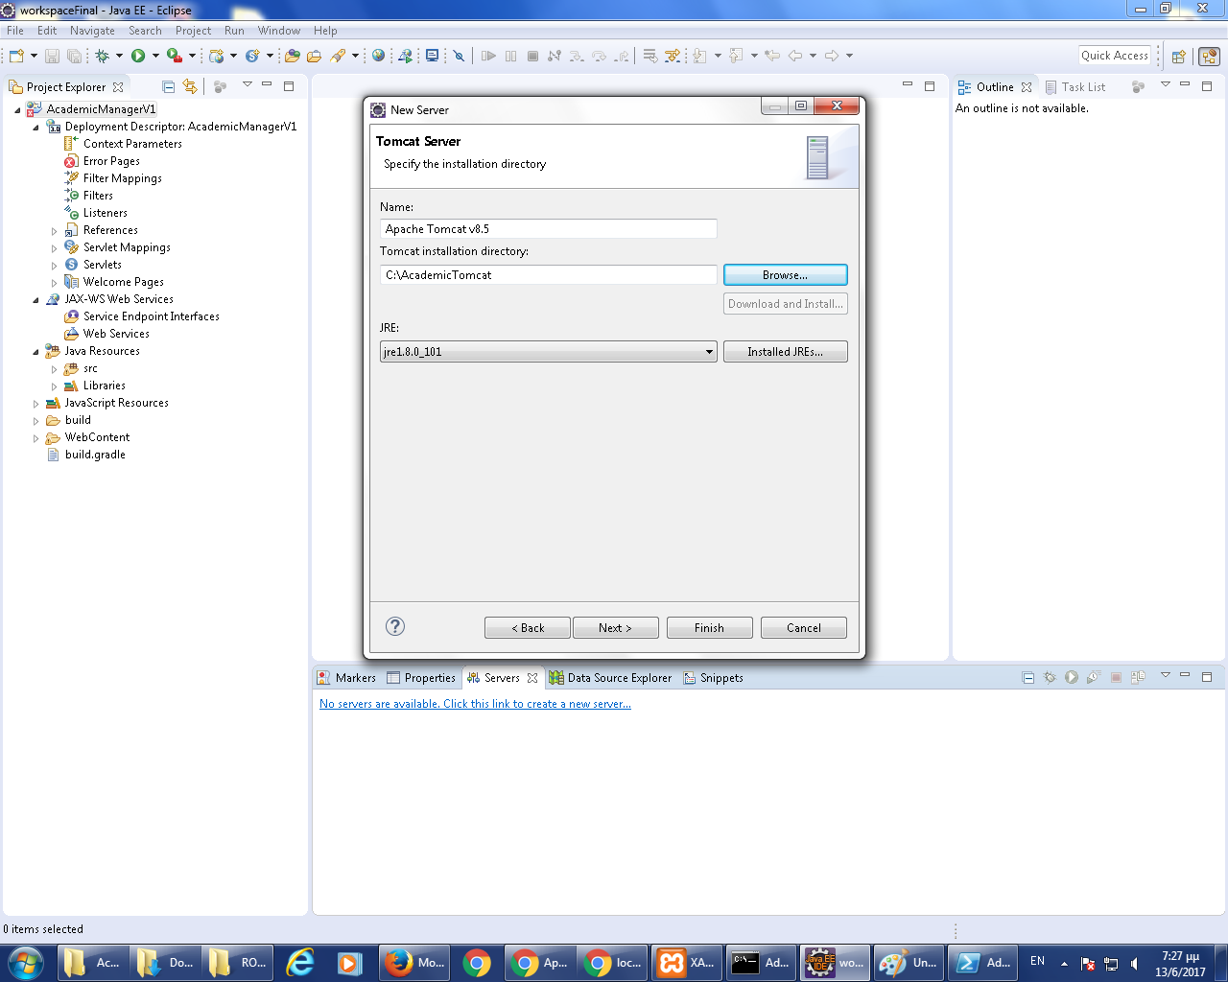

* 1. Add JAVA_HOME parameter in %TOMCAT_HOME%/bin/catalina.bat (on Linux: catalina.sh)

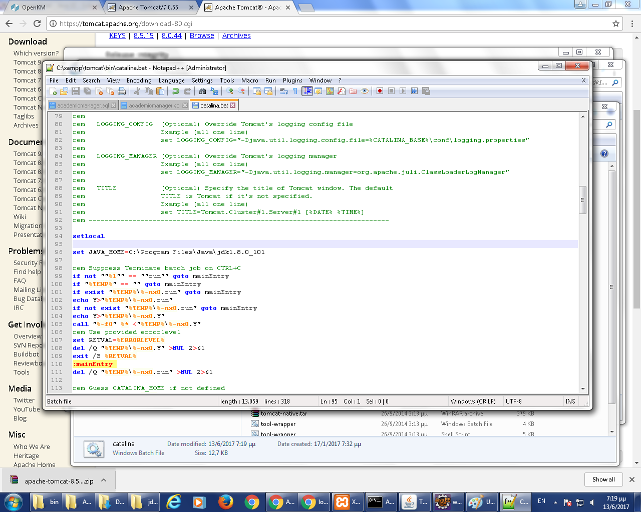

* 1. Configure the JDBC connection string in %TOMCAT_HOME%/conf/context.xml:

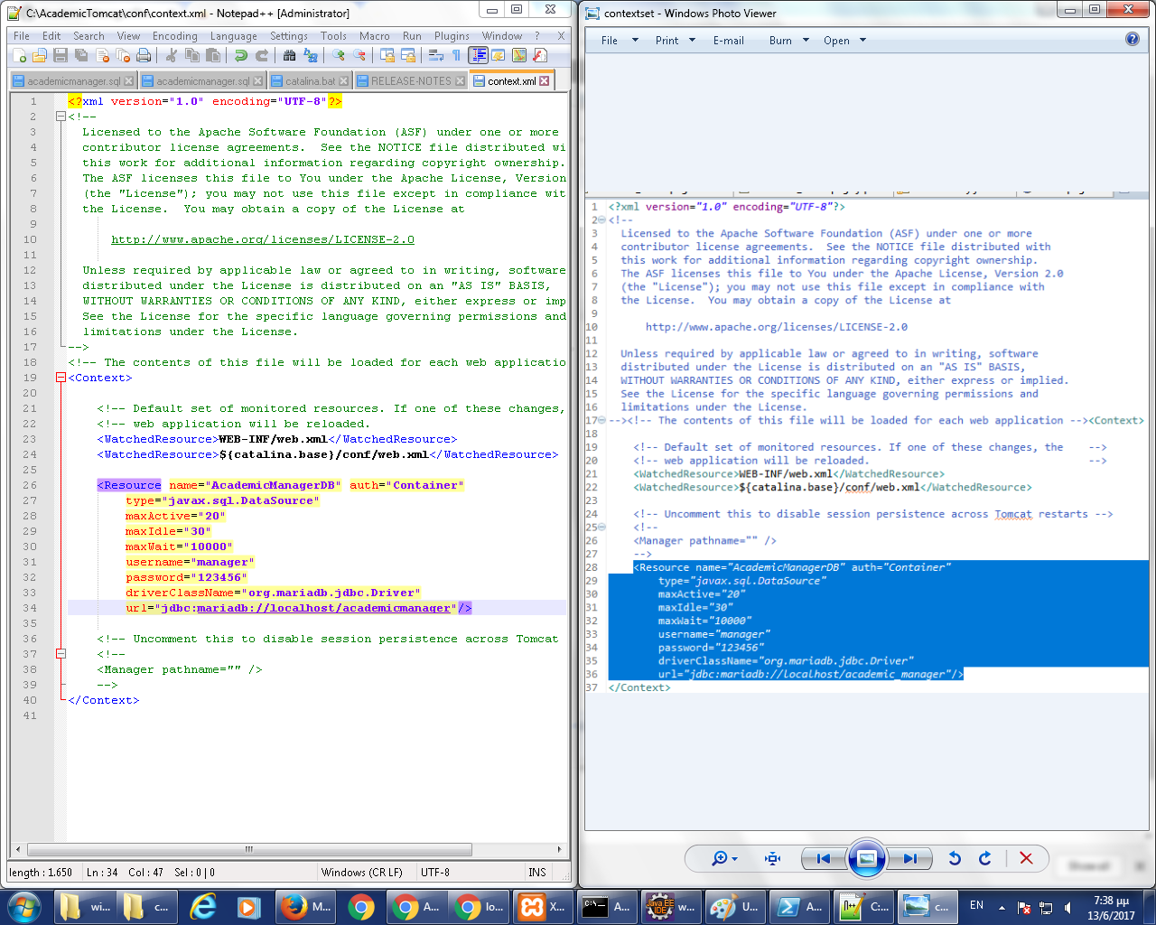

# Build Project

Run imported project on server.

