CENTRIQ AI
Technical Architecture Document
Intelligent Workplace Concierge for HR · IT · Admin · PMO

— — — — — — — — — — — — — — — — — — — —

Contents
Contents 2
1. Executive Summary 4
2. Architecture at a Glance 4
2.1 Layer responsibilities 5
3. Technology Stack 6
4. Frontend Architecture 6
4.1 Screens 6
4.2 The assistant experience 6
4.3 Identity 7
5. Backend Architecture 7
5.1 Domain modules 7
5.2 Shared core 7
6. AI Orchestration & Language Models 7
6.1 Model tiers 8
6.2 Intent routing 8
6.3 Grounded answers 9
6.4 Resilience 9
7. Request Data Flow 9
8. Integrations & External Systems 10
8.1 Integrated applications & portals 10
9. Platform Extensibility & Authoring 11
9.1 Connector Studio 11
9.2 Form Library 11
9.3 URL Library (App Directory) 11
9.4 Other administration surfaces 12
10. Project IQ — Delivery-Knowledge Intelligence 12
9.1 How it works 12
9.2 What it delivers 13
11. Data & Persistence 13
11.1 Data domains 13
12. Security — Authentication, Authorization & RBAC 13
13. Deployment & Infrastructure 14
14. Cross-Cutting Concerns 14
14.1 Action safety & receipts 14
14.2 Notifications 14
14.3 Proactive nudges 14
14.4 Observability & adoption 14
15. Appendix — Model Inventory 15

1. Executive Summary
Centriq AI is an intelligent workplace concierge that unifies HR, IT, Admin, and PMO services behind a single conversational interface backed by role-specific portals. Employees interact through a natural-language assistant that understands intent, retrieves grounded answers from an internal knowledge base, executes real actions (raising tickets, applying for leave, booking rooms, generating documents), and orchestrates approvals — while managers, HR, IT, and PMO users get purpose-built consoles over the same data and AI capabilities.
The platform has two tiers: a React single-page web application, and a Fast API backend whose core is a multi-agent orchestration graph. A self-hosted language-model runtime provides tiered models for routing, reasoning, tool use, summarization, and embeddings. The system integrates with a broad set of enterprise portals — Zoho, Microsoft 365 Apps, Alchemy, Udemy Business, ManageEngine, Admin Portals, Tech Elevate, and an AI Xchange Marketplace — positioning Centriq as an intelligence layer over the existing tool landscape rather than a replacement for it.

Key architectural characteristics
- Conversational-first, portal-backed — one AI assistant plus role consoles over shared services.
- Multi-agent orchestration — a stateful graph routes each turn to a domain agent that runs a reason–act tool loop.
- Self-hosted, tiered models — cost- and latency-optimized model tiers; no external model vendor.
- Grounded and governed — retrieval with citations, an answer cache, and access control on sensitive data.
- Action-safe writes — every write is authorized, de-duplicated, receipted, and reversible.
- Resilient by design — circuit breakers, a concurrency gate, model warm-up, and graceful fallbacks.

2. Architecture at a Glance
Centriq AI is organized as horizontal layers. Requests flow from clients through an edge layer into the web and application tiers, down into AI orchestration and the model tier, and out to shared data stores and external enterprise systems.
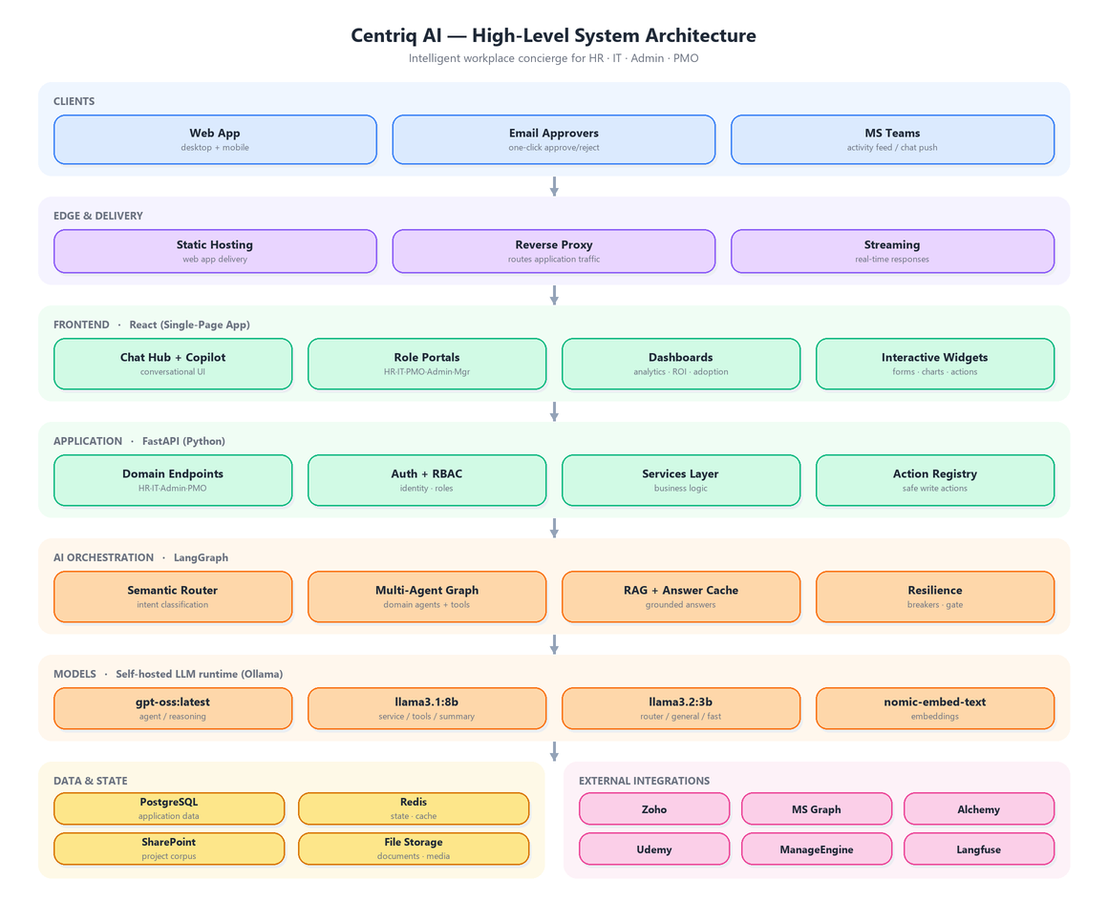
Figure 1 — High-level layered system architecture.

2.1 Layer responsibilities
Layer | Responsibility | Technology
Clients | Employee & manager access; email approvals; Teams push | Web app, email, MS Teams
Edge & Delivery | Web app delivery, reverse proxy, real-time streaming | Reverse proxy
Frontend | Chat hub, copilot, role portals, dashboards, widgets | React
Application | Business endpoints, auth, access control, safe actions | Fast API (Python)
AI Orchestration | Intent routing, multi-agent graph, retrieval, caching | Lang Graph
Models | Routing, reasoning, tool use, summarization, embeddings | Self-hosted LLM runtime
Data & State | Relational data, vector search, state, corpus, files | PostgreSQL, Redis, SharePoint
External Integrations | Enterprise portals for HR, IT, learning, productivity | Zoho, MS Graph, Udemy…

3. Technology Stack
The stack is intentionally described at the architectural level. Implementation libraries and versions are omitted; the choices below define the shape of the system.
Concern | Technology
Frontend | React single-page web application (installable)
Backend | FastAPI application (Python)
AI orchestration | LangGraph multi-agent graph
Language models | Self-hosted LLM runtime (see §6 for the model tiers)
Relational & vector data | PostgreSQL with vector search
State, cache & messaging | Redis
Knowledge corpus | SharePoint (project & document content)
Edge | Reverse proxy with static web-app hosting and streaming
Observability | Self-hosted LLM tracing (Langfuse) plus audit logs

4. Frontend Architecture
The frontend is a React single-page web application. An authenticated shell wraps all in-app screens, providing navigation and role-based gating; the chat hub is the default experience, with role portals and dashboards mounted as dedicated screens.

4.1 Screens
Area | Representative screens
App shell & core | Chat hub (default), settings
Employee self-service | Onboarding, documents, directory, my requests, team, library
Role portals | HR, IT, PMO, Manager, Admin, Leadership
AI-driven consoles | Project IQ, Udemy Business, Tech Elevate, Analytics
Admin & platform | Access management, roles, connectors, LLM controls, automation
Analytics & insight | ROI dashboard, observability, adoption, feedback triage

4.2 The assistant’s experience
The chat experience combines a rich composer (with slash-commands, file attachments and mentions), a streamed message view, and a set of interactive widgets that the backend can summon inline as part of a response — for example leave application, room booking, travel requests, dynamic forms, document generation, escalation, quick-choice cards, a proactive nudge feed, a morning briefing, and inline charts. A portal-aware copilot can also drive the visible screen, such as filtering the directory in response to a natural-language request.

4.3 Identity
Users sign in through corporate single sign-on. The signed-in identity and role travel with each request so the assistant and portals can present role-appropriate capabilities and enforce access.

5. Backend Architecture
The backend is organized into domain modules over a shared services and orchestration core. Modules are thin — they validate input, enforce role requirements, and delegate to the services layer; the conversational surface hands off to the orchestration graph. Recurring background work (model warm-up, directory synchronization, scheduled reports and automations, proactive-nudge scans, and data-retention maintenance) runs under the application lifecycle.

5.1 Domain modules
Domain | Capabilities
HR & People | Leave & policy, people data, attendance, recognition
IT & Assets | Tickets, assets, software installation, licenses
Admin & Facilities | Facilities, travel, announcements, escalations
PMO & Projects | Projects, staffing, capability, training, Project IQ
Library & Docs | Bookshelf, documents, forms, app directory
Onboarding | New-hire journey, exits, setup, progress tracking
AI & Analytics | Analytics, knowledge corpus, tracing, model controls
Platform / Admin | Access control, integration, automation, connectors

5.2 Shared core
Beneath the modules sits a shared core: a domain services layer (business logic), a library of per-domain AI agents, an orchestration pipeline of shared pre/post hooks, a connector framework that turns external systems into AI-usable tools, a document generation subsystem, and a tool layer that exposes safe actions to the agents.

6. AI Orchestration & Language Models
The heart of Centriq is a stateful orchestration graph. Each conversation has durable, resumable memory, so context survives across turns. Every turn passes through a pre-processing spine, is routed to a domain agent that runs a reason–act tool loop and is finalized through summarization and state tracking before being streamed back to the client.
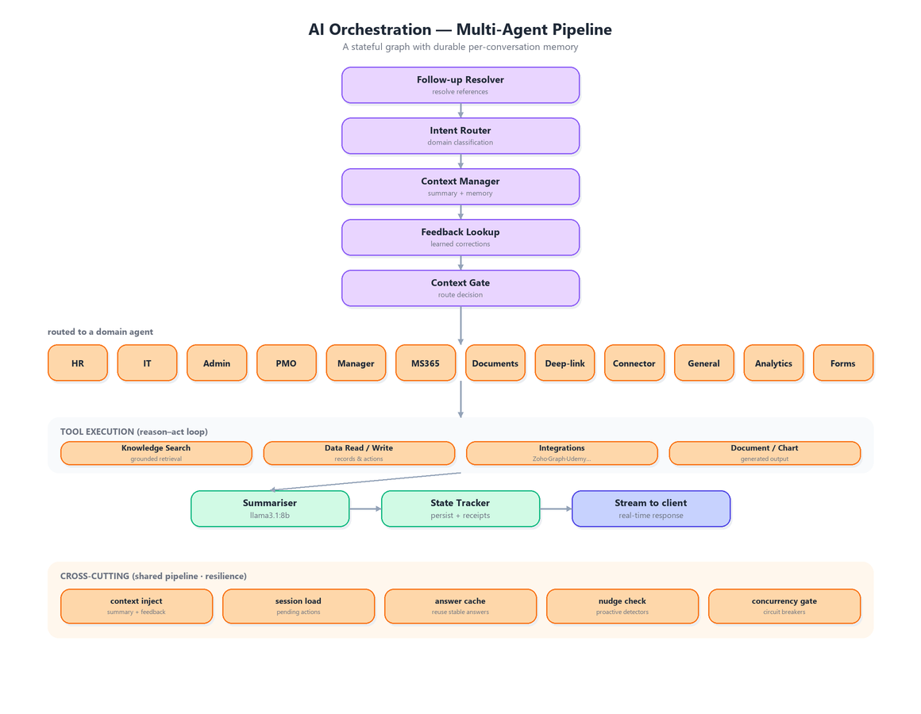
Figure 2 — Multi-agent orchestration pipeline.

6.1 Model tiers
All models run on a shared, self-hosted runtime. They are tiered to balance capability against latency and shared-hardware contention.
Model | Tier / role | Used for
gpt-oss:latest | Agent | Reasoning and tool-calling agent
llama3.1:8b | Service / Summarizer | Domain tool-calling and summarization
llama3.2:3b | Router / General / Fast | Intent routing, general chat, quick tasks
nomic-embed-text | Embeddings | Semantic routing, retrieval, caching, matching

A background heartbeat keeps each tier resident on the shared hardware, and the application proactively warms models when a user is about to send a message, avoiding cold-start latency.

6.2 Intent routing
Routing is two-stage. A semantic router compares the request against curated example utterances using embeddings, producing a confidence tier; high-confidence matches route directly to a domain, while ambiguous cases fall through to a model-based router. Deterministic interceptors handle high-value, unambiguous phrasings before any model call.

6.3 Grounded answers
Domain agents ground answers by retrieving from an internal corpus (policies, projects, IT documentation) that is chunked and embedded for vector search, with reranking and citation extraction so answers carry their sources. A semantic answer cache reuses stable informational answers, while action, per-user, and refusal responses are excluded from caching.

6.4 Resilience
- Circuit breakers — per-tier breakers open on repeated failure and shift load to fallback models.
- Concurrency gate — a gate bounds simultaneous model calls under load.
- Health probing — runtime health is monitored and reported (healthy / degraded / down).
- Graceful fallback — memory, connectors, and warm-ups fail soft without breaking a request.

7. Request Data Flow
A chat turn traverses the full stack. The front end first handles deterministic actions locally where possible; otherwise, it sends the message to the backend and consumes a streamed response in real time.
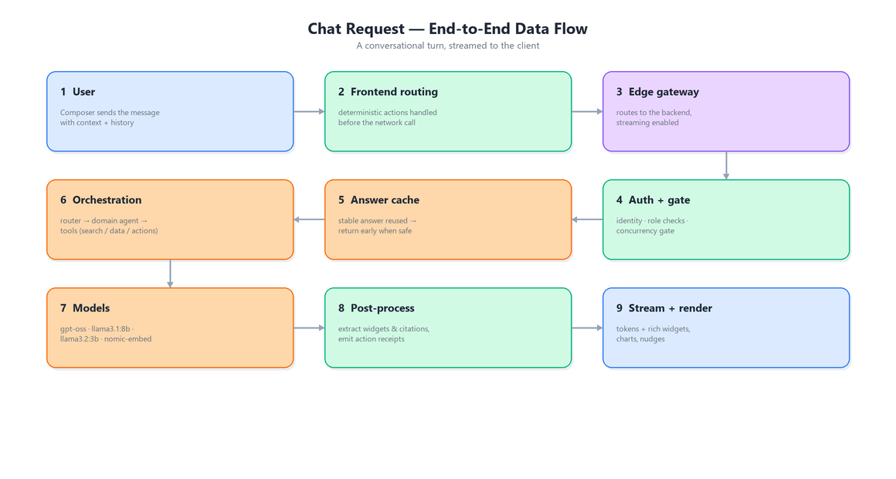
Figure 3 — End-to-end chat request data flow.
Responses interleave answer text with inline markers that the client renders as interactive widgets, charts, citation cards, and downloads. Completed actions emit durable receipts, and post-processing may queue proactive nudges for the user.

8. Integrations & External Systems
Centriq acts as an intelligence layer over a landscape of enterprise portals. Integrations are delivered through dedicated service modules and a generic connector framework, which exposes external operations as AI-usable tools gated by role and persona.
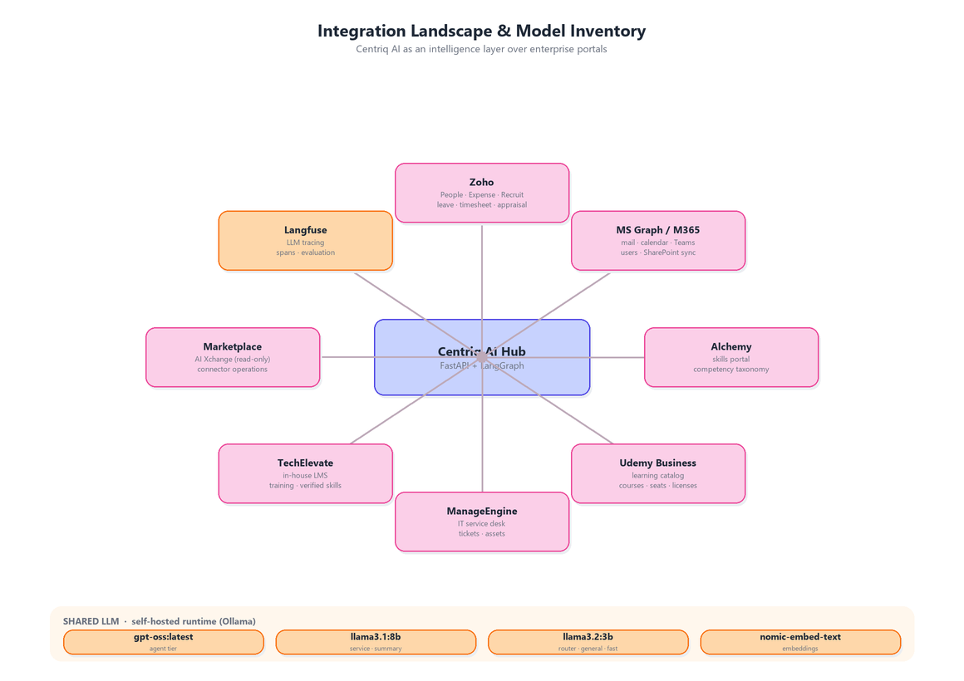
Figure 4 — Integration landscape and model inventory.

8.1 Integrated applications & portals
System | Type | Access | What Centriq uses it for
Zoho | HRMS suite | Read / Write | People, Expense, Recruit — leave, timesheet, attendance, appraisal, directory, document generation
Microsoft 365 | Productivity | Read / Write | Mail, calendar, Teams messages, room booking, user directory, SharePoint sync; sends email as the user, community post and post related data read
SharePoint | Content | Read | Project knowledge corpus for Project IQ and document retrieval
Alchemy | Skills portal | Read | Competency taxonomy and employee skills for directory, matching, capability planning
Udemy Business | Learning | Read + provisioning | Course catalog search, seat/license requests, inactive-seat reclamation
Tech Elevate | In-house LMS | Read / Write | Local training catalog, verified-skill flywheel, MCQ creation training recommendations
ManageEngine | IT service desk | Read / Write | IT ticket and asset operations
AI Xchange Marketplace | Connector hub | Read-only | Marketplace operations surfaced as tools
Lang fuse | Observability | Outbound traces | Language-model traces, spans, and evaluation

Some live integration paths are activated by configuration once credentials are provisioned; until then they run in a safe, disabled state.

9. Platform Extensibility & Authoring
Centriq is designed to be extended and curated by business administrators without engineering effort. Several authoring surfaces turn static admin artefacts into living, AI-curated capabilities — each discoverable through the same conversational interface.

9.1 Connector Studio
Connector Studio lets administrators onboard external systems as AI-usable tools without code. An administrator imports a system’s interface description, and its operations become tools the assistant can call. Each connector can be drafted, tested, and published; individual operations can be enabled or disabled; and access is gated by role and persona so only the right users can invoke each operation. Connectors are managed centrally and refreshed immediately, so changes take effect across the assistant at once. The AI Xchange Marketplace was onboard this way, in read-only mode.

9.2 Form Library
The Form Library is a catalogue of digital forms with AI assistance on both sides:
- Authoring — an administrator describes the form they want in plain language, and the system drafts its fields for review and refinement — removing manual form-building.
- Filling — employees complete forms conversationally in chat, with identity fields pre-filled from their profile and a deliberate confirmation step before anything is submitted.
The library also improves itself: it mines recent chat questions that should have matched a form and suggests trigger phrases to the administrator.

9.3 URL Library (App Directory)
The URL Library is a curated directory of internal applications surfaced through chat when a user asks where to do something. Administrators can draft an entry’s description and trigger phrases from a short plain-language note, and the directory learns additional trigger phrases from near-miss questions, so the right app is found next time. Entries are curated by administrators; the system does not reach into internal apps directly.

9.4 Other administration surfaces
Surface | Purpose
Automation Hub | Recurring email and report rules created by managers, HR, IT, and PMO
Access Management | Roles and the capabilities mapped to them, with per-user overrides
Model Controls | Model tiers and routing thresholds
Company Settings & Announcements | Organisation-wide configuration and broadcasts

10. Project IQ — Delivery-Knowledge Intelligence
Project IQ is an internal capability that turns the organisation’s project history into reusable delivery knowledge. It is not an external portal; rather, it is an AI module layered on the SharePoint project corpus and the internal people and allocation data.
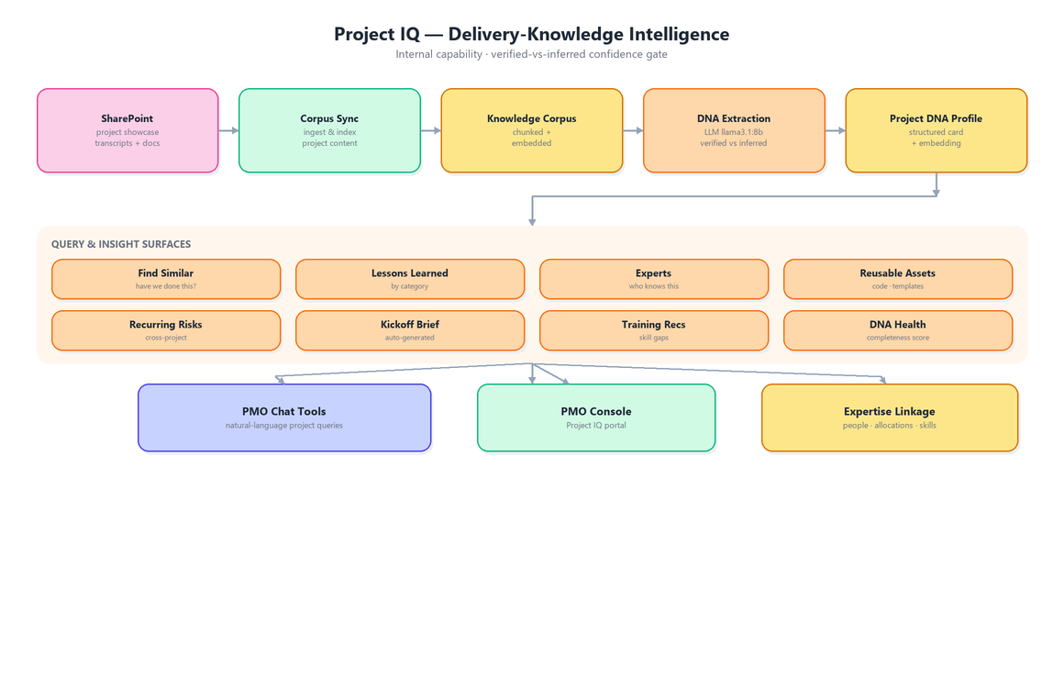
Figure 5 — Project IQ delivery-knowledge pipeline.

9.1 How it works
- Source — project showcase content (meeting transcripts and documents) is synchronized from SharePoint and indexed into the knowledge corpus.
- DNA extraction — a language model (service tier) distils each project into a structured “Project DNA” profile covering capabilities, integrations, lessons, reusable assets, and expertise.
- Confidence gate — every extracted fact is marked verified (explicitly stated in the source) or inferred, so downstream views can filter to trustworthy facts only.
- Similarity — each profile is embedded for vector search, enabling a “have we done this before?” query across the whole portfolio.

9.2 What it delivers
Project IQ powers find-similar-projects, lessons learned, expert discovery, reusable-asset lookup, recurring-risk detection, auto-generated kickoff briefs, and training recommendations. These surfaces both as a PMO console and as natural-language tools inside the assistant, with expert results linked to people, allocations, and skills so the right person can be found — not just the right document.

11. Data & Persistence
Application data lives in a hosted PostgreSQL database with vector search for embeddings. Redis holds conversation state, caches, and internal messaging. A SharePoint corpus feeds Project IQ and document retrieval, and runtime uploads persisted on durable storage so they survive redeployment.

11.1 Data domains
Domain | Data
People & HR | Employee records, leave requests & balances, attendance, recognition
Knowledge | Policy & project content chunked for retrieval, routing examples, cached answers
IT & Admin | Tickets, software catalog & install requests, travel, announcements
PMO & Projects | Projects, project profiles, allocations, training records
AI memory & safety | Conversation memory, pending actions & receipts, proactive nudges
Integrations | Connector definitions, operations, scopes, call logs
Access & identity | Roles, role-to-capability maps, per-user overrides, directory data
Observability | AI request and model-call logs, insight signals

Conversation memory is purged on a retention schedule, and completed action records are cleaned up automatically.

12. Security — Authentication, Authorization & RBAC
Access is layered: corporate single sign-on establishes identity, an access allow-list restricts the application to approved users, and a capability-based model governs what each role can see and do.
- Single sign-on — identity is established through corporate SSO and travels with each request.
- Role-based access — protected capabilities are guarded by role, from employee through HR, IT, PMO, manager, and admin.
- Capability catalogue — a catalogue of capabilities (portals, modes, features) is mapped per role, with per-user overrides.
- Data-boundary control — sensitive personal data is limited to the individual, their manager, and HR.
- Sensitive-data exclusion — highly sensitive personal fields are deliberately never surfaced anywhere in the product.

13. Deployment & Infrastructure
The application runs as a set of containerized services on a single private network: a web/reverse-proxy service that delivers the web app and forwards application traffic to the backend (with streaming enabled for real-time responses), the backend service itself, a Redis service for state and caching, and a self-hosted observability stack for language-model tracing.
The application database (PostgreSQL) and the language-model runtime are hosted externally to the container deployment and reached over the network. Runtime uploads are kept on durable storage, so they persist across redeployments. A public entry point fronts the deployment and forwards traffic to the web/proxy service.

14. Cross-Cutting Concerns

14.1 Action safety & receipts
Write actions run through a shared safety flow: each action is authorized, made idempotent, de-duplicated, executed, and recorded as a durable receipt with one-click undo. The undo path is guarded so an action can never be reversed accidentally by a link preview. This spine underpins IT tickets, HR queries, and planned automation bundles.

14.2 Notifications
Approvals route to Teams chat with an email fallback; other notices go to email plus a Teams activity feed. Email is sent from the signed-in user’s mailbox currently, once approved it will send using app’s own mailbox using a branded template. Proactive push remains disabled until the corporate messaging setup is complete.

14.3 Proactive nudges
Deterministic detectors (for example expiring leave or stale approvals) run on a schedule and after each answer, surfacing de-duplicated nudges into an in-app feed. The same signal stream feeds adoption and feedback analytics.

14.4 Observability & adoption
Language-model activity is traced, and every AI request and model call is logged. Dashboards surface feedback triage, feature adoption across the workforce, and a learning loop that promotes negative feedback and escalations into curated answers and routing improvements.

15. Appendix — Model Inventory
All models are served from a shared, self-hosted runtime.
Purpose | Model
Agent (reasoning & tool use) | gpt-oss:latest
Service & summarisation | llama3.1:8b
Routing, general & fast tasks | llama3.2:3b
Embeddings | nomic-embed-text

Model tiers, routing thresholds, and integration activation are configurable at runtime and may differ from the defaults shown here.

