“Theory of Automata”
Assignment # 02

DCS Theory of Automata
Submitted By: Muhammad Ali
Registration Number: NUM-BSCS-2024-46
Section: B
“On my honor, as a student of Namal University, I have neither given nor received unauthorized assistance on this academic work.”

Submitted To:
Mr. Bilal Adrar
June 7th, 2026
Department of Computer Science
Namal University, Mianwali

Lab # 06
“Computer Architecture”

OBJECTIVES:
- To extend the functionality of a 32-bit ALU by adding new operations like NAND, logical left shift, and arithmetic right shift.
- To understand how ALU control signals (Sel codes) are assigned and used for different operations.
- To design and implement an 8-to-1 multiplexer for selecting one of multiple 32-bit inputs.
- To learn how to integrate a multiplexer with an ALU to provide flexible input selection.
- To enhance a register file by adding an asynchronous reset feature to clear all registers.
- To implement read-after-write forwarding so updated data is immediately available.
- To develop and modify testbenches for verifying correct functionality of all components.
- To practice testing multiple sequential operations like reads and writes in digital systems.
VERILOG:
Verilog is a hardware description language (HDL) used to design and model digital electronic systems such as logic circuits, processors, and FPGA-based projects. It allows engineers to describe hardware behavior and structure using a syntax similar to the C programming language, making it relatively easy to learn. Verilog is widely used for simulation, verification, and synthesis of digital systems, enabling designers to test and implement their designs efficiently on hardware like FPGAs and ASICs.
TASK 1 Module Code:
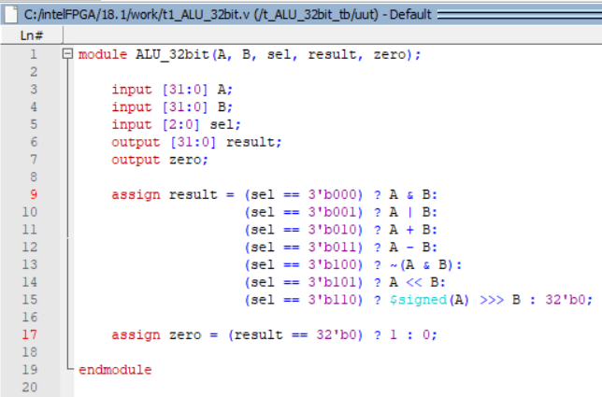

Testbench:

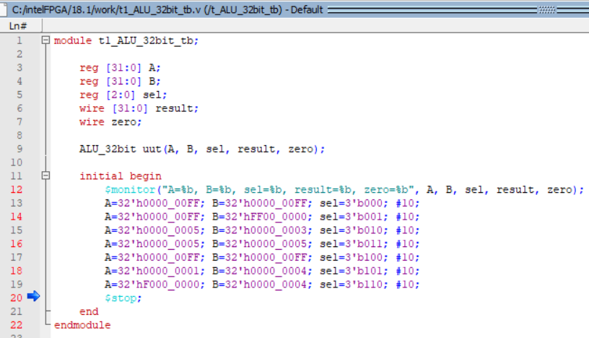
Waves:
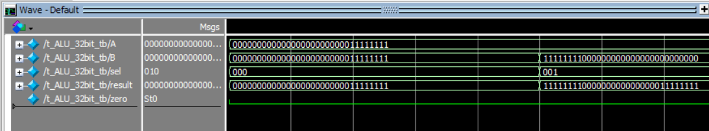
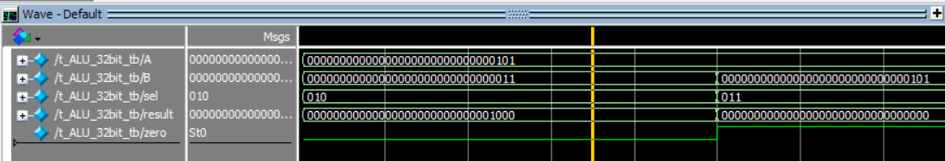
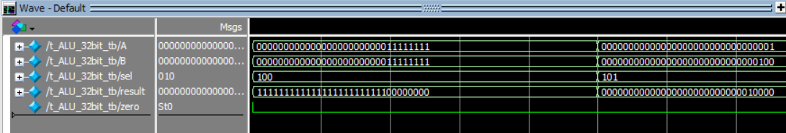
Output:
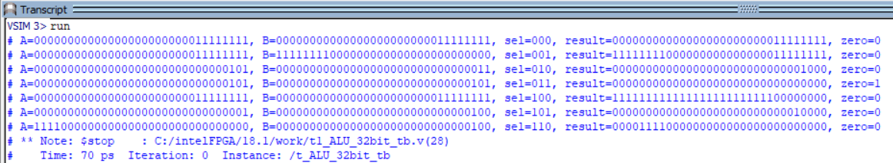
Code Explanation:
This task extends the ALU by adding new operations like NAND (~(A & B)), left shift (A << B), and arithmetic right shift ($signed(A) >>> B), each controlled by new sel codes. The testbench apply different inputs and verify that these operations work correctly. The zero flag is also checked to ensure it becomes 1 when the result is zero, otherwise 0.
=====================================================================================

TASK 2 Module Code:
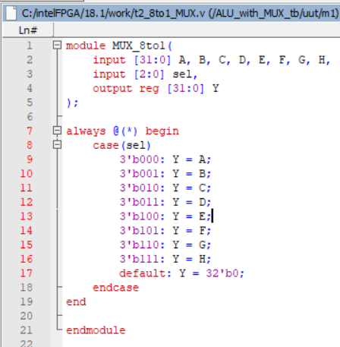

Mux with ALU Module Code:
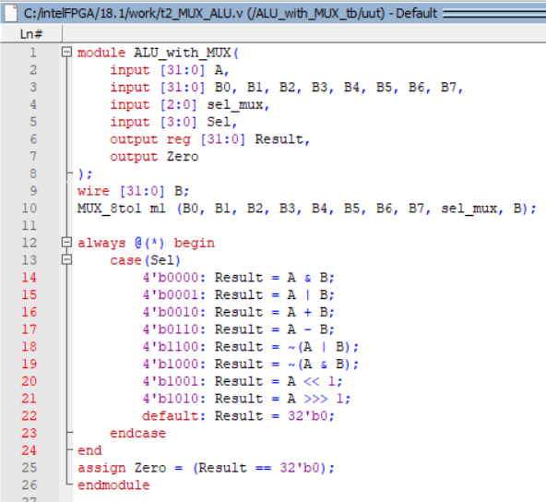
Testbench:
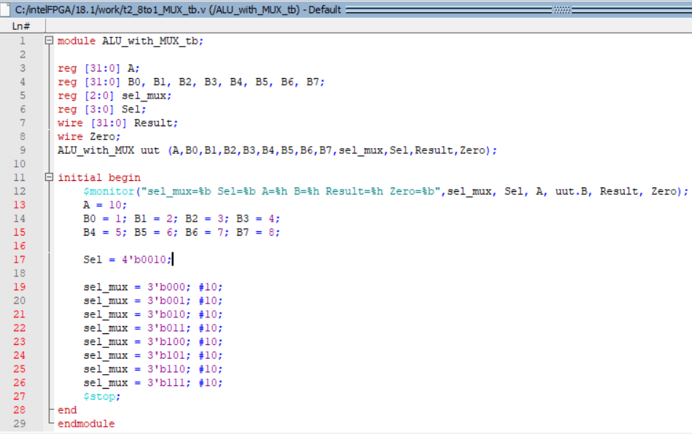

Waves:
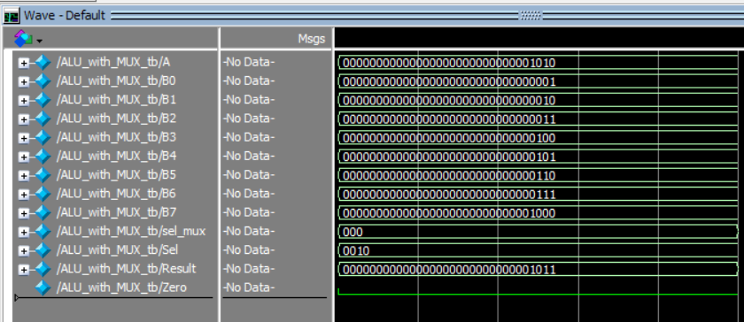

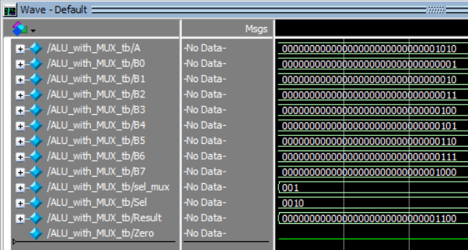

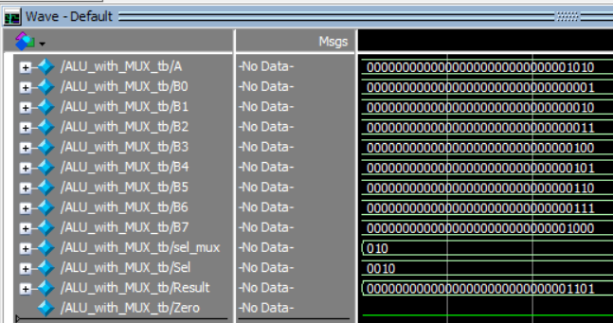

Output:
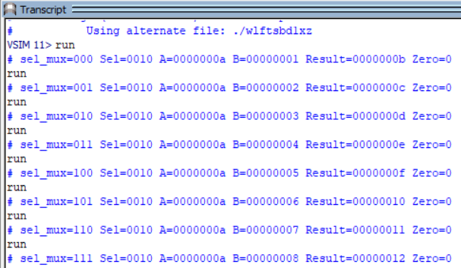
Code Explanation:
This design combines an 8-to-1 multiplexer with an ALU. The multiplexer selects one of eight 32-bit inputs (B0–B7) based on the select signal sel_mux, and this selected value is used as input B for the ALU, while A is the other input. The ALU performs operations like AND, OR, addition, subtraction, and shifts depending on the control signal Sel, and outputs the result along with a Zero flag if the result is zero. The testbench checks the design by changing the select signal to test all inputs, showing how the MUX allows flexible input selection for the ALU.
==============================================================

TASK 3 Module Code:
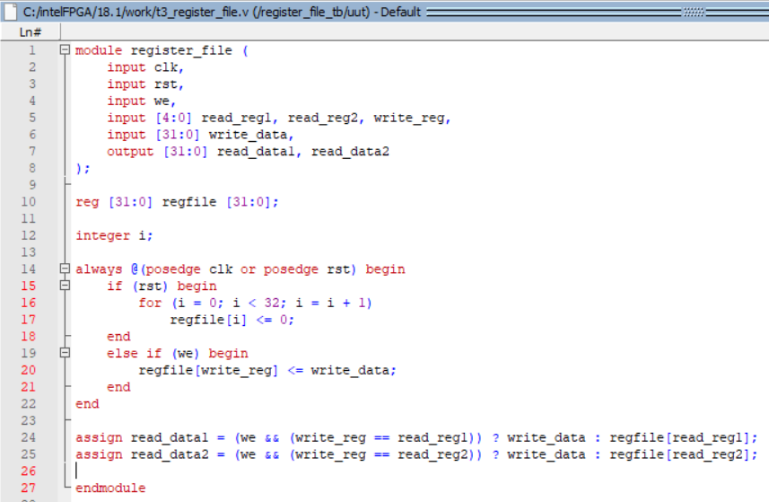

Testbench:
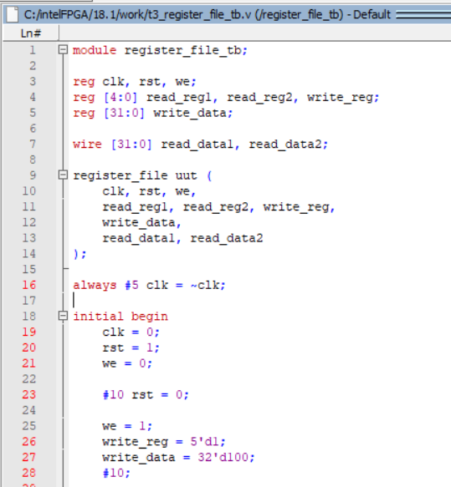

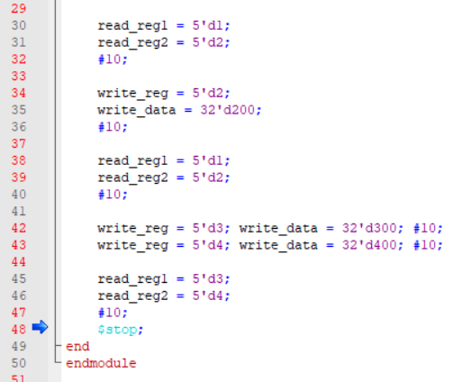

Waves:
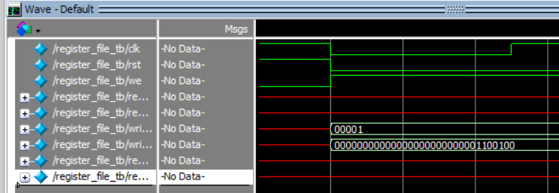

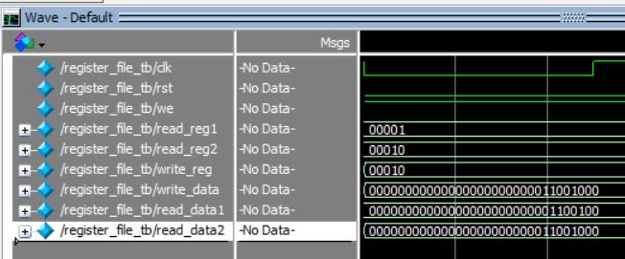

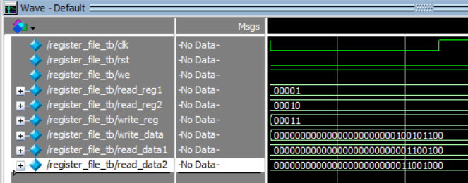

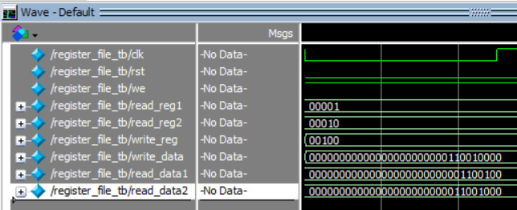

Code Explanation:
The register file stores 32 registers and includes an asynchronous reset to clear all values. Read-after-write forwarding ensures that if a register is written and read in the same cycle, the new value is returned immediately. The testbench verifies reset, write operations, forwarding behavior, and multiple sequential reads and writes.

