CMPE 48A: Cloud Computing Term Project
  - Phase #1 Report – Ali Gökçek

Team Member: Umut Şendağ
Application Source Code: https://github.com/cisco-open/martian-bank-demo
- Tentative Cloud Architecture:
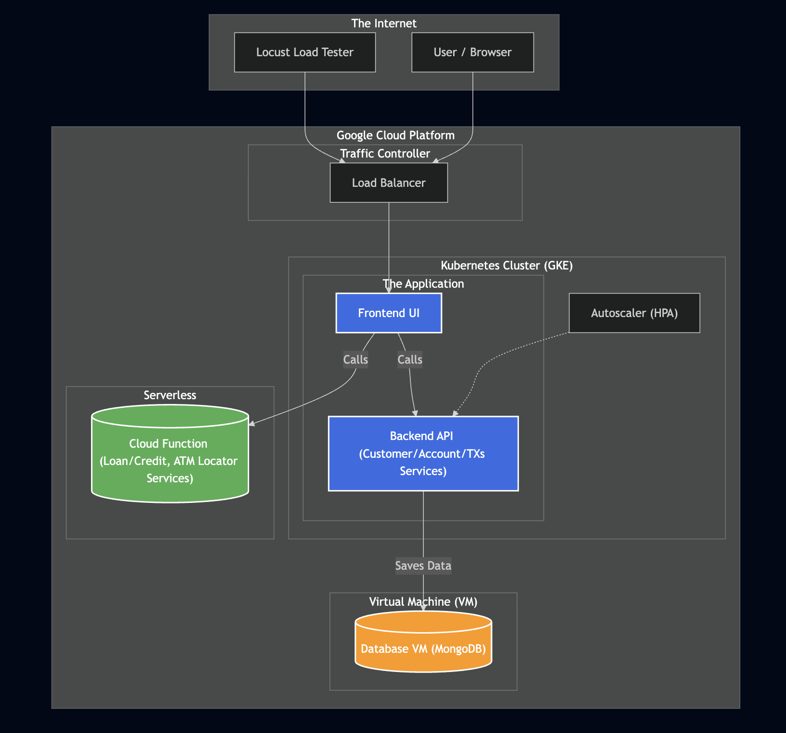
We have designed a hybrid cloud-native architecture that leverages the strengths of Containers, Virtual Machines, and Serverless computing. The system is divided into three distinct layers:
- Containerized Core (Kubernetes / GKE):
  - Components: The Frontend UI and the primary Backend API (handling Customer Accounts and Transactions) are containerized and deployed on Google Kubernetes Engine (GKE).
  - Scalability: We utilize a Horizontal Pod Autoscaler (HPA) on the Backend API. This satisfies the requirement to deploy workloads in a scalable manner. The HPA will monitor CPU utilization and automatically scale the number of API pods during load testing.
  - Traffic Management: An External Global Load Balancer routes internet traffic to the cluster, ensuring a unified entry point.
- Virtual Machine Layer (Compute Engine):
  - Component: The MongoDB Database is installed and hosted on a standalone Google Compute Engine (GCE) Virtual Machine.
  - Functional Role: This VM handles all persistent data storage for the application. Extracting the stateful database from the Kubernetes cluster.
- Serverless Layer (Cloud Functions):
  - Component: The Loan/Credit and ATM Locator services are implemented as standalone Google Cloud Functions.

2. Cost Estimation:
We have optimized resource selection to ensure the total monthly cost remains well below the $300 free trial budget.

Projected Monthly Cost: ~$172.55
Component | Resource Configuration | Estimated Monthly Cost | Justification
GKE Nodes | 3x e2-medium instances (2 vCPU, 4GB RAM) | $139.20 | Sufficient resources to host the Python-based microservices and system pods.
GKE Management | Zonal Cluster | $0.00 | Management fees are waived for a single Zonal cluster.
Database VM | 1x e2-small instance (0.5 vCPU, 2GB RAM) | $11.10 | Provides adequate memory for the MongoDB database while minimizing compute costs.
Load Balancing | Global HTTP(S) Load Balancer | $18.25 | Required for external traffic routing and ingress management.
Storage (Disks) | 40GB Standard Persistent Disks for each | $4.00 | Covers boot disks for nodes and data storage for the VM.
Serverless | Cloud Functions (Gen 1) | $0.00 | Usage is expected to fall within the free tier (first 2 million invocations).
Total |  | ~$172.55 | (58% of Total Budget)

The estimated cost of $172.55 leaves a safety buffer of over $120. We will further control costs by stopping the Database VM and deleting Load Balancers when the environment is not in active use.

