

**Payment Cartridge Integration**

***int_checkoutcom | Version 19.1.0***



**Table of Contents**

1. Summary 1-3

2. Component Overview 2-4

2.1 Functional Overview 2-4

2.2 Use Cases 2-4

2.3 Limitations, Constraints 2-4

2.4 Compatibility 2-4

2.5 Privacy, Payment 2-4

3. Implementation Guide 3-5

3.1 Setup 3-5

3.2 Configuration 3-5

3.3 Custom Code 3-5

3.4 External Interfaces 3-5

3.5 Testing 3-5

4. Operations, Maintenance 4-6

4.1 Data Storage 4-6

4.2 Availability 4-6

4.3 Support 4-6

5. User Guide 5-7

5.1 Roles, Responsibilities 5-7

5.2 Business Manager 5-7

5.3 Storefront Functionality 5-7

6. Known Issues 6-8

7. Release History 7-9

# Summary

[Checkout.com](https://www.checkout.com) is a software platform that has integrated 100% of the value chain to create payment infrastructures that truly make a difference. Checkout.com is authorised and regulated by the Financial Conduct Authority under the Electronic Money Regulations 2011 (reference number 900816) to issue electronic money and provide payment services.

The Checkout.com cartridge allows Salesforce Commerce Cloud (SCC) store owners to process payments through the [Checkout.com Payment Gateway](https://docs.checkout.com/getting-started/introduction).

This implementation guide describes how to integrate the Checkout.com payment cartridge into SCC reference application, Site Genesis. The integration is cross-browser, cross-device compatible, and can accept online payments from all major credit cards.

The Checkout.com LINK cartridge package contains a single folder named **int_checkoutcom**. This integration has been designed using Javascript Controllers and doesn’t contain any deprecated Pipelines code. For a maximisation of the conversion rate, the buyer is not redirected to third party sites during the payment process. Consequently, the shop operator does not need a PCI DSS certification to use the solution.

In order to test or effectively process payments through the Checkout.com Payment Gateway, you will need to open an account. Please contact your Checkout.com account manager or send an email to [support@checkout.com](mailto:support@checkout.com) for more information.

# Component Overview

## Functional Overview

The Checkout.com cartridge for Salesforce Commerce Cloud (SCC) connects your online store with the Checkout.com gateway and automates all payment processes, delivering a comprehensive payment integration with simple usability and maximum performance.

* Consolidated expertise for all payment methods and services
* End-to-end automation of all payment processes
* Seamless integration into the SCC checkout process
* Central administration directly in the SCC backend
* No PCI DSS certification necessary for you as a merchant
* Fast time-to-market due to the use of scalable cloud technologies

The following features are available directly through the SCC Business Manager in the Hub, Checkout.com’s payment management backend:

* Fully featured transaction management: handle authorisation, capture, void, full or partial refund, blacklisting and chargebacks
* Customer/Card holder details, cards and address management
* Integrated risk engine with handling of fraud prevention

Checkout.com’s cartridge for Salesforce Commerce Cloud allows shoppers to perform secure payments without leaving the store and gives store owners a full control over payments and customers management.

The payment workflow can be summarised into 3 steps:

* Display the bank card payment form
* Submit the form, charge the customer for the total amount of the order, handle the response
* Display the order confirmation page or the cart with an error message in case of failure

Upon completion of a payment, detailed information about the order and the corresponding transaction is available in the order details in Business Manager.

## Use Cases

There is currently a single use case for this cartridge: the shopper is using the Checkout.com payment method to complete a purchase on a Salesforce Commerce Cloud website:

1. On the billing checkout step, a credit card payment form is displayed
2. The shopper provides card details and places an order
3. In case of payment success, the shopper is redirected to the order confirmation page
4. In case of payment failure, the shopper is redirected to the cart and can try again

Please see section **5.3 Storefront functionality** for imagesof the payment process**.**

## Limitations, Constraints

1. The Checkout.com cartridge integration doesn't support multi-shipping and subscriptions in SiteGenesis.
2. The Checkout.com credit card form is not compatible with the default Site Genesis credit card form. The default Site Genesis should be disabled when the Checkout.com credit card form is enabled.

## Compatibility

Available since Demandware 18.3

Compatible with Demandware 16.2 and above

Cartridge developed in SiteGenesis 103.1.9

## Privacy, Payment

This integration requires access to the following customer data elements:

* Card Details
* Billing Address
* Shipping Address
* Order Details
* Customer Profile
* Some custom properties of Customer Payment Instruments.

# Implementation Guide

## Setup

The Checkout.com integration is contained in the storefront cartridge **int_checkoutcom**. This single cartridge contains all the payment processor integration functionalities. The integration is compatible with storefronts based on Javascript Controllers, as well as storefronts based on pipelines.

The **int_checkoutcom** cartridge folder contains the following files:

CONTROLLERS & PROCESSORS

* controllers/CKOMain.js
* scripts/payment/processor/CHECKOUTCOM_CREDIT.js

FORMS

* forms/default/creditcard.xml

HELPERS

* scripts/helpers/CKOEvent.js
* scripts/helpers/CKOHelper.js

STATIC FILES

* static/default/css/checkoutcom.css
* static/default/js/checkoutcom.js

TEMPLATE FILES

* templates/custom/ajax/output.isml
* templates/custom/common/response/3DSecure.isml
* templates/custom/credit/request/form.isml
* templates/resources/cko.properties

MISCELLANEOUS

* int_checkoutcom.properties
* scripts/hooks.json
* scripts/util/Countries.ds

The single **int_checkoutcom** Checkout.com cartridge is used for both testing (sandbox mode) and production (live mode). Once the cartridge installed, a parameter in the custom preferences of the Business Manager will allow you to set the running mode according to your needs.

## Configuration

The steps required to enable the Checkout.com cartridge on your website are as described below. The following assumes you have a sandbox with a clean Site Genesis site.

1. Download the int_checkoutcom cartridge from the LINK Marketplace.
2. Upload int_checkoutcom to your server, using a tool like UX Studio or Webdav. Apply the standard flow used to upload cartridges to your environment.
3. In the Business Manager, go to **Administration > Sites > Manage Sites**

In your target sites’s settings, add **int_checkoutcom** to the cartridge path.



1. Go to **Administration > Site Development > Site Import & Export** to import the XML files available in the **metadata** folder.

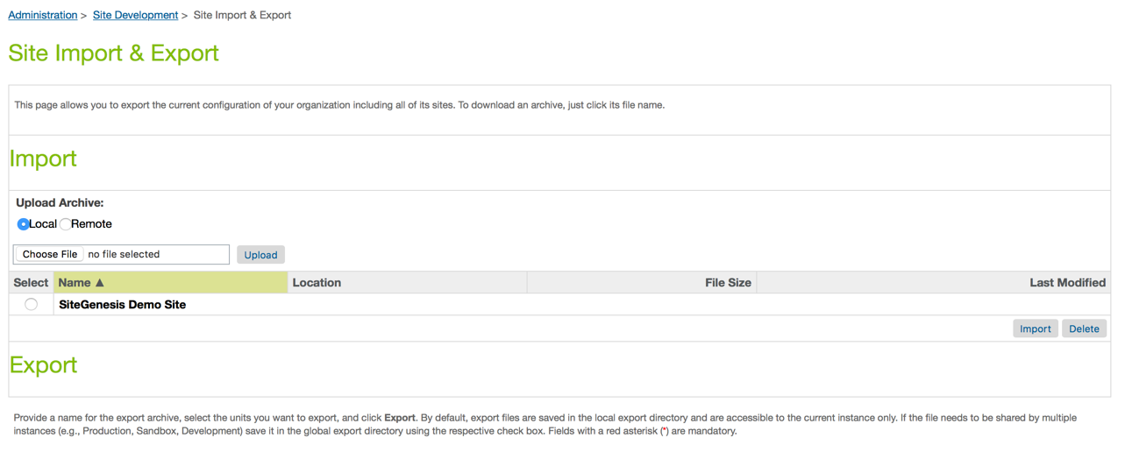

Once in the Site Import section, follow the steps below to import the metadata folder:

* Open a file browser (e.g. Windows Explorer in Windows) and locate the metadata folder of the cartridge. Step down the folder hierarchy until you are in the subfolder “sites”. Re-name the contained folder “SiteGenesisGlobal” to the name of the site for which you want to import int_checkoutcom’s settings, payment methods and services.
* Navigate back to the project’s root folder and create a zip **metadata.zip** out of the folder metadata.
* Login to Business Manager and go to **Administration > Site Development > Site Import & Export**
* Go to the section “Upload archive”. Choose “local” and click on the Browse button
* Navigate in the file system, select the **metadata.zip** then click on “Open” and upload the zip file.
* Check the import status in the Status section.

After the import has been completed successfully, all required Checkout.com data will be available globally and for the selected sites.

## Custom Code

In order to show the Checkout.com payment option on the billing page, the template **/app_storefront_core/cartridge/templates/default/checkout/billing/paymentmethods.isml** has to be modified accordingly.

Add the following code snippet to the paymentmethods.isml template file:

|  |
| --- |
| <iscomment>  Checkout.com - Integration example  Add this code to your paymentmethods.isml file  --------------------------------------------------------------  </iscomment>          <isif condition="${(dw.system.Site.getCurrent().getCustomPreferenceValue("ckoEnabled"))}">              <div class="payment-method <isif condition="${!empty(pdict.selectedPaymentID) && pdict.selectedPaymentID=='CHECKOUTCOM_CREDIT'}">payment-method-expanded</isif>" data-method="CHECKOUTCOM_CREDIT">                  <div class="form-row form-caption cko-form">                      <isinclude template="custom/credit/request/form" />                  </div>              </div>          <iselse>  <iscomment>  Site Genesis - Default Credit card block  Add the default Site Genesis credit card form code here.  --------------------------------------------------------------  </iscomment>          </isif> |

The code above will display the Checkout.com credit card form if enabled in the custom preferences, and display the default Site Genesis credit card form if not.

If your site is also using the default Site Genesis credit card form, please place the code of the form (found in the core paymentmethods.isml template file) after the **<iselse>** block as shown above.

Please note that the Checkou.com credit card form is not compatible with the default Site Genesis credit card form. Please disable the default credit card form if using the Checkout.com credit card form and vice versa.

## External Interfaces

The Checkout.com service endpoints are the external interface that this integration connects to. The documentation for the web service requests and responses can be found in the **charge with full card** section of the [Checkout.com API documentation](https://docs.checkout.com/reference/merchant-api-reference/charges/charge-with-full-card).

## Firewall Requirements

There are no specific firewall requirements.

## Testing

In order to test the payment workflow in sandbox mode, Checkout.com provides a set of card numbers allowing to simulate multiple payment cases.

Use any future expiry date (mm/yy) with these test cards.

|  |  |  |
| --- | --- | --- |
| **CARD** | **NUMBER** | **CVV** |
| Visa | 4242424242424242 | 100 |
| Visa | 4543474002249996 | 956 |
| MasterCard | 5436031030606378 | 257 |
| MasterCard | 2223000010479399 | 299 |
| MasterCard | 5199992312641465 | 010 |
| AMEX | 345678901234564 | 1051 |
| AMEX | 378282246310005 | 1000 |
| Diners Club | 30123456789019 | 257 |
| JCB | 3530111333300000 | 100 |
| Discover | 6011111111111117 | 100 |

# Operations, Maintenance

## Data Storage

No custom objects are created by this cartridge.

## Availability

The Checkout.com payment gateway is expected to have continuous uptime.

## Support

For questions regarding an account, contact your Checkout.com account manager or send an email to [support@checkout.com](mailto:support@checkout.com) . You can also contact us directly by phone: +44 207 323 388.

# User Guide

## Roles, Responsibilities

There are no recurring tasks to be perform in order to run the Checkout.com cartridge integration.

## Business Manager

The configuration parameters of the Checkout.com cartridge are available in Merchant Tools > Site Preferences > Custom Preferences.

You will find 2 groups of configuration screens. **Checkout.com Account** and **Checkout.com Global**.

1. **Checkout.com account**

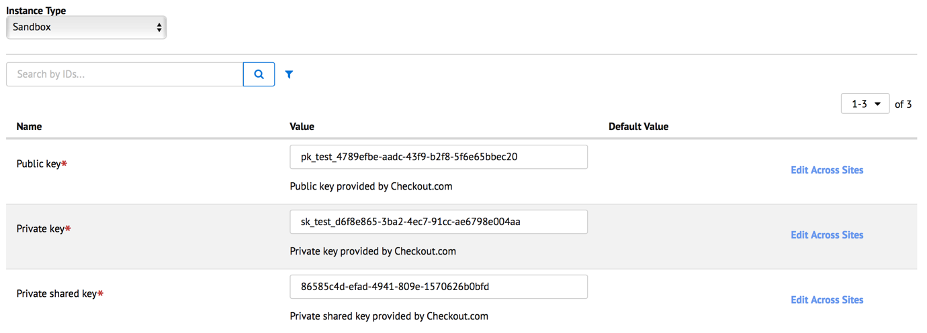

On this screen, you will have to provide a **Public Key**, a **Private Key** and a **Private Shared Key**. These elements are necessary, no matter if you are in production or in test mode. They will be available in your Checkout.com account once it’s been opened by your Account Manager. Please see the Contact section for more information on how to contact Checkout.com.

1. **Checkout.com global**

This screen contains the other configuration parameters for your Checkout.com payment integration. All parameters on this screen are compulsory and should be double checked:

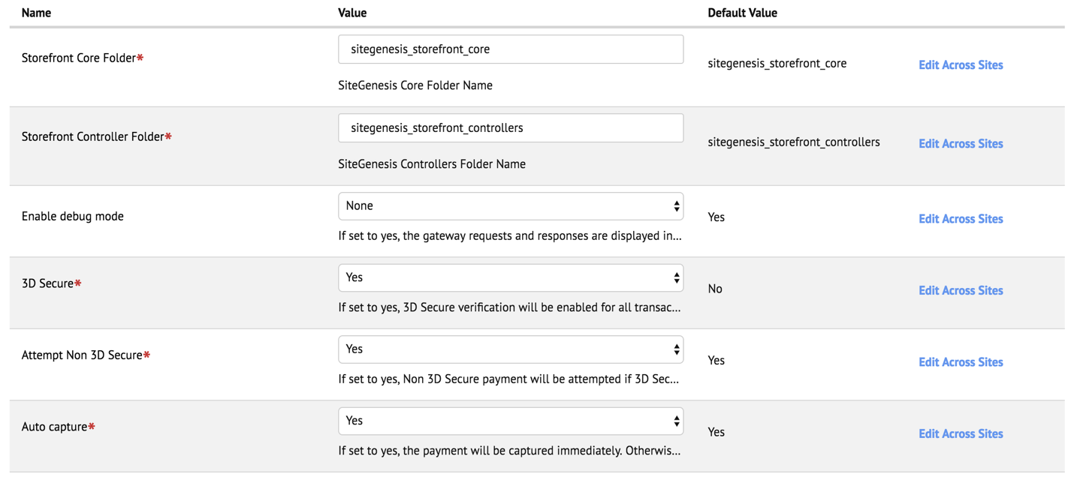

* **Enable**

Enables the Checkout.com credit card form. This credit card form is not compatible with the default Site Genesis credit card form. Please disable the default Site Genesis credit card form when enabling the Checkout.com credit card form.

* **Storefront core folder**

The name of the storefront core folder name. Used by the cartridge to determine a path for several assets included in the folder.

* **Storefront controller folder**

The name of the storefront controller folder name. Used by the cartridge to determine a path for several assets included in the folder.

* **Enable debug mode**

When the debug mode is enabled, the cartridge will log all gateway response in the log files of your website.

* **3D Secure**

Should 3D Secure be active

* **Attempt Non 3D Secure**

In case of failure of a 3D secure check, should the gateway try to fallback to a regular transaction without 3D Secure check.

* **Auto capture**

Should the transaction be captured immediately.

* **Auto capture time**

An integer or decimal number specifying how long after the authorization the transaction should be captured.

## Storefront Functionality

Once enabled, the Checkout.com integration will add a new functionality to your Salesforce Commerce Cloud store.

The Checkout.com payment method will show as an option on the billing page.

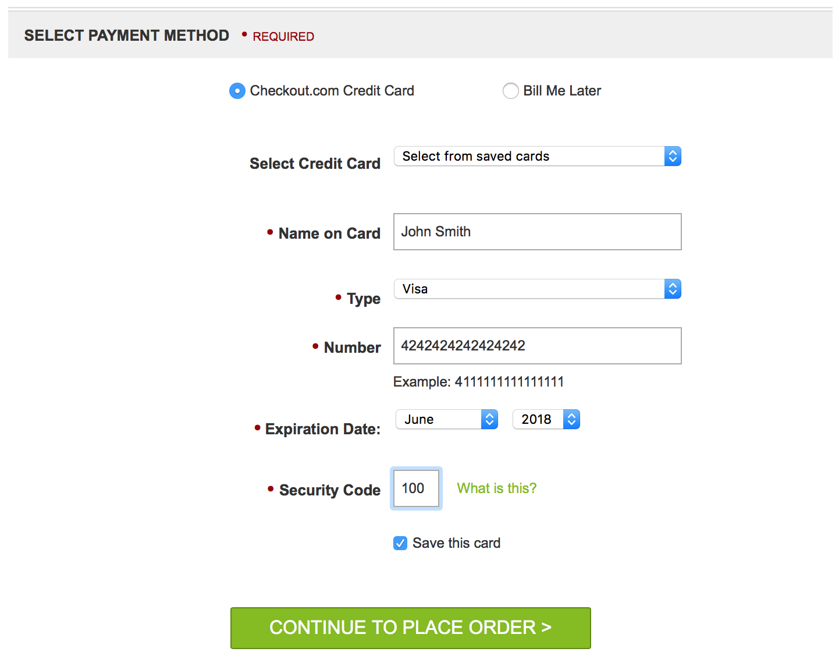

After having provided card details, the shopper can proceed to the order review page.

Clicking on the “Place Order” button will send a charge request to the Checkout.com payment processing server, without having to redirect the shopper.

In case of successful payment, the shopper will be redirected to the order confirmation page.

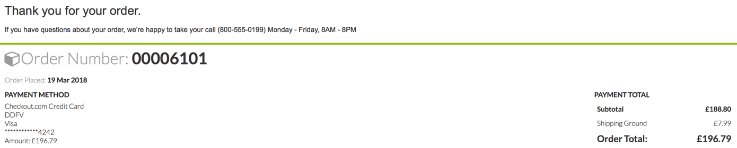

# Known Issues

No known issues at this time.

# Release History

|  |  |  |
| --- | --- | --- |
| **Version** | **Date** | **Changes** |
| 18.1.0 | 19 March 2018 | Initial release |
| 19.1.0 | 28 June 2019 | Documentation update |