Description (Compact filter KF)

Filtration process
1. Dirty liquid flows laterally through the intake box into the filter trough
2. The filter fleece retains the dirt particles as they flow through it
3. The dirt particles form a filter cake that separates even the smallest dirt particles
4. The clean liquid collects in the clean tank
5. Low and high pressure pumps supply the machine tool with cleaned KSS as required

Filter belt regeneration
1. The growing filter cake increases the flow resistance
2. The liquid level in the filter trough increases
3. The belt drive switches on at a defined level (alternatively: time-controlled)
4. The carrier belt transports a piece of clean filter fleece onto the filter surface
5. The level of the liquid decreases again
6.A sludge container or a take-up unit takes up the dirty filter fleece
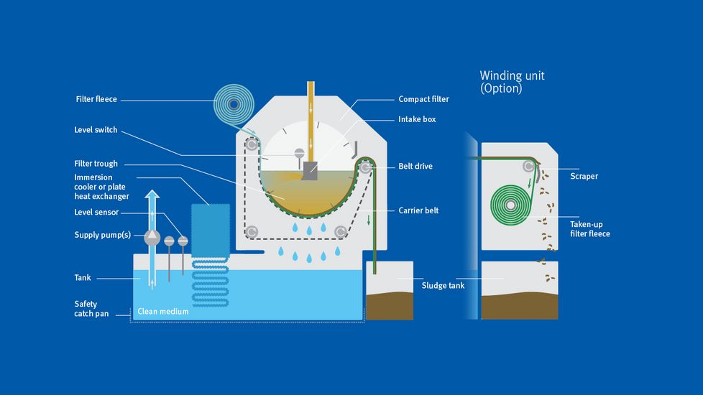

Description Compact filter KF-E

Filtration process
- Contaminated liquid flows from the side through the inlet box into the filter trough
- The filter fleece holds back the contaminant particles during streaming
- The contaminant particles form a filter cake, which separates even tiny dirt particles
- The filtered fluid collects in the clean tank

Filter belt regeneration
- The growing filter cakes increase the flow resistance
- The fluid level in the filter trough increases
- The belt drive switches on at a defined level (alternatively: time-controlled)
- The carrier belt transports a piece of clean filter belt to the filter surface
- The fluid level decreases again
- A brush and back-flushing device clean the filter belt

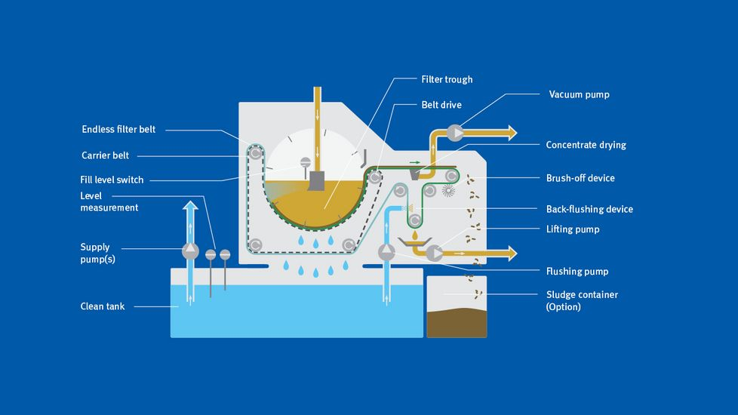

- Filtering process (Superfine filter MicroPur®)

- The filter pump conveys the dirty cooling lubricant tangentially into the filter bowl
- Centrifugal force causes larger solids to accumulate on the housing wall
- The cooling lubricant flows through the filter elements from the outside to the inside
- A filter cake (concentrate) forms on the surface of the filter element and acts as an additional deep-bed filter aiding microfiltration
- The filtered cooling lubricant (filtrate) enters the clean tank

Regeneration process
- The growing filter cake causes a reduction in the volumetric flow or an increase in the pressure differential at the filter cartridge
- The regeneration phase starts in response to pressure or time control: The intake valve closes and the drain valve opens
- The flushing pump conveys the cooling lubricant that has just been cleaned to the filter element, from the inside to the outside
- The filter cake is released and enters the sludge tank
- Downstream equipment for sludge treatment (automatic concentrator) further reduces the concentrate and conveys it to an external container

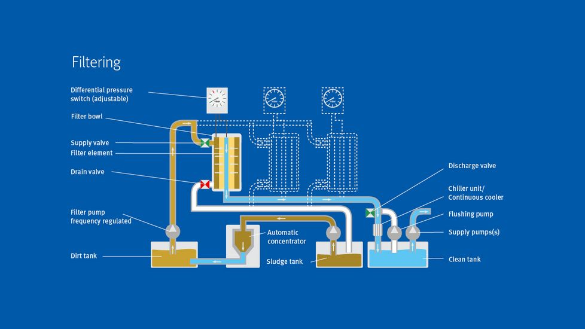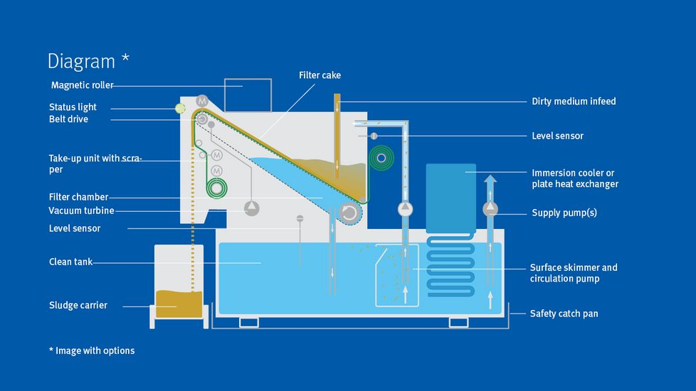

- Filtration process (Vacuum filter VLO)

- A lift pump conveys the waste fluid into the intake box
- Having been cleaned, the KSS flows through the continuous roll into the filter chamber and subsequently into the clean tank
- A filter cake is formed on the continuous roll which, as a depth filter, retains the finest dirt particles

Regeneration process
- The growing filter cake increases the flow resistance through the filter surface
- The vacuum in the filter chamber increases
- When the level reaches a defined threshold value, the belt drive cuts in and conveys the continuous roll a little further
- The continuous roll without filter cake reaches the filter surface; the volume flow through the filter chamber increases again
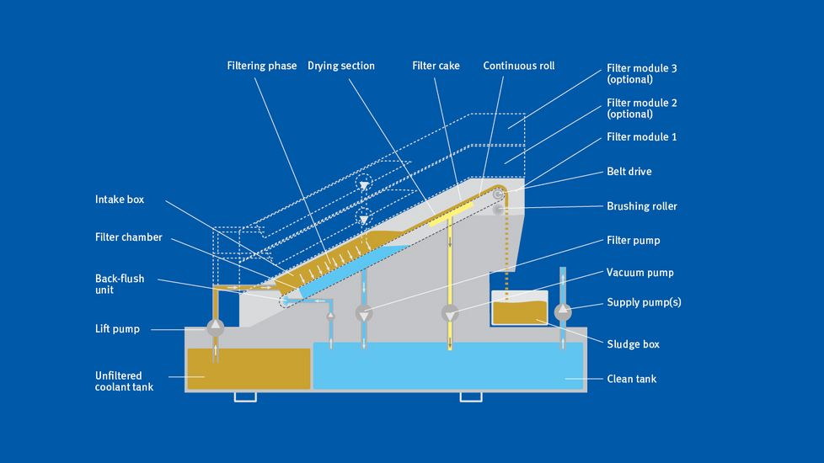

Description (Gravity Belt Filter)
Filtration process
- Contaminated liquid flows through the inlet box into the filter trough
- The filter fleece holds back the contaminant particles during streaming
- The contaminant particles form a filter cake, which itself separates even the smallest dirt particles
- The filtered fluid collects in the filtered fluid tank
Regeneration process
- The growing filter cake increases the flow resistance
- The fluid level in the filter trough increases
- At a defined level, the belt drive switches on (alternatively: time-controlled)
- The carrier belt transports a piece of clean filter fleece to the filter surface
- The fluid level sinks again
- A sludge container takes up the dirty filter fleece

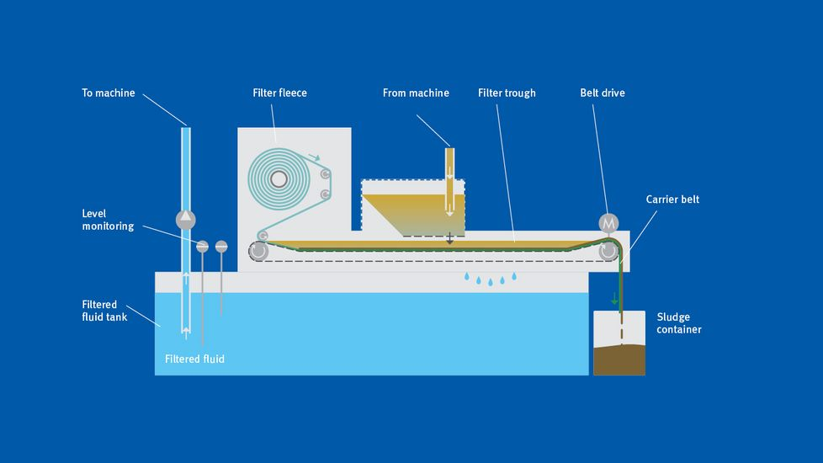

Description// Vacuum rotation filter VRF

Filtering process
- Contaminated liquid flows through the intake box into the filter.
- The filter pump draws contaminated liquid into the interior of the filter drum.
- The filter element on the filter drum retains dirt particles as they flow through.
- The dirt particles form a filter cake that also separates smaller particles.
- The filter pump conveys the cleaned liquid into the tank.
- Low and high-pressure pumps supply the machine tool with cleaned cooling lubricant as required.

Regeneration process
- The growing filter cake increases the flow resistance; the underpressure rises.
- At a defined underpressure, the filter drum rotates and the backwash pump loosens the filter cake.
- The scraper belt transports the settled sludge out of the filter into the sludge tank.

