AI Chat Workspace

Application Architecture:

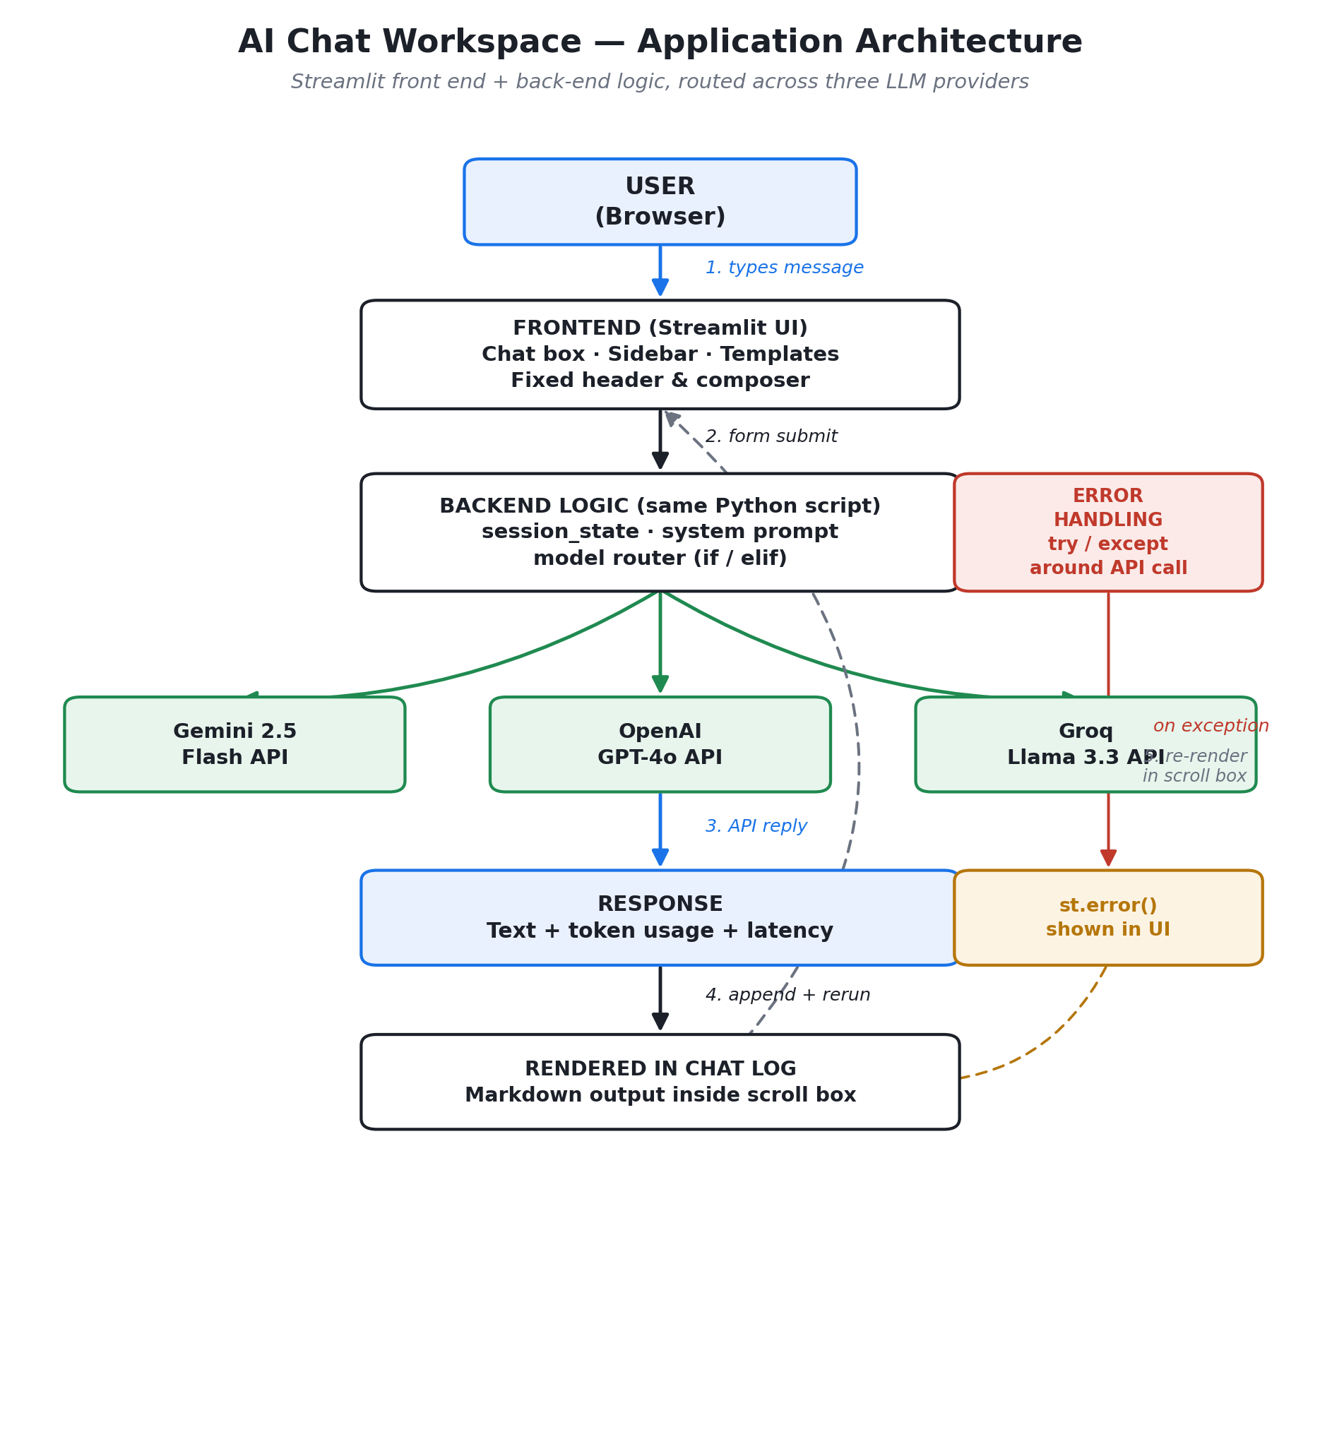

Request Flow
- 1. User input — the user types a message in the Streamlit chat box, or clicks a prompt template which pre-fills it.
- 2. Form submit — clicking Send triggers the Streamlit form; the app validates the input isn't empty before proceeding.
- 3. Session state — the message is appended to the active chat session, and the system prompt plus full conversation history are prepared as the request payload.
- 4. Model router — an if/elif block reads the selected model label and dispatches to the matching provider function:
- • Gemini 2.5 Flash → Google GenAI SDK
- • GPT-4o → OpenAI SDK
- • Groq (Llama 3.3 70B) → OpenAI-compatible client pointed at Groq's endpoint
- 5. API call — the chosen provider function calls its LLM API using a key defined as a constant in the code (never exposed in the UI).
Response Flow
- 1. LLM reply — the provider returns generated text plus usage metadata (input/output token counts).
- 2. Normalization — each provider's response shape is normalized into a common (text, in_tokens, out_tokens, elapsed_time) tuple.
- 3. State update — the assistant's reply is appended to the session, and running token counters are updated.
- 4. Re-render — st.rerun() refreshes the page; the full conversation (markdown-rendered) redraws inside the fixed-height scrollable chat box, with the composer pinned at the bottom.
Error Handling
- Empty prompt — blocked client-side with a warning before any API call is made.
- Invalid / missing key — the provider call raises an authentication error, caught and shown as "Invalid or missing API key" without exposing the key itself.
- Connection failure — network/timeout exceptions are caught and reported as a connectivity error.
- Rate limits — HTTP 429 / rate-limit exceptions are caught and shown with a retry suggestion.
- Fallback — all other exceptions fall through to a generic error message; the failed user message is popped from history so the session stays consistent.
API Integration
- Single entry point — get_ai_response()/call_model() is the only place that talks to external APIs, keeping provider-specific code isolated from the UI layer.
- Provider keys — stored as constants in the backend code, one per provider (Gemini, OpenAI, Groq) — never sent to or rendered in the frontend.
- Consistent interface — regardless of provider, the rest of the app only ever deals with plain text + token counts, so switching models is a one-line dropdown change with no UI impact.

