Technical Research Report

Topic
The Evolution of AI Agents and Modern AI Engineering

Submitted by : Ali Haider

Supervisor : Dr. Gufran Rana

Abstract
Artificial Intelligence has evolved rapidly from simple Large Language Model (LLM) applications that generate text responses to sophisticated autonomous AI agents capable of reasoning, planning, and interacting with external tools and environments. This report examines this evolution through seven core concepts: LLM applications, AI agents, tool calling, memory, planning, multi-agent systems, and the future of AI engineering. Real-world examples and architecture diagrams are included to illustrate how modern agentic systems are designed and deployed to solve complex, multi-step tasks.

1. Introduction
Traditional LLM applications are reactive: they generate a single response to a single prompt and cannot act independently. As real-world problems demanded multi-step reasoning and interaction with external systems, AI agents emerged — systems that plan, call tools, retain memory, and collaborate with other agents to achieve goals. This report explains the building blocks of this evolution and their role in modern AI engineering.

2. LLM Applications
Large Language Models (LLMs) such as GPT, Claude, and Gemini form the foundation of modern AI systems. In their basic form, they follow a simple input-output pattern: a user provides a prompt and the model returns a single static response, with no memory, tool access, or autonomy.
- Text generation: articles, emails, summaries
- Question answering :static chatbot responses
- Content assistance :code generation, translation

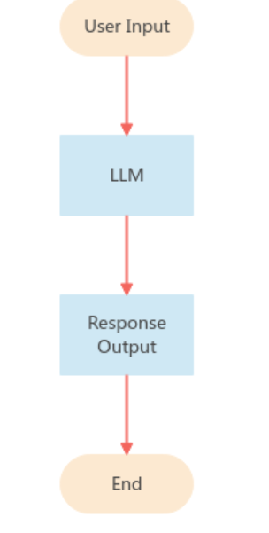
Real-world example:
Early ChatGPT and simple FAQ chatbots — they answer a query but cannot plan multi-step tasks or use external tools.

3. AI Agents
An AI agent is built on top of an LLM and acts autonomously to achieve a goal instead of just answering one prompt. Agents follow a continuous perceive → decide → act → observe cycle, repeating until the task is complete.
- Autonomy acts without step-by-step instructions
- Goal-directed behaviour across multiple steps
- Environment interaction via tools and data

Goal → [ Perceive → Decide → Act → Observe ]
(loop repeats) → Task Complete

Real-world example:
Claude Code and GitHub Copilot Agent Mode read a codebase, plan changes, write code, and fix errors with minimal human input.

4. Tool Calling
Tool calling (function calling) lets an agent interact with external systems APIs, databases, search engines, or code execution instead of only generating text. The agent selects a tool, sends a structured request, and feeds the result back into its reasoning.
- Tool selection choosing the right tool for the step
- Structured input/output
- Result integration back into reasoning

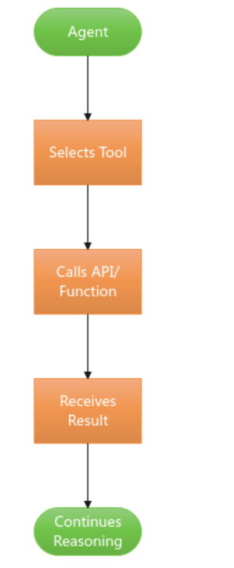
Real-world example:
Claude and GPT-4 call a weather API for live data, or a code-execution tool to run and debug scripts.

5. Memory
Memory allows agents to retain and reuse information across steps or sessions. Short-term memory holds the current context window, while long-term memory stores information externally (e.g., in a vector database) for later retrieval via Retrieval-Augmented Generation (RAG).
- Short-term memory : current conversation/context
- Long-term memory : vector databases, RAG
- Enables personalization and continuity
Agent ↔ Short-Term Memory (context)
Agent ↔ Long-Term Memory (vector DB / RAG)

Real-world example:
Customer-support agents that recall a user's past tickets using a vector database to provide personalized responses.

6. Planning
Planning enables an agent to break a complex goal into smaller, ordered steps before or while acting. Techniques such as Chain-of-Thought and ReAct (Reason + Act) let agents reason about a task, take an action, observe the outcome, and revise the plan.
- Task decomposition into sub-goals
- Reasoning frameworks : Chain-of-Thought, ReAct
- Self-reflection and plan revision
Task → Decompose → Reason → Act → Reflect
→ Revise Plan (loop until goal met)

Real-world example:
AutoGPT-style agents decompose a research goal into sub-tasks, execute each with tools, and adjust the plan based on results.

7. Multi-Agent Systems
Multi-agent systems use several specialized agents that collaborate, often coordinated by an orchestrator agent, to solve tasks too complex for a single agent. Each agent may handle a distinct role such as research, coding, or review.
- Orchestrator : worker agent patterns
- Role specialization (planner, coder, reviewer)
- Inter-agent communication and debate
Orchestrator Agent
↓ ↓ ↓
Agent A Agent B Agent C
→ Combined Output

Real-world example:
Microsoft AutoGen and CrewAI coordinate multiple agents — e.g., a researcher agent and a writer agent — to jointly produce a report.

8. Future of AI Engineering
AI engineering is moving toward standardized agent frameworks, interoperable tool protocols (e.g., Model Context Protocol), and more reliable long-term memory and evaluation methods. Future systems are expected to be more autonomous, safer, and capable of large-scale multi-agent collaboration across industries.
- Standardized protocols for tool and agent interoperability
- Improved reliability, safety, and evaluation of agents
- Wider adoption in software engineering, research, and enterprise workflows

LLM Core → Standard Tool Protocols (MCP)
→ Interoperable Multi-Agent Ecosystems

Real-world example:
Anthropic's Model Context Protocol (MCP) is emerging as a standard for connecting agents to external tools and data sources.

9. Conclusion
AI engineering has progressed from simple, reactive LLM applications to autonomous agents capable of tool use, memory, and planning, and further to collaborative multi-agent systems. This evolution reflects a broader shift toward building AI systems that can reason, act, and work together to solve complex real-world problems, marking a defining direction for the future of AI engineering.

References
OpenAI Function Calling docs https://developers.openai.com/api/docs/guides/function-calling
Yao et al. (2022)ReAct paper – https://arxiv.org/abs/2210.03629
LangChain Agents docs https://docs.langchain.com/oss/python/langchain/agents
Anthropic (2024) Building Effective AI Agents https://www.anthropic.com/engineering/building-effective-agents
Wu et al. (2023) AutoGen paper https://arxiv.org/abs/2308.08155

