Freight Rate Prediction
Machine Learning Engineer Assessment, Spotter
Ali Haider | github.com/alihaider678/freight-rate-prediction

1. Problem understanding
The task is to predict the posted rate of a truckload in US dollars, a regression problem. The labelled data covers January to October 2025 and the loads to predict fall in November and December 2025, so the model is always predicting forward in time. That fact shaped every decision below: validation has to be time-based, and any feature whose relationship with price shifts over time is a risk even if it looks strong in-sample.
There is a second, smaller deliverable: a daily December curve for one fixed lane (Lexington to Fort Wayne, 360 miles, Dry Van, 32,000 lb) where only the date changes. The input file for this curve has no market_index or quote_signal, so the model also needs a principled way to predict without those per-load signals.

2. Data exploration and quality issues
The training file has 48,000 loads across 64 cities and three equipment types. There are no duplicate rows or IDs, and distances are consistent with the coordinates (about 1.18 times the straight-line distance, as expected for road miles). The issues found, and how each was handled:
Issue | Extent | Handling
Negative weight | 292 train, 145 validation | Treated as a sign error and made positive
Missing weight | 300 train, 165 validation | Equipment median, plus a missing flag
Missing market_index | 374 train, 249 validation | Not used per load; daily averages are used instead
Implausible rate per mile (< $1 or > $5, up to $14) | About 650 train loads | Removed from training only; kept in the holdout so metrics stay honest
Cities absent from training | 8 cities, 12% of validation lanes | Lane premium left missing; the model falls back on coordinates
Table 1. Data-quality issues and fixes. The same cleaning function is applied to every split.

Findings that shaped the model
- Distance dominates. Its correlation with rate is 0.91, which hides every other effect. Predicting rate per mile instead exposes the rest.
- Equipment, lane and weight matter. Average rate per mile is $2.12 for Dry Van, $2.30 for Flatbed and $2.38 for Reefer. After removing distance and equipment, lane explains about 31% of the remaining variation and weight correlates 0.43 with it.
- market_index works at the daily level, not per load. The daily average index correlates 0.88 with the daily rate level from January to August, while a load's deviation from that day's average is close to noise (0.06). However, the overall rate level drifts independently of the index: a straight index-to-price mapping fitted on January to August is biased by about 4.5% on September to October. The index relative to its own trailing 30-day average carries over well.
- quote_signal changes sign with its regime. When its daily average is around 2.2, quote_signal correlates +0.3 with rate; when the average is around 1.93, the correlation is -0.3 (across days, the two are correlated at 0.81). In November and December its daily average stays near 2.05, the neutral regime seen in August.

3. Approach
- Target: log(posted_rate / distance). Removing the distance scale lets the model learn the smaller effects, and the log makes it optimise relative error across rates from under $100 to over $6,000. Predictions are converted back by exponentiating and multiplying by distance.
- Features: log distance, equipment, weight, pickup and delivery coordinates and their differences, and lane, pickup and delivery premiums (mean residual log rate per mile, computed from training rows only).
- Market context: the daily market_index minus its trailing 30-day average, the daily average quote_signal, and each load's quote_signal minus that daily average. Together these let the trees learn the regime behaviour without memorising price levels. They use load features only, never labels.
- Model: LightGBM, chosen for its strength on tabular data with mixed numeric and categorical features, missing values and interactions such as the quote regime. A linear baseline is included for reference.

4. Train and validation split
A random split would leak information: loads from the same days and market conditions would appear on both sides, and the score would overstate how well the model predicts unseen months. I used a forward, time-based split instead:
- Training: January to August 2025, label outliers removed (37,968 loads).
- Holdout: September to October 2025, all loads (9,523). This plays the role of November and December.
- Tree count: chosen by early stopping on August, the last month inside the training window, so the holdout is never used for tuning.
For the final model the same procedure is shifted forward: the tree count is picked by early stopping on September to October, then the model is refit on all cleaned January to October data.

5. Validation results
Model (holdout Sep to Oct 2025) | MAE ($) | RMSE ($) | MAPE | Clean MAE ($)
Baseline: median $/mile by equipment x distance | 229.12 | 670.67 | 10.49% | 178.09
LightGBM without market signals | 100.88 | 630.93 | 4.43% | 48.24
LightGBM with market context (final) | 96.03 | 628.54 | 4.27% | 43.29
Table 2. Clean MAE excludes the roughly 1% of holdout loads with implausible labels; the final model's MAPE on those rows is 1.79%. The high RMSE on all rows comes almost entirely from those label errors.
The final model cuts the baseline error by 58% on all loads and by 76% on clean loads. Adding the market context improves on the no-market model by about 10% in clean MAE. An earlier version that used raw per-load market_index and quote_signal values performed worse than the no-market model on the holdout, which is what led to the daily, regime-aware features described above.

6. December prediction chart
The December rows have no market signals. For each date, the pipeline takes that day's market context from validation.csv and averages the model's prediction over every quote_signal observed on that date. Averaging the predictions, rather than plugging in one average signal, matters because the quote effect is non-linear. Tested on the holdout for the same fixed lane, a curve built this way had a correlation of 0.95 with the actual market-wide daily rate per mile, compared with 0.41 for the model without market signals.
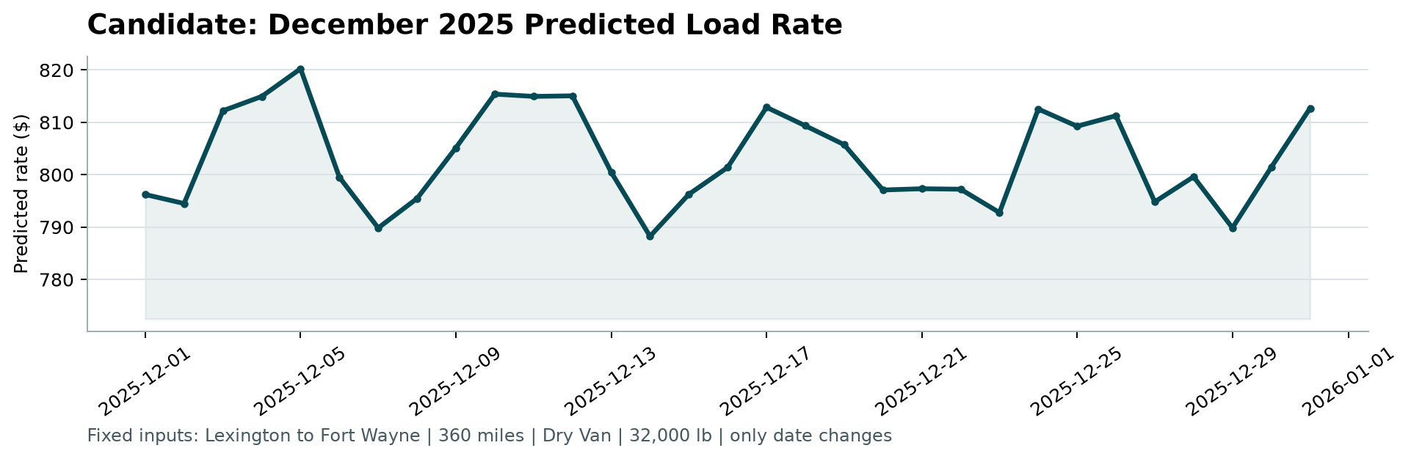
Figure 1. Chart produced by the provided score.py. Predictions range from $788 to $820, close to the $808 median for Dry Van loads on this lane in the training data, and move with the daily December market index.

7. Limitations and next steps
- The overall rate level for November and December cannot be confirmed from the data; the model assumes it stays near the January to October average, adjusted by market context.
- Unseen cities rely on coordinates alone and are less precise than known lanes. A regional or state-level premium would help.
- With more time: rolling-origin validation across several months, quantile models for prediction intervals, and monitoring of the quote_signal regime, since a shift in its behaviour would directly affect accuracy.

