Software Requirements Specification

IUB Ride Connect
Online Ride Booking System for The Islamia University of Bahawalpur

Final Year Project

Supervisor: Mr. Abdul Karim Nawaz
Presented by:
Ali Haider
S23BINFT1E02013

Department of Information Technology
The Islamia University of Bahawalpur

CERTIFICATE
This is to certify that Ali Haider, Roll No. S23BINFT1E02013, a student of BS Information Technology, has completed the compulsory requirement of the Final Year Project during the session 2023–2027. This project, titled "IUB Ride Connect – Online Ride Booking System," is submitted to the Department of Information Technology, The Islamia University of Bahawalpur, in partial fulfillment of the requirements for the degree of Bachelor of Science in Information Technology.
____________________________
Signature of Supervisor
The Islamia University of Bahawalpur

Table of Contents
1. Introduction 4
1.1 Purpose of this Document 4
1.2 Document Conventions 4
1.3 Intended Audience and Reading Suggestions 4
1.4 Scope of this Document 4
1.5 Product and Business Perspective 4
2. General Description 5
2.1 System Environment 5
2.2 Quality Function Deployment (QFD) 5
2.3 User Story / System Overview 5
3. Specific Requirements 7
3.1 External Interface Requirements 7
3.2 User Characteristics 7
3.3 Functional Requirements 7
3.4 Non-Functional Requirements 8
4. Analysis Model 9
4.1 Scenario-Based Model 9
4.2 Use Case Scenario 9
4.3 Use Case Diagram 9
4.4 Activity Diagram 10
4.5 Data Model 11
4.6 Behavioral Model 12
5. Requirement Change Management 14
5.1 Document Version History 14
5.2 Bugs and Glitches 14
5.3 Patches 14

Software Requirements Specification of
"IUB Ride Connect"

1. Introduction
This section introduces the Software Requirements Specification (SRS) document. It describes its purpose, conventions, intended audience, and scope, and outlines the product from a business perspective.

1.1 Purpose of this Document
This Software Requirements Specification (SRS) is intended to give a complete overview of the project "IUB Ride Connect," including its functional flow, interfaces, and underlying data structure. The document details all features that have currently been decided upon, along with the manner and priority of their implementation.

1.2 Document Conventions
This document interchanges the pronoun "we" with "the development team." A clear distinction is maintained between the terms "Rider" (a student/staff member booking a ride) and "Driver" (a verified student/staff member offering a ride). The term "System" refers to the IUB Ride Connect web application as a whole.

1.3 Intended Audience and Reading Suggestions
This document is intended for the project supervisor, evaluation committee, and development team. It may be read front-to-back, or by section: General Description gives an overview of the project; Specific Requirements details functional and interface requirements; and Analysis Model presents the diagrams supporting system design.

1.4 Scope of this Document
This SRS describes the functional and non-functional requirements of the IUB Ride Connect platform. The project was conceived to provide a dedicated, low-cost, and safe ride-booking service exclusively for the IUB community, with an anticipated development cycle spanning one academic semester, and continued enhancement thereafter (see Section 3.5, Future Enhancements referenced in the Project Proposal).

1.5 Product and Business Perspective
IUB Ride Connect is a self-contained web application rather than an extension of an existing product. It targets a niche, underserved market — intra-campus and inter-campus transportation for a specific university community — where verified drivers from within that same community reduce both cost and safety concerns compared to public or commercial ride-hailing services.

2. General Description
This section describes the product perspective and the system environment it requires. It also specifies the Quality Function Deployment (QFD) of the system and a narrative user story.

2.1 System Environment
The Rider or Driver interacts with the system through a web browser. Input submitted via HTML forms is sent to PHP scripts on the server, which validate the request, query or update the MySQL database, and return a rendered HTML response reflecting the updated state (e.g., a new ride record, an updated ride status, or a login session).

2.2 Quality Function Deployment (QFD)
Quality Function Deployment is a technique that translates customer needs into technical requirements. With respect to this project, the following categories of requirements were identified:
2.2.1 Normal Requirements
- A user-friendly and efficient booking interface for riders and drivers.
- Minimum maintenance cost, using widely-supported technologies (PHP, MySQL).
- Availability on standard desktop and mobile browsers.
- Easy to operate for non-technical university users.
2.2.2 Expected Requirements
- Development within limited student-project budget and timeline.
- Accurate, consistent fare calculation across vehicle types.
- Minimum hardware requirements — runnable on a standard local server (XAMPP).
- A clearly structured relational database design.
2.2.3 Exciting Requirements
- Future driver-rating system for quality assurance.
- Future GPS-based live ride tracking.
- Future online payment integration.
- Future dedicated mobile application.

2.3 User Story / System Overview
A Rider visits the IUB Ride Connect homepage and chooses "I'm a Rider" or "I'm a Driver." A Rider who has not yet logged in is redirected to the Rider Login page; after successful authentication, the Rider Dashboard appears with two options: "Book a Ride" and "Cancel Ride." To book a ride, the Rider enters the pickup location, drop-off location, distance in kilometres, and selects a vehicle type (Bike, Rickshaw, or Car), and indicates whether the trip is within the city. The system retrieves the relevant per-kilometre rate from the fares table and calculates the estimated fare automatically, saving the ride with a status of "Booked." The Rider may later cancel a ride by entering its Ride ID, which updates the ride's status to "Cancelled." A Driver, after logging in separately through the Driver Login page, is taken to the Driver Dashboard, where all ride bookings placed by riders are listed in a table showing the rider's name, pickup and drop-off locations, vehicle type, distance, fare, and current status.

3. Specific Requirements
This section covers the external interface requirements, user characteristics, and the detailed functional and non-functional requirements of the system.

3.1 External Interface Requirements
3.1.1 User Interfaces
The system provides simple HTML-form-based interfaces: a landing page for role selection, separate login pages for Riders and Drivers, a Rider Dashboard, a ride booking form, a ride cancellation form, and a tabular Driver Dashboard listing all bookings.
3.1.2 Hardware Interfaces
IUB Ride Connect is a web application accessible from any device with a standard web browser (desktop, laptop, or mobile), requiring only a network connection to the hosting server. No specialized hardware is required.
3.1.3 Software Interfaces
- Frontend: HTML, CSS, JavaScript
- Backend: PHP (server-side scripting)
- Database: MySQL, accessed via the mysqli extension
- Local Server Environment: XAMPP (Apache + MySQL + PHP)
- Design Tools: Canva (promotional flyer), Figma (optional UI mockups)

3.2 User Characteristics
There are two categories of end users: Riders and Drivers, both drawn exclusively from the verified IUB student, faculty, and staff community. Neither category requires specialized technical knowledge; basic familiarity with web forms is sufficient. Only one active session (rider or driver) is expected per browser at a time.

3.3 Functional Requirements
ID | Requirement | Description
FR-1 | Rider Registration & Login | The system shall allow a rider to log in with a username and password before accessing booking features.
FR-2 | Driver Login | The system shall allow a driver to log in separately from riders using driver credentials.
FR-3 | Book a Ride | The system shall allow a logged-in rider to enter pickup location, drop-off location, distance, and vehicle type to book a ride.
FR-4 | Fare Estimation | The system shall automatically calculate the estimated fare based on vehicle type, within/out-of-city rate, and distance travelled.
FR-5 | Cancel a Ride | The system shall allow a rider to cancel a previously booked ride using its Ride ID.
FR-6 | View All Bookings | The system shall allow a logged-in driver to view all ride bookings, including rider name, locations, vehicle type, distance, fare, and status.
FR-7 | Session Management | The system shall restrict access to booking and dashboard pages unless the respective user (rider/driver) is authenticated.
FR-8 | Logout | The system shall allow both riders and drivers to safely end their session.

3.4 Non-Functional Requirements
- Usability: The interface shall be simple enough for first-time users to book a ride without training.
- Performance: Fare calculation and ride booking shall complete within 2 seconds under normal local-server load.
- Security: Passwords shall be required for both rider and driver accounts; session state shall gate access to protected pages.
- Reliability: The system shall correctly persist every booked or cancelled ride in the database without data loss.
- Maintainability: The codebase shall be organised into discrete PHP scripts per feature to simplify future updates.
- Portability: The system shall run on any standard Apache/MySQL/PHP (XAMPP) environment without modification.

4. Analysis Model
This section presents the Software Requirements Specification through standard requirement-engineering models: scenario-based, data, and behavioral models.

4.1 Scenario-Based Model
This model depicts how the Rider and Driver interact with the system, and the specific sequence of activities performed as the software is used.

4.2 Use Case Scenario
The table below summarizes the use cases of the system, grouped by actor and module.
Actor | Module | Use Cases
Rider | Authentication | Register / Login, Logout
Rider | Ride Booking | Book Ride, Select Vehicle & View Estimated Fare, Cancel Ride
Driver | Authentication | Login, Logout
Driver | Ride Management | View All Ride Bookings

4.3 Use Case Diagram
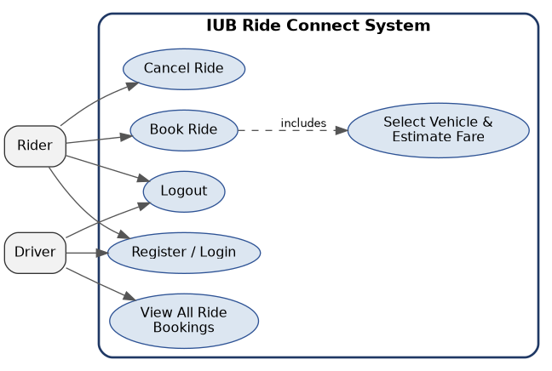
Fig. 4.1: Use Case Diagram for IUB Ride Connect
Use Case: Book Ride
Primary Actor: Rider | Goal: To book a ride from a chosen pickup point to a chosen drop-off point.
- Precondition: Rider is logged in.
- Trigger: Rider selects "Book a Ride" from the Rider Dashboard.
- Scenario: Rider enters pickup, drop-off, distance, and vehicle type → System calculates estimated fare → Ride record is saved with status "Booked."
- Exception: Required fields are missing; form re-prompts the Rider.
- Priority: Essential, must be implemented.
Use Case: Cancel Ride
Primary Actor: Rider | Goal: To cancel a previously booked ride.
- Precondition: Rider is logged in and holds a valid Ride ID.
- Trigger: Rider selects "Cancel Ride" and enters the Ride ID.
- Scenario: System updates the matching ride's status to "Cancelled" for that Rider.
- Exception: Ride ID does not belong to the logged-in Rider; no update occurs.
- Priority: Essential, must be implemented.
Use Case: View All Bookings
Primary Actor: Driver | Goal: To view all ride bookings placed by riders.
- Precondition: Driver is logged in.
- Trigger: Driver Dashboard loads after login.
- Scenario: System queries all rides joined with rider usernames and displays them in a table.
- Exception: No bookings exist; a "No bookings found" message is shown.
- Priority: Essential, must be implemented.

4.4 Activity Diagram
The activity diagram below illustrates the flow of the "Book Ride" process, from Rider login through fare calculation to booking confirmation.
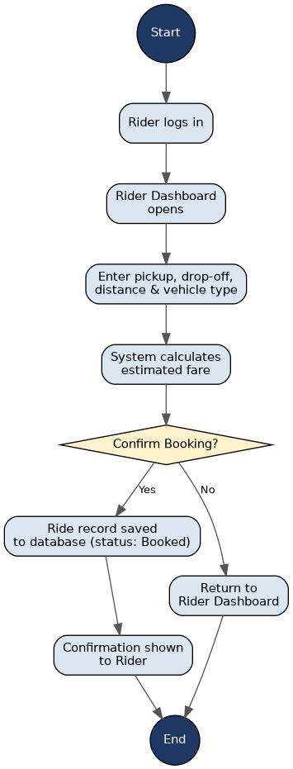
Fig. 4.2: Activity Diagram — Book Ride

4.5 Data Model
Unlike systems without persistent storage, IUB Ride Connect relies on a relational MySQL database to store users, drivers, fare rates, and ride records. The entity-relationship structure below reflects the current database schema.
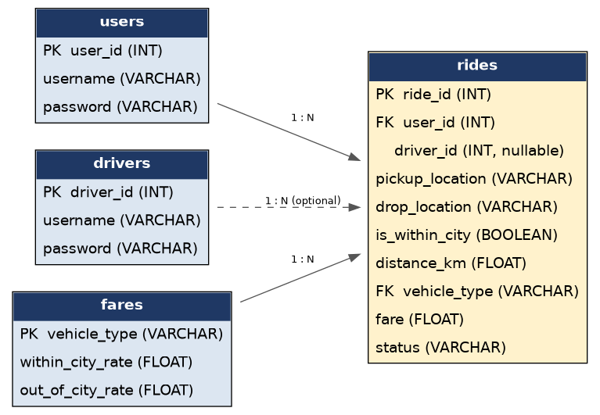
Fig. 4.3: Entity-Relationship / Data Model for IUB Ride Connect

4.6 Behavioral Model
The behavioral model indicates how the system responds to external events. As the system follows a straightforward request–response flow rather than complex object states, the sequence diagram below is used to describe the interaction between the Rider, the PHP-based system, and the MySQL database during ride booking.
Sequence Diagram — Book Ride
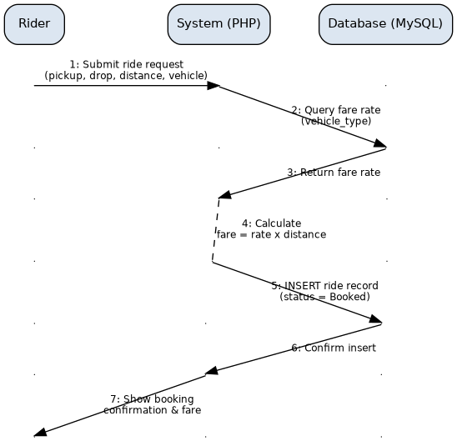
Fig. 4.4: Sequence Diagram — Book Ride

5. Requirement Change Management
The development team intends to release a complete and functional system that follows the guidelines described in this SRS. As the system may be extended with future enhancements (Section 2.2.3), updates to this document will be version-controlled.

5.1 Document Version History
Version | Date | Description
1.0 | 29 Oct 2025 | Initial Software Requirements Specification for IUB Ride Connect.

5.2 Bugs and Glitches
Any bugs, glitches, or general concerns identified during testing or evaluation will be documented by the development team and addressed prior to final submission or in a subsequent maintenance cycle.

5.3 Patches
As the local server environment (XAMPP) or underlying PHP/MySQL versions are updated, corresponding compatibility fixes will be applied and documented as patches to this system.

Prepared by: Ali Haider
Roll No: S23BINFT1E02013

