Software Design Document

IUB Ride Connect
Online Ride Booking System for The Islamia University of Bahawalpur
Final Year Project


Supervisor: Mr. Abdul Karim Nawaz
Presented by:
Ali Haider
S23BINFT1E02013
Department of Information Technology
The Islamia University of Bahawalpur

CERTIFICATE
This is to certify that Ali Haider, Roll No. S23BINFT1E02013, a student of BS Information Technology, has completed the compulsory requirement of the Final Year Project during the session 2023–2027. This document, the Software Design Document (SDD) for the project titled "IUB Ride Connect – Online Ride Booking System," is submitted to the Department of Information Technology, The Islamia University of Bahawalpur, in partial fulfillment of the requirements for the degree of Bachelor of Science in Information Technology.
_______________________
Signature of Supervisor
The Islamia University of Bahawalpur

Table of Contents
1. Introduction 4
1.1 Purpose 4
1.2 Scope 4
1.3 Definitions, Acronyms and Abbreviations 4
1.4 References 4
1.5 Document Overview 4
2. System Architecture 5
2.1 Architectural Style 5
2.2 Architecture Diagram 5
2.3 Technology Stack 5
3. Data Design 6
3.1 Entity-Relationship Diagram 6
3.2 Data Dictionary 6
4. Component Design 8
4.1 Module Descriptions 8
4.2 Component Diagram 8
5. Interface Design 10
5.1 User Interface Design 10
5.2 Use Case Diagram 10
6. Procedural and Behavioral Design 11
6.1 Activity Diagram — Book Ride 11
6.2 Sequence Diagram — Rider Login 11
6.3 Sequence Diagram — Book Ride 12
7. Deployment Design 13
8. Design Constraints, Assumptions and Security Considerations 14
8.1 Design Constraints 14
8.2 Assumptions 14
8.3 Security Considerations 14

Software Design Document of
"IUB Ride Connect"

1. Introduction

1.1 Purpose
This Software Design Document (SDD) describes the architectural, data, component, and interface design of IUB Ride Connect. It translates the functional and non-functional requirements captured in the Software Requirements Specification (SRS) into a concrete technical design that guides implementation.

1.2 Scope
This document covers the design of the currently implemented system: rider and driver authentication, ride booking with automatic fare calculation, ride cancellation, and a driver-facing view of all bookings. It also documents the underlying database design and the technology stack used to realize this design.

1.3 Definitions, Acronyms and Abbreviations
- SDD — Software Design Document
- SRS — Software Requirements Specification
- PK / FK — Primary Key / Foreign Key
- Rider — a student/staff member who books a ride
- Driver — a verified student/staff member who views ride bookings

1.4 References
This document should be read together with the Software Requirements Specification (SRS) for IUB Ride Connect, which defines the functional requirements (FR-1 to FR-8) referenced throughout this design.

1.5 Document Overview
Section 2 presents the system's architectural design. Section 3 details the database design. Section 4 describes each software component. Section 5 covers interface design. Section 6 presents procedural/behavioral design through sequence diagrams. Section 7 describes the deployment design, and Section 8 discusses design constraints and security considerations.

2. System Architecture

2.1 Architectural Style
IUB Ride Connect follows a classic three-tier architecture: a Presentation Layer (HTML/CSS/JavaScript rendered in the browser), an Application Layer (PHP scripts implementing business logic), and a Data Layer (a MySQL relational database). Each rider or driver request is handled synchronously: the browser submits an HTML form, the relevant PHP script processes it and interacts with the database as needed, and an updated HTML page is returned.

2.2 Architecture Diagram
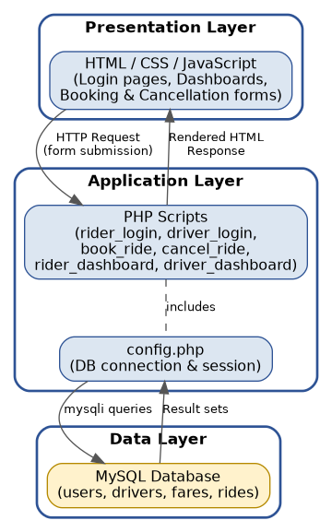
Fig. 2.1: Three-Tier Architecture of IUB Ride Connect

2.3 Technology Stack
- Presentation: HTML, CSS, JavaScript
- Application: PHP (procedural scripts, one per feature)
- Data: MySQL, accessed through the mysqli extension
- Local Server Environment: XAMPP (Apache + PHP + MySQL)

3. Data Design

3.1 Entity-Relationship Diagram
The system's data layer consists of four tables: users (riders), drivers, fares (per-vehicle rate table), and rides (booking records). A ride references exactly one rider and one fare entry, and optionally one driver.
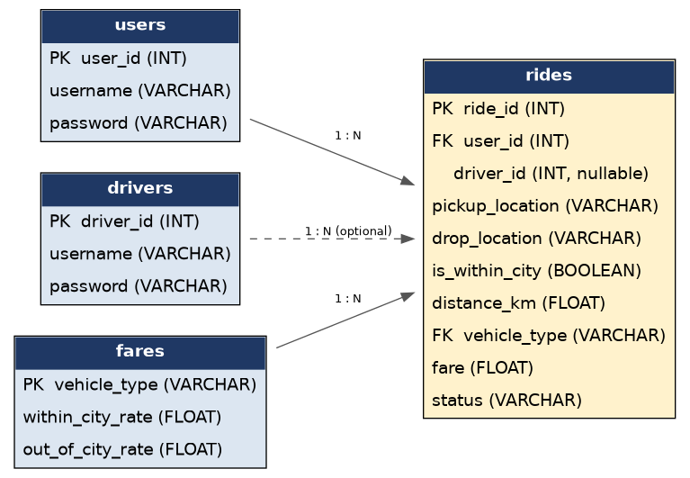
Fig. 3.1: Entity-Relationship / Data Model for IUB Ride Connect

3.2 Data Dictionary
Table: users
Field | Type | Description
user_id | INT (PK) | Auto-incrementing unique identifier for each rider account.
username | VARCHAR(50) | Unique login name chosen by the rider.
password | VARCHAR(255) | Rider's login password.

Table: drivers
Field | Type | Description
driver_id | INT (PK) | Auto-incrementing unique identifier for each driver account.
username | VARCHAR(50) | Unique login name chosen by the driver.
password | VARCHAR(255) | Driver's login password.

Table: fares
Field | Type | Description
vehicle_type | VARCHAR(20) (PK) | Vehicle category — Bike, Rickshaw, or Car.
within_city_rate | FLOAT | Per-kilometre rate applied for rides within the city.
out_of_city_rate | FLOAT | Per-kilometre rate applied for rides outside the city.

Table: rides
Field | Type | Description
ride_id | INT (PK) | Auto-incrementing unique identifier for each ride.
user_id | INT (FK → users) | Identifies the rider who booked the ride.
driver_id | INT (nullable) | Identifies the assigned driver, if any.
pickup_location | VARCHAR(100) | Text description of the pickup point.
drop_location | VARCHAR(100) | Text description of the drop-off point.
is_within_city | BOOLEAN | True if the ride is within city limits.
distance_km | FLOAT | Distance of the ride in kilometres.
vehicle_type | VARCHAR(20) (FK → fares) | Vehicle type selected for the ride.
fare | FLOAT | Calculated fare = applicable rate × distance.
status | VARCHAR(20) | Current ride status: Booked or Cancelled.

4. Component Design
The application is composed of discrete PHP scripts, each responsible for one feature. All data-facing scripts include config.php, which centralizes the database connection and session handling.

4.1 Module Descriptions
Module / File | Responsibility | Key Interactions
index.html | Landing page; lets the user choose Rider or Driver role. | Links to rider_login.php and driver_login.php
config.php | Establishes the MySQL connection and starts the PHP session. | Included by every other server-side script
rider_login.php | Authenticates a rider against the users table and starts a rider session. | Reads/writes $_SESSION['rider_id']; queries users table
driver_login.php | Authenticates a driver against the drivers table and starts a driver session. | Reads/writes $_SESSION['driver_id']; queries drivers table
rider_dashboard.php | Landing page for a logged-in rider; links to booking and cancellation. | Guards access using $_SESSION['rider_id']
book_ride.php | Collects ride details, computes the fare, and inserts a new ride record. | Reads fares table; inserts into rides table
cancel_ride.php | Cancels an existing ride belonging to the logged-in rider. | Updates status field in rides table
driver_dashboard.php | Displays every ride booking to a logged-in driver. | Joins rides with users table for rider names

4.2 Component Diagram
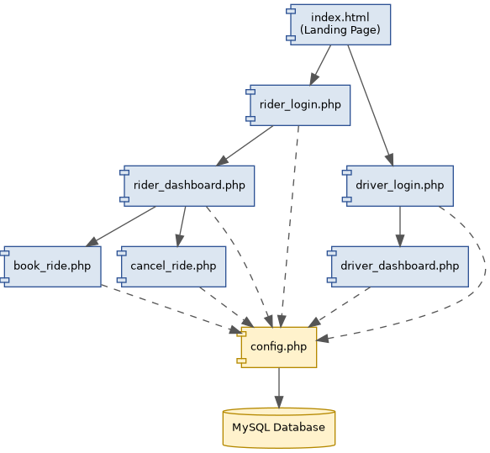
Fig. 4.1: Component Diagram for IUB Ride Connect

5. Interface Design

5.1 User Interface Design
The interface is intentionally minimal, favoring clarity over visual complexity, and consists of the following screens:
- Landing Page — lets the user choose "I'm a Rider" or "I'm a Driver."
- Rider / Driver Login — username and password fields with a submit button.
- Rider Dashboard — links to "Book a Ride" and "Cancel Ride."
- Book a Ride Form — pickup location, drop-off location, distance (km), vehicle type dropdown, and a within-city checkbox.
- Cancel Ride Form — a single Ride ID field.
- Driver Dashboard — a table listing every booking with rider name, locations, vehicle type, distance, fare, and status.

5.2 Use Case Diagram
The use case diagram below summarizes the interactions supported by the interface for each actor, as detailed further in the SRS.
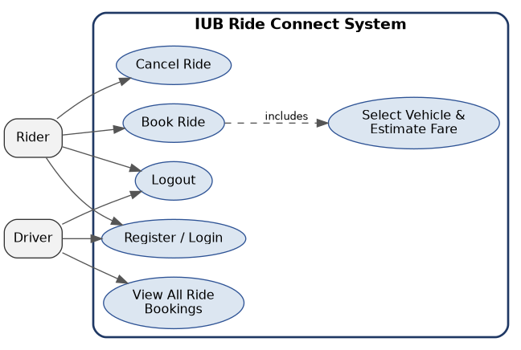
Fig. 5.1: Use Case Diagram for IUB Ride Connect

6. Procedural and Behavioral Design
This section presents the dynamic behavior of the system through an activity diagram and two sequence diagrams covering the system's two most central workflows: login and ride booking.

6.1 Activity Diagram — Book Ride
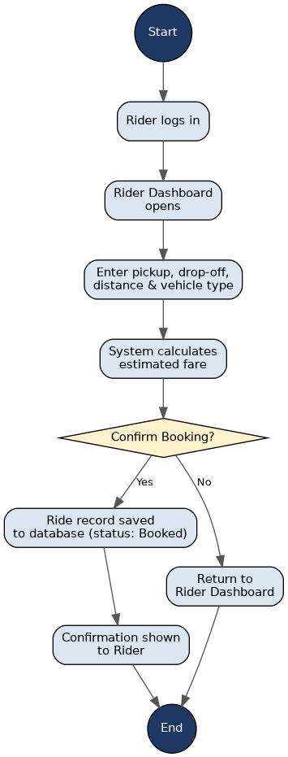
Fig. 6.1: Activity Diagram — Book Ride

6.2 Sequence Diagram — Rider Login
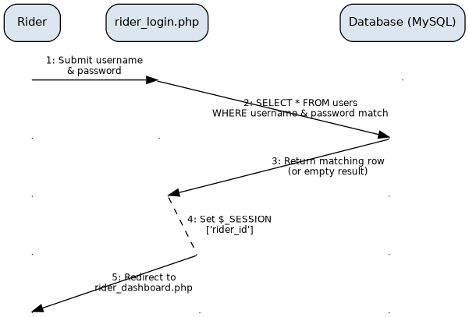
Fig. 6.2: Sequence Diagram — Rider Login

6.3 Sequence Diagram — Book Ride
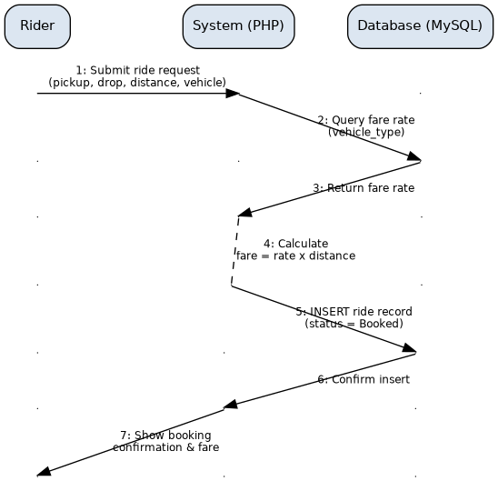
Fig. 6.3: Sequence Diagram — Book Ride

7. Deployment Design
The current deployment target is a local development server running XAMPP. The client device connects to the Apache HTTP Server over HTTP; Apache invokes the PHP engine to execute the application scripts, which in turn communicate with the MySQL server using the mysqli extension.
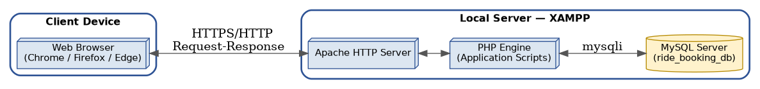
Fig. 7.1: Deployment Diagram for IUB Ride Connect
For production or public deployment, this design anticipates migrating the Apache/PHP/MySQL stack to an online hosting provider, as noted under Future Enhancements in the accompanying Project Proposal.

8. Design Constraints, Assumptions and Security Considerations

8.1 Design Constraints
- The system currently runs on a single local server instance (XAMPP); it is not yet configured for concurrent multi-user production load.
- Fare calculation depends on a manually maintained fares table rather than a live pricing engine.
- Ride-to-driver assignment is not yet automated; the driver_id field in rides remains unassigned in the current implementation.

8.2 Assumptions
- All riders and drivers are verified members of the IUB community, registered through channels outside the scope of this document.
- Only one rider or driver session is active per browser at a time.

8.3 Security Considerations
The current implementation stores rider and driver passwords in plain text and authenticates using direct SQL comparison. This is acceptable for an academic prototype but is explicitly flagged here as a limitation: a production-ready version should hash passwords (e.g., using PHP's password_hash()/password_verify() functions) and use parameterized queries throughout to prevent SQL injection, since some existing scripts build queries via direct string interpolation of user input.

Prepared by: Ali Haider
Roll No: S23BINFT1E02013

