React 2025 Documentation

Introduction
React is a JavaScript library (often mistakenly called a framework) used for building dynamic user interfaces.

There are two main ways to start using React:
- CDN links in an HTML file (good for learning and quick testing).
- Installing Node.js and creating a React project (recommended for real projects).

Using CDN Links
Create a folder with three files:
- index.html
- style.css
- code.js (you can name this file whatever you want)
Inside the <head> of index.html, add the React, ReactDOM, and Babel CDN links. At the bottom of the <body>, link your code.js file like this:
<script src="./code.js" type="text/babel"></script>
Required CDN links:
<script crossorigin src="https://unpkg.com/react@18/umd/react.production.min.js"></script>
<script crossorigin src="https://unpkg.com/react-dom@18/umd/react-dom.production.min.js"></script>
<script src="https://unpkg.com/babel-standalone@6/babel.min.js"></script>

First Project (Hello React)
Inside your HTML file, create an empty <div> with an id. Usually, we call it root, but the name is optional. Example:
<div id="root"></div>
In code.js, write:
ReactDOM.render("hello", document.getElementById("root"));
This code displays "hello" inside the root div. Run Live Server, and you should see "hello" in your browser.
You can also render JSX (JavaScript XML), which looks like HTML but is not exactly the same:
ReactDOM.render(<h1>Hello</h1>, document.getElementById("root"));
👉 JSX requires Babel (from the CDN link) to work.

Installing React with Node.js
Instead of using CDN links, you can install React through Node.js.
- Download and install Node.js from the official website.
- Check installation:
- node -v
- Create a React application using cmd, set the location for your project, than:
- Let’s create the project under desktop,via cmd: C:\Users\user\Desktop>
- npx create-react-app@latest myapp
or
npm create vite@latest myapp2025 (recommended)
- node it is runtime environment (بيئة تشغيل) allow to use javascript outside the browser such as make server, handle with database and files
- npm : node package manager, it is a tool to install or run javascript package
- create vite : use the vite package to create the project
- @latest : use the most recent version of vite
- Vite is a project starter and a tool that helps developers run and build web apps very quickly

⚠️ Project names must be lowercase (no capital letters).
You got a question to procced, answer by y
Than choose your framework => react
Than choose language => javascript
Than cd myapp2025
Now your are inside your project folder, type npm install
Now open the project folder (e.g., myapp2025) in VS Code.

As we mention above that Node is runtime environment, and can run Javascript outside browser, simple example, create a test.js outside src folder just has single line of code console.log(“hello”) this time I show my message out of browser, in terminal type [node test.js] your message will be showed in terminal

Cleaning the Project
Inside the src folder, you will see several files. For simplicity, delete everything except:
- App.jsx (component)
- main.jsx
App.jsx contains the following code:
import { useState } from 'react'
import reactLogo from './assets/react.svg'
import viteLogo from '/vite.svg'
import './App.css'

function App() {
const [count, setCount] = useState(0)
return (
<>
<div>
<a href="https://vite.dev" target="_blank">
<img src={viteLogo} className="logo" alt="Vite logo" />
</a>
<a href="https://react.dev" target="_blank">
<img src={reactLogo} className="logo react" alt="React logo" />
</a>
</div>
<h1>Vite + React</h1>
<div className="card">
<button onClick={() => setCount((count) => count + 1)}>
count is {count}
</button>
<p>
Edit <code>src/App.jsx</code> and save to test HMR
</p>
</div>
<p className="read-the-docs">
Click on the Vite and React logos to learn more
</p>
</>
)
}

export default App
remove every single line of code and replace it with :
function App() {
return (
<h1>hello every one</h1>
)
}
export default App
Now you can build your project from scratch using only App.jsx and main.jsx.

Main.jsx and Root Element
In main.jsx, clean your file and type the following:
import { createRoot } from 'react-dom/client'
import App from './App.jsx'
const myRoot=createRoot(document.getElementById('root'))
myRoot.render(
<App />
)
- Import {createRoot } from ‘react-dom/client ‘ mean import a function called createRoot from library react-dom/client that render your application into the browser
- Import App, mean import function App from App.jsx
- The root div exists in public/index.html. React uses it as the placeholder for rendering.
- All your project is rendered inside this root div which named myRoot

From your terminal (select command prompt not powershell)just type : npm run dev in order to start your server you get the link for localhost with port, click over it and your browser will show the content of App function which is :
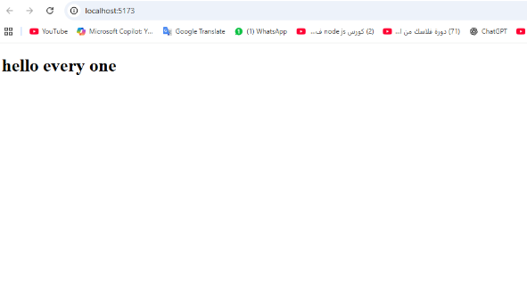

Creating Multiple Components
We notice that each imported function such as App looks like a component, in order to create an new component Footer for example, we do the following :
under src folder create a new file Footer.jsx (F is capital letter)
inside Footer.jsx we type the following code:

function Footer() {
return <footer>This is a footer</footer>;
}
export default Footer;

we can write in another way

export default function Footer(){
return <footer>This is a footer</footer>;
}

In order to use component Footer first we have imported inside App.jsx

In App.jsx:

import Footer from "./Footer"
function App() {
return (
<>
<h1>hello every one</h1>
<Footer />
</>
)
}
export default App
👉 without closed tags (fragment) you got an error in rendering your project,in React, every component must return one parent element. we can replace it by <div> and </div> or any JSX tags

JSX (JavaScript XML) and not HTML
In React, we write tags like <h1>, <div>, and <p> that look like regular HTML tags, but in fact they are JSX elements. JSX only looks like HTML — it’s actually JavaScript under the hood.

In plain HTML, we can add inline styles using the style attribute, for example:
<h1 style="color:red">Hello World</h1>

However, in React (JSX), writing styles this way will cause an error. This is because in JSX, the style attribute expects a JavaScript object, not a plain string.
For example, in React we write:
<h1 style={{ color: "red", textDecoration:"underline" }}>Hello World</h1>
Here, {{ color: "red", textDecoration:"underline" }}is an object where:
- The first { } means we are writing JavaScript inside JSX.
- The second { } is the object itself containing the style property.

<h1 style={
{color:"red",
textDecoration:"underline"
}
}>hello every one</h1>

Using Images in React

Method 1: Import Image (since we are using vite)

import myImg from "./mypic.jpg";
function App() {
return <img src={myImg} alt="My Image" />;
}

Method 2: Require (in older builder)
function App() {
return <img src={require("./mypic.jpg")} alt="My Image" />;
}

Styling in React

ClassName
Another example proof that we are not writing HTML but JSX, in plain HMTL we use class for elements while in JSX we use className:

<h1 className="heading">This is a heading</h1>
To link this component with the CSS file, at the top of App.jsx file
import “./style.css”
If your css file is under css folder under assets under src, your import became
import "./assets/css/style.css"
inside style.css we write normal css properties
.heading{
color:red
}

Inline Style
Inline styles are objects in JSX:
<h1 style={{ fontSize: "20px", color: "red", border: "2px solid green" }}>
Hello
</h1>

CSS Modules
CSS Modules in React are a way to write CSS so that the styles are applied only to the component that imports them, without affecting the rest of the app. Normally, if you write CSS in a regular file, the classes can affect other components.

Let say I have 2 component header and footer, and each of them contains unordered list, the best practice is to create 2 folders with the name of components header and footer, inside each of them I have jsx file and css file, the structure (just for ths src folder):
Myapp2025
Src
Footer
Footer.jsx
Footer.module.css
Header
Header.jsx
Header.module.css

Inside Header.jsx
import styles from "./Header.module.css"
//you can call your css file ass you want
export default function Header(){
return(
<header>
<h1>this is a header</h1>
<ul className={styles.ul}>
<li>link 1</li>
<li>link 2</li>
<li>link 3</li>
</ul>
</header>
)
}

Inside Footer.jsx
import styles from "./Footer.module.css"
export default function Footer(){
return(
<footer>
<h1>this is a footer</h1>
<ul className={styles.ul}>
<li>link 1</li>
<li>link 2</li>
<li>link 3</li>
</ul>
</footer>
)
}
Footer.jsx and Header.jsx contains <ul> tag with className ul
Footer.module.css and Header.module.css contains same class which .ul with different properties
Footer.module.css
.ul{
display: flex;
gap:20px
Header.module.css
.ul{
display: flex;
gap:50px;
list-style: none;
}
.class1{
color:red;
}
.class2{
Text-decoration:underline
}
Although the <ul> element has same class in 2 different component but each one has it’s own properties

NB
suppose I want to apply class1 and class2 for heading <h1> in Header.jsx
<h1 className={`${styles.class2} ${styles.class1}`}>this is a header</h1>

Conditional styling
Conditional styling in React involves applying different styles to components or elements based on specific conditions, such as the component's state, props, or other data. (see in props)

Props in React
Props (properties) allow passing values to components, suppose I have a heading <h1> used in many places in your project, so it is better to make it as a component and you use it when it is necssary, in some case heading h1 is Hello ali you have 40 , and sometimes Hello Sara you have 25 , Hello is fixed but the name is variable,so …

Let’s create a Greeting component
- Create folder Grreting
- Contains Greeting.jsx

Greeting.jsx contains the following:

export default function Greeting(props) {
return (
<h1>Hello, {props.name} you have {props.age}!</h1>;
)}
So Greeeting now is a function takes parameter called props, it is an object has key called “name” and “age”

In App.jsx where I have to import Greeting component

import Greeting from "./Greeting/Greeting"
export default function App() {
return (
<>
<Greeting name="Ali" age="45"/>
<Greeting name="Sara" age="25" />
</>
)
}

Excecution of code above return 2 heading h1
Hello Ali you have 45
Hello Sara you have 25
NOTE: In React (JSX), all props you pass without {} are treated as strings., in order to pass a boolean or a number we use {}

Greeting.jsx contains the following:
export default function Greeting(props) {
let cls=props.succedd===true ? "success" : "failed"
return (
<h1 className={cls}>Hello, {props.name} you have {props.age}</h1>;
)}
We must pass 3 values as props, name and age and succedd, the css class is based on props.succedd

We can summarize the code above as follow:
export default function Greeting(props) {
return (
<h1 className={ props.succedd===true ? "success" : "failed"}>Hello, {props.name} you have {props.age}</h1>;
)}

In App.jsx where I have to import Greeting component

import Greeting from "./Greeting/Greeting"
export default function App() {
return (
<>
<Greeting name="Ali" age="45" succedd={true}/>
<Greeting name="Sara" age="25" succedd ={false}/>
</>
)
}

true and false here are boolean not string, must be closed by {} and small letter

Destruction props
Instead of pass a props as parameter and call props.name we can pass “name” and “age” directly as following
export default function Greeting({name,age}) {
return (
<h1>Hello, {name}! you have {age}</h1>;
)}
No change is App.jsx or the file you import this component Greeting
<Greeting name="Ali" age="45" />

Rendering List in React
Rendering a list means showing items from an array as repeated elements in the UI, such as list of students, list of fruits ….

const students = [

{ name: "Ali", age: 20, grade: 95 },

{ name: "Sara", age: 22, grade: 75 },

{ name: "John", age: 19, grade: 50 },

];

I want to display students in unordered list

Student.jsx
export default function Student(){
const studentsList = [
{ name: "Ali", age: 20, grade: 95 },
{ name: "Sara", age: 22, grade: 75 },
{ name: "John", age: 19, grade: 50 },
];
const students= studentsList.map(function(std,index){
return <li key={index}>{std.name} - {std.age} - {std.grade}</li>
})
//it is javascript function that loop throgh all studntsList element and for each element create
//<li>contains student name – student age and student grade </li>
//key={index} represent a unique key for each element

return(
<ul>
{ students }
</ul>
)
}
Run of this code display the following
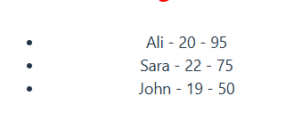

Exercise 1
Create a small React app that displays a list of student profile cards with different styling based on grade (under react 2025 folder studentprofilecards)
- If grade >= 90 → green border
- If grade between 60–89
- If grade < 60 → red border
Solution
Under your desktop npm create vite@latest studentprofilecards
enter studentprofilecards : npm install
the structure of your project :
src/
┣ StudentCard/
┃ ┣ StudentCard.jsx
┃ ┗ StudentCard.module.CSS
┣ data/
┃ ┗ students.js
┣ App.jsx
┗ main.jsx

Student.js
const students = [
{ name: "Ali", age: 20, grade: 95 },
{ name: "Sara", age: 22, grade: 75 },
{ name: "John", age: 19, grade: 50 },
];
export default students

StudentCard.jsx
import styles from "./StudentCard.module.css"
export default function StudentCard(props){
let states=props.grade>=90 ? "excellent" : (props.grade >=60 && props.grade<90) ? "good" : "bad"
return (
<div className={`${styles.card} ${styles[states]}`}>
<h3>{props.name}</h3>
<h3>{props.age}</h3>
<h3>{props.grade}</h3>
</div>
)
}
StudentCard accept props as parameter, that props contains name, grade and age, this card has a class name called crad(styles.card), states is new class based on grade, if your grade >=90 states=”excellent” if grade is between 60 and 90 states = “good” otherwise “bad”

Since I ma using module css I can not say
<div className={`${styles.card} ${styles.states}`}> error because states is not inside module file
for that I called in that way styles[states]

StudentCard.module.CSS
.card{
border:2px solid green;
padding:10px;
flex-basis: 350px;
}
.excellent {
background-color: rgba(0,255,0,0.2);
}
.good {
background-color: rgba(0,0,255,0.2);
}
.bad {
background-color: rgba(255,0,0,0.2);
}

App.jsx

import Students from "./Data/Students"

import StudentCard from './StudentCard/StudentCard'

import './App.css'

export default function App() {

const sutdentsCard=Students.map(function(singleStudent,index){

return <StudentCard key={index} name={singleStudent.name} age={singleStudent.age} grade={singleStudent.grade} />

})

// sutdentsCard is an array contains 3 div, each one contains name and grade and age

return (

<div className='container test'>

{sutdentsCard}

</div>

)

}

The output of this project

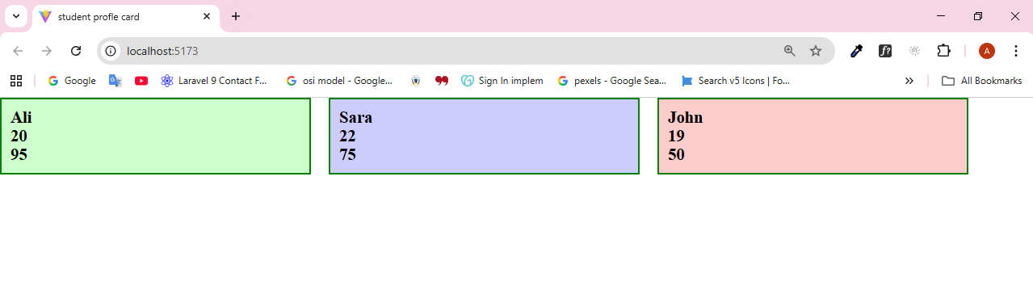
In students.js I have 3 students, each of them has a grade, and sepcific background based on their grade

Event Handler
at same project studentprofilecards just we create EventHandler compoent that takes 2 simples buttons and 1 input type text, in order to test onClick and onChange event
export default function EventHandler(){
function handleClickGreet (){
console.log("hello every one")
}
function handleClickWelcome(name){
console.log(`hello ${name}`)
}
function handleInputChange(e) {
console.log(e.target.value)
}

return(
<>
<button onClick={handleGreet}style={{marginBlock:"10px"}}> click without parameter</button> <br/>
<button onClick={()=> handleWelcome ('ali')} style={{marginBlock:"10px"}}>click with a parameter</button> <br/>
<input type="text" onChange={handleInputChange} style={{marginBlock:"10px"}} />
</>
)
}

onClick event
The onClick attribute in React is case sensitive and must be written in camelCase. When assigning functions to it, there are two cases to consider:
- If the function does not take any parameters, you can simply pass the function reference inside curly braces, such as {greet}.
- If the function requires parameters, you cannot call it directly (e.g., welcome("Ali")), because in JavaScript this means it will execute immediately during rendering. To avoid that, you wrap it inside an anonymous function, like () => welcome("Ali"). This way, React stores the function and only executes it when the event occurs.

onChange event
The onChange event in React triggers every time the value of a text box changes. In other words, with each key press on the keyboard, the handleInputChange function is executed. When you run your application and type in the text box, you’ll notice that every letter you enter is immediately logged in the console.

React Hooks
In React, Hooks are special functions that let you “hook into” React features, think of hooks as tools that add extra power to your functions.
Hook: خطّاف/ شي يتعلق بشيء

The Most Common Hooks
- useState → lets your component remember data (state).
useEffect → lets your component do something after rendering (side effects like fetching data, timers).
- useContext → allows sharing data between components without passing props manually.

useState Hook
useState is a special React Hook that lets your component remember values between re-renders.
In our example below I re-render my component UseState when I change the state

Toggle heading name
in project (hooksproject) ,add in your App component UseState.jsx component that contains the following code:
step1
export default function UseState(){
return(
<>
<h1>jawad</h1>
</>
)}
Simple component takes fragments (empty tags) and a heading h1, let’s update this compoent and create a variable name with value “jawad” and heading h1 takes this value

Step2
export default function UseState(){
const name=”jawad”;
return(
<>
<h1>{name}</h1>
</>
)}
Same result nothing change, now I want onClick event over the heading to change its value to a new name, so I need to change the value of variable name

Step 3
export default function UseState(){
let name=”jawad”;
function handleChangeName(){
name=”fadi”
console.log(name)
}
return(
<>
<h1 onClick={handleChangeName}>{name}</h1>
</>
)}
When you click over heading h1 nothing change in your heading but in yur console you got fadi the new value of variable name, but my target is to change the contents of h1!!!!
Here is the role of useState

Step 4
Import useState function from react and add line number 2 to your code

import { useState } from "react" // note we use {} because react library export many functions,files they called Named export not default export such as componet
export default function UseState(){
console.log(useState())
let name=”jawad”;
function handleChangeName(){
name=”fadi”
console.log(name)
}
return(
<>
<h1 onClick={handleChangeName}>{name}</h1>
</>
)}
I focus here on console.log(useState()), this consloe.return and array with 2 element : [undefined, ƒ] first element is a value second element is a function

Let’s update
Console.log(useState(“jawad”) => ['jawad', ƒ] then useState takes a value

Let’s update
Const a=useState(“jawad”)
Console.log(a[0])=> return jawad // since a is an array so a[0] is the first element

Let’s update
Using destructring, as useState is an array with 2 elements so
Const [name,setName]=useState(“jawad”), name takes the default value “jawad” and setName is the function which the second element is the array useState

Step5
import { useState } from "react"
export default function UseState(){
let [name,setName]=useState(”jawad”);
function handleChangeName(){
if(name===”jawad”
setName(“fadi”)
else
setName(“jawad”)
}
return(
<>
<h1 onClick={handleChangeName}>{name}</h1>
</>
)}
setName is function used to change the value of name, setName takes “fadi” and replace it “jawad” with useState heading h1 changes its content

Counter Example
For this example follow the new project counterreact2025

import { useState } from "react"
//import {dynamicStyle} from "./styles/dynamicstyle"
function App() {
const [counter,setCounter]=useState(0)

function handleIncrease(){
setCounter((counter)=>counter+1)
}
// function handleDecrease(){
// setCounter((counter)=>counter-1)
// }
return (
<>
<h1>counter</h1>

<button style={{marginInline:"20px"}}onClick={handleIncrease}>increase</button>
<span style={{color:counter>0 ? "green" : "red"}}>{counter}</span>
{/* <span style={dynamicStyle(counter)}>{counter}</span> */}
<button onClick={()=>setCounter((counter)=>counter-1)} style={{marginInline:"20px"}}>decrease</button>
</>
)
}
export default App

form in react
in hooksproject we have Form.jsx that contains form with input type text and radio buttons and checkbox and select element that contains countries:
Forms.jsx
import { useState } from "react"
import styles from "./Form.module.css"

export default function Form() {
const countries=[
"lebanon","syria","jordan","qatar","ksa"
]

const optionCountries=countries.map((country,index)=>{
return <option value={index} key={index}>{country}</option>
})

const [userName,setUserName]=useState("")
const [selCountry,setSelCountry]=useState("-1")
const [gender,setGender]=useState("male")
const [isMarried,setIsMarried]=useState(false)

//this function change state of username in each change on text box
function handleUserName(e){
setUserName(e.target.value)
console.log(e.target.value)
}

//this function change state of selCountry in each select of new country from list
function handleSelectCountry(e){
setSelCountry(e.target.value)
console.log(e.target.value)
}

//after fill the form, the submit phase
function handleSubmit(e) {
e.preventDefault(); // stop refresh
if(selCountry==="-1" || userName==='') //mean if your text box is empty or you did not choose any country, your combobox still at –select country -- , then do nothing
return

let maritalStatus=isMarried ? "married" : "not married"
alert(`Name: ${userName}\nCountry: ${countries[selCountry]}\nGender: ${gender}\nMarried? ${maritalStatus}` );
};

return (
<div style={{width:"800px",margin:"20px auto",border:"2px solid black",padding:"20px"}}>
<form action="" method="" onSubmit={handleSubmit} >
<div className={styles.group_level}>
<label className={styles.label}>user name</label>
<input type="text" value={userName} onChange={handleUserName}/>
</div>
<div className={styles.group_level}>
<label className={styles.label}>select country</label>
<select onChange={handleSelectCountry} value={selCountry}>
<option value="">--Select Country--</option>
{optionCountries}
</select>
</div>

<div className={styles.group_level}>
<label className={styles.label}>select gender</label>
<label>Male</label><input type="radio" checked={gender==="male"} onChange={()=>setGender("male")}></input>
<label>Female</label><input type="radio" checked={gender==="female"} onChange={()=>setGender("female")}></input>
</div>
<div>
<label className={styles.label}>maried</label><input type="checkbox" checked={isMarried} onChange={()=>setIsMarried(!isMarried)} />
</div>

<button type="submit">Submit</button>

</form>
</div>
)
}

Todo project
In this project we will wlak step by step to make a mini project that involves props and components and map function and useState, this project :
- Display jobs to do (eat, watch tv, study …)
- Add new project
- Remove some project

Create a new project todoproject
Create component ToDoItem that contains ToDoItem.jsx which represent single job to do which is a p element contains number of job and job descrption

ToDoItem.jsx contains the following code:
export default function ToDoItem(props){
return (
<p>Job number : {props.jobId} - Job to do is : {props.jobName}</p>
)
}
Then this component takes props as parameter and this props has 2 keys jobId and jobName

In App.jsx we need to import ToDoItem and use it
App.jsx

import ToDoItem from './ToDoItem/TODoItem'
function App() {

const jobsToDo=["job1","job2","job3"]

const jobs=jobsToDo.map((job,index)=>{
return <ToDoItem jobName={job} key={index} jobId={index}/>
})
return (
<>
{jobs}
</>
)
}
Code above return the following output:

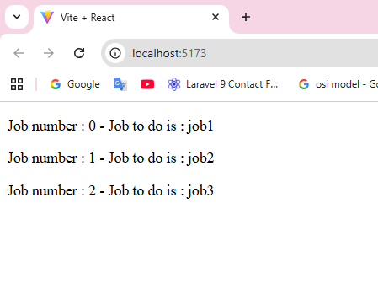

Now let’s make a simple form that add a new job and re-render inside the list of jobs, so we need to update App.jsx

App.jsx

import { useState } from 'react'
import ToDoItem from './ToDoItem/TODoItem'

function App() {
const jobsToDo=["job1","job2","job3"]

const [listJob,setListJob]=useState(jobsToDo) //assign jobsToDo array to state listJob because to update in each re-render or in each add new job

const [jobName,setJobName]=useState("") //this for input text

//this function is for change state of jobName or to save the value of text box
function handleChangeJobName(e){
setJobName(e.target.value)
}

//on submit, this function trigger
function handleSubmitForm(e){
e.preventDefault() // stop refresh
setListJob([...listJob,jobName]) //update listJob by adding new jobName, this spread operator mean update listJob with adding a new element jobName (such as listJob.push(jobName))
setJobName("") // to empty the input text
}

const jobs=listJob.map((job,index)=>{
return <ToDoItem jobName={job} key={index} jobId={index}/>
})
return (
<>
<form onSubmit={handleSubmitForm>
<input type='text' value={jobName} onChange={handleChangeJobName} />
<button>add</button>
</form>
{jobs}
</>
)
}

export default App

run of this code return the following, type a new job and press add, the ne job appear in the list below
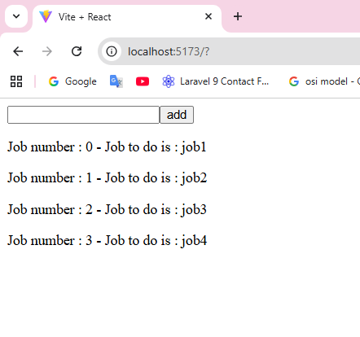
Now we need to add a delete button or span next of each job, so I need to update my ToDOItem component to the following:
Step1

export default function ToDoItem(props){

function handleClickTrash(a){
alert(a)
}
return (
// <p>Job number : {props.jobId} - Job to do is : {props.jobName}</p>
<p>Job number : {props.jobId} - Job to do is : {props.jobName} -
<button onClick={()=>handleClickTrash(props.jobId)}>delete</button></p>
)
We add a button that has atribute onClick, that trigger a function handleClickTrash, that function takes a parameter the props.jobId for each job, and this function just fire an alert with id of job, if you press on firs tbutton we get an alert with number 0 , second button number 1 …
But we don’t want alert with jobId we want to remove that job fom list, so let’s update the function handleClickTrash, but here we have an issuem the compoent that has the state of list [listJob] is App,jsx so we can not update form compoent ToDoItem, so we must create the function that remove job from list in App.jsx then pass it to ToDoItem.jsx as props as following :

Step 2
In App.jsx I made the following changes, the function that filter the list and pass it to ToDoItem as props
const jobs=listJob.map((job,index)=>{
return <ToDoItem jobName={job} key={index} jobId={index} onDelete={deleteJobItem}/>
})

function deleteJobItem(id){
const newListJob=listJob.filter(function(job,index){
return index!=id
}) // this function return all job from list that has different id passed by function
setListJob(newListJob)

}

export default function ToDoItem(props){

function handleClickTrash(a){
props.onDelete(a)
}
return (
// <p>Job number : {props.jobId} - Job to do is : {props.jobName}</p>
<p>Job number : {props.jobId} - Job to do is : {props.jobName} -
<button onClick={()=>handleClickTrash(props.jobId)}>delete</button></p>
)

todoprojectfinal is a complete version for todo list

useEffect Hook
- useEffect is a React Hook.
- It lets you run some code after your component renders.
- Runs once at the start + every time count changes.

Let’s make an example what do we mean with after compoents renders
Under hooksproject, under hooks, create UseEffect.jsx that contains:

Step1

import { useState } from "react";
export default function USeEffect(){
const [name,setName]=useState("kassem")
function handleClick(){
setName("fadi")
console.log(name)
}

return(
<>
<h1 onClick={handleClick}>{name}</h1>
</>
)
}
And sure we need to import this omponent aunder App.jsx and lunch it
App.jsx
import { useState } from 'react'
import Form from "./Hooks/Form"
import UseState from "./Hooks/UseState"
import UseEffect from './Hooks/UseEffect'

function App() {
return (
<>
<Form />
<UseState />
<UseEffect />
</>
)
}
export default App

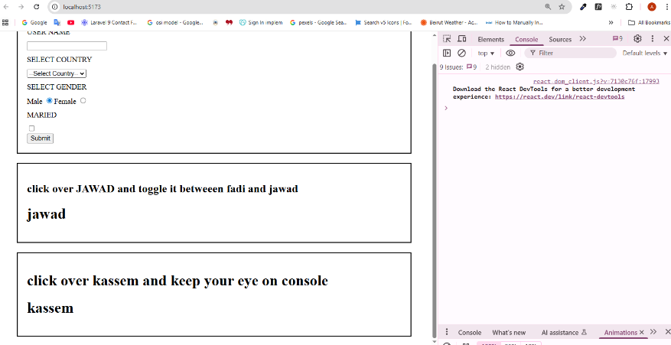
The default value of the state variable name is "kassem". When I click on "kassem", the state updates to "fadi". However, if you check the console immediately after calling the state update, it will still log the old value ("kassem"). This happens because useState updates the state asynchronously, and the new value becomes available only after the component re-renders. After the re-render, the <h1> correctly displays "fadi".

And now is the function of useEffect, is to do something after re-renders, let’s update UseEffect.jsx by adding useEffect function nd import useEffer from “react”
import { useEffect, useState } from "react";

useEffect(()=>{
console.log(name) // useEffect trigger an arrow function that display in console the {name}
},[name]) // [name] in each change of state {name} this useEffect runs

Now the main role for useEffect is use it with API (From jsonplaceholder.com I choose /users api ), so I create UseEffectApi.jsx that contains the following:
import { useEffect, useState } from "react";

export default function USeEffectApi(){
const [counter,setCounter]=useState(0)
function handleClick(){
setCounter((prev)=>prev+1)
}

useEffect(()=>{
fetch("https://jsonplaceholder.typicode.com/users")
.then(res=>res.json())
.then(data=>console.log(data))
},[counter])

return (
<div style={{border:"2px solid black",width:"800px",margin:"20px auto",padding:"20px"}}>
<h1>{counter}</h1>
<button onClick={handleClick}>add</button>
</div>)
}

Just this code above mean, I have a button that changest he state of counter, in each click counter increase 1, and the useEffect means in each change of state {counter} useEffect fetch data from api and convert to json then display in console
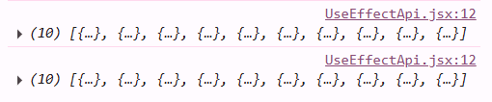

Array of objects contains 10 users, now using useEffect that load users, let’s create useState users and setUsers as following:

import { useEffect, useState } from "react";

export default function USeEffectApi() {
const [users, setUsers] = useState([])

const usersList = users.map((user) => {
return <p key={user.id} style={{border:”2px solid green”}}>{user.id} - {user.name}</p>
})

useEffect(() => {
fetch("https://jsonplaceholder.typicode.com/users")
.then(res => res.json())
.then(data => setUsers(data))
}, [users])

return (
<div style={{ border: "2px solid black", width: "800px", margin: "20px auto", padding: "20px" }}>
<h1 style={{textAlign:"center"}}>list of users</h1>

{usersList}
</div>)
}

Code above,create state {users} that is an empty array, then I make an array using map function that return a paragraph <p> contains name and id for each name inise array {users},
useEffect to fetch data from api users, then change to json then update state {users} using setUsers, this code above return :
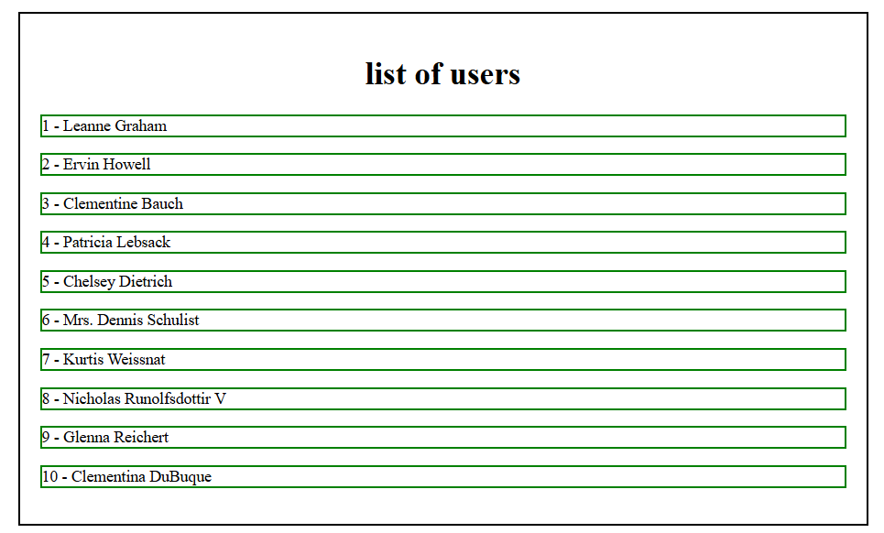

Now I want to update my compoent by adding a text box at the top of names for filter names beased on change in text box
Let’s update UseEffectApi as following:

import { useEffect, useState } from "react";

export default function USeEffectApi() {
const [allUsers, setAllUsers] = useState([]); // original list
const [users, setUsers] = useState([]); // filtered list

useEffect(() => {
fetch("https://jsonplaceholder.typicode.com/users")
.then(res => res.json())
.then(data => {
setAllUsers(data);
setUsers(data); // show full list at first
});
}, []);

function handleChange(e) {
const value = e.target.value.toLowerCase();
const filter = allUsers.filter((user) =>
{
return user.name.toLowerCase().includes(value)
}
);// I filter than main users (all usres)
setUsers(filter); // I change state offilterred users
}

// maping is done over filtered users which by default it contains all users
const userList=users.map(user => (
<p style={{ border: "2px solid green" }} key={user.id}>
{user.id} - {user.name}
</p>
))

return (
<div
style={{ border: "2px solid black", width: "800px", margin: "20px auto", padding: "20px"
}}
>
<h1 style={{ textAlign: "center" }}>list of users</h1>
<p style={{ textAlign: "center" }}>
<input style={{ padding: "5px"}} type="text" onChange={handleChange} />
</p>
{userList}
</div>
);
}
Why idid another state for filterd name ???let say I have the following:
const [users, setUsers] = useState([])

const usersList = users.map((user) => { return <p style={{border:"2px solid green"}}key={user.id}>{user.id} - {user.name}</p> })

useEffect(() => {
fetch("https://jsonplaceholder.typicode.com/users")
.then(res => res.json())
.then(data => setUsers(data)) }, [])

function handleChange(e){ let filter=users.filter((user)=>{ return user.name.toLowerCase().includes(e.target.value) })

all is related to state {users}, maping also related to {users} when I fire {handleChange} function, filter is made on {users} and maping on {users} , if I type “er” I get all names that contains “er” , {users} became all names that contains “er”, made a backspace nothing change because {users} is filtered now, for that I need to state one all names and one filtered names.
ال state الأساسية تحتوي على كل ال users بينما الذي يعرض هو ال filtered users

useEffectchoice between posts,users and comments
in this mini project I have three buttons users, comments and posts, in each click button you display a list based on your choice

useContext Hook
as a definition, useContext allows sharing data between components without passing props manually., let’s make a simpl example without using useContext (usecontextpart1), our project consist of the folowing structrure, App.jsx import 2 compoent Header.jsx and Body.jsx, and in turn, Header.jsx import compoent button.jsx, so this is a simple project with header contains a button, inside body I have a heading, button allow to show or hide the heading
App.jsx =>father
Header.jsx =>child
Button.jsx =>grand child
Body.jsx => child

App.jsx

import { useState } from 'react'
import Header from "./Header"
import Body from "./Body"

function App() {
const [show,setShow]=useState(true) //state has default value true

function changeStatus(){
setShow(!show)
}
return (
<div style={{margin:"20px auto",width:"80vw"}}
<Header clickButton={changeStatus}/> //props (clickButton) passed to Header contains the function changeStatus
<Body showHeading={show} />//pass the state show as props to Body
</div>
)
}
export default App

Body.jsx

export default function Body({showHeading}){
return (
<>
{showHeading ? <h1>hello world</h1> : <></> }
</>)
}

Simple compoent,accept the props showHeading passed from App, which contains the value of state show (true/false) and if true h1 appear if not <>/<> empty fragment
showHeading ? <h1>hello world</h1> : <></> mean if showHeading===true ? <h1>….
Header.jsx
import Button from "./button"
export default function Heading({clickButton}){
return(
<header style={{padding:"20px",backgroundColor:"rgba(20,20,56,0.5)",display:"flex",justifyContent:"center"}}>
<Button toButton={clickButton}/>
</header>)
}

Compoent Header accept props clickButton from App, and in turn pass it ot component Button by new props toButton

Button.jsx

export default function Button({toButton}){
function handleChangeStatus(){
toButton()
}
return(<>
<button onClick={handleChangeStatus}>click to show or hide heading</button>
</>)
}

A simple compoent that present a button and onClik event that trigger function:
toButton() which clickButton whhich changeStatus()
we pass a props from father to child to grand child, that is called props drilling

here is the role of useContext (usecontextpart2)
create file Context.jsx
import { useContext } from "react"
export const AppContext = createContext();
let’s suppose the AppContext (named as you want) is the carrier that caries values through your components
App.jsx
import { useState } from 'react'
import Header from "./Header"
import Body from "./Body"
import { AppContext } from './Context' // import the carrier

function App() {

const [show, setShow] = useState(true)

function changeStatus() {
setShow(!show)
}
return (
<AppContext.Provider value={{ show, changeStatus }}> //props are ehere
<div style={{ margin: "20px auto", width: "80vw" }}>
<Header /> //no more props
<Body /> //no more props
</div>
</AppContext.Provider>
)
}
export default App

Body.jsx
import { useContext } from "react"
import { AppContext } from "./Context"

export default function Body() {

const { show } = useContext(AppContext)
return (
<>
{show === true ? <h1>hello world</h1> : <></>}
</>)
}

In header.jsx nothing change except no more props
Button.sx

import { useContext } from "react"
import { AppContext } from "./Context"

export default function Button() {

const { changeStatus } = useContext(AppContext)

return (<>
<button onClick={changeStatus}>click to show or hide heading</button>
</>)
}

React Router
React Router is a library for React that lets you create navigation and manage different pages (routes) in a single-page application without reloading the browser.
In order to user the library react router we must install it
- npm install react-router-dom
let’s start with a simple example before using Link,(simplereactrouter) after installing react-router-dom, in App.jsx:
import { Route, Routes } from "react-router-dom"
export default function App() {
return (
<main>
<h1>this is header</h1> //heading 1
<Routes>
<Route path="/" element={<h1>this is main</h1>} /> //main heading
<Route path="/hello" element={<h1>this is hello</h1>} /> //heading 2
<Route path="/world" element={<h1>this is world</h1>} /> //heading 3
</Routes>
<h1>this is footer</h1> //heading 4
</main>
)
}

When I lunch my app main heading,heading 1 and heding 4 appear, but heading2 only will be showen if I go to url /hello and heading for url /world, in url type : http://localhost:5173/world you got

This is header
This is world
This is footer

let’s make a simple project (reactrouter) a header contains a nav bar with 2 internal links, /contactus and /aboutus

main.jsx
import { StrictMode } from 'react'
import { createRoot } from 'react-dom/client'

import App from './App.jsx'
import { BrowserRouter } from 'react-router-dom'

createRoot(document.getElementById('root')).render(
<StrictMode>
<BrowserRouter>
<App />
</BrowserRouter>
</StrictMode>,
)

Just import BrowserRouter from react-router-dom and wrap your App with BrowerRouter, mean this route is applied on all App

Header.jsx
import { Link } from "react-router-dom"
export default function Header() {
return (<>
<header>
<h1>this is header</h1>
<nav>
<ul>
<Link to="/about">About Us</Link>
<Link to="/contact">Contact Us</Link>
</ul>
</nav>
</header>
</>)
}

Instead of using a href, we use Link, and sure we need to import Link from react-router-dom, to=”/about” is the pathe that should be appear in the url, so we can name it as we want

AboutUs.jsx and ContactUs.jsx just contains heading <h1>…</h1> and lorem
App.jsx
import Header from "./Header"
import ContactUs from "./ContactUs"
import AboutUs from "./AboutUs"
import Footer from "./Footer"

import { Route, Routes } from "react-router-dom"
function App() {
return (
<>
<Header />
<Routes>
<Route path="/about" element={<AboutUs />} />
<Route path="/contact" element={<ContactUs />} />
</Routes>
<Footer/>
</>
)
}

export default App
to and path should be same name

as react is a single page application, we can swap between pages without relaod, you page :
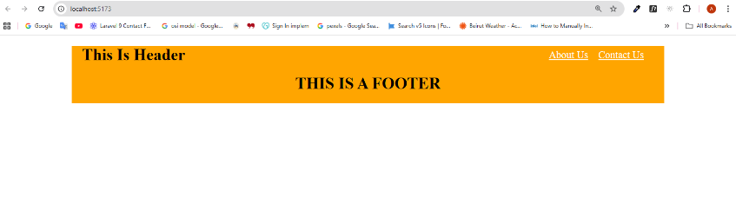
Figure 1 first lunch
When you click on AboutUs/ContactUs
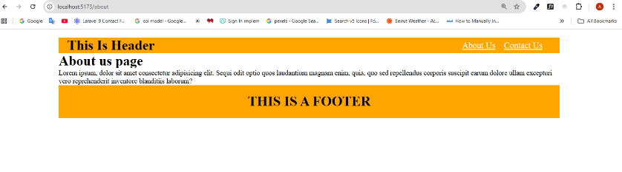
The route “/about” and same for route “/contact”, header and footer appear in both routes the changes is only in body section, each component exist outside routes should be appear in different route of routes

As we mention in figure 1 first lunch nothing is appear except header and footer, so I need a page that be showen as home page, so I modify my App.jsx by adding a new Route

<Route path="/ " element={<Home />} /> // home page / main root
<Route path="/about" element={<AboutUs />} />
<Route path="/contact" element={<ContactUs />} />
And I create a new compoent Home.jsx, so when I lunch my app I get the home section
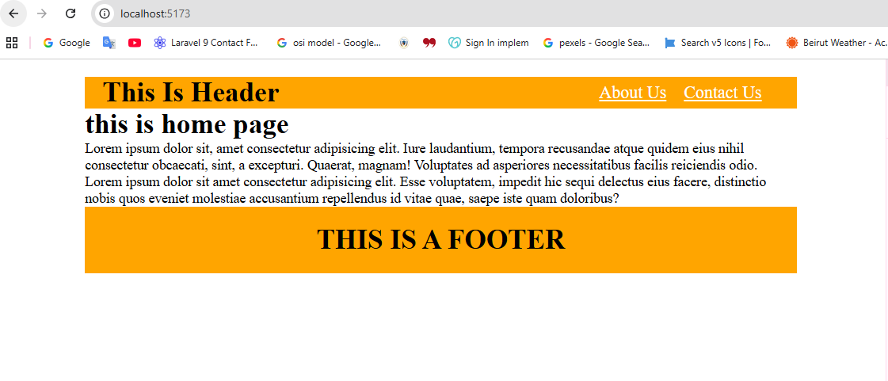

Suppose I want “This is header” inside heder compoent be a link to home page, I should modify header and wrap h1 with link to become :
<Link to="/"><h1>this is header</h1></Link>

Now we talk about parameter in route, so let’s create mini project routerparams that explain the hook useParams.
npm install react-router-dom

I have a Header.jsx contains 2 Link, post towords to all posts and home page
Header.jsx
import { Link } from "react-router-dom"

export default function Header(){
return(
<header>
<nav>
<Link to="/" style={{marginInline:"10px"}}>Home page</Link>
<Link to="/posts" >Posts</Link>
</nav>
</header>
)
}

Home.jsx
export default function Home() {
return(<>
<h1>ih this Home page </h1>
</>)
}

Post.jsx
import Card from "./Card"
export default function Posts(props) {

let postsArr=props.posts.map((post)=>{
return <Card key={post.id} {...post} />
})
return(<div className="container">
{postsArr}
</div>)
}
Note: {…post} is equivalent to id={post.id} title={post.title} , {…post} all contents of post, and Post.jsx accept a props which the arr of posts from App.jsx

Card.jsx
export default function Card(props)
{
return (
<div>
<p>post Id : {props.id}</p>
<p>post title : {props.title}</p>
</div>
)}

App.jsx
import { Route, Routes } from "react-router-dom"
import Header from "./Header"
import Home from "./Home"
import Posts from "./Posts"
import "./App.css"

function App() {
const posts=[
{
"id": 1,
"title": "sunt aut facere repellat provident occaecati excepturi optio reprehenderit",
"body": "quia et suscipit\nsuscipit recusandae consequuntur expedita et cum\nreprehenderit molestiae ut ut quas totam\nnostrum rerum est autem sunt rem eveniet architecto"
},
{
"id": 2,
"title": "qui est esse",
"body": "est rerum tempore vitae\nsequi sint nihil reprehenderit dolor beatae ea dolores neque\nfugiat blanditiis voluptate porro vel nihil molestiae ut reiciendis\nqui aperiam non debitis possimus qui neque nisi nulla"
},
{
"id": 3,
"title": "ea molestias quasi exercitationem repellat qui ipsa sit aut",
"body": "et iusto sed quo iure\nvoluptatem occaecati omnis eligendi aut ad\nvoluptatem doloribus vel accusantium quis pariatur\nmolestiae porro eius odio et labore et velit aut"
},
{
"id": 4,
"title": "eum et est occaecati",
"body": "ullam et saepe reiciendis voluptatem adipisci\nsit amet autem assumenda provident rerum culpa\nquis hic commodi nesciunt rem tenetur doloremque ipsam iure\nquis sunt voluptatem rerum illo velit"
},
{
"id": 5,
"title": "nesciunt quas odio",
"body": "repudiandae veniam quaerat sunt sed\nalias aut fugiat sit autem sed est\nvoluptatem omnis possimus esse voluptatibus quis\nest aut tenetur dolor neque"
},
{
"id": 6,
"title": "dolorem eum magni eos aperiam quia",
"body": "ut aspernatur corporis harum nihil quis provident sequi\nmollitia nobis aliquid molestiae\nperspiciatis et ea nemo ab reprehenderit accusantium quas\nvoluptate dolores velit et doloremque molestiae"
},
{
"id": 7,
"title": "magnam facilis autem",
"body": "dolore placeat quibusdam ea quo vitae\nmagni quis enim qui quis quo nemo aut saepe\nquidem repellat excepturi ut quia\nsunt ut sequi eos ea sed quas"
},
{
"id": 8,
"title": "dolorem dolore est ipsam",
"body": "dignissimos aperiam dolorem qui eum\nfacilis quibusdam animi sint suscipit qui sint possimus cum\nquaerat magni maiores excepturi\nipsam ut commodi dolor voluptatum modi aut vitae"
},
{
"id": 9,
"title": "nesciunt iure omnis dolorem tempora et accusantium",
"body": "consectetur animi nesciunt iure dolore\nenim quia ad\nveniam autem ut quam aut nobis\net est aut quod aut provident voluptas autem voluptas"
},
{
"id": 10,
"title": "optio molestias id quia eum",
"body": "quo et expedita modi cum officia vel magni\ndoloribus qui repudiandae\nvero nisi sit\nquos veniam quod sed accusamus veritatis error"
}
]
return (
<>
<Header />
<Routes>
<Route path="/" element={<Home/>}/>
<Route path="/posts" element={<Posts posts={posts}/>}/>
</Routes>
</> )
}export default App

when I lunch my application I got tjis web page, header exist and home page
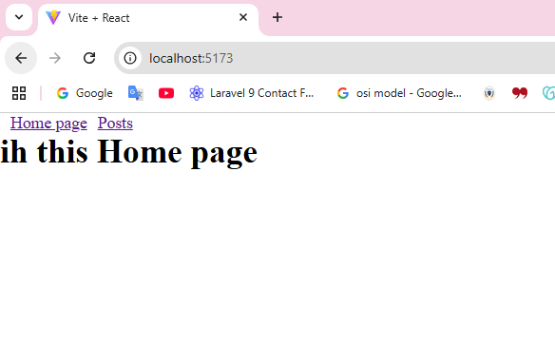
When I click Posts Link, header remind in page and instead oh home page I got Posts.jsx

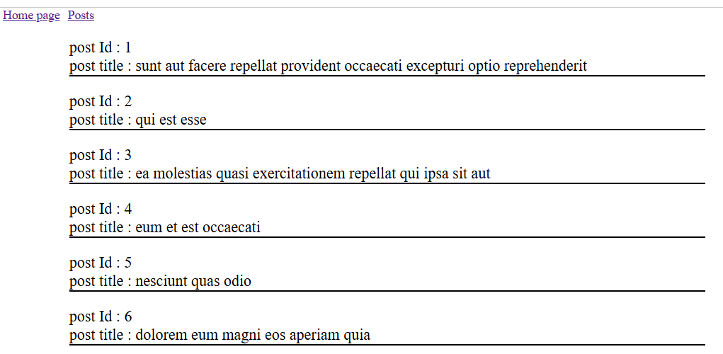
As we can see Header exist and instead of Home.jsx I have Posts.jsx, till this point I did not use useParams, why I need useParams ???? let say I want to read article with id:5, on click of id:5 a new page appear and contains only details of article 5,

First we create a PostDetails.jsx file contains :
import { useParams } from "react-router-dom"

export default function PostDetails(props) {
const {postId}=useParams() //this variable should be same as passed in url (App.jsx)

let post=props.allPosts.find((onePost)=>{
return parseInt(postId)===onePost.id
}) // mean give the first object where its id equal to postId passed by url
return(<>
<p>id : {post.id}</p>
<p>title : {post.title}</p>
<p>body : {post.body}</p>
</>)
}
PostDetails accept the whole array from App.jsx as props

Update App.jsx to :
import { Route, Routes } from "react-router-dom"
import Header from "./Header"
import Home from "./Home"
import Posts from "./Posts"
import PostDetails from "./PostDetails"
import "./App.css"
function App() {
const posts=[
{
"id": 1,
"title": "sunt aut facere repellat provident occaecati excepturi optio reprehenderit",
"body": "quia et suscipit\nsuscipit recusandae consequuntur expedita et cum\nreprehenderit molestiae ut ut quas totam\nnostrum rerum est autem sunt rem eveniet architecto"
},
{
"id": 2,
"title": "qui est esse",
"body": "est rerum tempore vitae\nsequi sint nihil reprehenderit dolor beatae ea dolores neque\nfugiat blanditiis voluptate porro vel nihil molestiae ut reiciendis\nqui aperiam non debitis possimus qui neque nisi nulla"
},
{
"id": 3,
"title": "ea molestias quasi exercitationem repellat qui ipsa sit aut",
"body": "et iusto sed quo iure\nvoluptatem occaecati omnis eligendi aut ad\nvoluptatem doloribus vel accusantium quis pariatur\nmolestiae porro eius odio et labore et velit aut"
},
{
"id": 4,
"title": "eum et est occaecati",
"body": "ullam et saepe reiciendis voluptatem adipisci\nsit amet autem assumenda provident rerum culpa\nquis hic commodi nesciunt rem tenetur doloremque ipsam iure\nquis sunt voluptatem rerum illo velit"
},
{
"id": 5,
"title": "nesciunt quas odio",
"body": "repudiandae veniam quaerat sunt sed\nalias aut fugiat sit autem sed est\nvoluptatem omnis possimus esse voluptatibus quis\nest aut tenetur dolor neque"
},
{
"id": 6,
"title": "dolorem eum magni eos aperiam quia",
"body": "ut aspernatur corporis harum nihil quis provident sequi\nmollitia nobis aliquid molestiae\nperspiciatis et ea nemo ab reprehenderit accusantium quas\nvoluptate dolores velit et doloremque molestiae"
},
{
"id": 7,
"title": "magnam facilis autem",
"body": "dolore placeat quibusdam ea quo vitae\nmagni quis enim qui quis quo nemo aut saepe\nquidem repellat excepturi ut quia\nsunt ut sequi eos ea sed quas"
},
{
"id": 8,
"title": "dolorem dolore est ipsam",
"body": "dignissimos aperiam dolorem qui eum\nfacilis quibusdam animi sint suscipit qui sint possimus cum\nquaerat magni maiores excepturi\nipsam ut commodi dolor voluptatum modi aut vitae"
},
{
"id": 9,
"title": "nesciunt iure omnis dolorem tempora et accusantium",
"body": "consectetur animi nesciunt iure dolore\nenim quia ad\nveniam autem ut quam aut nobis\net est aut quod aut provident voluptas autem voluptas"
},
{
"id": 10,
"title": "optio molestias id quia eum",
"body": "quo et expedita modi cum officia vel magni\ndoloribus qui repudiandae\nvero nisi sit\nquos veniam quod sed accusamus veritatis error"
}
]

return (
<>
<Header />
<Routes>
<Route path="/" element={<Home/>}/>
<Route path="/posts" element={<Posts posts={posts}/>}/>
<Route path="/postDetails/:postId" element={<PostDetails allPosts={posts}/>}/>
</Routes>

</>
)
}

export default App

<Route path="/postDetails/:postId" element={<PostDetails/>} /> // new
This is a new Route towards us to path postDetails with a postId and open PostDetails.jsx

Let’s update Card.jsx
import { Link } from "react-router-dom";

export default function Card(props)
{
return (
<div>
<p><Link to={`/postDetails/${props.id}`}>post Id : {props.id}</Link></p>
<p>post title : {props.title}</p>
</div>
)}
The new update is wrap props.id with Link

