**AppFlowy:**

## Step # 01:

Click on the link of the git repository of the appFlowy. After clicking, create a fork in your repository and clone the project in local storage. Link of the git repository of the appFlowy.

- <https://github.com/AppFlowy-IO/AppFlowy>

## Step # 02:

Go to appflowy documentation by clicking on the following link:

[AppFlowy - AppFlowy Docs](https://docs.appflowy.io/docs/documentation/appflowy)

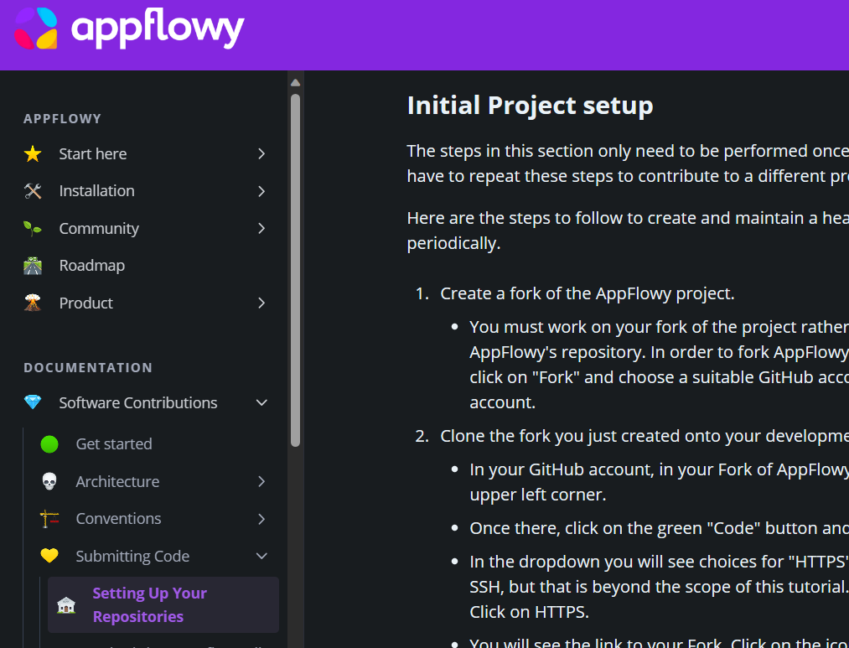

Click on the setting up your repsositories and perform the steps.

## Step # 03:

Run the command and install vcpkg, i recommend somewhere like C:\src\vcpkg

1. git clone https://github.com/microsoft/vcpkg
2. .\vcpkg\bootstrap-vcpkg.bat

## Step # 04:

Go to appflowy documentation by clicking on the following link:

[AppFlowy - AppFlowy Docs](https://docs.appflowy.io/docs/documentation/appflowy)

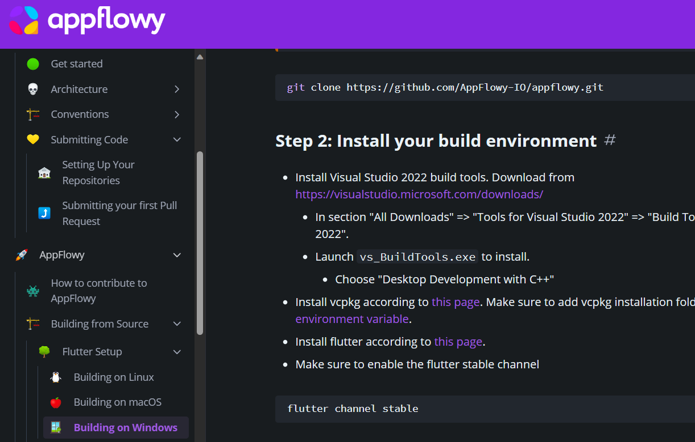

Click on the building on windows and perform the steps.

## Step 4:

* Open the frontend folder located at xx/AppFlowy/frontend with VS Code.
* Go to the Run and Debug tab and then click AF-desktop: Clean + Rebuild All for the first time running.

**Note: I follow all the steps as mention in the document but at the end I found an error.**