Correct Offline-First Synchronisation with Conflict-Free Replicated Data Types
Project 06 · Vite + React PWA · Yjs CRDT · y-websocket · Playwright · no GPU
Ali Hamza
One of six benchmarked engineering projects built on a single RTX 5080
RTX 5080 (16 GB, Blackwell) · Windows 11 · July 2026

Abstract
Offline-first applications are easy to demonstrate and hard to make correct: the difficulty is not caching a shell but merging concurrent edits made while disconnected, without losing writes. This project builds an inventory PWA whose synchronisation is backed by a conflict-free replicated data type (Yjs), including a delta-counter for concurrent quantity adjustments, and proves its correctness with an automated suite that maps a catalogue of concurrency scenarios to sixteen executable tests. Every scenario — same-field and different-field concurrent edits, a quantity increment of five and three merging to eight rather than overwriting to five or three, delete-versus-edit tombstones, long offline replay, three-way convergence, and cross-tab synchronisation — converges to an identical state across all replicas and the server. The suite passes 16 of 16, and this green suite is the deliverable.
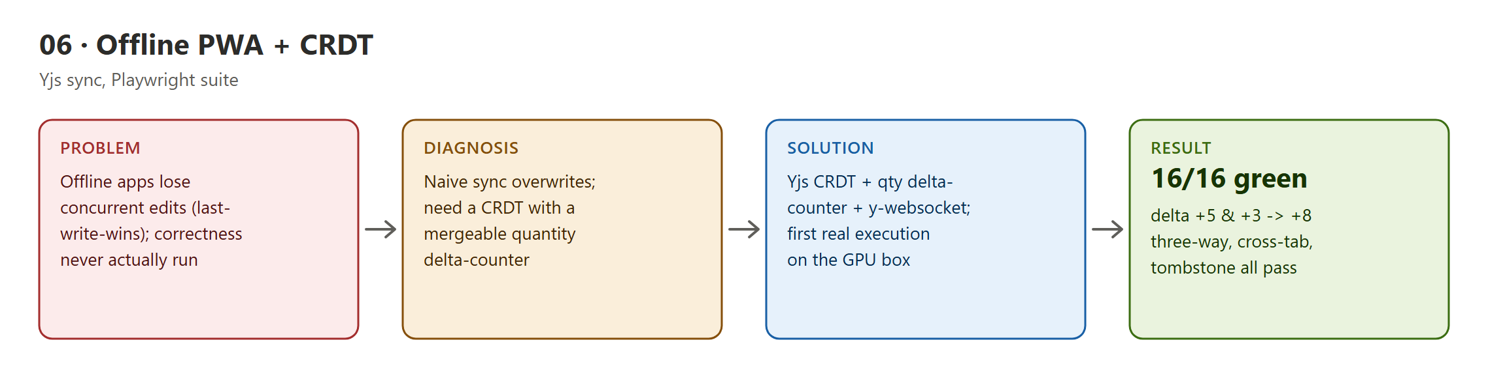
Figure 1 — Project 06: problem, diagnosis, solution, and result.

Contents

1. Introduction and problem statement
The hard part of offline-first is conflict resolution. Under last-write-wins, two users who each adjust a stock count while offline will clobber one another on reconnect, silently losing an adjustment. A correct system must merge both intents — a decrement of five and an increment of three must net to minus-two — and converge every replica to the same state regardless of message order.
The project's claim is therefore a correctness claim, and correctness claims must be executed, not asserted. Before this work the suite had only been import-audited, never run.

2. Background and related work
- CRDTs (Shapiro et al., 2011). The theory of conflict-free replicated data types that guarantees convergence without coordination.
- Yjs (Jahns). The high-performance CRDT implementation used for the shared document, with y-websocket for relay.
- Playwright. Drives multiple isolated browser contexts to reproduce genuine concurrent offline editing.

3. System design and method
The application (Vite + React, installable PWA with a service worker) stores inventory in a Yjs document. Item fields are last-writer-wins registers, but quantity uses a delta-counter so concurrent adjustments sum rather than overwrite; deletes are tombstones so a delete-versus-edit resolves to hidden-but-preserved. A y-websocket server relays updates and persists room snapshots atomically. The Playwright suite runs eight scenario specs under two client projects (sixteen executions), each spinning up isolated A/B/C browser contexts and a unique sync room, and asserts convergence across all replicas and the server.

4. Implementation and engineering challenges
The following defects were found by building and running the system — several by an independent deep-review pass — and are recorded as problem, diagnosis, and resolution.
- Making the concurrency catalogue executable. Each scenario — same-field, different-field, delete-versus-edit, long offline queue, three-way, quantity delta, cross-tab — is expressed as an isolated Playwright test with its own room and contexts, asserting an identical converged state on every replica plus the server. On its first real execution the suite passed 16 of 16 in about six seconds.
- A persistence round-trip that lost data on restart. Live rooms were keyed by the unsanitised decoded name while snapshots were written under a sanitised filename, so a room containing a slash reconnected to an empty document after a restart, and distinct room names could collide on one snapshot file. Room names are now canonicalised once at every entry point, so the live key, the snapshot filename, and the preload key agree.
- Unbounded snapshot accumulation. Every test room persisted a snapshot forever and all were reloaded into memory on boot. A configurable age-based pruning step now removes stale snapshots before preload.
- Verifying green rather than trusting a marker. The suite was re-run live rather than trusting a cached pass marker, confirming 16 of 16 after the persistence fixes.

5. Experimental results
The automated correctness suite — the project's central deliverable — passes all sixteen runs, covering the full concurrency scenario catalogue with convergence assertions across clients and server. The headline scenario, two offline quantity adjustments of five and three, converges to a combined eight rather than overwriting to either operand, demonstrating genuine CRDT merge rather than last-write-wins.
Scenario | Guarantee | Result
Quantity delta (+5 and +3) | adjustments sum to +8 | pass
Same-field concurrent edit | converges to one defined value | pass
Different-field edits | both survive | pass
Delete vs edit | tombstone hides, edit preserved | pass
Three-way + cross-tab | all replicas converge | pass

6. Discussion and limitations
The project demonstrates distributed-systems correctness, not a cached-shell facsimile of offline support. The reproducible, executable concurrency suite is the credible artifact: it turns an easily-asserted claim (“it syncs”) into a falsifiable, passing specification.

6.1 Known limitations and future work
- Demonstration recording outstanding. The automated suite is the proof; a two-window screen recording remains as an illustrative extra.
- Best-effort sync acknowledgement. y-websocket lacks per-update acknowledgement, so the pending-count indicator can under-report just before a socket drop; the converged state is never wrong (Yjs re-syncs), only the progress hint.

7. Conclusion
Every claim in this report traces to an artifact on disk — locked dataset splits, trained weights, generated report files, or passing test output — and the numbers were read from those artifacts after an independent re-audit and re-run. The engineering narrative is deliberately honest about what was measured, what was reframed when a commercial dependency was replaced by a local model, and what remains gated on external inputs.

8. References
- Shapiro et al. Conflict-Free Replicated Data Types. SSS 2011.
- Jahns. Yjs: A CRDT framework. 2015–.
- Kleppmann & Beresford. A Conflict-Free Replicated JSON Datatype. 2017.
- Playwright. End-to-end browser testing. Microsoft.

