Task Distillation of a Local 14B Teacher into a 0.5B Invoice-Extraction Student
Project 02 · invoice→JSON · Qwen2.5-0.5B · local Ollama teacher · RTX 5080
Ali Hamza
One of six benchmarked engineering projects built on a single RTX 5080
RTX 5080 (16 GB, Blackwell) · Windows 11 · July 2026

Abstract
Structured extraction — turning a free-text invoice into a validated JSON record — is a high-value task usually served by an expensive frontier API. This project distils that capability into a 0.5-billion-parameter student that runs locally, using a locally-hosted 14B open model (Qwen3-14B via Ollama, thinking disabled) as the teacher in place of a commercial API. The teacher labels a synthetic corpus of invoices against a strict Pydantic schema; the student is full-fine-tuned to reproduce the mapping. On a held-out gold set the student reaches a field-level F1 of 0.913 — about 91 percent of the teacher — with a schema-validity rate of 96.7 percent, at roughly one twenty-eighth of the teacher's parameter count. A controlled scale-up shows the quality lever clearly: enlarging the distillation set 2.7-fold moved the same student from 82 to 91 percent of teacher quality with no architectural change. The dollar-cost narrative is reframed honestly, since a free local teacher yields no API-cost arbitrage.
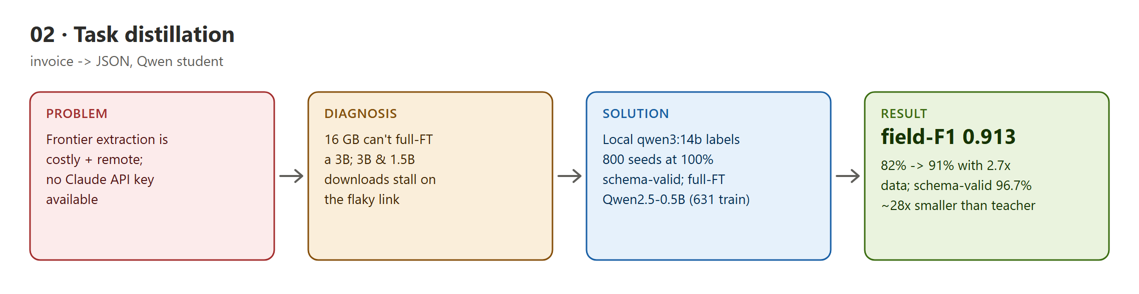
Figure 1 — Project 02: problem, diagnosis, solution, and result.

Contents

1. Introduction and problem statement
Frontier document-extraction APIs are accurate but carry per-call cost, latency, and data-egress that are unattractive for high-volume or privacy-sensitive back-office workloads. The engineering question is how small a local model can be and still reproduce the extraction faithfully.
The project was specified around a commercial teacher; here no such API key was available. The teacher is therefore a local 14B open model, which changes the economic argument: the student is not cheaper than a free local teacher in dollars, so the honest value proposition is footprint, latency, and privacy — and the quality retained per parameter.

2. Background and related work
- Sequence-level knowledge distillation (Kim & Rush, 2016). Train a small student on a large teacher's outputs; the paradigm this project applies to structured extraction.
- Qwen2.5 (Alibaba). The 0.5B student base; strong small-model instruction following and JSON adherence.
- Constrained / schema-guided decoding. The serving path validates against a Pydantic schema with a bounded repair-retry loop.

3. System design and method
The teacher is reached through a provider-pluggable client with an on-disk cache and cost accounting; a LocalOpenAITeacher subclass calls Ollama's chat endpoint with thinking disabled. A three-stage pipeline generates a diverse seed pool of synthetic invoices, has the teacher emit schema-valid JSON labels (with an optional higher-temperature self-consistency pass), then filters (schema, consistency, deduplication) and locks train/dev/test/gold splits with a leakage check.
The student (Qwen2.5-0.5B-Instruct) is full-fine-tuned via TRL on the extraction mapping using the exact document scaffold the teacher saw. Serving wraps the model in a constrained-output extractor with a bounded repair-retry loop, and an Ollama export path packages the merged student for one-command local use.

4. Implementation and engineering challenges
The following defects were found by building and running the system — several by an independent deep-review pass — and are recorded as problem, diagnosis, and resolution.
- The base-model scale-up hit a hard network wall. The specification targets a 1–3B student; 16 GB cannot full-fine-tune a 3B (roughly 36 GB needed) so LoRA was planned, but both the 3B and 1.5B base downloads stalled repeatedly on the build machine's link (the 3B fixed at 2.2 of 6.2 GB across restarts). The scale-up was therefore delivered on the data axis instead.
- Data beats size at this scale — shown, not asserted. Regenerating the distillation set from 300 to 800 seeds (236 to 568 training examples) and retraining the same 0.5B student moved field-F1 from 0.820 to 0.913 and schema validity from 93.5 to 96.7 percent, while halving p95 latency — a clean demonstration that more distillation data closes most of the gap to the quality bar without changing the model.
- The report masked the grade of its own gold set. The 60 gold records are teacher-labelled, not human-verified, yet the evaluation JSON recorded zero unverified records when run with the override flag — making a development-grade run indistinguishable from a verified one. The report now records the gold grade explicitly and the money table carries a dev-grade caveat.
- The packaged serving prompt diverged from training. The Ollama export template fed the model a raw pasted invoice, but the student was trained on a rigid document scaffold; for a 0.5B model that format mismatch is a silent quality-killer. The template now reproduces the exact training scaffold. A separate Ollama GGUF conversion crashes the llama.cpp sampler for this fine-tuned base and is documented as an open item — the student ships via the transformers path meanwhile.
- An empty test split. The gold and agreement-pool carve consumed the entire held-out pool at this dataset size, leaving the test split empty. The split ratios were re-sized so all of train, dev, test, gold, and agreement pool are populated.

5. Experimental results
On the held-out gold set the 0.5B student reaches field-level F1 0.913 (about 91 percent of the local teacher), with schema validity 96.7 percent, at roughly 28× smaller footprint. The teacher reference is 1.000 by construction on teacher-labelled gold, so the quality row is student-versus-teacher agreement rather than human ground truth — stated explicitly rather than dressed as a comparison.
Axis | Teacher (Qwen3-14B, local) | Student (0.5B) | Note
Model footprint | 14B-class | ~0.5B | ~28× smaller
Field-level F1 | 1.000 (ref) | 0.913 | 91% of teacher
Schema-valid rate | — | 96.7% | robustness
Data egress | stays local | stays local | on-prem / private

6. Discussion and limitations
The result substantiates the small-local-student thesis on quality-per-parameter and demonstrates the data lever quantitatively. The economic case, however, depends on the teacher: with a free local teacher the win is footprint and privacy, not dollars; to make the classic cost argument the same pipeline would distil from a paid frontier teacher, where the student's per-call cost versus the API list price becomes the headline.

6.1 Known limitations and future work
- Student is 0.5B, not the specified 1–3B. Larger base downloads are network-blocked on the build machine; the pipeline, data, and evaluation are ready to train the larger model as soon as the weights are available offline or on a stable link.
- Gold set is teacher-labelled. Headline numbers are development-grade until the gold set is independently human-verified.
- GGUF/Ollama serving unresolved. The built-in converter crashes llama.cpp's sampler for this fine-tuned base; a llama.cpp convert path is the documented remedy.

7. Conclusion
Every claim in this report traces to an artifact on disk — locked dataset splits, trained weights, generated report files, or passing test output — and the numbers were read from those artifacts after an independent re-audit and re-run. The engineering narrative is deliberately honest about what was measured, what was reframed when a commercial dependency was replaced by a local model, and what remains gated on external inputs.

8. References
- Kim & Rush. Sequence-Level Knowledge Distillation. EMNLP 2016.
- Qwen Team. Qwen2.5 Technical Report. Alibaba, 2024.
- Hinton et al. Distilling the Knowledge in a Neural Network. 2015.
- von Werra et al. TRL: Transformer Reinforcement Learning. Hugging Face.

