DevOps Assignment Report
Docker + Kubernetes + CI/CD (GitHub Actions)

Student Name | Ali Hashim
Registration / Roll No | 04072212040
Course / Section | Devops
Instructor | Muhammad imran
Submission Date | 24 Dec 2025
GitHub Repository Link (required on first page) | https://github.com/alihashim021/Devops

Table of Contents
1. Overview
2. Repository Structure
3. Task 1 - Dockerization
4. Task 2 - Docker Hub + Kubernetes Deployment + Ingress + Monitoring
5. Task 3 - CI/CD (GitHub Actions on Release)
6. Conclusion
Appendix A - Commands & Configuration Files

1. Overview
This report documents the implementation of the DevOps assignment using Docker, Kubernetes (single-node cluster), NGINX Ingress, monitoring via Helm (Kube-Eagle), and CI/CD automation with GitHub Actions triggered on Releases.
Tools/Environment used (update if different):
- OS: macOS (Intel)
- Docker Desktop: Installed and running
- Minikube: v1.37.0 (Docker driver)
- Kubernetes: v1.34.0 (Minikube cluster)
- Helm: v4.0.4
- kubectl: Installed (client version may vary)
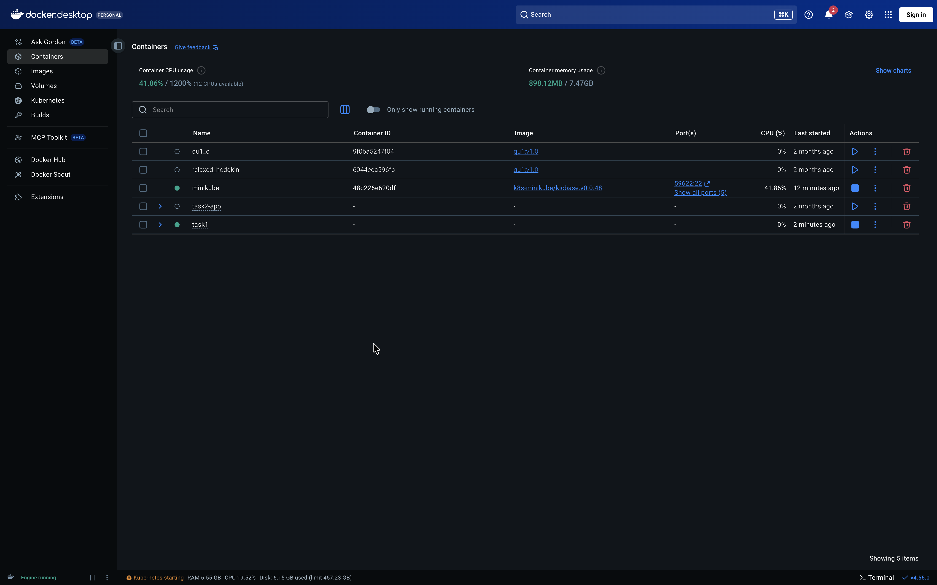
Screenshot: Minikube cluster running (terminal showing 'kubectl get nodes')

2. Repository Structure
A private GitHub repository named 'devops' was created. The repository contains the required folder structure under 'project/' with separate subfolders for each task, and a report folder. Each task folder includes a README.md file.
Recommended repository tree (example):
devops/
project/
task1/
README.md
backend/
docker-compose.yml
task2/
README.md
k8s/
task3/
README.md
.github/workflows/
task4/
README.md
report/
DevOps_Assignment_Report.pdf (or .docx)
Collaborator added: muhammadimranfarooqi (as required).

Screenshot: GitHub repo showing collaborator added + folder structure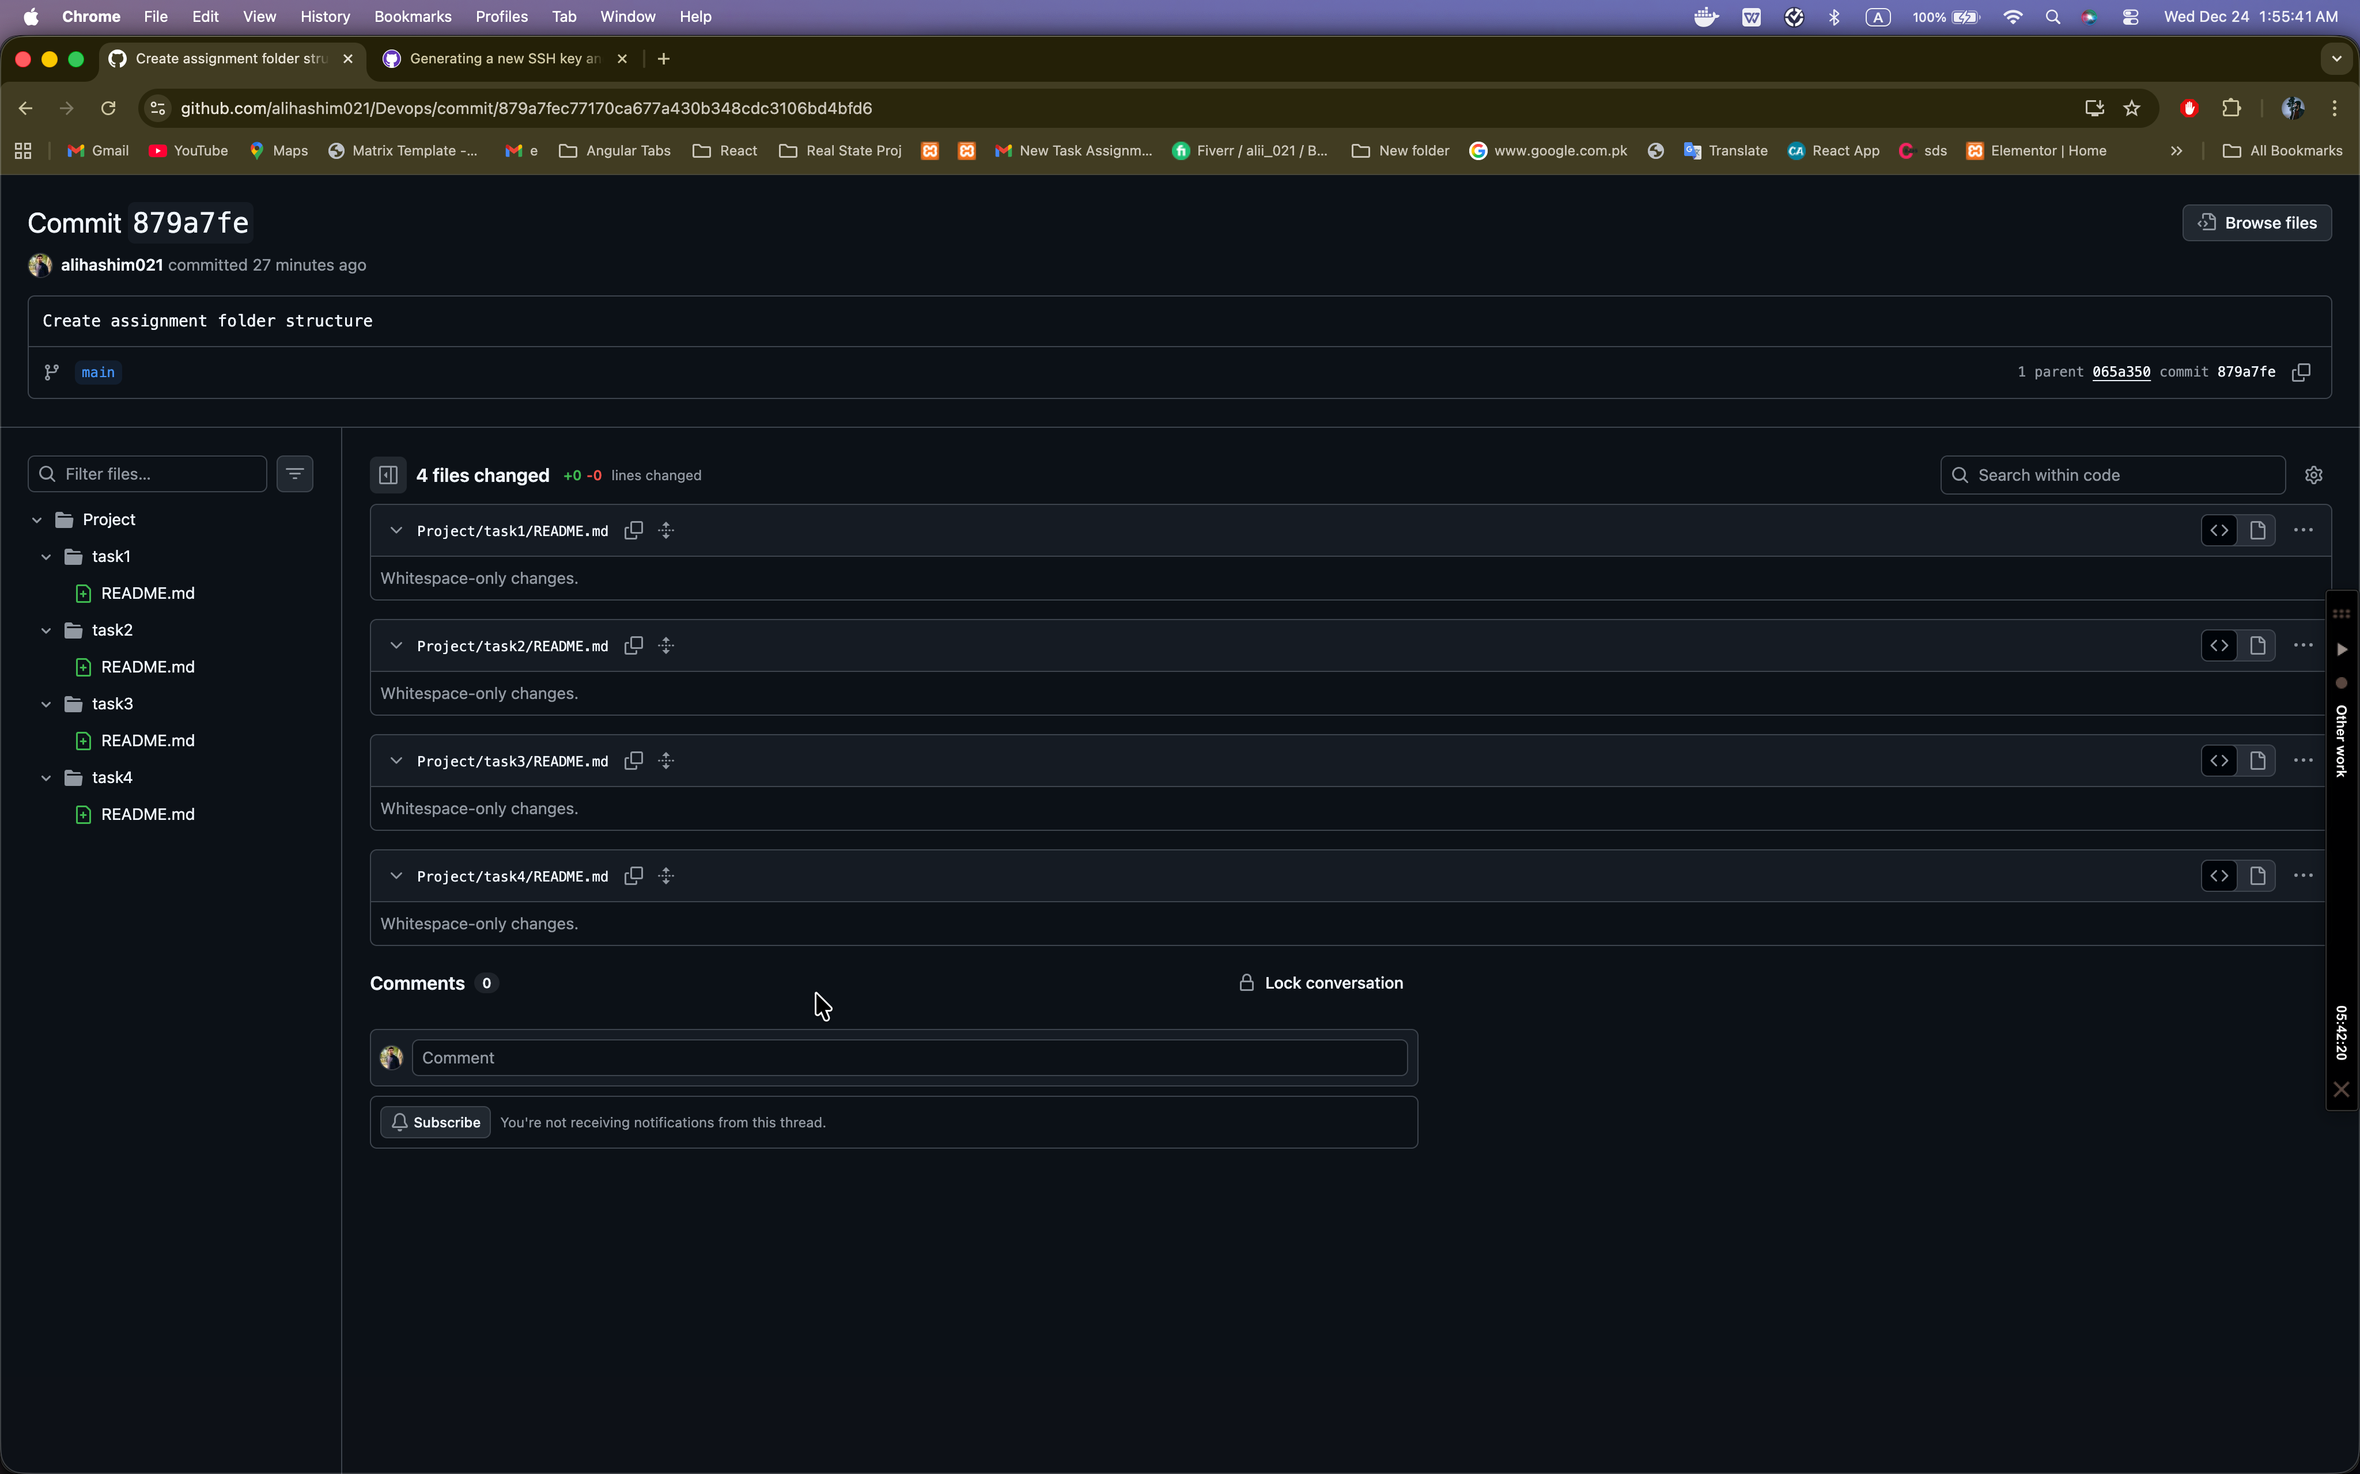

3. Task 1 - Dockerization
Objective: Containerize the project components. Since the frontend is a React Native mobile application (runs on device/emulator), the backend API and database were containerized and run locally using Docker.
3.1 Backend Dockerfile
A Dockerfile was created for the backend service to build a runnable container image.

Screenshot: Dockerfile in repo + successful docker build output
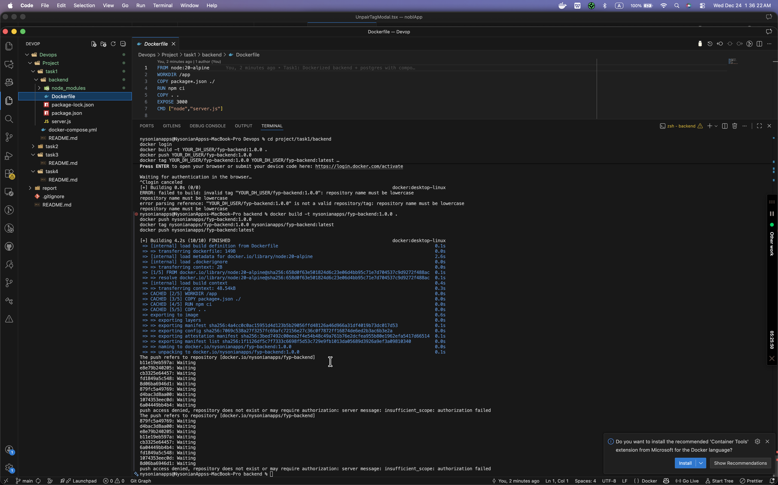

3.2 Docker Compose (Backend + Database)
A docker-compose.yml file was used to run the backend and database together for local development/testing.
Key commands used:
- docker compose up --build
- curl http://localhost:3000/health (or open in browser)
- docker compose down

Screenshot: Docker Desktop showing running containers for backend + 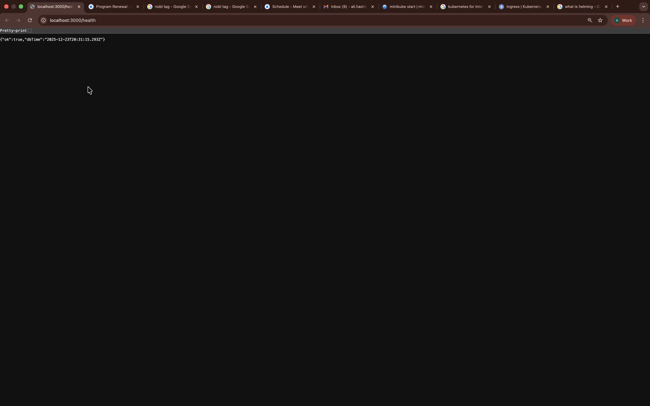database

Screenshot: Health endpoint response in browser/terminal


4. Task 2 - Docker Hub + Kubernetes Deployment + Ingress + Monitoring
4.1 Push Docker Images to Docker Hub
The backend image was tagged and pushed to Docker Hub (versioned tag + latest).
Example commands (replace with your actual Docker Hub username/repo):
- docker login
- docker build -t nysonianapps/fyp-backend:<tag> .
- docker push nysonianapps/fyp-backend:<tag>
- docker tag nysonianapps/fyp-backend:<tag> nysonianapps/fyp-backend:latest
- docker push nysonianapps/fyp-backend:latest

4.2 Deploy to Single-Node Kubernetes Cluster (Minikube)
A single-node Kubernetes cluster was created using Minikube. Kubernetes manifests were applied to deploy the database and backend services.
Verification commands:
- kubectl get nodes
- kubectl -n devops get pods,svc
- kubectl -n devops describe deployment backend

4.3 Expose Application using NGINX Ingress
The NGINX Ingress controller was installed using Helm, and an Ingress resource was created to route external HTTP traffic to the backend service.
Ingress installation (Helm):
- helm repo add ingress-nginx https://kubernetes.github.io/ingress-nginx
- helm repo update
- helm install ingress-nginx ingress-nginx/ingress-nginx --namespace ingress-nginx --create-namespace

4.4 Monitoring via Helm (Kube-Eagle)
Kube-Eagle monitoring was installed using Helm. Metrics Server was enabled to provide cluster metrics as required by the monitoring stack.
- minikube addons enable metrics-server
- helm repo add kube-eagle https://raw.githubusercontent.com/cloudworkz/kube-eagle-helm-chart/master
- helm repo update
- helm install kube-eagle kube-eagle/kube-eagle --namespace monitoring --create-namespace
- kubectl -n monitoring get pods,svc

Screenshot: Monitoring namespace pods/services for kube-eagle
[Insert screenshot here]

5. Task 3 - CI/CD (GitHub Actions on Release)
A CI/CD pipeline was configured using GitHub Actions. On publishing a new GitHub Release, the workflow builds a new Docker image, pushes it to Docker Hub, and deploys it to the single-node Kubernetes cluster.
Implementation summary:
- Added required GitHub repository secrets: DOCKERHUB_USERNAME and DOCKERHUB_TOKEN.
- Configured a self-hosted GitHub Actions runner on the same machine that hosts the Minikube cluster (so kubectl can reach the cluster).
- Created .github/workflows/release.yml with a Release trigger.
- Validated by creating a Release tag (e.g., v1.0.1) and confirming the rollout updated the deployment image.

6. Conclusion
All required DevOps tasks were completed: Dockerization, Docker Hub publishing, deployment to a single-node Kubernetes cluster, exposure through NGINX Ingress, monitoring installation via Helm, and CI/CD automation on GitHub Releases.

Appendix A - Commands & Configuration Files
Attach or paste key configuration files here if required by the instructor (Dockerfile, docker-compose.yml, Kubernetes YAML, and workflow YAML). Alternatively, reference their paths in the repository.
File list (example):
- project/task1/backend/Dockerfile
- project/task1/docker-compose.yml
- project/task2/k8s/all.yaml (namespace, deployments, services, ingress)
- .github/workflows/release.yml

