Marketplace Builder Hackathon 2025 (Day-2)
Customized Car Rental Marketplace Plan
Objective:
The aim of this plan is to build a feature-rich, scalable, and user-friendly car rental platform tailored for a seamless rental experience. The core aspects of this project include:
1. Sanity CMS: To manage car listings and rental orders efficiently.
2. Clerk: For secure and easy user authentication.
3. Custom APIs: To handle car rentals, user orders, and order tracking.
4. Stripe: For reliable and secure payment processing.
This platform is designed to provide both administrators and end-users with an intuitive, reliable system that aligns with modern web development standards.
System Architecture
Workflow Overview:
The system will operate in the following sequence:

- User Authentication: Secure login and signup powered by Clerk
- Car Browsing: Real-time data fetched from Sanity CMS ensures up-to-date car availability.
3. Rental Process: Users can select a car, specify rental durations, and proceed to checkout.
4. Payment Processing: Transactions are handled securely through Stripe, ensuring data protection.
5. Order Tracking: Rental order statuses are updated dynamically via custom APIs.

Architecture Diagram:
[User] -->|Signin| Clerk
[User] -->|Browses Cars| Frontend (Next.js)
[Frontend] -->|Fetches Cars| Sanity CMS
[Frontend] -->|Processes Payment| Stripe API
[Frontend] -->|Tracks Orders| Custom APIs

Features & Workflows
Frontend Features:
- Authentication:
  - Use Clerk to handle user login/signup.
  - Session management is handled by Clerk without involving Sanity CMS.
- Car Browsing:
  - Fetch and display car data from Sanity CMS using GROQ queries.
  - Implement filters (e.g., price range, car type) and sorting functionality.
- Checkout Process:
  - Collect user rental details and payment information via Stripe-hosted checkout.
  - Display an order confirmation and receipt after successful payment.

- Order Tracking:

  - Retrieve rental duration and order status via custom APIs.
Backend Features:
- Sanity CMS:
  - Manage car listings and orders using Sanity Studio.
  - Customize schemas for car details and order tracking.
- Custom APIs:
  - /product/cars: Fetch available cars.
  - /order /rent: Create and save rental orders.
  - /product/track-order: Retrieve the status of rental orders.
- Admin Panel:
  - Enable the admin to add, update, or delete cars via Sanity Studio.
Endpoint | Method | Description
/product/cars | GET | Fetch all available cars.
/order/rent | POST | Create a rental order and save details.
/product/track-order | GET | Retrieve the status of a rental order by its ID.
/payment/checkout | POST | Process payment using Stripe.

Sanity CMS Schemas

Car Schema:
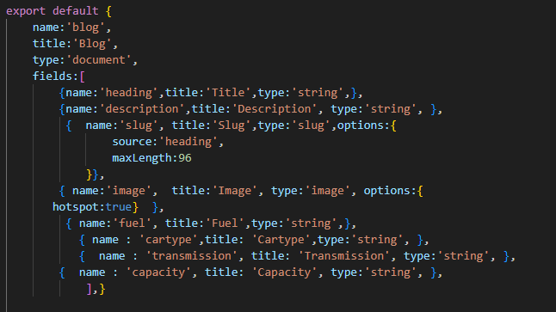
Deliverables
1. System Architecture Diagram:
A detailed visual representation of how components interact, including user authentication, car data fetching, payment processing, and order tracking.
2. Sanity Schemas:
Custom schemas for cars and rental orders, designed for easy management and scalability.
3. API Endpoints:
Fully functional endpoints for retrieving cars, creating orders, tracking rentals, and processing payments.
4. Frontend Pages:
- Home: Highlights featured cars and promotional offers.
- Car Listings: Displays all available cars with filter options.
- Car Details: Provides detailed information for each car.
- Checkout: Allows users to complete the rental process.
- Order Tracking: Enables users to monitor the status of their rentals.

