

NAME;
ALI HASSAN
ROLL NO;
338
SECTION;
BSAI (3B)
SUBJECT;
Artificial Intelligence Lab

SUBMENTED TO;
Sir Rasikh Ali

Tasks
Artificial Intelligence Lab

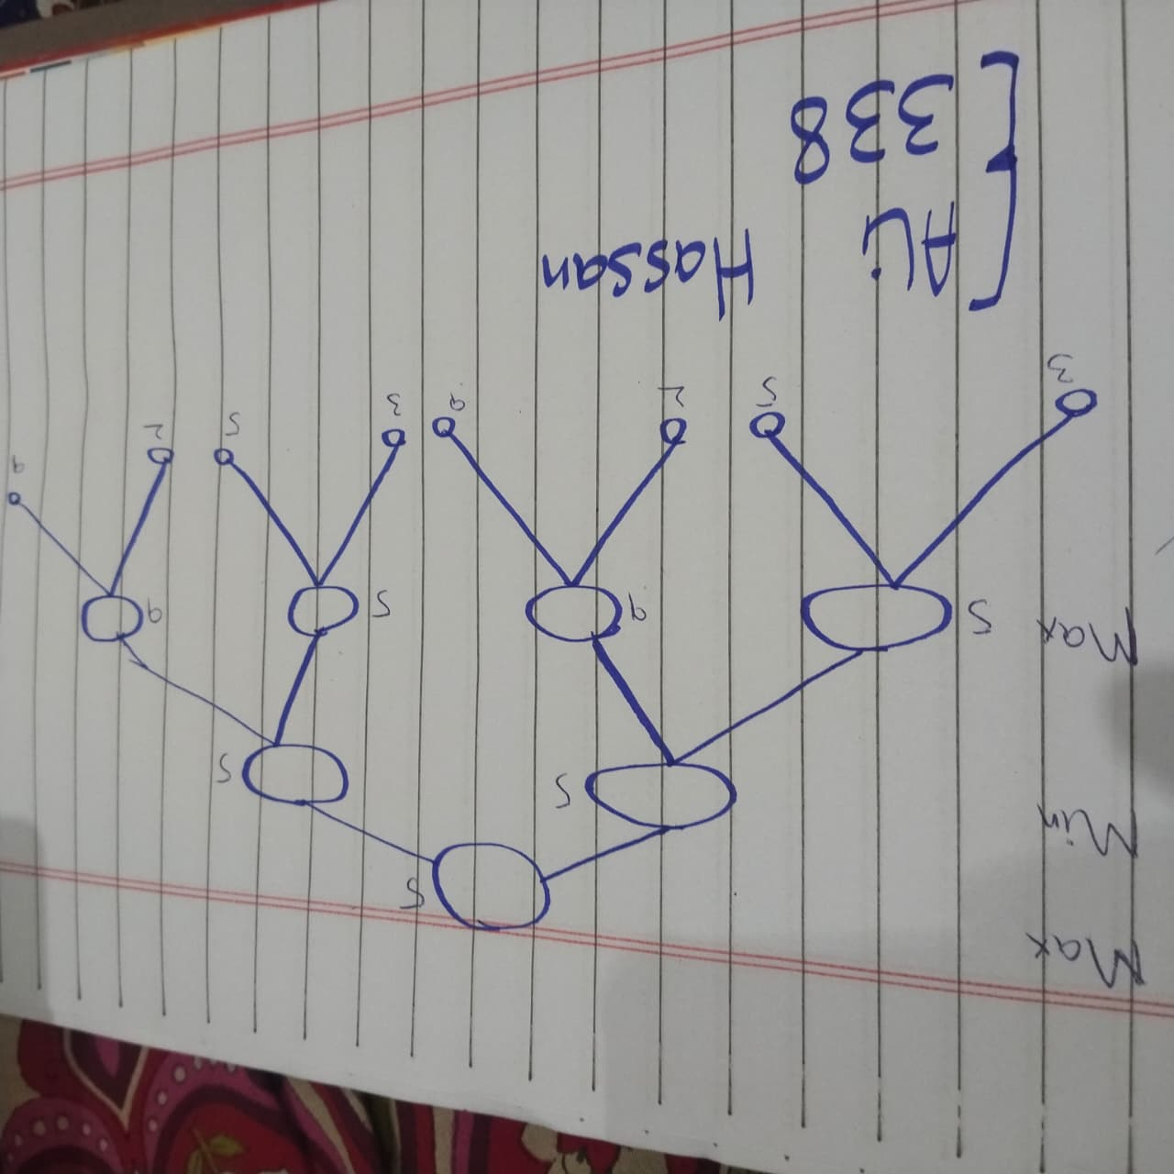

- Representation of Grapgh:
Show all the Leaves
(3,5,2,9,3,5,2,9)
Max,
I have those leaves [3,5] and [2,9] as well as 5 is result and second [3,5] and 9 is result the [2,9] both nodes.
As well as Min,
[5,9] both is 5

So, at Max point (5,5) is max 5.

Task 2 & 3

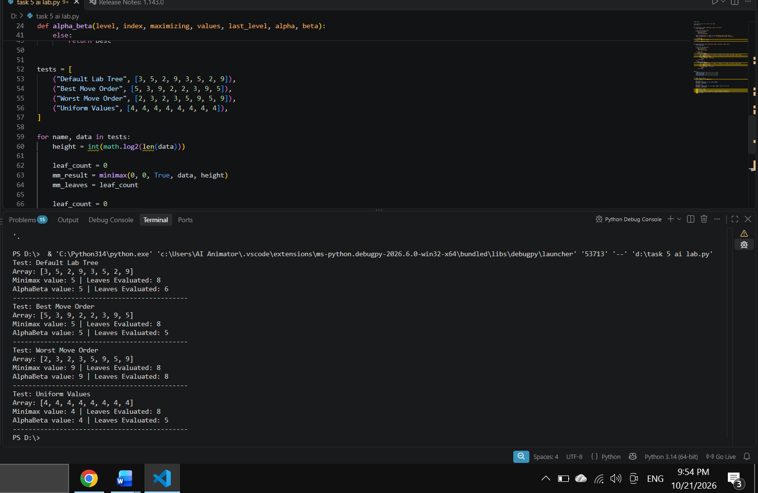

Level | Scores List | Root Values | Minimax Leaves | Alpha-Beta Leaves
Normal | [3,5,2,9,3,5,2,9] | 5 | 8 | 6
Order | [5,3,9,2,5,3,9,2] | 5 | 8 | 5
Equal (Edge Case) | [4,4,4,4,4,4,4,4] | 4 | 8 | 5
Order | [2,9,3,5,2,9,3,5] | 5 | 8 | 8

Explanation;
Minimax as well as Alpha and Beta gave a Ans every test point same. Min check is 8 leaves as well as Alpha and Beta can skip branch an Alpha >= Beta. A default both trees gave a 5 as well as Alpha and Beta check only 6 leaves.
Move Ordering;
the order Alpha and Beta check only 5 leaves Ans is 5. In other order no was prune and so it checks all 8 leaves Ans is 9.
Edge Case;
There are all leaves equal (4) and pruning starts early as well as Alpha and Beta check 5 leaves Ans 4.

Reflection;

1. What did you learn from self-study?
After run code myself and test diff. trees, I learn Min expect both players make their best moves. I understood that Alpha and Beta gives same result skip branches that not affect final answer.

2. How will you use this in a real AI system?
I use this games Chess, Tic-Tac-Toe and Connect Four. It helps computer choose best move fast avoid unncessery searching.

3. What surprised you during the experiment?
I surprise that change leaf order did not change final answer and change work Alpha and Beta do. In the order, it check 5 leaves, while in the other order, it checked all 8.

4. How will you improve your learning in the future?
I will putt the best moves first, test bigger trees see how much pruning happens. I want try this small game like Tic-Tac-Toe.

