Questiton1:

Task1:

Whoam I for displaying name

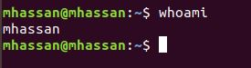

Task2:

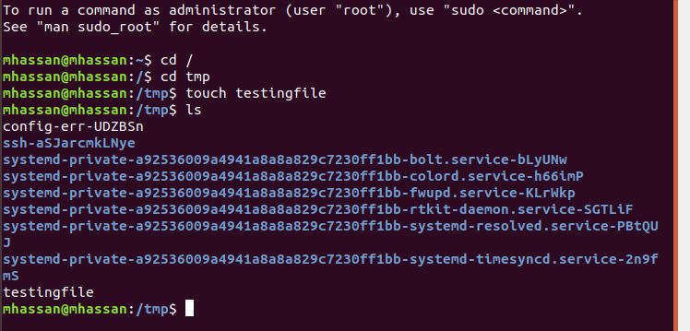

Task3:

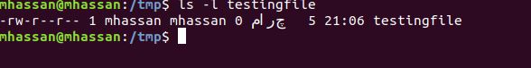

Task4:

Rmdir for deletion of empty directory while rm for non empty directory or file

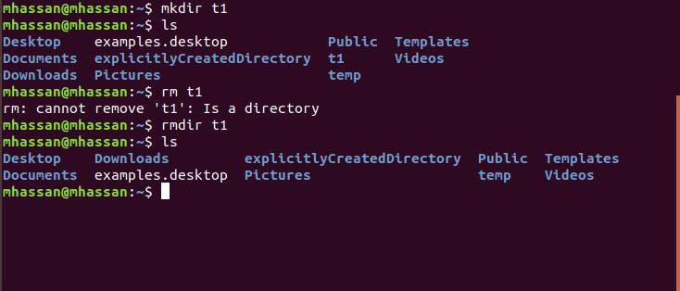

Task5:

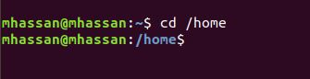

Task6:

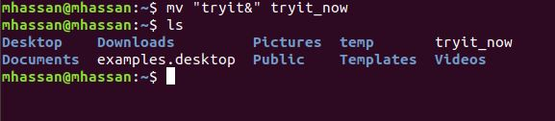

Task7:

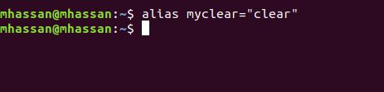

Task8a):



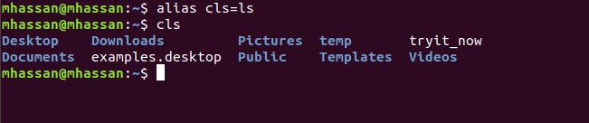

8b):

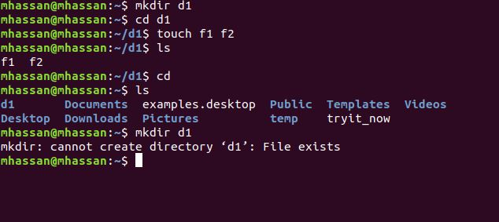

Question2:

Task1:

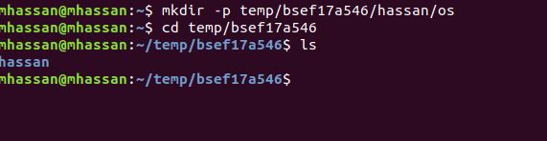

Task2:

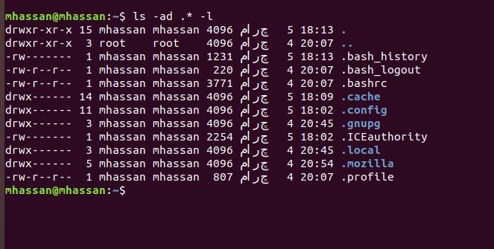

Task3:



Task4:

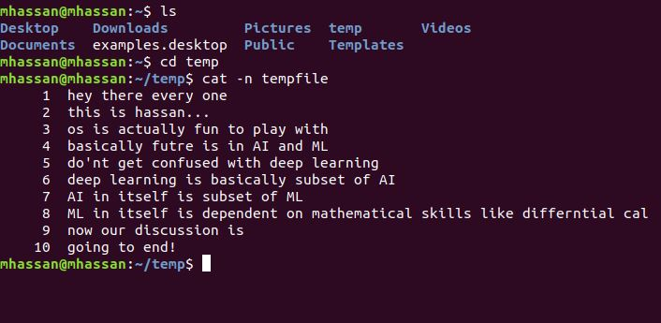

Task5:

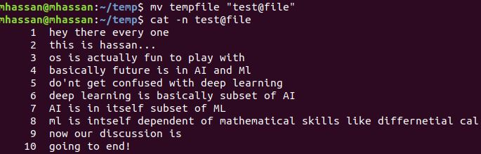

Task6:

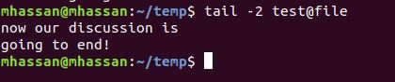

Task7:

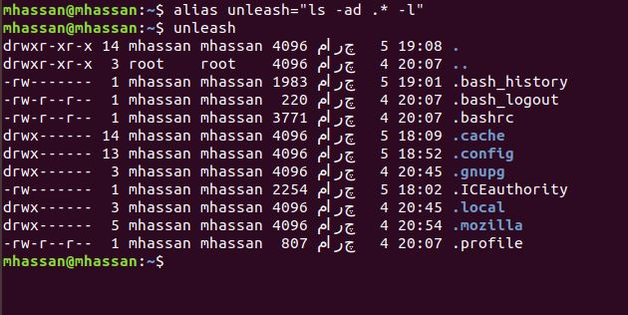

Task8:

**man** command_name is used….

Task9:

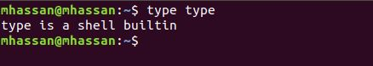

Task10:

rm -rf can be used for both directories and files (basically it is applicable for unix and linux both),however rm -r can also be used

Question3:

Task1:

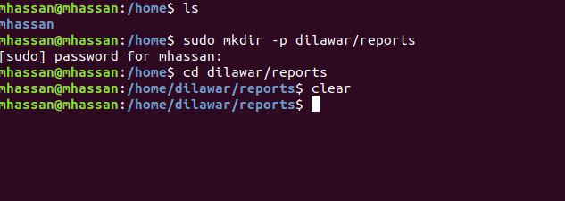

Task2:

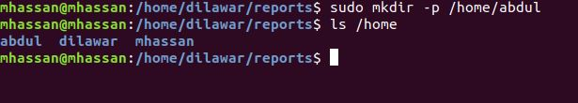

Task3:

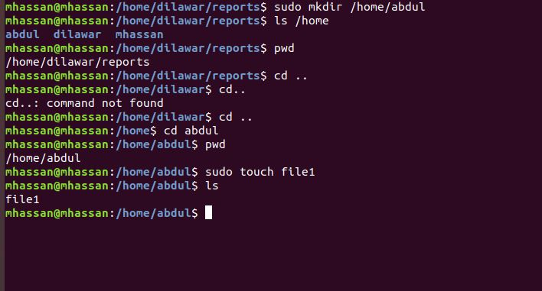

Task4:

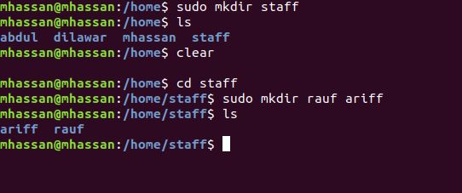

Task5:

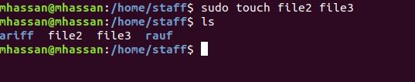

Task6:

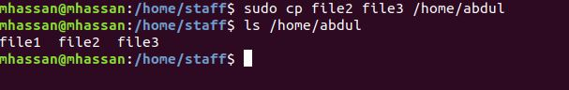

Task7:

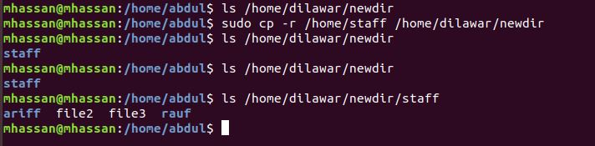

Task8:

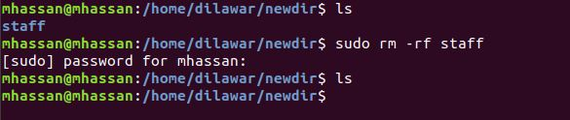

Task9:

