**Name: Ali Hassan**

**Reg No: FA21-BCS-093-A**

**Assign No: 2**

**Course: OOPs**

**Program 1**

**Solution Code:**

class Car {  
 private String brand;  
 private String model;  
 private int year;  
  
 Car() {  
 this.brand = "";  
 this.model = "";  
 this.year = 0;  
 }  
  
 Car(String b, String m, int y) {  
 brand = b;  
 model = m;  
 year = y;  
 }  
  
 // Setters  
 void setBrand(String b) {  
 brand = b;  
 }  
 void setModel(String m) {  
 model = m;  
 }  
 void setYear(int y) {  
 year = y;  
 }  
  
 // Getters  
 String getBrand() {  
 return brand;  
 }  
 String getModel() {  
 return model;  
 }  
 int getYear() {  
 return year;  
 }  
  
 // Display info  
 void info() {  
 System.*out*.println("Brand: " + brand + ", Model: " + model + ", Year: " + year);  
 }  
}

public class Main {  
 public static void main(String[] args) {  
 System.*out*.println("Main Method ...");  
  
 Car car1 = new Car();  
  
 car1.setBrand("BMW");  
 car1.setModel("M5");  
 car1.setYear(2022);  
  
 System.*out*.println("\nObject - 1");  
// using get method to display all fields  
 System.*out*.println("Printing the info using \'Get Method\'");  
 System.*out*.println("Brand: " + car1.getBrand() + ", Model: " + car1.getModel() + ", Year: " + car1.getYear());  
  
// using user-defined method info()  
 System.*out*.println("Printing the info using \'User-Defined Method\'");  
 car1.info();  
  
 Car car2 = new Car("Audi", "A6", 2024);  
 System.*out*.println("\nObject - 2");  
  
// using user-defined method info()  
 System.*out*.println("Printing the info using \'User-Defined Method\'");  
 car1.info();  
 }  
}

Output:

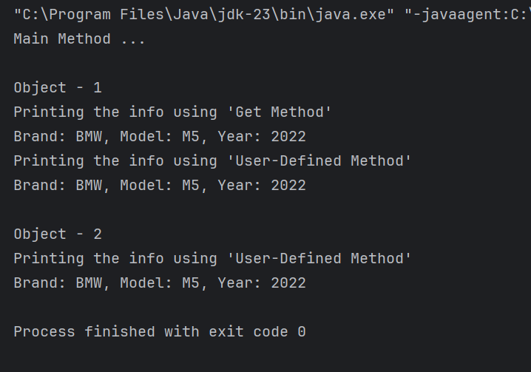

**Program 2**

**Solution Code:**

public class Person {  
 private String name;  
 private int age;  
  
 Person() {  
 name = "Default";  
 age = 0;  
 }  
  
// Setters  
 void setName(String n) {  
 name = n;  
 }  
 void setAge(int a) {  
 age = a;  
 }  
  
// Getters  
 String getName() {  
 return name;  
 }  
 int getAge() {  
 return age;  
 }  
  
 void printDetails() {  
 System.*out*.println("Name: " + name + ", age: " + age);  
 }  
}

public class Main {  
 public static void main(String[] args) {  
 System.*out*.println("Main Method ...");  
  
// Creating Person Object with Default Values  
 Person person1 = new Person();  
  
// Printing person1's details  
 person1.printDetails();  
  
// Now initialize the values using setter methods  
 person1.setName("Ali Hassan");  
 person1.setAge(22);  
  
 person1.printDetails();  
 }  
}

Output:

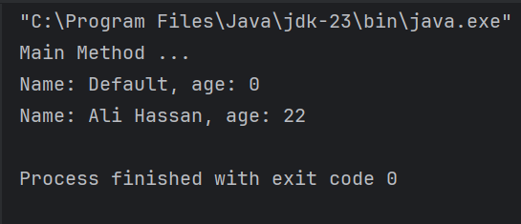

**Program 3**

Solution Code:

public class Student {  
 private String name;  
 private int rollno;  
  
// Default Constructor  
 Student() {  
 name = "Default";  
 rollno = 0;  
 }  
  
// Setters  
 void setName(String n) {  
 name = n;  
 }  
 void setRollno(int r) {  
 rollno = r;  
 }  
  
// Getters  
 String getName() {  
 return name;  
 }  
 int getRollno() {  
 return rollno;  
 }  
  
// Display info  
 void info() {  
 System.*out*.println("RollNo: " + rollno + ", Name: " + name);  
 }  
}

public class Main {  
 public static void main(String[] args) {  
 System.*out*.println("Main Method ...");  
  
// Creating Student class object  
 Student std1 = new Student();  
  
 System.*out*.println("RollNo: " + std1.getRollno() + ", Name: " + std1.getName());  
 std1.setName("Ahmad");  
 std1.setRollno(112);  
  
 System.*out*.println("RollNo: " + std1.getRollno() + ", Name: " + std1.getName());  
 }  
}

Output:

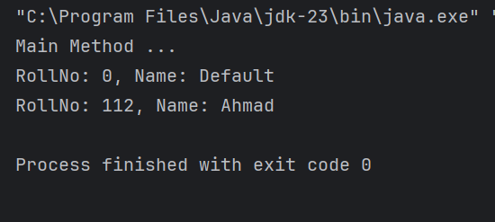

**Program 4**

Solution Code:

public class BankAccount {  
 private double balance;  
  
 BankAccount() {  
 balance = 0.0;  
 }  
  
// Setter  
 void setBalance(Double b) {  
 balance = b;  
 }  
  
// Getter  
 double getBalance() {  
 return balance;  
 }  
  
// Show balance  
 private void showBalanace() {  
 System.*out*.println("Your balance: " + balance);  
 }  
  
// Deposit money  
 void deposit(double amount) {  
 if (amount > 0) {  
 balance += amount;  
 showBalanace();  
 } else {  
 System.*out*.println("Enter a Valid Amount greater than Zero !");  
 }  
 }  
  
 void withDrawMoney(double m) {  
 if (m < balance) {  
 balance -= m;  
 showBalanace();  
 } else {  
 System.*out*.println("Enter a Valid Amount less than : " + balance);  
 }  
 }  
}

import java.util.Scanner;  
  
public class Main {  
 public static void main(String[] args) {  
 Scanner sc = new Scanner(System.*in*);  
 System.*out*.println("Main Method ...");  
  
// Creating an object  
 BankAccount account1 = new BankAccount();  
 int amount = 0, choice = 0;  
  
 do {  
 System.*out*.print("Enter Choice \n1 -> deposit Or 2 -> withdraw Or Any key -> exit: ");  
 choice = sc.nextInt();  
  
 if (choice == 1) {  
 System.*out*.print("Enter Your Deposit Amount: ");  
 amount = sc.nextInt();  
 account1.deposit(amount);  
 } else if (choice == 2) {  
 System.*out*.print("Enter Your WithDraw Amount: ");  
 amount = sc.nextInt();  
 account1.withDrawMoney(amount);  
 } else {  
 break;  
 }  
  
 } while (choice != 0);  
  
 }  
}

Output:

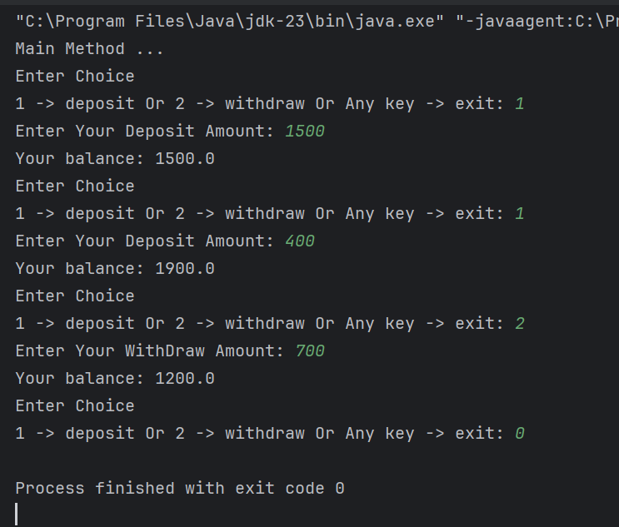

**Program 5**

Solution Code:

public class Book {  
 private String title;  
 private String author;  
 private int price;  
  
// Default Constructor  
 Book() {  
 title = "Default";  
 author = "none";  
 price = 0;  
 }  
  
// Parameterize Constructor  
 Book(String t, String a, int p) {  
 title = t;  
 author = a;  
 price = p;  
 }  
  
// Setters  
// void setTitle(String t) {  
// title = t;  
// }  
// void setAuthor (String a) {  
// author = a;  
// }  
 void setPrice(int p) {  
 price = p;  
 }  
  
// Getters  
// String getTitle() {  
// return title;  
// }  
// String getAuthor() {  
// return author;  
// }  
 int getPrice() {  
 return price;  
 }  
  
// Print Details  
 void details() {  
 System.*out*.println("Book Title: " + title + ", Author: " + author + ", Price: " + price);  
 }  
}

public class Main {  
 public static void main(String[] args) {  
 System.*out*.println("Main Method ...");  
  
// Creating an object  
 Book book1 = new Book();  
 System.*out*.println("Before initializing !");  
 book1.details();  
 book1 = new Book("Atomic Habits", "James Clear", 1200);  
 System.*out*.println("After initializing !");  
 book1.details();  
  
 book1.setPrice(1500);  
 System.*out*.println("After updating the price of book !");  
 book1.details();  
 }  
}

Output:

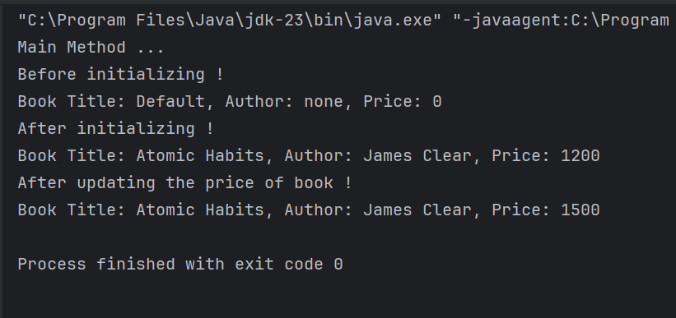

**The End**