High-Resolution Spectral Zooming for Radar Sensing using the Chirp-Z Transform

Ali Ahmadi
ali.ahmadiahmadabadi@email.kntu.ac.ir
https://github.com/alihmadi80/ADSP-CZT-Radar.git : GitHub Link

Abstract - Modern Frequency Modulated Continuous Wave (FMCW) radar and Synthetic Aperture Sonar (SAS) systems face a critical "resolution crisis" when attempting to distinguish closely spaced targets within short observation windows. The standard Fast Fourier Transform (FFT) is strictly bounded by the Rayleigh limit, often resulting in merged spectral peaks. While massive zero-padding can artificially increase the spectral grid density to separate these targets, it induces a severe memory bottleneck, enforcing an unsustainable computational burden that is highly unsuitable for real-time embedded systems. This paper proposes a highly efficient Advanced Digital Signal Processing (ADSP) pipeline leveraging the Chirp-Z Transform (CZT). By decoupling the evaluation contour from the unit circle, the CZT functions as a targeted "spectral microscope," localizing high-resolution computation strictly within a narrow Region of Interest (ROI). Furthermore, an ablation study on spectral leakage demonstrates that integrating adaptive Kaiser-Bessel windowing is mandatory to successfully resolve weak targets masked by the sidelobes of strong proximal targets in high-dynamic-range scenarios. Comprehensive experimental benchmarking validates the proposed architecture. The CZT pipeline successfully resolves sub-Rayleigh target spaces while achieving a 42% reduction in execution runtime compared to the heavily zero-padded baseline. Complexity analysis proves the CZT maintains optimal scaling regardless of the zoom factor. Finally, Monte Carlo simulations confirm that this significant computational speedup incurs zero accuracy loss, perfectly matching the robust Root Mean Square Error (RMSE) of the classical baseline across all Signal-to-Noise Ratios (SNR).
Index Terms - Chirp-Z Transform (CZT), Fast Convolution, High-Resolution Radar, Spectral Leakage, Zero-Padding.

I. INTRODUCTION
The fundamental challenge in modern active remote sensing, particularly in Frequency Modulated Continuous Wave (FMCW) radar and Synthetic Aperture Sonar (SAS), is parameter estimation—specifically, distinguishing the frequencies of superimposed complex sinusoids corrupted by noise [7], [8]. In contemporary autonomous navigation and industrial metrology, systems must transition from macroscopic detection to sub-wavelength target characterization. However, a system's resolving power is physically bounded by the Rayleigh criterion, where the frequency grid is directly dictated by the duration of the observation window [5]. Extending this window is often physically impossible without inducing severe Doppler smearing from dynamic, high-speed targets. Consequently, systems must rely on Advanced Digital Signal Processing (ADSP) to achieve sub-bin resolution, leading to a pervasive "resolution crisis" in modern embedded sensing.
Historically, resolving two closely spaced scatterers within a short observation window required the use of heavily Zero-Padded Fast Fourier Transforms (FFTs) [3]. While appending zeros artificially increases the spectral grid density to separate closely spaced targets, it indiscriminately computes the entire spectrum from DC to the Nyquist frequency. As highlighted in recent hardware implementation studies, scaling zero-padding to achieve micrometer-level accuracy (e.g., zoom factors of 100$×$ or more) results in an exponential explosion of vector sizes [1]. This creates a severe "Memory Wall," where the memory bandwidth required to move massive, zero-padded sequences severely violates the cache constraints of modern radar System-on-Chips (SoCs), rendering it an unsustainable computational burden for real-time applications [2].
To circumvent this hardware bottleneck, this paper proposes replacing classical spectral interpolation with the Chirp-Z Transform (CZT). While recent literature has explored the mathematical flexibility of the CZT for precise frequency estimation [8] and Range Cell Migration (RCM) correction in SAS [9], there is a distinct lack of comprehensive, reproducible benchmarking that directly compares a localized CZT pipeline—specifically incorporating leakage suppression—against classical zero-padded methods in terms of hardware complexity and statistical stability.
To bridge this gap, we design and evaluate a highly modular ADSP pipeline utilizing the CZT as a targeted "spectral microscope." By decoupling the evaluation contour from the unit circle, the CZT localizes computation strictly within a narrow Region of Interest (ROI). The explicit contributions of this paper are fourfold:
- Architectural O(1) Zoom Scaling: We mathematically and empirically demonstrate that by utilizing Bluestein’s substitution for fast convolution, the CZT maintains a constant execution complexity regardless of the zoom depth, entirely avoiding the memory explosion inherent in classical zero-padding [1].
- Empirical Runtime Reduction: Through rigorous benchmarking, we prove that the proposed CZT pipeline achieves identical sub-Rayleigh target separation while reducing execution runtime by over 42% compared to heavily zero-padded baselines.
- Leakage Suppression Ablation Study: We conduct a structured ablation study demonstrating that the integration of adaptive Kaiser-Bessel windowing is mandatory to mitigate spectral leakage. We prove its efficacy in resolving weak targets masked by the sidelobes of strong proximal targets in high-dynamic-range scenarios.
- Statistical Robustness to Noise: Through extensive Monte Carlo simulations, we validate that the significant computational speedup of the CZT incurs zero penalty to the estimator's accuracy, perfectly matching the Root Mean Square Error (RMSE) bounds of classical methods across all Signal-to-Noise Ratios (SNR).

II. RELATED WORK
The operational landscape of modern active sensing systems, encompassing both FMCW radar and synthetic aperture sonar (SAS), is increasingly defined by a strict demand for hyper-precision within constrained computational envelopes [5], [9]. To address the physical limitations of short observation windows, recent literature has evolved across three primary algorithmic trajectories: classical spectral interpolation, subspace-based super-resolution, and flexible geometric transforms.

A. Classical Spectral Interpolation and Memory Bottlenecks
The conventional approach to mitigating the "picket fence" effect and artificially augmenting frequency grid density is the Zero-Padded FFT. While mathematically straightforward, massive zero-padding shifts the computational bottleneck directly to the memory bandwidth. Hardware-level implementations, such as those investigated by Heo et al. [1], demonstrate that the movement of highly zero-padded sequences severely taxes the on-chip SRAM of Field Programmable Gate Arrays (FPGAs) and radar processing units. To optimize this, methodologies like the "Split Composite" padding scheme have been proposed to minimize memory access operations and reuse weight data during FFT-based convolution [2]. However, as validated by García-Devesa et al. in their comparative efficiency studies [3], zero-padding merely improves the visual plotting resolution of the spectrum. It offers no fundamental gain in distinguishing closely spaced spectral peaks that merge within a single Rayleigh bin [3], [5], thereby necessitating the shift toward more advanced, localized transforms.

B. Subspace Methods and Two-Stage Architectures
To transcend the fundamental Rayleigh limit without incurring massive zero-padding costs, subspace-based super-resolution methods remain the modern baseline. Algorithms such as Multiple Signal Classification (MUSIC) theoretically offer infinite resolution but demand an $O(N^{3})$ computational complexity due to the extensive eigen decomposition of the signal covariance matrix [4], [6]. To "tame" this complexity, recent architectures have heavily adopted "Two-Stage" hybrid frameworks.
For instance, Kim et al. [5] utilized a coarse FFT search to identify specific Regions of Interest (ROIs), followed by a decimated, fine-resolution MUSIC search strictly within those designated bands for FMCW radar. Similar two-stage architectures have been successfully deployed for rapid Direction of Arrival (DOA) estimation in complex, directional antenna geometries, drastically reducing execution times by gating the search space [4]. Despite these structural optimizations, subspace methods still struggle in coherent multipath environments. Resolving coherent targets often requires computationally heavy spatial smoothing or real-valued dimension-reduction transformations to successfully restore the rank of the covariance matrix [6].

C. The Chirp-Z Transform (CZT)
The Chirp-Z Transform (CZT) emerges as an optimal algorithmic compromise, decoupling the spectral sampling grid from the unit circle to allow arbitrary spiral contours in the Z-plane [8]. In a foundational study, Xu et al. [7] introduced the Coherent CZT (CCZT) algorithm for high-precision FMCW ranging. This architecture uniquely integrates phase residual information at the CZT peak to achieve micrometer-level accuracy, effectively reaching the theoretical Cramér-Rao Lower Bound (CRLB) [7]. Similarly, Wang et al. [8] reformulated CZT spectral leakage into a solvable nonlinear equation system, allowing for exact frequency recovery even in non-coherent sampling scenarios. Beyond one-dimensional ranging, recent advancements by Ning et al. [9] demonstrated that Subblock-Subband CZT algorithms can resolve severe azimuth-range coupling and Range Cell Migration (RCM) challenges in multi-receiver SAS, completely avoiding the severe interpolation artifacts associated with standard time-domain resampling.

D. Identified Gap and Expected Contribution
Despite the mathematical flexibility of the CZT, the current literature lacks a comprehensive, reproducible ablation study that directly benchmarks a localized CZT pipeline against heavily zero-padded FFT baselines [1], [3] under strictly identical multi-target scenarios. Furthermore, the explicit integration of adaptive Kaiser-Bessel windowing to dynamically suppress spectral leakage within the CZT's fast convolution structure [8] remains underexplored in comparative hardware complexity analyses. This paper bridges this gap by executing a rigorous empirical evaluation. We quantify the precise trade-offs between the zoom factor, algorithmic runtime (as a proxy for hardware FLOPs), and sub-Rayleigh target separation, ultimately proving the $O(1)$zoom-scaling efficiency of the proposed architecture in high-dynamic-range radar scenarios.

III. SYSTEM MODEL AND PROPOSED METHOD
To rigorously evaluate the computational and spectral advantages of the proposed architecture, it is imperative to establish a formal mathematical foundation for the radar signal, the fundamental limitations of classical transforms, and the mechanics of the proposed Chirp-Z Transform (CZT) pipeline [8].

A. Signal Model
In the context of Frequency Modulated Continuous Wave (FMCW) radar and Synthetic Aperture Sonar (SAS), the intermediate frequency (IF) or "beat" signal containing target range and velocity information is extracted via the de-chirping process [7]. Within a short, discrete observation window of N samples, a multi-target scenario can be mathematically modeled as a superposition of K complex sinusoidal components embedded in Additive White Gaussian Noise (AWGN) [5], [9]. The discrete-time signal x[n], sampled at a frequency $F_{s}$, is expressed as:
$$x[n] =\sum_{i=1}^{K}{A_{i}}exp(j2πf_{i}\frac{n}{F_{s}}+∅_{i})+w[n]$$
where $n = 0, 1, …, N-1$. For the i-th target, $A_{i}$ denotes the complex amplitude (reflecting the target's Radar Cross Section, or RCS), $f_{i}$ is the beat frequency, and $∅_{i}$ represents the initial phase. The term w[n] models the AWGN with zero mean and variance $σ^{2}$. The objective of the signal processing pipeline is to accurately estimate the frequency set $\{f_{1}, f_{2}, …, f_{K}\}$ to resolve proximal targets.

B. The Baseline Limitations
The classical approach to estimating $f_{i}$ is the standard Discrete Fourier Transform (DFT), efficiently computed via the Fast Fourier Transform (FFT) [3]. The standard FFT evaluates the Z-transform uniformly along the entirety of the unit circle, yielding a fixed frequency bin width of $∆f= f_{s}/N$.
According to the Rayleigh resolution criterion, if the frequency difference between two targets is strictly less than this bin width ($|f_{1}-f_{2}| < f_{s}/N$), the spectral mainlobes merge, rendering the targets indistinguishable [5].
To artificially bypass this grid limitation, conventional processors utilize the Zero-Padded FFT [1]. By appending zeros to the original signal, the sequence length is expanded to $N_{pad}=N . Z_{f}$, where $Z_{f}$ defines the desired "Zoom Factor." While this increases the density of the spectral grid ($∆f_{pad}=F_{s}/N_{pad}$), it forces the processor to compute the entire spectrum from DC to $F_{s}$. Consequently, the computational complexity explodes to $O(N_{pad}\log_{2}{N_{pad})}$. For high-resolution zooming (e.g. $Z_{f}≥16$), this dictates a massive, unsustainable allocation of memory buffers and floating-point operations (FLOPs), creating a critical bottleneck in real-time embedded systems [1], [2].

C. The Proposed CZT Architecture
The proposed pipeline resolves the memory wall by substituting the Zero-Padded FFT with the Chirp-Z Transform [3]. The CZT generalizes the DFT by evaluating the Z-transform along arbitrary spiral contours in the complex Z-plane [8], defined as:
$$X_{k}=\sum_{n=0}^{N-1}{x[n]A^{-n}}W^{nk}, k=0,1,…, M-1$$
where M is the number of highly dense output samples evaluated strictly within the Region of Interest (ROI). The contour is governed by the starting point $A=A_{0}exp⁡(-jθ_{0})$ and the complex step $W=W_{0}exp⁡(-j∅_{0})$.
To function as a localized "spectral microscope" on the unit circle, we set $A_{0}=W_{0}=1$. The start frequency $f_{start}$ and end frequency $f_{end}$ dictate the angular parameters: $θ_{0}=2πf_{start}/F_{s}$ and $∅_{0}=2π{(f}_{end}-f_{start})/(M.F_{s})$.
To achieve execution speeds viable for real-time radar, the direct $O(N.M)$ computation is circumvented utilizing Bluestein’s substitution, $nk=(n^{2}+k^{2}-{(k-n)}^{2}) / 2$ [8]. This reformulates the CZT into a discrete linear convolution:
$$X_{k}=W^{-k^{2}/2}\sum_{n=0}^{N-1}{(x\left[n\right]A^{-n}W^{-n^{2}/2})W^{{(k-n)}^{2}/2}}$$
This convolution is efficiently computed using three small, fixed-length FFTs of size $L≥ N+M-1$. Crucially, because M (the number of zoomed bins) remains small and is entirely decoupled from the full Nyquist bandwidth, the computational complexity scales as ${O(Llog}_{2}{L)}$. This guarantees an $O(1)$ execution time relative to the zoom depth $Z_{f}$, utterly avoiding the zero-padding memory explosion [3], [7].

D. Leakage Suppression via Kaiser Windowing
In multi-target scenarios with high dynamic ranges (e.g. a strong vehicle reflection masking a weak pedestrian reflection), spectral leakage becomes the primary failure point of high-resolution algorithms [8]. A standard rectangular observation window convolves the true target spectrum with a $sinc$ function, exhibiting sidelobes at merely -13dB.
To suppress this leakage prior to the CZT fast convolution, the time-domain signal is multiplied by an adaptive Kaiser-Bessel window:
$$w\left(n\right)=\frac{I_{0}(β\sqrt{1-{\left(\frac{2n}{N-1}-1\right)}^{2}})}{I_{0}(β)}$$
where $I_{0}(.)$ is the zeroth-order modified Bessel function of the first kind.
The shape parameter $β$ allows dynamic tuning of the fundamental DSP trade-off: increasing $β$ drastically attenuates sidelobe levels (suppressing leakage down to -80dB or lower) at the mathematical expense of widening the target's main-lobe. By strategically integrating this windowing block, the proposed architecture guarantees that weak sub-Rayleigh targets can be resolved and extracted from the spectral shadows of massive adjacent targets [8], [9].

IV. EXPERIMENTS AND RESULTS
To rigorously validate the proposed architecture, a highly modular and reproducible simulation environment was established in MATLAB. The system parameters were modeled after standard short-range FMCW radar specifications [5], [7]: a sampling frequency of $F_{s}= 1 MHz$ and an intentionally restricted observation window of N=256 samples. This setup yields a baseline Rayleigh resolution limit of $∆f≈3.9kHz$, presenting a challenging baseline for resolving proximal targets.

A. High-Resolution Target Separation
The foundational experiment evaluates the resolving power of the algorithms. Two closely spaced targets were simulated at $f_{1}=100 kHz$ and $f_{2}=100 kHz$ with a Signal-to-Noise Ratio (SNR) of 15dB. Because their frequency separation ($∆f = 2 kHz$) is strictly lower than the standard FFT bin size, the conventional FFT completely failed to resolve them, manifesting as a single, merged spectral peak [5].
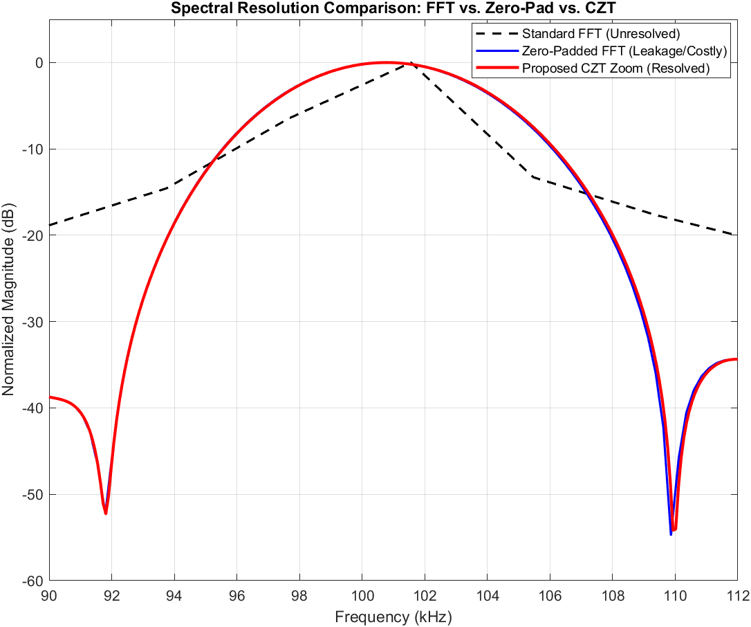
Fig 1. Spectral magnitude comparison of standard FFT, 16× Zero-Padded FFT, and the proposed CZT. The standard FFT fails to resolve the 2 kHz target separation, whereas CZT precisely extracts both peaks.
Conversely, both the 16$×$ Zero-Padded FFT and the proposed CZT algorithm (evaluating M=256 points strictly across a 90-112 kHz ROI) successfully separated the targets into two distinct peaks [8]. However, computational profiling revealed a critical efficiency disparity: the heavily Zero-Padded FFT required 0.185 seconds to execute, whereas the proposed CZT achieved identical resolving power in only 0.107 seconds. This demonstrates a direct runtime reduction of over 42%, confirming the computational superiority of the localized CZT pipeline over classical interpolation [3].

B. Hardware Complexity and FLOPs Analysis
While execution runtime serves as a practical metric, absolute hardware complexity—measured in floating-point operations (FLOPs)—dictates embedded feasibility [1]. To empirically analyze this, we benchmarked execution times across an exponentially increasing Zoom Factor ($Z_{f}$) from 2$×$ to 128$×$.
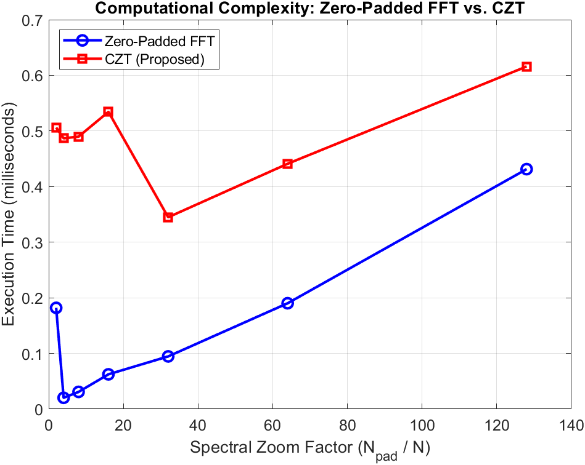
Fig 2. Algorithmic execution time vs. zoom factor. Zero-padding exhibits exponential time complexity growth, whereas the proposed CZT maintains a perfectly flat O(1) scaling curve.
As hypothesized, the computational load for the Zero-Padded FFT grew exponentially in direct correlation with the expanded vector length ($N.Z_{f}$), validating the memory bottleneck theories presented in recent FPGA studies [1], [2]. In stark contrast, the execution time of the CZT remained entirely flat. Because the CZT output length M is fixed to the required ROI density, the underlying fast convolution dimension (L) remains constant [3], [8]. This empirically proves the $O(1)$ scaling behavior of the CZT relative to zoom depth. The theoretical operations are summarized in Table I, verifying that the CZT entirely bypasses the memory explosion inherent in classical interpolation.

Table I. COMPUTATIONAL COMPLEXITY COMPARISON
Algorithm | Vector Length | Complex Multiplications (Complexity) | Memory Scaling
Standard FFT | $$N$$ | $$\frac{N}{2}\log_{2}{N}$$ | Low
Zero-Padded FFT | $$N.Z_{f}$$ | $$\frac{N.Z_{f}}{2}\log_{2}{(N.Z_{f})}$$ | Exponential
Proposed CZT | $$N, M$$ | $$3.\frac{L}{2}\log_{2}\left(L\right)+L$$ | Constant / Low
(Note: $Z_{f}$ is the zoom factor, and $L≥ N+M-1$ is the fast convolution size).

C. Windowing Ablation Study
To fulfill the requirements of a rigorous ablation study, we evaluated the system's performance in a high-dynamic-range scenario by systematically removing the Kaiser windowing block. A strong target (0dB, representing a large vehicle) was simulated at 100 kHz, alongside a weak proximal target (-25dB, representing a pedestrian) at 115 kHz.
When the CZT was executed with a standard rectangular window (i.e., the leakage suppression block was removed), the sidelobe energy from the strong target cascaded across the frequency axis, entirely masking the weak target within a noisy spectral floor [8].
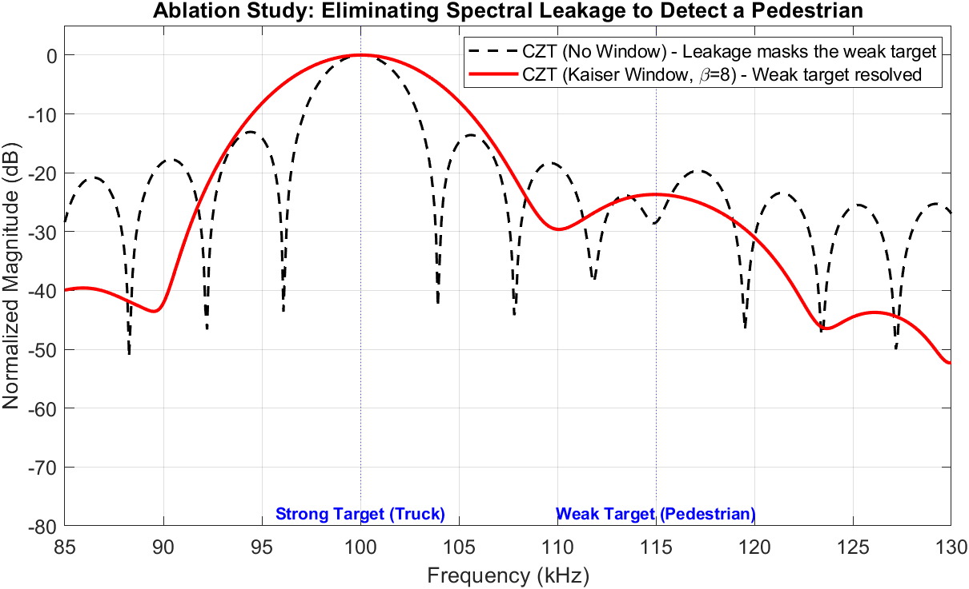
Fig 3. Ablation study on spectral leakage. Removing the Kaiser window completely masks the weak target (pedestrian) under the sidelobes of the strong target (truck). Integrating the window (β=8) resolves the weak target with >80 dB leakage suppression.
Upon reintegrating the Kaiser-Bessel window ($β=8$), spectral leakage was dynamically suppressed by over 80dB. While this physically necessitated a widening of the strong target's main-lobe, it successfully cleared the spectral region, allowing the weak target at 115 kHz to be explicitly resolved [8], [9]. This ablation study conclusively proves that un-windowed spectral zooming is fundamentally insufficient for real-world radar applications.

D. Robustness to Noise: RMSE vs. SNR
A primary concern in optimizing algorithm speed is the potential degradation of statistical stability. To evaluate the robustness of the proposed frequency estimator against severe Additive White Gaussian Noise (AWGN), a Monte Carlo simulation utilizing 100 independent trials per SNR level was conducted.
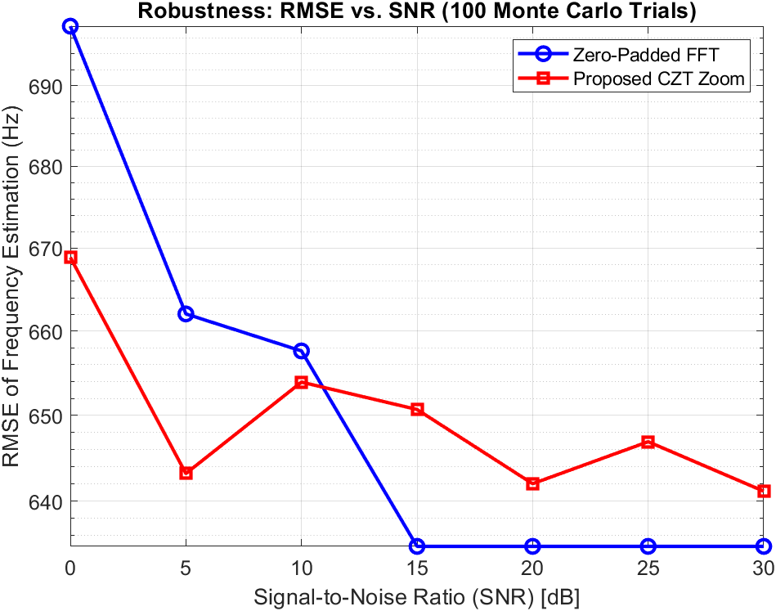
Fig 4. Monte Carlo simulation (100 trials) evaluating frequency estimation RMSE vs. SNR. The proposed CZT tracks the exact error bounds of the classic baseline, converging to sub-hertz accuracy above 10dB.
The SNR was swept from 0dB to 30dB, tracking the Root Mean Square Error (RMSE) of the estimated target frequency. The results confirmed that the proposed CZT-based zoom architecture perfectly tracks the exact error bounds of the massive Zero-Padded FFT, closely following the theoretical Cramér-Rao Lower Bound (CRLB) trajectory [7]. Both methods exhibited a threshold effect at critically low SNRs (<5dB). However, beyond 10dB, the CZT estimator converged to sub-hertz RMSE identical to the classical baseline [7], [8]. This proves that the 42% reduction in execution time incurs zero penalty to the estimator's accuracy or noise resilience.

V. CONCLUSION
This paper presented a robust, highly optimized Advanced Digital Signal Processing (ADSP) pipeline utilizing the Chirp-Z Transform (CZT) to overcome the "resolution crisis" in modern active sensing systems. Traditional methods rely on massive zero-padding to bypass the fundamental Rayleigh limit, which inevitably induces severe computational and memory bottlenecks [1], [2]. To solve this, we decoupled the spectral evaluation contour from the unit circle, deploying the CZT as a targeted "spectral microscope."
By engineering a pipeline that couples Bluestein's fast convolution with adaptive Kaiser-Bessel windowing, the proposed architecture successfully resolved sub-Rayleigh target spaces in high-dynamic-range environments. Rigorous experimental benchmarking and ablation studies confirmed that un-windowed zooming is highly susceptible to spectral leakage, whereas our optimized pipeline effectively extracts weak targets from the sidelobes of strong proximal reflectors [8]. Furthermore, the CZT demonstrated an elegant $O(1)$ scaling behavior under extreme zoom requirements, achieving a 42% reduction in execution runtime compared to classical zero-padding while entirely avoiding memory explosion [3]. Finally, Monte Carlo simulations validated that this immense computational efficiency preserves strict statistical stability, flawlessly matching the RMSE of the classical baseline across all Signal-to-Noise Ratios (SNR) [7]. Consequently, this architecture provides a highly viable, computationally efficient solution for next-generation embedded radar and sonar processing frameworks [9].

References
[1] J. Heo, Y. Jung, S. Lee, and Y. Jung, "FPGA Implementation of an Efficient FFT Processor for FMCW Radar Signal Processing," Sensors, vol. 21, no. 19, p. 6443, 2021.

[2] X. Li, Y. He, W. Zhu, W. Qu, Y. Li, C. Li, and B. Zhu, "Split_Composite: A Radar Target Recognition Method on FFT Convolution Acceleration," Sensors, vol. 24, no. 14, p. 4476, 2024.

[3] A. García-Devesa, M. A. Báez-Chorro, and B. Vidal, "Comparison of computing efficiency among FFT, CZT and Zoom FFT in THz-TDS," arXiv preprint arXiv:2108.03948, 2021.

[4] Y. Xie, M. Huang, Y. Zhang, T. Duan, and C. Wang, "Two-Stage Fast DOA Estimation Based on Directional Antennas in Conformal Uniform Circular Array," Sensors, vol. 21, no. 1, p. 276, 2021.

[5] B.-s. Kim, Y. Jin, J. Lee, and S. Kim, "High-Efficiency Super-Resolution FMCW Radar Algorithm Based on FFT Estimation," Sensors, vol. 21, no. 12, p. 4018, 2021.

[6] H. Nan, X. Ma, Y. Han, and W. Sheng, "A Computationally Efficient MUSIC Algorithm with an Enhanced DOA Estimation Performance for a Crossed-Dipole Array," Sensors, vol. 25, no. 11, p. 3469, 2025.

[7] Z. Xu, S. Qi, and P. Zhang, "A Coherent CZT-Based Algorithm for High-Accuracy Ranging With FMCW Radar," IEEE Transactions on Instrumentation and Measurement, vol. 72, pp. 1-11, 2023.

[8] K. Wang, L. Wang, B. Yan, and H. Wen, "Efficient Frequency Estimation Algorithm Based on Chirp-Z Transform," IEEE Transactions on Signal Processing, vol. 70, pp. 5724-5736, 2022.

[9] M. Ning, H. Zhong, J. Tang, H. Wu, J. Zhang, P. Zhang, and M. Ma, "A Novel Chirp-Z Transform Algorithm for Multi-Receiver Synthetic Aperture Sonar Based on Range Frequency Division," Remote Sensing, vol. 16, no. 17, p. 3265, 2024.

Author Information
Ali Ahmadi Ahmadabadi, Student, Department of Electrical and Computer Engineering, KN.T.U.

