RIGA TECHNICAL UNIVERSITY
Faculty of Computer Science, Information Technology and Energy
Alīna Žogota-Kiliča

Student of Academic Master (Second Cycle) Study Programme “Digital Humanities”, student ID 241RHM001

“IMPROVING AN ACADEMIC INFORMATION SYSTEM THROUGH COGNITIVE LOAD PRINCIPLES AND USER-CENTERED INFORMATION ARCHITECTURE: A CASE STUDY OF LUIS”

MASTER THESIS

Scientific adviser RTU FCSITE docent
Ilze Andersone

Riga 2026
RIGA TECHNICAL UNIVERSITY
FACULTY OF COMPUTER SCIENCE, INFORMATION TECHNOLOGY AND ENERGY

Work Performance and Assessment Sheet of the Master thesis “Improving an Academic Information System through Cognitive Load Principles and User-Centered Information Architecture: A Case Study of LUIS”

The author of the graduation thesis
Student Alīna Žogota-Kiliča_________________________________________________
(signature, date)

The graduation thesis has been approved for the defense
Scientific adviser
Scientific adviser RTU FCSITE docent, Ilze Andersone___________________________
(signature, date)
Declaration of Academic Integrity

I declare that this work is my own and does not contain any unacknowledged work from any source.

Signature__________________

Date______________________
ABSTRACT
Keywords: cognitive load, usability, information architecture, academic systems, user-centered design
This master’s thesis “Improving an Academic Information System through Cognitive Load Principles and User-Centered Information Architecture: A Case Study of LUIS” examines how cognitive load theory and information architecture principles can improve the usability of academic information systems in Latvia. The study focuses on how workflow structure, navigation, and interface clarity affect user mental effort and task performance.
The research follows a structured analytical pipeline that integrates quantitative usability data from 92 LUIS users with natural language processing methods applied to open-text feedback. The analysis distinguishes between intrinsic task difficulty and extraneous interface-related effort to identify the main sources of usability problems. The results show that most user difficulties are caused not by task complexity but by unclear terminology, fragmented navigation, hidden interface elements, and delayed system feedback.
Based on these findings, the thesis selects two high-impact workflows for redesigning and develops redesigned solutions for both student and administrative use cases. These workflows are tested with interactive prototypes on 51 LUIS users. The evaluation shows improved clarity, reduced perceived mental effort, and more efficient workflow completion compared to the current LUIS version.
The thesis contributes a replicable methodological framework for analyzing and redesigning academic information systems and provides practical information-architecture recommendations for future national study-process platforms in Latvia.
The total volume of the thesis is 95 pages, including 29 figures, 7 tables, 5 appendices, and 43 sources.
ANOTĀCIJA
Atslēgvārdi: kognitīvā slodze, lietojamība, informācijas arhitektūra, akadēmiskās sistēmas, lietotājcentrēts dizains
Šis maģistra darbs “Akadēmiskās informācijas sistēmas uzlabošana, izmantojot kognitīvās slodzes principus un lietotājcentrētu informācijas arhitektūru: LUIS gadījuma izpēte” analizē, kā kognitīvās slodzes un informācijas arhitektūras principi var tikt izmantoti akadēmisko informācijas sistēmu lietojamības uzlabošanai Latvijā. Pētījumā aplūkots, kā lietotāji uztver uzdevumu grūtību, kā saskarnes struktūra ietekmē mentālo piepūli un kā šos secinājumus var izmantot praktiskā darba plūsmu pārveidē.
Pētījumā izmantota strukturēta analītiskā pieeja, kas apvieno kvantitatīvus lietojamības datus no 92 LUIS lietotājiem ar dabiskās valodas apstrādes metodēm brīvo komentāru analīzei. Šī pieeja ļauj identificēt prioritārās darba plūsmas, galvenos saskarnes radītās slodzes avotus un biežākās lietojamības problēmas dažādās lietotāju grupās.
Rezultāti rāda, ka galvenās problēmas rodas no navigācijas struktūras, neskaidras terminoloģijas, slēptiem saskarnes elementiem un fragmentētām vairāku soļu darba plūsmām, nevis no pašu uzdevumu sarežģītības. Balstoties uz šiem secinājumiem, tika izstrādāti uzlaboti dizaina risinājumi prioritārajām studentu un administratoru darba plūsmām un pārbaudīti prototipu testēšanā ar 51 LUIS lietotāju. Testēšanas rezultāti uzrāda augstāku skaidrību, mazāku mentālo piepūli un labāku lietošanas ērtumu salīdzinājumā ar esošo LUIS versiju.
Darbs piedāvā atkārtojamu metodoloģisku ietvaru akadēmisko sistēmu darba plūsmu analīzei un uzlabošanai, kā arī sniedz praktiskus ieteikumus nākotnes nacionālo platformu attīstībai.
Darba kopējais apjoms ir 95 lappuses, tajā iekļauti 29 attēli, 7 tabulas, 5 pielikumi un 43 izmantotie avoti.
ABBREVIATIONS USED IN THE THESIS
AI - Artificial Intelligence
ANN - Artificial Neural Network
CLT - Cognitive Load Theory
DH - Digital Humanities
IA - Information Architecture
IZM – The Ministry of Education and Science
LLM - Large Language Model
Low-Fi - Low Fidelity
LUIS - Latvian Academic Information System
MLA - Machine Learning Algorithm
UI - User Interface
UX - User Experience
VARAM - The Ministry for Environmental Protection and Regional Development
VIIS - State Education Information System
TABLE OF CONTENTS
INTRODUCTION 9
1. Theoretical Framework and Context 13
1.1. Digital Humanities and Academic Information Systems 13
1.2. Cognitive Load Theory for Digital Workflows 14
1.2.1. Intrinsic and Extraneous Load 16
1.2.2. Split-Attention Effect on Interface Design 17
1.3. User-Centered Design and Information Architecture 18
1.4. Big Data Concepts and NLP Methods 20
1.5. National Education Digitalization Policies 21
1.6. Academic Information Systems in Latvia 25
1.6.1. LUIS as a Case Study 26
1.6.2. Gaps in Existing Research 26
1.7. Integrated Framework for This Thesis 27
Chapter Summary 28
2. Analytical FRAMEWORK and Methods 29
2.1. Research Methods 29
2.2. Methodological Pipeline for Academic System Redesign 30
2.3. Data Collection and Sampling 32
2.4. Tools Used for Data Collection, Analysis, and Prototyping 34
2.5. Data Preparation 36
2.5.1. Quantitative Analysis Methods 37
2.5.2. NLP Based Analysis Methods 37
2.6. Linking Findings to Cognitive Load and Information Architecture 39
Chapter Summary 40
3. PRACTICAL PART 1: analytical groundwork results 41
3.1. Statistical Data Processing Results 41
3.2. NLP Analysis Results 49
3.3. Summary of Analytical Findings 57
3.4. Workflow Selection for Practical Part 58
Chapter Summary 58
4. Practical Part 2: User Experience Case Study 60
4.1. Design Principles Derived from Analysis 60
4.2. Selected Workflows & Existing Problems 61
4.3. Redesign Strategy 67
4.4. Low-Fidelity Wireframes 74
4.4.1. Low-Fidelity: Mobile Course Registration 74
4.4.2. Low-Fidelity: Desktop Course Registration 76
4.4.3. Low-Fidelity: Grade Entry (Admin) 76
4.5. Prototype Development and Testing 77
4.6. Prototype Testing Results 79
4.7. User Interface Design Style Guide 84
4.8. Future Work 89
Chapter Summary 90
DISCUSSION 91
CONCLUSION 93
LIST OF REFERENCES 96
APPENDICES 101

INTRODUCTION
This master’s thesis, “Improving an Academic Information System through Cognitive Load Principles and User-Centered Information Architecture: A Case Study of LUIS,” examines how usability problems in Latvian academic information systems can be reduced by improving information structure and lowering unnecessary cognitive effort. The Latvian Academic Information System (LUIS) is one of the main platforms used by higher education institutions for enrollment, course registration, grade tracking, and reporting. Although it supports daily academic and administrative tasks, users often report issues with navigation, unclear terminology, slow feedback, and visual inconsistency. These problems reduce productivity and cause frustration. As higher education becomes increasingly digital, the usability of these systems becomes an important topic.
For Digital Humanities research, this work illustrates how user-generated data and interface analysis can support evidence-based critique of digital public systems.
In Latvia, academic data is managed across several separate platforms, including the State Education Information System (VIIS), the University of Latvia’s LUIS, and Riga Technical University’s ORTUS. Because these systems were developed independently, their functions overlap and the user experience is fragmented. According to recent national policy decisions, academic information systems in Latvia are expected to be gradually unified under a new national architecture (IZM, 2025; VARAM, 2025). LUIS will therefore be replaced or merged with this new platform. However, it is currently operational and remains foundational for daily academic tasks, and its issues continue to affect users. Studying LUIS now provides a concrete case for understanding user needs and generates input that can guide future system development. Researching user-experience principles and psychology-informed user flows can support short-term improvements for the existing system and form a knowledge base for future national platforms.
This research is novel in its interdisciplinary focus, combining user-centered design, information architecture, and cognitive load principles to examine a national academic information system. In the Latvian higher education context, few studies analyze academic platforms from this perspective. Cognitive principles help explain how workflow structure, navigation complexity, and visual noise influence user attention and mental load, while information architecture and interface design offer ways to reduce this effort by improving clarity, grouping, and structure. By combining these perspectives with user data and automated text analysis, this thesis develops practical, data-supported redesign proposals that make academic systems easier to use. Although the current dataset is modest in size, NLP is included because future national systems will generate large volumes of open-text feedback, and a scalable, automated analysis method is therefore required in the proposed framework.
This research aims to develop a replicable methodological framework for analyzing and redesigning academic information systems. This includes survey structuring, systematic data processing, thematic and NLP-based analysis, workflow examination, and the integration of cognitive load and information architecture principles into design decisions. This study does not aim to optimize interfaces for commercial efficiency, but to analyze how digital structures shape human cognitive effort in institutional contexts.
To achieve this aim, the following tasks were set:
- Analyze relevant literature and national digitalization policies to establish the theoretical and institutional context for improving academic information systems.
- Develop the methodological framework by outlining the full analytical pipeline that will later serve as a replicable approach for academic information system redesign.
- To apply and validate this method to the LUIS system to produce practical redesign recommendations for high-impact student and administrative workflows.
- Identify usability issues through a user survey, focusing on cognitive load, navigation friction, terminology, workflow clarity, and device-based differences.
- Process and analyze survey data using descriptive statistics, priority scoring, correlation analysis, and NLP methods to reveal recurring patterns in user experience.
- Select high-load and high-impact workflows for redesign, based on combined statistical, qualitative, and NLP indicators.
- Develop low-fidelity prototypes and high-fidelity visual proposals, following cognitive load principles and information architecture rules defined in the methodological framework.
- Assess redesigned workflows with users, collecting task-based metrics and short cognitive-load assessments.
- Evaluate results and interpret implications, connecting user testing outcomes back to the methodological framework to validate the approach and refine the redesign recommendations.
- Compare the number of workflow steps before and after redesigning to quantify structural improvement and reduction in cognitive load.
The hypothesis is that usability problems in LUIS come from structural design rather than task complexity, and that improving information architecture based on cognitive load principles will lead to higher clarity, lower mental effort, and easier workflows.
The object of the research is LUIS, and the subject is usability improvement in academic information systems through user-centered information architecture and cognitive load principles.
The research question is: How can user-centered information architecture, informed by cognitive load principles, improve the usability of academic information systems, and what does the case of LUIS show about reducing unnecessary mental effort in such platforms?
This thesis uses mixed methods. Qualitative work includes heuristic observation of workflows. Quantitative work includes surveys with Likert scales, usability scoring, and descriptive statistics. NLP methods are used to analyze open-text feedback. Data was collected between April 2024 and November 2025, and the analysis and testing were completed within that period. User data analysis is used as a supporting tool to identify priorities for interface improvement. In this research, data analysis is not a method of system improvement itself but serves to understand user behavior and evaluate the effects of proposed design changes. The actual improvements are guided by cognitive principles, user-centered design, and interface-design practices.
The main limitation of this study is the lack of access to LUIS system logs, which limits the possibility of deeper statistical analysis of user behavior. For this reason, the research relies on observable workflows, self-reported feedback, and the author’s practical experience in daily academic administration. Another limitation concerns the scope of the study, which focuses on small, targeted usability improvements rather than a full system redesign. Reliability and validity are addressed through triangulation of survey data, established usability principles, and transparent interpretation of results.
The thesis is organized into three parts that are structured into four chapters reflecting the development of the methodological framework and its application: First chapter presents the theoretical foundations: cognitive load, information architecture, user-centered design, and national digitalization context. Second chapter presents the methodological framework and analytical pipeline, including survey design, quantitative processing, NLP analysis, and workflow-selection logic. Third and fourth parts apply the framework to LUIS. Chapter three is Part I of Practical Part: analytical groundwork and workflow selection. Chapter four is Part II of Practical Part: redesign and user testing of selected workflows. The chapter presents the original and redesigned workflows, testing outcomes, and a comparison of workflow structure and cognitive load before and after redesign. Appendices include the survey instrument, data-processing code, prototype screenshots, and supporting visualizations.
From a Digital Humanities perspective, the thesis treats LUIS as a sociotechnical artifact and examines how digital structures, terminology, and workflows shape everyday academic practice and cognitive effort.
In conclusion, this research shows how cognitive-load principles and interface-design methods can improve the usability of academic information systems in Latvia, using LUIS as an example. The study offers practical, user-centered recommendations supported by user data. These insights can help improve the current system and guide the design of future national academic platforms planned under Latvia’s digitalization strategy.

Theoretical Framework and Context
This chapter provides the theoretical foundations that support the methodological framework developed in Chapter Two. It introduces the core concepts - Digital Humanities, cognitive load, user-centered design, information architecture, accessibility, Big Data and NLP - that later guide how usability problems are analyzed and how redesign decisions are made.

Digital Humanities and Academic Information Systems
Digital Humanities (DH) brings together the humanities, social sciences, and computing to study how digital tools shape communication, knowledge, and everyday practices. Recent DH studies highlight that the field is no longer limited to text analysis or cultural archives, but also examines the systems, platforms, and infrastructures that organize information and structure institutional life (Berry & Fagerjord, 2017; Schreibman et al., 2016). In this sense, DH provides a useful lens for analyzing digital systems not only as technical tools but also as cultural and organizational artifacts.
Academic information systems such as VIIS and LUIS can also be treated as DH artifacts. They organize educational data, structure workflows, and shape how students and staff interact with academic processes. They are sociotechnical systems, part technical, part institutional, and they reflect decisions about design, policy, and communication (Orlikowski, 2000). Research in education technology and digital governance shows that these systems influence academic participation and everyday work practices (Persico & Pozzi, 2015). For this thesis, treating LUIS as a DH artifact helps connect user behavior, cognitive effort, and design choices with broader questions of digital transformation in higher education.
This conceptual link also explains why methods from User Experience (UX) research, information architecture (IA), cognitive psychology, and basic NLP belong in a DH project. They support the study of how people engage with digital systems, how information is structured, and how complexity affects users. DH encourages this interdisciplinary approach, combining human-centered analysis with technical methods to understand interaction patterns and improve digital tools. It also supports a critical perspective on digital systems, treating interface structures and workflows as design decisions that shape user behavior and cognitive effort rather than as neutral technical solutions. This supports the overall aim of the thesis: to analyze usability problems in LUIS and propose design improvements grounded in psychology, interface design, and user feedback.
These ideas form the conceptual bridge to the methodological steps outlined in Chapter Two, where DH principles guide how LUIS is analyzed as a sociotechnical system rather than only as an interface.

Cognitive Load Theory for Digital Workflows
Cognitive Load Theory (Sweller, 2011) describes how mental effort is managed during task performance, emphasizing the limits of working memory and its capacity to handle only a small number of elements at once. When a digital system shows too much information at once or presents it in a confusing way, the user becomes overloaded and makes more mistakes. The theory divides mental effort into three parts: intrinsic, extraneous, and germane load. Intrinsic load depends on how difficult the task is. Extraneous load comes from poor design or unclear instructions. Germane load is the useful effort that helps users understand and remember what they do (Sweller, 2011). In the context of LUIS, this theory helps explain why many users experience frustration and slower work. The interface requires too many steps, unclear labels, and separate screens for related actions. These design problems increase extraneous load and make simple actions difficult. A good design should focus on reducing unnecessary steps and keeping attention on the main goal. The aim is not to make the system simpler in function, but clearer in use (Sweller, 2011). This connection between cognitive effort and design efficiency makes Sweller’s theory highly relevant for usability testing in this research.
(Ouwehand et al., 2025) look at how Cognitive Load Theory (CLT) is changing in today’s digital and online learning environments. They argue that the commonly identified forms of cognitive load - intrinsic, extraneous, and germane - remain relevant, but new factors are emerging due to technological change. For example, interactive features, rich visuals, and immersive interfaces may either help users learn or increase unnecessary mental effort depending on how well they are designed. In the context of systems like LUIS, this means design choices must go beyond just making tasks simpler. They must consider how the digital environment (screens, menus, animations) affects how much thinking users spend on how to use the system rather than what they need to do. Reducing extraneous load and directing germane load toward meaningful tasks supports better usability and user satisfaction.
(Marek Pałys, 2024) explains how cognitive psychology contributes to understanding how people think, remember, and make decisions, and how these insights are applied in user experience (UX) design. He discusses concepts such as limits of working memory, automatic grouping of visual elements based on Gestalt principles, and common decision-making shortcuts used by users. For example, menus organized by similarity or proximity are processed more quickly, as users rely on Gestalt principles to interpret structure (Marek Pałys, 2024). Paļys also emphasizes cognitive load as a key concept, referring to the amount of mental effort required when interacting with a system. He argues that interface design can influence how much effort users must invest, affecting their ability to focus on task goals rather than interface mechanics (Marek Pałys, 2024). In the context of a system such as LUIS, this perspective highlights the role of clear menu organization, consistent visual cues, and simplified interaction paths in supporting more confident and efficient use by students and staff.
(Alasmari, 2020) examined how screen size affects students’ cognitive load in mobile learning environments and found that smaller displays may, in some cases, be associated with lower reported mental effort. The study suggests that simplified interfaces on smaller screens reduce the effort spent on navigation, allowing more attention to be allocated to the learning task itself (Alasmari, 2020). Given that LUIS is accessed across multiple devices, this finding underlines the importance of responsive layouts that preserve visibility of key actions and avoid unnecessary layout shifts. Button size, menu visibility, and stable workflow structure remain relevant factors across device contexts. Consideration of device-specific interaction conditions supports the broader aim of improving usability through cognitive and visual design principles.
This perspective informs the analytical framework used in the thesis, where intrinsic and extraneous cognitive load are measured and later applied as criteria for selecting workflows for redesign.
    - Intrinsic and Extraneous Load
(Leppink et al., 2013) developed a questionnaire designed to capture three commonly distinguished forms of cognitive load: intrinsic load, related to task complexity; extraneous load, caused by interface or system demands; and germane load, associated with effort that supports learning or task performance. They tested the instrument in several student groups and confirmed the three-part structure. This is important because it gives researchers a simple way to separate the load that comes from the task itself from the load caused by poor interface design or unclear workflow (Leppink et al., 2013). For a system like LUIS, this distinction is useful. It allows the researcher to design a usability test that targets intrinsic and extraneous load specifically. For example: how much mental effort is spent because the task itself is complex? And how much extra effort is caused by unclear navigation or terminology? This research does not explore germane load, as the focus is on completing administrative workflows, not on learning new concepts. Using this framework will support a more focused and measurable analysis of interface challenges.
(Darejeh et al., 2024) analyze 76 studies that measure cognitive load in different digital environments, such as web systems, mobile apps, and virtual reality. They explain that there is no single perfect way to measure cognitive load because each method has strengths and limits. The most common tools are subjective scales, such as NASA-TLX or Paas’ mental effort scale, where users rate how hard they felt the task was. Other studies use performance data, like task time and error counts, or physiological measures, such as eye-tracking or heart rate. The authors recommend choosing a method that matches the goal of the test and the resources available (Darejeh et al., 2024). For a system like LUIS, cognitive load can be measured through short surveys right after users complete specific tasks. These surveys can ask users to rate how mentally demanding, confusing, or frustrating the task felt. This method is simple, non-invasive, and works well with qualitative observations. When combined with task completion time and small notes on where users hesitate, it gives a good picture of which parts of the interface create unnecessary effort.
(Faudzi et al., 2024) examined how the design of mobile learning applications influences users’ cognitive load, defined as the mental effort required to use an interface. Their findings indicate that visually cluttered layouts, excessive color use, and inconsistent navigation increase the effort users must invest in understanding how the system works, rather than focusing on content. The study proposes a way to operationalize this additional effort as extra mental load and shows that simpler, more consistent interface structures are associated with lower perceived effort. In the context of systems such as LUIS, this suggests that usability is influenced not only by available features but also by how clearly interaction paths are presented. Interfaces that are visually restrained, structurally predictable, and provide timely feedback are linked to fewer user errors and lower perceived stress. These findings support an approach to LUIS usability improvement that emphasizes reductions in unnecessary cognitive load through careful visual and structural design.
(Skulmowski & Xu, 2022) explain that digital and online systems can create extra mental effort for users, called extraneous cognitive load. This happens when people must spend time figuring out how to use the interface instead of focusing on their main task. For example, too many visuals, moving elements, or complex menus can distract users instead of helping them. The authors point out that visual and interactive features should only be added when they serve a clear purpose, such as guiding attention or improving understanding. For systems like LUIS, this means that design should support users in finishing tasks with as little unnecessary effort as possible. Every color, animation, or button should have a clear role. A simple, predictable layout reduces cognitive load and helps users stay focused and confident while using the system.
These distinctions directly inform the survey structure and later the redesign criteria, as the Practical Part specifically targets reductions in extraneous cognitive load.
    - Split-Attention Effect on Interface Design
(Cierniak et al., 2009) examined how the presentation of information influences mental effort during learning. Their findings show that when users are required to divide attention between separate sources, such as a diagram and accompanying text, additional effort is needed to integrate the information. This phenomenon is described as a split-attention effect. A similar mechanism can be observed in interface use: frequent switching between menus, pop-ups, and information panels increases cognitive load and slows task completion. In the context of Latvian academic information systems, this highlights the importance of grouping related interface elements and maintaining visual coherence. Clear layout, limited duplication of information, and close alignment between text and visual elements help reduce unnecessary mental effort during task execution.
(Xiao et al., 2024) revisit Fitts’ Law in the context of contemporary digital interfaces, focusing on how movement time and accuracy depend on target size, distance, and placement. Their review across different devices shows that smaller targets, longer distances, and inconsistent layouts are associated with slower interaction and higher error rates. When interface layouts follow Fitts’ Law principles, including larger interactive elements, predictable placement, and shorter movement paths, users tend to complete actions more quickly and with fewer mistakes (Xiao et al., 2024).
For systems such as LUIS, this suggests that design details such as button size, menu positioning, and the spatial arrangement of frequently used actions directly affect performance. Poor placement of common functions or small interaction targets on mobile devices can increase effort and reduce efficiency. Applying Fitts’ Law during prototype design helps lower navigation friction and supports more reliable task execution.
These principles inform later interface decisions in the prototype design, particularly those related to grouping, visual hierarchy, and limiting unnecessary shifts of attention across the screen.

User-Centered Design and Information Architecture
User-centered design draws on principles from cognitive psychology, particularly limits of attention and memory (Marek Pałys, 2024; Sweller, 2011). Rather than starting from system logic, it approaches design from the perspective of real users, their skills, needs, and everyday practices.
(Puebla et al., 2022) examined how older adults (aged 60+) use mobile language-learning applications and found that many existing systems do not adequately support their needs. The study followed a design-thinking process with twenty-two German-speaking older adults and resulted in a prototype that encouraged social interaction, activity, and practice. The findings show that older users valued applications that supported learning together, staying active, and building on personal interests, rather than designs implicitly tailored to younger users. For an academic information system such as LUIS, this highlights the importance of accounting for wide variation in technical skills, physical abilities, and learning styles. Clear layout, predictable flow, visible feedback, and supportive interface cues are therefore especially relevant. The study supports the view that inclusive usability should be considered from the outset, rather than added later as a corrective measure.
Information architecture links cognitive principles to system structure. When information is grouped clearly and workflows follow a logical sequence, users can form mental models more quickly and complete tasks with less unnecessary effort (Ghafur et al., 2025; Marek Pałys, 2024).
(Ghafur et al., 2025) applied process-mining techniques to student admission logs and showed that administrative workflows often slow down because of hand-offs, redundant approvals, and unclear task paths. By analyzing detailed system logs, their study demonstrates how time loss can be traced to specific structural decisions and where redesign can simplify processes. In the context of LUIS, this suggests that usability issues are not limited to interface elements alone. The underlying structure of workflows also plays a key role: clearer process paths and fewer manual steps can significantly reduce user frustration.
Navigation and visual hierarchy translate cognitive load ideas into interface decisions. Clear paths, consistent placement, and visible priorities help users focus on what they need to do instead of searching for controls (Faudzi et al., 2024; Xiao et al., 2024).
This forms the structural backbone of the redesign strategy in Chapter Three, where workflows are simplified and reorganized using IA rules derived here.
Digital Accessibility and WCAG 2.2
The Web Content Accessibility Guidelines 2.2 (W3C, 2024) provide clear instructions about how digital platforms should be designed so people with different disabilities can use them easily. The standard covers issues like how big and clear buttons should be, how keyboard navigation must work, and how the interface should remain predictable and understandable. For a system like LUIS, using WCAG 2.2 means checking that menu buttons are large enough, navigation works without a mouse, colors provide enough contrast, and that help options are always visible. Applying these guidelines supports not just usability but fair access to the platform for all users. WCAG principles later serve as an evaluative checklist in the redesign to support clarity, readability, and equitable access across devices.

Big Data Concepts and NLP Methods
In this thesis, Python was used to organize and clean the data, create new variables, and prepare open-text comments for further analysis. This reflects the basic principles of working with unstructured data: standardize inputs, reduce noise, and extract recurring themes that support decision making. Although the dataset is small, the same logic used in larger Big Data contexts applies, value appears only after the data is structured, simplified, and connected to the research questions. NLP is included because future national platforms will collect large volumes of open-text feedback. Integrating NLP in the framework ensures that the method remains scalable and applicable beyond a small-sample research setting.
User feedback, logs, and open-ended survey responses are forms of unstructured data that require cleaning and structuring before they can support analysis. (Malviya & Malmgren, 2019) in Big Data for Managers note that unstructured text often contains the most valuable insights about user behavior, but it must be standardized to reveal patterns. This applies to the LUIS usability dataset: users describe issues in different words, with varying detail and clarity, and these comments cannot be analyzed without pre-processing.
(Duarte Nancy, 2019) argues that data alone rarely leads to action; what matters is how the story behind the data is communicated. She emphasizes the importance of presenting data with empathy for the audience, focusing on what people need to understand and do next. In the context of systems such as LUIS, this implies presenting usability results in a way that clearly shows their impact on students and staff. Duarte introduces the concept of a “Data Point of View” (or DataPOV), which involves defining the message or action the data should support before presenting it. She also proposes using a narrative structure that begins with the current situation, moves through the problem, and concludes with a proposed solution. She further stresses that visual elements should support the message rather than distract from it (Duarte Nancy, 2019). This perspective aligns closely with usability research, as it frames survey results and interface-testing outcomes as a clear, human-centered explanation of what needs improvement and why.
Natural Language Processing (NLP) provides tools for analyzing short, open-ended user comments. In this thesis, NLP is applied to organize and summarize free-text responses related to LUIS usability. Such comments often reveal issues that structured survey questions do not fully capture, including unclear labels, confusing steps, or missing functions. The analytical process follows standard introductory NLP procedures, including tokenization, lowercasing, stopword removal, and lemmatization. These methods are described in Natural Language Processing with Python (Bird et al., 2009). Pre-processing helps normalize user comments so that related terms are treated consistently, making recurring patterns easier to identify.
Once the text is cleaned, the analysis relies on simple frequency counts and keyword checks. This approach reflects the statistical foundations described in Speech and Language Processing (Jurafsky & Martin, 2009). For short survey responses, such techniques are often sufficient to surface repeated usability issues. When many users repeat terms such as “too many steps,” “not visible,” or “slow,” these expressions act as indicators of workflows that may generate increased cognitive load.
NLP is not used as the primary analytical method in this thesis. Instead, it functions as a supporting tool that helps group similar comments and makes qualitative coding more systematic. Insights from corpus linguistics (O’Keeffe & McCarthy, 2022) demonstrate that even relatively simple text analyses can reveal consistent patterns in how users describe their experiences. In this study, NLP therefore supports the broader interpretation of user behavior, navigation difficulties, and cognitive effort within LUIS.
The goal is not to build complex models but to use lightweight NLP to clarify which issues appear most often and how they connect to the redesign work in the Practical Part. These techniques guide the analytical pipeline in Chapter Two, where structured and unstructured responses are processed together to identify recurring usability problems.

National Education Digitalization Policies
A national report titled “Evaluation of the Digitalization of Higher Education Institutions in Latvia” (Augstākās izglītības iestāžu digitalizācijas izvērtējums Latvijā) was prepared for the Ministry of Education and Science in December 2020 (Izglītības un zinātnes ministrija, 2020). The study assessed how Latvian higher education institutions use digital technologies in both academic and administrative processes and identified the main obstacles preventing deeper integration. It concluded that most universities rely on fragmented internal systems, with limited interoperability between institutional databases and state registers. The report also noted that many systems, including LUIS and similar academic information tools, were originally built to meet narrow administrative needs and have not evolved to support user-friendly, data-driven, or personalized processes. Weaknesses were found in interface usability, the lack of shared technical standards, and the absence of a coordinated digital governance model across institutions. The evaluation recommended developing unified digital principles for study-process management, modernizing interfaces, and promoting user-centered design practices to improve accessibility and efficiency. This report establishes the pre-reform baseline for the current 2025-2029 digitalization initiatives and provides essential context for examining how LUIS usability improvements align with national modernization (Izglītības un zinātnes ministrija, 2020).
The Ministry of Education and Science explains how EU and national funds support higher education and research in Latvia from 2021 to 2027. The total funding is about €365 million. It focuses on improving research infrastructure, building digital study environments, and modernizing study-process systems (Izglītības un zinātnes ministrija, 2024). The plan aims to make learning more accessible and data use more open. It also supports innovation and digital skills, helping Latvian universities take part in European research and digital education projects. These goals connect directly with the current “Digitization of Study Processes” (Studiju procesa digitalizācija) initiative and show that usability, accessibility, and system connection are now key parts of Latvia’s higher education policy (Izglītības un zinātnes ministrija, 2024).
On 25 June 2024, the Cabinet of Ministers approved Order No. 522, which started the investment project “Centralizētas platformas un sistēmas” (Centralized platforms and systems). The goal is to build shared digital tools for education and municipalities (Ministru kabinets, 2024). The order gives legal support to create a national register for education documents and connect it with existing systems like VIIS. It also plans to standardize data formats, use shared digital services, and move all documents online instead of on paper. The plan has clear funding, timelines, and technical steps, which makes it an important legal base for the coming digital reforms. For this thesis, it explains how the state plans to connect different education systems under one structure and why improving user experience in LUIS fits into this bigger process.
The Cabinet Regulation No. 315, published on 30 May 2025 in “Latvijas Vēstnesis”, sets out detailed implementation rules for Measure 4.2.2.11 “Digitization of Study Processes” under the EU cohesion policy programme 2021-2027 (Ministru kabinets, 2025). The regulation defines objectives such as creating shared study-management systems, promoting student-centered and flexible study processes, and facilitating integration with national data registers. It establishes funding parameters, eligible costs, and governance requirements, including user-interface accessibility for students with functional impairments. The document’s inclusion of user-experience elements like digital resource management and student data.
The Ministry of Education and Science (IZM) presentation from May 2025 outlines the implementation rules for the national programme “Digitization of Study Processes” (IZM, 2025). It frames the programme as an effort to modernize higher education through improvements in digital tools used for study management. Key priorities include reducing administrative workload, automating data exchange between universities, and improving student access to study information. The presentation makes it explicit that digitalization also includes usability and user experience, not only technical infrastructure.
The IZM presentation provides the most detailed description of how the state plans to implement the “Digitization of Study Processes” project in practice. It describes a broad plan that connects technological development with organizational processes and user needs. The main problems identified include fragmented systems across universities, the absence of shared study-process standards, and limited possibilities for students to combine or personalize study modules. In response, the ministry proposes a shared digital system that connects data, processes, and interfaces within a single network.
A central element of the reform is the digital student archive, designed to function as a lifelong learning record. It will store study results, achievements, and micro-credentials in one place and follow students across institutions. The presentation also details plans to automate data exchange between university systems and national registers, allowing information such as admission, enrolment, and completion data to move automatically between institutions and VIIS without manual input. Another stated objective is paperless administration, including the removal of physical signatures, printed documents, and manual approvals. All stages, from course selection to exam results, are intended to take place digitally (Izglītības un zinātnes ministrija, 2025).
These changes require clear interface design, readable information structures, and reliable workflows with minimal error risk. Overall, the presentation supports the view that Latvia’s digitalization reform addresses not only technical systems but also how students, academic staff, and administrators experience the academic process.
This information ties into Latvia educational system development plans. The Ministry for Environmental Protection and Regional Development (VARAM) has a key role in Latvia’s digital transformation. In May 2025, the ministry announced a €33.4 million national co-financing programme to support projects under the EU LIFE initiative. This confirmed that VARAM will continue to manage both digital and environmental projects from 2025 onward. (VARAM, 2025). This administrative change shows that VARAM is now responsible for large national projects that include both funding and technical development. Some of these projects deal with system integration and modernization. Although the publication mainly focuses on environmental programmes, it also shows VARAM’s growing role in digital governance and public-sector innovation. This is important for the current reform of academic information systems, because VARAM also leads the work on creating a unified digital architecture for education (VARAM, 2025).
Artificial Intelligence in Higher Education: Context and Limitations
The Ministry of Education and Science notes that future study-process platforms may include artificial intelligence tools, especially for content search and automated processing (IZM, 2025). This provides important national context, but AI development is outside the scope of this thesis. The present study focuses on usability, interface clarity, and cognitive effort, not on algorithmic automation.
Artificial intelligence (AI) refers to systems that perform tasks associated with human cognitive abilities, including decision-making, adaptation, and pattern recognition (Mitchell, 2019). Machine learning (ML) is a subset of AI that improves performance by learning from data (Ertel, Wolfgang, 2011; Negnevitsky, Michael, 2011). In academic information systems such as LUIS, most automation today comes from ML-based tools rather than full, adaptive AI (Lamarre et al., 2023; Zawacki-Richter et al., 2019)
Current research shows that AI in higher education is mainly used for prediction, personalised feedback, and adaptive learning systems, but it often lacks pedagogical grounding and raises concerns about privacy and transparency (Zawacki-Richter et al., 2019). For this reason, AI features must be combined with strong human-centered design principles. Even when AI tools are introduced, users still rely on clear workflows, predictable navigation, understandable interfaces, and accessible design.
In this thesis, AI is mentioned only to acknowledge its role in national digitalization plans. The practical work focuses on improving usability through design and psychology rather than building or evaluating AI components.
These policies justify why the thesis develops a reusable redesign framework: future national systems will require scalable, evidence-based methods for evaluating and improving academic workflows.

Academic Information Systems in Latvia
This chapter reviews the main national and institutional sources about the digitalization of higher education in Latvia. The chapter draws on government policies, project documents, and university reports to describe how academic information systems are currently being developed and revised. The main systems discussed are VIIS and LUIS. Both are part of a wider plan to create one clear and user-friendly digital environment for education.
(“Education and Student Information Systems,” 2023) discusses how student information systems are becoming central to education management in many countries. Most systems still serve mainly for collecting and reporting data, but they are now expected to support daily academic work and decision-making. The same report notes that modern education systems should use information tools that are connected, user-friendly, and able to provide real-time support for teachers, students, and administrators. For Latvia, this finding is directly relevant to the Latvian Academic Information Systems. At present, LUIS and VIIS function mainly as a data storage and reporting system, with limited options for personalization or intuitive interaction.
    - LUIS as a Case Study
The reviewed materials show that the reform aims to reduce administrative work, make data sharing between institutions easier, and improve system usability and access. The literature also shows that technical changes must go together with good user experience. This supports the focus of this study on visual design and psychology in improving academic information systems.
In conclusion the reviewed sources show that Latvia’s education system is moving from separate institutional systems to one connected digital platform. Government projects led by VARAM and IZM aim to link systems, automate data flow, and make them easier for students and staff to use. Most official documents describe technical and structural changes but say little about how users experience these systems.
The distance between technical reforms and everyday user experience strengthens the need for a methodology that integrates cognitive, organizational, and UX perspectives, which is developed in the next chapter.
    - Gaps in Existing Research
While user-centered design and cognitive psychology have each been studied in isolation, there is little research that combines them to address usability problems in academic information systems. Existing studies mostly focus on business or entertainment platforms, which means the specific needs and constraints of educational systems like LUIS are often overlooked. The interaction between cognitive load and interface design in these systems deserves more attention, especially in finding the balance between mental effort and clear, motivating design.
Few studies also deal with how personalization can be scaled in academic systems; it is important to understand how design can stay effective without adding technical or support burdens. There is also a research gap around how to include cultural or institutional context in personalization decisions, something critical for national platforms like LUIS. These gaps motivate the combined methodological approach proposed in Chapter Two, which merges cognitive load analysis, IA principles, and NLP-supported thematic analysis.

Integrated Framework for This Thesis
This thesis combines concepts from DH, cognitive psychology, UX design, information architecture, and basic NLP because each field explains a different part of how users interact with academic information systems. Digital Humanities provides a broader perspective by treating systems such as LUIS as sociotechnical artifacts that shape communication, participation, and everyday academic work. From this perspective, usability problems are not only technical issues but also reflect cultural and organizational factors.
Cognitive Load Theory explains why certain workflows feel difficult by linking interface choices to the amount of mental effort users need to complete tasks. It helps distinguish between problems caused by task complexity and those caused by unclear design, which is useful when interpreting survey responses and planning improvements.
Information architecture and UX design translate these psychological insights into practical interface decisions. They show how grouping, naming, layout structure, and navigation patterns affect usability. These concepts guide the redesign in the practical part, with the aim of reducing unnecessary complexity and making key actions easier to notice.
Data analysis and NLP methods support the analytical part by organizing and interpreting open-ended user responses. They make it possible to identify recurring words, patterns, and themes across different roles and workflows.
Together, these perspectives form a connected framework. DH provides the institutional context, cognitive load explains mental effort, UX and IA guide workflow redesign, and NLP supports the analysis of user feedback. This combination allows the thesis to move from problem identification to concrete design suggestions grounded in user needs.
This integrated framework forms the conceptual basis for the methodological pipeline presented in Chapter Two and is later operationalized in the redesign work in Chapter Three.
Chapter Summary
This chapter introduced the theoretical and institutional context for studying usability in LUIS. It began with the perspective of DH, which treats academic platforms as sociotechnical systems that shape communication and everyday academic routines. CLT provided the psychological basis for understanding why certain workflows feel difficult and how interface choices affect mental effort. Concepts from user-centered design and information architecture were used to connect these cognitive principles with practical interface. The chapter also reviewed digital accessibility requirements through WCAG 2.2 and explained how basic NLP methods support the analysis of open-ended usability feedback. A review of national digitalization policies showed how VIIS, LUIS, and related systems fit into Latvia’s broader goals for modernizing higher education. Gaps in existing research highlighted the need to combine cognitive psychology, UX principles, and DH perspectives when evaluating academic systems. The chapter concluded with an integrated framework that links these approaches and supports the analytical and practical work developed in the following chapters.
Together, these concepts create the theoretical structure that supports the step-by-step analytical and redesign methodology developed in the next chapter.

Analytical FRAMEWORK and Methods
This chapter explains the full analytical pipeline used in the thesis. It describes how survey data were collected, cleaned, and processed, and how quantitative methods and NLP were applied to identify the main usability issues in LUIS. The chapter also outlines the workflow-selection logic and shows how each analytical step links back to cognitive load and information architecture principles from the theoretical framework.
Each subchapter corresponds to one step of the pipeline, forming a clear and replicable methodological structure.

Research Methods
This study uses a mixed-methods research design, also described as a pragmatic approach (Abdulai & Owusu-Ansah, 2014). This approach was selected because the research aims to identify practical usability improvements in a real academic system rather than to test a single theoretical position. Combining qualitative and quantitative methods allows the analysis to focus on observable user difficulties, measured effort, and reported experience within LUIS.
Qualitative methods were used to examine how users interact with redesigned prototype interfaces. During testing, participants evaluated usability, perceived effort, and clarity of actions while completing concrete academic tasks. Quantitative methods were applied to survey data to identify recurring usability problems and to compare perceived difficulty and effort before and after redesign. Automated analysis tools were then used to structure the data and detect patterns related to cognitive load and user behavior.
This methodological structure follows directly from the research aim defined in the introduction: improving LUIS usability through user-centered information architecture and cognitive load principles. Qualitative findings explain how and why users encounter problems, while quantitative results indicate where these problems are most concentrated. NLP techniques are used to analyze open-text feedback and support interpretation, not to automate decision-making. Together, these methods inform and justify the subsequent workflow and information-architecture redesign.

Methodological Pipeline for Academic System Redesign
This study follows a structured analytical pipeline that links the user survey with the redesign and testing stages. The pipeline begins with collecting user feedback and preparing the dataset for analysis. Quantitative summaries and NLP methods are then used to identify recurring patterns in cognitive load, terminology issues, navigation friction, and workflow complexity. These findings guide the selection of a small number of high-impact workflows. The selected workflows are mapped in detail, examined in relation to cognitive load and information architecture principles, redesigned, and then tested with users. The last step brings together all results into a reusable information-architecture framework.
Pipeline overview as seen in Figure 2.1.:
- Collect user feedback: Survey with structured and open-text questions on workflows and cognitive load.
- Preprocess data: Cleaning, standardization, creation of helper variables, NLP preparation.
- Quantitative summarization: Descriptive statistics, frequency patterns, cognitive-load signals.
- NLP thematic grouping: Tokenization, lemma extraction, collocations, and topic patterns.
- Workflow selection: Identify 1-3 workflows with the highest impact.
- Map existing workflow steps: Count steps, find load sources, document structural issues.
- Connect findings with theory: Apply CLT and IA principles to interpret problems.
- Redesign workflows: Create improved flows, reduce steps, prepare low-fidelity prototypes and high-fidelity suggestions.
- Prototype evaluation: User testing, success rate, task time, error patterns, cognitive-load impressions.
- Integrate findings: Produce redesign recommendations and a reusable IA framework.

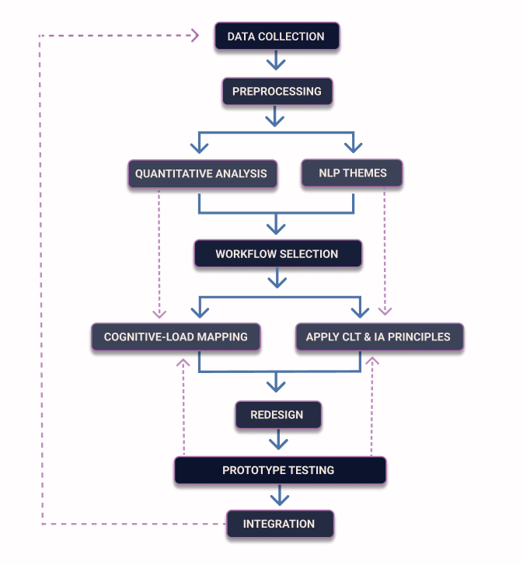
Fig. 2.1. Workflow redesign framework
NLP- Natural Language Processing, CLT- Cognitive Load Theory, IA- Information Architecture

In addition to the described linear UX pipeline, the analytical stages in this thesis interact in multiple directions. Quantitative data and NLP themes not only support workflow selection but also inform cognitive-load interpretation and the application of CLT and IA principles. Prototype testing closes the loop by returning new clarity, difficulty and effort-based insights back into the analytical cycle. This creates an iterative model where structural, linguistic and navigational issues are refined across several stages rather than in a single pass.

Data Collection and Sampling
This section explains how the empirical data used in this thesis were collected and how participants were selected. The data collection strategy was designed to operationalize the theoretical concepts discussed in Chapter 1 - particularly cognitive load, navigation clarity, and information architecture - by translating them into measurable survey questions and usability indicators.
Primary data were collected directly from LUIS users through questionnaires and task-based feedback. This approach follows established usability research practices that rely on first-hand user input to capture both quantitative measures and subjective experience (Abdulai & Owusu-Ansah, 2014). The surveys were used to collect data on system usability, perceived effort, interface clarity, and user preferences for improvement within real academic workflows.
The survey structure was derived from the theoretical framework of this thesis. Concepts from cognitive load theory, user-centered design, and information architecture were mapped to concrete variables such as task difficulty, clarity importance, number of steps, perceived effort, and navigation friction.
Secondary sources included published and unpublished materials such as academic books, journal articles, reports, theses, and online databases (Abdulai & Owusu-Ansah, 2014). These sources were used to contextualize the findings and to situate the study within existing research on interface design in education and digital usability.
(Weichbroth, 2024) presents a structured framework for usability testing of digital systems, with a focus on mobile and web applications. The article argues that many usability studies produce weak or inconclusive results because testing procedures are inconsistently applied or insufficiently documented. To address this problem, Weichbroth proposes a step-by-step testing process that includes defining concrete goals, selecting participants, designing realistic user tasks, and collecting both quantitative and qualitative data. The framework emphasizes that usability testing should be conducted under controlled conditions while still reflecting real user behavior. Typical methods include time-on-task measurement, error tracking, observation of user actions, and short post-task questionnaires (Weichbroth, 2024).
In the context of this thesis, Weichbroth’s framework supports the decision to combine task observation with short questionnaires focused on cognitive load and user perception. It also aligns with the use of prototype-based testing grounded in realistic academic tasks. Applying this structured approach helps ensure that the usability findings are methodologically grounded and relevant to real institutional workflows.
Sampling Strategy and Dataset Overview:
The target population for this study consists of active LUIS users at the Stockholm School of Economics in Riga, including students, administrative staff, and faculty. In total, 92 responses were collected, providing a diverse enough sample within the institution.
Participants were recruited through internal mailing lists, direct invitations, and voluntary participation. The aim was not to achieve national representativeness but to gather detailed, experience-based insights from users who rely on LUIS daily.
Although the sample represents a single institution, it covers different user roles and a wide range of workflow habits. This provides enough variation to identify clear patterns in LUIS usage and to select the workflows that were targeted in the usability improvement phase. These data form the empirical basis for the analytical pipeline described in Section 2.2 and directly support the later workflow prioritization and redesign stages.
The dataset comes from an online survey created in Google Forms represented in List P1.1. Dataset structure: LUIS_Usability_Survey_Final.csv in Appendix 1). The goal was to understand how LUIS users complete common workflows, where they experience friction, and which tasks create the highest cognitive load. The survey was open for one week and shared with students, administrative staff, and academic staff at the Stockholm School of Economics in Riga. In total, 92 valid responses were collected.
The dataset includes both structured and open-text questions. The structured fields cover user role, years of experience, device type, usage frequency, workflow frequency, self-reported task difficulty, number of steps, and estimated task time. The open-text fields describe where users get stuck, which interface elements are confusing, and what they would change. These comments form a small corpus that is later used for thematic and lexical analysis.
Most variables are categorical (for example “Daily”, “Desktop/Laptop”). Several questions use ordinal scales from 1 to 5 to measure task difficulty and interface-related effort. The dataset also contains free-text descriptions that give detailed insight into specific usability problems. Before analysis, all responses were anonymized, manually checked, and cleaned. Duplicate or irrelevant entries were removed.
These variables form the quantitative and qualitative inputs for the pipeline stages described in following chapters.

Tools Used for Data Collection, Analysis, and Prototyping
This subsection describes the digital tools used for data collection, processing, prototype design, and usability testing. Each tool supports a specific stage of the analytical and practical pipeline outlined in Section 2.2.
Google Forms
Google Forms was used to collect the main survey data. It supports fast distribution, basic logic rules, and direct export to Excel or CSV formats (Google Forms, 2025). The exported files were later used for statistical analysis and pattern detection in the analytical part of the thesis.
During the prototype testing stage, Google Forms was also used to collect feedback after participants interacted with the Figma screens. Short task-based forms were designed to capture clarity, effort, and overall task experience. This setup allowed both the initial usability survey and the prototype evaluation to be conducted using the same tool, without the need for additional platforms or costs.
Google Colab
Google Colab was used for cleaning, transforming, and analyzing the survey dataset (Google Colaboratory, 2025). The original Excel export was uploaded and processed using Python. The purpose was not predictive modelling, but structured data preparation and exploration analysis.
The workflow included renaming columns to standardized labels, creating helper variables, converting open-ended responses into structured formats, handling missing values, and filtering incomplete entries. The resulting cleaned dataset was then used for descriptive statistics, cognitive-load indicators, and the NLP analysis presented later in this chapter.
Figma
Figma was used to create interface prototypes and redesign concepts for LUIS (Figma, 2025). It supports fast edits, shared links, and simple animations, which helps show how improved workflows might look in practice. Adobe XD was considered, but according to (What Is Future of XD?, 2024) it is no longer developed and updated, so the project uses Figma as the main design tool.
Additional tools
WCAG color-contrast checkers are used to verify the readability of prototype elements (W3C, 2024). These checks support the design principles discussed in the theoretical part.
Maze User Research and Testing Platform was initially considered as the main tool for prototype testing because it integrates directly with Figma and supports task completion time, success rate, mis-click metrics, and short post-task questions (Figma Prototype Testing with Maze | Maze + Figma, 2024). The platform is well suited for larger usability studies and would also be appropriate for future academic systems development.
In the context of this thesis, Maze could not be used due to budget limitations, and the constraints of the free version did not allow full workflow testing. The prototype evaluation was therefore conducted using Google Forms combined with interactive Figma prototypes. This approach made it possible to gather task-based feedback and user reactions in a consistent format without additional costs.
A language-model assistant (ChatGPT 5.1 by OpenAI) was used only to support clarity of academic English, assist with structuring draft sections, and help with code formatting. All research decisions, data analysis, and interpretations were carried out independently by the author.
Together, these tools form an integrated technical environment that supports the full research pipeline, from initial data collection to prototype testing and evaluation. Their combined use ensures that the Analytical and Practical Parts of the thesis remain transparent, reproducible, and methodologically consistent. The cleaned datasets and prototype materials produced with these tools are further processed in the following data preparation and analysis stages.

Data Preparation
This section describes how the raw survey data was transformed into an analysis-ready dataset for the quantitative and NLP stages of the pipeline. All cleaned datasets, survey responses, analysis notebooks with code used, live prototype links, project files and additional materials are publicly available in the project repository (Žogota-Kiliča, 2025).
The survey export from Google Forms required cleaning before it could be used for analysis. The original file included long text fields, multi-selection answers stored in a single string, and inconsistent column names. To prepare a usable structure, column names were standardized, fields were checked for missing values, and formatting issues were corrected. Dataset structure of LUIS_Usability_Survey_Final.csv is presented in Table P2.1. in Appendix 2.
The cleaned Excel export served as the base file, but it did not contain the helper variables needed for analysis. These were created in Google Colab during the automated processing stage. New variables included steps_numeric, task_time_seconds, task_time_category, workflows_used_count, and a composite priority_score. They support the descriptive statistics, cognitive-load interpretation, and prioritisation used later in the analysis.
Multi-selection answers such as workflows used, friction points, and priority workflows were converted into structured Python lists. Ordinal fields such as task difficulty, clarity importance, and task time were kept as ordered categories. Missing entries such as “Not sure” were treated as missing values and replaced with median values only when numeric consistency was required. No responses were deleted or modified, as the goal was to prepare the data without changing the meaning of what users wrote.
User roles and device types were encoded using simple one-hot encoding, which enabled comparisons across groups possible in the later cross-tabulation and correlation analysis. After all transformations, the final cleaned dataset was exported as LUIS_Usability_Survey_Final.csv, which forms the base for all statistical analysis, NLP work, and visualizations (Žogota-Kiliča, 2025).
This prepared dataset is used as the input for the quantitative analysis in Section 2.5.1. and the NLP analysis in Section 2.5.2.
    - Quantitative Analysis Methods
To narrow down the workflows, the study combined three signals from the survey: how many people use the workflow, how difficult users rate it, and how strongly users want it improved. This produces a short, clear list of workflows with the highest impact on overall usability.
Each row in the dataset represents one respondent evaluating one specific workflow. The difficulty, time, clarity, and cognitive-load ratings in each row correspond directly to that workflow, not to the system as a whole. This structure allows workflow-level statistical analysis without mixing tasks.
Survey responses were reviewed to identify recurring patterns in how users describe problems, where they get stuck, and which workflows cause the most cognitive effort. The analysis focuses on task difficulty, navigation issues, unclear terminology, and workflow steps that feel unnecessary. Comments were grouped into themes, so it is clear which problems are widespread, and which affect only specific user groups.
Quantitative data from the survey (frequency of workflow use, perceived difficulty, estimated time, and cognitive-load ratings) were summarized using simple descriptive statistics. This helps show which workflows generate the highest load, which tasks take the longest, and where users report the most friction. The results guide the selection of one to three workflows for the improvement concept in the Practical Part. A small comparative check (students vs. staff, and desktop vs. mobile users) is included to clarify differences in user experience.
These quantitative results establish the first evidence-based shortlist of candidate workflows for redesign.
    - NLP Based Analysis Methods
While quantitative analysis shows which workflows are problematic, NLP is used to explain how users describe and experience these problems.
NLP is used here to support the quantitative findings by organizing the open-text comments into clearer patterns. Usability surveys produce short, unstructured comments, so basic NLP helps standardize the text and reveal repeated issues that contribute to extraneous cognitive load. The aim is not to build predictive models, but to understand how users talk about LUIS in their own words.
Analysis follows the basic steps described in Natural Language Processing with Python (Bird et al., 2009) and the introductory statistical approach in Speech and Language Processing (Jurafsky & Martin, 2009).
All steps were carried out in Google Colab using Python, NLTK and scikit-learn. The input was the cleaned file LUIS_Usability_Survey_Final_NLP.csv, prepared from the same dataset used in the quantitative analysis, which keeps the pipeline consistent and reproducible. Additional NLP variables added to the base dataset structure of LUIS_Usability_Survey_Final.csv are presented in Table P2.2. in Appendix 2.
The relevant open-text fields (“friction points”, “stuck point”, “key fix”, and additional comments) were merged into one field and then processed through a simple NLP pipeline:
- Lowercasing the text
- Tokenizing the comments
- Removing punctuation and stopwords
- Lemmatizing the remaining tokens
- Counting keywords and common phrases
- Grouping related terms into themes
- Extracting collocations and bigram patterns
- Running a small LDA topic model
These steps reduce noise and help identify patterns that are not visible in the raw text.
The NLP analysis focuses on three questions:
- Which words and phrases users repeat when describing difficulties?
- How these patterns relate to extraneous cognitive load?
- How different user roles express their problems?
Preparing text fields
The NLP analysis uses the same cleaned survey dataset as the quantitative part. Several open-ended fields were available (for example friction_points, stuck_point, key_fix and additional comments). These fields appeared in different formats, so they were combined into one column, open_text_all, where each respondent has a single short text describing their main problems and suggestions. Empty entries were ignored.
Creating one consolidated text field makes the later NLP steps clearer and keeps the comments linked to structured variables such as role and workflow_to_improve. This forms the base corpus for tokenisation, lemmatisation, frequency analysis and topic modelling.
This prepared text corpus is then used for frequency analysis, collocations, theme grouping, and topic modelling in the results chapter.

Linking Findings to Cognitive Load and Information Architecture
This subsection helps interpret the quantitative and NLP findings through the lens of cognitive load theory. Based on cognitive load theory, the analysis distinguishes between intrinsic task difficulty and extraneous interface-related effort. The survey and later statistical processing are designed to identify whether users struggle more with the task itself or with how the system presents it. Attention is given to navigation structure, label clarity, repeated steps, and feedback timing, as these factors are known to increase extraneous cognitive load. This distinction prepares the ground for result interpretation in the Practical Part.
Germane cognitive load is not examined in this study. LUIS is an administrative platform intended for routine actions rather than a learning environment. In cognitive load theory, germane load relates to schema construction during learning (Sweller, 2011) which is not the focus of this system. For this reason, the analysis framework deliberately concentrates on intrinsic load (task complexity) and extraneous load (design-related effort).
The survey structure makes it possible to separate task-related difficulty from interface-related effort. Task difficulty is used as an indicator of intrinsic load, while clarity importance and interface-related difficulty are used as indicators of extraneous load. This distinction allows the analysis to later identify whether user effort comes mainly from the task itself or from how the interface presents and structures it.
The analytical setup also allows results to be interpreted across different user groups and usage contexts. Variables for role and device type are included so that potential differences between students and administrative staff, as well as between desktop and mobile use, can be examined later in the analysis.
At the methodological level, this structure defines how redesign priorities will be interpreted later. If extraneous load appears higher than intrinsic load for specific workflows, this points to interface structure, navigation, terminology, and feedback as the main redesign targets rather than task logic itself. This principle defines the analytical logic of the study without assuming any specific outcomes in advance.
Chapter Summary
This chapter introduced the analytical framework and methodological pipeline applied in the thesis. It outlined the mixed-method research design and explained why surveys, quantitative analysis, and NLP were combined to study usability in LUIS. The chapter also described the data collection process with active system users, the preparation and cleaning of the dataset, and its structure for subsequent analysis.
The quantitative analysis section focused on workflow frequency, perceived difficulty, clarity importance, and cognitive-load indicators used to identify workflows with the highest impact. The NLP section described how open-ended feedback was processed to surface recurring usability patterns that do not emerge in fixed-choice survey questions.
All analytical steps were interpreted using cognitive load theory and information architecture, with an explicit distinction between intrinsic task difficulty and extraneous interface-related effort.
Taken together, these methods establish a replicable analytical pipeline that directly supports the results presented in the next chapter and the workflow redesign work in the Practical Part of the thesis.

PRACTICAL PART 1: analytical groundwork results
This chapter reports the outcomes of the analytical pipeline outlined in Chapter 2. It summarizes the quantitative findings, NLP-supported themes, and cognitive load indicators that later guide the selection of redesign workflows. The purpose of this chapter is not to propose design solutions, but to present empirical evidence that justifies the focus of the practical UX work in Chapter 4.

Statistical Data Processing Results
This subsection begins with an overview of how frequently different workflows are used across user roles, establishing a baseline for later difficulty, clarity, and cognitive-load analysis.
Workflow frequency results
This subsection presents how often different LUIS workflows are used across user roles. These usage patterns provide the baseline for identifying which tasks have the highest practical impact on everyday system use (Table 3.1).

Table 3.1
Role Distribution in the LUIS Usability Survey
Role | Count | Percentage
Student | 78 | 84.8%
Administrative staff | 12 | 13.0%
Academic staff (lecturer) | 2 | 2.2%
Total | 92 | 100%

The workflow frequency analysis shows that most users interact with LUIS through a small set of high-volume tasks, mainly course search and registration, viewing grades or exam results, and accessing transcripts. Administrative staff rely on different workflows, most often exam grade entry, transcript export, enrollment, and academic report preparation. Less frequent tasks include study plan updates, payments, and course information management. These patterns are consistent across roles: a small group of workflows accounts for most system use and generates the largest number of complaints. This makes them the most impactful candidates for redesign.
The distribution of user roles is shown in Table 3.1, where students form 84.8% of respondents, administrative staff 13%, and lecturers 2.2%. The role-based workflow summary in Figure 3.1 also shows that students mainly use front-end workflows, while administrative staff work with structurally heavier back-office processes. Lecturers appear only in a small number of actions. These differences confirm that usability issues depend strongly on user role, so redesign efforts must target the workflows most relevant to each group rather than applying a single universal solution.

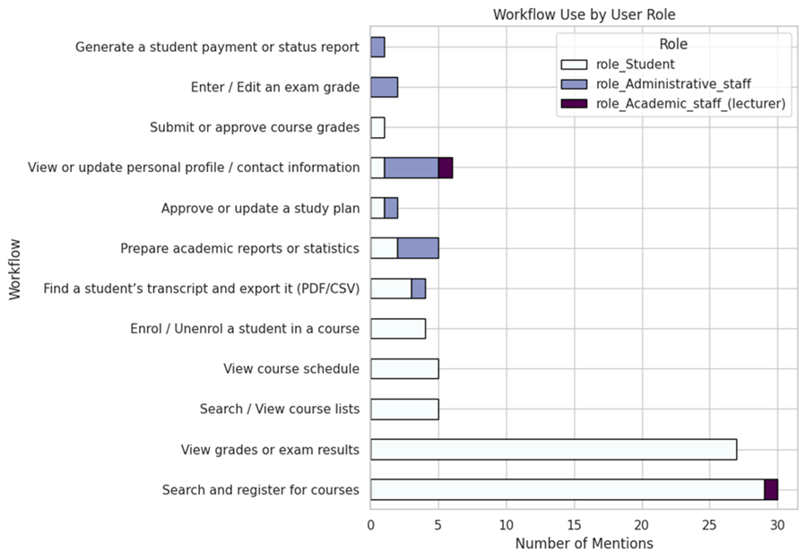
Fig. 3.1. Workflow usage by role

These frequency patterns establish the structural baseline for the next stage of the analysis, which examines how difficult users find these workflows and how much cognitive effort the interface adds to each task.
Difficulty, Clarity and Cognitive Load Ratings
After identifying the most frequently used workflows, the next step is to examine how difficult these workflows feel to users and how much cognitive effort the interface adds.
The difficulty ratings show that most workflows are not complex by nature. Intrinsic difficulty stays mostly between levels 1 and 3, which means users understand the tasks and do not find the underlying logic difficult. In contrast, extraneous difficulty is consistently high across all workflows. Many respondents rated interface-related effort at levels 4 or 5, indicating that unclear labels, fragmented navigation, and unpredictable page structure create additional mental load. Clarity importance follows a similar pattern, with most users rating it at level 3 or 4. Together, intrinsic difficulty, extraneous difficulty, and clarity importance form the cognitive-load profile of the system and are illustrated in Figure 3.2.

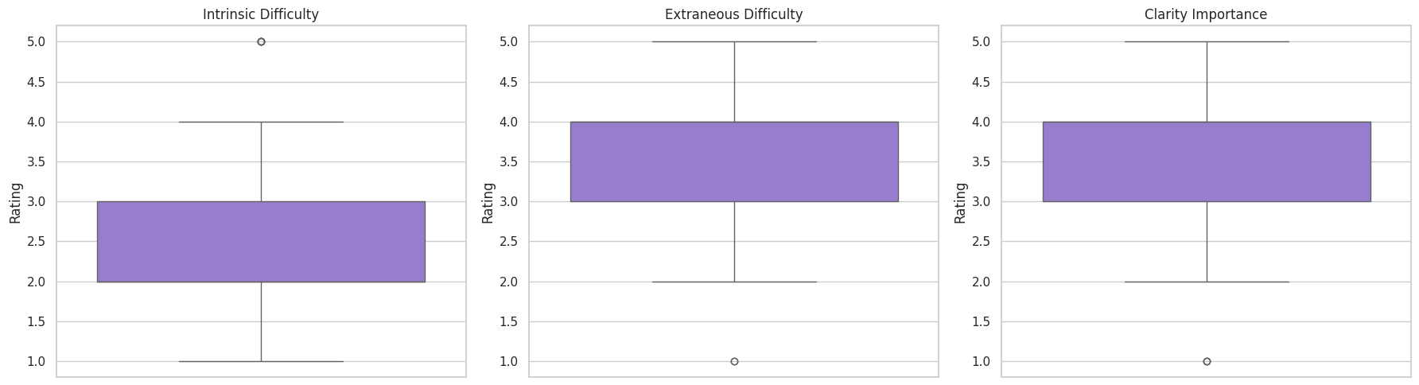
Fig. 3.2. Boxplots

The numeric values confirm the same patterns seen in workflow frequency. Student workflows have low intrinsic difficulty but high extraneous difficulty due to menu structure and inconsistent terminology. Administrative workflows show both higher intrinsic complexity and high clarity dependence. These results are shown in Table P3.1, Summary of difficulty and clarity findings across workflows, in Appendix 3. Together, the difficulty and clarity ratings show that the main source of effort in LUIS comes from how the system presents actions and information, not from the tasks themselves. This provides a direct link to the CLT discussed in the theoretical part and explains why later redesign steps focus on reducing extraneous load.
Taken together, these distributions confirm that the main source of cognitive effort in LUIS does not come from the nature of the tasks, but from how the system presents actions, labels, and navigation. To summarize these patterns in a compact format, the main findings on intrinsic difficulty, extraneous difficulty, and clarity importance are presented in Table P3.1. in Appendix 3. This summary shows how user groups experience different types of cognitive load, and which aspects of the interface contribute most to unnecessary effort.
These difficulty and clarity patterns form the basis for the composite priority score, which combines usage frequency, perceived effort, and clarity importance to identify the workflows with the highest redesign impact.
Priority Scoring
To move from difficulty patterns to concrete redesign decisions, the next step is priority scoring.
The priority scoring step combines four indicators for each workflow: intrinsic difficulty, extraneous difficulty, clarity importance, and the frequency of workflow each respondent uses. This creates a single numeric value that reflects how demanding a workflow feels in practice and how often users encounter problems.
The highest priority scores appear in administrative workflows: transcript export, academic report preparation, and exam grade entry. These tasks involve multi-page paths, unclear field structures, and strict sequences. They consistently show high extraneous difficulty and high clarity importance. This indicates that most of the effort comes not from the task logic but from the way information is presented.
Student workflows such as course registration, viewing grades, and viewing schedules fall in the medium range. These tasks are used far more often, but their structure is simpler. Their priority scores come mainly from unclear navigation, hidden actions, and inconsistent terminology. These workflows are high-volume, but not structurally heavy. The results show two separate problem types:
- Administrative workflows contain deeper structural issues and generate the highest cognitive load.
- Student workflows are overloaded with navigation friction and unclear labels.
For redesign planning, this means structural improvements are needed for administrative tasks, while student-facing tasks require better navigation, clearer hierarchy, and more predictable page structure. A horizontal bar chart of these scores is included as Figure 3.3. and full scoring outputs are provided in Table P3.2. Priority scores in Appendix 3.

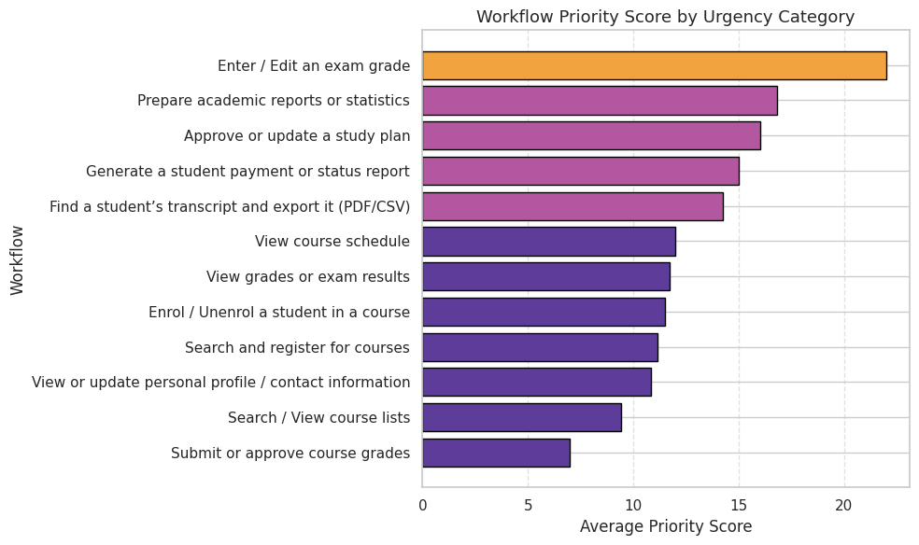
Fig. 3.3. Workflow priority score by urgency category

The priority scores were used as input for the next analytical step, which examines relationships between difficulty, clarity, task time, and workflow demand using correlation analysis. The scoring approach converts perceived effort and usage frequency into a ranked list that guides the selection of workflows for redesign.
Correlations
A correlation matrix was generated for the main numeric variables in the dataset: intrinsic difficulty, extraneous difficulty, clarity importance, task time, steps, workflows used, and the composite priority score shown in Figure 3.4. The results show a consistent pattern across all workflows.

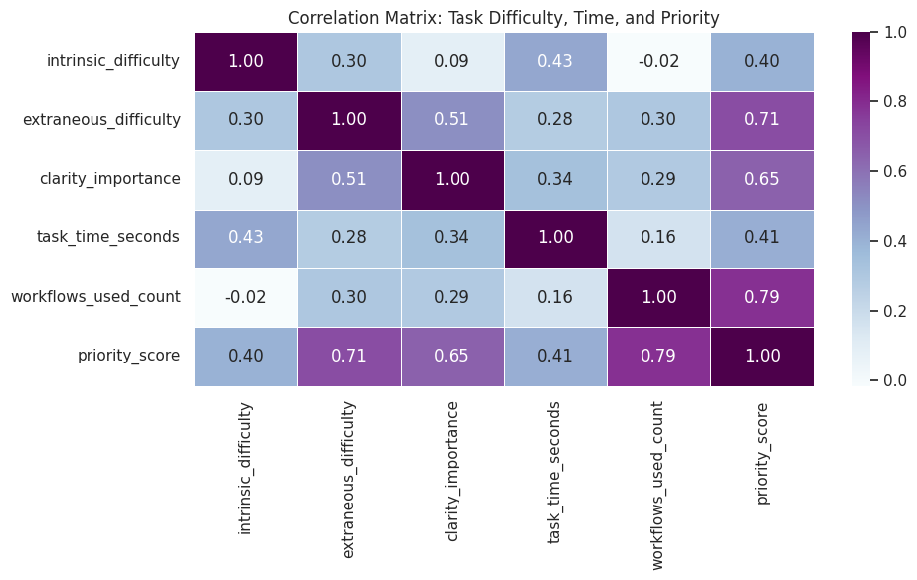
Fig. 3.4. Correlation matrix of task difficulty, time and priority

First, extraneous difficulty has a clear positive correlation with the priority score. This means that workflows which feel confusing, unclear, or hard to navigate are also the ones users want improved the most. This supports the earlier finding that most usability problems in LUIS come from interface structure rather than the task itself.
Second, clarity importance also correlates strongly with the priority score. Users rate workflows as a higher priority when clear labels, predictable steps, and consistent navigation matter for completing the task. In other words, when clarity is missing, the workload increases and users highlight the workflow as a problem area.
Intrinsic difficulty shows a smaller relationship with the priority score. Users rarely struggle with the logic of the task; they struggle with how the system presents it. This pattern confirms that cognitive load mainly comes from design choices, navigation paths, field visibility, terminology, not from the academic tasks themselves.
Finally, task time and steps_numeric show almost no meaningful correlation with the other variables. Users do not judge a workflow based on how long it takes or how many steps it includes. They react to whether the structure is understandable. This reinforces that improving clarity and reducing unnecessary interface friction are more important for usability than reducing task length.
Together, these correlations show that the highest-priority workflows are not the longest or most complex ones, but the ones where unclear design increases mental effort. This insight forms the basis for selecting workflows for redesigning in the Practical Part.
Device Use
Device use was analyzed by splitting responses into desktop and mobile categories. This made it possible to compare how often users switch between devices and where they experience the most friction. Most respondents use a desktop or laptop, which fits the nature of many LUIS workflows, especially administrative tasks that involve several steps and require precise data entry.
Mobile use is also common, mainly among students. Many users access LUIS on both desktop and mobile, which means navigation and clarity issues appear across screen sizes. These problems are not limited to one environment.
Administrative staff rely almost entirely on desktop devices. Their workflows need a larger screen and more stable layout. Students move between devices more often and use LUIS during lectures, between classes, or while checking grades on the move. On small screens, unclear labels and crowded layouts become even harder to manage.

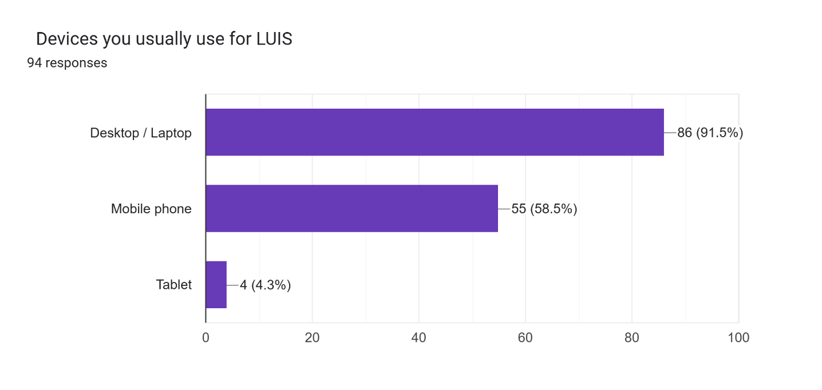
Fig. 3.5. Device use distribution

As Figure 3.5. shows the initial device distribution of 86 desktop and 55 mobile device users collected in the Google Forms survey. It demonstrates the general pattern: desktop use dominates, and mobile use is also significant.

Table 3.2
Device Distribution Table
User Group | Uses Desktop | Uses Mobile | Total Users
All respondents | 84 | 55 | 92
Desktop only | 37 | – | 37
Mobile only | – | 8 | 8
Uses both | 43 | 43 | 43
Tablet users | 4 | – | 4

As shown in Table 3.2, the Python-based analysis of device use reveals that most users rely on desktop devices, many also use mobile, and only a small group uses mobile alone. This confirms that LUIS must function reliably across both screen types. These patterns directly support the redesign choice to test the main administrative workflow on desktop and the most problematic student workflow on mobile.

Summary of Quantitative Findings
The automated analysis confirms the same patterns observed in the earlier descriptive review but adds more detail. Intrinsic difficulty is low across most workflows, which shows that the tasks themselves are simple. The strongest signals come from extraneous difficulty and clarity importance, indicating that users mainly struggle with the interface rather than with task logic. Correlation analysis further shows that workflows with unclear labels, inconsistent paths, or multiple screens receive the highest priority for improvement.
Role-based patterns show clear differences. Students mainly struggle with navigation in course registration and grade viewing workflows. Administrative staff experience higher cognitive load in complex, multi-screen tasks such as exam grade entry, enrolment, and report preparation. This confirms that redesign work cannot rely on a single universal solution.
Device use adds another layer. Most respondents work on desktop devices, but many students also use LUIS on mobile. This means that student-facing workflows must be evaluated on mobile as well, while administrative workflows remain primarily desktop-based.
Together, these results guide the choice of workflows for redesign. Administrative tasks require structural simplification, while student tasks require clearer labels and more predictable navigation. The next step is NLP analysis, which examines how users describe these problems in their own words and checks whether the qualitative themes support the quantitative signals.

NLP Analysis Results
While quantitative analysis shows which workflows generate the highest cognitive load, it does not explain how users describe these problems in their own words. For this reason, NLP was used to analyze the open-text survey responses. This section presents the results of text cleaning, frequency analysis, and thematic grouping, which together clarify the language users use to describe friction in LUIS.

Tokenization and Basic Cleaning
Following the NLP preparation steps described in Section 2.4.2, the consolidated open-text field (open_text_all) was processed using basic text-cleaning procedures. Each comment was lowercased, split into individual tokens, and stripped of punctuation, digits, and stop words. This produced a set of tokens that contain only meaningful words relevant to how users describe their experience.
The cleaned tokens were stored as a new column and also combined into one list for later frequency analysis. This step reduces noise in the text and makes it easier to see recurring usability terms instead of grammatical fillers. Because the corpus is small, the cleaning process stays simple and focused on interpretability rather than complex modeling.
After basic cleaning, lemmatization was applied to further standardize the wording of user comments and reduce linguistic variation.
Lemmatization
Lemmatization was applied as the next step in the NLP pipeline described in Chapter 2 to make the language in the user comments more consistent. Each token was reduced to its base form, so variants such as labels/label or confusing/confusion appear as one term. This created a new lemmas column, which became the main input for the later frequency counts, collocations, and theme grouping.
Because the corpus is small, lemmatization has a clear practical benefit: it reduces variability in wording and highlights repeated concepts more reliably. The original tokens were kept for reference, but all further steps use the lemmatized version to keep the analysis stable and readable.
Keyword Frequencies and Lexical Patterns
Following preprocessing and lemmatization, the first NLP output examined was keyword frequency analysis. All lemmas were aggregated into a single list and counted to identify the most common usability-related terms. The most frequent words cluster around four areas: navigation, clarity, layout, and system behavior.
Frequent lemmas include find, menu, label, field, unclear, confusing, hidden, small, slow, and error. A bar chart with the twenty most frequent lemmas is included in Figure 3.6. This pattern is consistent with the quantitative results. Terms such as find, menu, label, and field indicate difficulties in locating actions or interpreting labels. Terms such as unclear and confusing points to naming problems. Words like hidden, small, and far refer to visibility and placement issues. Slow, validation, and feedback describe timing and system response.

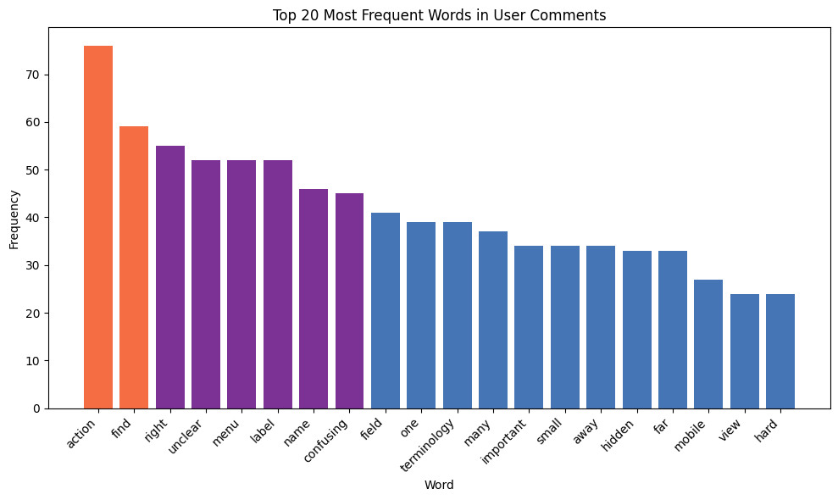
Fig. 3.6. Most frequent words used comments

These terms form small lexical groups that reflect how users experience the interface:
- Orientation problems (menus, pages, views).
- Unclear terminology (labels, names).
- Visibility and layout issues (hidden, small).
- Slow or late feedback (validation, error).
Collocations and Bigram Patterns
To move beyond single-word counts and examine how users connect usability problems in practice, a collocation and bigram analysis was conducted.
Frequency counts show which words matter, but not how users connect them. To see which terms appear together, bigram collocation analysis was run using NLTK’s BigramCollocationFinder with PMI scoring. The analysis used the lemma list and included only bigrams that appeared at least twice, so accidental pairs were filtered out.
The top bigrams show clear patterns, as seen in Table 3.3. Phrases such as search function, main page, get stuck, and duplicate step point directly to navigation and workflow structure. Users often complete a form and receive an error only at the final stage, which adds unnecessary extraneous load and requires them to repeat earlier steps. Bigrams such as access permission, permission issue, and issue block reflect role-based problems. These usually appear in administrative workflows or in student actions that unexpectedly fail.
Table 3.3
Bigram Patterns
Theme | Example Bigrams | What They Indicate
Navigation & Structure | search function, main page, get stuck, duplicate step | Users struggle to find actions, return to main screens, or avoid repeated steps.
Permissions & Access | access permission, permission issue, issue block | Role-based restrictions or unexpected blocks during tasks.
System Feedback & Timing | validation error, system feedback, appear late, performance slow | Late messages, slow responses, and unclear system states.
Conceptual Clarity | make sense, sense click | Confusion about why actions are required or how pages connect.

Another group of bigrams relates to system feedback and timing. Pairs such as validation errors, system feedback, appear late, and performance slow show frustration with late or unclear messages. Users often complete a form and only then receive an error, which increases extraneous load and forces them to redo steps.
Finally, phrases like make sense, get stuck, and sense click show conceptual confusion. These comments suggest that some parts of the system feel illogical or hard to interpret, which links directly to the clarity and terminology issues seen in the quantitative results.
Overall, the collocation analysis confirms that usability problems appear as chains of difficulty rather than isolated issues. Users describe sequences of searching, repeating actions, receiving late feedback, and handling unclear logic. These linguistic patterns reinforce the earlier findings and show how interface structure contributes to cognitive load.
These patterns reinforce the earlier quantitative and frequency-based findings by showing how multiple sources of friction combine within single workflows.
Word clouds and visual summaries
To complement the frequency and collocation analysis, a visual summary of the corpus was created using word clouds.
The main word cloud was generated in Google Colab using the word cloud library shown in Figure 3.7. While word clouds are not analytical tools on their own, they are useful for communicating dominant themes to non-technical readers. The cloud confirms the same core vocabulary seen in the frequency tables: find, menu, label, unclear, confusing, terminology, hidden, small, far, slow, validation, and error. These terms form the central visual cluster, with less frequent terms appearing around them.

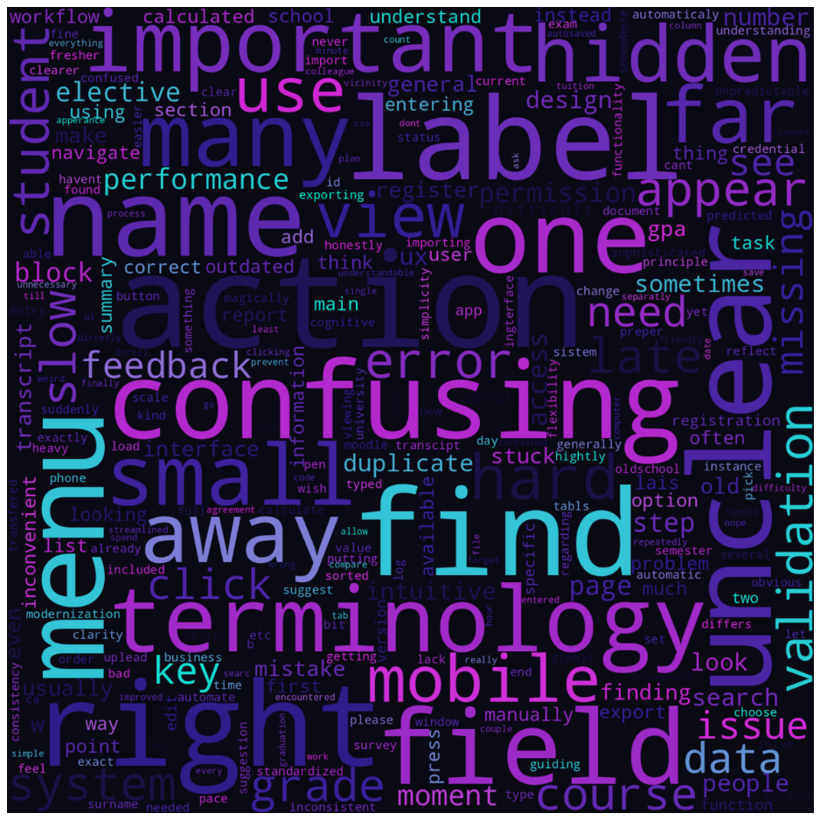
Fig. 3.7. Word cloud of open-text responses

In addition to the global word cloud, topic-specific word clouds were created for each LDA topic. These show the most important words for four inferred themes: navigation, terminology, errors and feedback, and layout. Each topic cloud uses a separate color map and title overlay, making it easier to communicate differences between shown in Figure 3.8.

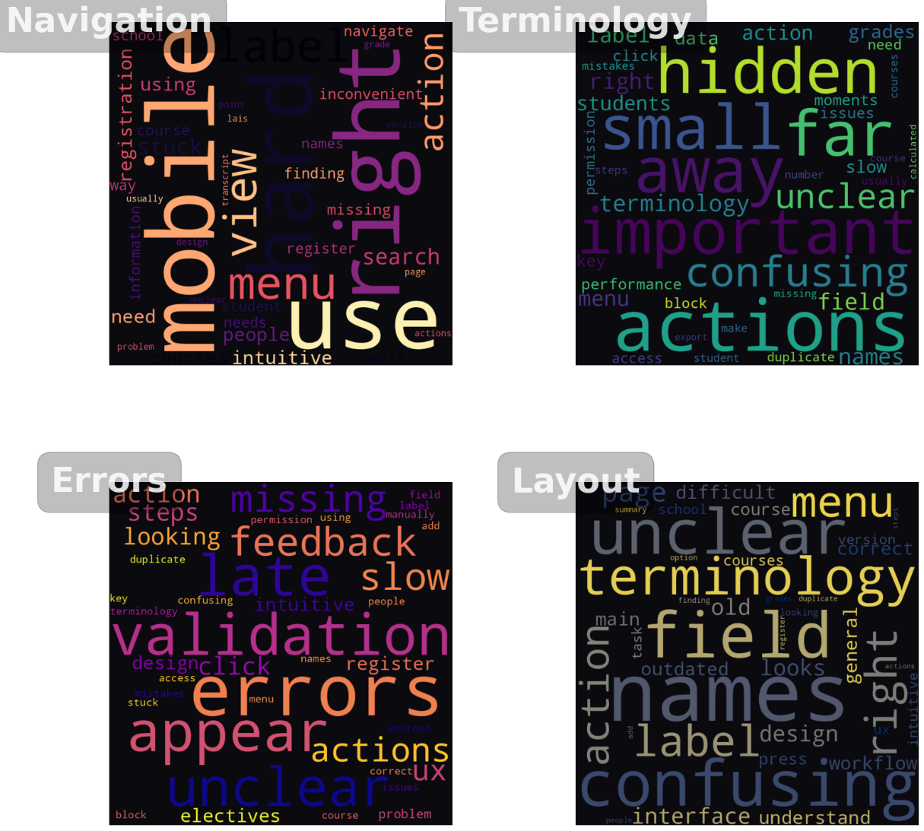
Fig. 3.8. Theme specific word clouds

Thematic grouping and topic modelling
To move beyond single words, the comments were organized into broader themes using two simple methods: rule-based thematic grouping and an LDA topic model. First, a small theme dictionary was built from the most frequent lemmas and bigrams.
- Words about menus, pages, fields, and searching were grouped as navigation.
- Words such as unclear, confusing, terminology, and name were grouped as clarity and terminology.
- Words like hidden, small, far, away, and duplicated formed a layout and visibility theme.
- Words such as slow, late, feedback, and validation formed a performance and feedback theme.
- Permission, access, and block formed a smaller permissions theme.
A helper function tagged each comment with one or more themes. Navigation was the most common, followed by clarity/terminology, layout/visibility, performance/feedback, and permissions. This order matches the quantitative results, where most friction came from finding actions and understanding labels.
Second, a small LDA model (4 topics) was run to check whether an unsupervised method produced similar patterns. It did.
- Navigation (find, menu, mobile, search, stuck).
- Terminology and clarity (unclear, terminology, field, hidden, small).
- Errors and system feedback (validation, error, late, slow, missing).
- Layout and visibility (label, page, confusing, field, menu).
Each comment was assigned to its most likely topic. Table 3.4 shows the main LDA topics with their keywords, how users describe each issue, and what it means for the interface. Students mostly fell into navigation and terminology topics. Administrative staff concentrated on topics about errors, slow feedback, and duplicated steps in multi-screen workflows. Lecturers appeared only in a few comments and were mainly linked to terminology and layout issues.

Table 3.4
Summary of LDA Topics in User Comments
Topic | Main Keywords | What Users Describe | UI/UX Meaning
Navigation | find, menu, right, mobile, use | Trouble locating actions, getting stuck, unclear paths | Improve structure, surface key actions, reduce steps
Terminology | unclear, terminology, hidden, small, field | Labels and field names feel confusing or misleading | Standardize naming, simplify language, improve clarity
Errors & Feedback | validation, appear, late, feedback, slow, missing | Delayed system responses and error messages | Faster feedback, clearer system states, visible validation
Layout & Visibility | names, confusing, field, label, menu, page | Inconsistent layout: elements are hard to notice | Clean layout, stronger hierarchy, consistent placement
The two methods arrive at almost identical themes, which strengthens the reliability of the findings. Across all comments, users describe the same set of issues: getting stuck in navigation, unclear naming, hidden or poorly placed elements, delayed messages, and occasional permission blocks.
These themes are used in the next section to connect qualitative user statements with the quantitative workflow priorities.

Summary of Analytical Findings
The combined quantitative and NLP analysis shows a consistent pattern: users do not struggle with the academic tasks themselves, but with how the system presents and structures them. Intrinsic difficulty remains low across most workflows, while extraneous difficulty and clarity importance are consistently high.
Students most often reported navigation and terminology issues in workflows such as course registration and grade viewing. Administrative staff reported higher cognitive load in more complex, multi-step tasks, including grade entry, report preparation, and study plan updates. Device use further differentiates these experiences, as students frequently switch between desktop and mobile use, while administrative workflows remain largely desktop based.
The NLP results confirm these patterns. Frequent words and collocations point to unclear labels, navigation friction, hidden or small interface elements, slow feedback, and duplicated steps. Topic modelling groups these into four dominant themes: navigation, terminology, layout, and system feedback. NLP also reveals issues that do not fully appear in fixed-choice survey fields, such as late validation messages and inconsistent naming.
Taken together, the findings show that LUIS requires clearer navigation, more consistent terminology, improved visibility, and faster feedback across both desktop and mobile contexts. Based on this evidence, a small number of high-impact workflows were selected for the practical redesign phase.

Workflow Selection for Practical Part
The results show that LUIS creates unnecessary effort because of unclear labels, long navigation paths, hidden elements, and slow feedback. These findings confirm that the main usability problems in LUIS stem from interface structure rather than task complexity. For this study, the focus is narrower. Based on the combined quantitative and NLP results, two workflows were selected for the practical redesign.
- Exam Grade Entry (desktop)
This workflow has the highest average priority score in the quantitative results. It combines higher intrinsic difficulty with very high extraneous difficulty and clarity importance. Administrative staff describe it as long, fragmented, and stressful because it involves several steps across multiple screens and carries high responsibility. The NLP results add detail: users mention late validation errors, unclear field names, and uncertainty about where changes are saved. For these reasons, exam grade entry is selected as the main desktop workflow for redesign.
- Search and Register for Courses (desktop and mobile)
This is the most frequently mentioned workflow in the survey and generates the largest number of student comments. The task itself is simple, but users describe confusion caused by navigation, unclear terminology, hidden elements, and inconsistent page structure. It appears strongly in the NLP themes of navigation and unclear labels. Many students use mobile devices for this workflow, and the comments show that mobile navigation increases cognitive effort. Because of this, the workflow was selected for redesign in both desktop and mobile formats.
Together, these workflows cover the most urgent problem areas that are realistic to address within this thesis. Exam grade entry represents the most demanding administrative task on desktop. Course registration captures the most problematic student-facing workflow on mobile. Focusing on these two workflows allows the redesign to respond directly to the strongest evidence from both the quantitative and NLP results.

Chapter Summary
This chapter presented the empirical results of the analytical pipeline applied to LUIS. Quantitative analysis showed that intrinsic task difficulty remains low across most workflows, while extraneous difficulty and clarity importance are consistently high. This confirms that users do not struggle with academic tasks themselves, but with how the system presents actions, labels, and navigation.
Role-based differences were visible across the results. Students tended to report more friction in navigation-heavy workflows, such as course registration and grade viewing. Administrative staff reported higher cognitive load in more complex, multi-step tasks, including exam grade entry, report preparation, and study plan management. Device analysis also indicated that students often switch between desktop and mobile use, while administrative workflows remain largely desktop based. These patterns informed the focus of the redesign.
The NLP analysis confirmed and enriched the quantitative findings. Repeated lexical patterns and topic modelling revealed four dominant usability problem areas: navigation, terminology, layout and visibility, and system feedback. Users consistently described getting stuck on menus, encountering unclear labels, missing visible actions, and receiving late validation messages. Several issues, such as delayed feedback and inconsistent naming, appeared more clearly in the NLP results than in fixed-choice survey fields.
Together, these results provide a clear empirical justification for the practical redesign focus. Based on combined priority scoring, correlation analysis, device use, and NLP themes, two workflows were selected for redesign in Chapter 4:
- Exam Grade Entry (desktop).
- Search and Register for Courses (desktop and mobile).
These workflows represent the strongest concentration of usability pressure across both administrative and student contexts.
This evidence-based grounding ensures that the practical UX work in the next chapter responds directly to observed cognitive load patterns rather than to assumed design problems.

Practical Part 2: User Experience Case Study
This section defines the concrete UX and information-architecture principles used in the redesign. These principles are derived directly from the quantitative and NLP findings in Chapter 3 and translate the identified usability problems into actionable design rules. They guide all workflow reconstructions in this practical case study.

Design Principles Derived from Analysis
Based on the results of the analytical part, the next step is to apply these findings to the redesign of selected LUIS workflows. In this Practical Part, the author focuses on reducing this extraneous load and rebuilding the workflows, so they feel more predictable and easier to complete.
The redesign changes demonstrated in the following sections, directly informed by survey and NLP findings, that guide the reconstruction of both administrative and student-facing workflows:
- Simplifies structure.
- Shorten navigation paths.
- Stabilizes key action locations.
- Improves feedback timing.
- Removes deep menu paths and duplicated pages.
- Groups related actions are on a single screen to reduce attention switching following the split-attention principle.
- Improvs visibility with real-time validation and short confirmations placed close to the action area.
- Uses a consistent layout hierarchy: heading → subheading → main content → actions.
- Keeps action buttons in the same place across workflows.
The redesign also adapts each workflow to the device context identified in the survey. Students often switch between desktop and mobile, so the layouts are built separately.
- Mobile uses a simple one-column structure with larger tap targets, fewer elements per screen, and collapsible sections for long information.
- Desktop keeps wider tables, stronger overview, a stable left navigation, and a persistent action bar so key buttons stay in the same predictable place.
Basic WCAG 2.2 principles are applied throughout (W3C, 2024):
- High contrast for text and icons.
- No color-only meaning.
- Large touch areas on mobile.
- Clear keyboard focus paths on desktop.
These choices follow the usage patterns seen in the data and aim to reduce confusion across different user groups.

Selected Workflows & Existing Problems
This section describes the current state of the selected workflows prior to redesign. It uses concrete interface examples to make existing usability problems visible and to relate these observations to the analytical findings discussed in Chapter 3. The screenshots show recurring issues in navigation structure, visibility, and feedback that limit user support.
The workflows chosen for redesign come directly from the quantitative and NLP results. Exam grade entry showed the highest pressure for administrative users, with high intrinsic and extraneous difficulty, unclear field structure, and several points where users reported getting stuck. Course search and registration appeared most often in student comments, especially in mobile scenarios, and showed repeated patterns of confusing navigation, unclear labels, and hidden actions.
These two workflows represent the strongest problem areas in the system. They capture different types of friction:
- Administrative workflows with long, multi-step structures and high responsibility.
- Student workflows with simple task logic but high navigation overhead, especially on mobile.
The Practical Part follows directly from these findings. The goal is to reduce unnecessary steps, improve clarity, and support the contexts users work in. For this reason, exam grade entry is redesigned for desktop, while course search and registration are redesigned for both desktop and mobile.
Mobile Course Registration - Existing Problems
The student mobile view shows major usability problems specifically in the context of course registration shown in Figure 4.1. In both screenshots, the interface displays only a header, a “Grades” or “E-talons” dropdown, and a large empty area. No courses, no registration options, and no navigation path to them are available. The layout collapses into a narrow, non-responsive structure that hides core actions. Important elements are pushed off-screen, and the menu structure does not adapt to mobile. As a result, students cannot access course lists, registration functions, or even basic academic information without switching to a desktop.
The visuals highlight several issues:
- Key actions are missing completely (no visible link to courses or registration).
- Interface loads as almost a blank screen, with only a title bar and a single dropdown.
- The hierarchy is unclear, and the system does not signal where course-related actions are located.
- Tabs (“Profile”, “Studies”) overlap and compete for attention, but neither reveals course functions.
- Navigation relies on desktop-style menus, which do not render on mobile.
This confirms the survey results: students struggle most with navigation and visibility on mobile. The screenshots illustrate why- the system does not show essential workflows in the mobile view, which forces students to switch devices and creates unnecessary frustration.
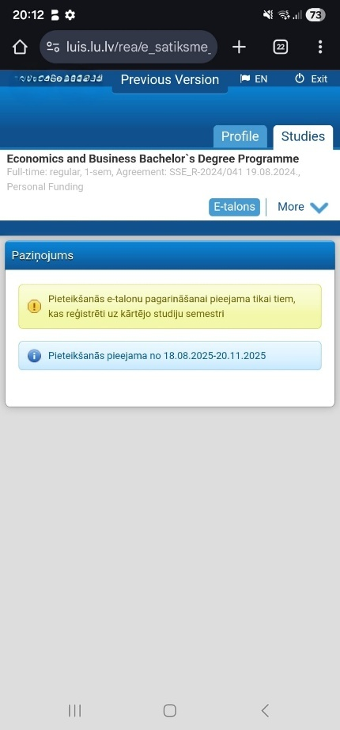
Fig. 4.1. Current LUIS mobile interface

Desktop Course Registration - Existing Problems
The desktop version of course registration shows the same structural issues as the mobile view in a wider layout seen in Figure 4.2. The workflow is split across several screens, and most elements are hidden inside collapsible folders. Students must search through multiple menus to understand where to start.

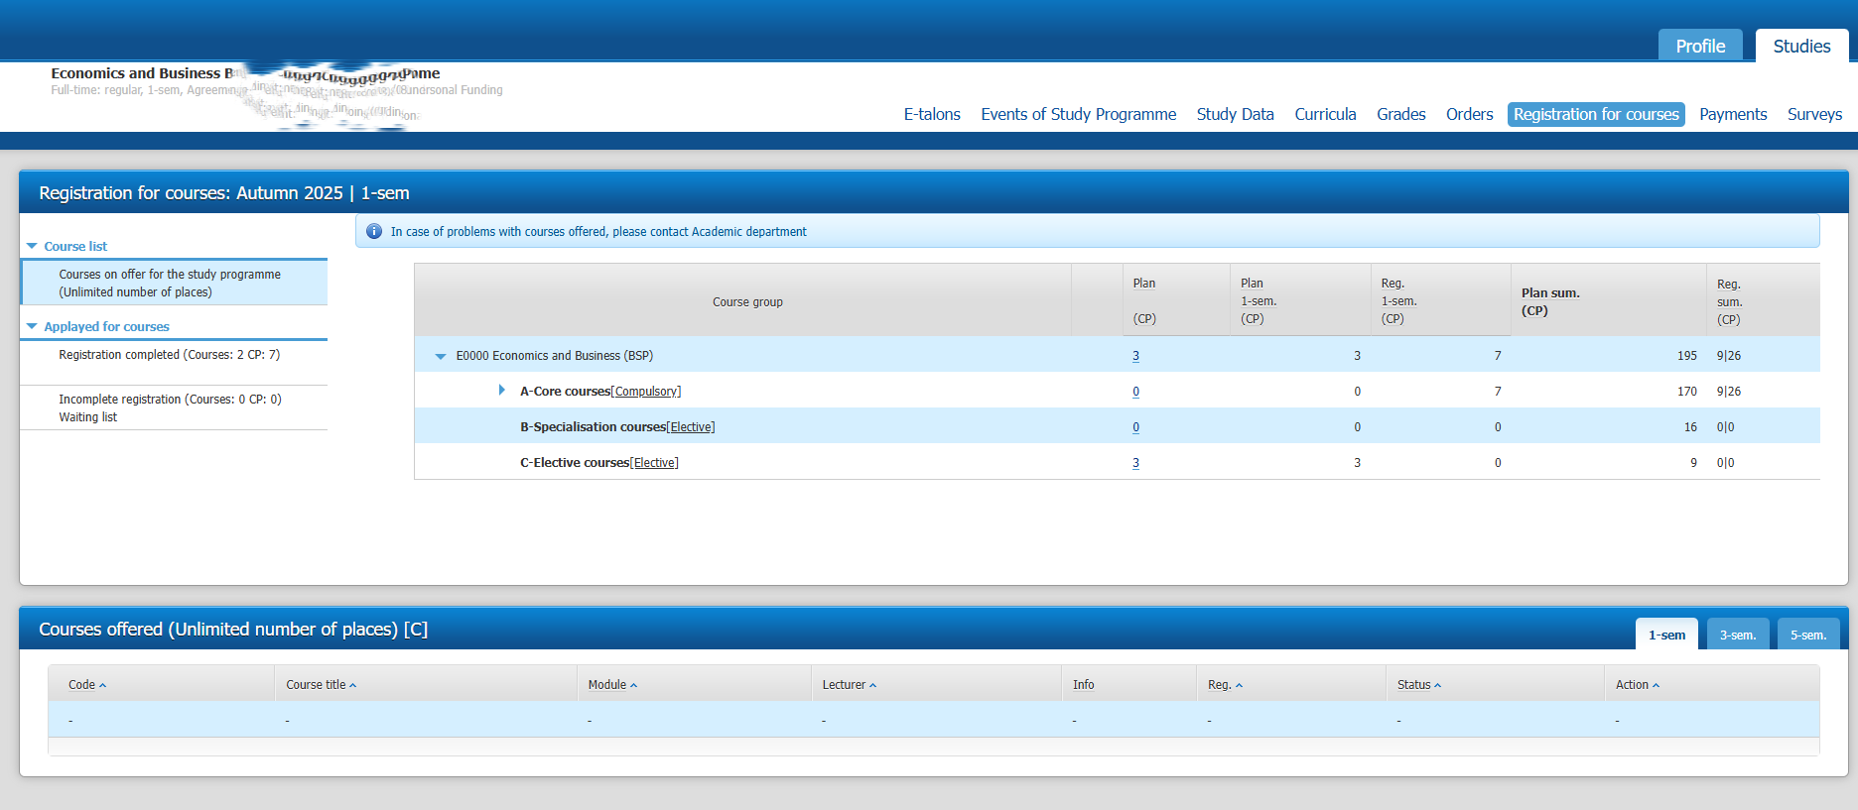Fig. 4.2. Desktop course registration screen

The page layout is overloaded. The top section repeats programme information, while the core actions sit far below the fold. This pushes essential elements out of view and forces unnecessary scrolling. “The “Courses on offer” block is presented as an empty-looking table with no clear entry point, even when courses are available” as shown in figure 4.3. The two columns (“Course list” and “Applied for courses”) create visual noise and do not support the task flow.

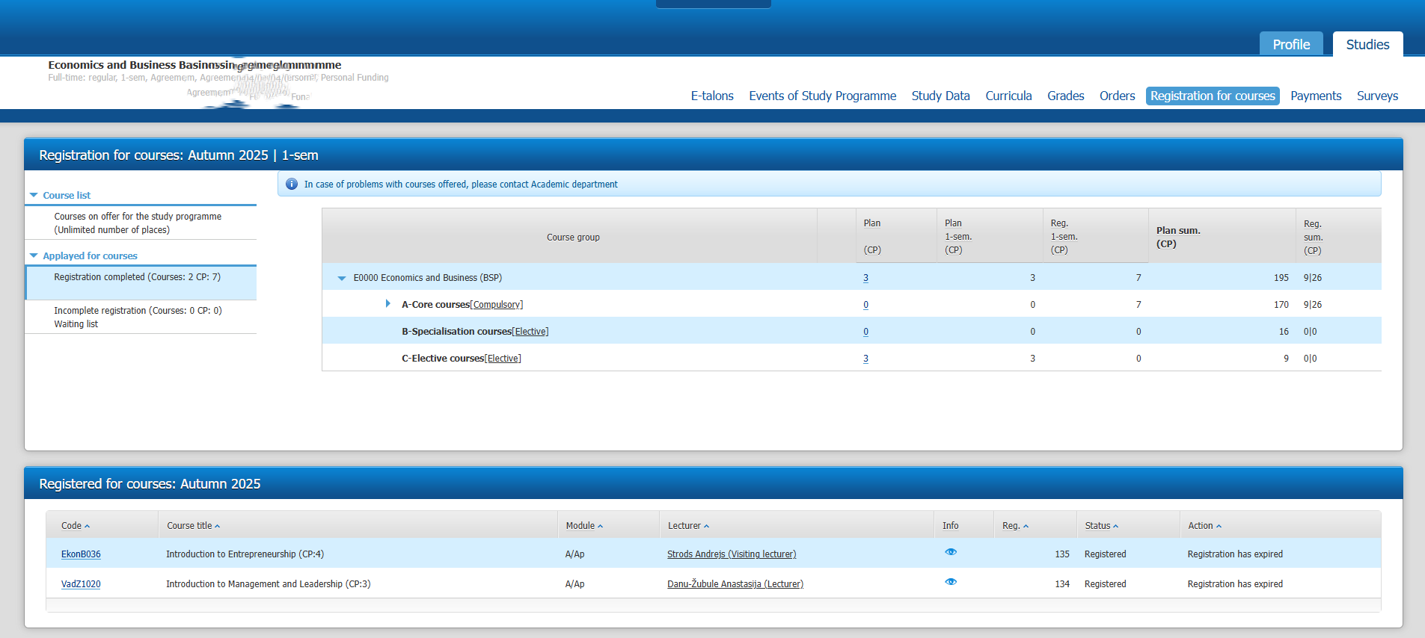
Fig. 4.3. Current desktop course registration screen
Navigation inside the registration tree is unclear. Categories such as A-Core, B-Specialization, and C-Elective are hidden inside expandable folders. Their naming is not meaningful for first-year students and does not give any cues about which courses belong where. The system does not show basic affordances like a clear “Register” button next to each course.
Users reported in the survey that the structure feels unpredictable. The screenshots illustrate repeated issues:
- Registration table shows many empty rows with dashes.
- Action buttons are placed far away from course titles.
- Status messages (“Registration has expired”) appear with no color coding.
- Navigation switches between unrelated states.
Overall, the desktop workflow requires students to click, expand, and re-check several sections before they find relevant courses. This matches the quantitative data on high extraneous difficulty and the NLP themes on navigation and unclear labels. The screenshots demonstrate these problems clearly.
Exam Grade Entry - Existing Problems
The Grade entry existing workflow visuals show that the grade-entry interface is visually overloaded and difficult to interpret as can be seen on Figures 4.4., Figure 4.5., Figure 4.6 and Figure LUIS existing grade entry workflow 4 in Appendix 4. The first issue is the amount of information placed on one screen without grouping. Multiple long tables stacked together, each containing student names, course codes, statuses, registration dates, grade versions, and action buttons. Because everything uses the same beige background and the same font size, nothing stands out. As a result, users often need to scan rows manually to locate the correct place for entering or editing grades, which contributes to the additional effort illustrated in Appendix 4.

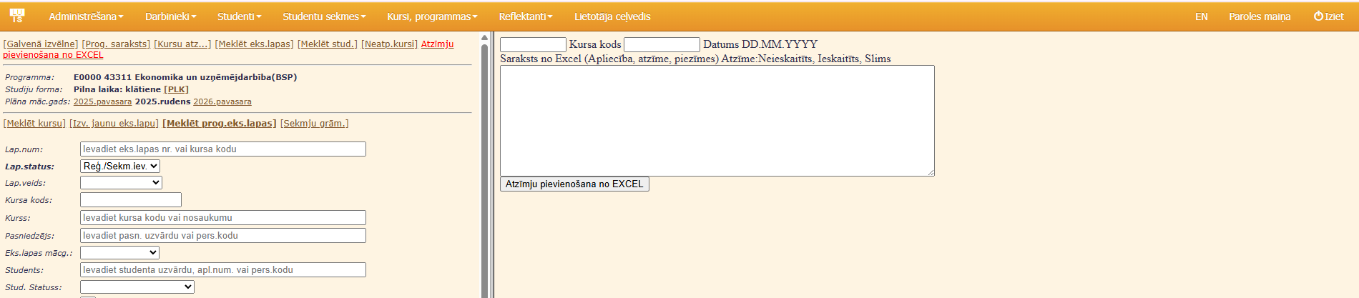
Fig. 4.4. Fragmented grade entry workflow 1

Figure 4.4. and Figure 4.5. highlight how fragmented the workflow is. Before reaching the actual grade-entry table, users must complete a long set of filters: programme, course code, lecturer, student, status, academic year, and more. Many fields repeat information or require very specific internal codes that users do not always know. The filter section takes up a large part of the screen, pushing the functional area far below. This creates extra scrolling and makes it easy to miss steps.

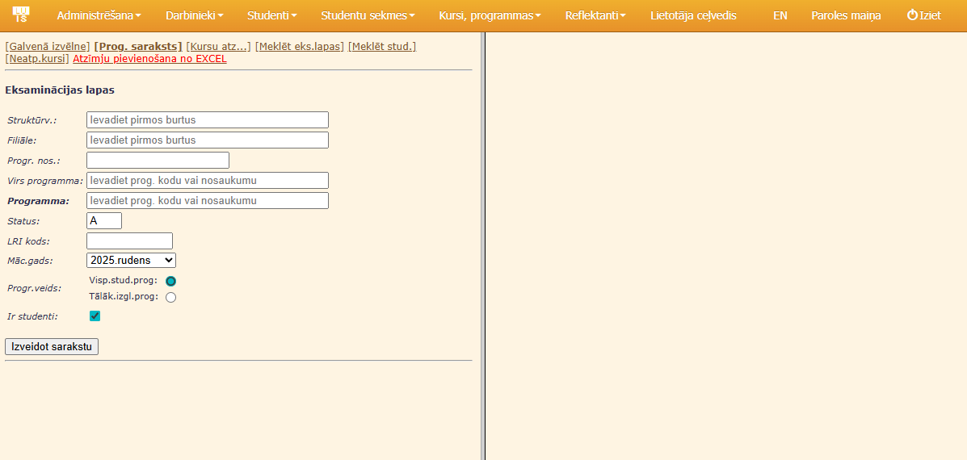
Fig. 4.5. Fragmented grade entry workflow 2

Figure 4.6 shows the result of applying these filters. The interface displays a long, dense table with more than a dozen columns. Information about registration status, study status, exam version, editing actions, and print options is placed side by side. Grade entry is not visually emphasized, despite being the primary task of the workflow. Instead, grade values are positioned between several unrelated administrative fields.
The table presents a complete list of students without grouping or clear visual hierarchy. As a result, users need to follow each row carefully from left to right to reduce the risk of mistakes, which becomes particularly demanding in larger cohorts.

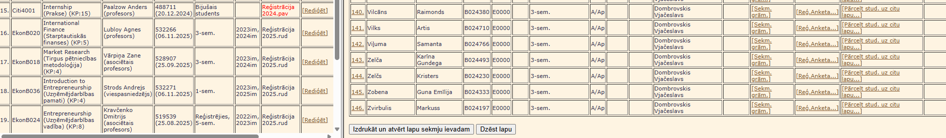
Fig. 4.6. Fragmented grade entry workflow 3

With all three screenshots, the layout provides very limited supportive cues. Fixed headers and sticky areas are missing, and the separation between searching, editing, and confirming grades is unclear. As a result, the workflow is distributed across several panels, which requires frequent shifts of attention. Users described this experience as stressful and confusing. The screenshots show the same underlying issues: dense information on a single screen, weak structural hierarchy, and limited guidance on the next action. This combination contributes to high extraneous cognitive load and increases the likelihood of errors during grade entry.
Together, the mobile and desktop screenshots show the same structural problems described in the analytical results: unclear navigation paths, hidden actions, visual overload, and weak feedback. In the student workflows, the main barrier is visibility and access to key actions, especially on mobile. In the administrative workflow, the main barrier is information overload and lack of functional hierarchy. These observations form the direct baseline for the redesign strategy presented in the next section.

Redesign Strategy
The redesign strategy translates the analytical findings and the design principles outlined in Section 4.1 into concrete structural changes. The goal is to reduce extraneous cognitive load, shorten navigation paths, and make each workflow predictable and readable across desktop and mobile contexts.
The redesign process followed four structured phases:
Workflow Decomposition
Each selected workflow was first mapped as a sequence of existing steps based on screenshots, system use, and user descriptions. This made it possible to identify duplicated actions, unnecessary transitions, hidden decisions, and overloaded screens.
Cognitive Load Mapping
Each step was then evaluated as contributing either to intrinsic or extraneous cognitive load. Steps that existed only because of poor navigation, unclear terminology, or fragmented layout were marked as redesign targets.
Structural Simplification
Navigation paths were shortened by:
- Removing duplicated screens.
- Merging related actions into a single view.
- Eliminating unnecessary confirmation layers.
- Relocating key actions next to the content they affect.
This resulted in a reduced number of total steps for both student and administrative workflows. To make the effect of structural simplification measurable, the number of interaction steps was counted before and after the redesign for each selected workflow. Table 4.1 presents the reduction achieved for both administrative and student workflows.

Table 4.1
Workflow Steps Comparison
Workflow | Before Redesign | After Redesign | Step Reduction
Exam Grade Entry (Desktop) | 11 | 5 | -6
Course Registration (Desktop) | 4 | 3 | -1
Course Registration (Mobile) | N/A | 3 | -

The administrative workflow Exam Grade Entry (Desktop) shows the largest improvement. The original workflow required eleven steps, including multiple filter stages, screen switches, and repeated validations. After redesigning, the same task is completed in five steps, resulting in a reduction of six steps. This confirms that the administrative workflow previously contained a long and fragmented path with several indirect actions needed before actual grade entry could begin.
For Course Registration (Desktop), the number of steps was reduced from four to three. Although this numerical change is limited, survey comments show that the original desktop flow was frequently experienced as unclear, unpredictable, or, in some cases, temporarily unavailable. For this reason, the redesign addresses not only step count, but also visibility of actions, clarity of terminology, and the placement of key controls.
For Course Registration (Mobile), the “Before” value is marked as N/A, because effective mobile registration was not possible in the original LUIS interface. The redesigned version introduces a fully functional three step mobile workflow, which did not exist previously. This represents a structural addition rather than a simplification of an existing process.
Overall, the step comparison confirms that the largest usability gains come from restructuring long administrative paths and from enabling previously unavailable mobile workflows. This directly reflects the survey and NLP findings on high extraneous cognitive load caused by deep navigation, hidden actions, and delayed system feedback.

Interface Recomposition
After structural simplification, the redesigned flows were rebuilt using:
- Stable action zones.
- Consistent button placement.
- One primary action per screen.
- Grouped content blocks.
- Real-time feedback.
To ensure that these redesign principles are applied to real usage contexts, the next step translates the analytical findings into concrete user profiles. This is done through short personas that represent the main student and administrative user types identified in the data.
Target Users and Personas
The redesign starts with clarifying what each workflow must achieve and who the redesigned interface is built for as seen in Figures 4.7-4.9. To keep the work focused on real behavior patterns from the survey, three short fictional personas are used. Personas are a standard UX method for describing typical users in a simple way. They help translate the analytical findings into clear design decisions and show the specific problems each group faces. The survey and NLP results showed clear differences between students and administrative staff, and between mobile and desktop use. Using personas helps keep these differences visible throughout the redesign process and supports the explanation of task flows, wireframes, and prototype choices.

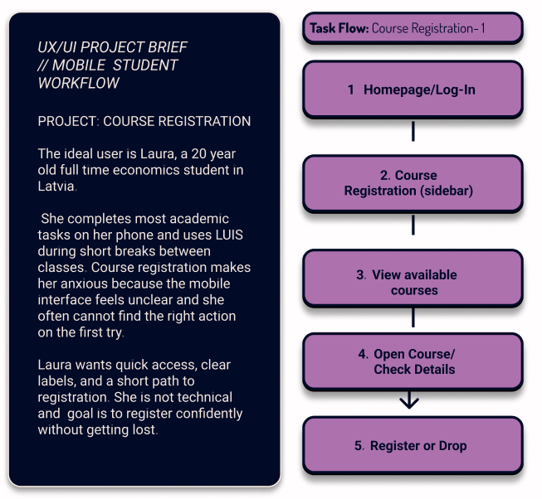
Fig. 4.7. Project brief course registration - mobile

Student Persona - Mobile (Laura)
Laura is a first-year student who checks LUIS several times a day Figure 4.7. She uses a mobile phone most of the time, including during lectures. She struggles with small buttons, unclear labels, and finding where to register for courses. She wants quick access to grades, course lists, and transcripts without clicking through several screens.

Student Persona - Desktop (Kristaps)
Kristaps is a second-year student who prefers to use a laptop demonstrated in Figure 4.8. He finds the desktop version visually crowded and often searches for course information on several different menus. He wants a simple course list with clear categories and predictable actions. He prefers to see full course details in one place.

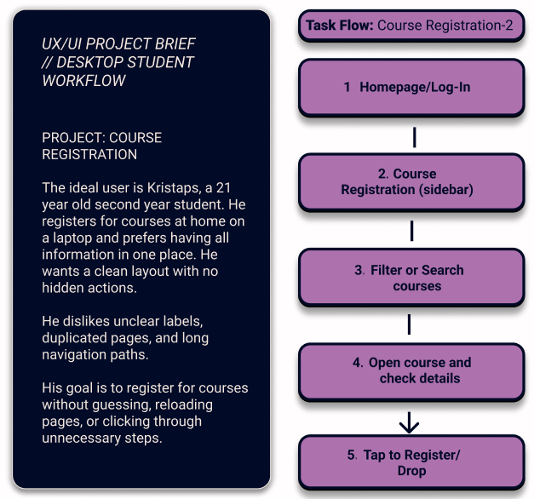
Fig. 4.8. Project brief course registration - desktop

Administrator Persona - Grade Entry (Anna)
Anna is an administrator responsible for exam grade entry shown in Figure 4.9. She uses a desktop and works with LUIS daily. Her main problems are long multi-screen workflows, unclear field naming, hidden functions, and late validation errors. Grade entry requires precision and speed, so she needs a clean layout, stable table structure, and clear system feedback.

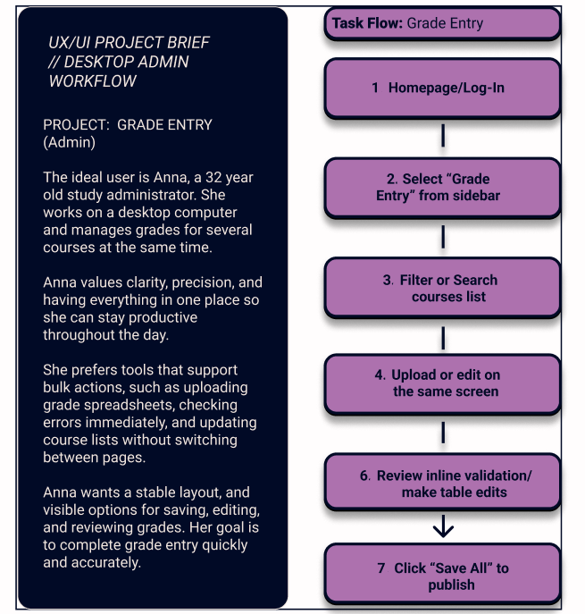
Fig. 4.9. Project brief course registration – mobile

Based on this strategy, the next step is to translate the structural decisions into low-fidelity wireframes that define layout, grouping, and action placement before any visual styling is added.

Low-Fidelity Wireframes
Once the redesign goals, personas, and usage contexts were defined, the next step was to translate these principles into concrete screen structures. This translation was carried out using low-fidelity wireframes, which focus on layout, navigation, and task flow before any visual styling is introduced.
These low-fidelity wireframes represent the initial stage of shaping the redesigned workflows. Their purpose is to clarify structural decisions prior to visual design, including how information is grouped, where actions are placed, and which steps can be removed or simplified. The wireframes reflect the earlier redesign strategy, emphasizing shorter navigation paths, clearer terminology, reduced category depth, predictable action placement, and earlier system feedback.
Wireframes were created in Figma using simple shapes and a neutral layout. They show structure and logic only- no typography, color, or visual styling. This stage focuses on navigation flow, grouping, button placement, and the order of actions. It allows quick changes based on the analytical findings before moving to high-fidelity design.
These wireframes act as blueprints for the high-fidelity concept and support the user testing stage that follows.
    - Low-Fidelity: Mobile Course Registration
The mobile wireframes created on Figma software use a simple one-column layout because students rely heavily on their phones and often struggle with crowded screens seen on Figure 4.10. The structure focuses on keeping one clear entry point for course registration, reducing the number of taps needed, and making every action easy to reach with the thumb. The course list is presented as a clean vertical stream with short titles and essential details such as ECTS and course type. Each item functions as a large tap target instead of a small text link, which directly addresses the size and precision problems students described in the survey.
When a course is opened, the details appear in a single card with a clearly visible Register or Drop button. The action is placed in a stable position and does not require searching through several panels. After registering, the confirmation appears directly inside the same card to remove any uncertainty about whether the action was saved.
This layout tackles the main issues found in the analysis: long navigation paths, deep menu structures, small interactive elements, and unclear feedback. The wireframe reduces the path to course registration to one predictable route, keeps the interface light, and places actions where students expect them. It reflects the real usage pattern identified in the survey, where clarity and immediacy matter more than the number of features shown on screen.

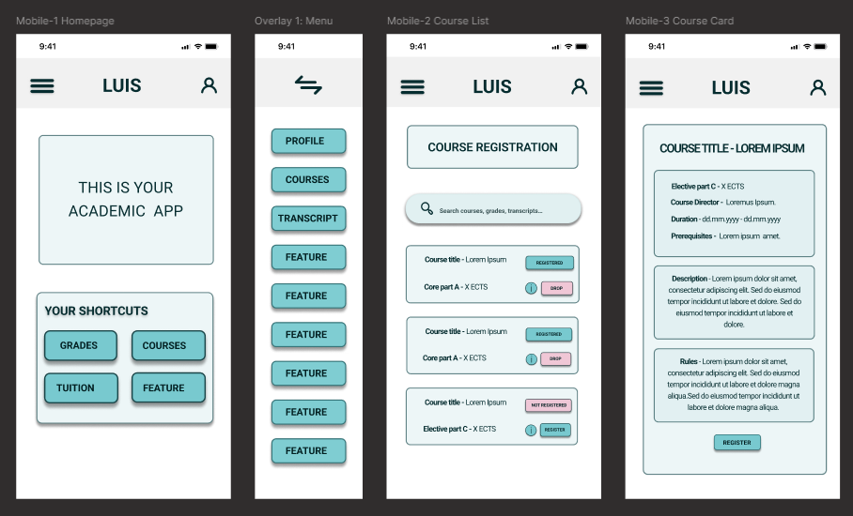
Fig. 4.10. Mobile Lo-Fi wireframes

While the mobile version prioritizes speed and reachability, the desktop version responds to different spatial and interaction needs.

    - Low-Fidelity: Desktop Course Registration
The desktop wireframes display more information at once, while maintaining a clearer and more consistent structure than the current system (see Figures P5.1. - P5.4. in Appendix 5 and the overview in Figure 4.11). The left-side navigation remains fixed across screens, which helps users keep track of their location within the system.
The course list is presented as a compact table that includes only the fields needed for decision-making. Search, filter, and sorting controls are placed at the top of the page, in line with common user expectations. This layout reduces visual scanning and limits unnecessary interaction steps.

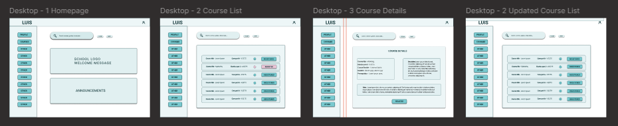
Fig. 4.11. Student desktop wireframes - overview

The main interaction happens inside the course itself. Registration and drop actions are placed close to the course name, making them easy to find without opening extra pages. When an action is taken, the feedback appears inside the same row to avoid losing context while scrolling.
These layout choices address the main problems students described in the survey: crowded tables, unclear actions, too many paths to the same task, and confusion after clicking buttons.
Unlike student workflows, the administrative grade-entry process requires high precision and sustained focus, which shapes the structure of the next wireframe.
    - Low-Fidelity: Grade Entry (Admin)
The grade-entry workflow focuses on reducing the long, fragmented steps that administrators deal with. The layout keeps everything on one page and uses a clear structure, so the user doesn’t lose context. The redesigned wireframe keeps the course information, the grade table, and the main actions visible in a stable layout, which supports fast scanning and reduces the chance of errors visible in detail on Figures P5.5. - P5.8. in Appendix 5 and as overview on Figure 4.12.)

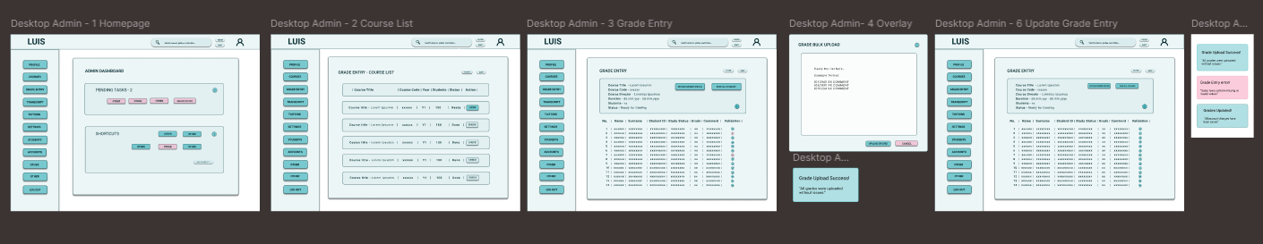
Fig. 4.12. Admin desktop wireframes - overview
The table is simplified into readable rows with larger input fields. Validation appears directly inside the row, not at the end of the process, so mistakes are caught early. A short summary block above the table shows course title, code, dates, and student count, giving the user immediate orientation before entering grades.
These decisions address the most common problems from the survey: complicated multi-step paths, late error messages, unclear button hierarchy, and dense tables that were hard to work with. The new structure creates a calmer workflow where the user stays on one page and receives feedback immediately.
These low-fidelity wireframes define the full structural logic of the redesigned workflows and form the basis for interactive testing. In the next stage, these structures are converted into clickable prototypes for user evaluation.

Prototype Development and Testing
This section presents the practical testing phase of the redesigned workflows. The goal is to evaluate whether the structural and cognitive improvements developed in the low-fidelity wireframes lead to better usability in real user interaction. The redesigned interface was demonstrated through Figma prototypes, applying the UX, IA and CLT principles discussed in the theoretical part. Using prototypes of website before creating actual web pages is helpful and time saving, because it allows user testing before investing in expensive and complex development and having to create changes from the backend of the process.
Prototype interfaces for all three selected workflows were created in Figma to show possible usability improvements for LUIS (Figures 4.13. and Figures P5.9. - P5.10. in Appendix 5. Figma allowed quick testing of layout, color, and navigation choices before real implementation. The (Figma, 2025) Smart Anime feature helps create smooth transitions between screens, showing how menus open, pages move, or buttons react. These animations make the interface easier to follow and reduce user confusion. Smart Animate connects matching layers between frames and automatically animates change such as size, color, or position. This creates a more natural user experience during navigation and helps visualize how the final system might feel to use. Using such prototypes made it possible to collect feedback on both visual clarity and emotional comfort, linking the design work directly to the psychological and usability principles discussed in the theoretical part.

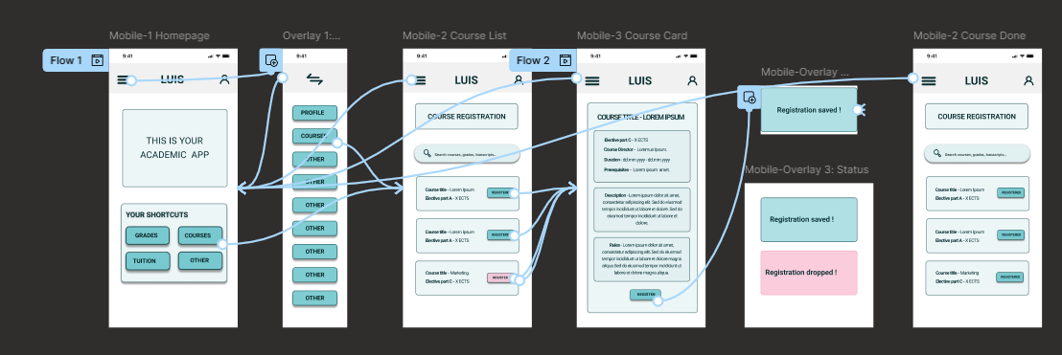
Fig. 4.13. Student mobile workflow prototype wiring

Prototype Usability Testing
The testing evaluated interactive low-fidelity prototypes that focused on structure and workflow clarity rather than final visual design. In the testing phase, the same participants who completed the original LUIS survey were invited to test the redesigned workflows. This approach kept the feedback consistent and made it possible to compare new observations directly with earlier comments and reported frustrations.
Testing was carried out using interactive Figma prototype links (Žogota-Kiliča, 2025), embedded in a short Google Forms questionnaire listed in Appendix 1 (List P1.2). This format allowed participants to open the prototype in their browser, complete the assigned tasks, and immediately respond to a small set of follow-up questions related to clarity, effort, and overall experience.
The purpose of the test was not to evaluate a finished interface, but to examine whether the redesigned information structure and clearer workflow descriptions support easier task understanding and completion. Participants completed short tasks and then evaluated workflow ease, perceived mental effort, and clarity.
The results of this prototype testing are presented in the following section, where task clarity, user confidence, and perceived effort are compared to the original LUIS workflows.

Prototype Testing Results
A total of 51 participants took part in the second survey conducted during prototype testing. This included 35 student mobile users, 3 administrative staff users, and 13 student desktop users, as shown in Figure 4.14. The sample represents more than half of the original 92 survey respondents.

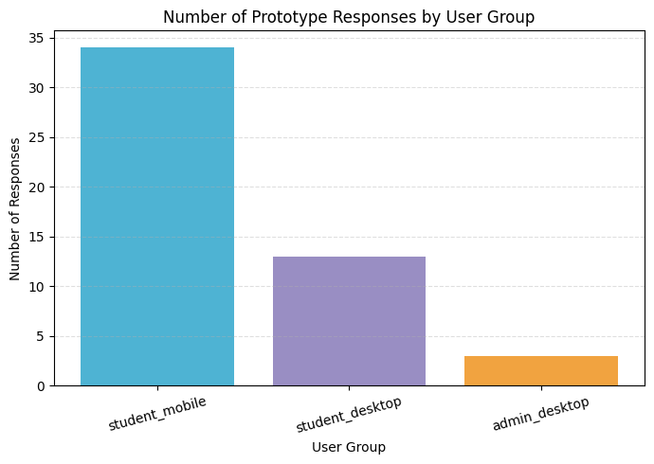
Fig. 4.14. Number of prototype test responses
In the second survey, the author tested the redesigned LUIS workflows with the same three user groups: students using mobile devices, students using desktop devices, and administrative staff. Data from the three Excel sheets were imported into Google Colab and merged into a single dataset (Workflow_Prototype_Test_Cleaned.csv). Column names were simplified (difficulty, mental effort, easier than LUIS, comments), and additional fields were added, including user_group, rescaled difficulty, combined score, tokens, and lemmas for NLP processing. The structure of the final dataset is documented in Table P2.3 in Appendix 2.
One question used the opposite scale (1 = easy, 5 = hard), it was rescaled it to match the others. After this, all scores followed the same direction: 1 = negative, 5 = positive. This made the results comparable to the first survey.
The descriptive results showed improvement. On average, users rated the prototype as easy to use (4.06), required less mental effort (4.26), and felt it was easier than the current LUIS design (4.16). These findings were compared to the overall results to the first survey. All three areas improved: ease increased by 0.50, mental effort by 1.74, and clarity by 0.66. This confirms that the redesigned workflows reduce confusion and lower cognitive load (Table 4.2).
Table 4.2
Change in Perceived Difficulty and Clarity After Prototype Testing
Metric | Old Average | Prototype Average | Change
Intrinsic Difficulty | 3.57 | 4.06 | +0.49
Extraneous Difficulty | 2.52 | 4.26 | +1.74
Clarity Importance | 3.50 | 4.16 | +0.66

The user groups also gave different scores. Mobile students gave the highest ratings, which shows that the one-column layout works well on phones. Desktop students also rated the workflow positively, but a lower because they see more information on the screen (Table 4.3).

Table 4.3
Improvement of Mental Effort after prototype testing
User Group | Ease | Mental Effort | Easier than LUIS
Student (mobile) | 4.15 | 4.47 | 4.41
Student (desktop) | 3.85 | 4.00 | 3.85
Admin (desktop) | 4.00 | 3.00 | 2.67

Administrative staff gave more cautious ratings, likely because the prototype represented a simplified conceptual version of a complex real workflow rather than a fully functional operational tool seen in Figure 4.15.

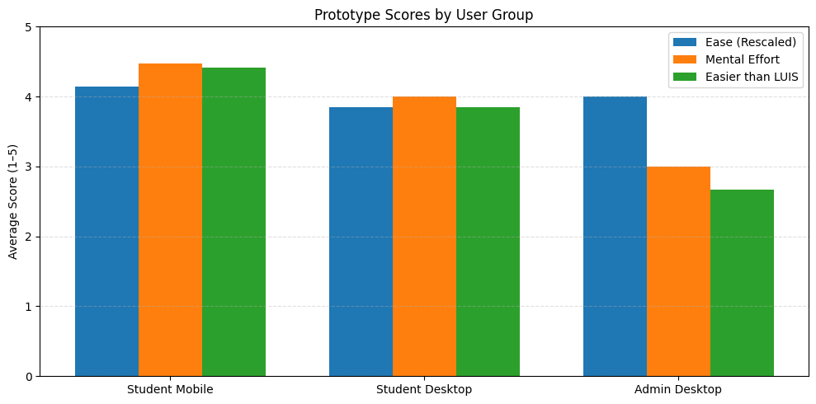
Fig. 4.15. Prototype scores by user group

Overall, the prototype testing indicates improved clarity in the redesigned workflows compared to the current LUIS interface. Task execution required less reported mental effort, and ease-of-use ratings increased across all user groups. The strongest differences were observed among mobile users, whose ratings were consistently higher than those for the existing interface, as shown in Figure 4.16.

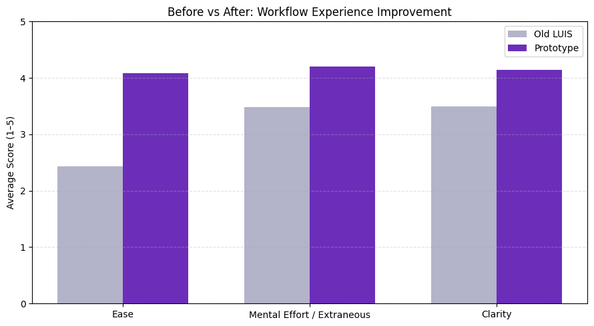
Fig. 4.16. Improvement of mental effort after prototype testing

The prototype comments were processed using the same NLP steps as in the main analysis. Figure 4.17 shows the 20 most frequent words extracted from the open-ended feedback after prototype testing. The most frequent term was “course”, followed by “everything”, “button”, and “clear”. Frequently occurring positive descriptors included “simple”, “good”, and “worked”. Less frequent terms such as “confusing” and “nothing” appeared in a small number of responses and did not form dominant patterns. Overall, the most common words were “clear”, “easy”, “fine”, “worked”, and “understandable”. Bigram analysis produced comparable results. The feedback focused mainly on clarity and interaction flow, which aligns with the quantitative findings.

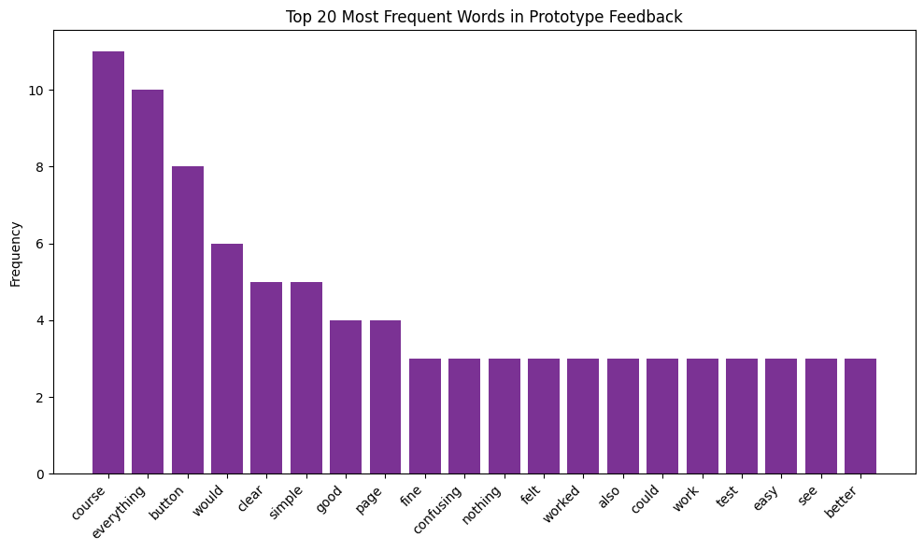
Fig. 4.17. Most common words in prototype feedback

Word cloud visualization is seen in Figure 4.18. illustrates the same feedback patterns discussed in the previous chapter. Frequently mentioned terms like “course,” “everything,” “button,” and “clear” stand out visually, confirming the main usability concerns and positive impressions raised by participants. It provides a quick visual summary of the most common words used in open-text responses, helping to highlight recurring themes visually.

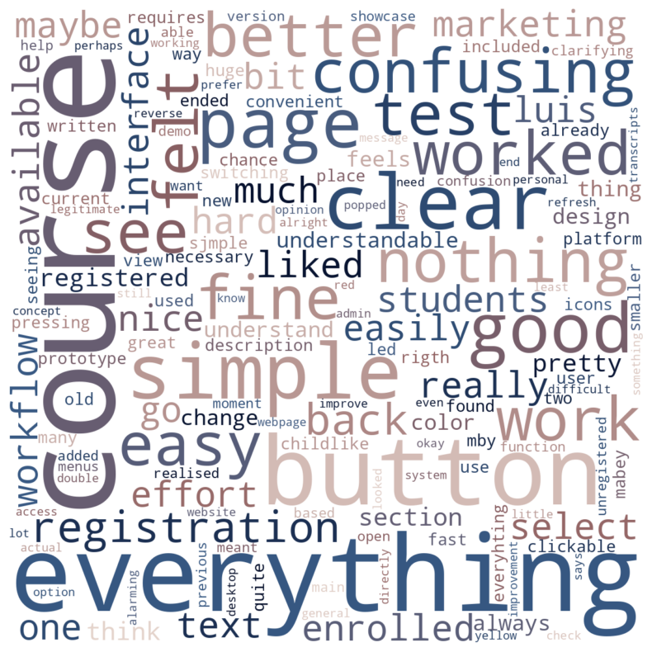
Fig. 4.18. Word cloud of prototype feedback

Summary of Testing Results
The workflow test shows that the redesigned information structure improves clarity and reduces cognitive load for both students and staff, which confirms that information architecture and layout hierarchy were the main drivers of the observed usability improvements.
The test results confirm that the redesign direction is meaningful and that the main issues identified earlier, navigation complexity, unclear labels, and scattered information, were addressed effectively.

User Interface Design Style Guide
This section presents the visual layer that supports the redesigned information architecture. While the previous sections focused on workflow logic and structure, the style guide defines how these improvements are expressed visually through color, typography, spacing, and basic interface components. The goal is to reinforce clarity, hierarchy, and accessibility without introducing unnecessary visual complexity.
The style library defines the visual rules that support the redesigned information architecture. It introduces a compact set of colors, typography, and basic components that keep the interface clear, predictable, and readable. The aim is not to finalize a visual identity, but to show how an updated academic system could look when guided by cognitive-load principles and accessibility requirements.
The color scheme is limited to six functional colors named in detail in Table P3.3. Style guide color codes in Appendix 3 and demonstrated visually in Figure 4.19. Each color has a clear role, which reduces visual noise and prevents users from relying on color alone to understand meaning. The palette is calm, low contrast in tone, and aligned with WCAG 2.2 guidelines. This palette was chosen because it stays stable across mobile and desktop, reduces cognitive effort, avoids bright or highly saturated tones, and maintains sufficient contrast between text and background.

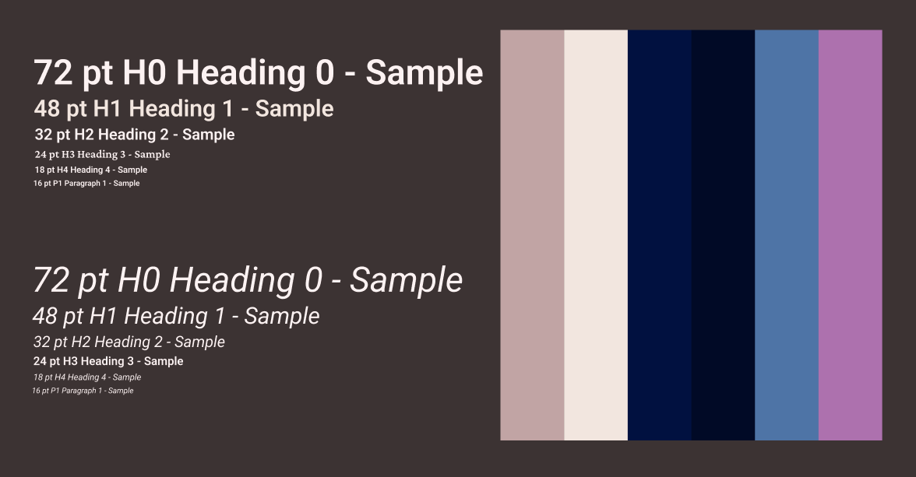
Fig. 4.19. Style guide

The component set includes buttons, cards, search bars, and top navigation. All components follow the same rounding, spacing, and color logic. The interface uses Roboto, a standard sans-serif typeface that remains readable in small sizes and works well on both mobile and desktop screens as seen on Figure 4.19. Using one typeface keeps the interface calm and consistent. It supports the principle of recognition over recall because the hierarchy is easy to scan:
- H1 (48 pt) – page titles
- H2 (32 pt) – section headers
- H3 (24 pt) – card headings
- H4 (18 pt) – action text
- P1 (16 pt) – regular body text
The layout follows an 8-point spacing system, which creates predictable rhythm across screens. It improves chunking and helps users understand grouping. Key rules:
- 8 px increments between smaller elements
- 24-32 px padding inside cards and containers
- Wide spacing between tap targets on mobile
- Actions placed close to the user’s main focus area
- This supports working memory limits and reduces visual clutter.
The style library in this thesis is not a complete design system. Its purpose is to demonstrate how improved information architecture can be visually supported through stable hierarchy, accessible color use, and consistent spacing. It provides a clear visual direction that future UX/UI teams can build on, without assuming a full redesign or final brand identity.
The style guide sets a visual baseline for the redesigned workflows. It reflects the cognitive-load principles and information-architecture decisions discussed earlier by defining concrete visual rules, including hierarchy, color use, typography, and spacing. These choices support the structural changes introduced in previous sections and help keep the interface predictable and easy to follow.

High-Fidelity Design Proposal
Building on the low-fidelity wireframes and the defined style guide, the next section presents the high-fidelity screen proposals. These screens apply the color palette, typography, spacing system, and component rules to show how the redesigned workflows would appear in a realistic mobile and desktop interface context.
The high-fidelity screens in this chapter show how the Style Guide can be applied to the redesigned information architecture as seen on Figure 4.20. These screens are not interactive prototypes and were not used for usability testing. Their role is to demonstrate a possible visual direction that supports the structural and cognitive principles developed earlier.

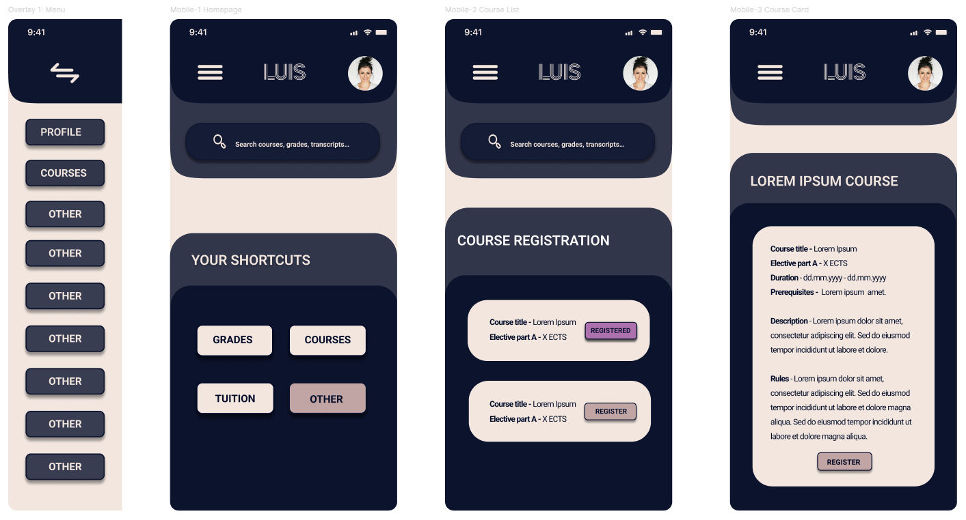
Fig. 4.20. High-fidelity mobile screens

Because this research focuses on information architecture and cognitive load, full prototyping or animation was not required. The high-fidelity screens serve as a visual interpretation of the improved layout logic and help illustrate visual hierarchy, color use, spacing and grouping, application of typography and icon style and overall tone of an updated academic interface. These screens show how a clean and predictable visual layer can reinforce the redesigned workflows described in the previous sections.
Mobile Homepage
The mobile homepage uses the new color palette and spacing rules to create a clear entry point into the system. The top bar contains only three elements - menu, system name, and profile-which keeps orientation stable across all screens. The search field is placed prominently to reduce navigation steps, and four shortcut buttons give quick access to core tasks such as grades and courses. The single-column layout, large tap targets, and clean grouping support faster scanning and match the behavior patterns identified in the survey.
Slide Out Menu
The slide-out menu follows the simplified navigation logic developed in information architecture redesign. It uses large buttons, short labels, and wide spacing to make every option easy to select on a small screen. The menu removes unnecessary nested categories and keeps all main items visible at once. This solves previous issues with deep navigation, inconsistent naming, and hidden options, while maintaining the same structure across all screens for predictability.
Course List
In the mobile course list, each course is shown as a card that groups the title, course part, and ECTS in a single view. Using a one-column layout makes scanning simpler and avoids the dense tables used in the original LUIS interface. The action state (Register or Registered) is visible directly on the card through a clear label. This allows users to act without opening additional pages and makes the current course status immediately understandable.
Course Card
The course card brings key information together in one place, including the description, prerequisites, rules, and duration. Information is separated into clear sections with enough spacing to make scanning easier. The Register button appears consistently at the bottom of the card. This reduces earlier issues with fragmented content and unclear hierarchy, as users can review all relevant details on a single screen without moving between pages.
These high-fidelity style screens are not a finished interface, but a visual demonstration of how the redesigned information architecture and psychological principles can be supported through a consistent visual layer. They help translate the structural improvements into a clear and modern direction that can guide future development work on LUIS.

Future Work
This study shows that improvements in information architecture and workflow structure can significantly reduce extraneous cognitive load in academic information systems. Future work should first extend the redesigned concepts into full, production-level workflows. Implementing the redesigned structures in a real LUIS environment would make it possible to observe actual user behavior, measure task completion times, track navigation paths, and record interaction errors under real conditions. This would allow direct validation of the prototype-based findings using behavioral data rather than self-reported perceptions.
A second direction for future work is large-scale validation across user groups and institutions. While this study focused on one institution, LUIS serves a broad national user base. Testing the redesigned workflows with a larger and more diverse sample, especially with administrative staff from different faculties and institutions, would strengthen the generalizability of the findings and reveal role-specific differences in workflow complexity that were outside the scope of this thesis.
Further development could also focus on the creation of a full design system for LUIS successor platforms. The style guide presented in this thesis can serve as a structural and visual starting point, but a complete system would require extended component libraries, interaction standards, responsive layout rules, and formal accessibility specifications. Close collaboration with developers of the national academic information systems would be essential to align UX decisions with technical constraints, data security requirements, and long-term system maintenance.
Another possible direction for future work is the use of system log analysis. In this study, usability evaluation relied on surveys and prototype testing, while real usage logs could capture navigation behavior, error frequency, and task duration under everyday conditions. Linking such log data with cognitive load indicators could support longer-term monitoring of usability changes and help prioritize future redesigned work.
Together, these directions outline a clear path from prototype-based research toward real-world system transformation. By combining workflow implementation, large-scale testing, design system development, and behavioral data analysis, future work can build directly on the methodological and analytical foundation established in this thesis.
Chapter Summary
This Practical Part demonstrated how the analytical findings were translated into redesigned workflows and a structured interface concept for LUIS. The redesign focused on reducing extraneous cognitive load through clearer navigation paths, simplified terminology, improved grouping of information, and a consistent visual hierarchy grounded in cognitive load theory and information architecture principles.
Prototype testing results indicate consistent improvement across all measured dimensions. Users rated the redesigned workflows as easier to use, with lower reported mental effort and higher clarity compared to the current LUIS interface. The findings suggest that simplified structure and more predictable interaction patterns support faster understanding and reduced cognitive strain. Differences between user groups remain visible, but positive change was observed across all groups, with particularly strong results in mobile student workflows.
The evaluation supports the central assumption of this thesis that usability problems in academic information systems are driven mainly by interface structure and presentation rather than by task logic. The redesigned workflows demonstrate that clearer information architecture, stable layout logic, and consistent terminology already produce measurable benefits even before full system implementation. This confirms that information architecture operates as a primary usability layer and that cognitive-load principles can guide effective system restructuring at an early design stage.

DISCUSSION
The findings of this thesis confirm that many structural problems in academic information systems can be addressed effectively through cognitive-load principles and user-centered information architecture. The observed improvements in workflow clarity, reduced mental effort, and more predictable navigation indicate that even partial, structure-focused redesigns can deliver measurable usability gains without requiring full system replacement.
The distinction between intrinsic and extraneous cognitive load proved especially useful for understanding where intervention is most effective. In the case of LUIS, workflows generally show low intrinsic difficulty, meaning that users understand the academic logic of the tasks. The main source of difficulty lies in extraneous load created by unclear labels, inconsistent navigation, scattered layouts, and excessive visual noise. This confirms that the primary usability barrier is not what users must do, but how the system presents what must be done. For future academic platforms, this implies that reducing extraneous load should be a design priority before functional expansion.
The results also highlight the importance of distinguishing information architecture from visual design. In this thesis, the initial focus was on reorganizing structure, grouping, terminology, and task flow, while visual styling remained secondary. Even at this stage, measurable improvements in usability were observed. This suggests that well-structured information architecture can guide effective design decisions independently of full UI development and can form the foundation for large-scale academic system redesign.
From an institutional and governance perspective, the findings indicate that usability should not be treated as a purely aesthetic concern, but as an operational factor in digital public services. In academic environments, weaknesses in information structure directly affect study processes, grade handling, and administrative accuracy. In the context of national digitalization initiatives, this supports the inclusion of early user testing, cognitive design principles, and role-based workflow modelling as part of standard development practices.
The practical value of this work is also clear for institutional IT teams. Even in legacy systems such as LUIS, smaller interventions - such as rewriting labels, restructuring layouts, simplifying navigation, and improving feedback placement - can produce substantial usability improvements. These are realistic changes that can be implemented even when full platform renewal is not immediately possible.
From a Digital Humanities perspective, these findings position academic information systems as sociotechnical infrastructures, where interface structure, terminology, and workflow logic actively shape institutional practices and everyday academic work.
Finally, the interdisciplinary approach used in this thesis - combining usability surveys, NLP analysis, cognitive theory, and interface design - shows a transferable framework for academic system evaluation. This method can be reused for internal usability audits, workflow testing, and redesign planning in other institutions or national platforms.
Overall, the thesis contributes not only a diagnosis of current usability problems in LUIS but also a structured roadmap for how academic information systems in Latvia can evolve toward clearer structure, lower cognitive load, and stronger alignment with real user behavior.

CONCLUSION
This thesis explored how cognitive-load principles, information architecture, and simplified visual structure can improve the usability of academic information systems, using LUIS as a case study. The main aim was to identify which design factors create unnecessary cognitive effort for users and to develop a redesign strategy that reduces this load. The research combined theoretical insights, a structured analytical process, and a practical demonstration of redesigned workflows. The results show that usability problems in LUIS come mainly from the structure and organization of the interface rather than from the academic logic of the tasks themselves.
From a Digital Humanities perspective, this thesis demonstrates how computational methods such as survey analysis and NLP can support qualitative interpretation of complex digital infrastructures. Academic information systems can be understood as cultural and institutional artefacts rather than purely technical tools. By examining how users interact with structure, language, and navigation, this research approaches LUIS as a socio-technical system embedded in everyday academic practice.
The theoretical part demonstrated that cognitive load theory, user-centered design, and visual hierarchy offer a clear framework for analyzing academic systems. The distinction between intrinsic and extraneous load proved especially useful. Most tasks in LUIS have low intrinsic difficulty, meaning users understand the academic rules behind tasks. However, the interface introduces high extraneous load through unclear terminology, inconsistent navigation paths, small interactive elements, and delayed feedback. This shows that reducing extraneous load should be the main priority when improving administrative information systems.
The empirical results confirmed these insights. Survey findings revealed low intrinsic difficulty but consistently high extraneous difficulty and high clarity importance across all user groups. Students reported repeated issues with navigation and unclear labels, especially on mobile devices. Administrative staff worked with more complex workflows but still faced problems caused by interface structure. NLP analysis supported this by showing repeated terms such as “find,” “menu,” “unclear,” “hidden,” “duplicate,” “slow,” and “error.” These patterns matched the quantitative data and showed that users struggle with how LUIS presents information rather than with the tasks themselves.
The Practical Part applied these findings by redesigning two priority workflows: Search and Register for Courses (desktop and mobile) and Exam Grade Entry (desktop).
The redesign focused on shortening navigation paths, clarifying terminology, grouping related elements, applying predictable structure, and introducing basic accessibility support. Low-fidelity interactive prototypes were created and tested. High-fidelity screens were developed as visual proposals to show a possible future UI direction and were not used for testing.
Usability testing with the low-fidelity interactive prototypes showed clear improvements across all measured dimensions. Ease of workflow increased, mental effort decreased, and clarity ratings improved. Mobile users gave the strongest ratings, reflecting the benefits of simplified one-column layouts and clearer grouping. Desktop students also showed positive responses, and administrative staff reported improvement in their complex workflows. These results confirm that improving information architecture alone can meaningfully reduce cognitive load, even without full UI implementation.
This study met its stated aim and provided support for the proposed hypothesis. The findings indicate that targeted improvements in structure, terminology, and visual organization can substantially improve the usability of an academic information system. The research shows theoretical relevance through the application of cognitive load principles to an academic platform and empirical relevance through measurable user improvements observed after workflow redesign. The methods applied in this thesis -survey analysis, NLP techniques, workflow scoring, and structured redesign - together form a replicable framework that can be adapted for other institutional platforms.
The research question asked how user-centered information architecture, informed by cognitive-load principles, can improve the usability of academic information systems and what the case of LUIS shows about reducing unnecessary mental effort. The results show that clearer structure, consistent terminology, and improved visual grouping directly reduce extraneous cognitive load for all user groups. The case of LUIS shows that many usability barriers come from how information is organized rather than from the academic tasks themselves.
Future research could continue this work by developing fully interactive high-fidelity prototypes, running behavioral usability tests, and analyzing real system logs when they become available. Another direction is the creation of a complete design system for future national academic platforms based on the style guide principles proposed in this thesis.
Overall, the research shows that improving information architecture is a realistic and effective way to modernize academic information systems. Clear structure, consistent labels, and predictable visual layout help system users complete tasks with less mental effort. The results provide a practical foundation for future design and development work on LUIS and similar academic platforms as Latvia moves toward unified national education systems.

LIST OF REFERENCES
Abdulai, R. T., & Owusu-Ansah, A. (2014). Essential Ingredients of a Good Research Proposal for Undergraduate and Postgraduate Students in the Social Sciences. Sage Open, 4(3), 2158244014548178. https://doi.org/10.1177/2158244014548178
Alasmari, T. (2020). The Effect of Screen Size on Students’ Cognitive Load in Mobile Learning. Journal of Education, Teaching and Learning, 5(2), 280–295.
Berry, D. M., & Fagerjord, A. (2017). Digital humanities: Knowledge and critique in a digital age. Polity.
Bird, S., Klein, E., & Loper, E. (2009). Natural language processing with Python. O’Reilly.
Cierniak, G., Scheiter, K., & Gerjets, P. (2009). Explaining the split-attention effect: Is the reduction of extraneous cognitive load accompanied by an increase in germane cognitive load? Computers in Human Behavior, 25(2), 315–324. https://doi.org/10.1016/j.chb.2008.12.020
Darejeh, A., Marcusa, N., Mohammadi, G., & Sweller, J. (2024). A critical analysis of cognitive load measurement methods for evaluating the usability of different types of interfaces: Guidelines and framework for Human-Computer Interaction (No. arXiv:2402.11820). arXiv. https://doi.org/10.48550/arXiv.2402.11820
Duarte Nancy. (2019). Data Story: Explain Data and Inspire Action Through Story. IdeaPress Publishing.
Education and student information systems: OECD Digital Education Outlook 2023. (2023). In OECD. https://www.oecd.org/en/publications/oecd-digital-education-outlook-2023_c74f03de-en/full-report/education-and-student-information-systems_ef9f7b25.html
Ertel, Wolfgang. (2011). Introduction to Artificial Intelligence. Springer.
Faudzi, M. A., Cob, Z. C., Ghazali, M., Omar, R., & Sharudin, S. A. (2024). User interface design in mobile learning applications: Developing and evaluating a questionnaire for measuring learners’ extraneous cognitive load. Heliyon, 10(18), e37494. https://doi.org/10.1016/j.heliyon.2024.e37494
Figma. (2025). Smart animate layers between frames – Figma Learn—Help Center. https://help.figma.com/hc/en-us/articles/360039818874-Smart-animate-layers-between-frames?utm_source=chatgpt.com
Figma Prototype Testing with Maze | Maze + Figma. (2024, 2025). Maze. https://maze.co/integrations/figma/
Ghafur, I. A., Abdurrahman, L., & Putra, S. A. (2025). Utilization of Process Mining to Analyze and Identify Improvement Opportunities in the New Student Admission Process. Proceedings of the 2025 14th International Conference on Software and Computer Applications, 6–12. https://doi.org/10.1145/3731806.3731832
Google Colaboratory. (2025). [Computer software]. Google LLC. https://colab.research.google.com
Google Forms. (2025). [Computer software]. Google LLC. https://www.google.com/forms/about/
Izglītības un zinātnes ministrija. (2020). Augstākās izglītības iestāžu digitalizācijas izvērtējums Latvijā (p. 80). Izglītības un zinātnes ministrija. https://ppdb.mk.gov.lv/wp-content/uploads/2020/12/Digitalizacijas_izvertejums_PETIJUMS.pdf
Izglītības un zinātnes ministrija. (2024, April 3). ES fondu atbalsts augstākajai izglītībai un zinātnei (2021-2027). https://www.izm.gov.lv/lv/es-fondu-atbalsts-augstakajai-izglitibai-un-zinatnei-2021-2027
Izglītības un zinātnes ministrija. (2025, May 27). 4.2.2.11. Pasākuma “Studiju procesa digitalizācija” īstenošanas noteikumi [Government presentation]. https://www.izm.gov.lv/lv/media/28545/download?attachment
IZM. (2025, May 27). Latvijā uzsāk augstākās izglītības digitalizāciju: Modernizēts studiju process, mazāks birokrātiskais slogs un plašāka pieejamība studentiem | Izglītības un zinātnes ministrija. Izglītības un zinātnes ministrija. https://www.izm.gov.lv/lv/jaunums/latvija-uzsak-augstakas-izglitibas-digitalizaciju-modernizets-studiju-process-mazaks-birokratiskais-slogs-un-plasaka-pieejamiba-studentiem
Jurafsky, D., & Martin, J. H. (2009). Speech and language processing: An introduction to natural language processing, computational linguistics, and speech recognition (Second edition). Pearson Prentice Hall.
Lamarre, E., Smaje, K., & Zemmel, R. (2023). Rewired: The McKinsey Guide to Outcompeting in the Age of Digital and AI. John Wiley & Sons.
Leppink, J., Paas, F., Van der Vleuten, C. P. M., Van Gog, T., & Van Merriënboer, J. J. G. (2013). Development of an instrument for measuring different types of cognitive load. Behavior Research Methods, 45(4), 1058–1072. https://doi.org/10.3758/s13428-013-0334-1
Malviya, A., & Malmgren, M. (2019). Big data for managers: Creating value. Routledge.
Marek Pałys. (2024, December 2). Understanding the Impact of Cognitive Psychology on UX Design. Startup House. https://startup-house.com/blog/cognitive-psychology-ux-design
Ministru kabinets. (2024, June 25). Rīkojums Nr. 522: Par investīcijas 2.1.2.1.i. “Centralizētās platformas un sistēmas” nolūka “Pašvaldību pakalpojumu digitālā transformācija un pašvaldību atbalsta procesu modernizācija un centralizācija, t. Sk. Sadarbībā ar valsts pārvaldes institūcijām” projekta “Izglītību apliecinošo dokumentu reģistrs pases un koplietošanas pakalpojumu attīstības plāna” apstiprināšanu. Latvijas Vēstnesis. https://likumi.lv/ta/id/353057
Ministru kabinets. (2025, May 30). Eiropas Savienības kohēzijas politikas programmas 2021–2027. Gadām 4.2.2. Specifiskā atbalsta mērķa … 4.2.2.11. Pasākuma “Studiju procesa digitalizācija” pirmās un otrās projektu iesniegumu atlases kārtas īstenošanas noteikumi. Latvijas Vēstnesis, Nr. 103 (Official Gazette). https://www.vestnesis.lv/op/2025/103.5
Mitchell, M. (2019). Artificial intelligence: A guide for thinking humans. Farrar, Straus and Giroux.
Negnevitsky, Michael. (2011). Artificial Intelligence: A Guide to Intelligent Systems (3rd ed.). Pearson Education Limited.
O’Keeffe, A., & McCarthy, M. (2022). The Routledge handbook of corpus linguistics. Routledge.
Orlikowski, W. J. (2000). Using Technology and Constituting Structures: A Practice Lens for Studying Technology in Organizations. Organization Science, 11(4), 404–428. https://doi.org/10.1287/orsc.11.4.404.14600
Ouwehand, K., Lespiau, F., Tricot, A., & Paas, F. (2025). Cognitive Load Theory: Emerging Trends and Innovations. Education Sciences, 15(4), 458. https://doi.org/10.3390/educsci15040458
Persico, D., & Pozzi, F. (2015). Informing learning design with learning analytics to improve teacher inquiry. British Journal of Educational Technology, 46(2), 230–248. https://doi.org/10.1111/bjet.12207
Puebla, C., Fievet, T., García, J., Tsopanidi, M., & Clahsen, H. (2022). Promoting social and collaborative language learning among older adults in the digital era: Development and evaluation of a smartphone app prototype using a design-thinking approach. Gerontechnology, 21(1), 1. https://doi.org/10.4017/gt.2022.21.1.483.06
Schreibman, S., Siemens, R. G., & Unsworth, J. (2016). A new companion to digital humanities. Wiley/Blackwell.
Skulmowski, A., & Xu, K. M. (2022). Understanding Cognitive Load in Digital and Online Learning: A New Perspective on Extraneous Cognitive Load. Educational Psychology Review, 34(1), 171–196. https://doi.org/10.1007/s10648-021-09624-7
Sweller, J. (2011). CHAPTER TWO - Cognitive Load Theory. In J. P. Mestre & B. H. Ross (Eds.), Psychology of Learning and Motivation (Vol. 55, pp. 37–76). Academic Press. https://doi.org/10.1016/B978-0-12-387691-1.00002-8
VARAM. (2025, July 5). Nacionālais finansējums. Vides aizsardzības un reģionālās attīstības ministrija. https://www.varam.gov.lv/lv/nacionalais-finansejums
W3C. (2024). Web Content Accessibility Guidelines (WCAG) 2.2. https://www.w3.org/TR/WCAG22/?utm_source=chatgpt.com
Weichbroth, P. (2024). Usability Testing of Mobile Applications: A Methodological Framework. Applied Sciences, 14(5), 1792. https://doi.org/10.3390/app14051792
What is future of XD? No way to download anymore. (2024, January 2). Https://Community.Adobe.Com. https://community.adobe.com/t5/adobe-xd-discussions/what-is-future-of-xd-no-way-to-download-anymore/m-p/14330917#M74348
Xiao, H., Sun, Y., Duan, Z., Huo, Y., Liu, J., Luo, M., Li, Y., & Zhang, Y. (2024). A Study of Model Iterations of Fitts’ Law and Its Application to Human–Computer Interactions. Applied Sciences, 14(16), 7386. https://doi.org/10.3390/app14167386
Zawacki-Richter, Olaf; Marin, Victoria I.; Bond, & Melissa; Gouverneur, Felicitas. (2019). Systematic Review of Research on Artificial Intelligence Applications in Higher Education. International Journal of Educational Technology in Higher Education, 16(39), 1–27. https://doi.org/10.1186/s41239-019-0171-0
Žogota-Kiliča, A. (2025). LUIS-Usability-Thesis-Zogota: Case study on redesigning academic system workflows through usability analysis, cognitive load theory and prototype testing [Computer software]. GitHub. https://github.com/aliiane/LUIS-Usability-Thesis-Zogota

APPENDICES
Supplementary datasets, full analysis notebooks, prototype testing live links, Figma project, all datasets and additional figures that are not included in the thesis PDF are available in the project repository (Žogota-Kiliča, 2025).

Appendix 1
1. Initial LUIS usability survey questionnaire
- Role: student; academic staff (lecturer); administrative staff; other.
- Experience with LUIS: less than 6 months; 6–12 months; 1–3 years; more than 3 years.
- Frequency of LUIS use: daily; a few times per week; a few times per month; rarely.
- Devices used: desktop/laptop; mobile phone; tablet.
- Workflows used at least monthly (multiple choice): personal profile; course search and registration; course schedule; grades or exam results; transcript export; exam grade entry; enrolment or unenrollment; study plan approval; payment or status reports; course grading; course list search; course information management; tuition or invoices; academic report preparation; other.
- Workflow is most in need of improvement (single choice from the same list).
- Frequency of selected workflow: daily; weekly; monthly; a few times per semester; rarely.
- Estimated number of steps: 1–2; 3–4; 5–6; 7+; not sure.
- Task difficulty (intrinsic): scale 1–5.
- Interface-related difficulty (extraneous): scale 1–5.
- Estimated task time: under 1 minute; 1–3 minutes; 3–5 minutes; 5–10 minutes; over 10 minutes.
- Friction points (multiple choice): difficult to find menu; too many pages; unclear terminology; hidden actions; unclear errors; slow feedback; duplicate steps; mobile difficulties; performance issues; access or permission issues; other.
- Where the user gets stuck (open text).
- Main improvement suggestion (open text).
- Two highest-priority workflows for improvement (select two).
- Overall need for clearer workflows: scale 1–5.
- Additional comments (open text).
2. LUIS workflow prototype test questionnaire
Test task 1: Enroll in the Marketing course using the mobile prototype.
Test task 2: Your task is to upload grades using the Excel upload option.
Single workflow only. Visual design was not evaluated.
Participants followed the path that felt logical to them.

- Perceived workflow difficulty: scale 1–5 (1 = very easy, 5 = very difficult).
- Perceived mental effort required: scale 1–5 (1 = low effort, 5 = high effort).
- Compared to the current LUIS design, this workflow is easier to use: scale 1–5 (1 = much harder, 5 = much easier).
- If anything felt unclear, confusing, or better than expected, describe it (open text).

Appendix 2.
1. Dataset structure: LUIS_Usability_Survey_Final.csv
Column name | Description | Data type | Example
timestamp | Time when the response was submitted | Date-time | 53:57.4
role | User role | Categorical | Student
experience | Years of experience with LUIS | Categorical | 1–3 years
usage_frequency | How often LUIS is used | Categorical | A few times per month
devices | Devices used for LUIS | Categorical (multi) | Desktop / Laptop, Mobile phone
workflows_used | Workflows used at least monthly | Categorical (multi) | View grades; Course registration
workflows_used_count | Number of workflows selected | Numeric (integer) | 4
workflow_to_improve | Workflow selected as most urgent to improve | Categorical | Search and register for courses
workflow_frequency | Frequency of selected workflow | Categorical | Monthly
steps_estimate | Estimated number of steps | Categorical | 4–Mar
intrinsic_difficulty | Perceived task difficulty (logic of task) | Ordinal (1–5) | 3.5
extraneous_difficulty | Perceived interface-related difficulty | Ordinal (1–5) | 4
clarity_importance | Importance of better clarity | Ordinal (1–5) | 2
task_time | Estimated time to complete task | Categorical | 3–5 min
task_time_seconds | Numeric version of task time | Numeric (integer) | 240
friction_points | Selected interface problems | Categorical (multi) | Can’t find menu; Confusing terminology
priority_workflows | Two workflows selected as top priorities | Categorical (multi) | Course registration; View grades
priority_primary | First selected priority workflow | Categorical | Search and register for courses
comments | Additional open-text user comment | Text | UX design is very old school
clarity_score | Numeric clarity score | Ordinal (1–5) | 3
priority_count | Number of workflows selected as priorities | Numeric (integer) | 1
role_Academic staff (lecturer) | One-hot encoded lecturer role | Binary (TRUE/FALSE) | FALSE
role_Administrative staff | One-hot encoded admin role | Binary (TRUE/FALSE) | FALSE
role_Student | One-hot encoded student role | Binary (TRUE/FALSE) | TRUE
priority_score | Composite workflow priority score | Numeric (integer) | 13

2. Dataset: Additional NLP variables added to the base dataset
Column name | Description | Data type | Example
open_text_all | Combined open-text responses from all comment fields | Text | “Too many pages/tabs…”
tokens | Tokenised words | List of strings | ['many','one','action']
lemmas | Lemmatized tokens | List of strings | ['many','one','action']
themes | Theme labels assigned during NLP classification | List of tags | ['navigation','clarity']
clean_text | Fully cleaned text for modeling | Text | many one action navigation clarity
dominant_topic | Topic ID assigned by the topic model | Integer | 2

3. Workflow_Prototype_Test_Cleaned.csv
Column name | Description | Data type | Example
timestamp | Time when the response was submitted | Time (string) | 03:11.3
difficulty | Perceived task difficulty | Ordinal (1–5) | 1
mental_effort | Perceived mental effort | Ordinal (1–5) | 5
easier_than_luis | Comparison with current LUIS | Ordinal (1–5) | 4
comments | Open-text user feedback | Text | “Everything was really good and clear”
user_group | Test group and device | Categorical | student_mobile
difficulty_rescaled | Rescaled difficulty score | Integer | 5
combined_score | Combined evaluation score | Integer | 14
tokens | Tokenised words from comment | List of strings | [‘everything’, ‘good’, ‘clear’]
lemmas | Lemmatized tokens | List of strings | [‘everything’, ‘good’, ‘clear’]

Appendix 3
Additional tables and figures
1. Summary of difficulty and clarity findings across workflows
Aspect | Main Pattern | What It Means | Affected Groups
Intrinsic Difficulty | Mostly levels 1–3 | Tasks are understood and not logically complex | Students (course tasks), Admin staff (routine tasks)
Higher Intrinsic Difficulty | Seen mainly in admin workflows | These tasks involve more rules and decisions | Admin staff (grade entry, enrolment, reports)
Extraneous Difficulty | Mostly levels 3–5 across all workflows | Users struggle with the interface, not the task logic | Students and Admin staff
Student Workflows | High extraneous difficulty despite low intrinsic | Navigation, terminology, and layout issues dominate | Students
Admin Workflows | High extraneous difficulty with multi-step tasks | Layout, unclear field structure, inconsistent feedback | Administrative staff
Clarity Importance | Mostly levels 3–5 | Clear labels and predictable structure are needed | All roles
Low Clarity Scores | Rare across roles | Confirms clarity is a universal pain point | All roles
System-wide Trend | High extraneous difficulty overall | Usability issues are widespread, not isolated | Entire user base
Implication for Redesign | Focus on reducing extraneous load | Improve labels, navigation, visibility, workflow structure | System-wide

2. Priority scores
Workflow | Avg. Priority Score | Interpretation
Transcript export | High (24) | Complex structure, unclear sequence, high cognitive load
Report preparation | High (23) | Many steps, unclear fields, frequent confusion
Exam grade entry | High (23) | Multi-page workflow, validation issues, high clarity need
View course schedule | Medium-high (18) | Simple task but poor navigation
Course registration | Medium (17) | High-volume task with unclear menus and hidden actions
View grades | Medium (17) | Structural clarity issues; low intrinsic difficulty
View/update profile | Medium (17) | Labeling and navigation confusion
Study plan updates | Medium (17) | Procedural task; unclear steps for many users

3. Style guide color codes
Purpose | Color name | Hex | Notes
Primary structural background | Dark Navy | #011140 | Headers, navigation, strong structural blocks; high contrast.
Secondary structural background | Deep Navy | #010A26 | Top bars, secondary navigation, cards with stronger emphasis.
Main interactive / focus accent | Soft Blue | #4E74A6 | Icons, focus states, highlights for active items.
Neutral content background | Soft Beige | #F2E6DF | Main reading area behind text; low visual load.
Primary action accent | Muted Rose | #A67C7C | Main buttons such as Register and Save.
Secondary accent (status / highlights) | Soft Lilac | #AD71AE | Secondary emphasis, subtle status badges, supporting charts or tags.

Appendix 4
LUIS existing grade entry workflow 4
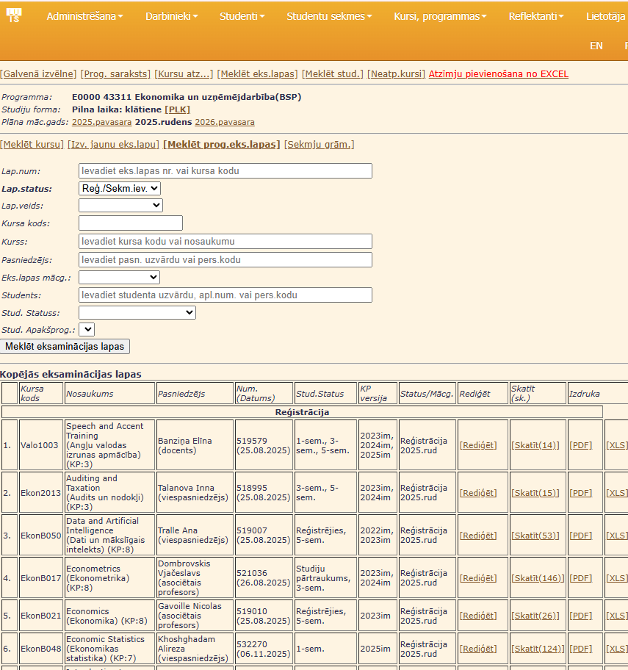

Appendix 5
1. Student desktop wireframe – homepage
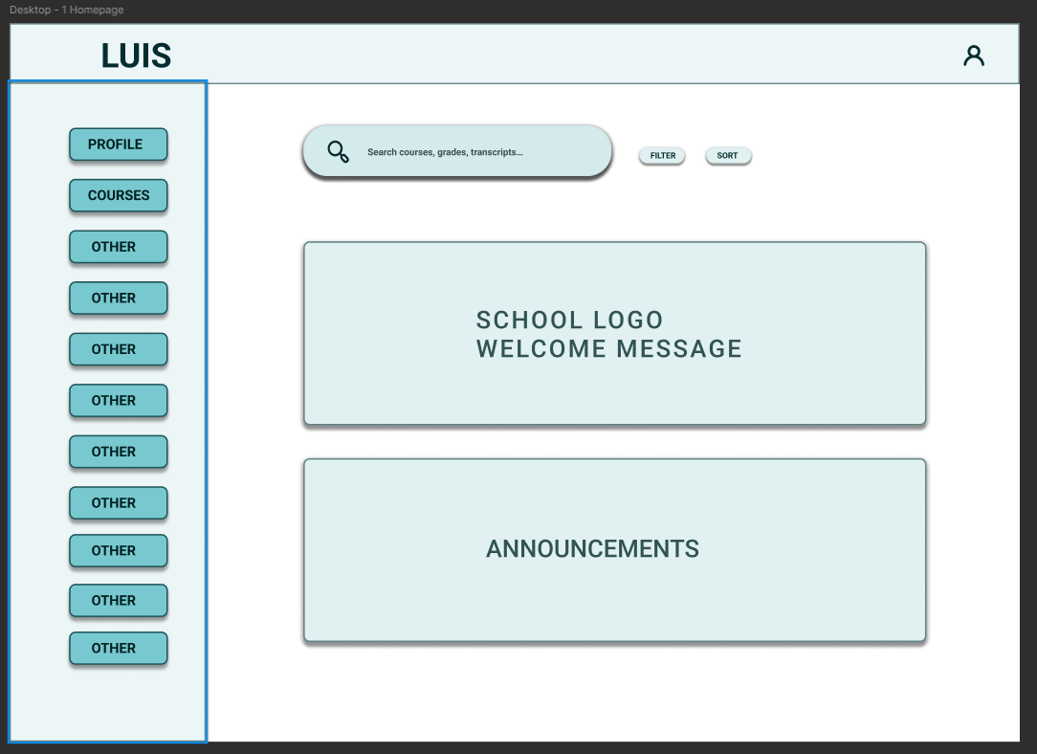

2. Student desktop wireframe – courses 1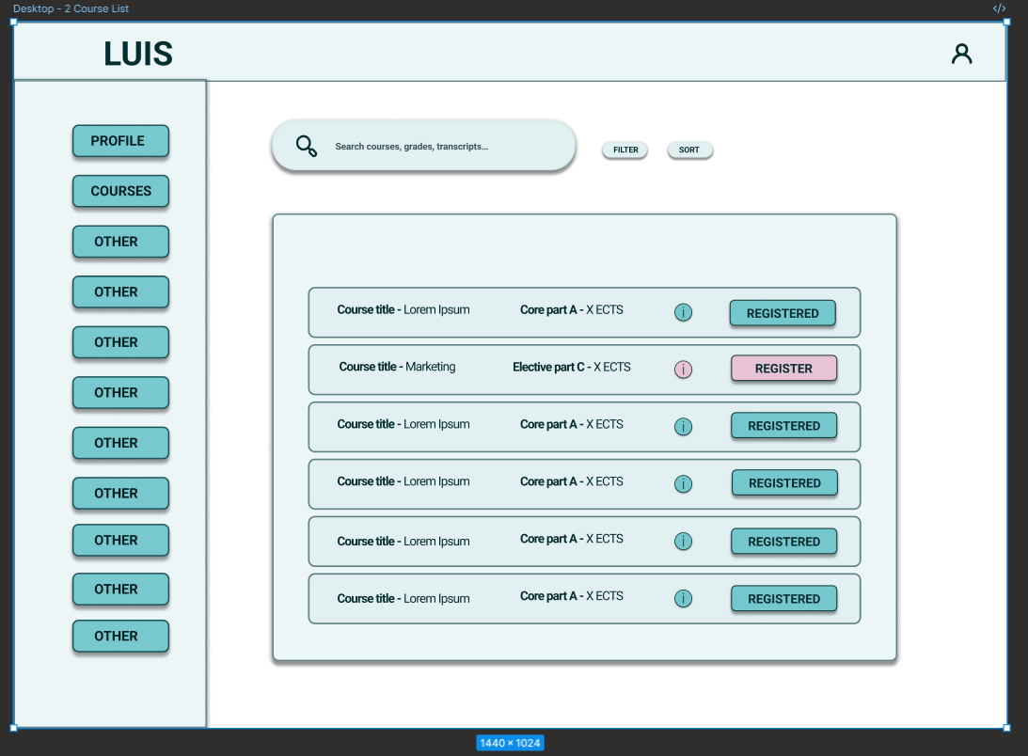
3. Student desktop wireframe – course details
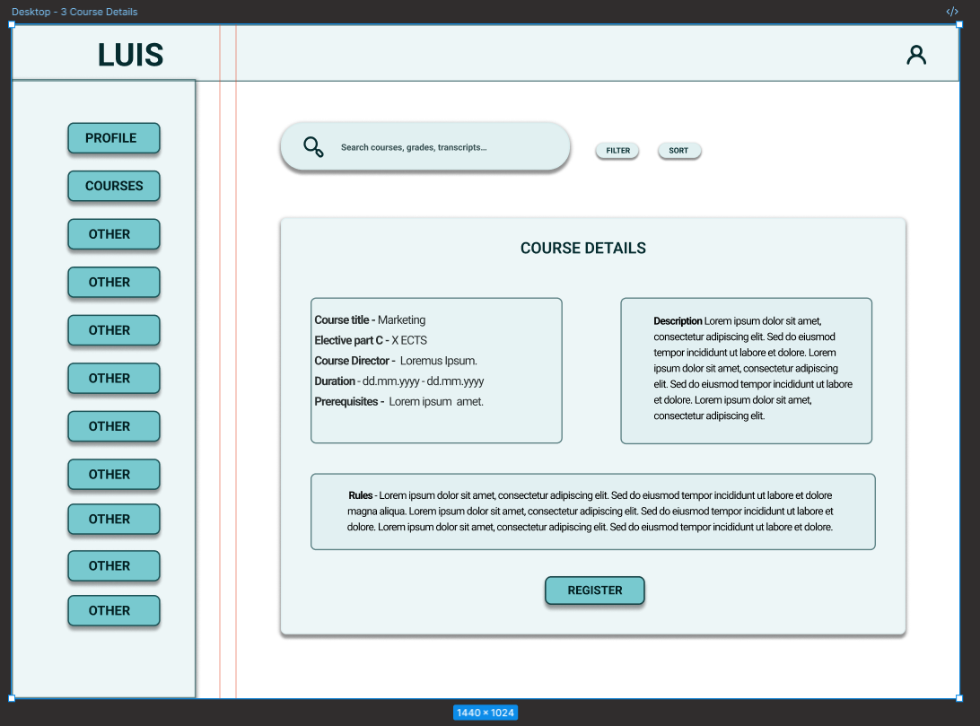

4. Student desktop wireframe – courses 2
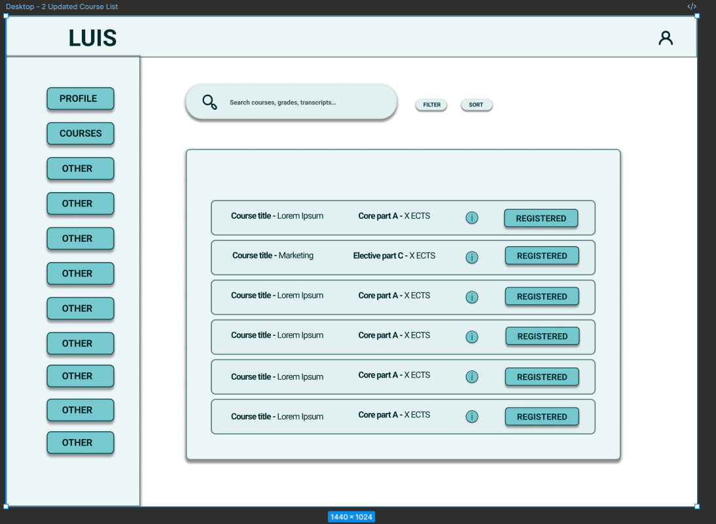
5. Admin desktop wireframe – homepage
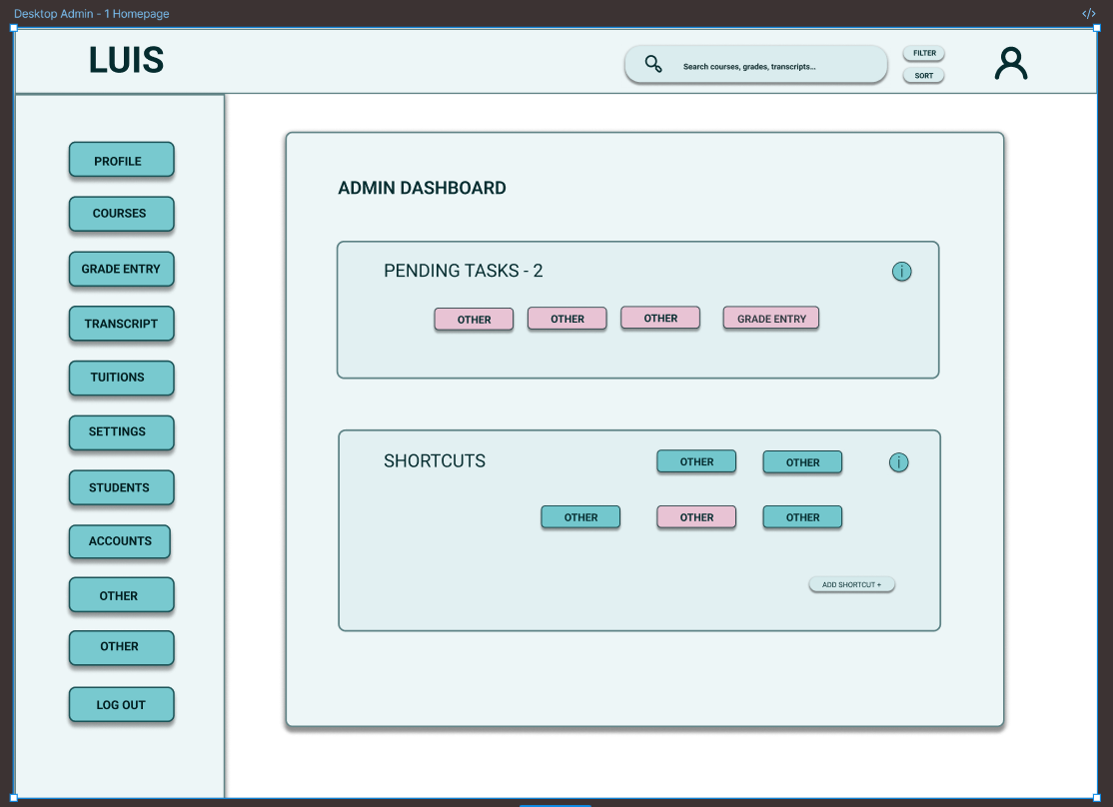

6. Admin desktop wireframe – course list
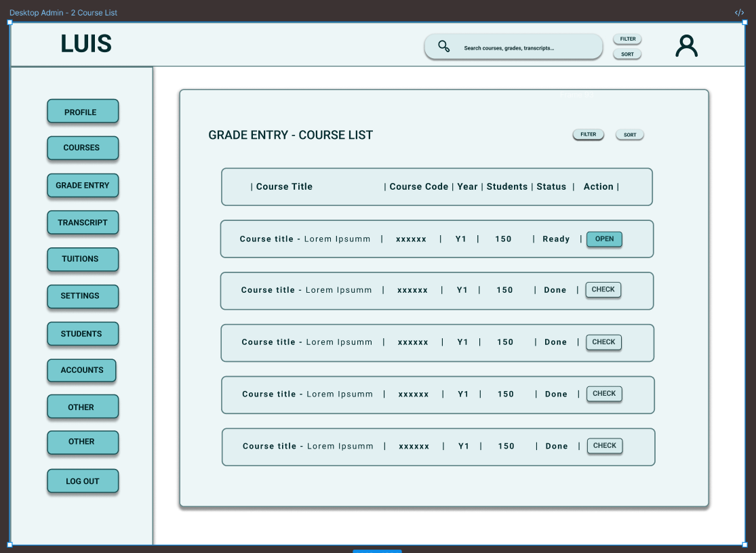
7. Admin desktop wireframe – grade entry
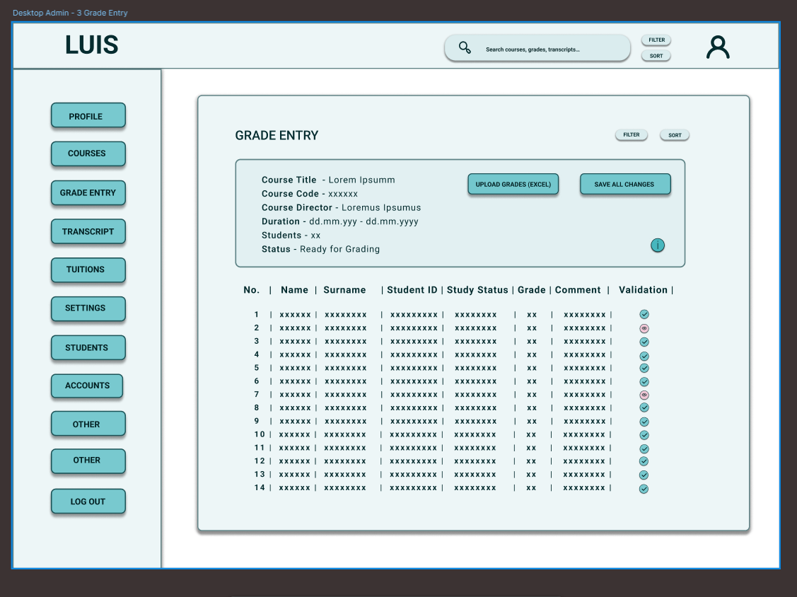

8. Admin desktop wireframe – onscreen pop-up grade upload
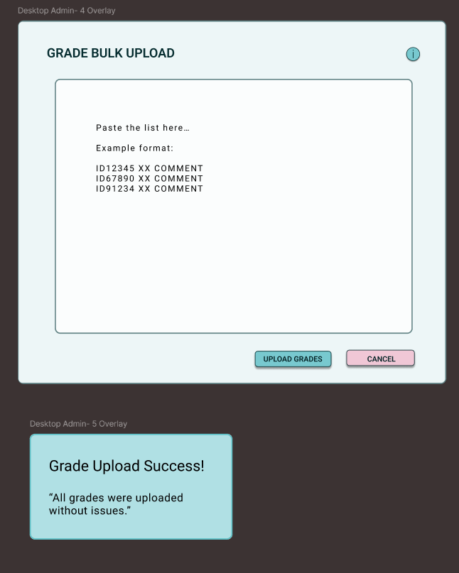
9. Student desktop workflow prototype wiring
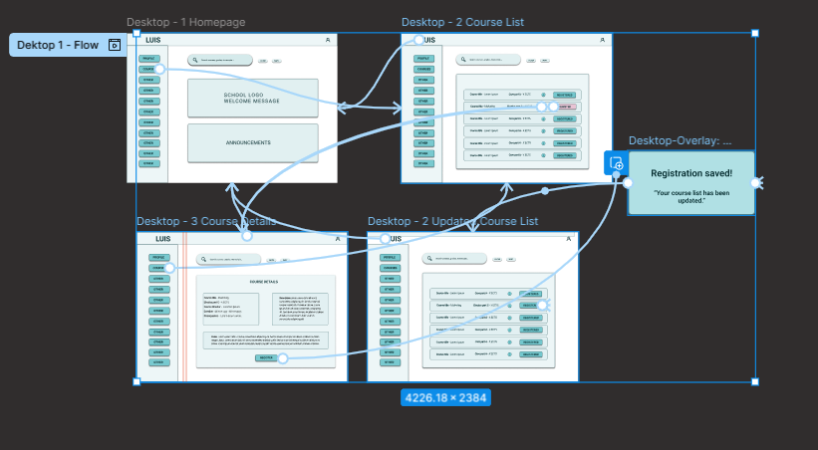

10. Admin desktop workflow prototype wiring
