**NAME: ALI GHULAM MURTAZA**

**ROLL NO: SFI-24S-001**

**LAB NO: 8**

**Task 1: Make a calculator using the function the code should use only 2 operands(+ and  -) for division and multiplication as well.**

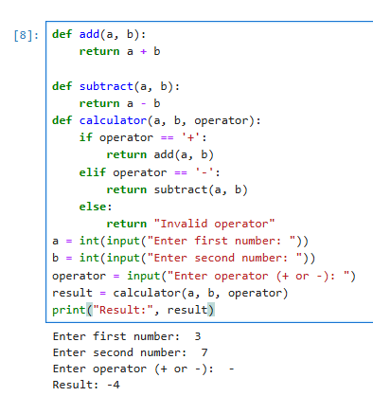

**Task 2: Write a functions that ask the user the shape and make the star shaped.(Like it asks the shape(triangle or Rectangle) and make that shape..)**

