Atlas v4.0 Performance Analysis Report
Bitcoin 15-Minute Prediction System - Deep Analysis

Executive Summary
Atlas v4.0 has been running for approximately 57 predictions, achieving a win rate of 34.5% with an average Brier score of 0.2416. The system is currently performing below random chance (50% win rate), indicating significant issues with the prediction methodology. However, the Brier score is marginally better than random (0.25), suggesting that while directional predictions are wrong more often than right, the probability estimates have some calibration value.

Key Performance Statistics
Metric | Value
Total Predictions | 57
Resolved Predictions | 55
Pending Predictions | 2
Correct Predictions | 19
Incorrect Predictions | 36
Win Rate | 34.5% (Below Random 50%)
Average Brier Score | 0.2416 (Better than 0.25 random)

Deep Analysis: What Is Going On?

1. Why Is Win Rate So Low?
The 34.5% win rate is significantly below the 50% random baseline. This indicates a systematic bias in the prediction system. Looking at the direction bias, the system made 24 UP predictions, 10 DOWN predictions, and 22 NEUTRAL predictions. This shows that when the system makes a directional call, it heavily favors UP predictions. However, the market during this period appears to have been trending downward or sideways, causing most UP predictions to fail.

2. Why Is Brier Score Better Than Win Rate?
The Brier score of 0.2416 is actually better than random (0.25), which seems contradictory to the low win rate. This is because Brier score measures probability calibration, not just directional accuracy. The system tends to make predictions with probabilities close to 50% (range 0.398-0.565, mean 0.511). When the predicted probability is close to 0.5, the Brier score penalty is smaller regardless of outcome. In other words, the system is appropriately uncertain and doesn't make extreme wrong predictions.

3. Agent Performance Analysis
The Darwinian weight adjustment system shows interesting results. RSI Master, Support/Resistance, and Order Flow agents all have maximum weights (5.0), while MACD Trend has been heavily penalized to 0.27 weight. Interestingly, MACD Trend has a higher individual win rate (58.9%) than RSI Master (57.1%), yet it was penalized more. This suggests the weight adjustment algorithm may have issues - it might be penalizing based on recent performance rather than overall accuracy. Additionally, 4 of 8 agents (Momentum Hawk, Volume Whale, Volatility Watcher, Sentiment Reader) have made zero predictions, likely because they are filtered out by the current market regime detection (only "RANGING" regime agents are active).

4. Probability Concentration Problem
The predicted probabilities are concentrated in a very narrow range (0.398 - 0.565) with a standard deviation of only 0.043. This indicates that the system is essentially making near-random predictions. A well-calibrated prediction system should have probabilities spread across a wider range when it has genuine insight. The narrow spread suggests the agents are not finding strong signals in the market data and defaulting to near-neutral predictions.

Performance Visualization
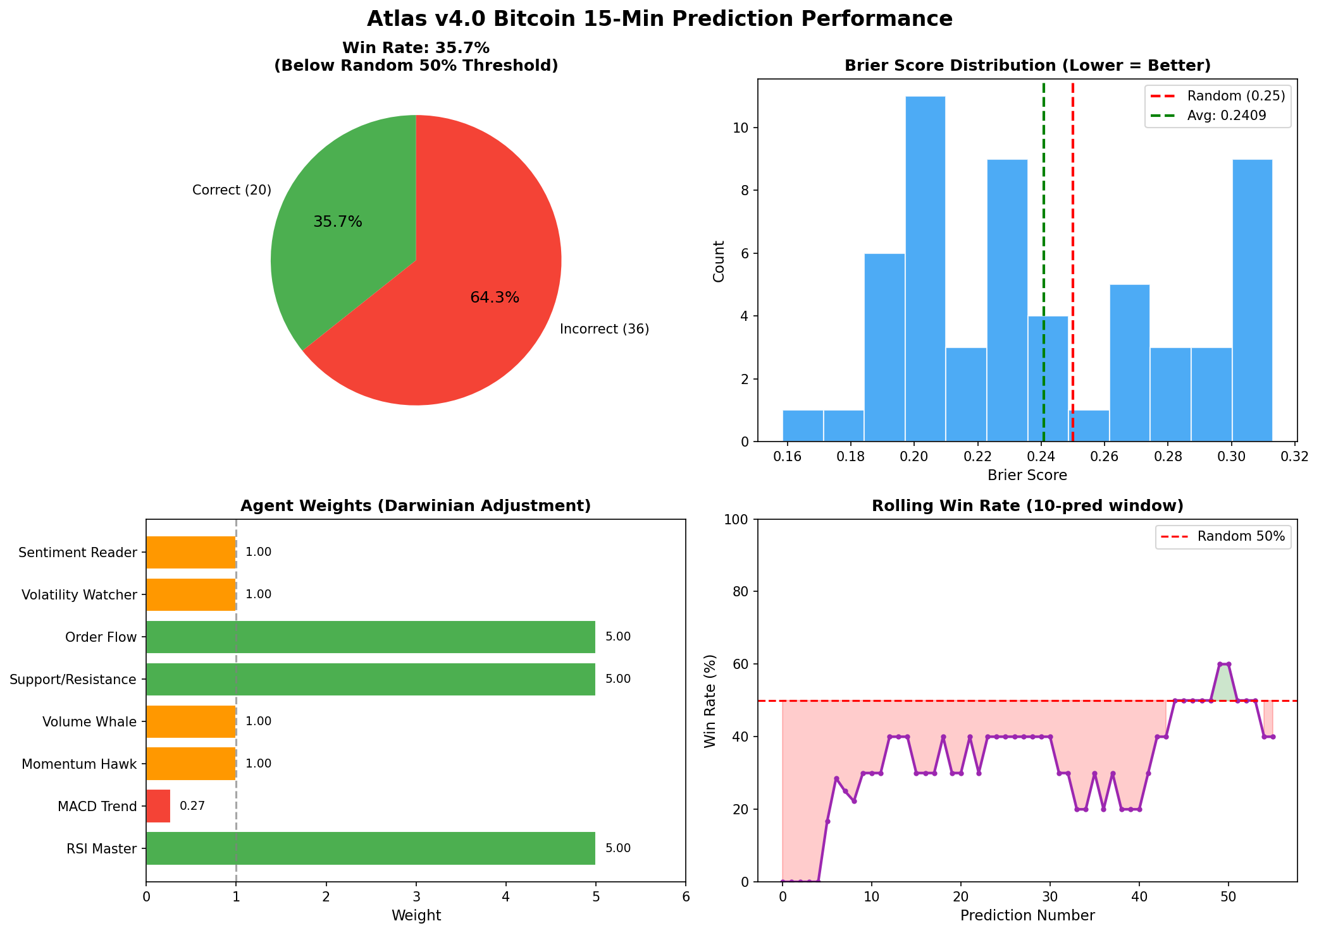
Figure 1: Atlas v4.0 Performance Analysis Dashboard

Recommendations

Short-term Fixes
1. Fix the regime filtering to use all agents, not just regime-specific ones. The current setup leaves 50% of agents unused.
2. Investigate why MACD Trend was penalized despite good performance - there may be a bug in the weight adjustment logic.
3. Add a confidence threshold - only make predictions when confidence exceeds a minimum level (e.g., 55% probability).

Medium-term Improvements
1. Implement regime-aware prediction adjustment - if market is in a downtrend, weight DOWN predictions more heavily.
2. Add ensemble diversity by ensuring agents have different signal sources and are not all converging on similar predictions.
3. Consider using market odds from Polymarket as a baseline - the system should at minimum match market efficiency.

Long-term Strategy
1. Collect more training data - 57 predictions is insufficient for meaningful learning.
2. Implement backtesting on historical data to validate strategies before live prediction.
3. Consider adding external signals (on-chain metrics, derivatives data, sentiment) that are currently collected but may not be effectively used.

Conclusion
Atlas v4.0 is currently underperforming with a 34.5% win rate. The primary issues are: (1) heavy UP prediction bias during what appears to be a downtrend, (2) narrow probability distribution indicating lack of genuine signal detection, (3) ineffective use of the multi-agent system due to regime filtering, and (4) potential bugs in the Darwinian weight adjustment. However, the marginally better-than-random Brier score (0.2416 vs 0.25) suggests the system has potential if these issues are addressed. The Darwinian learning mechanism is working (weights are adjusting), but the underlying prediction logic needs refinement.
The system should continue running to collect more data, but immediate fixes to the regime filtering and weight adjustment logic are recommended to improve performance.

