**OSPF**

We will use in medium or medium-large networks because EIGRP can only use up to 255 routers. OSPF can use unlimited routers and we define OSPF routes on the basis of router area. We can configure 4.2 billion areas in OSPF.

Our main concern is with backbone area, **AREA 0.** Every network should be gone through area 0.

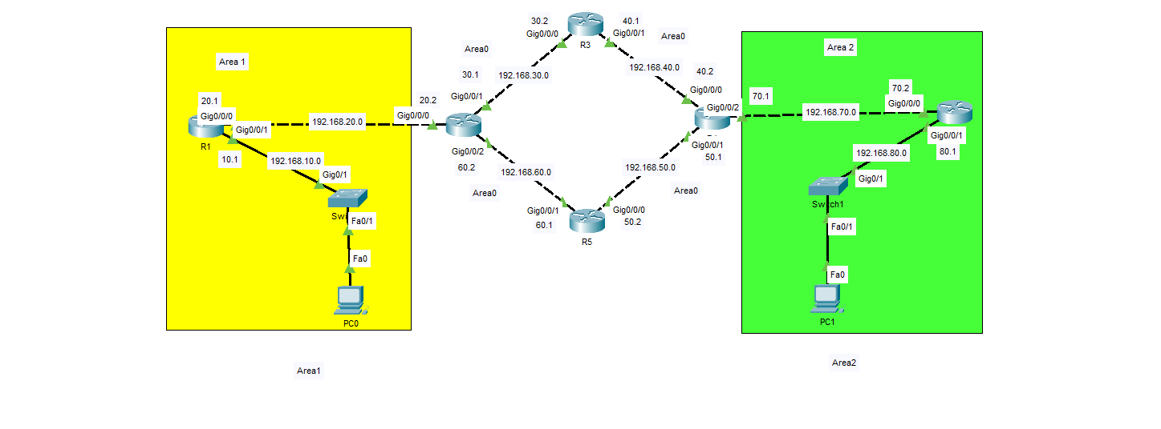

**Router 1:**

R1>en

R1#configure t

R1(config)#router ospf 300

R1(config-router)#network 192.168.10.0 0.0.0.255 area 1

R1(config-router)#network 192.168.20.0 0.0.0.255 area 1

R1(config-router)#

**Router 2:**

R2>en

R2#configure t

R2(config)#router ospf 300

R2(config-router)#network 192.168.20.0 0.0.0.255 area 1

R2(config-router)#network 192.168.30.0 0.0.0.255 area 0

00:42:09: %OSPF-5-ADJCHG: Process 300, Nbr 192.168.20.1 on GigabitEthernet0/0/0 from LOADING to FULL, Loading Done

R2(config-router)#network 192.168.60.0 0.0.0.255 area 0

R2(config-router)#

**Router 3:**

R3> en

R3#configure t

R3(config)#router ospf 300

R3(config-router)#network 192.168.30.0 0.0.0.255 area 0

R3(config-router)#network 192.168.40.0 0.0.0.255 area 0

00:46:15: %OSPF-5-ADJCHG: Process 300, Nbr 192.168.60.2 on GigabitEthernet0/0/0 from LOADING to FULL, Loading Done

R3(config-router)#

**Router 4:**

R4>en

R4#configure t

R4(config)#router ospf 300

R4(config-router)#network 192.168.40.0 0.0.0.255 area 0

R4(config-router)#network 192.168.50.0 0.0.0.255 area 0

00:53:40: %OSPF-5-ADJCHG: Process 300, Nbr 192.168.40.1 on GigabitEthernet0/0/0 from LOADING to FULL, Loading Done

R4(config-router)# network 192.168.70.0 0.0.0.255 area 2

R4(config-router)#

**Router 5:**

R5>

R5#configure t

R5(config)#router ospf 300

R5(config-router)#network 192.168.50.0 0.0.0.255 area 0

R5(config-router)#network 192.168.60.0 0.0.0.255 area 0

R5(config-router)#

00:56:35: %OSPF-5-ADJCHG: Process 300, Nbr 192.168.70.1 on GigabitEthernet0/0/0 from LOADING to FULL, Loading Done

00:56:44: %OSPF-5-ADJCHG: Process 300, Nbr 192.168.60.2 on GigabitEthernet0/0/1 from LOADING to FULL, Loading Done

R5(config-router)#

**Router 6:**

R6>en

R6#configure t

Enter configuration commands, one per line. End with CNTL/Z.

R6(config)#router ospf 300

R6(config-router)#network 192.168.70.0 0.0.0.255 area 2

R6(config-router)#network 192.168.80.0 0.0.0.255 area 2

R6(config-router)#

01:00:18: %OSPF-5-ADJCHG: Process 300, Nbr 192.168.70.1 on GigabitEthernet0/0/0 from LOADING to FULL, Loading Done

R6(config-router)#