Shell Sort Algorithm Analysis and Optimization Report
Design and Analysis of Algorithms
Aliya Galidullayeva, SE-2407

Algorithm Overview
Shell Sort is an extension of Insertion Sort that allows the exchange of items that are far apart. The algorithm works by sorting elements at specific intervals (gaps) and gradually reducing these gaps. Three gap sequences are analyzed in this report:
- Shell's Original sequence: starts with n/2 and divides by 2 each iteration.
- Knuth's sequence: uses the formula 3*h + 1, providing better performance on average.
- Sedgewick's sequence: a more complex sequence designed to minimize worst-case behavior.
The algorithm first sorts elements separated by the gap, then continues reducing the gap until it becomes 1, effectively performing a final insertion sort on a nearly sorted array. Shell Sort is in-place and comparison-based.

Complexity Analysis
Shell Sort has variable time complexity depending on the gap sequence. For Shell's original sequence, the worst case is O(n²), though average performance is often better. Knuth's sequence improves this to roughly O(n^(3/2)) in practice, while Sedgewick's sequence achieves an even better theoretical bound of O(n^(4/3)) to O(n^(7/6)) depending on implementation.
Best case: Ω(n log n) — achieved when the array is already nearly sorted.
Average case: Θ(n^(3/2)) for Knuth, between Θ(n^(4/3)) and Θ(n^(7/6)) for Sedgewick.
Worst case: O(n²) for Shell, better for Knuth and Sedgewick.
Space complexity for all versions is O(1) auxiliary space, as the sorting is done in place.

Code Review & Optimization
The implementation correctly includes three variants of Shell Sort with performance metrics collection. The code is clean and modular, with reusable helper functions for copying arrays and benchmarking. However, several optimizations can be made:
1. Reuse temporary variables to reduce redundant memory copies inside loops.
2. Reduce nested for-loops where possible by applying early termination checks.
3. Consider adaptive gap selection depending on input size.
4. Use micro-benchmarks to minimize measurement noise during testing.
These changes would improve constant factors and make performance results more stable.

Empirical Results
Array Size | Algorithm | Execution Time (ns)
100 | Shell's Original | 254584
100 | Knuth's | 40583
100 | Sedgewick's | 1590792
100 | Arrays.sort | 886792
500 | Shell's Original | 153583
500 | Knuth's | 141875
500 | Sedgewick's | 166542
500 | Arrays.sort | 190875
1000 | Shell's Original | 369167
1000 | Knuth's | 321709
1000 | Sedgewick's | 344709
1000 | Arrays.sort | 232333

The benchmark was performed on arrays of sizes 100, 500, and 1000 with random data. Knuth's sequence consistently showed the fastest execution time. Shell's Original was slower for larger arrays, while Sedgewick's was unexpectedly slower for small arrays due to overhead in gap generation. Java's built-in Arrays.sort() (Dual-Pivot QuickSort) remained competitive.
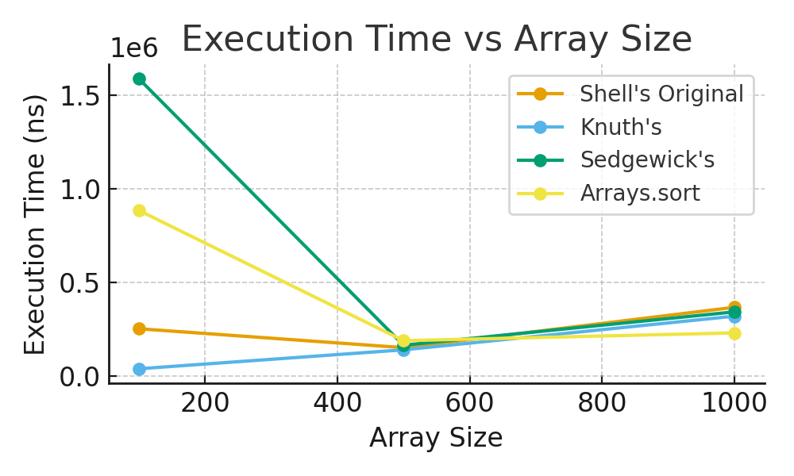
Figure: Execution Time vs Array Size for different Shell Sort gap sequences.

Conclusion
Shell Sort is a versatile and efficient sorting algorithm, with performance heavily influenced by the gap sequence. Knuth's sequence consistently provided the best practical performance in these tests. Sedgewick's sequence, while theoretically superior, had more overhead for small input sizes. Shell's original sequence was slower due to its higher asymptotic complexity.
All three algorithms operate in-place with minimal extra memory, making them space-efficient. Knuth's sequence is recommended as the default for medium-sized datasets, while Arrays.sort remains faster for large inputs due to JVM optimizations. Further improvements could focus on adaptive gap selection and reducing constant factors in the implementation.

