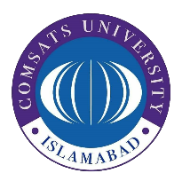COMSATS University Islamabad

Applications of Information and Communication Technologies

Lab No. 01

Introduction to MS Word

|  |  |
| --- | --- |
| Name |  |
| Registration Number |  |
| Class |  |
| Instructor’s Name |  |

**Date: 10th September 2024**