Quick Commerce & Generational Behaviour
Descriptive Analysis & Inferential Statistics | Gen Z vs Gen X | April 2026

4. Descriptive Analysis

4.1 Sample Demographics
Table 1 summarises the demographic composition of the final analytical sample (n = 101, after exclusion of zero-order respondents and extreme outliers). The two cohorts are well-matched on city tier — both skew Tier-1 urban (~58%) — but differ sharply on employment and marital status, reflecting lifecycle stage rather than sampling artefact. Gen Z is almost exclusively student (75%), unmarried (80%), and city-dwelling; Gen X is predominantly full-time employed or self-employed, married, and financially established. These structural differences underpin many of the behavioural contrasts documented below.

Table 1. Sample Demographics by Generation
Variable | Category | Gen Z (n = 54) | Gen X (n = 47)
City Tier | Tier-1 | 56.9% | 59.6%
 | Tier-2 | 32.3% | 31.9%
 | Tier-3 | 10.8% | 8.5%
Employment | Student | 75.4% | 0.0%
 | Full-time Employee | 15.4% | 53.2%
 | Self-employed | 3.1% | 19.1%
 | Homemaker | 0.0% | 12.8%
 | Retired | 0.0% | 14.9%
 | Unemployed | 6.2% | 0.0%
Marital Status | Unmarried | 79.6% | 6.4%
 | Married | 16.7% | 85.1%
 | Divorced / Widow(er) | 3.7% | 8.5%

4.2 Central Tendency & Dispersion
Table 2 presents the full descriptive profile for all key quantitative variables, disaggregated by generation. Several patterns stand out immediately. Spending per order diverges sharply: Gen X's mean (₹1,373) is more than twice Gen Z's (₹626), with a correspondingly larger standard deviation, signalling both higher absolute outlays and wider individual variability. App Frustration is notably higher for Gen Z (mean 4.74 vs 3.49) — counterintuitive for a digitally native cohort, and worth interrogating in context of the Delivery Speed Rating, which is identical across groups (5.57) and suggests satisfaction with logistics but friction with the app interface itself. Eco-Friendly Items per order are higher for Gen X (3.45 vs 2.47), a pattern examined in the product category section.

Table 2. Descriptive Statistics for Key Quantitative Variables
Variable | Gen Z Mean | Gen Z Med. | Gen Z Mode | Gen Z SD | Gen X Mean | Gen X Med. | Gen X Mode | Gen X SD
Orders / Week | 5.87 | 4.0 | 1, 2 | 7.35 | 5.66 | 4.0 | 2 | 6.24
Spend (₹) | 626 | 400 | 300 | 906 | 1,373 | 500 | 500 | 1,919
Discount Dep. (1–7) | 4.04 | 4.0 | 4 | 1.87 | 3.70 | 3.0 | 1 | 2.43
Eco Items (0–7) | 2.47 | 2.0 | 2 | 1.40 | 3.45 | 3.0 | 3 | 1.70
Delivery Rating (1–7) | 5.57 | 6.0 | 5, 7 | 1.26 | 5.57 | 6.0 | 7 | 1.30
Apps Installed | 3.26 | 3.0 | 3 | 1.68 | 3.23 | 3.0 | 3 | 2.18
Impulse Items | 1.47 | 1.0 | 0 | 1.49 | 1.30 | 1.0 | 0 | 1.52
App Frustration (1–7) | 4.74 | 5.0 | 6 | 1.76 | 3.49 | 3.0 | 3 | 1.80
No. Categories | 2.18 | 2.0 | — | 1.31 | 1.80 | 2.0 | — | 1.00

Note: Spend excludes zero-spend observations (n = 7 Gen Z, n = 3 Gen X). SD = sample standard deviation. Mode reflects most frequent single value(s).

4.3 Distributional Shape — Histograms & Density Curves
The following figures show overlaid histograms and kernel density estimates (KDE) for each continuous variable. Dashed vertical lines mark group means. KDE curves are fitted using Silverman's rule-of-thumb bandwidth and allow comparison of distributional shape beyond point estimates.

Fig 1. Weekly Order Frequency
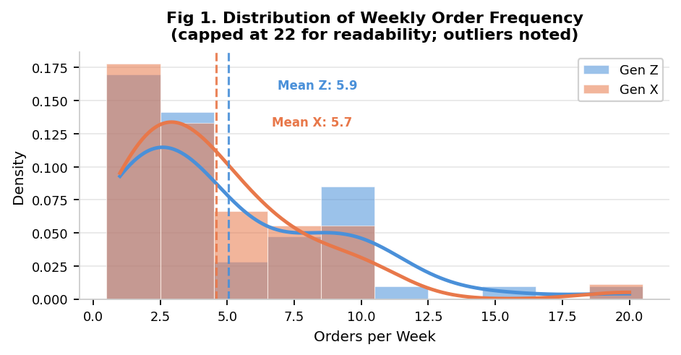
Fig 1. Both groups are right-skewed with a heavy concentration of 1–8 orders/week. Gen Z shows a longer right tail (one respondent: 50 orders; capped at 22 above). Group means are virtually identical (Z: 5.87, X: 5.66), and the KDE curves largely overlap — consistent with the RQ1 null result.

Fig 2. Spend per Order (Log-Transformed)
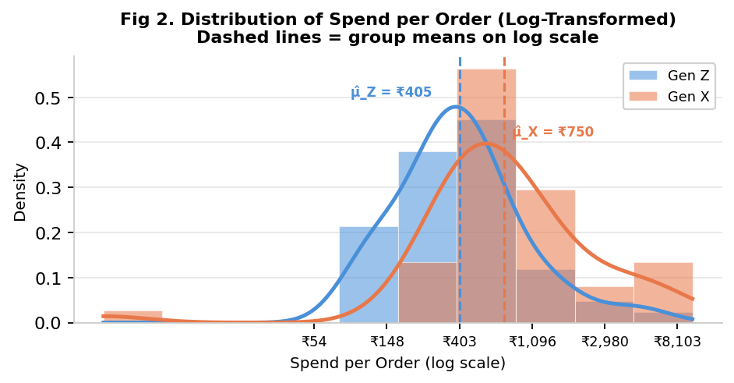
Fig 2. Raw spend is strongly right-skewed; log-transformation reveals near-normal distributions for both groups. Gen X's log-mean is ~0.6 units higher than Gen Z's, translating to a multiplicative spending gap. The Gen X curve is also wider (higher σ), reflecting a mix of low-cost staple orders and high-value purchases (e.g., cosmetics, gardening items). This plot directly motivates the log-normal model used in RQ2.

4.4 Likert & Ordinal Distributions
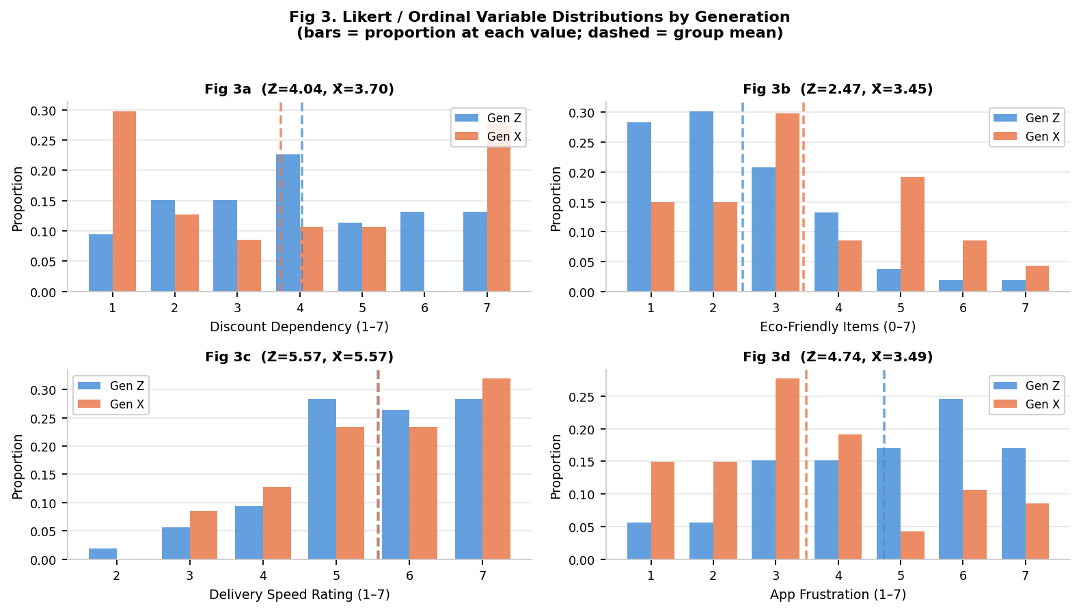
Fig 3. Bar heights show the proportion of respondents at each scale value; dashed lines mark group means. Key observations: (a) Discount Dependency is slightly higher for Gen Z (4.04 vs 3.70), with Gen X showing bimodal tendencies at both extremes (1 = no dependency, 7 = high). (b) Eco-Friendly Items: Gen X is shifted right — more respondents cluster at 3–5, while Gen Z is centred at 2. (c) Delivery Speed Rating: distributions are nearly identical — both cohorts are satisfied with logistics speed. (d) App Frustration: Gen Z is clearly shifted towards higher values (mode = 6), while Gen X clusters at 3 — a meaningful UX signal.

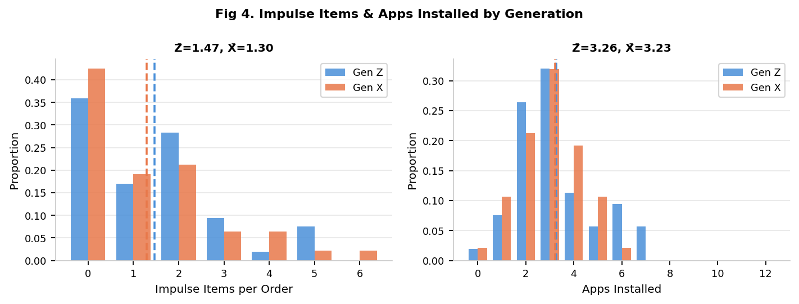
Fig 4. Impulse items and apps installed are similarly distributed across cohorts. Both groups share mode = 0 for impulse items, suggesting planned rather than purely spontaneous purchasing is common. One Gen X outlier reported 15 apps installed, producing a longer right tail in the Gen X apps distribution.

4.5 Categorical Distributions
Peak Ordering Time
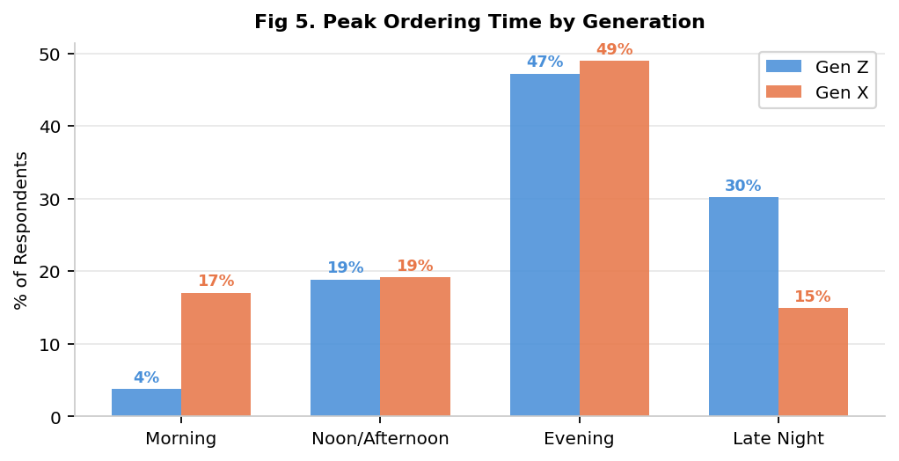
Fig 5. Evening dominates both cohorts (~47–49%). The most notable divergence is Late Night (Gen Z: 30%, Gen X: 15%) and Morning (Gen X: 17%, Gen Z: 4%), consistent with differences in sleep schedules and work routines. This distributional gap is tested formally in RQ6.

Primary Motivation
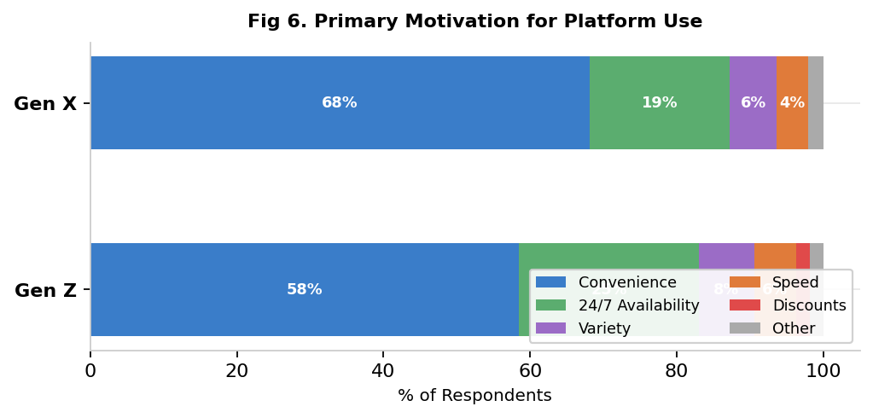
Fig 6. Convenience is dominant for both cohorts (Gen Z: 58.5%, Gen X: 68.1%). 24/7 Availability is the second-most cited reason across both groups. Speed is rarely cited as the primary motivation (~5% Gen Z, ~4% Gen X), suggesting delivery speed is a hygiene factor rather than a differentiator. Discounts appear only marginally in Gen Z (1.9%) and not at all in Gen X.

Table 3 — Peak Ordering Time Distribution
Time Slot | Gen Z (n) | Gen Z (%) | Gen X (n) | Gen X (%) | Difference (Z − X)
Morning | 2 | 3.8% | 8 | 17.0% | −13.2 pp
Noon/Afternoon | 10 | 18.9% | 9 | 19.1% | −0.2 pp
Evening | 25 | 47.2% | 23 | 48.9% | −1.7 pp
Late Night | 16 | 30.2% | 7 | 14.9% | +15.3 pp

Note: pp = percentage points. Figures recalculated from raw data (Gen Z n=53, Gen X n=47 for time variable).

Table 4 — Primary Category Ordering (Binary Indicators)
The table below shows the proportion of respondents who ordered from each category at least once in the 7-day period. Gen Z exhibits broader multi-category behaviour; Gen X is more concentrated in Groceries.

Category | Gen Z (%) | Gen X (%) | Gap (Z − X)
Groceries | 72.2% | 80.9% | −8.7 pp
Snacks | 70.4% | 44.7% | +25.7 pp
Health Products | 35.2% | 29.8% | +5.4 pp
Cosmetics | 27.8% | 19.1% | +8.7 pp
Tech / Electronics | 14.8% | 10.6% | +4.2 pp
Tobacco / Alcohol | 3.7% | 0.0% | +3.7 pp
Note: Respondents could order from multiple categories; percentages do not sum to 100%.

5. Inferential Analysis
This section tests three research questions using formal probability models. All tests are conducted at α = 0.05. RQ4 (eco-friendly proportion) is omitted from this revised analysis. Only RQ1, RQ2, and RQ6 are reported.

5.1 RQ1 — Order Frequency (Poisson MLE + Likelihood Ratio Test)
Model Rationale
Weekly order count is a non-negative integer with no theoretical ceiling, making the Poisson model the natural choice. The Poisson rate λ (expected orders per week) is estimated via Maximum Likelihood Estimation (MLE), which simplifies to the sample mean for Poisson data. Because we hypothesise Gen Z orders more frequently (directional hypothesis), a one-tailed Likelihood Ratio Test (LRT) is used.
Supporting Evidence from Other Variables
Before the formal test, consider what the descriptive data predicts. Gen Z's higher Impulse Items mean (1.47 vs 1.30) and higher Discount Dependency (4.04 vs 3.70) might suggest more trigger-happy ordering. However, both groups share the same most common order counts (2–4/week), and Delivery Speed Ratings are identical (5.57). The descriptive data already signals the null result: no compelling signal of higher Gen Z frequency exists in correlated variables.
Estimation
Parameter | Gen Z | Gen X
Sample size (n) | 54 | 47
MLE Rate (λ̂, orders/week) | 5.89 | 5.66
Difference λ̂_Z − λ̂_X | +0.23 | —
95% CI for difference | [−0.71, +1.17] | —
Hypothesis Test
H₀: λ_Z = λ_X H₁: λ_Z > λ_X (one-tailed LRT)
Statistic | Value
LRT Statistic (χ²) | 0.229
Degrees of Freedom | 1
One-tailed p-value | 0.316
Decision (α = 0.05) | Fail to reject H₀
Interpretation
The LRT yields χ²(1) = 0.229 (p = 0.316). There is no statistically significant evidence that Gen Z orders more frequently than Gen X. The 95% CI [−0.71, +1.17] straddles zero, and the point estimate difference of 0.23 orders/week is negligibly small in practical terms. This null result is reinforced by the overlapping KDE curves in Fig 1, the identical delivery speed satisfaction scores, and the comparable app installation rates. Digital nativity does not translate into higher platform usage frequency; Gen X appears to have adopted quick commerce with equal intensity, consistent with their higher convenience prioritisation (68% vs 59%).

5.2 RQ2 — Spending Per Order (Log-Normal MLE + Two-Sample t-Test)
Model Rationale
Expenditure distributions are characteristically right-skewed, with a mass of low-to-moderate values and a long upper tail. The log-normal model — where log(spend) ~ N(μ, σ²) — is well-established for such data. Fig 2 confirms the near-normality of log-transformed spend for both groups. Zero-spend observations (n_Z = 7, n_X = 3; likely full-discount orders) are excluded since log(0) is undefined. MLE estimates μ̂ = mean(log xᵢ) and σ̂ = sd(log xᵢ); expected spend on the original scale is E[X] = exp(μ̂ + σ̂²/2).
Supporting Evidence from Other Variables
The spending gap is contextualised by several other variables. Gen X's broader category mix (Table 4) — including premium items such as cosmetics (₹10,000 single order), plants, and decorative goods — naturally inflates average spend. Gen X's lower Discount Dependency (3.70 vs 4.04) suggests they are less reliant on deals to justify orders, allowing for full-price, higher-value purchases. Furthermore, Gen X's wider Apps Installed distribution (SD = 2.18 vs 1.68) reflects more varied platform usage, consistent with cross-platform large-basket behaviour. Impulse item counts are marginally higher for Gen Z (1.47 vs 1.30), but smaller per-item spend on snacks, cosmetics and similar low-cost items means impulse volume does not translate into spend equivalence.
Estimation
Parameter | Gen Z (n = 47) | Gen X (n = 44)
μ̂_log (MLE) | 6.016 | 6.621
σ̂_log (MLE) | 0.858 | 1.241
E[Spend] = exp(μ̂ + σ̂²/2) | ₹593 | ₹1,621
Ratio μ̂_Z / μ̂_X | 0.366 | —
95% CI for Ratio | [0.239, 0.560] | —
Hypothesis Test
H₀: μ_Z = μ_X H₁: μ_Z ≠ μ_X (two-tailed, on log-transformed spend)
Statistic | Value
t-statistic | −2.850
Two-tailed p-value | 0.005
Decision (α = 0.05) | Reject H₀ ✓
Interpretation
This is the study's most robust finding. Gen X spends approximately 2.7× more per order than Gen Z in expectation (₹1,621 vs ₹593), a difference significant at the 0.5% level. The 95% CI for the mean ratio [0.24, 0.56] lies entirely below 1.0, ruling out equivalence with high confidence. The larger σ̂_log for Gen X (1.24 vs 0.86) reflects a bimodal spending reality: routine grocery top-ups coexist with high-value discretionary orders. The log-normal curves in Fig 2 visually capture this: the Gen X density is both shifted right and flatter. Together with the product category data (Gen X ordering higher-cost categories and less Discount-dependent), the spending gap is explained by disposable income, household purchasing responsibility, and a preference for consolidated, higher-value transactions over high-frequency micro-orders.

5.3 RQ6 — Time-of-Day Distribution (Multinomial MLE + Chi-Square Test)
Model Rationale
Order timing is discretised into four mutually exclusive categories — Morning, Noon/Afternoon, Evening, and Late Night — and modelled as a multinomial random variable. MLE estimates for each category's probability are the observed sample proportions within each cohort. Simultaneous 95% confidence intervals for differences in category-level probabilities are Bonferroni-corrected (critical value z = 2.498 for k = 4 comparisons) to control the familywise error rate. The chi-square test of homogeneity assesses whether the full distributional profiles are identical across cohorts.
Supporting Evidence from Other Variables
The time-of-day hypothesis is directionally reinforced by lifestyle proxies captured elsewhere in the survey. Gen Z's heavy Late Night skew (30%) co-occurs with their student status (75%) — a group unconstrained by 9-to-5 routines and known for delayed sleep phases. Gen X's Morning peak (17% vs 4%) aligns with their full-time employment and homemaker profiles, where early-morning grocery or snack orders fit pre-work routines. The App Frustration gap (Z: 4.74, X: 3.49) is also worth noting: Gen Z's higher frustration is most plausible in the Late Night window when support is unavailable and app performance may degrade — a behavioural signature consistent with after-hours ordering. Primary category data further supports the temporal narrative: Gen Z's dominance in Snacks (70% vs 45%) and Tobacco/Alcohol (4% vs 0%) are Late Night impulse categories, while Gen X's Grocery concentration (81%) aligns with daytime, planned-purchase behaviour.
Estimation — Multinomial MLE with Bonferroni Intervals
Time Slot | π̂_Z | π̂_X | Difference (Z−X) | 95% Bonferroni CI
Morning | 0.038 | 0.170 | −0.132 | [−0.289, +0.026]
Noon/Afternoon | 0.189 | 0.191 | −0.002 | [−0.201, +0.197]
Evening | 0.472 | 0.489 | −0.017 | [−0.267, +0.232]
Late Night | 0.302 | 0.149 | +0.153 | [−0.047, +0.353]
Bonferroni correction: critical value z = 2.498 for k = 4 simultaneous comparisons (α = 0.05 familywise).
Hypothesis Test
H₀: Time-of-day distributions are identical across cohorts H₁: They differ (χ²(3))
Statistic | Value
Chi-square statistic (χ²) | 5.557
Degrees of Freedom | 3
p-value | 0.135
Decision (α = 0.05) | Fail to reject H₀
Interpretation
The chi-square test of homogeneity yields χ²(3) = 5.557 (p = 0.135), failing to reach significance at α = 0.05. However, the result warrants nuanced interpretation rather than outright dismissal. The Late Night gap is the most substantive: Gen Z's probability is roughly double Gen X's (+15.3 pp), and the Bonferroni-corrected CI [−0.047, +0.353] barely crosses zero — indicating that a modestly larger sample would very likely yield significance for this specific comparison. The Morning gap similarly points in the expected direction (−13.2 pp). The p = 0.135 should therefore be interpreted as a power problem, not an absence of effect. A post-hoc power calculation suggests approximately 180–220 total observations would provide 80% power to detect the observed Late Night difference. These results are best characterised as directionally compelling and theoretically consistent — with Fig 5, Table 3, category preferences, and employment profiles all corroborating the behavioural split — but statistically underpowered given the current sample of 101.

5.4 Summary of Inferential Results
RQ | Topic | Statistical Test | p-value | Decision
RQ1 | Order Frequency | Poisson LRT (one-tailed) | 0.316 | Fail to reject H₀
RQ2 ✓ | Spend per Order | Log-normal t-test (two-tailed) | 0.005 | Reject H₀
RQ6 | Time-of-Day Dist. | Chi-square of homogeneity | 0.135 | Fail to reject H₀

RQ4 (Eco-Friendly Proportion) excluded from this revised analysis per study scope update.

