EEM 5524

Advanced Communication Electronics

 Subject: Software Defined Radio

REPORT

**Due Date:** **April 20, 2017**

Ali Kaan TÜRKMEN

1642180002

**1.Software Defined Radio**

**a) Defination of Software Defined Radio**

As it has described by FCC(Federal Communication Commission) It is a radio that includes a transmitter in which the operating parameters of the transmitter, including the frequency range, modulation type or maximum radiated or conducted output power can be altered by making a change in software without making any hardware changes.

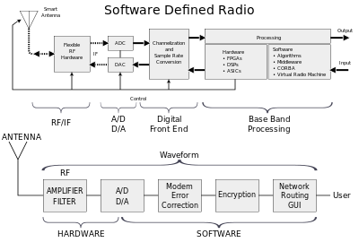

Figure 1. Block Diagram of Software Defined Radio

Traditional hardware based radio devices limit cross-functionality and can only be modified through physical intervention. This results in higher production costs and minimal flexibility in supporting multiple waveform standards. By contrast, software defined radio technology provides an efficient and comparatively inexpensive solution to this problem, allowing multi-mode, multi-band or multi-functional wireless devices that can be enhanced using software upgrades.

**b) FPGA (Field Programmable Gate Array)**

FPGAs contain an array of [programmable](https://en.wikipedia.org/wiki/Programmable_logic_device" \o "Programmable logic device) [logic blocks](https://en.wikipedia.org/wiki/Logic_block" \o "Logic block), and a hierarchy of reconfigurable interconnects that allow the blocks to be "wired together", like many logic gates that can be inter-wired in different configurations. [Logic blocks](https://en.wikipedia.org/wiki/Logic_block" \o "Logic block) can be configured to perform complex [combinational functions](https://en.wikipedia.org/wiki/Combinational_logic" \o "Combinational logic), or merely simple [logic gates](https://en.wikipedia.org/wiki/Logic_gate" \o "Logic gate) like [AND](https://en.wikipedia.org/wiki/AND_gate) and [XOR](https://en.wikipedia.org/wiki/XOR_gate). In most FPGAs, logic blocks also include memory elements, which may be simple [flip-flops](https://en.wikipedia.org/wiki/Flip-flop_(electronics)" \o "Flip-flop (electronics)) or more complete blocks of memory.

One of the most important features of FPGA is the ability to perform paralled operations.

Some of : Xilinx, Altera

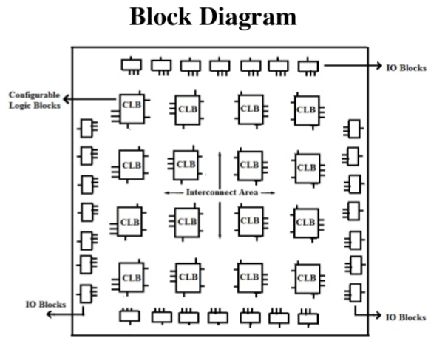

Figure 2. FPGA Block Diagram

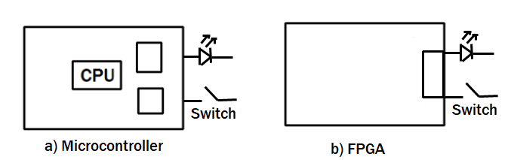

Figure 3. Comparing microcontroller and fpga as simple

If we compare microcontroller and FPGA as simple as possible we can say that, microcontroller has its own perhipherals that let us to use them by programming the microcontroller. But with FPGA we can design the FPGA’ logic block for our needs in Project. Also It lets us to do parralel processing which is so important for voice, image and digital signal processing.

So FPGA’s advantages in SDR applciations are ;

* Do anything and flexible
* Super fast than microcontroller
* Field programmable
* Ability of parallel processing
* High I/O

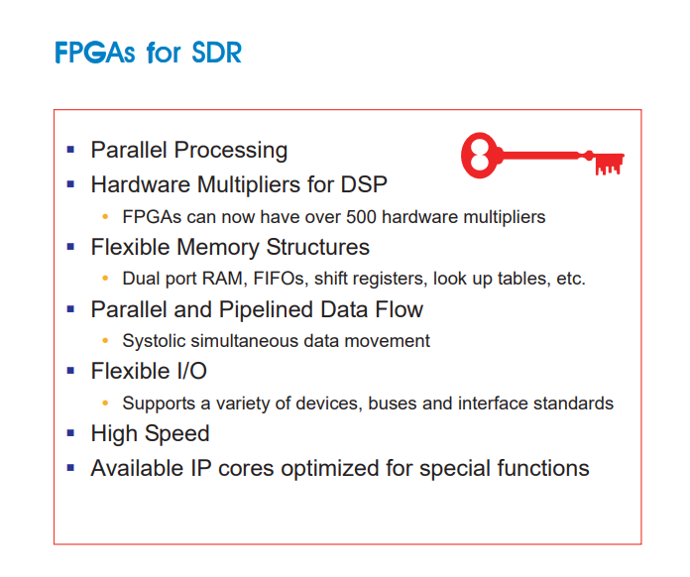

Figure 4. FPGAs for SDR

**c) DSP ( Digital Signal Processing)**

DSPs are processors or microcomputers whose hardware, software, and instruction sets are optimized for high-speed numeric processing applications­ an essential for processing digital data representing analog signals in real time. When acting as a digital filter, for example, the DSP receives digital values based on samples of a signal, calculates the results of a filter function operating on these values, and provides digital values that represent the filter output; it can also provide system control signals based on properties of these values. The DSP’s high-speed arithmetic and logical hardware is programmed to rapidly execute algorithms modelling the filter transformation.

We take real-world signals like voice, audio, video, temperature, pressure or position and by using digital signal processing. We call the process as digital signal processing.

Signals need to be processed so that the information that they contain can be displayed, analyzed, or converted to another type of signal that may be of use.

Analog products detect signals such as sound, light, temperature or pressure and manipulate them. Converters such as an Analog-to-Digital converter then take the real-world signal and turn it into the digital format of 1's and 0's.

From here, the DSP takes over by capturing the digitized information and processing it. It then feeds the digitized information back for use in the real world. It does this in one of two ways, either digitally or in an analog format by going through a Digital-to-Analog converter. All of this occurs at very high speeds.

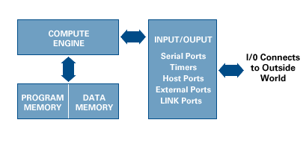

Figure 5. DSPs Block Diagram

**d) Difference Between FPGA and ASIC**

An ASIC is a unique type of integrated circuit meant for a specific application while an FPGA is a reprogrammable integrated circuit.An ASIC can no longer be altered once created while an FPGA can.It is common practice to design and test on an FPGA before implementing on an ASIC.An ASIC wastes very little material compared to an FPGA and the recurring costs are low.FPGA is better than an ASIC when building low volume production circuits.

**d) Software Defined Radio Transmitter Block Diagram**

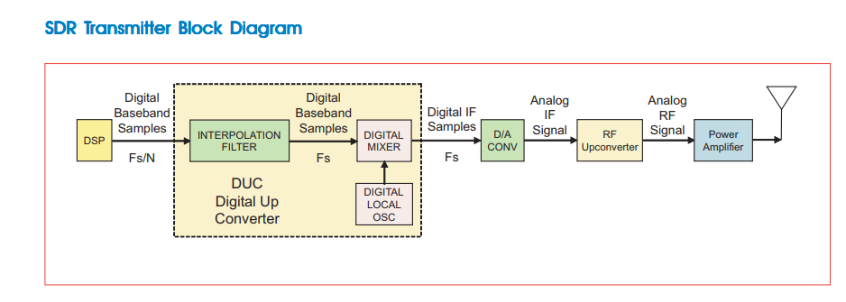

Figure 6. SDR Transmitter Block Diagram

The input to the transmit side of an SDR system is a digital baseband signal, typically generated by a DSP stage as shown in this figure above. The digital hardware block in the dotted lines is a DUC (digital upconverter) that translates the baseband signal to the IF frequency. The D/A converter that follows converts the digital IF samples into the analog IF signal. Next, the RF upconverter converts the analog IF signal to RF frequencies. Finally, the power amplifier boosts signal energy to the antenna

**e) Software Defined Radio Receiver Block Diagram**

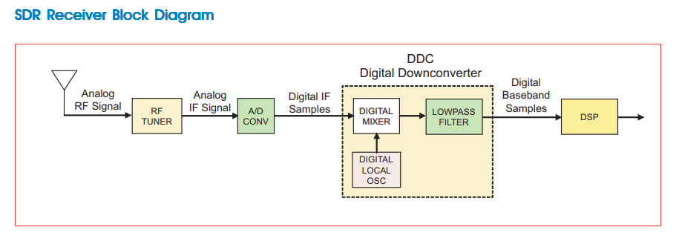

Figure 7. SDR Receiver Block Diagram

This figure shows a block diagram of a software SDR Receiver Mixer eceiver Mixer defined radio receiver. The RF tuner converts analog RF signals to analog IF frequencies, the same as the first three stages of the analog receiver. The A/D converter that follows digitizes the IF signal thereby converting it into digital samples. These samples are fed to the next stage which is the digital downconverter (DDC) shown within the dotted lines. The digital downconverter is typically a single monolithic chip or FPGA IP, and it is a key part of the SDR system.

A conventional DDC has three major sections:

• A digital mixer

• A digital local oscillator

• An FIR lowpass filter

The digital mixer and local oscillator translate the digital IF samples down to baseband. The FIR lowpass filter limits the signal bandwidth and acts as a decimating lowpass filter. The digital downconverter includes a lot of hardware multipliers, adders and shift register memories to get the job done. The digital baseband samples are then fed to a block labeled DSP which performs tasks such as demodulation, decoding and other processing tasks. Traditionally, these needs have been handled with dedicated application specific ICs (ASICs), and programmable DSPs.

**f) Software Defined Radio Application Fields**

SDR has many application fields in industrial communication technology.

In all application fields it provides real-time flexibility and security. It’s a good advantages in military applications. In commerical applications it provides international connectivity and it helps projects in prototyping.

Also it helps projects which are Bluetooth, WLAN, GPS, Radar, WCDMA, GPRS, GSM, AM, FM.

**h) Sofrware Defined Radio Programmability**

Programmability is the one of most important ability of software defined radios. Software defined radio system is one in which the baseband processing as well as DDC / DUC modules are programmable.

**i) Sofrware Defined Radio Architecture**

The digital radio system consists of three main functional block.

* RF section
* IF section
* BB section

RF section is essentially analog hardware. IF and BB section are digital section.

BB operations include channel codding, source codding, control functionality.

BB modem has new and adapted modulation schemes, also self adaptive and has a download control.

**j) Software Defined Radio Listening Mode Example**

We can use wireless devices in listening mode. When we use the wireless device as listener. We can collect datas which are turning around us. It is really easy to do by one wireless device and some tools in Linux systems. (Espacially Kali Linux Network Tools)

As how we use wireless devices in listening mode, we can use the SDR technology in listening mode. It can be a greatful gagget to listen the RF signals.

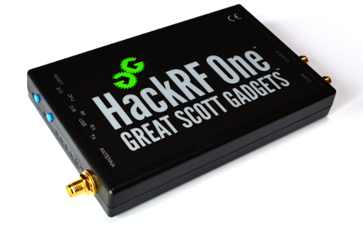

Figure 8. HackRF One Device

**2. Conclucions**

With SDR anything is possible in RF design and prototyping within current limits. It has many application fields in industrial communication . We are not dependent on hardware design. With software we can design what we want. It has reusability, reconfigurability and recyling. It provides multimode devices. Single devices is adequate to do this. And also it is cheaper.

**Sources**

[**http://www.dynamicc4.com/download/Pentek/Handbook/DgtlRcvrHbk43_9thEdition.pdf**](http://www.dynamicc4.com/download/Pentek/Handbook/DgtlRcvrHbk43_9thEdition.pdf)

[**http://www.dynamicc4.com/download/Pentek/Handbook/SWR_FPGAF_6th.pdf**](http://www.dynamicc4.com/download/Pentek/Handbook/SWR_FPGAF_6th.pdf)