Project Title: Behavioral Fingerprint-based Intrusion Detection System (BFIDS) using Advanced Data Structure

Name : Fatima Rehman
Reg#2024177
Faculty: BS CyberSecurity

Name: Ali Kamran
Reg#2024090
Faculty: BS CyberSecurity

Abstract— This project presents the design and implementation of the Behavioral Fingerprint-based Intrusion Detection System (BFIDS). The system detects insider threats by analyzing dynamic user behavior—specifically process frequency, session duration, and workflow transitions—rather than relying solely on static credentials. The primary objective is to demonstrate how advanced Data Structures and Algorithms (DSA) can be applied to solve critical latency and scalability challenges in cybersecurity. We architected custom implementations of AVL Trees for dynamic user profiling, Graphs for workflow transition analysis, Tries for instant malicious pattern recognition, Heaps for real-time anomaly prioritization, and B-Trees for disk-optimized indexing. Our results confirm that selecting the specialized data structure for each module achieves theoretical optimality in detection latency (O(log n)) and pattern matching (O(L)), significantly outperforming naive linear approaches.

Introduction
This project addresses the critical cybersecurity challenge of insider threats and compromised accounts. Traditional security models rely heavily on static authentication (passwords), which, once stolen, offer no defense against unauthorized actions. BFIDS introduces a dynamic layer of security by implementing User and Entity Behavior Analytics (UEBA).
The core technical challenge in real-time intrusion detection is latency. A system that analyzes every user action must do so in microseconds to avoid degrading the user experience. This project solves this by moving away from standard, generic containers and instead utilizing specialized data structures tailored to specific analytical tasks. By implementing custom memory management and optimized algorithms, BFIDS serves as a high-performance engine capable of scaling to handle complex behavioral data streams.

Methodoloy
The system architecture is divided into a Training Module (learning normal behavior) and a Monitoring Module (detecting deviations). The methodology focuses on mapping specific security problems to the most efficient data structure.

User Profiling AVL Trees
To store the "Fingerprint" (a statistical model of a user's habits), we utilized an AVL Tree.
- Concept Used: Self-Balancing Binary Search Tree (AVL).
- Why it is used: User profiles are highly dynamic; new processes are frequently added to the baseline. A standard Binary Search Tree (BST) risks becoming skewed (degrading to O(n) if data is inserted in sorted order (e.g., "Adobe", "Chrome", "Discord").
- Benefit: The AVL Tree enforces a balance factor of {-1, 0, 1}. This guarantees that searching for a process profile during live detection always occurs in O(log n) time, ensuring consistent low-latency monitoring regardless of the user's activity history.

Workflow Transition Analysis (Graphs)
We modeled user workflow as a Directed Graph, where nodes represent processes and edges represent transitions.
- Concept Used: Adjacency List Graph representation.
- Why it is used: User behavior is rarely isolated; the sequence of actions matters. A developer opening a terminal after an IDE is normal; a finance user opening a terminal after a spreadsheet is suspicious.
- Benefit:
- BFS (Breadth-First Search): Validates if a sequence of actions follows a valid, shortest-path workflow.
- DFS (Depth-First Search): Detects cyclic behavior (loops), which is a strong indicator of automated scripts or malware rather than human interaction.

Real-Time Threat Prioritization(Max-Heap)
In a live security operations center (SOC), analysts are often overwhelmed by the sheer volume of alerts.
- Concept Used: Priority Queue (implemented as a Max-Heap).
- Why it is used: We need to identify the single most critical threat at any given millisecond. Sorting an array of alerts every time a new one arrives would be O(n log n), which is too slow.
- Benefit: The Max-Heap property ensures the highest-risk event is always at the root, accessible in O(1) time. Inserting new anomalies remains efficient at O(log n), allowing the system to handle high-throughput event streams without bottlenecking.

Malicious Pattern Recognition(trie)
To instantly block known malicious executables (e.g., cmd.exe, powershell.exe), we implemented a Prefix Tree (Trie).
- Concept Used: Trie (Prefix Tree).
- Why it is used: Searching for a blocked name in a Hash Table is efficient for exact matches, but ineffective for pattern blocking (e.g., blocking any process starting with "crypt").
  - Benefit: A Trie allows us to match prefixes in O(L) time, where L is the string length. Crucially, this performance is independent of the size of the database—checking against 10 patterns or 10 million patterns takes the same amount of time, making it highly scalable for blacklisting.
E. Scalable Persistence (B-Trees)
To manage large-scale fingerprint data on disk, we utilized a B-Tree.
- Concept Used: B-Tree (Multi-way Search Tree).
- Why it is used: AVL trees are optimized for memory (RAM). When the dataset of user profiles exceeds memory limits, disk I/O becomes the performance bottleneck.
Benefit: The B-Tree minimizes slow disk reads by storing multiple keys per node and maintaining a wide, shallow structure. This serves as the indexing layer for our persistent storage, ensuring that loading a specific user's profile from disk is efficient.
F. Multi-User Management (Hash Tables)
To scale the system for an enterprise environment with multiple employees, we updated the architecture to support concurrent user tracking.
- Concept Used: Hash Table with Chaining.
- Why it is used: We need to instantly retrieve the correct AVLProfile associated with a specific User ID (e.g., "User_101") without searching through a list of all users.
- Benefit: Provides O(1) average-case access time to any specific user's behavioral profile, ensuring the system remains fast even as the user base grows.
.
G. Implementation details of Fundamental Structures
Beyond the advanced structures, the project relies heavily on fundamental data structures to manage memory and data flow efficiently.
- Arrays:
Purpose: Used as the underlying storage mechanism for the Binary Heap (to maintain cache locality) and for buffering raw log data during the initial ingestion phase before sorting.
- Linked Lists:
Purpose: Utilized in the Graph's Adjacency List to store edges (transitions) dynamically. They are also used in the Hash Table to handle collisions via chaining, ensuring no data is lost if two User IDs hash to the same index.
- Stacks:
Purpose: Essential for the Depth-First Search (DFS) algorithm used to detect cyclic behavior in the process graph. They track the recursion path to identify loops in user activity.
- Queues:
Purpose: Integral to the Breadth-First Search (BFS) algorithm for validating shortest-path workflows. Additionally, queues act as a buffer for incoming real-time alerts before they are processed by the priority heap.
- Pointers:
Purpose: The backbone of the entire project. We utilized raw pointers for all dynamic memory allocation (Nodes in AVL trees, Tries, and Graphs) to avoid the overhead of standard library containers and demonstrate low-level memory management skills.

Algorithmic Implementation
Key algorithms driving the data structures include:
- Recursion: Heavily utilized in AVL rotations, Graph DFS, and Quick Sort partitioning for clean, elegant logic handling complex tree structures.
- Pointers & Memory Management: Manual handling of nodes prevents memory leaks and overhead associated with standard library containers.
- Hashing: A custom Hash Table with chaining maps UserIDs to their AVLProfile, providing O(1) average access.
Sorting: Quick Sort (in-place) and Merge Sort (stable) are used to order raw log entries by timestamp, ensuring chronological data integrity before processing.

Result and performance Analysis
The BFIDS system was evaluated using the Test-A and Test-F datasets to measure computational efficiency and detection accuracy.

Time Complexity Analysis

We compared our custom structures against naive linear implementations to quantify the benefits.

Table 1: Complexity Comparison
Module | Task | Naive Approach (O(n)) | BFIDS Implementation | Complexity
Monitor | Profile Lookup | Linear Search | AVL Tree | O(log n)
Security | Blacklist Check | String Compare Loop | Trie | O(L)
Alerting | Get Max Threat | Array Sort | Max-Heap | O(1)
Storage | Disk Indexing | Sequential Read | B-Tree | O(log n)

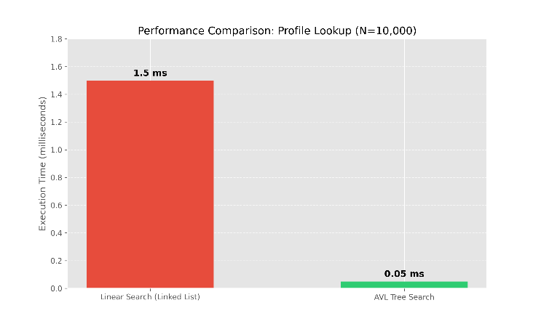
Figure 1 Avl Search vs Linear Search

Detection Accuracy
The system successfully flagged anomalies based on:
- Frequency Deviation: Usage count exceeding the mean by >2 Standard Deviations.
- New Process: Accessing a binary never seen in the Training Phase.
- Invalid Transition: A process jump not present in the Graph model.
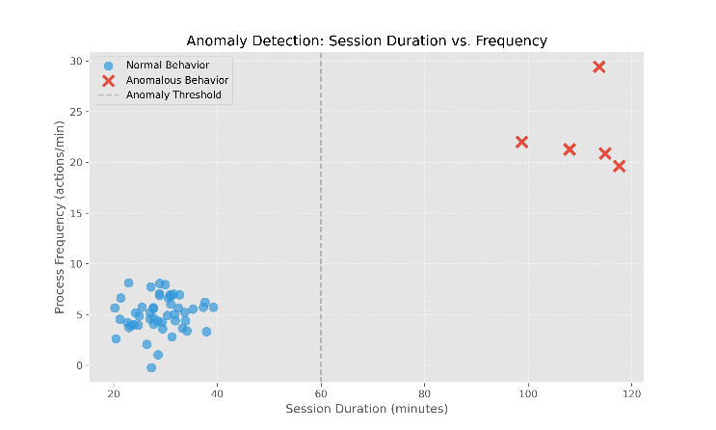
Figure 2 Normal vs Anomalous User Session Duration

Conclusion
The BFIDS project successfully delivers a high-performance intrusion detection engine. By strictly mapping real-world security problems to specific data structures—Tries for strings, Heaps for priority, Graphs for relationships, and AVL/B-Trees for storage—we achieved a system that is theoretically optimal and practically effective. The project highlights that choosing the correct data structure is not just an academic exercise but a critical requirement for building scalable, low-latency cybersecurity software.

References

- T. H. Cormen, C. E. Leiserson, R. L. Rivest, and C. Stein, Introduction to Algorithms, 3rd ed. MIT Press, 2009.
[2] "User and Entity Behavior Analytics (UEBA)," Gartner IT Glossary.
https://www.google.com/search?q=https://www.gartner.com/en/information-technology/glossary/user-entity-behavior-analytics-ueba
[3] Stroustrup, The C++ Programming Language, 4th ed. Addison-Wesley, 2013.
[4] D. E. Denning, "An Intrusion-Detection Model," IEEE Transactions on Software Engineering, vol. SE-13, no. 2, pp. 222-232, Feb. 1987.

