Phantasm-DB: Autonomous Cognitive Deception & Relational Forensic Architecture in a Psychiatric EHR System



GROUP MEMBERS: | Fatima Rehman | Ali Kamran
REG .NO# | 2024177 | 2024090
FACULTY: | Cyber Security
COURSE & SECTION: | CS-232 E
INSTRUCTOR: | Ms Mah Rukh
SUBMISSION DATE: | 6 May,2026

Table Of Contents
Phantasm-DB: Autonomous Cognitive Deception & Relational Forensic Architecture in a Psychiatric EHR System 1
Phantasm-DB: Autonomous Cognitive Deception & Relational Forensic Architecture in a Psychiatric EHR System 2
I. INTRODUCTION 3
II. SYSTEM ARCHITECTURE 3
A. Serenity EHR: The Clinical Interface 3
B. Phantasm-DB: The Deception Engine 4
III. RELATIONAL DATABASE DESIGN: THE 10 ENTITIES 4
A. The Identity Layer (ISA Hierarchy) 4
B. The Forensic & Deception Layer 4
IV. BACKEND MONITORING & ACTIVE DEFENSE MECHANICS 5
A. Deep Packet Inspection & Heuristic Flagging 5
B. Context Switching & The Honeypot Gate 5
C. Forensic Archiving & Non-Repudiation 5
V. SYSTEM DEPLOYMENT AND EXPERIMENTAL SETUP 5
A. Serverless Infrastructure & Initialization 6
B. Attack Simulation and System Response 6
C. Security Operations Centre (SOC) 6
VI. CONCLUSION 6

Phantasm-DB: Autonomous Cognitive Deception & Relational Forensic Architecture in a Psychiatric EHR System
Abstract— Traditional Database Management Systems (DBMS) operate on a rigid, binary "Access/Deny" security paradigm. Once an attacker bypasses the perimeter via SQL injection, compromised credentials, or zero-day exploits, the system implicitly trusts the authenticated session, exposing highly sensitive data. Furthermore, standard security logging mechanisms are often flat, volatile, and susceptible to tampering by intruders. This paper presents Phantasm-DB, an autonomous "Active Defence" middleware and cognitive deception engine, integrated directly into a production-grade psychiatric Electronic Health Record (EHR) system known as Serenity. Instead of passively blocking malicious requests, Phantasm-DB dynamically traps attackers in a "Shadow Schema" a structurally identical but entirely synthetic honeypot environment. As the attacker interacts with fabricated psychiatric data, their raw SQL payloads, network fingerprints, and behavioural metrics are fossilized in an immutable relational ledger. This architecture ensures zero exposure of actual Protected Health Information (PHI) while providing administrators with high-fidelity forensic intelligence via a serverless edge architecture.
Index Terms— Database Security, Relational Databases, Honeypots, SQL Injection, Active Défense, Cognitive Deception, Healthcare Data, Serverless Architecture, Electronic Health Records (EHR).

I. INTRODUCTION
The exfiltration of medical data, particularly psychiatric records, presents a unique and irreversible threat vectors in modern cybersecurity. Unlike financial data, which can be reissued or frozen, a patient’s medical history, psychological evaluations, and Social Security Numbers (SSNs) are immutable. Threat actors specifically target this Protected Health Information (PHI) for its high blackmail and ransomware value.
Contemporary DBMS architectures lack the behavioural intelligence necessary to differentiate between an authorized clinical user and a compromised session executing automated data-scraping. When an intrusion occurs, passive defence systems simply block the attack. This traditional approach inadvertently alerts the hacker to the security mechanism, prompting them to adapt and pivot to new attack vectors.
To address this "Visibility Gap," we propose Phantasm-DB, a relational deception architecture deployed beneath Serenity EHR, a psychiatric portal serving psychologists, psychiatrists, therapists, and their patients. The system utilizes real-time payload inspection via Python serverless functions, asynchronous PostgreSQL schema routing, and JWT-based session masking to silently misdirect attackers into a synthesized reality, capturing their intent without compromising actual system integrity.

II. SYSTEM ARCHITECTURE
The architecture is bifurcated into two seamlessly integrated layers: The Clinical Interface (representing the target) and The Deception Engine (representing the active defence mechanism). The application utilizes a modern Single-Page Application (SPA) frontend communicating via RESTful APIs to a Vercel-hosted Python middleware layer.

A. Serenity EHR: The Clinical Interface
Serenity EHR is a production-grade, HIPAA-compliant web application providing role-based access control (RBAC) for healthcare providers and patients. Authentication mandates a Two-Factor Authentication (2FA) workflow, utilizing an identification lookup followed by an email-dispatched One-Time Password (OTP).
- Provider Interface: Psychiatrists authenticate using their National Provider Identifier (NPI). The dashboard utilizes a master-detail layout displaying an active caseload. Providers can review psychiatric diagnoses (e.g., Major Depressive Disorder, Generalized Anxiety Disorder), manage active pharmacotherapy, author session progress notes, and generate PDF clinical reports.
- Patient Portal: Patients securely authenticate via their Medical Record Number (MRN) and the designation of their attending provider. The portal renders treatment overviews, daily assigned therapy tasks (e.g., "Cognitive Restructuring"), and a secure interface for prescription management.
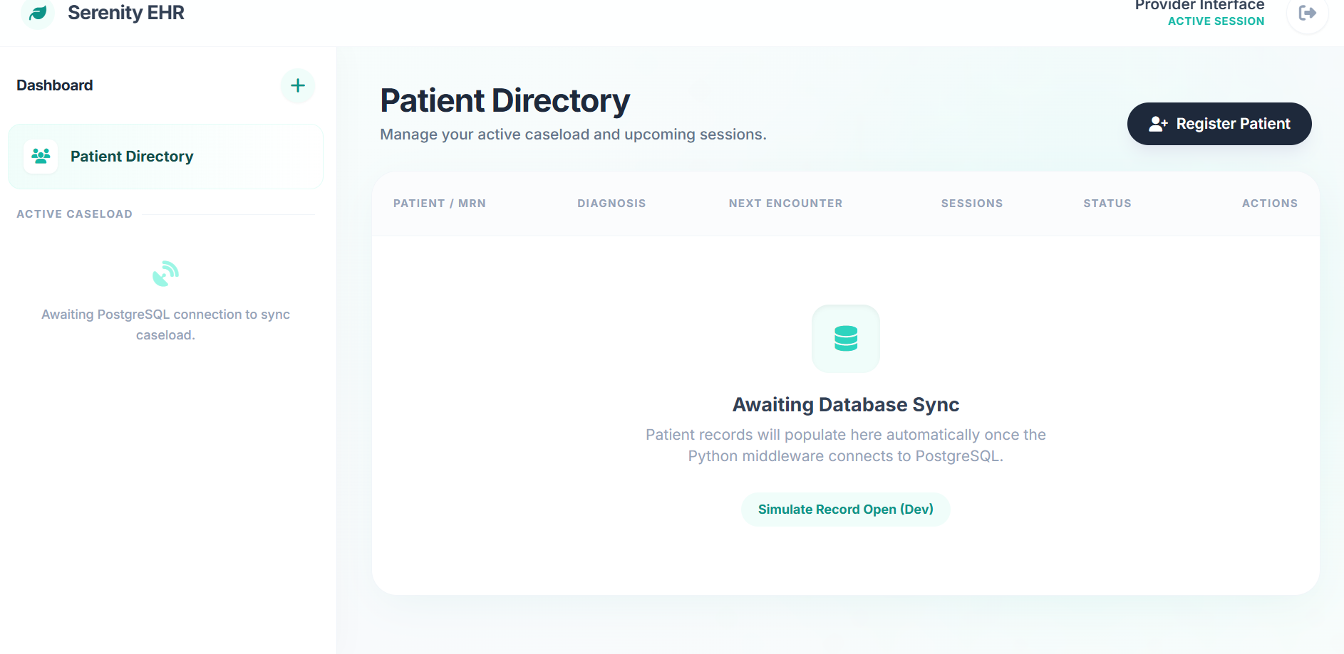
[Fig. 1: Serenity EHR Doctor Dashboard]
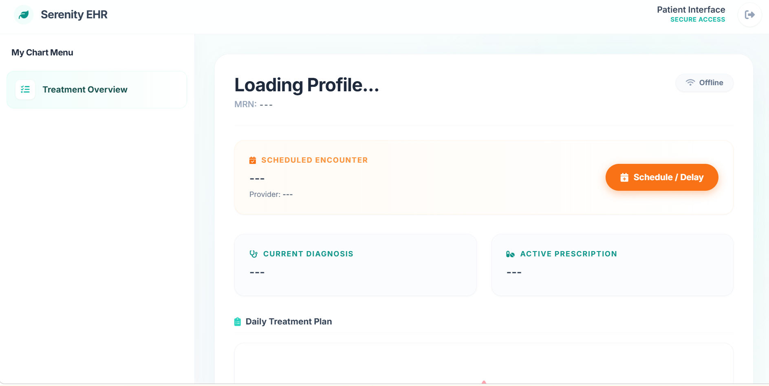
[Fig. 2: Serenity EHR Patient Portal]

B. Phantasm-DB: The Deception Engine
Operating invisibly behind the Serenity EHR frontend is the Phantasm-DB middleware. It functions as an intelligent proxy between the client layer and the relational data layer. When a threat actor attempts a database breach (e.g., injecting ' OR 1=1 -- into an authentication field), the system intentionally suppresses standard "Access Denied" HTTP exceptions.
Instead, the middleware evaluates the query against predefined heuristic structures. Upon identifying a malicious signature, the session is silently flagged at the database level. The backend intercepts the authentication request and issues a masked JSON Web Token (JWT) payload, indicating a compromised session state. The attacker is successfully authenticated and directed into the Provider Dashboard, which is populated entirely by highly sensitive, procedurally fabricated psychiatric profiles. The attacker operates under the illusion of a successful breach, while the database safely archives their activities in an isolated ledger.
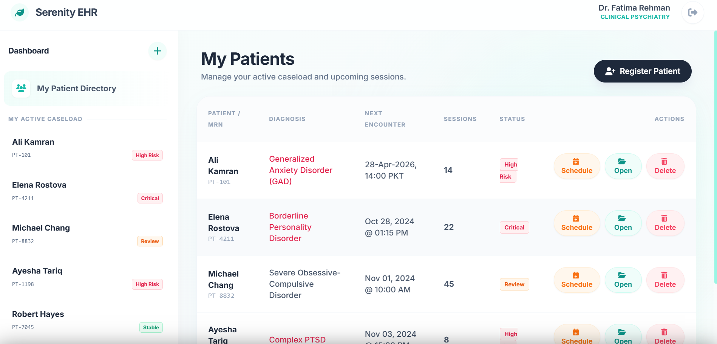
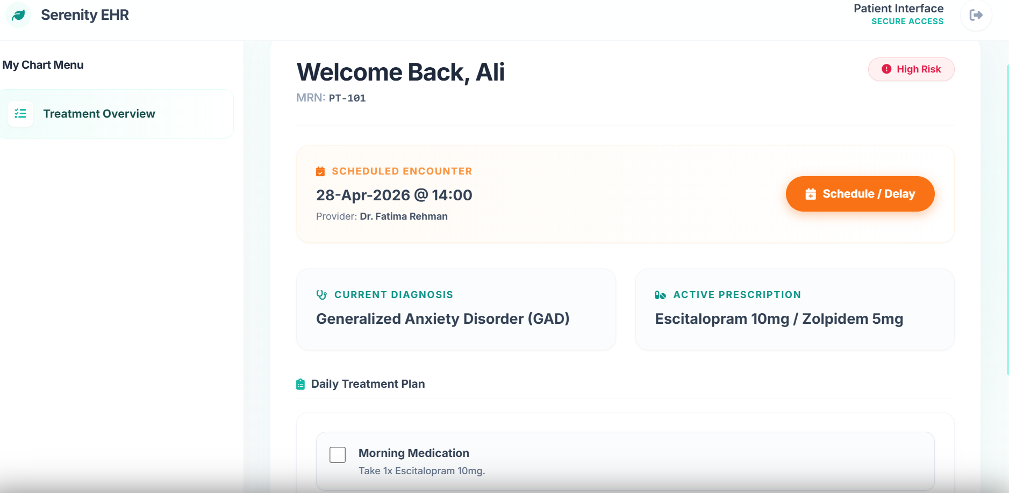
[Fig. 3: Attacker View showing SQLi execution and subsequent Shadow Data Dump]

III. RELATIONAL DATABASE DESIGN: THE 10 ENTITIES
The foundation of Phantasm-DB is a highly normalized relational schema utilizing the SQLAlchemy Object-Relational Mapper (ORM). It employs advanced database paradigms, including Generalization (ISA Hierarchies) and associative entities, to orchestrate the monitoring loop.
[Fig. 4: Entity-Relationship Diagram (ERD) detailing the ISA hierarchy]
[Fig. 5: Relational Database Schema Map]

A. The Identity Layer (ISA Hierarchy)
To manage both legitimate users and threat actors without polluting clinical datasets, a Top-Down Specialization (Inheritance) approach is utilized.
- Global_Identities (Superclass): The root monitoring entity. Every HTTP request generates or updates a record here. It stores the identity_id, ip_address, and maintains a continuously calculated risk_score.
- Production_Users (Subclass): Inherits from the superclass to manage authorized human personnel. It tracks failed_login_count and maintains a critical boolean flag: is_flagged_as_attacker. It undergoes further disjoint specialization into the Doctor and Patient entities.
- Threat_Actors (Subclass): A designated entity for persistent malicious agents, storing fingerprint_hash and threat_class.

B. The Forensic & Deception Layer
The following entities operate autonomously within the backend to monitor, flag, and deceive incoming sessions:
- Forensic_Ledger (Strong Entity): The core immutable vault. The security middleware asynchronously inserts a record here for every interaction, logging the raw_query, ip_address, endpoint, and a boolean confirming if the user was_deceived.
- Real_Time_Alerts (Weak Entity): Depends entirely on the Forensic_Ledger. It aggregates massive query dumps into actionable, high-level alerts for the administrative dashboard.
- Detection_Policies: Stores regular expressions mapped to specific cyber threats (e.g., (UNION SELECT|OR 1=1) for SQLi, <script> for XSS). The backend loads these policies into memory for payload scanning.
- System_State: A singleton configuration table controlling global honeypot parameters, including throttle_delay limits and global deception_active flags.
- Shadow_Manifest: Maps the production schemas to their respective decoy variants, facilitating the search_path switch.
- Lure_Blueprints: Stores the algorithmic generation rules (e.g., Python Faker templates) dictating the structural realism of the synthetic data.
- Honey_Tokens: Specific decoy primary keys acting as explicit tripwires. Querying a Honey Token guarantees an immediate threat escalation.

IV. BACKEND MONITORING & ACTIVE DEFENSE MECHANICS
The Phantasm-DB intelligence loop is executed via asynchronous Python middleware. The monitoring sequence operates through a strict chronological pipeline:

A. Deep Packet Inspection & Heuristic Flagging
Upon receiving a request at an API endpoint (e.g., /api/auth/lookup), the middleware invokes a heuristic scanning function. This function compares the request payload against the Detection_Policies matrix. If a signature match occurs (e.g., a path traversal ../ or command injection ;|ls), the backend immediately updates the Production_Users record, setting is_flagged_as_attacker = True.

B. Context Switching & The Honeypot Gate
Every subsequent request from the compromised user passes through a middleware guard function (honeypot_gate()). The database detects the is_flagged_as_attacker flag. Instead of querying the genuine Patient or Doctor tables, the backend short-circuits the request. It logs the action in the Forensic_Ledger with was_deceived = True, and returns an array of procedurally generated decoy objects.

C. Forensic Archiving & Non-Repudiation
Regardless of session legitimacy, an asynchronous logging function (write_audit_log()) writes the exact operational details to the database. By linking the event via Foreign Key to the attacker's Global_Identity, the system ensures forensic non-repudiation and structural integrity of the evidence chain.

V. SYSTEM DEPLOYMENT AND EXPERIMENTAL SETUP
The system architecture is optimized for modern cloud-native environments, utilizing a serverless deployment model to ensure high availability, horizontal scalability, and resistance to Denial of Service (DoS) attacks.

A. Serverless Infrastructure & Initialization
- Edge Compute Routing: The backend is deployed via Vercel (vercel.json), routing API calls to serverless Python 3.11 functions. This prevents attackers from executing persistent shell attacks against a centralized server instance.
- Database Connectivity: A PostgreSQL database is connected using the asynchronous asyncpg driver alongside SQLAlchemy 2.0. To prevent connection pool exhaustion in serverless environments, pooling is disabled (NullPool) with strict SSL context verification enforced.
- System Seeding: Upon deployment, an initialization endpoint securely provisions the 10-table schema via Base.metadata.create_all and seeds the root Administrative identity.

B. Attack Simulation and System Response
To evaluate the efficacy of the active defence mechanisms, penetration testing scenarios were simulated:
- The Attack Vector: A simulated adversary attempts a SQL injection on the authentication endpoint: DOC-001' OR 1=1 --.
- The Detection Phase: The heuristic engine identifies the Boolean inference signature. The attacker’s IP is logged, and the is_flagged_as_attacker parameter is tripped in the PostgreSQL database.
- The Deception Phase: The system synthesizes a successful authentication response and drops the attacker into the dashboard. API queries intercept the flagged JWT token, executing the honeypot_gate().
- The Resolution: The attacker is served highly volatile, synthetic psychiatric data. Attempts to exfiltrate or modify this data return HTTP 200 (OK) responses, but the backend securely discards the modifications while fossilizing the payloads in the Forensic_Ledger.

C. Security Operations Centre (SOC)
Administrators access threat metrics via a hidden macro (Ctrl + Shift + F) on the authentication screen, invoking an MFA Administrative Gateway. Once authenticated, the SOC Dashboard provides a live data feed of the Forensic_Ledger. This interface allows administrators to view exact SQL payloads, clear threat flags, and monitor the overarching Anomaly Score of the network in real-time, providing total visibility over the deception environment.
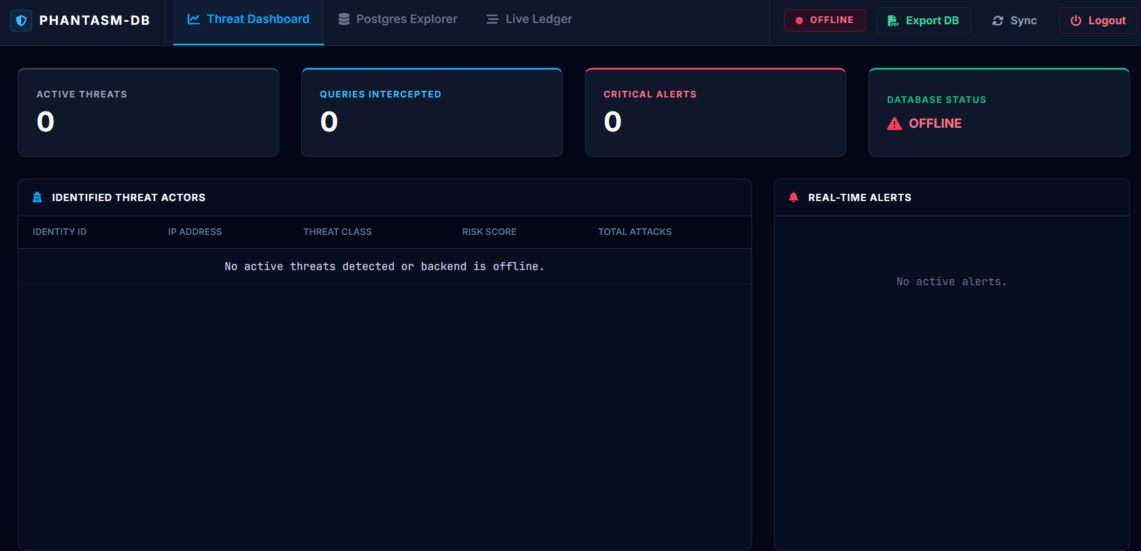
[Fig. 6: Phantasm-DB Admin Dashboard showing the Forensic Ledger and Threat Gauges]

VI. CONCLUSION
The integration of Phantasm-DB into the Serenity Psychiatric EHR demonstrates a critical paradigm shift in database security. By migrating from a static, passive perimeter defense to an autonomous, cognitive deception model utilizing serverless edge architecture, data systems can effectively neutralize the impact of successful perimeter breaches. Adversaries expend critical resources exfiltrating synthetic data, while system administrators gain actionable, relationally structured forensic intelligence regarding the attacker's methodologies. This approach ensures that highly sensitive, immutable psychiatric data remains cryptographically secure and entirely unexposed, functioning effectively even in the event of a total perimeter failure.

