savills.fr

01/12/2023

TRISTAN

23/25 Rue du Pont-Neuf, 75001 Paris, France

RED FLAG REPORT

SAVILLS TECHNICAL DUE DILIGENCE RED FLAG AND CAPEX APPRAISAL

Evaluation Warning : The document was created with Spire.PDF for .NET.

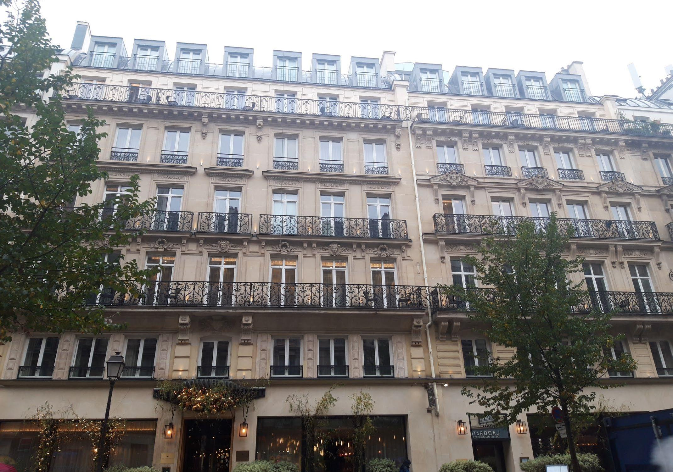

savills.fr

2

01/12/2023

Overall risk rating

The hotel is operated under the Maison Albar brand, a 5-star luxury hotel brand.

- Implementation of BMS for BACS decree compliance

Centaurus (formally Paris Inn) is the operator and owner of the hotel.

Tenure / extent of demise

- Investigate and repair the cause of the mosaic tiles lifting in the swimming pool

the spa / gym.

staircases and mechanical smoke extraction systems in

- Investigate and fix the source of the water ingress in the spa

stations next to fire exits, natural smoke extraction to

alarm system with smoke detection and manual call

- The requirement to undertake façade painting and cleaning before 2026 as per the city of Paris regulation

extinguishers throughout, automatic addressable fire

Fire protection systems:

Dry risers with two outlet valves at each level, fire

From a TDD perspective, we see no reason why the proposed loan facility should not proceed. Key points to consider are:-

city utility water supply network.

Recommendations

Domestic water services:

Cold water supply from a main metered connection to the

low voltage systems.

Sanitary & Storm drainage, electrical lighting & power, and

building including Heating, Cooling, Ventilation, and

MEP installations:

Mechanical & Electrical services required for a hotel

Windows and external doors:

Timber framed with double glazing.

masonry and painted wrought iron blaconies.

Façades:

Typical Paris Haussmanian façades with ashlar stone

the mechanical & electrical installations for the next ten years.

equipment on level 6 technical room with fixed ladder.

The mechanical and electrical services were all replaced in 2016 and remain in good condition. We do not anticipate any major owner life cycle capital expenditure pertaining to

technical roof with built-up felt. Secure access to HVAC

Roof:

Pitched roof with zinc covering overthermal insulation;

The maintenance programme by the operator is appropriate. Limited capex costs were identified by the Savills team.

reinforced with steel beams.

Structure:

Solid load-bearing masonry and steel with concrete floors

The finishes fittings and services installations are in good condition.

basement level

office on each floor, laundry room and staff room at

hotel.

Back of house:

Kitchen and offices at ground floor level, housekeeping

Overall the hotel is in satisfactory condition, typical with the age of construction. Full renovation was undertaken in 2016 to the building interiors and to the external envelope of the

level and with spa and gym / fitness room in basement 1.

General condition

Front of house:

Reception hall, restaurant and courtyard at ground floor

Floor loading:

Not assessed by Savills.

Ceiling void:

0.3 - 0.4 m (on-site measurement).

CONCLUSIONS AND RECOMMENDATIONS

guestrooms and 2.23 m in spa / gym.

Storey height:

2.8 m in reception, 2.42 m to corridors, 2.17-2.40 m to

Number of Keys:

60

Number of levels:

2 basement levels, ground floor and 6 upper levels.

Total surface area (m

):

Total

€

0

€

168 245

Total

€

0

€

158 125

To be verified

2

BatiParis website). Last renovation November 2016.

C. Environmental

€

0

€

0

€

0

Years 6-10

€

0

€

69 575

€

69 575

Year of construction:

Original construction around 1850-1914 (according to the

Property information:

B. Services

€

0

€

69 575

€

69 575

Years 2-5

€

0

€

88 550

€

88 550

A. Fabric

€

0

€

98 670

€

98 670

Year 1

€

0

€

0

€

0

recoverable

cost

recoverable

cost

Element

Service Charge

Capex / owner

Total

Year

Service Charge

Capex / owner

Total

Service Charge recoverable

Capex / owner cost

Service Charge recoverable

Capex / owner cost

Year 1

Years 2-5

Years 6-10

A. Fabric

B. Services

C. Environmental

€0

€0

€10 000

€20 000

€20 000

€30 000

€40 000

€40 000

€50 000

€60 000

€60 000

€80 000

€70 000

€80 000

€100 000

Version - Report issue date:

01.12.2023

€90 000

Site visit date:

16 November 2023

Purpose of TDD:

Red Flag TDD Report

€120 000

€100 000

Property address:

23/25 Rue du Pont Neuf, 75001 Paris, FRANCE

Capex costs

General information:

SUMMARY OF PROPERTY

SAVILLS TECHNICAL DUE DILIGENCE RED FLAG AND CAPEX APPRAISAL

Evaluation Warning : The document was created with Spire.PDF for .NET.

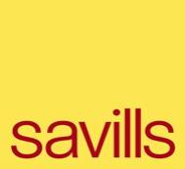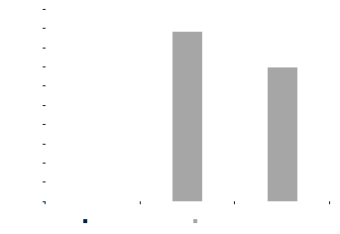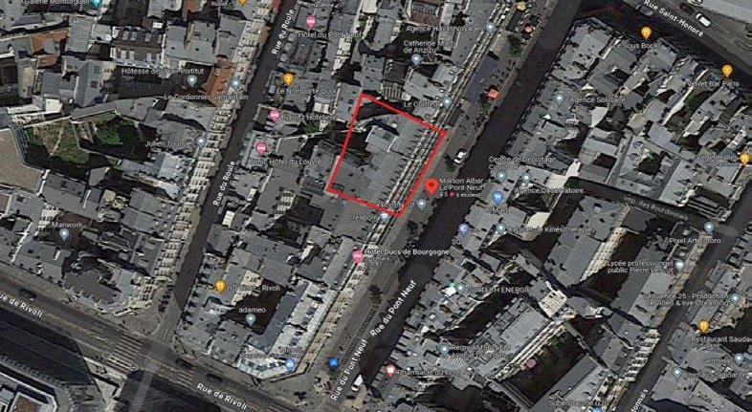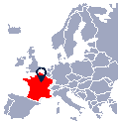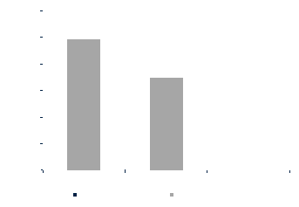

savills.fr

2

01/12/2023

Lifts

The lift machinery and tracking system were replaced in 2016 as part of the hotel renovation project.

No capex anticipated in the next 10 years.

the building overall renovation project. The systems present well.

Life Safety

The life safety systems including fire protection, fire alarm, and smoke extraction were installed in 2016 as part of

No capex anticipated in the next 10 years.

Decree

comply with the Building Automation & Control Systems (BACS) decree.

2027, given the nominal capacity of its HVAC systems.

BMS - BACS

The asset is not equipped with a building management system (BMS). We recommend that a BMS is installed to

Capex is provided in the long term for the installation of a BMS workstation, cabling and controls as the asset will be subject to this decree by January 1,

system is in good order.

and monitoring of the VRV system (guest rooms temperature set-points & operation, and room lighting control). The

BMS

A Daikin control system was installed in 2016 as part of the building overall renovation project, providing control

No capex anticipated in the next 10 years.

systems

installed in 2016 as part of the hotel renovation project. Systems present well in 2023.

Low voltage

The electrical low voltage systems including access control, CCTV, intruder and telecommunication systems were

No capex anticipated in the next 10 years.

& Power

hotel renovation project. Systems present well.

Electrical lighting

The building is fully provided with LED lighting. The electrical power distribution was installed in 2016 as part of the

No capex anticipated in the next 10 years.

part of the hotel renovation project.

Plumbing services

The plumbing services including the guest rooms water supply and drainage installations were installed in 2016 as

The building plumbing services are in good condition. No Capital expenditure is anticipated in the long term.

treatment

building overall renovation project. Installations are in good order.

Terminal

The guest rooms and common areas terminal treatment (FCU’s and AHU’s) was installed in 2016 as part of the

No capex anticipated in the next 10 years.

Production

Heating

During the Savills site visit, there was a leak in one of the duct of the district heating substation.

The leak in the hot water pipework should be repaired in the short term. Cost falls under the maintenance Opex budget. No capex is anticipated.

Production

remains in good condition.

Heating

The district heating substation was installed in 2016 as part of the hotel renovation project. The infrastructure

No capex anticipated in the next 10 years.

production

remains in good condition.

Cooling

The district cooling substation was installed in 2016 as part of the building overall renovation project. The system

No capex anticipated in the next 10 years.

B. Services Installations

Areas

the floor is lifting in several areas.

Back of House

The finishes of the back of house are in a satisfactory condition. However, we have noted that the epoxy coating to

We have added a cost to reapply an epoxy coating to the affected areas.

Reception Lobby

Internal Areas -

The finishes and fittings of the reception lobby are in a satisfactory condition. The interior is well maintained.

No risk to lender.

- Water ingress is visible on the skylight above the pool. The waterproofing needs to be checked.

compatibility with the waterproofing membrane.

- The mosaic tiles in the swimming pool are lifting (re-occurring issue). There might be an issue with the

Amenities

have been noted:-

Internal Areas -

The finishes and fittings of the hotel amenities are in a satisfactory condition. However, the following minor defects

We have included an allowance for conducting an investigation to locate the source of the tile issue and water ingress and undertake necessary repairs.

Guestrooms

Internal Areas -

The finishes and fittings of the guestrooms are in a satisfactory condition. The interior is well maintained.

No risk to lender.

External Areas

The courtyard terrace with garden is well maintained and in a good condition.

No risk to lender.

Flammability Risk

as indicated in the Tristan Façade Fire Safety Risk Matrix.

Façades -

The hotel façades are made of solid masonry with internal thermal insulation so there is a low risk of flame spread

No risk to lender.

façades of building in Paris are renovated every 10 years, we have allocated a cost for façade cleaning in the medium term.

Façades

The façades to the building (front and courtyard) appear in good condition. No major damage was noted.

Considering that the French Building and Housing Code "Code de la Construction et de l'Habitation" (CCH) in articles L. 126-2 and L. 126-3 requires

Roof

The roof zinc covering is in good condition (renovated in 2016). We saw no evidence of leaks and water damage.

No risk to lender.

Structure

The structure of the building is in good condition and no visible displacement, failure or damage was noted.

No risk to lender.

hotel.

in 2016. The quality and the condition of the components and materials correspond to what is expected of a 5-star

General

Generally the hotel is in a good condition and interior presents well throughout, reflecting a good quality renovation

No risk to lender.

A. Building Fabric

Risk Rating

Element

Key Consideration

Savills Comment

SUMMARY OF KEY OBSERVATIONS

SAVILLS TECHNICAL DUE DILIGENCE RED FLAG AND CAPEX APPRAISAL

Evaluation Warning : The document was created with Spire.PDF for .NET.

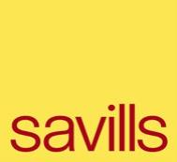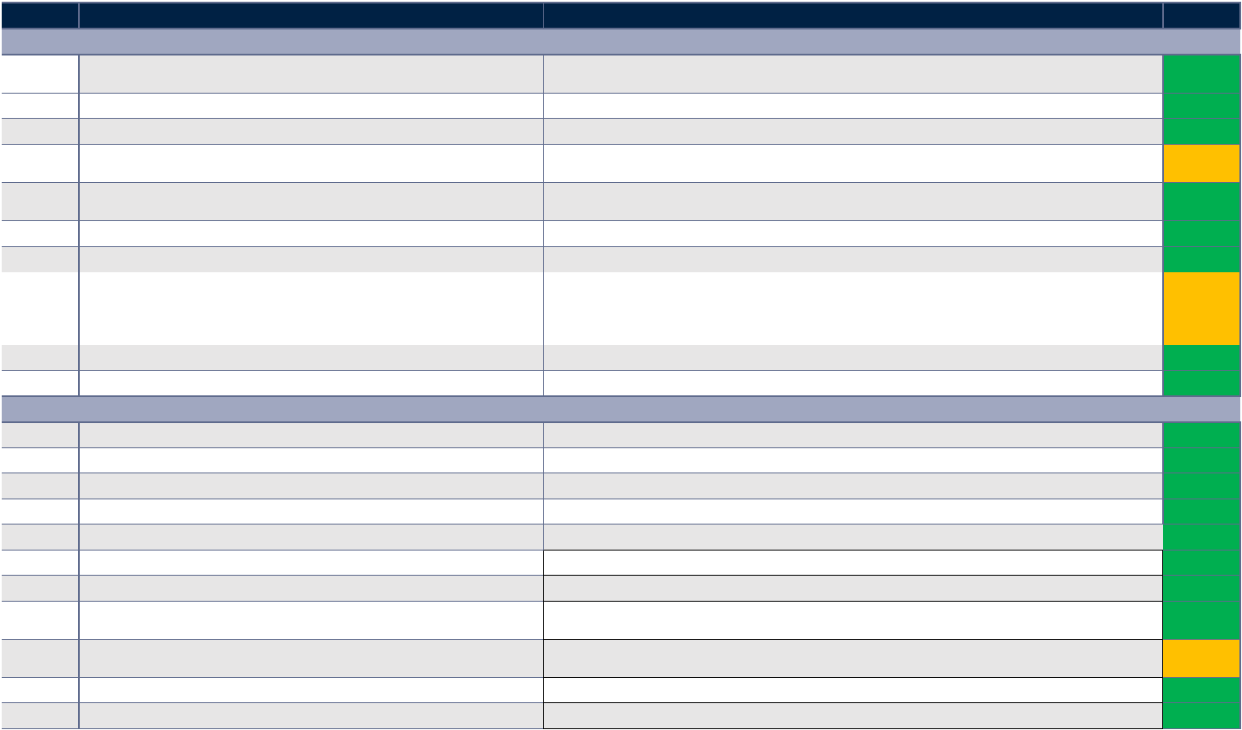

savills.fr

3

01/12/2023

Accessiblity

There are 3 accessible guestrooms (#101, #307 and #407).

Owner to provide the Accessibility Notice included in the last building permit application file for completeness.

Fire safety

According to the Security Commission report read on site, the emergency lighting is not functioning properly.

Owner to provide latest report.

limit of 30 persons in occupation of basement 1 level.

restaurant, 31 staff. The certificate had observations (we did not see the full list). One of the observations is a strict

type N (Restaurant) and X (Sport/Wellness) with a public occupancy of 148 persons for the hotel, 94 persons for the

The hotel is classified as an ERP (Establishment Open to the Public) 4th category type O (Hotel) with activities of

ERP regulation

The last Security Commission has a favourable opinion and was undertaken on 15 June 2022 (consulted on site).

Owner to provide the Public Access Opening certificate and the last Security Commission certificate for completeness.

Asbestos

No asbestos was seen on the site visit but the building is of some age.

Owner to provide the Asbestos Report on the hotel for completeness

E. Compliance

Insurance

Decenial

The last works date from 2016 and there should be a residual decennial insurance on the property until 2026.

Please provide the Decennial Insurance contract and the list of claims.

Q&A

Savills has sent Q&A to the owner. We are waiting for responses.

Responses from Owner awaited.

- Emergency lighting

However, Savills need to review the reports to verify the observations that have been made.

- Fire alarm and fire safety panel and components

- Smoke venting systems

- Fire doors: last verification in Septemeber 2023

- Fire Extinguishers

- Lifts: last verification on 17 January 2022 (every 5 years)

- Dry risers

- Gas installations: last verification in June 2022 (every 2 years)

- Das installations

- Electrical installations: last verification in April 2023 and March 2023 (Public Access)

Reports

- Electrical installations

- Fire alarm panel: last verification on 28 January 2022

Verification

This is a list of verification reports not yet seen which should be reviewed for completeness:-

We have looked at the Security Register on site. The following verifications are up to date:-

- As-built file (DOE)

- The Building Maintenance Instructions (DIUO)

Documents

requirement for building works since 1994):-

Missing

The owner should confirm that they hold the following documents for maintenance reasons (the DIUO being a legal

Documents awaited for review.

- Geometre measurement survey

- Building Permits application file including Security Notice and Accessibility Notice

- Building Permits

- Energy Performance Certificate

- Cadastral Plan and Title

Documents

held by the owner):-

Missing

The following documents would be useful to review for information but not essential for our report (these may be

Documents awaited for review.

- Last Security Commission certificate

Documents

- Public Access Opening Certificate

Missing

The following documents are important to review for our report (these may be held by the owner):-

Documents awaited for review.

D. Legal Considerations

greater than 1,000 m².

- Tertiary sector buildings of less than 1,000 m² located on a single site, with a total combined area equal to or

- Tertiary sector building with an area equal to or greater than 1,000 m²;

Specialist environmental engineers will need to be appointed by the Owner in order to conduct a more detailed and precise Décret Tertiaire assessment.

- Tertiary activities located within a building with an area equal to or greater than 1,000 m²;

implementing an Energy Management System coupled with the BMS and adding or improving thermal wall and roof insulation.

This Decree specifically relates to buildings that fall into one of the following three categories:-

fans coupled with the AC units (if free cooling is not available), implementing a complete metering strategy for power, heating, cooling and water,

Tertiaire include reducing temperature of hot water, implementing a BMS system for the HVAC and lighting (to comply with BACS regulation, implementing

- A final 60% reduction by 2050.

covered by the current owner. Typical solutions that will help reduce energy consumption and contribute to reaching the objective set by the Décret

- A further 50% reduction by 2040;

We have not been provided with the Energy Performance Certificate or the Declaration issued through the Operat Platform. The cost would need to be

- A 40% reduction by 2030;

Reduction

December 2022. The annual consumption for 2020 and 2021 should have also been declared on the OPERAT platform before 30 September 2022.

Consumption

buildings. The objective of the Décret Tertiaire is to reduce energy consumption in three stages:-

consecutive months of energy consumption between 2010 to 2019 when the hotel was in occupation), although a tolerance has been given until 31

Energy

The Décret Tertiaire is a legal text outlining essential measures for reducing energy consumption in tertiary sector

The owner of the hotel should have declared the energy consumption reference year on the OPERAT platform before 30 September 2022 (being 12

C. Environmental Considerations

SAVILLS TECHNICAL DUE DILIGENCE RED FLAG AND CAPEX APPRAISAL

Evaluation Warning : The document was created with Spire.PDF for .NET.

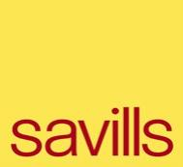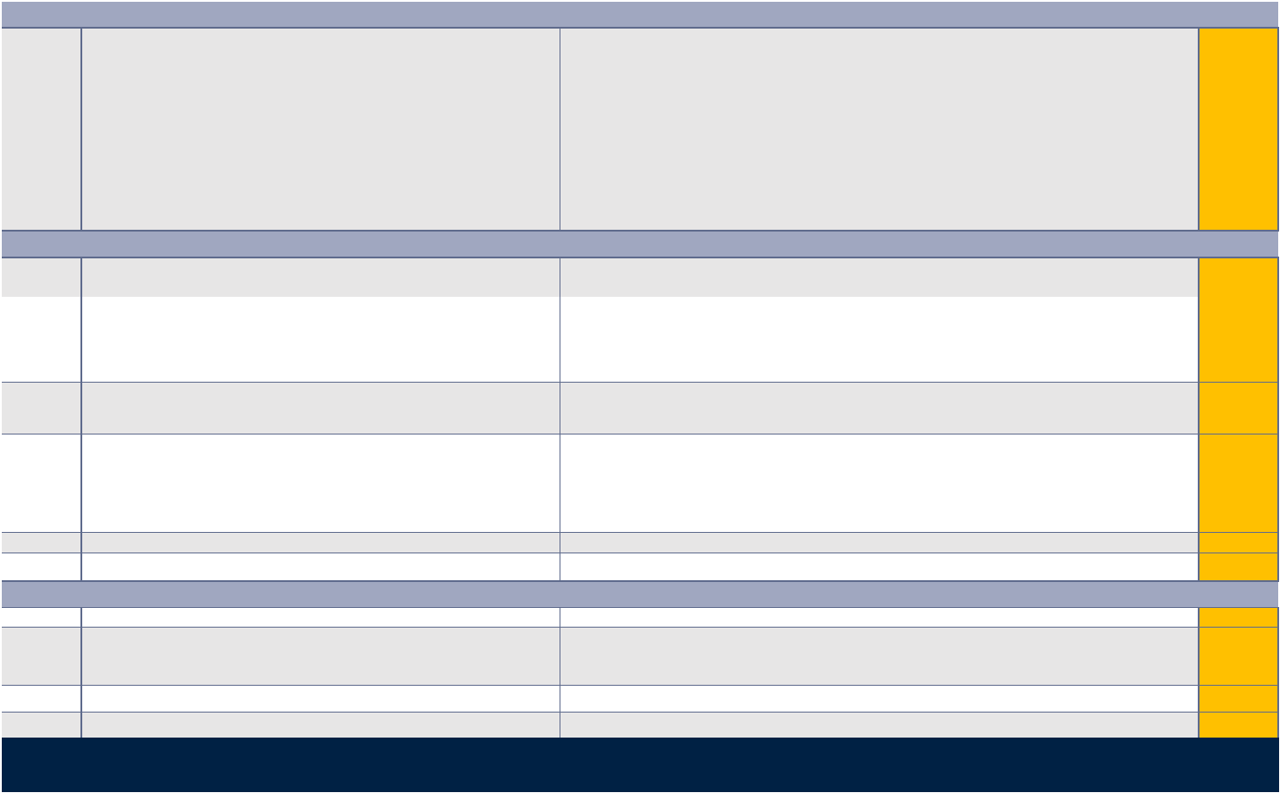

savills.fr

3

01/12/2023

1

No defect identified.

No capex allowance required for the next ten years.

€ -

€ - € -

B.3. Domestic Water Services

Sub-total

€

-

€

-

€

-

€

-

€

-

€

-

2027, given the nominal capacity of its HVAC systems.

Automation & Control Systems (BACS) decree.

cabling and controls as the asset will be subject to this decree by January 1,

1

We recommended that a BMS is installed to comply with the Building

Capex is provided in the long term for the installation of a BMS workstation,

€ 55 000

€ 55 000 € - € 55 000

B.2. Electrical Installations

Sub-total

€

55 000

€

-

€

-

€

55 000

€

-

€

55 000

1

No defect identified.

No capex allowance required for the next ten years.

€ -

€ - € -

B.1. Heating, Ventilation and Cooling (HVAC)

Sub-total

€

-

€

-

€

-

€

-

€

-

€

-

B. Services Installations

3

The epoxy coating applied on the floor of the back of house areas is lifting.

We include an allowance to reapply the epoxy coating to the affected areas.

€ 8 000

€ - € 8 000

waterproofing.

needs to be checked.

location of the water ingress and undertake the necessary repairs to the

2

Water ingress is visible on the skylight above the pool. The waterproofing

We allowed for the appointement of a waterproofing specialist to identify the

€ 10 000

€ 10 000

€ - € 10 000

issue with the compatibility with the waterproofing membrane.

the lifting tiles and undertake the necessary repairs.

1

The mosaic tiles in the pool are lifting (reccurent issue). There might be an

We allowed for the appointement of a pool wpecialist to identfy the issue with

€ 10 000

€ 10 000

€ - € 10 000

A.5. Internal Areas

Sub-total

€

28 000

€

-

€

20 000

€

-

€

-

€

28 000

1

No defect identified.

No capex allowance required for the next ten years.

€ -

€ - € -

A.4. External Areas

Sub-total

€

-

€

-

€

-

€

-

€

-

€

-

No defects seen to courtyard façades.

cleaning of the facade would be required before 2026.

required every 10 years. As the last renovation was done in 2016, the

defects. In accordance with the regulation, the cleaning of the facades is

facades in the medium term.

1

The facades to the building appear to be in good condition with no major

We include a small capex for the future cleaning and repainting of the main

€ 50 000

€ 50 000

€ - € 50 000

A.3. Facades

Sub-total

€

50 000

€

-

€

50 000

€

-

€

-

€

50 000

1

No defect identified.

No capex allowance required for the next ten years.

€ -

€ - € -

A.2. Roofs

Sub-total

€

-

€

-

€

-

€

-

€

-

€

-

1

No defect identified.

No capex allowance required for the next ten years.

€ -

€ - € -

A.1. Structure

€

-

€

-

€

-

€

-

€

-

€

-

A. Building Fabric

tenant cost

Year 1

Year 2-5

Year 6-10

cost

Rating

Element

Key Consideration

Savills Comment

Total

recoverable /

Short Term

Medium Term

Long Term

Capex / Owner

Risk

Service charge

CAPEX ASSESSMENT

Version - Report issue

01.12.2023

Site visit date:

16 November 2023

Purpose of TDD:

Red Flag TDD Report

Property address:

23/25 Rue du Pont Neuf, 75001 Paris, FRANCE

GENERAL INFORMATION

SAVILLS TECHNICAL DUE DILIGENCE RED FLAG AND CAPEX APPRAISAL

Evaluation Warning : The document was created with Spire.PDF for .NET.

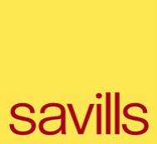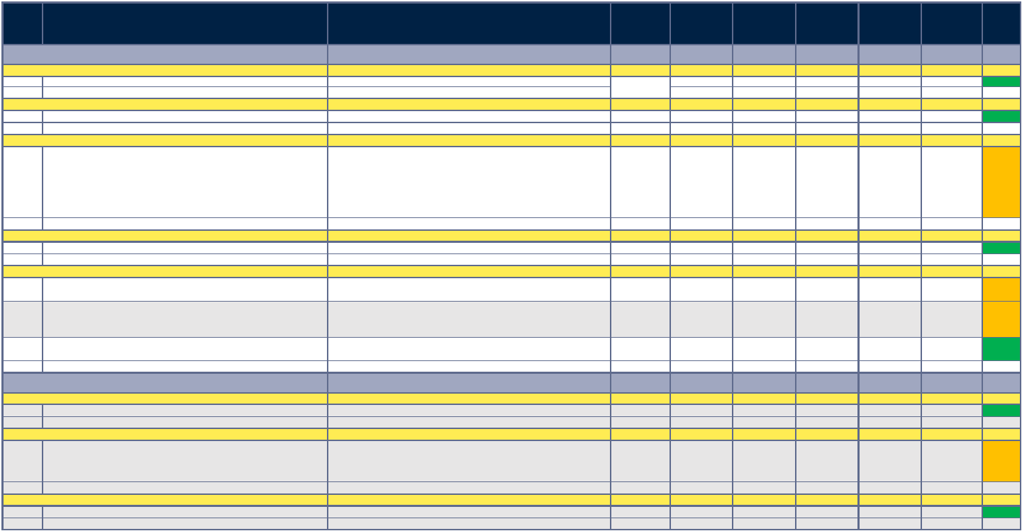

savills.fr

4

01/12/2023

Our Capex does not include routine maintenance, cyclical decoration or cleaning, except where these works are required to address defects or compliance issues.

The Capex budget does not include minor repairs and a threshold of €5,000 is used for this report. Cost items below this threshold have not been included in the Capex.

Low

A minor issue which is not considered to constitute a material issue in the short term.

Medium

Key issue to be clarified and/or fully considered in relation to the proposed property transaction or repairs having a significant cost implication.

High

Significant issue where an urgent remedy is required prior to the proposed property transaction or a serious defect requiring attention.

Risk Rating Key

TOTAL

€ 168 245 € - € 88 550 € 69 575 € - € 168 245

Contingency and Fees Sub Total

€ 35 245 € - € 18 550 € 14 575 € - € 35 245

Fees at 15%

€ 21 945 € - € 11 550 € 9 075 € - € 21 945

Contingency sum at 10%

€ 13 300 € - € 7 000 € 5 500 € - € 13 300

Sub-total (all works)

€ 133 000 € - € 70 000 € 55 000 € - € 133 000

Contingency and Fees

1

No defect identified.

No capex allowance required for the next ten years.

€ -

€ - € -

C.1. Environmental Considerations

Sub-total

€

-

€

-

€

-

€

-

€

-

€

-

C. Environmental and ICPE Considerations

1

No defect identified.

No capex allowance required for the next ten years.

€ -

€ -

€ - € -

B.6. Lifts

Sub-total

€

-

€

-

€

-

€

-

€

-

€

-

1

No defect identified.

No capex allowance required for the next ten years.

€ -

€ - € -

B.5. Public Health Systems

Sub-total

€

-

€

-

€

-

€

-

€

-

€

-

1

No defect identified.

No capex allowance required for the next ten years.

€ -

€ - € -

B.4. Fire Protection Systems

Sub-total

€

-

€

-

€

-

€

-

€

-

€

-

SAVILLS TECHNICAL DUE DILIGENCE RED FLAG AND CAPEX APPRAISAL

Evaluation Warning : The document was created with Spire.PDF for .NET.

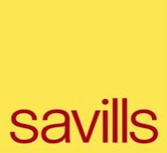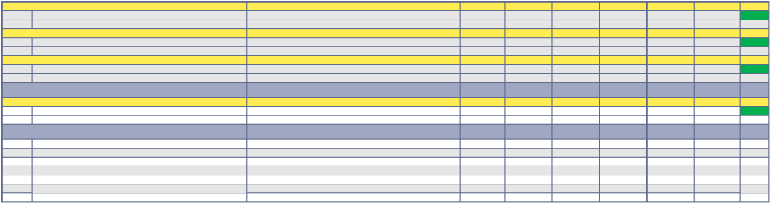

savills.fr

01/12/2023

PHOTOS

SAVILLS TECHNICAL DUE DILIGENCE RED FLAG AND CAPEX APPRAISAL

Evaluation Warning : The document was created with Spire.PDF for .NET.

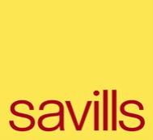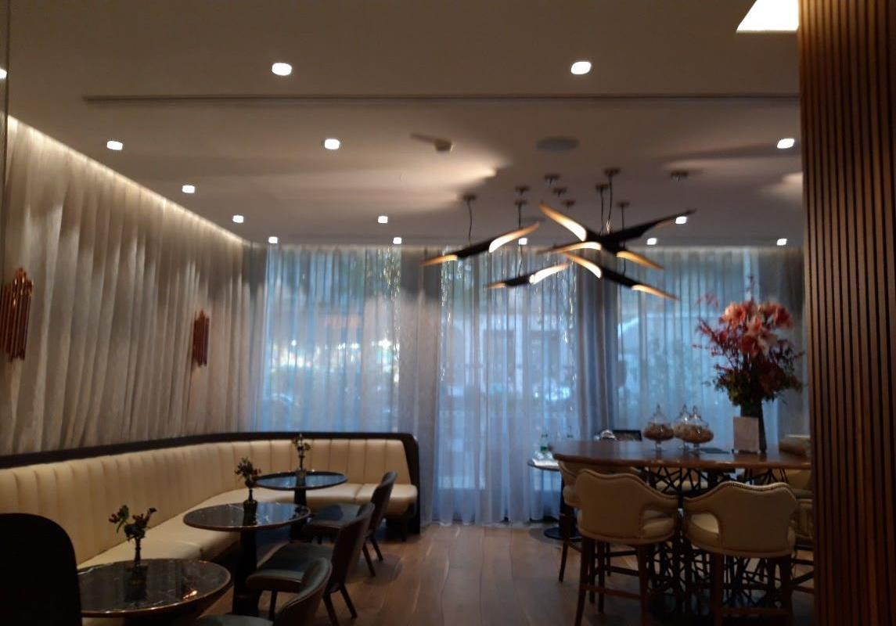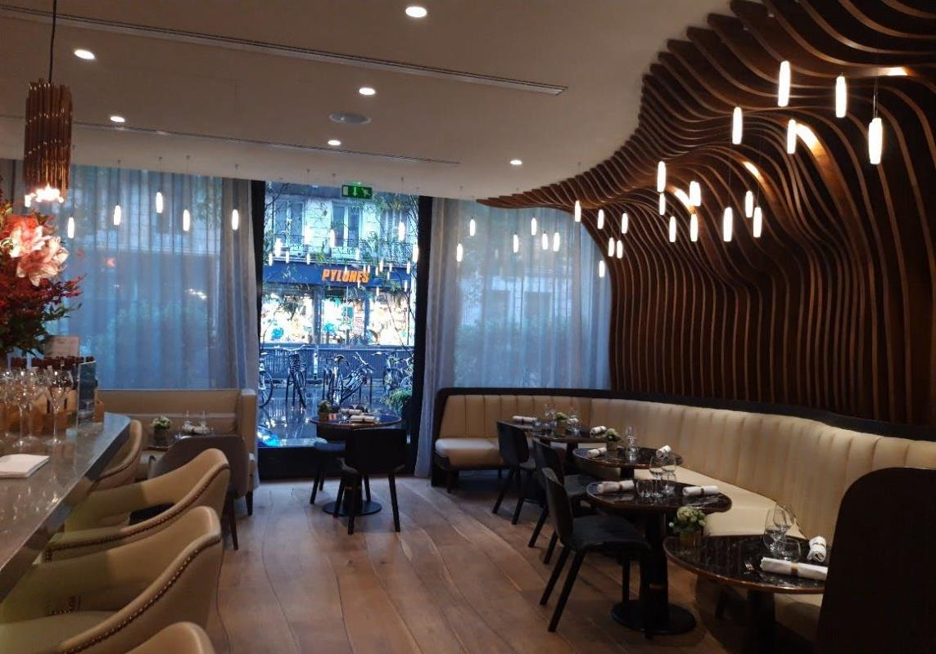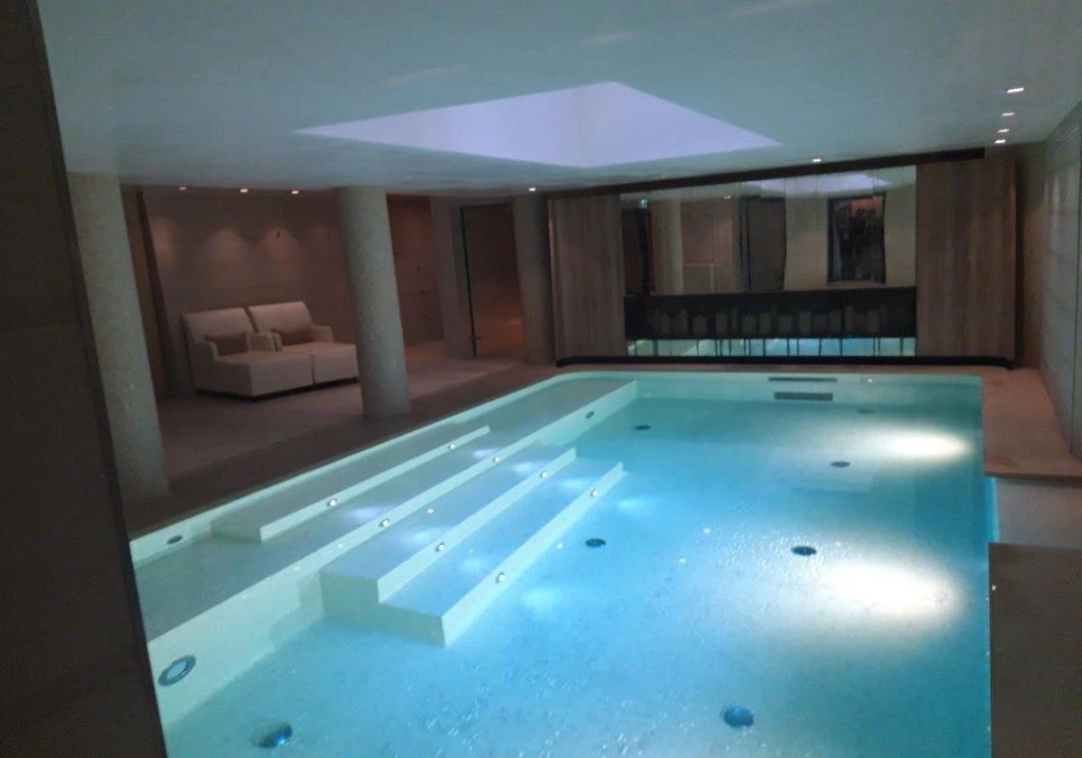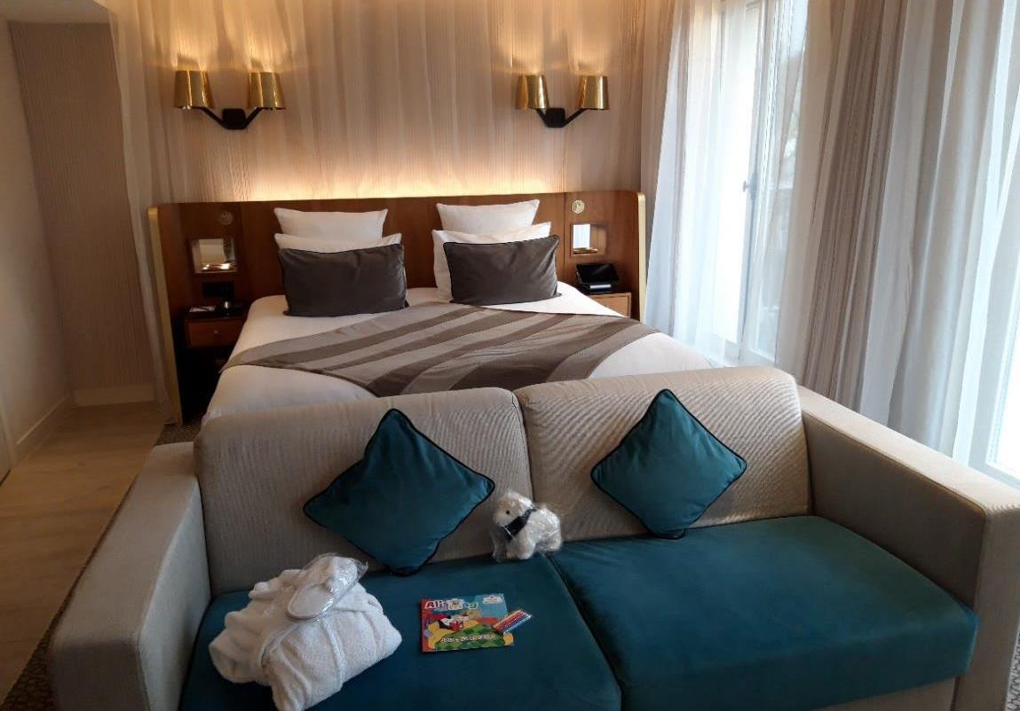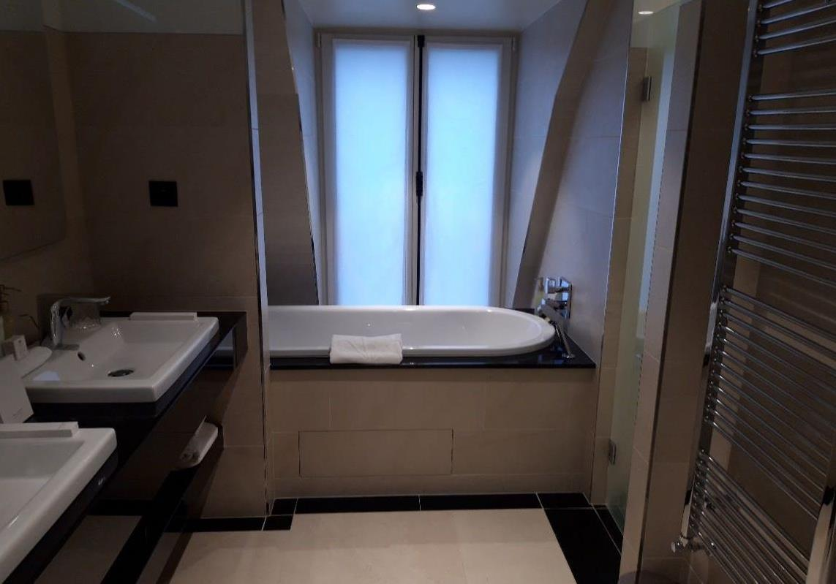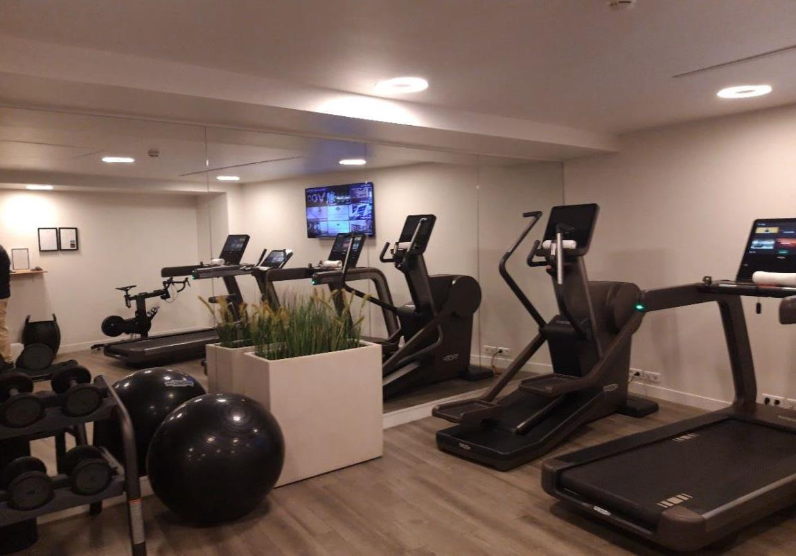

savills.fr

ghough@savills.com

aurelie.hubert@savills.fr

M: +33 6 03 49 03 59

M: +33 6 29 49 56 04

LD: +33 1 86 69 39 23

LD: +33 1 86 69 39 23

Director Building Consultancy

Building surveyor

Garth Ball MRICS

Aurelie Hubert

SAVILLS TECHNICAL DUE DILIGENCE RED FLAG AND CAPEX APPRAISAL

Evaluation Warning : The document was created with Spire.PDF for .NET.

