**POINT 1**

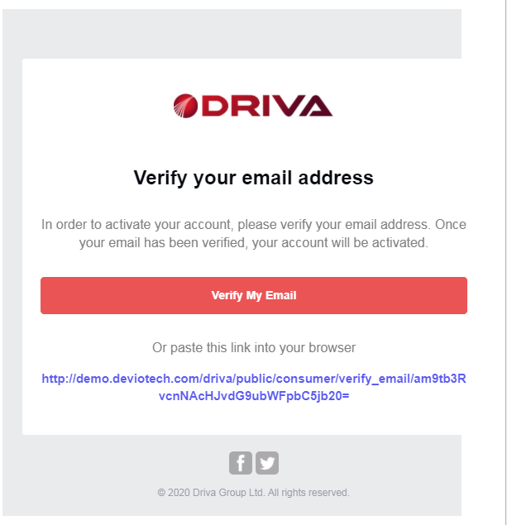

Please see the layout of the email above. You can see that the right side is not complete, and almost looks cut off. Please make sure that the email template is even for both sides.

**POINT 2**

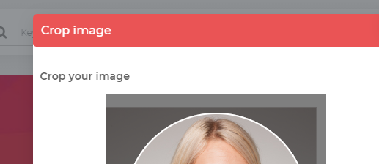

Replace “Crop image” with “Crop your image”  
Replace “Crop your image” with “Select the area that will be cropped”

**POINT 3**

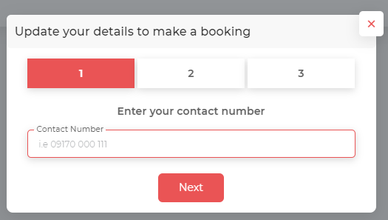

Replace the header with “Update your profile details to make a booking”  
Remove the placeholder text in the “Contact Number” field

**POINT 4**

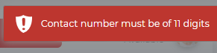  
  
Replace the above with “Check the contact number and try again”

**POINT 5**

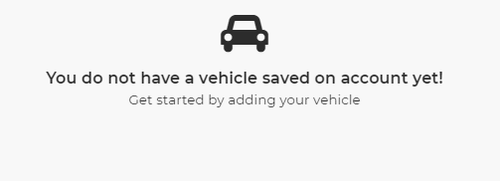

You are missing the word “your”. The first line should say:  
You do not have a vehicle saved on your account yet!

There should be an “Add” button underneath these statements. Also, the word “started” should be highlighted as a link and should also do the same function as the “Add” button.

The “Add” button should be like the “Next” button that is on the theme example: <https://pixinvent.com/demo/vuexy-vuejs-admin-dashboard-template/demo-1/forms/form-wizard>  
but it will be in red colour and with an “add” icon to the left of it. Replace “Next” with “Add”.

**POINT 6**

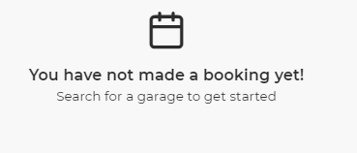  
There should be a “Book” button underneath these statements. Also, the word “Search” should be highlighted as a link and should also do the same function as the “Book” button.

The “Book” button should be like the “Next” button that is on the theme example: <https://pixinvent.com/demo/vuexy-vuejs-admin-dashboard-template/demo-1/forms/form-wizard>  
but it will be in red colour and with a “book” icon to the left of it. Replace “Next” with “Book”.

The “Book” button (and “Search” link) will take the user to the homepage, which will be like the homepage that you see on yell.com (which has not been done yet). This page should be established now as this is part of the consumer user.

**POINT 7**

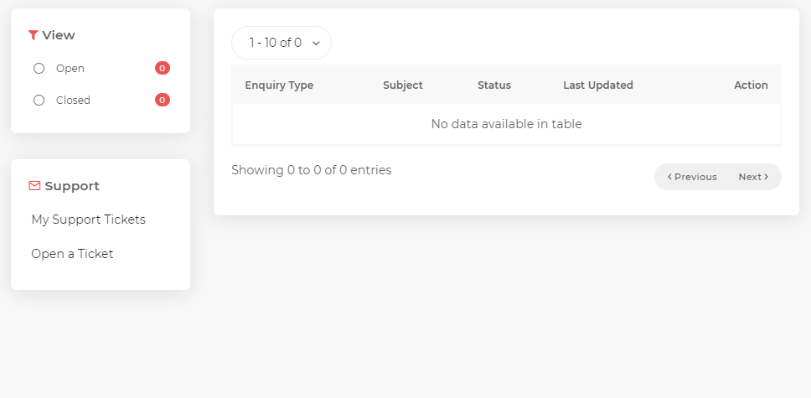

Replace “No data available in table” with “There are no support tickets to display”

Remove the Previous/Next buttons until the entries have exceeded the display (in the above case, 10 entries).

**POINT 8**

If the user clicks on “Open a Ticket”, the “View” and “Support” boxes should remain in their position.

See below to open a new support ticket.

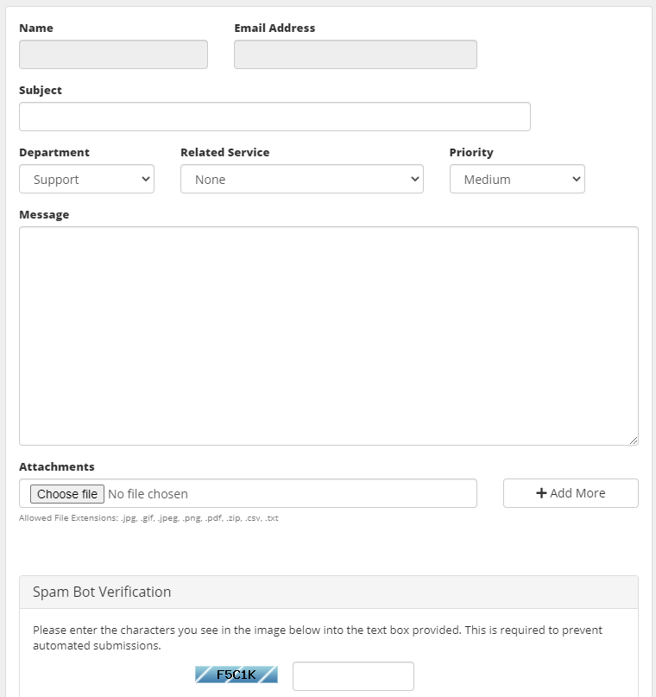

When the user opens a support ticket, the above should be the layout but with the same style you have been using. Use only the attributes below.

Full Name Email Address  
Subject  
Messages  
Attachments  
  
Google ReCaptcha  
[Cancel] [Submit]

The “Full Name” and the “Email Address” will be prefilled with the information saved under the account.

If there are recently opened tickets, then under the “View” and above the “Support” boxes should be “Your Recent Tickets”. For example, see below:

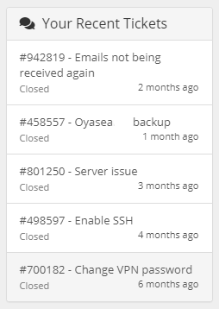

All support tickets will have a support number that can be searched up on by admin.