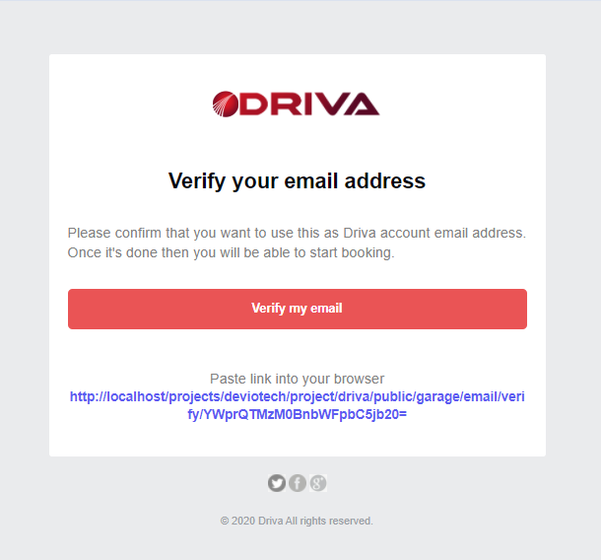

* There should be more of gap between the logo icon and “DRIVA” in the logo
* Use the facebook and twitter icons only and style it from the examples below. Increase the size more too  
    
  
* The copyright at the bottom will say:   
    
  © 2020 Driva Group Ltd. All rights reserved

**Consumer**  
  
**Verification Email**

|  |
| --- |
| [LOGO]  **Verify your email address**  In order to activate your account, please verify your email address. Once your email has been verified, your account will be activated.  **[Verify my email]**  Or paste this link into your browser http://etc... |

**Resend Email**

|  |
| --- |
| [LOGO]  **Verify your email address**  Here is your resent verification email link. Activate your account by verifying your email address.  **[Verify my email]**  Or paste this link into your browser http://etc... |

**Reset password**

|  |
| --- |
| [LOGO]  **Reset your password**  We received your request to reset your password. You can reset your password with the link below.  **[Reset my password]**  Or paste this link into your browser http://etc... |

**Password change**

|  |
| --- |
| [LOGO]  **Password update**  Your password has been updated successfully. Please use your new password to login to your account.  **[Login]** |

**Vehicle record update**

|  |
| --- |
| [LOGO]  **Vehicle records update**  You have edited your vehicle records. Login to your account to view more.  **[Login]** |

**Booking request**

|  |
| --- |
| [LOGO]  **Your booking request**  Your booking request has been sent to [GARAGE NAME]. They should respond as soon as they view your request. Login to your account to view more.  **[Login]** |

**Booking request - approved**

|  |
| --- |
| [LOGO]  **Your booking request has been approved**  Your booking request with [GARAGE NAME] has been approved. If you wish to proceed with the booking, please confirm by logging into your account.  **[Login]** |

**Booking request - rejected**

|  |
| --- |
| [LOGO]  **Your booking request has been declined**  Unfortunately, your booking request with [GARAGE NAME] has been declined. Login to your account to view more.  **[Login]** |

**Booking request - confirmation**

|  |
| --- |
| [LOGO]  **Booking [BOOKING ID] confirmation**  Your booking with [GARAGE NAME] has been confirmed. Please view the details below:  Booking ID: [BOOKING ID]  Garage name: [GARAGE NAME] Garage address: [GARAGE ADDRESS] Date/Time: DD MM YYYY at HH:MM  **[Login]** |

The four attributes to the booking seen above will be in a table when being displayed in the email. And, it will be left aligned in the table.

**Booking – Update (any update like messages, status changes, etc..)**

|  |
| --- |
| [LOGO]  **Booking [BOOKING ID] update**  Your booking has an update. Login to your account to view more.  **[Login]** |

**Booking - Complete**

|  |
| --- |
| [LOGO]  **Your booking [BOOKING ID] has been complete**  Your booking with [GARAGE NAME] has been marked as complete. Your vehicle should be ready for pick up. Login to your account to view more.  **[Login]** |

**Booking - Cancelled**

|  |
| --- |
| [LOGO]  **Your booking [BOOKING ID] has been cancelled**  Your booking with [GARAGE NAME] has been cancelled. Login to your account to view more.  **[Login]** |

**Support**

|  |
| --- |
| [LOGO]  **Customer support ticket [TICKET ID]**  We have received your customer support request. We will update you shortly. Login to your account to view more.  **[Login]** |

**Support – Status change**

|  |
| --- |
| [LOGO]  **Customer support ticket [TICKET ID]**  The status of your customer support ticket has changed. Login to your account to view more.  **[Login]** |

**Garage**

**Verification email**

|  |
| --- |
| [LOGO]  **Verify your email address**  In order to activate your account, please verify your email address. Once your email has been verified, your account will be activated.  **[Verify my email]**  Or paste this link into your browser http://etc... |

**Resent email**

|  |
| --- |
| [LOGO]  **Verify your email address**  Here is your resent verification email link. Activate your account by verifying your email address.  **[Verify my email]**  Or paste this link into your browser http://etc... |

**Reset password**

|  |
| --- |
| [LOGO]  **Reset your password**  We received your request to reset your password. You can reset your password with the link below.  **[Reset my password]**  Or paste this link into your browser http://etc... |

**Password change**

|  |
| --- |
| [LOGO]  **Password update**  Your password has been updated successfully. Please use your new password to login to your account.  **[Login]** |

**Application - submitted**

|  |
| --- |
| [LOGO]  **Your garage account application**  We have received your garage account application. You should receive a response within 48 hours.  **[Login]** |

**Application - accepted**

|  |
| --- |
| [LOGO]  **Congrats! Your account has been approved**  We have accepted your garage account application.  We have now sent a verification code to your garage address which will be required to activate your account. Please **contact** us if you do not receive the code within five working days.  **[Login]** |

**Application - declined**

|  |
| --- |
| [LOGO]  **Unfortunately, your application has been declined**  We believe that there is an issue with your application. Please go over the information again. If you believe that there was a mistake, please **contact** us.  **[Login]** |

**Verification code**

|  |
| --- |
| [LOGO]  **Congrats! Your account is up and running**  Your garage account has been verified. Your profile is now active and you will be able to manage your profile and accept bookings. Login to your account to view more.  **[Login]** |

**Profile – update request**

|  |
| --- |
| [LOGO]  **We have received your profile update request**  We have received your profile update. You should receive a response within 48 hours. Login to your account to view more.  **[Login]** |

**Profile – approved request**

|  |
| --- |
| [LOGO]  **Your profile update request has been approved**  We have approved your profile update request. Login to your account to view more.  **[Login]** |

**Profile – declined request**

|  |
| --- |
| [LOGO]  **Your profile update request has been declined**  Your profile update request has been declined. Login to your account to view more.  **[Login]** |

**Profile - Promotion**

|  |
| --- |
| [LOGO]  **Your profile is now featured**  Your [PROMOTION PACKAGE PLAN] has been approved and your profile is now featured. Login to your account to view more.  **[Login]** |

**Profile – Promotion ended**

|  |
| --- |
| [LOGO]  **Your promotion has ended**  Your [PROMOTION PACKAGE PLAN] has now ended. Login to your account to view more.  **[Login]** |

**Booking request**

|  |
| --- |
| [LOGO]  **Booking request received**  You have a booking request from [CUSTOMER NAME]. Please confirm if you would like to accept the request. Login to your account to view more.  **[Login]** |

**Booking request - approved**

|  |
| --- |
| [LOGO]  **Booking request approved**  You have approved of a booking request. Please await confirmation from [CUSTOMER NAME]. Login to your account to view more.  **[Login]** |

**Booking request - rejected**

|  |
| --- |
| [LOGO]  **Booking request declined**  You have declined a booking request. Login to your account to view more.  **[Login]** |

**Booking request - confirmation**

|  |
| --- |
| [LOGO]  **Booking [BOOKING ID] confirmation**  Your booking with [CUSTOMER NAME] has been confirmed. Please view the details below:  Booking ID: [BOOKING ID]  Garage name: [GARAGE NAME] Garage address: [GARAGE ADDRESS] Date/Time: DD MM YYYY at HH:MM  **[Login]** |

The four attributes to the booking seen above will be in a table when being displayed in the email. And, it will be left aligned in the table.

**Booking – Update (any update like messages, status changes, etc..)**

|  |
| --- |
| [LOGO]  **Booking [BOOKING ID] update**  You have updated a booking. Login to your account to view more.  **[Login]** |

**Booking - Complete**

|  |
| --- |
| [LOGO]  **Booking [BOOKING ID] marked as complete**  You have marked your booking with [CUSTOMER NAME] as complete. Login to your account to view more.  **[Login]** |

**Booking - Cancelled**

|  |
| --- |
| [LOGO]  **Your booking [BOOKING ID] has been cancelled**  Your booking with [CUSTOMER NAME] has been cancelled. Login to your account to view more.  **[Login]** |

**Support**

|  |
| --- |
| [LOGO]  **Support ticket [TICKET ID]**  We have received your support request. We will update you shortly. Login to your account to view more.  **[Login]** |

**Support – Status change**

|  |
| --- |
| [LOGO]  **Support ticket [TICKET ID]**  The status of your support ticket has changed. Login to your account to view more.  **[Login]** |