**POINT 1**

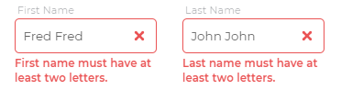

Remove the full stops from both of these statements. Also, you can see that there are more than two letters in each field but the error message shows. Please change it so the user can enter as two names (for example a double barrelled name or name like “Jean Paul” which could also be a first name).

**POINT 2**

<http://demo.deviotech.com/driva/public/consumer/register>  
Please provide dimensions for the background grey image ( 1919*985 )

Please provide the dimensions for the multicoloured cover art below ( 800*449 )



**POINT 3**

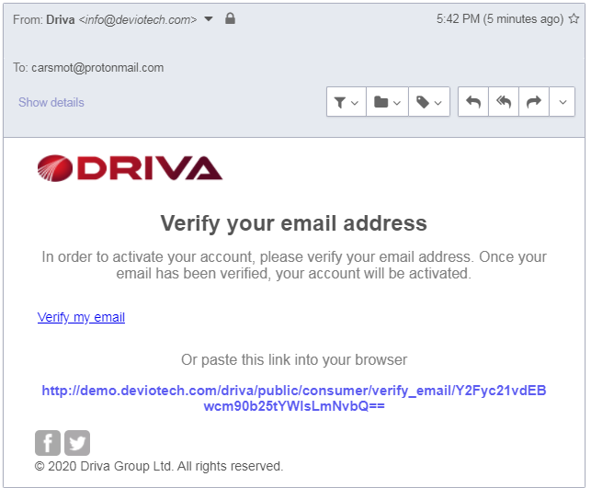

The layout looks different in protonmail. Can you maintain the layout for all emails.

**POINT 4**

C:\Users\Donitech\Desktop\po1.png

* Increase the length of the “Keyword or garage name” field so it’s slight longer than the location field
* The location field is not picking up “London” or postcode searches. Can you please check the api is correctly configured with this field

**POINT 5**

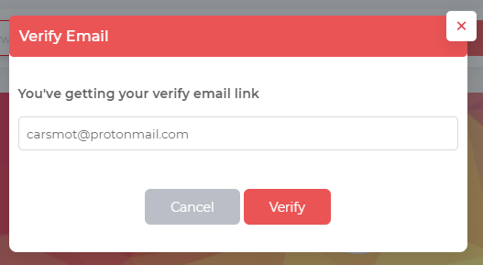

Replace “Verify Email” with “Verify your email address”

Replace “You’ve getting your verify email link” with “We will resend a verification link to your email address below so you can verify your account”

Replace the “Verify” button with “Resend”

**POINT 6**

I refer to POINT 5 above. If the email address has changed in the verification link field, then that is where the verification email link will be sent to and that will be the new email address associated with that account. Once verified, then that will be the new email for the user to log into.

**POINT 7**

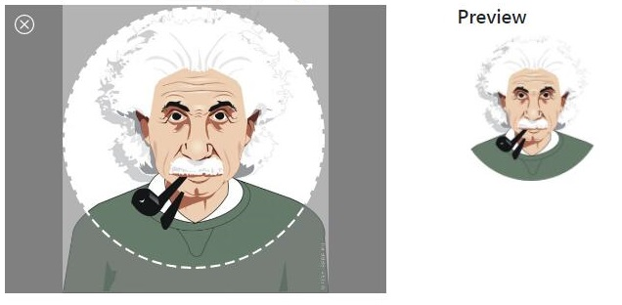

When uploading images, there should be an image preview and selector that allows the user to select the area that will be uploaded into the avatar. This should be throughout the site where required.

**POINT 8**

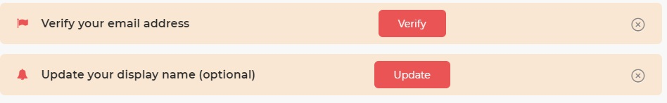

The “Verify” and the “Update” buttons should be moved closer to the close icons on the far right. Also, move the left margin more to the right. See below for example:

[icon] Verify your email address [Verify] [x]  
 [icon] Update your display name (optional) [Update] [x]

**POINT 9**

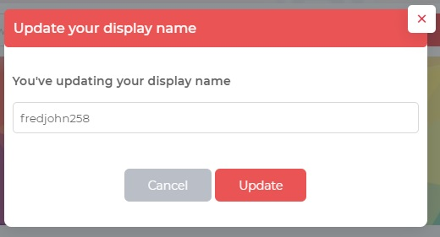

Replace “You’ve updating your display name” with “You can update your display name below with another display name if it is available”

If the display name is not available, the error message will be:  
Your chosen display name is not available. Please try another  
  
  
If the display name has been changed, the message will be:  
You have successfully changed your display name

The display name must be more than four characters, all in one word and no special characters (only alphabet and numbers). If the display name submitted does not fit this criteria, then the error message will be:  
Please change your display name and try again

Note: Updating the display name does not work

**POINT 10**

The user should be able to visit all menus whilst their email is not verified. The user’s email must be verified if he wishes to:

* Make a booking
* Open a ticket (Support)
* Add a vehicle to their account

**POINT 11**

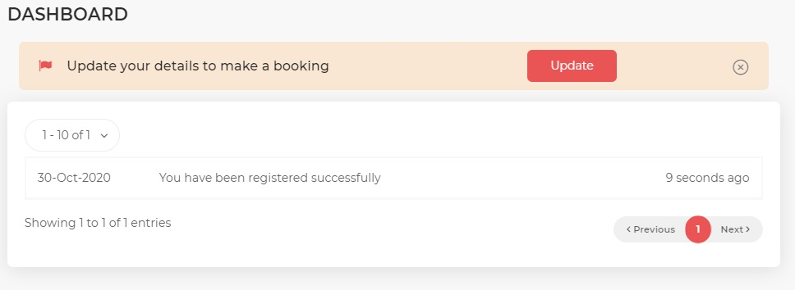

The yellow alert should be the same length as the container below. Please arrange the text, icons and button of the alert as described in POINT 8 of this document.

The “1 – 10 of 1” should only display when there are more than 10 entries in the notifications. If there is not more than 10 entries, then it should not be visible. The same goes for the “Showing 1 to 1 of 1 entries”.

**POINT 12**

Error on the profile page

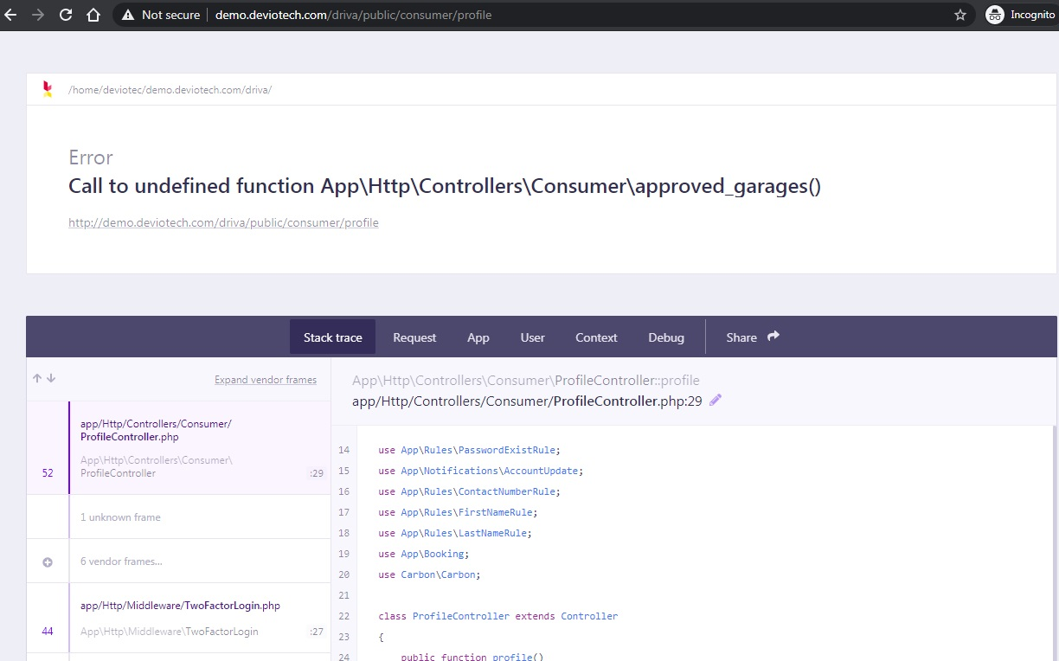

**POINT 13**

Rather than the yellow alerts for both the “Vehicle” and “Booking” when there is no entry for either, please do the following layout below with the text in the table for both “Booking” and “Vehicle” menus.

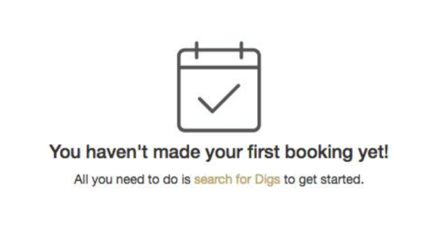

|  |  |
| --- | --- |
| [VEHICLE ICON]  You do not have a vehicle saved on account yet! Get started by adding your vehicle | [BOOKING ICON]  You have not made a booking yet! Search for a garage to get started. |

**POINT 14**

Replace the footer design with the design you see below (but in red colour) and with the links as is on the site already.

