
Bank Management system


Project submitted in the context of the course
(I3306E) Database II
Prepared by
Ali Kamel Ghrabi (102587)
Israa Ali AlZein (92472)

Lebanese University
Faculty of Sciences I
Department of computer Sciences
2023 – 2024

January 17, 2024

Acknowledgements

We extend our sincere gratitude to Dr. Mohammad Dbouk for his invaluable guidance, patience, and insightful feedback throughout the development of this project. Special thanks to our project partner for their dedicated efforts and collaboration, contributing significantly to the success of the endeavor.

Table of Contents
Abstract 3
Chapter 1: Introduction 6
1.1 User Guide 6
Chapter 2: Application Architecture 8
2.1 AAM (Application Architecture Model) 8
2.2 Description 9
Chapter 3: Database Modeling 10
3.1 ER Diagram 10
3.2 PDM (Physical Data Model) 11
Chapter 4: Services and Interface Modeling 12
4.1 Services of UMS 12
4.2 UI 12
Chapter 5: Implementation and Testing 13
5.1 Database Implementation 13
5.2 Database Connection Implementation 15
5.3 Testing 15
Chapter 6: Conclusion 18
Appendix 19
1) Creation of the Database: 19

Abstract
The Bank Management System project is a robust application developed to facilitate efficient management and operations within a banking environment. This web-based system employs a combination of C# for backend functionality and MS SQL Server for database management, offering a user-friendly interface for both customers and administrators.
Key Features:
- User Authentication:
  - Secure login functionality for both customers and administrators, ensuring data privacy and access control.
- Account Management:
  - Comprehensive account creation, modification, and deletion functionalities, capturing essential customer information such as name, phone, education, gender, address, occupation, and income.
- Transaction Handling:
  - Seamless processing of various transactions, including balance inquiries, withdrawals, transfers, and deposits.
- Database Integrity:
  - Implementation of referential-integrity constraints through triggers, ensuring the consistency and accuracy of database records.
- User Roles and Permissions:
  - Creation of user roles and permissions to control access levels, maintaining a secure environment.
- Dashboard Overview:
  - An intuitive dashboard providing a quick overview of essential metrics, including account details, transaction history, and customer information.
- Error Handling:
  - Implementation of robust error-handling mechanisms to address and report any issues during system operations
- Security:
  - Stringent security measures, including encrypted user data, secure login protocols, and role-based access control, to safeguard sensitive information.

This Bank Management System is designed to optimize banking operations, enhance customer experience, and ensure the security and integrity of financial transactions. Subsequent chapters will delve into the architectural design, database modeling, services, interface implementation, testing, and a comprehensive conclusion.

Introduction
Introduction:
Welcome to the Bank Management System, an advanced and user-friendly desktop application crafted to revolutionize banking operations. Developed using C# for a robust backend and MSSQL for efficient database management, this comprehensive system provides a suite of tools to streamline account management, transactions, and various essential aspects within a banking environment.
Description:
The Bank Management System offers a centralized platform for administrators to oversee and manage critical facets of banking operations. The application's dashboard provides a quick overview of key metrics, empowering administrators to make informed decisions and maintain a comprehensive understanding of the bank's financial landscape.
Key features encompass Account Management, Transaction Handling, Database Integrity with referential-integrity constraints, User Roles and Permissions, and a robust Search functionality. The emphasis on security ensures that only authorized personnel can access and modify sensitive data, guaranteeing the confidentiality and integrity of banking records.
With an intuitive design and a rich set of features, this system is tailored to meet the unique needs of banking institutions, fostering efficiency, organization, and secure financial transaction management.

User Guide

- Dashboard:
  - Upon logging in, administrators are greeted with a dashboard displaying key financial metrics. Navigate through various sections for detailed insights into account details, transaction history, and customer information.
- Account Management:
  - Comprehensive functionalities for creating, modifying, and deleting accounts, capturing essential customer information such as name, phone, education, gender, address, occupation, and income.
- Transaction Handling:
  - Seamless processing of various transactions, including balance inquiries, withdrawals, transfers, and deposits.
- Database Integrity:
  - Implementation of referential-integrity constraints through triggers, ensuring the consistency and accuracy of banking records.
- User Roles and Permissions:
  - Creation of user roles and permissions to control access levels, maintaining a secure banking environment.
- Search Functionality:
  - Utilize the search page to efficiently locate specific customer account information.

Goal of the Project
The primary goal of this project is to provide a hands-on learning experience in advanced database concepts, encompassing Indexes, Triggers, Transactions, and Procedures within the context of a Bank Management System. By undertaking the development of the system, the aim is to deepen the understanding of database management principles and their practical application in the banking domain. The project serves as a platform to explore database optimization through the use of indexes, ensuring efficient data retrieval and storage in the context of a bank's operational needs. Triggers are implemented to enforce specific rules and maintain data integrity, while Transactions are utilized to manage banking operations reliably and securely. Additionally, the project delves into the implementation of Procedures to automate complex tasks within a bank, showcasing the practical application of these advanced database topics in a real-world banking scenario.

Application Architecture
This chapter delves into the architectural design of the Bank Management System, outlining the key components and their interactions. The system employs a three-tier architecture, ensuring separation of concerns and promoting maintainability.

AAM (Application Architecture Model)
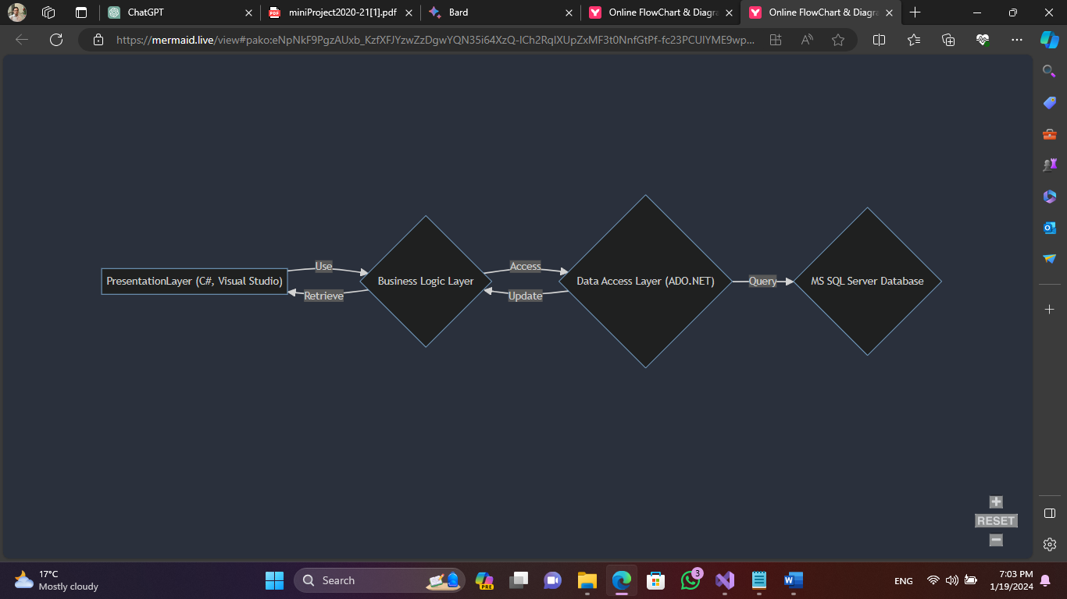
- Bank Management System Architecture.

Description
The presented Application Architecture Model (AAM) illustrates the integral components and interactions within the Bank Management System (BMS) application, developed exclusively using C# in Visual Studio with Microsoft SQL Server as the designated database management system (DBMS).
Server Side Configuration:
- The backbone of the BMS relies on Microsoft SQL Server, serving as the DBMS for efficient data storage and retrieval.
- The connection between the C# application and SQL Server is facilitated through the SqlConnection class in C#.
SqlConnection Con = new SqlConnection(@"Data Source=(LocalDB)\MSSQLLocalDB;AttachDbFilename=C:\Users\alikg\Documents\BankManagmentSystemDB.mdf;Integrated Security=True;Connect Timeout=30");
Application Development:
- The entire application is developed using C# programming language within the Visual Studio integrated development environment (IDE).
User Interface:
- The Bank Management System desktop application, developed in C# within Visual Studio, features user-friendly interfaces created using Windows Forms or WPF. These interfaces ensure a smooth and native user experience.
Services and Database Operations:
- Administrators interact with the application through well-designed graphical interfaces, powered by C#. The application seamlessly processes transactions, manages customer data, and communicates with the MS SQL Server database to ensure efficient and reliable banking operations.
Key Services Include:
- Addition of Customer Data: Admins can efficiently add essential customer details such as name, phone, education, gender, address, occupation, income, and more.
- Deletion of Customer Data: Admins have the capability to remove customer records from the database and that for updating information.
- Data Management: The user-friendly interface empowers administrators to perform various tasks, including viewing account details, making transactions, and updating customer information.
The provided SqlConnection code is crucial for establishing a secure and reliable connection between the C# application and the designated MSSQL database, ensuring smooth data transactions and interactions within the Bank Management System.

Database Modeling
This Chapter includes the different techniques used for the process of Database Engineering, Modeling and Development.
ERD plus was the Software that was used by us to produce the following

ER Diagram
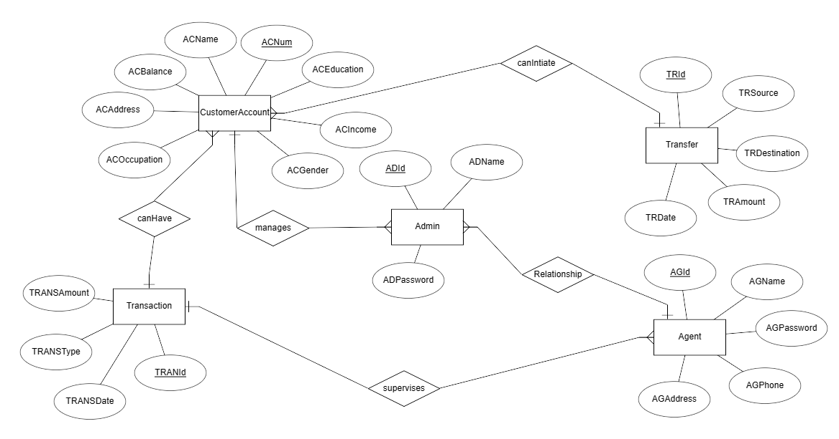
- ER Diagram of the Bank Management System.
The ER diagram illustrates the structure of a bank management system, showcasing key entities such as "Account," "Admin," "Agent," "Transfer," and "Transaction." Relationships are established, depicting connections between these entities. The system enables admins to supervise multiple agents, facilitating various transactions, transfers, and account management operations within the bank. The design promotes efficient data organization and retrieval in the context of a secure and functional banking application.
Entities:
- Account:
  - Captures details of bank accounts.
  - Attributes: ACNum (Primary Key), ACName, ACPhone, ACAddress, ACGen, ACOccup, AcEduc, AcInc, AcBal
  - Relationships:
    - One-to-many with Admin
    - One-to-many with Transfer
    - One-to-many with Transaction
    - Many-to-one with Agent
- Admin:
  - Stores information about administrators.
  - Attributes: AdId (Primary Key), AdName, AdPass
  - Relationships:
    - One-to-many with Account
- Agent:
  - Manages details of agents responsible for account management.
  - Attributes: AId (Primary Key), AName, APass, APhone, Aaddress
  - Relationships:
    - One-to-many with Account
- Transfer:
  - Records details of fund transfers.
  - Attributes: TrId (Primary Key), TrSrc (Foreign Key to Account.ACNum), TrDes (Foreign Key to Account.ACNum), TrAmt, TrDate
  - Relationships:
    - Many-to-one with Account (for both TrSrc and TrDes)
- Transaction:
  - Holds information about various transactions.
  - Attributes: TransactionID (Primary Key), AccountNumber (Foreign Key to Account.ACNum), TransactionType, Amount, TransactionDate
  - Relationships:
    - Many-to-one with Account

PDM (Physical Data Model)
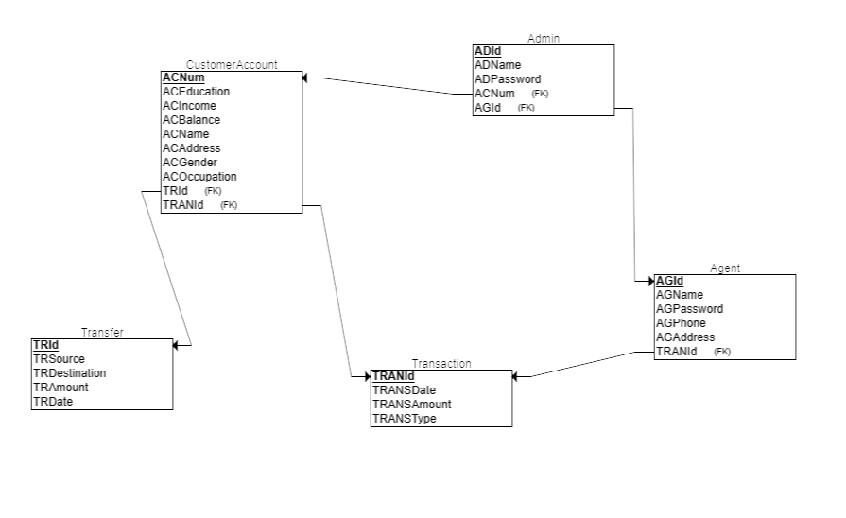
- Physical Data Model of the BMS
- Figure 3 illustrates the Physical Data Model (PDM) of the Bank Management System.
- The PDM is a product of ERD Plus, generated post the transformation from the Entity-Relationship (ER) diagram.
- The PDM serves as the blueprint for the database structure, aiding in the creation of individual SQL scripts for each table through ERD Plus tools.

Services and Interface Modelling
In this chapter, we will state the services that the BMS Application provides to the banks that use it.

Services of BMS
Our Application Provide many services that are “user friendly” to the Clients:
The Bank Management System (BMS) offers a comprehensive set of services designed to cater to the diverse needs of banks utilizing the application. These services encompass key functionalities, ensuring efficient and secure banking operations. The primary services include:
- Account Management:
  - Creation, modification, and deletion of customer accounts.
  - Real-time tracking of account balances and transaction history.
- Admin Control:
  - Secure login for administrators to manage system components.
  - User-friendly interfaces for efficient control over various aspects of the system.
- Transaction Handling:
  - Facilitation of fund transfers between accounts.
  - Real-time tracking of transactions and their details.
- Agent Management:
  - Addition, modification, and removal of agents associated with the bank.
  - Monitoring agent-related activities and transactions.
- User Authentication and Authorization:
  - Robust user authentication to ensure secure access.
  - Authorization mechanisms to control user roles and permissions.
- Data Management:
  - Addition, deletion, and modification of customer data.
  - Management of customer information with ease.
- Search Functionality:
  - Efficient search features to locate specific customer or transaction information.
  - Quick access to relevant data for improved decision-making.
- Report Generation:
  - Dynamic report generation for various aspects of banking operations.
  - Customizable reports to meet specific reporting requirements.

UI
The User Interface (UI) of the Bank Management System (BMS) has been crafted using Visual Studio, leveraging the specialized styling attributes for Windows C# desktop applications. Below is a snippet illustrating the UI design implemented in Visual Studio:

Figure 4 Welcome Page

Figure 5 Main Menu

Implementation and Testing
In this chapter, we will introduce the different types of Implementation methods we used in our development, and a brief look at some scenarios we encountered at development.

Database Implementation
For the Database Implementation of the Bank Management System (BMS), we utilized Microsoft SQL Server Management Studio (SSMS) to create the necessary tables and relationships. The following are key features and implementations in some of the tables.
Account Table:
CREATE TABLE [dbo].[AccountTbl] (
[ACNum] INT IDENTITY (1000, 1) NOT NULL,
[ACName] VARCHAR (50) NOT NULL,
[ACPhone] VARCHAR (50) NOT NULL,
[ACAddress] VARCHAR (100) NOT NULL,
[ACGen] VARCHAR (10) NOT NULL,
[ACOccup] VARCHAR (100) NOT NULL,
[AcEduc] VARCHAR (100) NOT NULL,
[AcInc] VARCHAR (50) NOT NULL,
[AcBal] INT NOT NULL,
[AId] INT NULL,
PRIMARY KEY CLUSTERED ([ACNum] ASC),
CONSTRAINT [FK_AId] FOREIGN KEY ([AId]) REFERENCES [dbo].[AgentTb] ([AId])
);
-- Index
CREATE NONCLUSTERED INDEX [IX_AccountTbl_ACName]
ON [dbo].[AccountTbl]([ACName] ASC);

-- Trigger
CREATE TRIGGER [Tr_update_AId_fk]
ON [AccountTbl]
After INSERT
AS
BEGIN
SET NOCOUNT ON
UPDATE TOP(1) AccountTbl SET AId = (
SELECT ag.AId
FROM AgentTb ag
WHERE ag.AStatus = 'Active')

Where AccountTbl.[ACNum] = (SELECT MAX (Inserted.[ACNum]) From inserted)
END
- The Tr_update_AId_fk trigger is implemented to automatically update the foreign key AId in the AccountTbl table after insert.
Admin Table:
CREATE TABLE [dbo].[AdminTbl] (
[AdId] INT NOT NULL,
[AdName] VARCHAR (50) NOT NULL,
[AdPass] VARCHAR (50) NOT NULL,
PRIMARY KEY CLUSTERED ([AdId] ASC)
);
Agent Table:
CREATE TABLE [dbo].[AgentTb] (
[AId] INT IDENTITY (1, 1) NOT NULL,
[AName] VARCHAR (50) NOT NULL,
[APass] VARCHAR (50) NOT NULL,
[APhone] VARCHAR (50) NOT NULL,
[Aaddress] VARCHAR (50) NOT NULL,
[AdId] INT NULL,
[AStatus] VARCHAR (50) NULL,
PRIMARY KEY CLUSTERED ([AId] ASC),
CONSTRAINT [FK_AdId] FOREIGN KEY ([AdId]) REFERENCES [dbo].[AdminTbl] ([AdId])
);
-- Index
CREATE NONCLUSTERED INDEX [IX_AgentTb_AName]
ON [dbo].[AgentTb]([AName] ASC);

Transaction Table:
CREATE TABLE [dbo].[TransactionTbl] (
[TId] INT IDENTITY (1, 1) NOT NULL,
[TName] VARCHAR (50) NOT NULL,
[TDate] DATE NOT NULL,
[TAmt] INT NOT NULL,
[TACNum] INT NOT NULL,
PRIMARY KEY CLUSTERED ([TId] ASC)
);
-- Trigger
CREATE TRIGGER LogTransactions ON TransactionTbl
AFTER INSERT
AS
BEGIN
INSERT INTO LogTbl (TransactionId, TransactionName, TransactionDate, TransactionAmount, AccountNumber)
SELECT TId, TName, TDate, TAmt, TACNum FROM inserted;
END;
- The LogTransactions trigger is implemented to log transactions into the LogTbl after an insert operation.
Transfer Table:
CREATE TABLE [dbo].[TransferTbl] (
[TrId] INT IDENTITY (1, 1) NOT NULL,
[TrSrc] INT NOT NULL,
[Trdes] INT NOT NULL,
[TrAmt] INT NOT NULL,
[TrDate] DATE NOT NULL,
PRIMARY KEY CLUSTERED ([TrId] ASC)
);
-- Trigger
CREATE TRIGGER LogTransfers ON TransferTbl
AFTER INSERT
AS
BEGIN
INSERT INTO LogTbl (TransactionId, TransactionName, TransactionDate, TransactionAmount, AccountNumber)
SELECT TrId, 'Transfer', TrDate, TrAmt, TrSrc FROM inserted;
END;
- The LogTransfers trigger logs transfers into the LogTbl after an insert operation.
Log Table:
CREATE TABLE [dbo].[LogTbl] (
[TransactionId] INT NOT NULL IDENTITY,
[TransactionName] VARCHAR (50) NOT NULL,
[TransactionDate] DATE NOT NULL,
[TransactionAmount] INT NOT NULL,
[AccountNumber] INT NOT NULL,
PRIMARY KEY CLUSTERED ([TransactionId] ASC)
);
- After INSERT trigger on TransferTbl, Logs transfers into LogTbl.

Deposit Procedure:
CREATE PROCEDURE Deposit (@accountNumber INT, @amount DECIMAL(18,2))
AS
BEGIN
SET NOCOUNT ON;
BEGIN TRANSACTION
UPDATE AccountTbl
SET AcBal = AcBal + @amount
WHERE ACNum = @accountNumber;
INSERT INTO TransactionTbl (TName, TDate, TAmt, TACNum)
VALUES ('Deposit', GETDATE(), @amount, @accountNumber);
COMMIT TRANSACTION
END
- Deposits a specified amount into a bank account, updating the account balance and recording the transaction details.

Withdraw Procedure:

CREATE PROCEDURE Withdraw (@accountNumber INT, @amount DECIMAL(18,2))
AS
BEGIN
SET NOCOUNT ON;
BEGIN TRANSACTION
DECLARE @currentBalance DECIMAL(18,2);
SELECT @currentBalance = AcBal
FROM AccountTbl
WHERE ACNum = @accountNumber;
IF @currentBalance >= @amount
BEGIN
UPDATE AccountTbl
SET AcBal = AcBal - @amount
WHERE ACNum = @accountNumber;
INSERT INTO TransactionTbl (TName, TDate, TAmt, TACNum)
VALUES ('Withdraw', GETDATE(), @amount, @accountNumber);
END
ELSE
BEGIN
RAISERROR('Insufficient balance', 16, 1);
END
COMMIT TRANSACTION
END
- Withdraws a specified amount from a bank account, updating the account balance if sufficient funds are available, and records the transaction details. Displays an error message for insufficient balance..

Database Connection Implementation & Appendix

- Database Selection:
  - Microsoft SQL Server was chosen as the relational database management system.
- Data Access with ADO.NET:
  - ADO.NET (ActiveX Data Objects .NET) was employed for database connectivity in C#.
- Connection Configuration:
  - A SqlConnection object was configured with a connection string specifying server details, database path, and security settings.
- Connection Establishment:
  - The SqlConnection object was utilized to establish a connection to the SQL Server database when needed.
- Executing SQL Commands:
  - SqlCommand was employed to execute SQL commands such as queries, updates, and stored procedures.
- Exception Handling:
  - Appropriate error-handling mechanisms were implemented to manage exceptions during database connection and query execution.
- Resource Management:
  - Explicit opening and closing of the database connection were ensured to manage resources efficiently.
- Connection Pooling Consideration & Appendix:
  - Connection pooling was taken into account for optimizing performance by reusing database connections.
USE master
GO
CREATE DATABASE BankManagementSystemDB
ON
( NAME = BankManagementSystemDB, FILENAME=‘C:\Users\alikg\Documents\BankManagmentSystemDB\BankManagmentSystemDB\database’)
LOG ON
( NAME = 'BankManagementSystemDB_log',FILENAME = 'C:\user\To\Documents\Data\BankManagementSystemDB.ldf')
SqlConnection Con = new SqlConnection(@"Data Source=(LocalDB)\MSSQLLocalDB;AttachDbFilename=C:\Users\UserPc\OneDrive\Documents\BankDb.mdf;Integrated Security=True;Connect Timeout=30;Encrypt=false;");
private void DisplayAccounts()
{
Con.Open();
string Query = "select * from AccountTbl";
SqlDataAdapter sda = new SqlDataAdapter(Query, Con);
SqlCommandBuilder builder = new SqlCommandBuilder(sda);
var ds = new DataSet();
sda.Fill(ds);
AccountDGV.DataSource = ds.Tables[0];
Con.Close();
}

Testing
We will share some of the scenarios of the BMS:

Progress Line in Desktop App Entrance

Figure 6 Progress Line in Desktop App Entrance
- Scenario: User enters the desktop application.
- Steps:
  - Launch the Bank Management System desktop application.
  - Observe the progress line or loading indicator during the application startup.
- Expected Outcome: The progress line should provide visual feedback, indicating the loading progress of the application and ensuring a responsive user experience.

Login Page Authentication
- Scenario: User attempts to log in on the second login page.
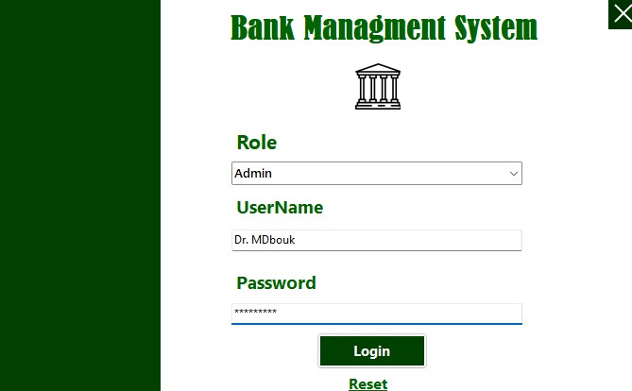
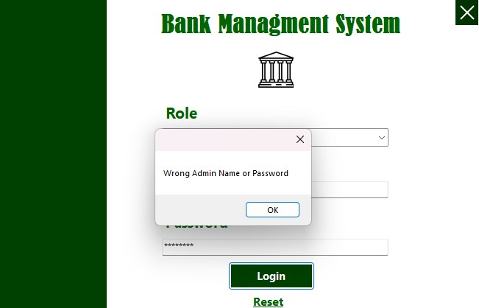 Figure 7 Login Page Authentication
- Steps:
  - Enter the username and password.
  - Submit the login credentials.
- Expected Outcome:
  - If the user is an admin, verify that the authentication process recognizes the admin role.
  - If the user is an agent, verify that the authentication process recognizes the agent role.
  - Check if the password meets security requirements (e.g., 8 characters or more).
  - Ensure the login credentials are correctly matched for authentication.
  - Validate that appropriate encryption techniques are applied for password security.
5.3.3. Admin Account Management
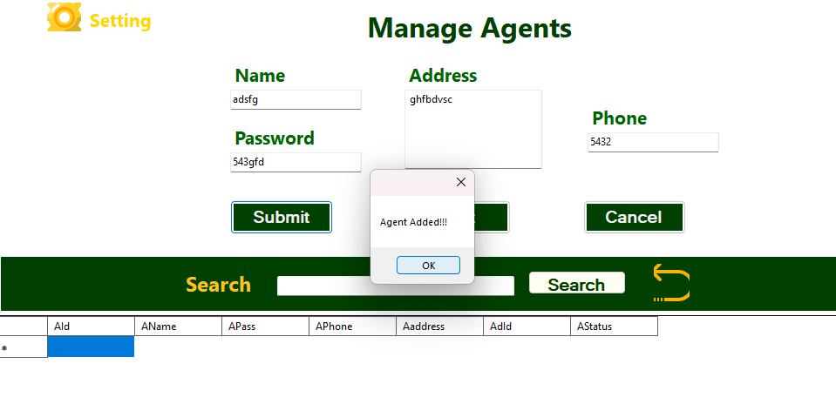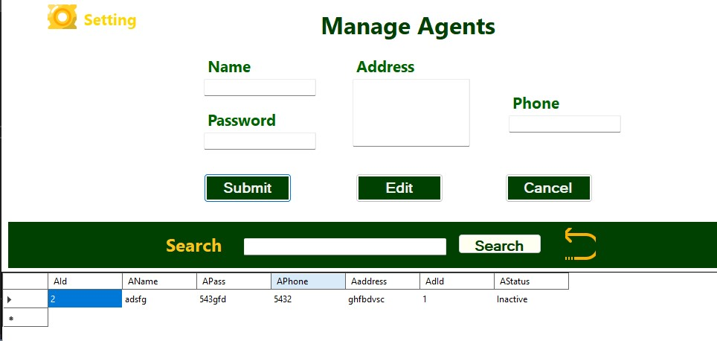

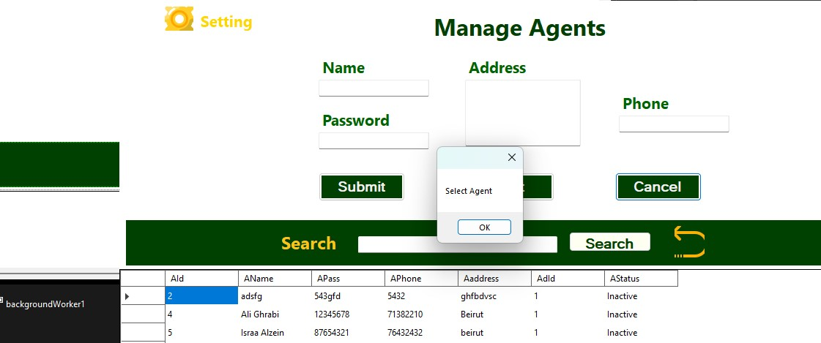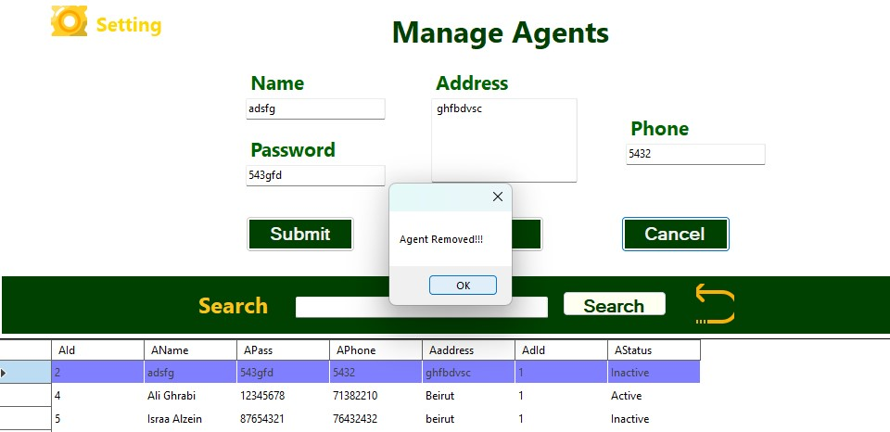
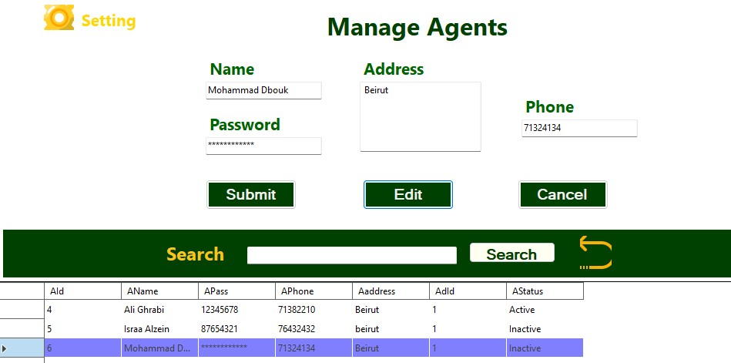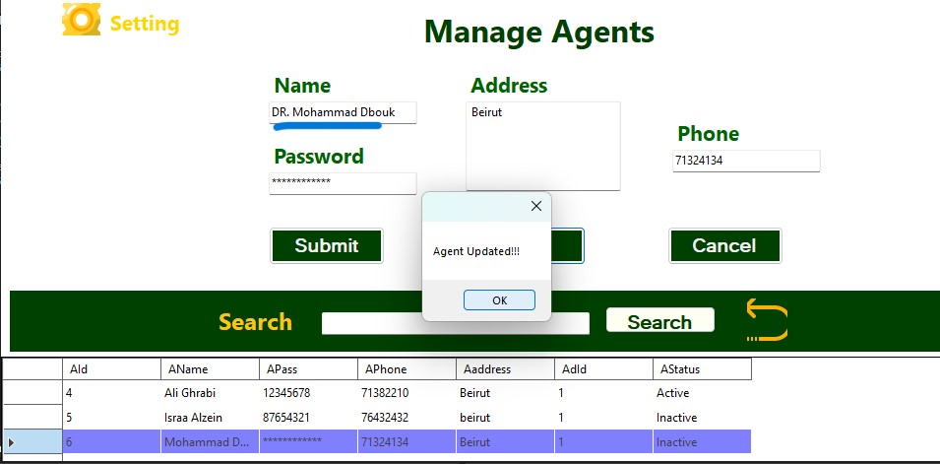
Figure 8 Admin Account Managment
- Scenario: Admin performs account management operations (Add, Delete, Search, Update).
- Steps:
  - Add Account:
    - Admin adds a new account with valid information.
    - Checks if the new account is successfully added to the system.
  - Delete Account:
    - Admin selects an existing account to delete.
    - Verifies that the selected account is removed from the system.
  - Search Account:
    - Admin searches for an existing account using specified criteria.
    - Validates that the search results match the expected account information.
  - Update Account:
    - Admin selects an account to update.
    - Modifies account details (e.g., name, phone number, address).
    - Ensures the changes are reflected in the system.
- Expected Outcome:
  - Successful addition of a new account.
  - Accurate deletion of the selected account.
  - Precise search results based on specified criteria.
  - Updated account details are correctly reflected in the system.

Agent Account Management
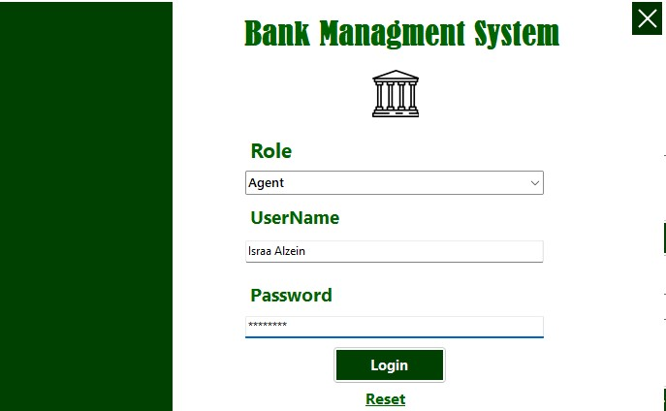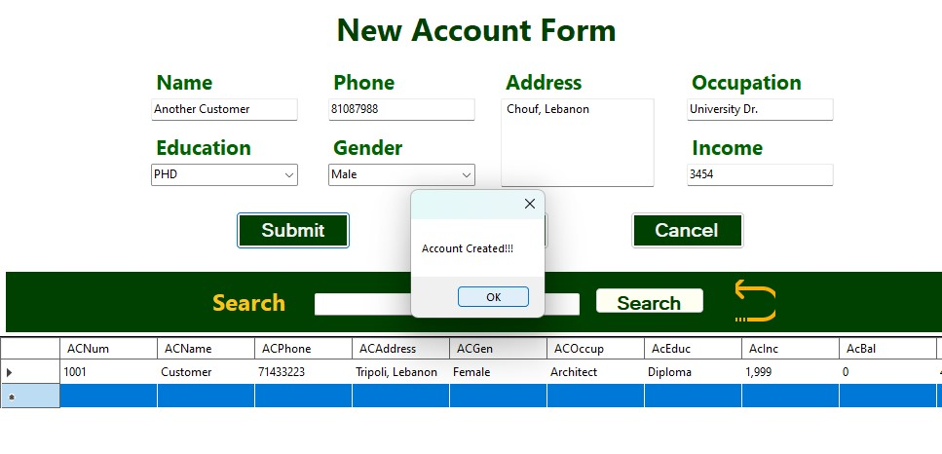
Figure 9 Agent Account Managment
- Scenario: Agent performs account-related operations and uses the panel to display information.
- Steps:
  - Add Account:
    - Agent adds a new account with valid information.
    - Checks if the new account is successfully added to the system.
  - Display Information:
    - Agent accesses the information panel.
    - Verifies that the panel displays relevant and updated information.
  - Update Account Status:
    - Agent updates the status of an account (e.g., from active to inactive).
    - Ensures the account status change is reflected in the system.
  - Display Account Details:
    - Agent selects an account to view detailed information.
    - Validates that the displayed details match the expected account information.
- Expected Outcome:
  - Successful addition of a new account by the agent.
  - Accurate and updated information displayed in the panel.
  - Correct reflection of the updated account status.
  - Precise display of account details in the information panel.

Agent Transaction Management
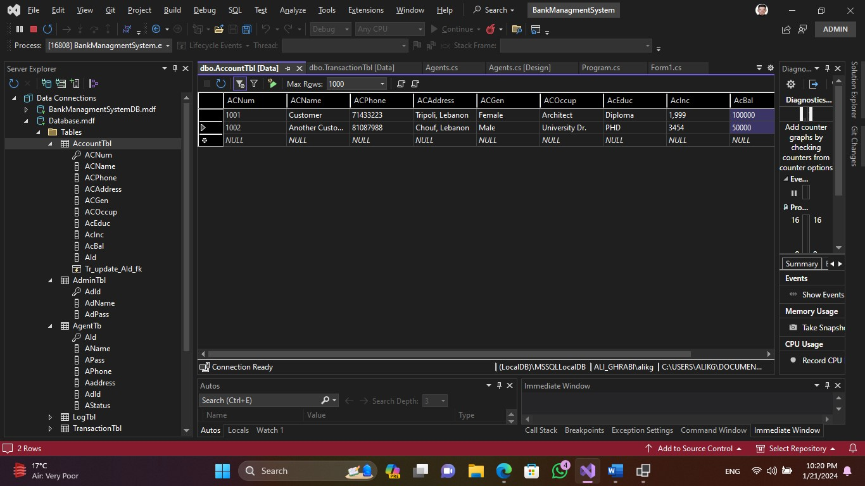
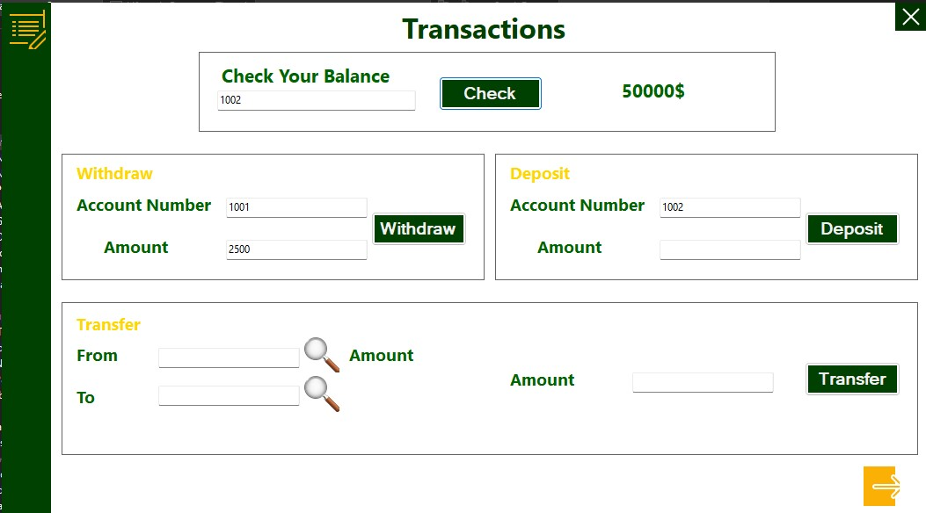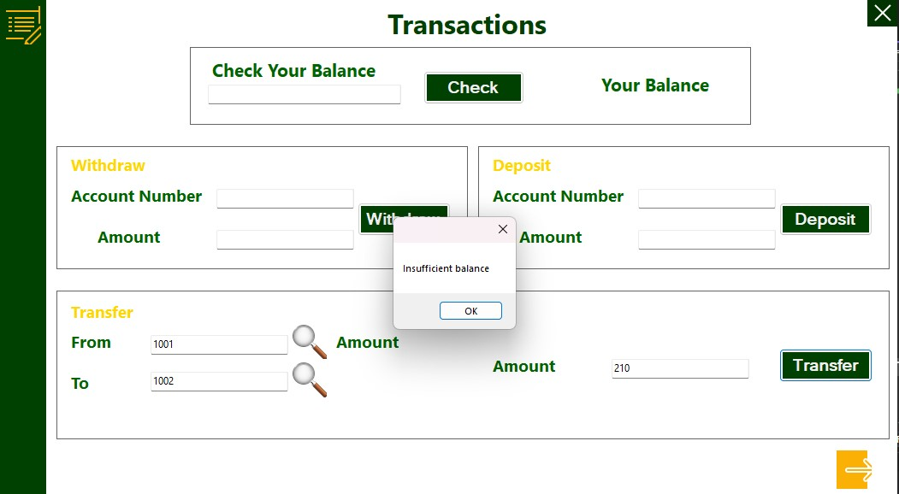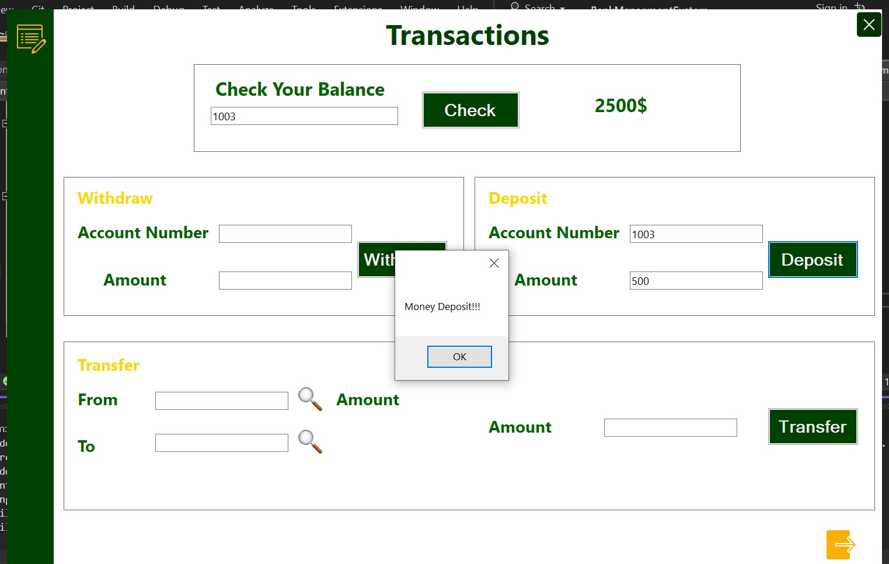
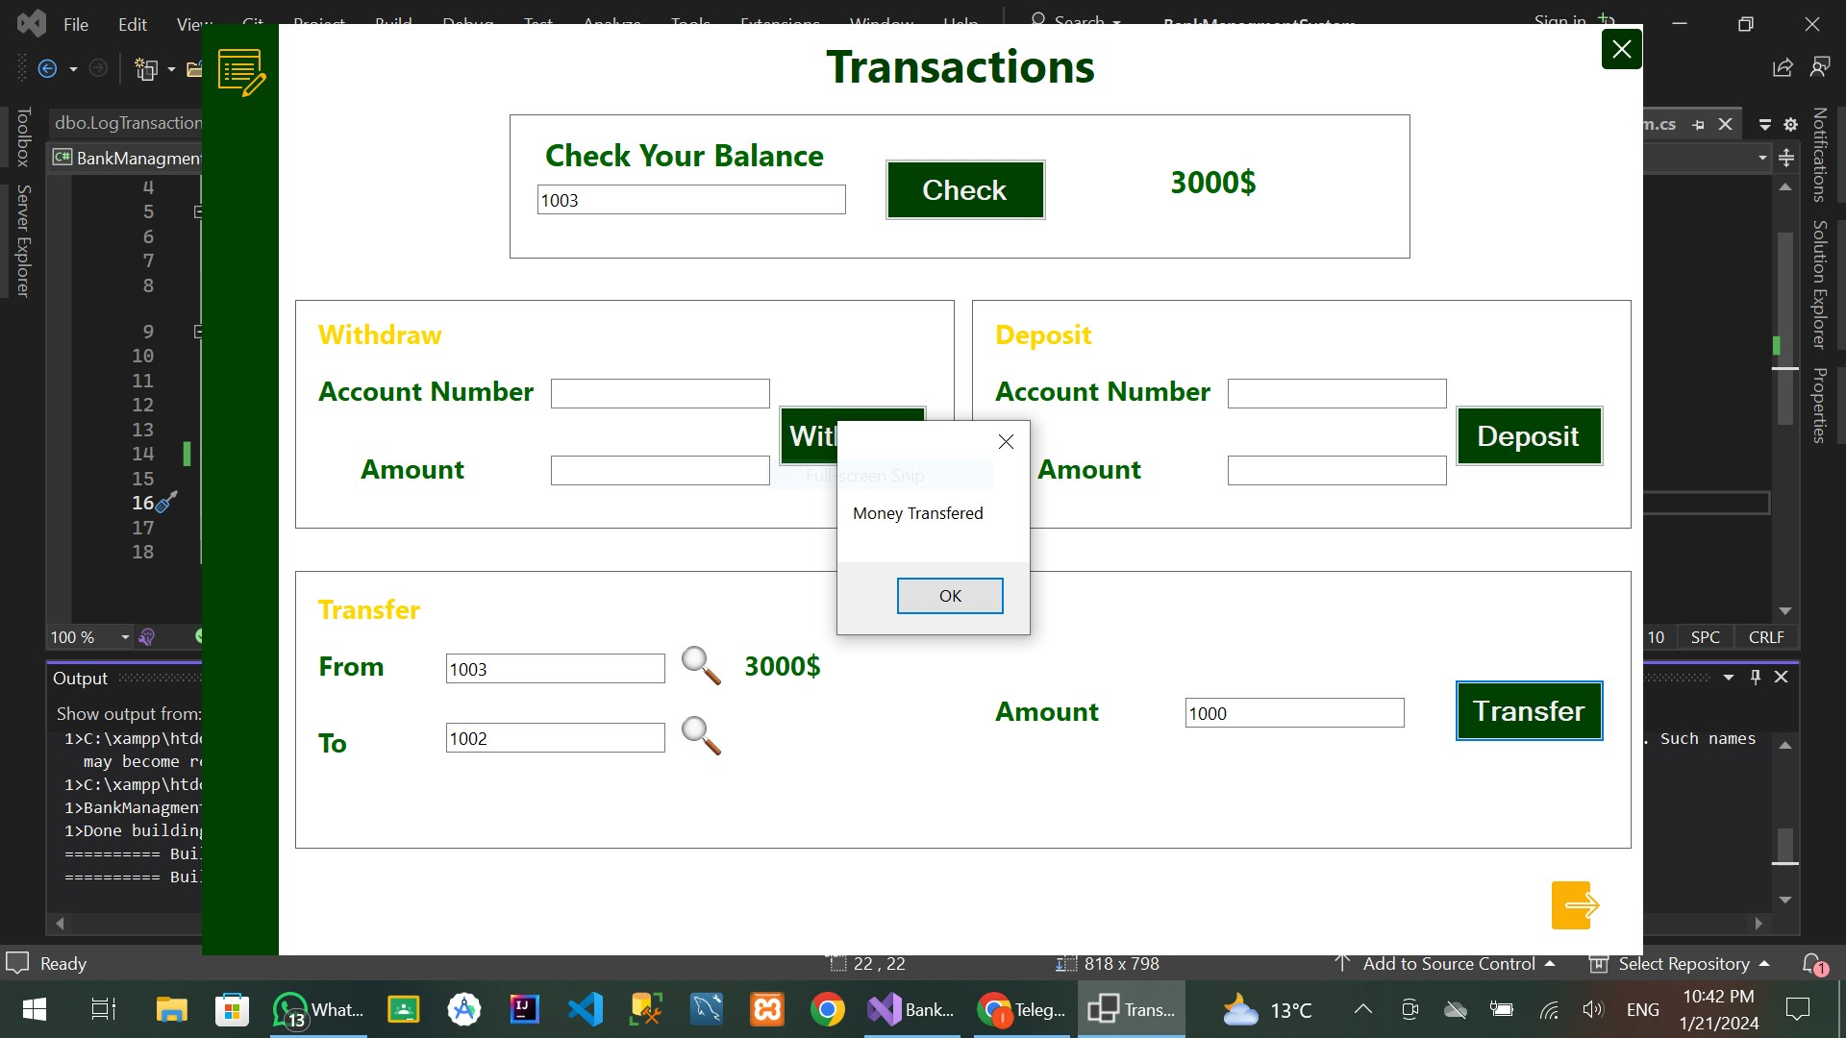

Figure 10 Agent Transaction Managment

- Scenario: Agent performs transaction-related operations.
- Steps:
  - Withdrawal Transaction:
    - Agent initiates a withdrawal transaction for a specific account.
    - Ensures the withdrawal amount is correctly deducted from the account balance.
  - Deposit Transaction:
    - Agent processes a deposit transaction for a chosen account.
    - Verifies that the deposited amount is accurately reflected in the account balance.
  - View Transaction History:
    - Agent accesses the transaction history section.
    - Validates that the displayed history includes the recent transactions.
  - Balance Inquiry:
    - Agent checks the current balance of a selected account.
    - Confirms that the displayed balance matches the calculated balance.
- Expected Outcome:
  - Successful completion of withdrawal and deposit transactions.
  - Accurate display of transaction history.
  - Correct reflection of updated account balances after transactions.
  - Precise presentation of current account balances during balance inquiry.

Conclusion
The Bank Management System (BMS) project, developed using C# and MS SQL Server, achieves a robust and efficient solution for bank management through meticulous application architecture, advanced database modeling, and thoughtful implementation of services. The project's key aspects include a well-structured Application Architecture Model (AAM), optimized database tables, and the integration of triggers and procedures for enhanced data management. The use of SSMS and ERD PLUS facilitates effective database scripting, while real-world testing scenarios ensure functionality and security. The project adheres to guidelines outlined in the project booklet, delivering a user-friendly and secure system that caters to both administrators and agents.

