Student Performance Prediction
A Big Data Analytics Project
Following the Data Analytics Lifecycle
Ali Khairy | Hamza Milad | Youssef Halawa | Abdelrahman Amgad
ESLSCA University — Big Data Analysis Course
Dr. Mohamed Labib | Spring 2026

Introduction: Big Data Context
This project applies the Data Analytics Lifecycle — as taught in the Big Data Analysis course — to the domain of educational analytics. Student performance data is well-suited for big data analytical techniques, as it combines multiple data types (numerical grades, categorical demographics, ordinal lifestyle indicators) and scales to institution-wide datasets.
We situate this project within the 5 Vs framework of Big Data (Lecture 1 & 2):
V | Dimension | Application in This Project
Volume | Size & scale | 395 student records, 28 features — scalable to institution-wide data
Velocity | Speed of data | Grades updated each period (G1→G2→G3); timely intervention required
Variety | Different formats | Mix of numerical grades, categorical demographics, ordinal lifestyle data
Veracity | Data quality | Checked for missing values, duplicates, and outliers before analysis
Value | Business impact | Predict at-risk students to enable early intervention and reduce dropout
Table 1 — The 5 Vs of Big Data applied to the student performance dataset
Following the Analytics Process (Lec 1 & 2): Business Objective → Data Preparation → EDA → Preprocessing → Analytics → Visualization, this project is formally structured within the six-phase Data Analytics Lifecycle (Lec 5).

Phase 1: Discovery
The Discovery phase defines the business problem, identifies stakeholders, and sets the analytical questions and KPIs (Lec 5).

1.1 Business Problem
Secondary schools struggle to identify at-risk students before it is too late to intervene. A predictive model built on early-semester data (G1, G2, study habits) can allow teachers and counselors to act while there is still time to support failing students.

1.2 Stakeholders
- School administration: requires a performance overview dashboard
- Teachers: need to identify struggling students after first period grades
- School counselors: need student-level pass/fail predictions
- Parents: benefit from early academic risk notifications

1.3 Analytical Questions
- Which student factors most significantly predict final grade G3?
- Can a classification model accurately identify students who will fail before the final exam?
- What is the relationship between study time, absenteeism, past failures, and academic outcomes?

1.4 KPIs
- KPI 1: Overall pass rate (target: > 75%)
- KPI 2: Classification model accuracy (target: > 80%)
- KPI 3: Grade prediction MAE (target: < 2.5 grade points)

Phase 2: Data Preparation
This phase covers data collection, cleaning, exploration, and preprocessing — following Lec 5: "Collect, clean, and explore the data."

2.1 Dataset
Based on the UCI Student Performance Dataset (Cortez & Silva, 2008) — 395 students, 28 features across demographic, academic, family/social, and lifestyle categories.
Property | Value | Property | Value
Records | 395 | Numeric Features | 16
Total Features | 28 | Categorical Features | 12
Regression Target | G3 (0–20) | Classification Target | Pass / Fail
Missing Values | 0 | Duplicate Rows | 0
Table 2 — Dataset summary

2.2 Data Cleaning (Lec 5 — "Handle missing values, standardize data")
- Zero missing values confirmed — no imputation required
- Zero duplicate rows
- Absences clipped at 75 to handle extreme outliers
- G3 = 0 cluster identified as dropouts — retained as valid observations

2.3 Preprocessing (Lec 1&2 — "Standardization, Normalization, Transformation")
- Label Encoding: 12 binary categorical variables encoded as 0/1
- StandardScaler: All numerical features normalized (zero mean, unit variance)
- Target Engineering: Pass/Fail derived (G3 ≥ 10 = Pass)
- Train/Test Split: 80% train / 20% test, stratified by class

Exploratory Data Analysis (EDA)
EDA is described in Lec 5 as "a crucial step focusing on summarizing and visualizing datasets to uncover patterns." We applied statistical and graphical techniques as recommended.

Descriptive Statistics
Feature | Count | Mean | Std | Min | 25% | 75% | Max
G1 | 395 | 12.43 | 3.47 | 1 | 10 | 15 | 20
G2 | 395 | 12.51 | 3.76 | 0 | 10 | 15 | 20
G3 | 395 | 12.10 | 4.31 | 0 | 10 | 15 | 20
Study Time | 395 | 2.45 | 1.14 | 1 | 1 | 3 | 4
Failures | 395 | 0.51 | 0.81 | 0 | 0 | 1 | 3
Absences | 395 | 3.71 | 3.33 | 0 | 1 | 5.5 | 23
Table 3 — Descriptive statistics
Overall pass rate: 76.2% — exceeds the 75% KPI target. Mean G3: 12.10/20 (std: 4.31).

Global Properties — Histograms (Lec 5 EDA)
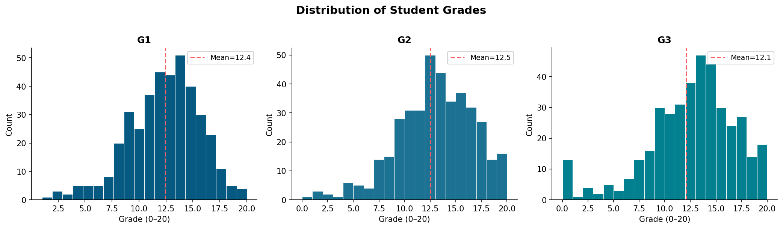
Figure 1 — Grade distributions (G1, G2, G3)
All three distributions are approximately normal with slight left skew. The zero cluster in G3 represents dropouts.

Correlation Analysis (Lec 5 — "Explore trends and correlations")
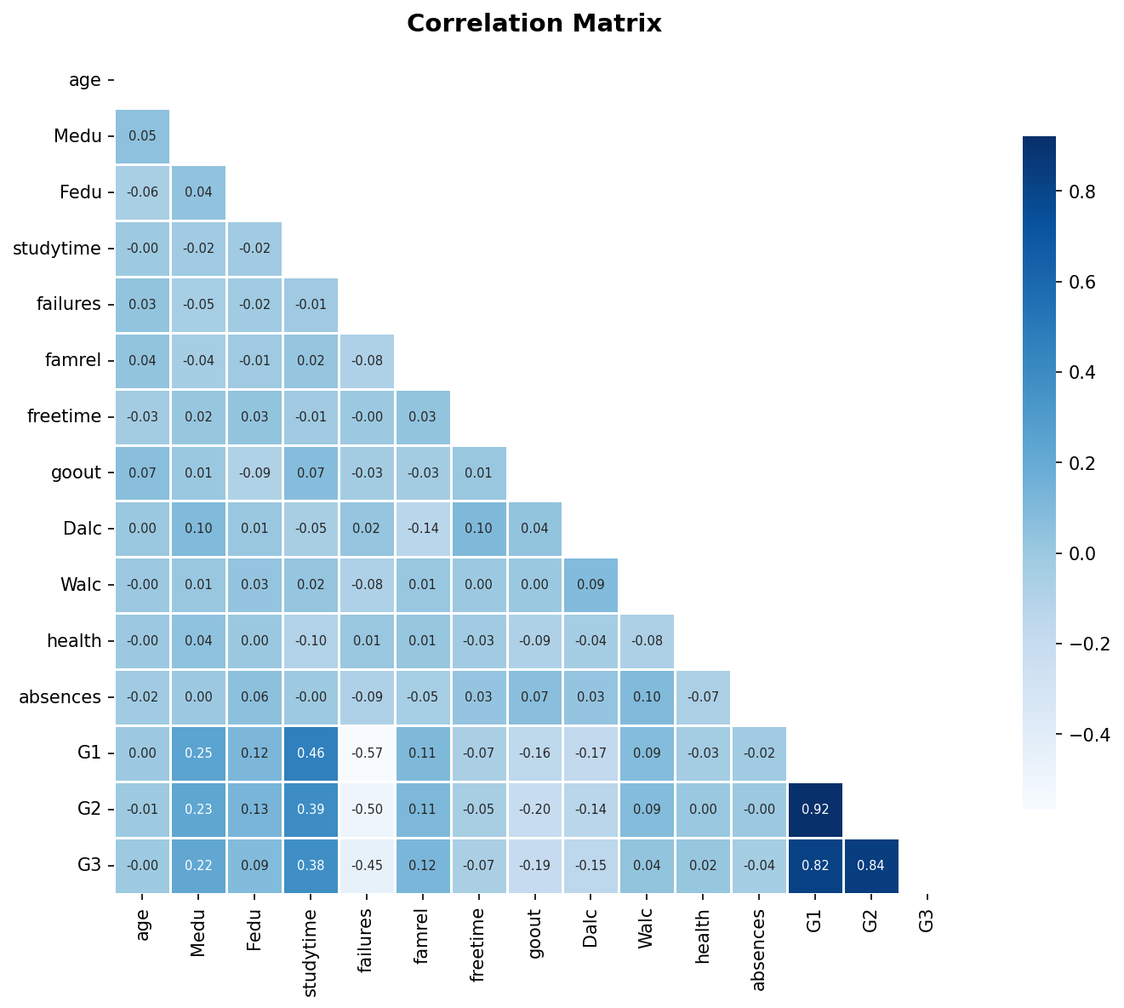
Figure 2 — Pearson correlation heatmap
G2 (r=0.92) and G1 (r=0.82) dominate. Failures (r=-0.38) and alcohol (r=-0.17) are the strongest negative predictors.

Group Properties — Subgroup Analysis (Lec 5 EDA)
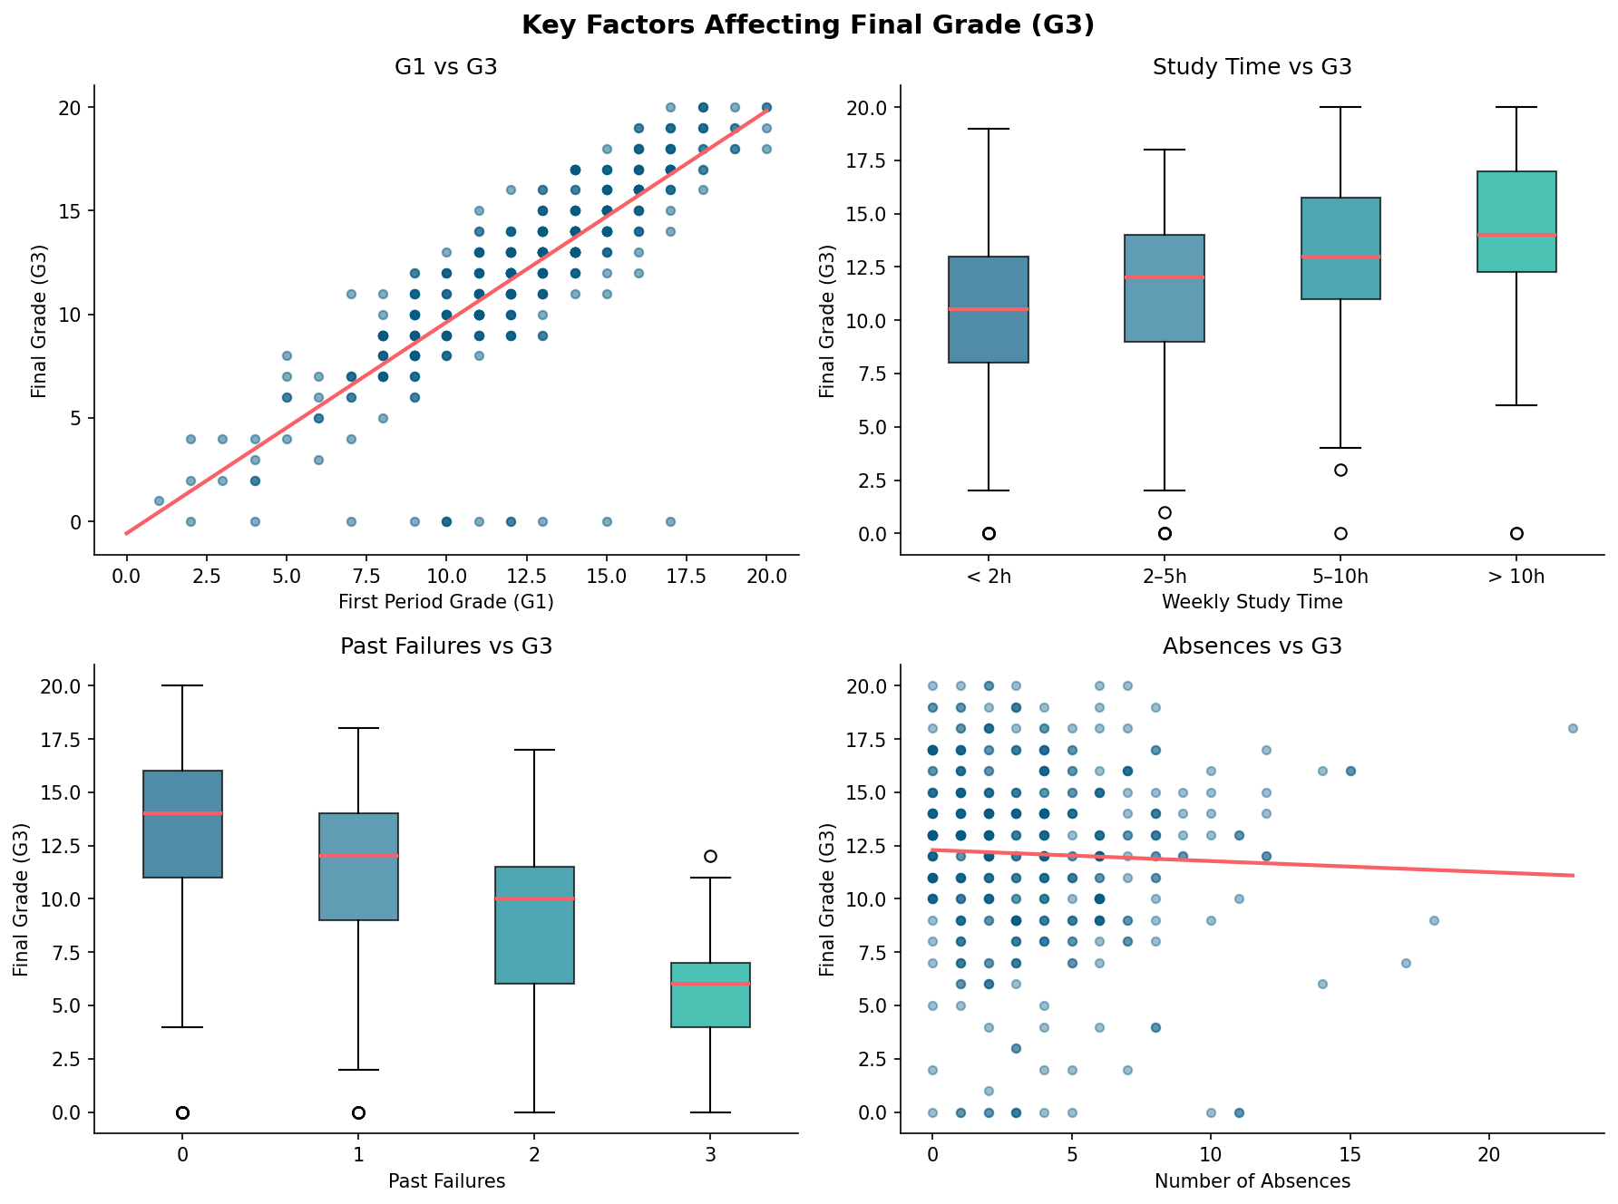
Figure 3 — Key factor relationships with G3
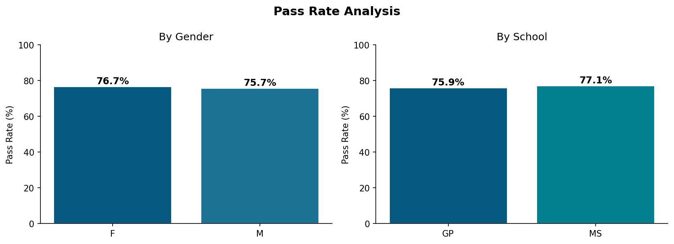
Figure 4 — Pass rate by gender and school
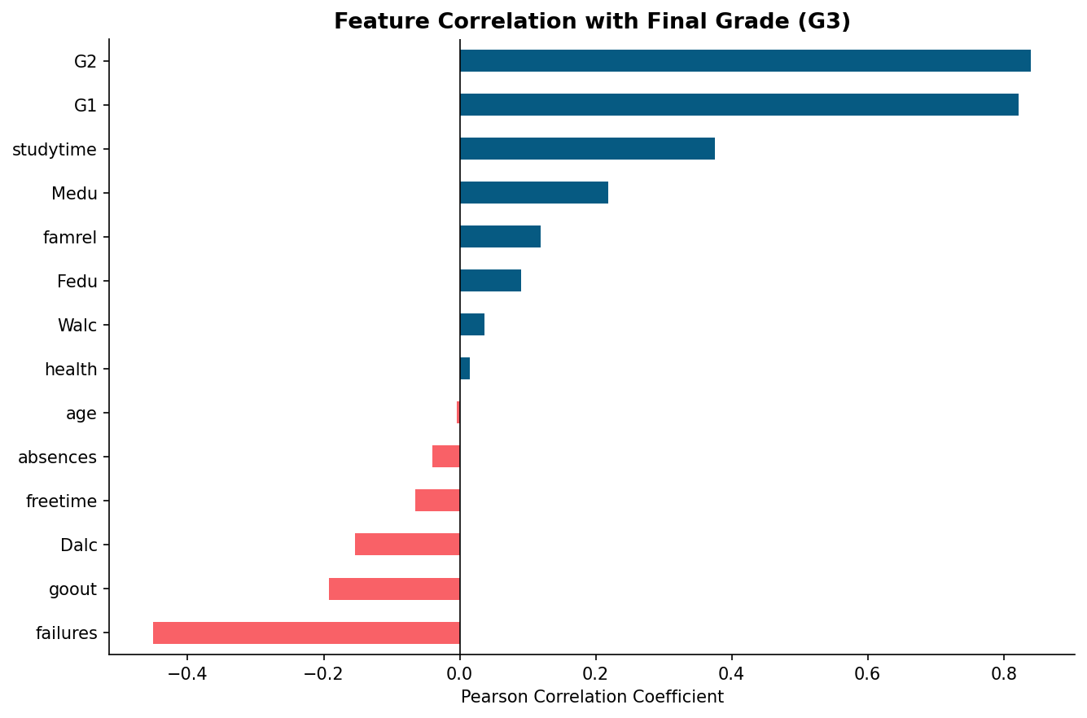
Figure 5 — Feature correlation ranking with G3

Phase 3: Model Planning
Selecting techniques and defining the workflow — Lec 5: "Identify appropriate methods, determine target variable, decide evaluation metrics."
Model | Task | Justification | Course Reference
Linear Regression | Grade Prediction (G3) | Continuous target variable | Analytics Tasks — Lec 1&2
Logistic Regression | Pass/Fail Classification | Quick baseline classifier | Lec 5 — Model Planning
Decision Tree (d=5) | Pass/Fail Classification | Non-linear patterns, interpretable | Lec 5 — Model Planning
Table 4 — Model planning blueprint
Evaluation metrics (Lec 5): Accuracy, Precision, Recall, F1 Score for classification; RMSE, MAE, R² for regression.

Phase 4: Model Building
"Build, train, and validate models using historical data" (Lec 5). All models use 15 features including G1, G2, study time, failures, absences, parental education, and lifestyle variables.

Linear Regression Results
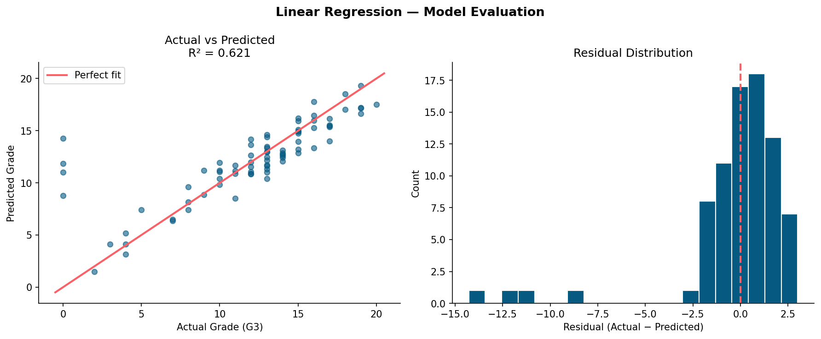
Figure 6 — Actual vs. predicted and residual distribution
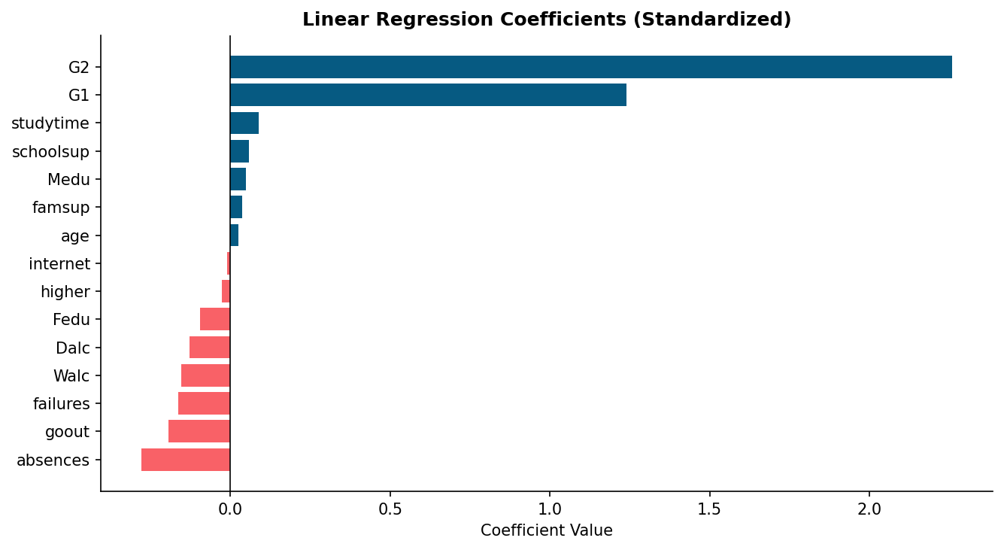
Figure 7 — Standardized coefficients
R² = 0.621 (explains 62.1% of variance). MAE = 1.63 grade points — within the 2.5 KPI target.

Classification Results
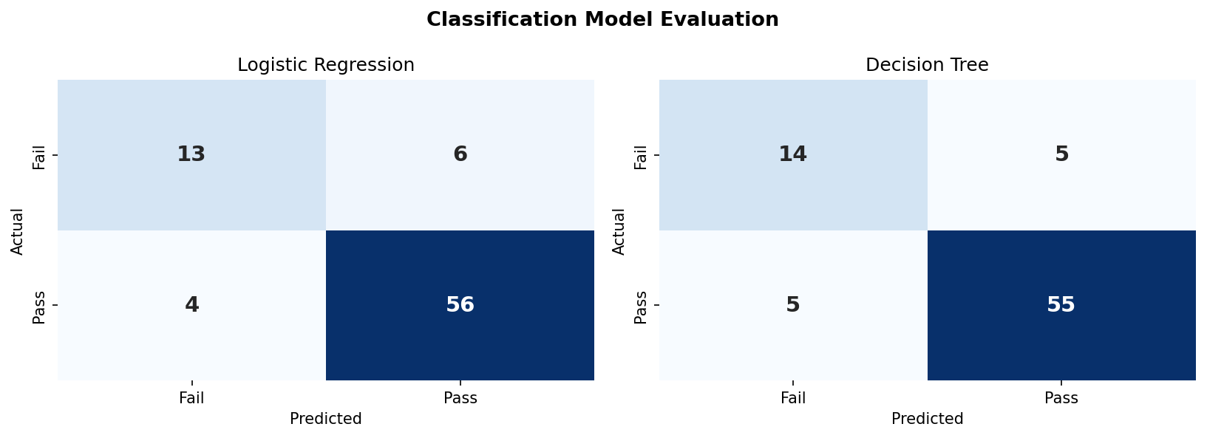
Figure 8 — Confusion matrices
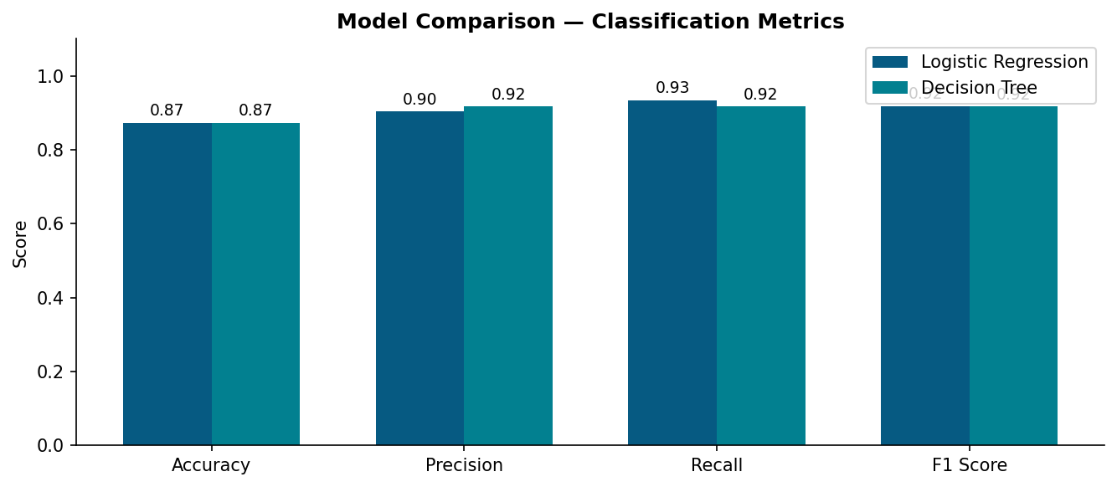
Figure 9 — Model metric comparison
Model | Accuracy | Precision | Recall | F1 Score
Linear Regression | R²=0.621 | RMSE=2.93 | MAE=1.63 | —
Logistic Regression | 87.3% | 90.3% | 93.3% | 91.8%
Decision Tree (d=5) | 87.3% | 91.7% | 91.7% | 91.7%
Table 5 — Model performance summary

Phase 5: Communication of Results
"Share findings, create visualizations, and provide actionable recommendations" (Lec 5). An interactive Power BI-style dashboard is provided as a separate HTML deliverable (as taught in Lec 6).

5.1 Key Findings
- G1 and G2 (prior grades) are the dominant predictors of G3, with correlations of 0.82 and 0.92 respectively
- Students with 1+ past failures score an average of 4 points lower in G3
- Studying >5h/week yields 2-3 additional grade points vs. studying <2h/week
- Every 10 additional absences is associated with approximately a 1-point drop in G3
- 76.2% of students pass — models identify the at-risk 23.8% with 87.3% accuracy

5.2 Recommendations
- Early Alert System: Flag students with G1 < 10 or any past failure for immediate counselor contact
- Attendance Monitoring: Trigger alerts when absences exceed 6 in a semester
- Study Skills Program: Target students studying <2h/week with structured workshops
- Parent Engagement: Prioritize outreach to families with low parental education (Medu/Fedu ≤ 1)
- Dashboard Deployment: Use the Power BI dashboard after each grading period to monitor cohort KPIs

Phase 6: Operationalize
"Ensure model accuracy over time and maintain updates" (Lec 5).
- Monitor classification accuracy each academic year — retrain if it drops below 80%
- Retrain models annually with new cohort data
- Update dashboard at end of each grading period (G1, G2)
- Scale to institution-wide deployment using Apache Spark / Hadoop (covered in this course) for large student populations

Conclusion
This project applied the six-phase Data Analytics Lifecycle (Lec 5) to student performance prediction, framed within the 5 Vs of Big Data (Lec 1&2) and visualized through a Power BI-style dashboard (Lec 6). Three models were built — Linear Regression (R²=0.621), Logistic Regression (87.3%), and Decision Tree (87.3%) — all exceeding project KPI targets. Five actionable recommendations are provided for school administrators and teachers.

References
Cortez, P., & Silva, A. M. G. (2008). Using data mining to predict secondary school student performance. FUBUTEC 2008, Porto, Portugal.
Labib, M. (2026). Lectures 1, 2, 5, 6: Big Data Analysis Course. ESLSCA University, Spring 2026.
UCI Machine Learning Repository: Student Performance Dataset. https://archive.ics.uci.edu/ml/datasets/Student+Performance

