Activation Experience Phase 1 – Demo UX Spec
Source: Activation Experience Phase 1 deck | Generated: 2026-02-16 07:34 (local)

1. Overview
This document specifies a clickable demo experience that mirrors the UX shown in the provided PowerPoint deck. It is intended for rapid prototyping (not a production build) so a developer can implement the screens and navigation and then use an agent such as GitHub Copilot to fill in boilerplate code.

2. Scope & Non‑Goals
In scope (demo):
- A multi-screen, clickable flow starting from Windows Activation Settings and continuing through the Product Activation Portal UX.
- Basic UI replication of the screens shown (layout, labels, buttons, and flow).
- Demo-friendly interactions (e.g., “Captcha” puzzle is not implemented; the Submit button advances the flow).
- Generation and display of a random Confirmation ID value on the “Receive Confirmation ID” screen.
- A branch to “Contact Assisted Support” when the user indicates activation did not succeed.
Out of scope (demo):
- Real activation, license validation, or backend integration.
- Real authentication flows (MSA/Entra ID/GOV); sign-in is simulated.
- Real Captcha puzzle behavior or bot detection.
- Localization, accessibility reviews, and production security hardening.

3. High-level user journey
Primary path (as implemented for demo):
- Settings Activation (Slide 1) → Automated Help → Product Activation Portal (Slide 2)
- Let’s Get Started → Security Verification (Captcha) → Sign‑In → Activation Flow (Slide 3)
- Answer # of Computers → Receive Confirmation ID → Confirm Activation Result → Contact Assisted Support (if activation failed)

4. Global requirements
Navigation
- Use client-side routing or a simple state machine. Each button advances to the next screen exactly as described.
- Provide a “Back” affordance only if it exists in the screenshot UI; otherwise omit for fidelity.
Visual fidelity
- Maintain the UX intent, labels, and sequencing shown in the deck screenshots.
- For demo: typography and spacing can be approximate, but major UI elements (titles, buttons, step order) must match.
Demo data
- Confirmation ID is a randomly generated value (format is flexible for demo).
- “# of computers” threshold: <= 1 is “within threshold”; > 1 is “outside of threshold”.

5. Screen-by-screen specification

S1. Windows Settings → Activation (Modern OA - Setting Experience)
Source slide: Slide 1
Screenshot (from deck):
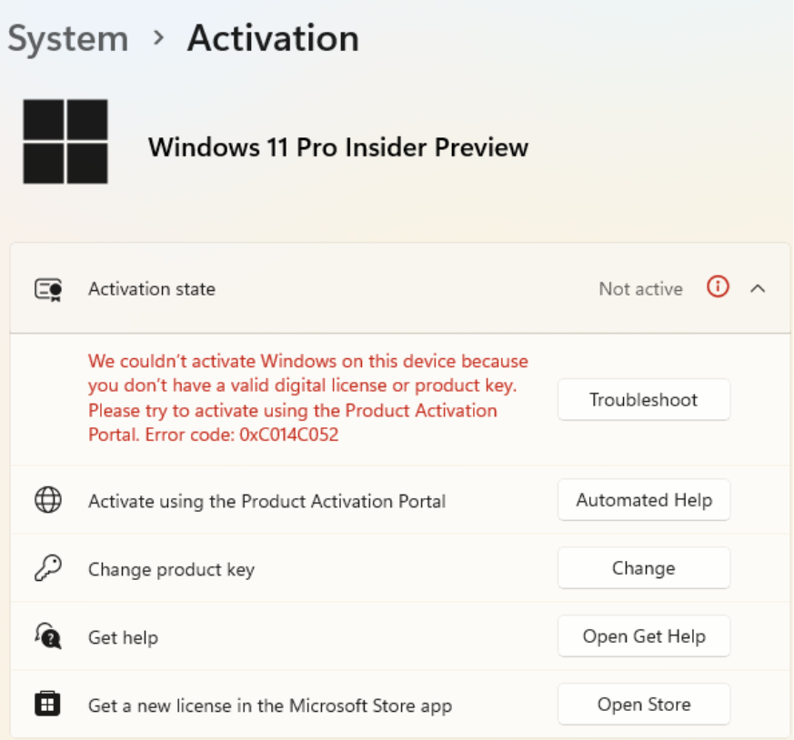
Purpose
Entry point from Windows activation settings when activation fails; provides an “Automated Help” entry to the portal flow.
UI elements
- Activation settings surface with an activation status area (as shown).
- Primary call-to-action: “Automated help” button.
Interactions
- User selects “Automated help” → navigate to S2.1 “Let’s Get Started”.
Validation / logic
- No inputs required on this screen for demo.
Implementation notes (demo)
- This screen can be implemented as a static mock of the settings page with only the “Automated help” button interactive.

S2.1. Product Activation Portal – Let’s Get Started
Source slide: Slide 2
Screenshot (from deck):
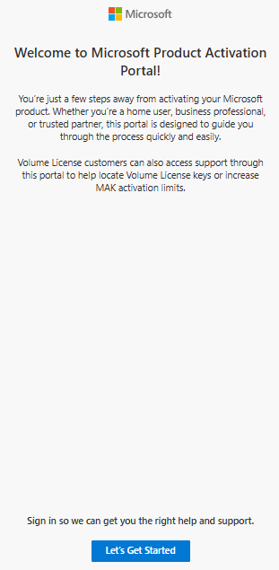
On-screen copy (OCR from screenshot; verify against image)
BE Microsoft
Welcome to Microsoft Product Activation
Portal!
You're just a few steps away from activating your Microsoft
product. Whether you're a home user, business professional,
or trusted partner, this portal is designed to guide you
through the process quickly and easily.
Volume License customers can also access support through
this portal to help locate Volume License keys or increase
MAK activation limits.
Sign in so we can get you the right help and support.
Let's Get Started
Purpose
Introduces the portal experience and starts the automated flow.
UI elements
- Header/branding: “Microsoft Support | User Experience | Product Activation Portal”.
- Title: “Let’s Get Started”.
- Body text (use the text shown in the screenshot).
- Primary CTA button at bottom: “Let’s Get Started”.
Interactions
- User selects “Let’s Get Started” → navigate to S2.2 “Security Verification (Captcha)”.
Validation / logic
- No inputs required.
Implementation notes (demo)
- Copy shown below is from OCR; verify wording against screenshot for final polish.

S2.2. Product Activation Portal – Security Verification (Captcha)
Source slide: Slide 2
Screenshot (from deck):
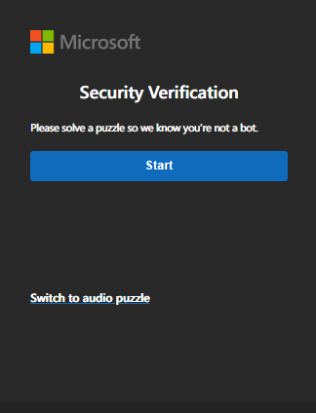
On-screen copy (OCR from screenshot; verify against image)
BE Microsoft
Security Verification
Please solve a puzzle so we know you're not a bot.
Switch to audio puzzle
Purpose
Simulates a security verification step. For demo purposes, no real puzzle is required.
UI elements
- Title: “Security Verification”.
- Start button to begin verification.
- Puzzle/verification area with a Submit button (as shown).
Interactions
- User selects “Start” → reveal the verification/puzzle area if it is not already visible.
- User selects “Submit” → navigate to S2.3 “Sign‑In”.
Validation / logic
- No puzzle validation; “Submit” always advances.
Implementation notes (demo)
- Copy shown below is from OCR; verify wording against screenshot for final polish.

S2.3. Product Activation Portal – Sign‑In
Source slide: Slide 2
Screenshot (from deck):
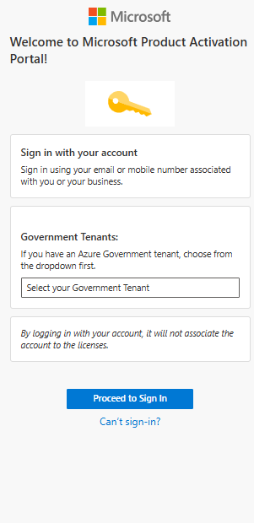
On-screen copy (OCR from screenshot; verify against image)
BE Microsoft
Welcome to Microsoft Product Activation
Portal!
o..
Sign in with your account
Sign in using your email or mobile number associated
with you or your business.
Government Tenants:
If you have an Azure Government tenant, choose from
the dropdown first.
Select your Government Tenant
By logging in with your account, it will not associate the
account fo the licenses.
Proceed to Sign In
Can't sign-in?
Purpose
Simulates user sign‑in options before continuing to the activation flow.
UI elements
- Title: “Sign‑In”.
- Supported account types: “MSA, Entra ID, & GOV Accounts”.
- Primary CTA: “Proceed to sign in” (active).
Interactions
- User selects “Proceed to sign in” → navigate to S3.1 “Answer # of Computers Question”.
Validation / logic
- No actual auth; this is a simulated continuation.
Implementation notes (demo)
- Keep the “Proceed to sign in” button enabled to match the requested demo behavior.
- Copy shown below is from OCR; verify wording against screenshot for final polish.

S3.1. Answer # of Computers Question
Source slide: Slide 3
Screenshot (from deck):
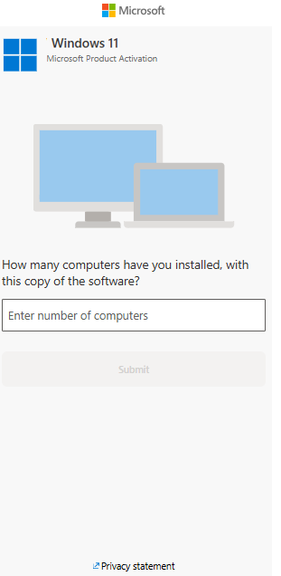
On-screen copy (OCR from screenshot; verify against image)
BE Microsoft
Hl Windows 11
Ell Microsoft Product Activation
How many computers have you installed, with
this copy of the software?
Enter number of computers
Submit
Purpose
Collects the number of computers/devices involved and determines whether the flow is within threshold.
UI elements
- Prompt asking for number of computers.
- Numeric input field.
- Submit button (active when input is present).
Interactions
- User enters a number in the input field.
- User selects “Submit”.
- If value <= 1 → navigate to S3.2 “Receive Confirmation ID (within threshold)”.
- If value > 1 → treat as outside threshold (see Validation/logic).
Validation / logic
- Threshold rule from deck: <= 1 is within threshold; > 1 is outside threshold.
- For demo, outside threshold can either: (a) show an inline message and keep user on screen, or (b) route directly to assisted support. Choose one and keep it consistent.
Implementation notes (demo)
- Input should accept integers; basic guardrails (empty, non-numeric) are sufficient for demo.
- Copy shown below is from OCR; verify wording against screenshot for final polish.

S3.2. Receive Confirmation ID (within threshold)
Source slide: Slide 3
Screenshot (from deck):
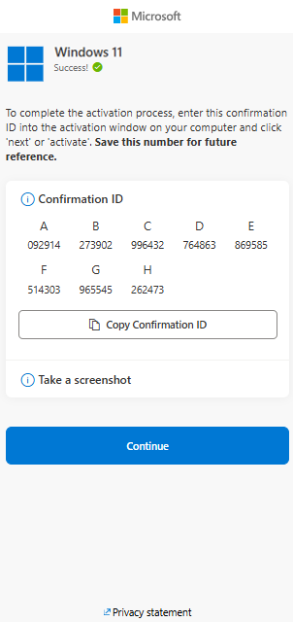
On-screen copy (OCR from screenshot; verify against image)
BE Microsoft
Windows 11
ll Success! @
To complete the activation process, enter this confirmation
ID into the activation window on your computer and click
‘next’ or ‘activate’. Save this number for future
reference.
@ Confirmation ID
A B Cc D E
092914 §=6273902 9996432 764863 869585
F G H
514303 965545 «= 262473
[Copy Confirmation ID
@ Take a screenshot
2 Privacy statement
Purpose
Displays a generated Confirmation ID and lets the user continue.
UI elements
- A “Confirmation ID” value shown prominently (as shown).
- Continue button.
Interactions
- On screen load, generate and display a random Confirmation ID.
- User selects “Continue” → navigate to S3.3 “Confirm if Activation Succeeded or Failed”.
Validation / logic
- Confirmation ID must be stable for the session once generated (do not change when user returns to the screen in the same session, unless you explicitly reset the flow).
Implementation notes (demo)
- Format is flexible for demo (e.g., random digits grouped with spaces/hyphens).
- Copy shown below is from OCR; verify wording against screenshot for final polish.

S3.3. Confirm if Activation Succeeded or Failed
Source slide: Slide 3
Screenshot (from deck):
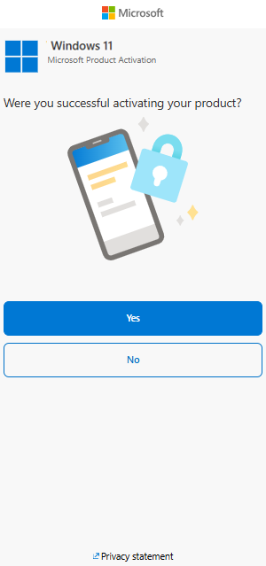
On-screen copy (OCR from screenshot; verify against image)
BE Microsoft
| | | Windows 11
| {| Microsoft Product Activation
Were you successful activating your product?
ry
=
2 Privacy statement
Purpose
Captures whether the user was able to activate after using the Confirmation ID.
UI elements
- Question: whether activation succeeded.
- Yes and No options (radio buttons or buttons, matching screenshot).
- Continue/Next action if present in the screenshot.
Interactions
- User selects “No” (could not activate) → navigate to S3.4 “Contact Assisted Support”.
- User selects “Yes” (activated) → end of demo flow (optionally show a simple success message screen, if and only if it appears in your UI plan).
Validation / logic
- Selecting “No” must route to assisted support screen.
Implementation notes (demo)
- The user explicitly requested the “No” path for the demo; ensure it is implemented and easy to trigger.
- Copy shown below is from OCR; verify wording against screenshot for final polish.

S3.4. Contact Assisted Support (Phone or Chat)
Source slide: Slide 3
Screenshot (from deck):
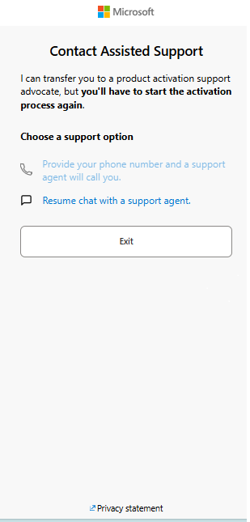
On-screen copy (OCR from screenshot; verify against image)
BE Microsoft
Contact Assisted Support
I can transfer you to a product activation support
advocate, but you'll have to start the activation
process again.
fF Resume chat with a support agent.
Exit
2 Privacy statement
Purpose
Provides escalation options to reach live support when activation failed.
UI elements
- Heading indicating contacting assisted support.
- Choice of support channel: Phone or Chat (as shown).
Interactions
- User selects Phone → show a demo stub (e.g., “Phone support selected”).
- User selects Chat → show a demo stub (e.g., “Chat support selected”).
Validation / logic
- This screen is reachable only when activation is failed (S3.3 = No) or when user is outside threshold (optional behavior in S3.1).
Implementation notes (demo)
- No real contact integration is required for demo.
- Copy shown below is from OCR; verify wording against screenshot for final polish.

6. Suggested implementation scaffold (optional)
The following section is optional guidance to help a developer implement the demo quickly. It is not part of the UX requirements shown in the deck.
Recommended approach
- Implement the flow as a finite state machine with one state per screen (S1, S2.1, S2.2, …).
- Store the entered “# of computers” and generated Confirmation ID in a single in-memory app state.
- Use a component per screen with shared layout/branding.
State model (example)
type AppState = {
current: 'S1'|'S2_1'|'S2_2'|'S2_3'|'S3_1'|'S3_2'|'S3_3'|'S3_4';
computersCount?: number;
confirmationId?: string;
captchaStarted?: boolean;
activationResult?: 'yes'|'no';
};

