

**NATIONAL UNIVERSITY OF SCINCES AND TECHNOLOGY**

**“FUNDAMENTALS OF PROGRAMMING”**

**LAB TASK # 04**

**SUBMITTED TO: Sir AFFAN**

**SUBMITTED BY:MUHAMMAD TOUSEEF**

**CMS:460700**

# TASK NO1:

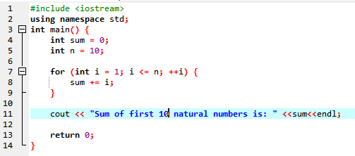

### RESULT:

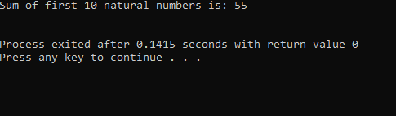

## TASK NO 2:

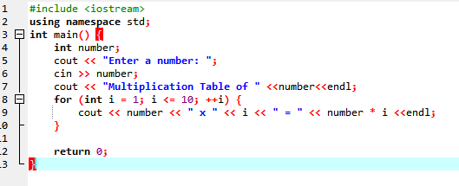

### RESULT:

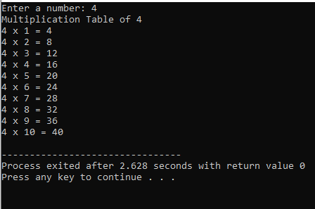

### TASK NO 3:

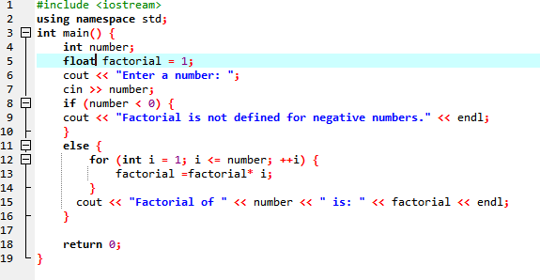

RESULTS:

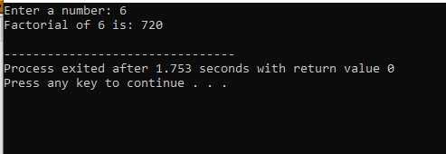

# TASK NO 4:

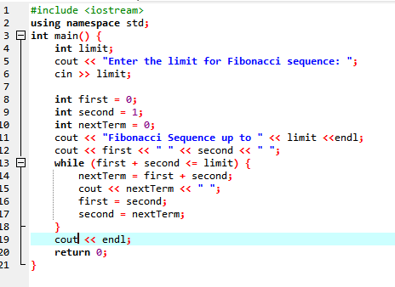

# RESULT:

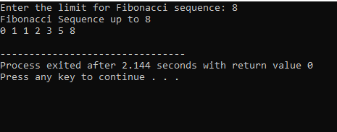

# TASK NO 5:

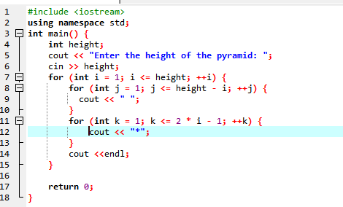

# RESULTS:

