

ASTANA IT UNIVERSITY
School of Software Engineering | Group SE-2409

SMART DRAINAGE SYSTEM BASED ON IoT TECHNOLOGIES FOR WATER LEVEL MONITORING AND CONTROL
UNIFIED DIPLOMA PROJECT REPORT
Pre-Defense 1 | 24 October 2026

Role | Name
IoT and hardware | Amanzholov Alikhan
Backend and architecture | Kenzhebek Bekarys
Frontend and UX | Mukhidinov Nursultan
Supervisor | Shyryn Tutkyshbayeva

Astana, Kazakhstan | 2026

Abstract
This report defines the design and evaluation basis of a smart drainage monitoring prototype intended for a laboratory tank or small controlled drainage channel. The proposed data path combines a water-level sensor and ESP32 device, or a deterministic simulator, with HTTP telemetry, a Go REST service, PostgreSQL storage and a React–TypeScript operator interface. The central engineering requirement is not simply to display a number; the interface must communicate whether the reading is valid, recent and supported by an available device.
The report integrates the three team contributions around eleven Pre-Defense 1 assessment areas. It distinguishes documented design decisions from completed implementation, reviews recent research and commercial alternatives, formalises functional and non-functional acceptance criteria, and specifies repeatable unit, integration and scenario tests. Ten research publications published between 2021 and 2025 were checked against scholarly publishers or indexed records, alongside official product and technology documentation. The available materials include a five-view React + TypeScript prototype running locally on mock data, editable sources of three architecture diagrams, and the records of three expert interviews held on 21 October 2026, which informed the functional requirements, interface design and operational constraints.
The prototype is designed to support operators in interpreting water-level trends and threshold conditions. Its planned time-to-threshold calculation is deliberately limited to an inspectable linear trend, and pump operation is restricted to simulation. The results of the present stage are the requirements, architecture, design artefacts and evaluation protocol against which later implementation can be assessed.
Keywords: Internet of Things; water-level monitoring; smart drainage; ESP32; REST API; event processing; human–computer interaction; prototype verification.

Report status and evidence boundaries
Reference date: 23 October 2026. The source package consists of the faculty pre-defense criteria, a team implementation plan, the earlier consolidated team report, two versions of the Nursultan interface report and an editable PlantUML context definition. These are project records, not evidence that every planned software component has been deployed. Values shown in the supplied dashboard artwork are illustrative.
Evidence available | Evidence not established in the supplied package
Project scope, planned technical stack, requirement and test criteria | Integrated API/database/frontend execution or successful CI build
Five illustrated UI/UX screens and use-case artwork | Acceptance testing by drainage operators
Three named specialist contacts with prepared thematic responses | Respondent-approved transcripts, exact interview dates or signatures
PlantUML context source and revised architectural designs | Physical sensor calibration, field results or verified pump actuation
Task allocation DIP-1 to DIP-22 in the team plan | Live YouTrack statuses, Git PR links and supervisor-specific remarks

Contents
1 Project Proposal
2 Evidence of Relevance and Stakeholder Input
3 Literature Review
4 Existing System Comparison
5 Technology Comparison and Architecture Decision Records
6 Requirements Specification
7 System Architecture and Diagrams
8 UX and Prototype Design
9 Verification and Evaluation Plan
10 Project Management and Risks
11 Supervisor Feedback
References
Appendix A PlantUML source definitions
Appendix B API and data model details

1. Project Proposal

1.1 Problem and users
Drainage channels and small collection reservoirs can experience level increases during intense inflow or obstruction. Where observation depends on intermittent visual checks, the operator may discover a threshold crossing only at the next inspection. The proposed work examines how a connected sensing chain can provide a time-stamped account of level changes while making monitoring failure visible. It does not assert a measured reduction in floods or describe the operating practices of a particular municipal site as established facts.
Intended users are drainage-maintenance staff and facility operators who interpret level information and warnings, and authorised system administrators who configure the limits used by the demonstration. A utility-management perspective helps define operational constraints, but deployment at an actual Kokshetau Zhylu site has not been documented.

1.2 Aim and six engineering objectives
The aim is to design, implement and evaluate a limited IoT water-level monitoring prototype in which measurements, time history, warning states and device availability are presented consistently to a human operator.
- Define a versioned telemetry contract covering centimetre units, device identity, sequence number, UTC timestamps and sensor health.
- Specify an ESP32 sensing node with noise filtering and a reproducible software simulator for scenarios when hardware is unavailable.
- Plan a Go REST API and PostgreSQL model for validation, idempotent storage, thresholds, state transitions and event history.
- Design a React–TypeScript dashboard showing current level, trends, device health, warnings, events and configuration views.
- Compare transport, data storage and interface alternatives using explicit architectural decision records and acceptance requirements.
- Define controlled tests for sensor error, end-to-end latency, delivery, threshold detection, usability and optional trend estimates.

1.3 Scope and system limits
Scope In | Scope Out
Water-level telemetry and simulator scenarios for a controlled tank/channel | Certified early-warning operation or flood prevention in real drainage infrastructure
Server-side validation, chronological history, threshold and connectivity events | Guarantees about all outdoor conditions, heavy debris or extended battery life
Five UI workflows with warning and freshness indications | Unsupervised control of a physical pump or motor
Optional simple linear time-to-critical estimate after sufficient valid data | Trained high-capacity ML forecasting without representative labelled measurements
Local Wi-Fi and reproducible test and deployment documentation | Production-grade identity, secure remote infrastructure and city-wide sensor coverage

1.4 Expected outputs and engineering complexity
The planned deliverables include editable architecture sources, a measurement/simulator module, a typed Go API, SQL migrations, the five-screen dashboard, a versioned contract, test scripts, a traceability matrix and a reproducible evaluation report. The current documents already provide design materials, but do not prove delivery of the full runnable chain.
Three subsystem boundaries create the primary difficulty: embedded measurements can be noisy or electrically incompatible; unreliable networks can reorder or duplicate packets; and a browser can display a stale but plausible low number after a loss of contact. The design therefore separates transport status from water state, retains reception timestamps, specifies sequence-based deduplication, and excludes questionable samples from alarms and trend calculations. The engineering questions are concrete and testable, not claims of new sensing theory.

2. Evidence of Relevance and Stakeholder Input

2.1 Specialist perspectives and provenance
Three expert interviews were held on 21 October 2026. They informed functional requirements, architecture and operational constraints. The full questions and answers are given in Appendix C. The table below outlines the interviewed specialists, their roles, and the key thematic insights gathered during the discussions.
Record and named specialist | Reported role | Questions | Main themes
E-01 Abdullayev Shynggys | Frontend developer; approximately three years of experience | 5 | Dashboard priorities; history and event log; warning display beyond colour; behaviour when the device stops sending; forecast as an estimate
E-02 Tungatarov Erzhigit Erbatyrovich | Executive Director "Кокшетау Жылу" | 5 | Usefulness of a monitoring system; limits of a prototype; unreliable or missing data; no automatic pump control; requirements before real use
E-03 Karim Kazhymukan Baimuratuly | IoT specialist and STEM teacher; international STEM Olympiad judging/organisation role reported by team | 6 | ESP32 suitability; sensor selection and 3.3 V logic; accuracy checks; Wi-Fi interruption and duplicates; essential tests; forecasting priority

2.2 Thematic synthesis
E-01 — dashboard. The latest valid measurement, its unit, the current status and the time of the last valid reading should be shown together in the main area; the warning state must be immediately noticeable and the graph is secondary. A historical chart and an event log should be provided, with consistent timestamps and units and a visible gap when measurements are missing. Warnings use text labels (WARNING, CRITICAL) with distinct visual indicators; colour must not be the only channel, and the interface must stay understandable on smaller screens and for users with colour difficulty. When the device stops sending, the dashboard shows OFFLINE or STALE DATA, keeps the last valid value with its recording time, and never presents it as proof that the current level is safe. A forecast is an approximate estimate; the interface explains why it is unavailable, and the measured level and warning state stay primary. → FR-06–FR-10, NFR-07–NFR-09.
E-02 — operational usefulness. Information must be clear, timely and decision-oriented: the current measurement, whether it needs attention, the time of the last update, and which device reported it. A controlled-environment prototype differs from a utility installation (environment, power, communications, maintenance, sensor suitability, alarm procedures); it needs a clear scope and must not be presented as a ready-to-use industrial solution. An old value must not be displayed as current; the last valid value stays visible with its timestamp, and lost communication is distinguished from a connected device producing invalid measurements. Automatic physical pump control should not be part of the first version; a simulated pump state is sufficient. Before real use, repeatable results for accuracy, warning behaviour, communication failure and recovery are needed, together with assessment of the sensor and installation and procedures for response and maintenance. → FR-06, FR-09, FR-11, NFR-09, scope-out list, R-01, R-12.
E-03 — hardware and testing. ESP32 is suitable for an educational project; the exact board, power requirements and sensor compatibility must be confirmed before assembly. For an ultrasonic sensor, the minimum distance, mounting and interference must be considered, and because ESP32 uses 3.3 V logic the sensor output voltage must be checked. Accuracy should be tested at several known water levels against reference measurements with repeated readings and original readings kept; filtering must not hide a genuine rapid rise. On Wi-Fi interruption the device detects failed requests and reconnects automatically, and the system identifies new versus already received measurements with sequence numbers or unique identifiers; both disconnection and recovery must be tested. Essential tests are normal operation, rising level, threshold crossings, invalid readings, Wi-Fi disconnection, backend unavailability and reconnection, with expected and actual results recorded and missing data never looking like a safe level. Forecasting is an additional feature: first a reliable pipeline, then a simple calculation shown only with enough valid data and a stable trend; machine learning is not a priority. → ADR-04, ADR-06, FR-10, FR-12, FR-13, NFR-02, NFR-03, R-02, R-03, R-04, R-07.

2.3 Verified Facts/Requirements
Evidence item | What can be established now | Requirement implication
V-01 Project records | The shared plan specifies a 5-second reporting default, 15-second offline timeout and 15/20 cm demonstration thresholds. These are proposed settings, not field-derived safety limits. | FR-01, FR-04, FR-09
V-02 Interface artefacts | Five-view React + TypeScript prototype running locally on mock data (Vite, port 5173); not yet connected to the API. | FR-06–FR-08, UI-01–UI-03
V-03 Research | Ten traceable scholarly publications cover monitoring, communication, forecasting, dashboard use and data anomalies [S1–S10]. | FR-02, FR-10, NFR-02
V-04 Standards and product documentation | Official sources document WCAG 2.2, ThingSpeak licensing constraints, Blynk connection status and Grafana no-data handling [T4–T8, T12]. | NFR-07, UI-N01
V-05 Team responsibility plan | Have named areas and a DIP-1–DIP-22 initial task allocation. | Traceability and review obligations

2.4 Team Assumptions/Hypotheses
Working hypothesis | Required validation evidence
H-01 Periodic manual inspection creates materially delayed awareness at target sites. | Observe inspection frequency and incident handling with actual drainage operators.
H-02 A combined level/state/freshness layout reduces interpretation mistakes. | Task-based usability sessions comparing the proposed layout with a simple level/chart view.
H-03 The selected ultrasonic module meets MAE ≤ 1 cm in the chosen vessel. | Five reference heights × ten repeated physical readings, with mounting geometry recorded.
H-04 15 seconds is an acceptable missed-report timeout for a user workflow. | Operator review and local-network false-offline measurements.
H-05 A short linear trend provides useful advance indication. | Three rising-level scenario comparisons and a threshold-only baseline.
H-06 A self-hosted deployment provides a cost or operational advantage. | Actual bill of materials, host upkeep, operating site constraints and alternative licensing.
H-07 The written records of E-01–E-03 reflect the respondents' views. | Respondent confirmation messages.

This distinction prevents a design preference from being misrepresented as a user-validated requirement. A specialist review can refine technical design; it does not replace observation of drainage work or successful evaluation on a real site.

3. Literature Review

3.1 Review approach and inclusion criteria
The review examines connected water-level sensing, low-power telemetry and warnings, processing of time-series anomalies, river-level forecasting and dashboard use. It prioritises journal or conference publications from 2021–2026 whose title, bibliographic details and topical relevance can be checked through publisher pages or indexed journal records. The review includes ten scientific publications [S1–S10]. Four additional themes—HTTP API contracts, product platform comparison, sensor datasheets and accessibility—are supported by official technical documentation in the references.
Studies of rivers, catchments, municipal sewers and laboratory tanks use different dynamics and operating scales. We therefore extract design implications but do not transfer published accuracy, cost or response-time numbers to this project. A model evaluated on daily hydrology is not a benchmark for five-second measurements in a small vessel.

3.2 Scientific publication analysis
Table 3.1. Recent scientific studies and their applicability to the Smart Drainage prototype.
Study | Method / technique | Finding and limits | Direct design implication
S1 Nageye et al., 2025 | Ultrasonic level/flow sensing, GSM/GPRS, AWS and pumping for Mogadishu drainage. | Published prototype with a reported six-month field evaluation in three zones; setting includes drainage infrastructure and active pumping. | Reference architecture only; the proposed educational system neither proves flood mitigation nor controls a pump.
S2 Adan & Alias, 2025 | ESP32/HC-SR04 monitoring, level-rise information, Blynk warnings and logging. | Describes an IoT early-warning implementation; ESP32 + ultrasonic early-warning implementation with Blynk notifications; its reliability figures are not reused in this project | Provides ESP32 sensor/UI precedent; motivates explicit reliability and separate event log.
S3 Zakaria et al., 2023 | LoRaWAN sensing unit with gateway, platform links and link-quality evaluation. | Assesses metrics such as packet delivery, RSSI, SNR and transmission delay; radio differs from Wi-Fi. | Supports PDR and connectivity tests; LoRaWAN remains a non-selected alternative.
S4 Rony et al., 2021 | Low-cost connected sewerage model, multiple sensors, notifications and waste-clearing concept. | Implementation context and quoted cost are specific to its component list and market. | Demonstrates threshold and system-integration patterns without making a cost superiority claim.
S5 Siddique et al., 2023 | Review of IoT/WSN flood monitoring and warning, including data-driven approaches. | Qualitative synthesis rather than independently repeated controlled sensor tests. | Sets the boundary between simple measured-state alerts and broader flood modelling.
S6 Sharafkhani et al., 2024 | Comparison of neural forecasting architectures over US river-gauge data. | Multi-step river forecast results depend on datasets, horizons and drift conditions. | Requires a precisely defined forecast horizon and baseline; does not warrant deep ML here.
S7 Adli Zakaria et al., 2023 | MLP, LSTM and XGBoost models using Muda River and meteorological data. | Algorithm ranking changes with horizon and inputs; daily-data task differs from this prototype. | Start with simple trend and report errors by scenario rather than copy reported scores.
S8 Almikaeel et al., 2025 | Hydro-Informer neural model integrating hydrological inputs for extreme events. | Uses extensive historical precipitation, discharge and level data from a river context. | Documents data requirements that make a trained predictor unsuitable for current scope.
S9 Tory et al., 2023 | Interview study of dashboard users’ workplace data practices. | General data-work population, not drainage operators or emergency decision-making. | Supports task-oriented layouts and observed usability tests rather than decorative dashboards.
S10 Pimentel Filho et al., 2024 | Multiresolution anomaly detection in hydrological time series. | Hydrological network data, wavelet methods and scales differ from a low-cost tank sensor. | Motivates marking anomalies and retaining raw evidence; simple median filtering is a separate choice.

3.3 Critical synthesis: sensing and transport
Connected sensing, alerting and remote visualisation are established features in recent research [S1–S5]. Their presence in earlier systems is not a reason to describe the new project as a novel flood-warning method. The value of this exercise is in defining a small, inspectable data flow and specifying what it should do when the sensor and network disagree. For example, an invalid ultrasonic observation must not promote or clear a CRITICAL state; an online ESP32 can still have a failed sensor. Research into hydrological anomaly detection [S10] reinforces the need to treat suspect measurements as data-quality events, not ordinary low readings.
LoRaWAN offers a different range/power/deployment trade-off and is documented in a real flood-monitoring study [S3]. The team selects Wi-Fi and HTTP for a known local test network. This narrows the environment sufficiently to measure packet delivery and API behaviour, but it leaves remote coverage unresolved. Retries and unique sequence identifiers belong at the application layer; HTTP alone does not prevent duplicates after a timeout.

3.4 Critical synthesis: prediction and operator decisions
The forecasting papers compare trained networks over rivers and longer temporal horizons [S6–S8]. No representative training dataset for this test vessel appears in the source package. The proposed linear trend therefore answers a smaller question: if the most recent accepted measurements continue at roughly the current rate, how long until the demonstration threshold is crossed? It must return “unavailable” for unstable, flat, falling or insufficient data. This is an engineering heuristic for evaluation, not a validated physical flood forecast.
Dashboard research [S9] and the prepared frontend discussion themes point toward a decision sequence: inspect the latest value, check freshness and connectivity, then open history or event evidence. The hypothesis that this reduces operator error remains untested. WCAG 2.2 provides measurable requirements for keyboard access, focus indication and readable warnings [T12].

3.5 Research gap addressed by the project
The reviewed sources demonstrate individual sensing, communication, monitoring and forecasting methods, but they do not provide evidence that this team’s exact combination of a five-second test stream, explicit no-data semantics, retransmission deduplication, server-owned thresholds and five-screen operator workflow already works. The report defines this integration and a reproducible assessment of its failure modes as the project’s contribution. It deliberately makes no scientific novelty or comparative accuracy claim before implementation.

4. Existing System Comparison

4.1 Comparator scope and interpretation
ThingSpeak and Blynk are hosted IoT application platforms; Grafana OSS is an observability and dashboard tool connected to a data source; Hach FL900 is an industrial flow-logger family whose features depend on the sensor, communications and service configuration. Comparing these as if they were identical turnkey drainage solutions would be misleading. The ten criteria below assess their documented capabilities and the additional assembly or programming required to match the proposed prototype. “Configurable” means the feature can be created through configuration or other components, not that it is a finished drainage-specific implementation [T4–T8].
Table 4.1. Four solutions assessed on ten criteria; bracketed codes identify official documentation.
Criterion | ThingSpeak | Blynk | Grafana OSS + DB | Hach FL900 family
1. Current readings | Channel data; free update interval constrained [T4] | Widgets for telemetry [T6] | Live visualisation through configured data source [T7] | Logger/sensor pairing; remote view depends on configuration [T8]
2. Historical chart | Saved channel history and plots [T5] | Datastream history charts [T6] | Queries time-series history from attached store [T7] | Stored logger readings and desktop viewing [T8]
3. Threshold alerts | Conditional React actions [T5] | Value-based automations [T6] | Configurable alert rules [T7] | Alarm operation varies by logger/sensor setup [T8]
4. ETA to critical | Custom MATLAB logic possible; not turnkey [T5] | Custom implementation required [T6] | Custom calculation/data needed [T7] | Not established for the reviewed model [T8]
5. Device freshness | Inactivity check can be configured [T5] | Online/offline lifecycle and timeout [T6] | No-data alerts when configured [T7] | Logger fault and service features are configuration-dependent [T8]
6. Custom logic | MATLAB/apps/API [T5] | Datastreams/templates/automation [T6] | Queries, panels and plugins [T7] | Vendor configuration within supported logger features [T8]
7. Cost/licensing | Free non-commercial limits and paid tiers [T4] | Free/paid service plans [T6] | OSS licence; hosting/operations extra [T7] | Purchase/service pricing requires quote [T8]
8. Deployment | Managed cloud; configure channels [T4–T5] | Managed cloud; device/template setup [T6] | Self-host or service; connect data source [T7] | Install/calibrate equipment and data service [T8]
9. Local persistence | External local buffer separate [T5] | Local retention not assumed for standard cloud plan [T6] | Can query local PostgreSQL or other storage [T7] | Data logger retains records locally [T8]
10. Pump integration | External actions possible; safeguards separate [T5] | Automations can request device action [T6] | Webhook integrations; control safety separate [T7] | General pump control not established for FL900 [T8]

4.2 Decision consequences
ThingSpeak’s documented non-commercial free option limits message updates to 15 seconds, whereas the demonstration contract proposes five-second posting [T4]. Blynk offers mature device lifecycle concepts [T6]. Grafana can handle missing data, but an application still has to define source identity, water thresholds and measurement validity [T7]. Hach loggers are a legitimate industrial benchmark, not evidence that industrial systems lack alerts or local logging; suitable sensor compatibility and service costs must be checked for the exact purchased model [T8].
The reason for a custom educational implementation is control over the entire contract: it allows the team to measure how a specific invalid packet becomes a diagnostic record, how one threshold transition produces one event, and how the browser distinguishes stale data from NORMAL. Commercial services may perform some of these functions better, but they do not remove the need to evaluate the project’s own integration. No lower-cost or higher-reliability claim is made.

5. Technology Comparison and Architecture Decision Records

5.1 Requirements-led comparison
The initial decisions favour interfaces that can be explained and tested with the planned team size. Alternatives are compared by integration overhead and requirement fit, not by unsupported benchmark scores. The decision records below describe the selected design; a technical choice does not mean its implementation has passed tests.
Table 5.1. Engineering choices, alternatives and the reasons for selecting the preliminary stack.
Decision | Selected for prototype | Alternative A | Alternative B | Rationale and trade-off
ADR-01 Backend | Go + net/http/chi | Node.js + Express | Python + FastAPI | Go: static typing, clear handler/service/repository boundaries; Node supports asynchronous I/O, while FastAPI supplies automatic API documentation [T17–T19].
ADR-02 Storage | PostgreSQL | PostgreSQL + TimescaleDB | InfluxDB 3 | PostgreSQL: explicit device/event relations, transactions and indexes are adequate at prototype scale. Timescale optimises partitioned time-series, while Influx is purpose-built for telemetry [T14–T16].
ADR-03 Transport | HTTP REST/JSON | MQTT publish/subscribe | WebSocket | HTTP: direct repeatable POST and status-code tests with one local device. MQTT is attractive for broker-based fleets; WebSocket suits push-oriented UI but is unnecessary for uploads [T20].
ADR-04 Controller | ESP32 with Wi-Fi | Arduino Uno R3 + Wi-Fi module | Raspberry Pi Pico W | ESP32: integrated Wi-Fi in the documented chip family. Uno R3 requires an added connection path; Pico W is viable. Board revision and IO levels must be checked [T1–T3].
ADR-05 Frontend | React + TypeScript | Vue + TypeScript | Angular | React + TS preserves the existing component concept and typed API responses. Vue and Angular both support typed applications; no measured performance advantage is claimed [T9–T11].
ADR-06 Sensor | Ultrasonic family: exact module unselected | Contact-type sensor | Discrete float switch | Ultrasonic distance can support continuous level history. Final model, environmental rating, blind zone and calibration require hardware evidence, not assumption.

5.2 Decision record details

ADR-01 · Go server
Status: proposed. Supports FR-02–FR-05, FR-09, FR-14 and NFR-04. Planned internal organisation is HTTP handlers → services (validation, state, freshness, trend) → repository. A switch to FastAPI would improve automatic interactive documentation, but would entail rework to the planned Go module.

ADR-02 · PostgreSQL
Status: proposed. Devices, per-device thresholds, measurements and events require referential integrity; a composite (device_id, seq) uniqueness rule prevents retry duplicates. A time-series extension becomes relevant only after real retention and query-volume measurements.

ADR-03 · REST over local Wi-Fi
Status: proposed. One packet carries identity, units, sensor flag, sequence and time. Retry policy, authentication, request size and duplicate handling must be tested. For any public network, transport encryption and stronger device identity would be required.

ADR-04 · ESP32
Status: hardware specifications defined, exact board/sensor still unverified. A classic ESP32 family datasheet describes integrated 2.4 GHz Wi-Fi [T1]; purchased module pinout, power and sensor voltage compatibility must be established before wiring.

ADR-05 · React with TypeScript
Status: Status: five views implemented as a local prototype on mock data; not yet connected to the API.. Typed components are planned for StatusBadge, TankGauge, LevelChart, EventsTable, DeviceStatus and ThresholdForm. Compile-time typing cannot guarantee that live JSON is correct, so runtime error states are essential.

ADR-06 · Ultrasonic sensing
Status: candidate sensing principle. Water height is not the distance reported by the transducer: measured level = calibrated reference height − measured air-gap distance. Smoothing and out-of-range filtering must be evaluated against the original readings; no sensor MAE is known.

5.3 Integration consequences
A versioned OpenAPI contract is the control point between the three owners [T13]. The device and simulator must produce identical field names; the backend alone derives the official water state; and the frontend must not recompute threshold levels from a raw value when the backend reports NO_DATA. Changes to offline rules, validity flags or time handling require a jointly reviewed contract revision and corresponding tests.

6. Requirements Specification

6.1 Functional requirements with MoSCoW priorities
Table 6.1. Functional requirements; conditions remain evaluation targets, not reported test outcomes.
ID | Priority | Requirement | Verifiable acceptance condition
FR-01 | Must | Generate/send measurement at configurable interval (5 s default). | Ten-minute fixed run: accepted sequence/timestamps within ±20% of N when there is no injected outage.
FR-02 | Must | Authenticate and validate JSON, types, ranges and sensor-health status. | Malformed request 400; invalid key 401; well-formed bad sensor sample is excluded from alarm/trend.
FR-03 | Must | Store device-specific, time-stamped measurement history. | Query by device/period returns correctly ordered unique records.
FR-04 | Must | Apply NORMAL, WARNING and CRITICAL thresholds with 1 cm hysteresis. | Scripted rising/falling cases transition on accepted samples according to defined rules.
FR-05 | Must | Persist one event for each state change; record connectivity changes. | Duplicate POST/retry never causes a duplicate state event.
FR-06 | Must | Display latest valid level, state, unit and timestamps. | Screen and API agree; no invalid or missing value is labelled current or zero.
FR-07 | Must | Display chronological history and visible missing intervals. | Selected range shows correct points and gaps against controlled API records.
FR-08 | Must | Distinguish WARNING and CRITICAL without colour alone. | Text label/icon/banner change with authoritative state.
FR-09 | Should | Expose online/offline and last successful contact independently of reading validity. | After >15 s without a received packet, show OFFLINE; contact resumes on a new packet.
FR-10 | Should | Offer a limited time-to-critical estimate for qualified rising series. | Return unavailable for too few points, non-rising/unstable, invalid or stale data; measure error on 3 scenarios.
FR-11 | Could | Provide simulated pump state with protective conditions. | No simulated command when sensor/network data are stale or invalid; no physical control.
FR-12 | Must in hardware mode | Filter repeated sensor observations and report sensor health. | Median of 5 and range rejection assessed with injected spikes and physical reference levels.
FR-13 | Must | Buffer and retry failed uploads with sequence identification. | Two-minute outage: reconcile distinct sequence numbers after reconnection without duplicates.
FR-14 | Must | Apply one versioned JSON/UTC API contract. | Device, backend, frontend examples and tests use the same request/response schemas.
FR-15 | Must for administrator flow | Reject invalid threshold edits and protect configuration update. | critical > warning > 0; failed or unauthorised edit does not change saved values.

6.2 Non-functional requirements
Table 6.2. Quality attributes and objective evaluation rules.
ID | Priority | Quality target | Acceptance evidence
NFR-01 | Should | End-to-end update latency | Mean and maximum measured over ≥20 local runs; provisional maximum target ≤5 s.
NFR-02 | Should | Physical level accuracy | MAE ≤1 cm is a provisional target for 5 levels ×10 readings; record actual value even if missed.
NFR-03 | Must | Communication recovery | Two-minute outage and recovery; unique-measurement delivery ratio ≥99% after allowed flushing interval.
NFR-04 | Must | Reproducible startup | Database/API start from clean checkout using documented docker compose command.
NFR-05 | Must | Credential hygiene | No real key, password or SSID secret committed; placeholder-only examples.
NFR-06 | Should | Automated testability | Unit cases for validation, hysteresis, outage, trend and API error codes are executable.
NFR-07 | Must for UI | Accessibility | Keyboard paths, visible focus, text labels and WCAG 2.2 AA contrast tests [T12].
NFR-08 | Should | Responsive interface | At 360 px and 1366 px wide, level/state/freshness and settings remain readable and operable.
NFR-09 | Must | Safe unavailability semantics | Offline, invalid sensor sample, no history and backend outage have distinct messages.
NFR-10 | Must in prototype environment | Integrity and local-network safety | Authenticated writes with non-committed key; HTTP plus X-API-Key confined to trusted local network.
NFR-11 | Should | Traceable development | Each accepted feature traced to DIP task, branch, review and supporting test evidence.

6.3 Canonical state and time semantics
A reading has three independent meanings: (a) contact from the device, (b) physical validity of the level and (c) the water-state classification derived from a valid observation. The prototype uses a five-second measurement interval, 15-second communication-loss timeout, 1 cm state hysteresis, and configurable demonstration thresholds of 15 cm for WARNING and 20 cm for CRITICAL. A threshold is not a site-calibrated emergency limit.
Proposed state rule: upon a valid rising reading, state becomes WARNING at level ≥ warning and CRITICAL at level ≥ critical. On a falling reading, CRITICAL persists until level < critical − 1 cm; WARNING persists until level < warning − 1 cm. Missing or invalid data cannot cause an automatic transition to NORMAL. “Online” means the service received any structurally accepted contact packet within 15 seconds; “current valid water level” requires a recent valid sample. NO_DATA describes lack of trustworthy current measurement, whereas OFFLINE describes connectivity. The UI is required to preserve that distinction.
The original report contained an alternative suggestion of two reporting intervals (10 s) for offline detection. That suggestion conflicts with the shared contract and the UI materials. For the purpose of this unified specification, 15 s is the configured demonstration default. Changing it requires a documented decision affecting firmware, backend, frontend and acceptance tests.

6.4 Requirement-to-component-to-test traceability
Table 6.3. Traceability between commitments, owning components and planned evidence.
Requirement IDs | Architectural responsibility | Verification evidence ID
FR-01, FR-12 | Sensor/simulator; firmware | VT-01 sample cadence; VT-02 physical filtering
FR-02, FR-14 | HTTP middleware; validation service | VT-03 API field and authentication cases
FR-03 | PostgreSQL repository | VT-04 history and ordering integration
FR-04, FR-05 | State service; event repository | VT-05 rise/fall hysteresis and duplicate events
FR-06, FR-08 | Dashboard; StatusBadge; TankGauge | VT-06 state/value and non-colour visual checks
FR-07 | HistoryPage; LevelChart; API | VT-07 history gap and empty-state checks
FR-09, NFR-09 | Freshness service; DevicePage | VT-08 15 s silence and sensor-failure distinction
FR-10 | Trend estimator; forecast card | VT-09 prediction and suppression scenarios
FR-11 | Simulation state module (optional) | VT-10 invalid-data actuation-inhibit test
FR-13, NFR-03 | Bounded queue; dedup repository | VT-11 outage recovery, PDR and uniqueness
FR-15 | Threshold handler; ThresholdForm | VT-12 invalid/save/auth checks
NFR-01 | Simulator + API + dashboard | VT-13 e2e timestamped latency
NFR-02 | Physical test stand | VT-14 50-reading MAE measurement
NFR-04, NFR-05, NFR-10 | Compose; configuration; code review | VT-15 clean start, key scan and trusted-network review
NFR-06, NFR-11 | Test suites; CI and Git review | VT-16 execution logs and traceability inspection
NFR-07, NFR-08 | Shared UI components and pages | VT-17 WCAG checks and responsive viewports

7. System Architecture and Diagrams

7.1 Overall data path and subsystem ownership
Alikhan’s device layer prepares measurements, optionally applying a median-of-five filter and checking range plausibility. The device or simulator supplies an identifier and monotonically increasing sequence number; lost uploads are buffered within configured limits. Bekarys’s backend validates the packet and key, records server-receipt time, stores measurements, derives state transitions and serves the REST endpoints. Nursultan’s frontend requests the current status, history, events and threshold configuration. It does not substitute its own alarm calculation for the backend response.
The diagram set separates scope, user goals and internal modules. Editable PlantUML definitions are collected in Appendix A, and standalone source files accompany this report. The rendered diagrams are design artefacts rather than screenshots of deployed components.

7.2 System context diagram
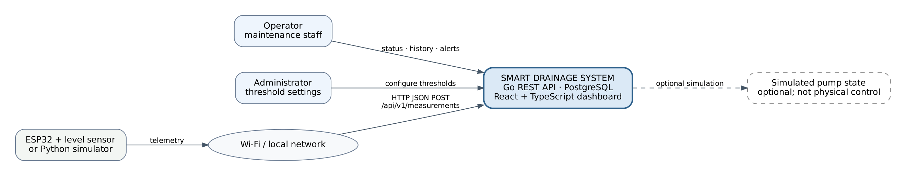
Figure 7.1. System context: external actors, device telemetry, local network and the prototype boundary.
External participants are the Operator, Administrator and the ESP32 sensor node or simulator. A local Wi-Fi segment carries JSON measurements to the system; read and configuration interactions originate from the dashboard. The pump element is explicitly optional and simulated; its drawing does not authorise physical actuation. This diagram corresponds to device contract FR-01, administrative FR-15 and operator FR-06–FR-09.

7.3 Use case diagram
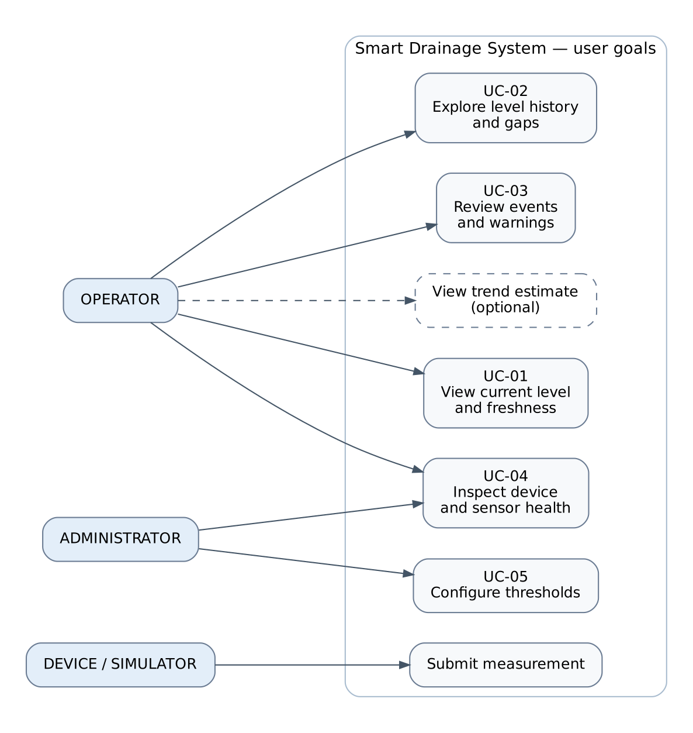
Figure 7.2. Use cases for operator, administrator and device/simulator actors; trend viewing is optional.
The operator’s task sequence is: check level and freshness, inspect warning or history, then consult the event log or device page if the information is incomplete. The administrator changes thresholds through an authenticated path. The device actor submits measurements but does not read administrator controls. The diagram maps to FR-01, FR-05–FR-10 and FR-15; the optional trend cannot be mistaken for a primary safety alarm.

7.4 Component diagram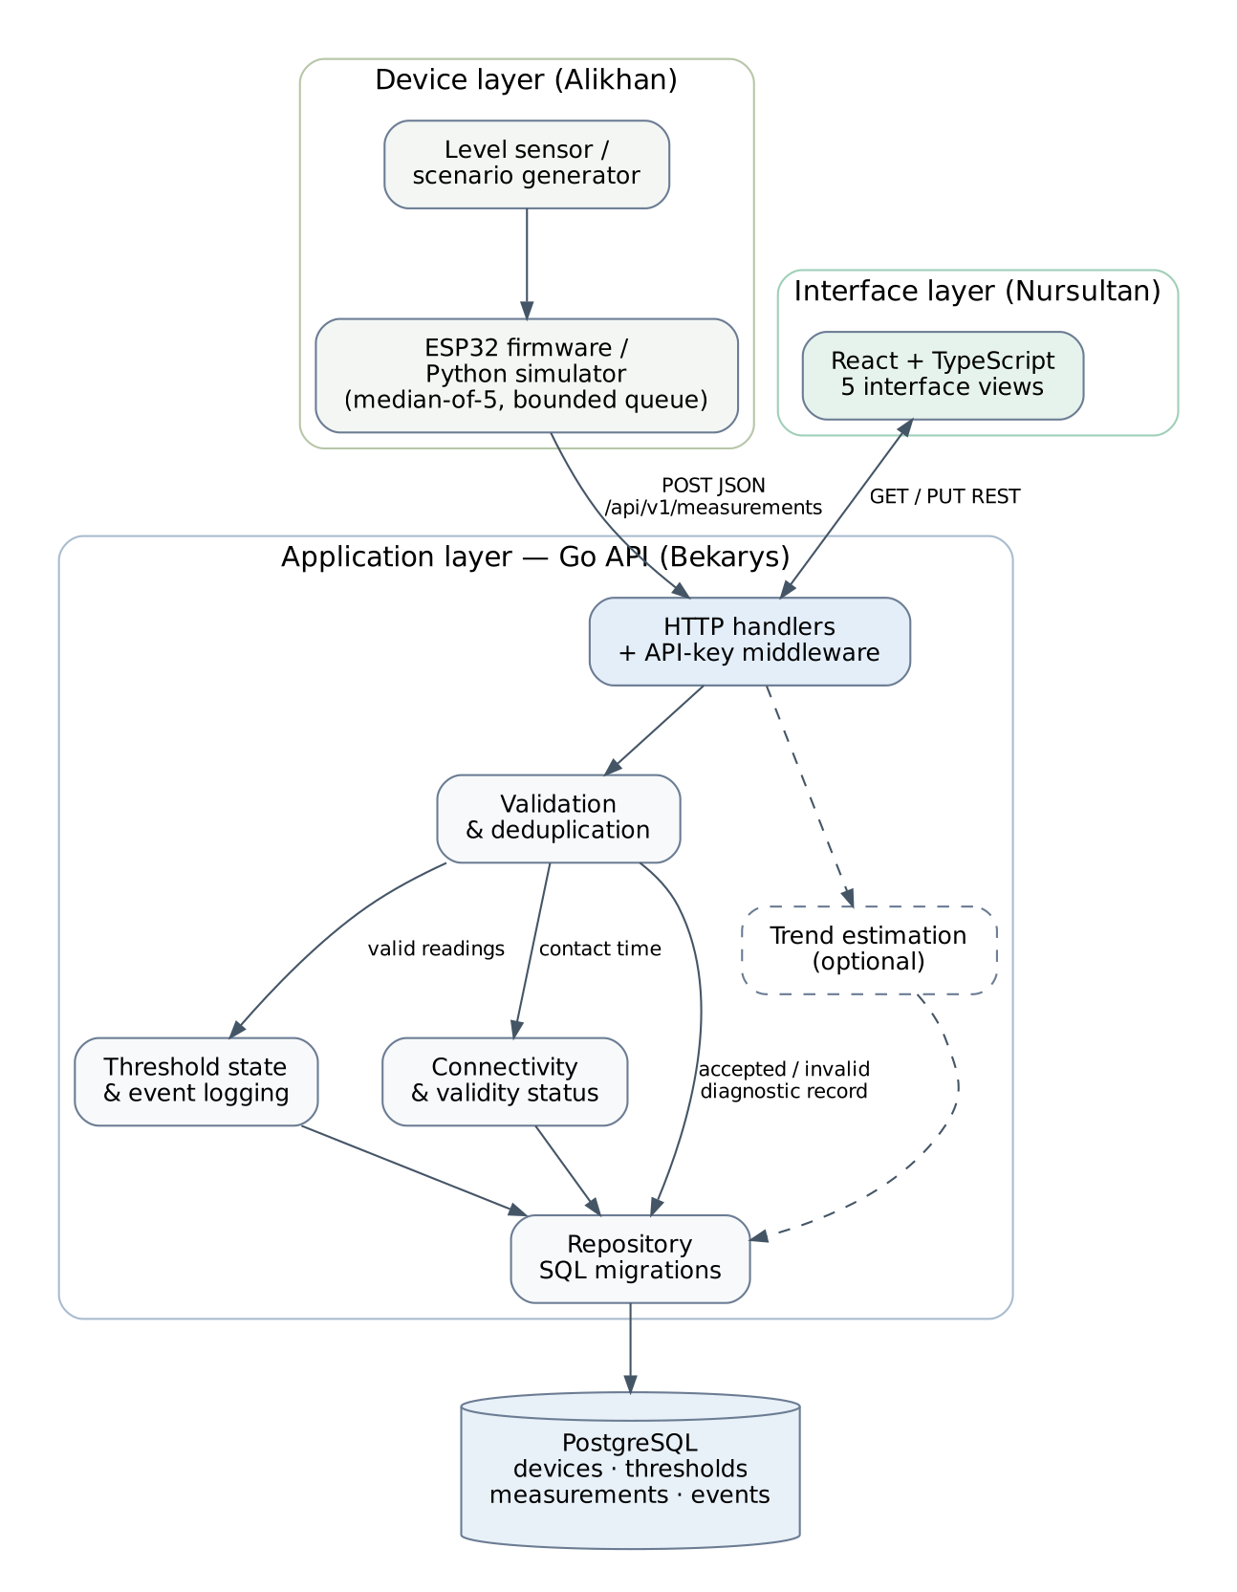

Figure 7.3. Planned component boundaries: sensor/simulator, Go services, database and browser interface.
The backend’s handler receives REST requests, the validation/deduplication service checks their structure and uniqueness, the state service records transitions, the freshness service decides whether reported data are current, and the repository owns SQL persistence. The optional trend module reads recent valid observations. PostgreSQL stores devices, threshold configurations, measurements and events. The read endpoints aggregate these results for the UI. The separation allows unit tests of state logic without real hardware or a database.

7.5 Proposed relational model and failure sequence
Entity | Core attributes | Integrity rule
devices | id, name, created_at | One persistent identifier per logical sensor node
thresholds | device_id, warning_cm, critical_cm, updated_at | One configuration per device; critical > warning
measurements | id, device_id, level_cm, valid, seq, recorded_at, received_at | Device foreign key; unique (device_id, seq) for a continuous device session
events | id, device_id, type, from_state, to_state, level_cm, created_at | One event per change; link to logical reading where possible

When Wi-Fi drops, the browser may still display the last accepted reading. After the 15-second contact timeout, the server should expose OFFLINE, retain the last valid timestamp and avoid calling the old level current. Following reconnection, retransmitted packets are deduplicated; new contact can restore ONLINE independently of whether the latest sensor value is valid. Recording both received_at and measured_at avoids treating delayed buffered messages as new observations. Sequence reset on device reboot remains an explicit implementation risk: a future session identifier may be needed to distinguish rebooted streams.

8. UX and Prototype Design

8.1 Interface status and design principles
Five views of the React + TypeScript single-page application run locally on a Vite development server (http://localhost:5173) with mock data; the header shows a "Demo / Mock Data" badge. The prototype is not yet connected to the Go API.

8.2 Five user scenarios and design artefacts

8.2.1 Dashboard / TankGauge
UC-01: The operator starts with the latest valid level, a prominent state label, time of measurement and connectivity status. TankGauge lines and the level chart add spatial and temporal context. A WARNING or CRITICAL banner identifies an actionable level condition; offline and invalid sensor states must be treated differently from a safe water level.
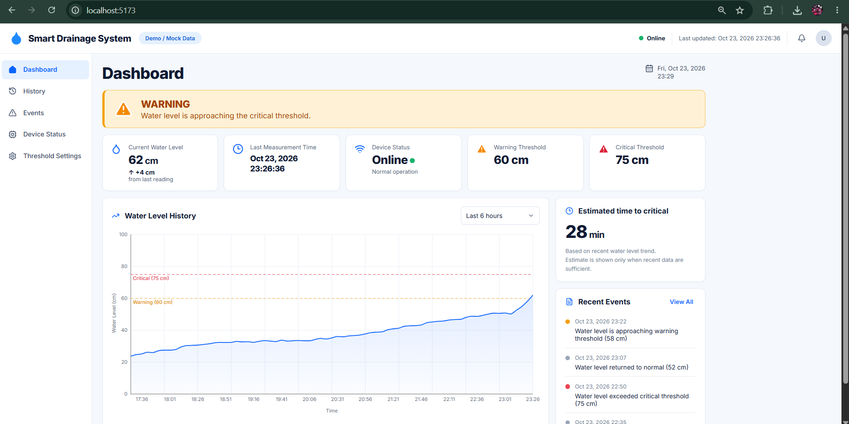
Figure 8.1. Dashboard design showing an illustrative rising-level warning, summary cards and trend panel. Execution screenshot of the React + TypeScript frontend application running locally (localhost:5173), demonstrating real-time dashboard components and telemetry rendering.

8.2.2 History and trend context
UC-02: The operator changes device and time period, then compares recorded values with the threshold lines. A discontinuity marks missing records. The period selection remains stable after refreshing the data; if the service returns no points, the graph displays an empty state instead of a flat line at zero.
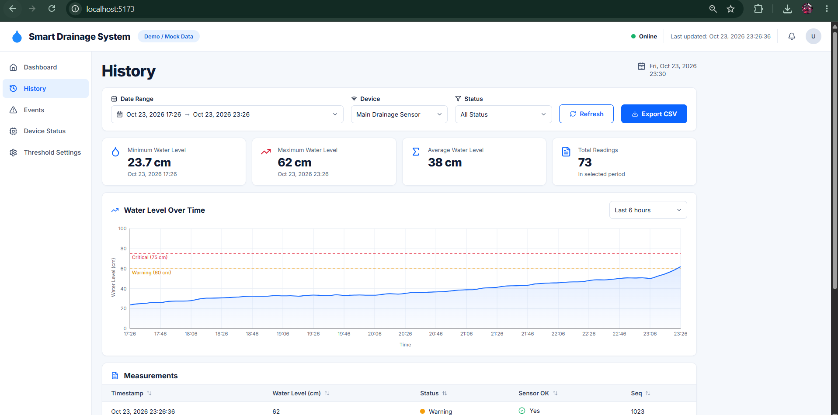
Figure 8.2. History page mockup with device and period filters, chronological readings and threshold guides. Execution screenshot of the React + TypeScript frontend application running locally (localhost:5173), demonstrating real-time dashboard components and telemetry rendering.

8.2.3 Events and warnings
UC-03: After a warning, the operator opens the events table to distinguish a level-state transition from a device-connectivity event. Each row identifies event time, type, device and severity. Refreshing the table must preserve event identity and must not fabricate current water levels for communication failures.
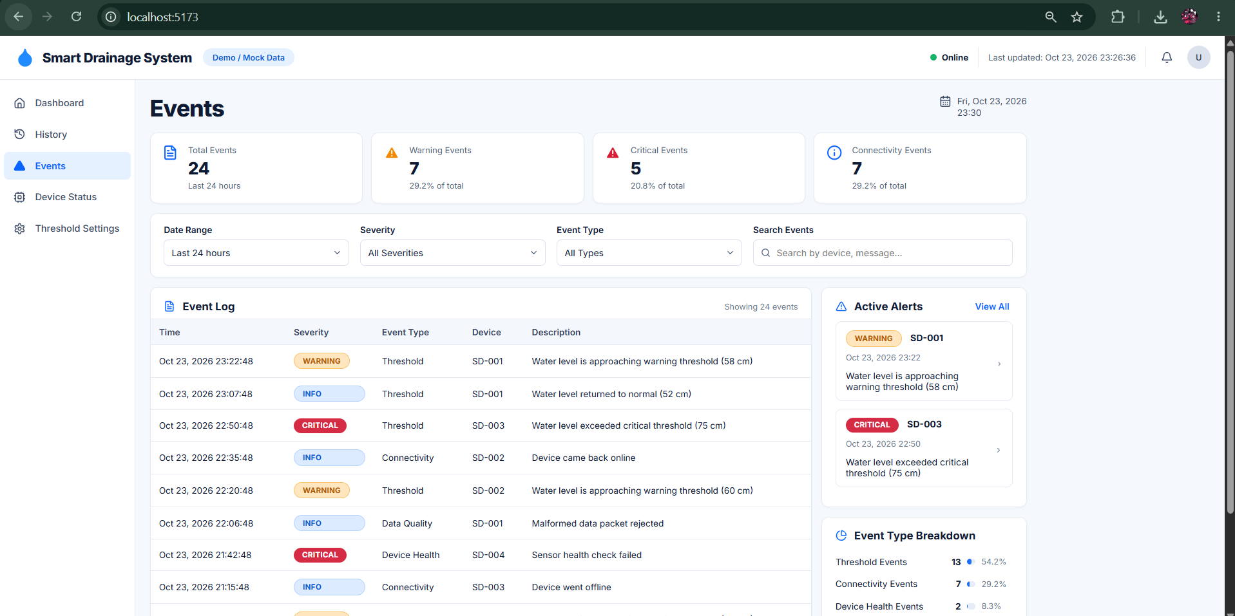
Figure 8.3. Event log design with severity filters and an illustrative notification summary. Execution screenshot of the React + TypeScript frontend application running locally (localhost:5173), demonstrating real-time dashboard components and telemetry rendering.

8.2.4 Device status
UC-04: The operator investigates loss of communication by checking last contact separately from last valid water measurement. Sensor failure while the device is still connected should produce a different explanation from an unreachable backend. Restoring network contact does not by itself establish a good level reading.
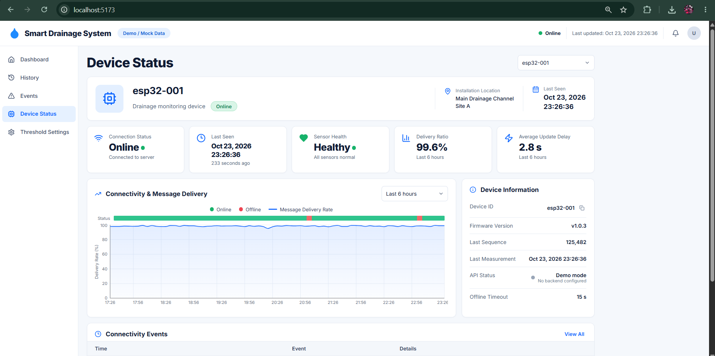
Figure 8.4. Device-status mockup combining connectivity history, metadata and sensor condition. Execution screenshot of the React + TypeScript frontend application running locally (localhost:5173), demonstrating real-time dashboard components and telemetry rendering.

8.2.5 Threshold settings
UC-05: An authorised administrator edits WARNING and CRITICAL settings. The form rejects non-numeric or reversed limits and retains the last accepted values until the server confirms the update. For public or untrusted hosting, a browser must not store an ESP32 device-ingestion API key.
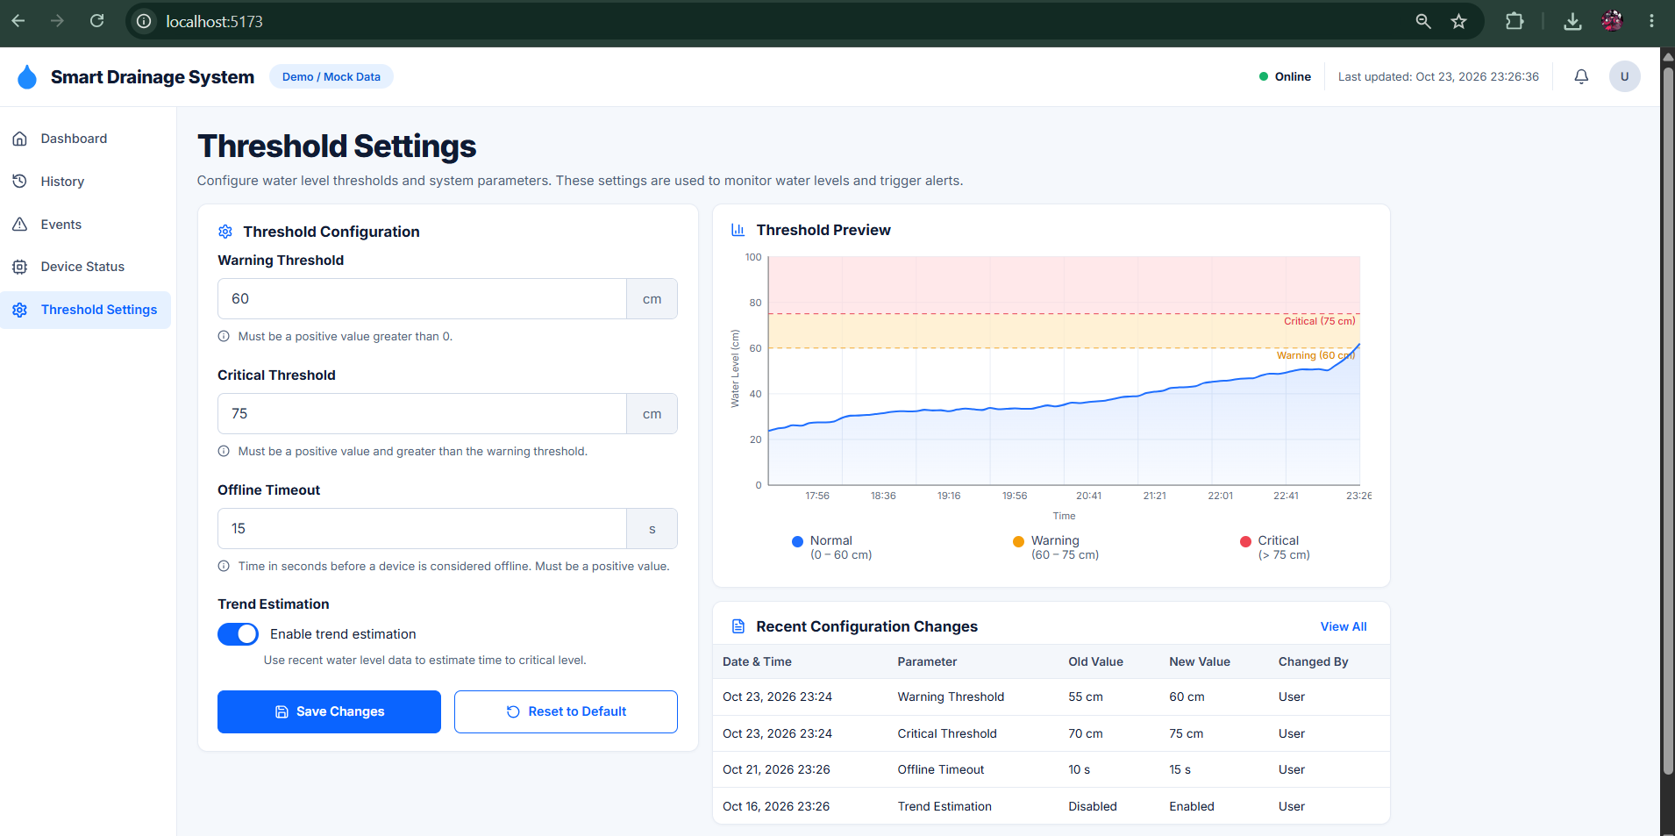
Figure 8.5. Threshold-settings design with validation hints and an illustrative preview. Execution screenshot of the React + TypeScript frontend application running locally (localhost:5173), demonstrating real-time dashboard components and telemetry rendering.

8.3 Failure-state designs
The supplementary monochrome concepts in the source package cover two cases absent from optimistic dashboard screenshots: a clearly stale offline reading and a threshold edit rejected before submission. These are useful test fixtures for the final React components.
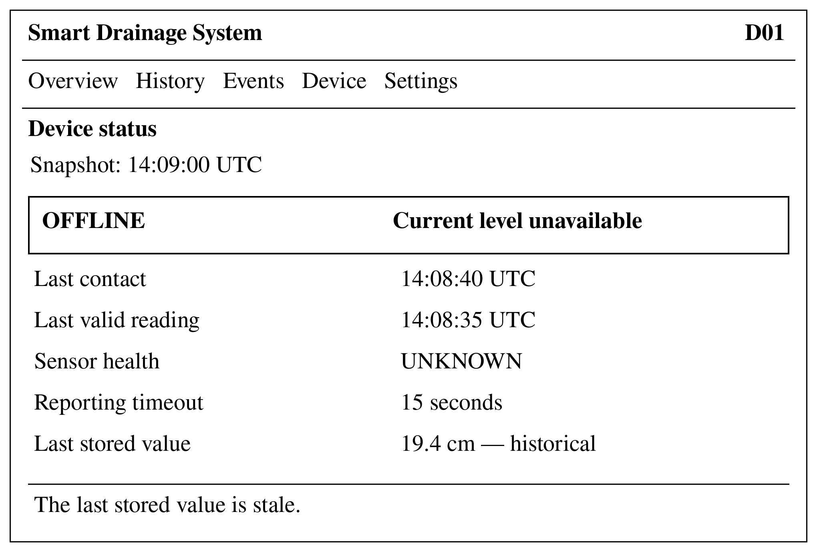
Figure 8.6. Concept of an offline device with a labelled historical value rather than a current safe reading.
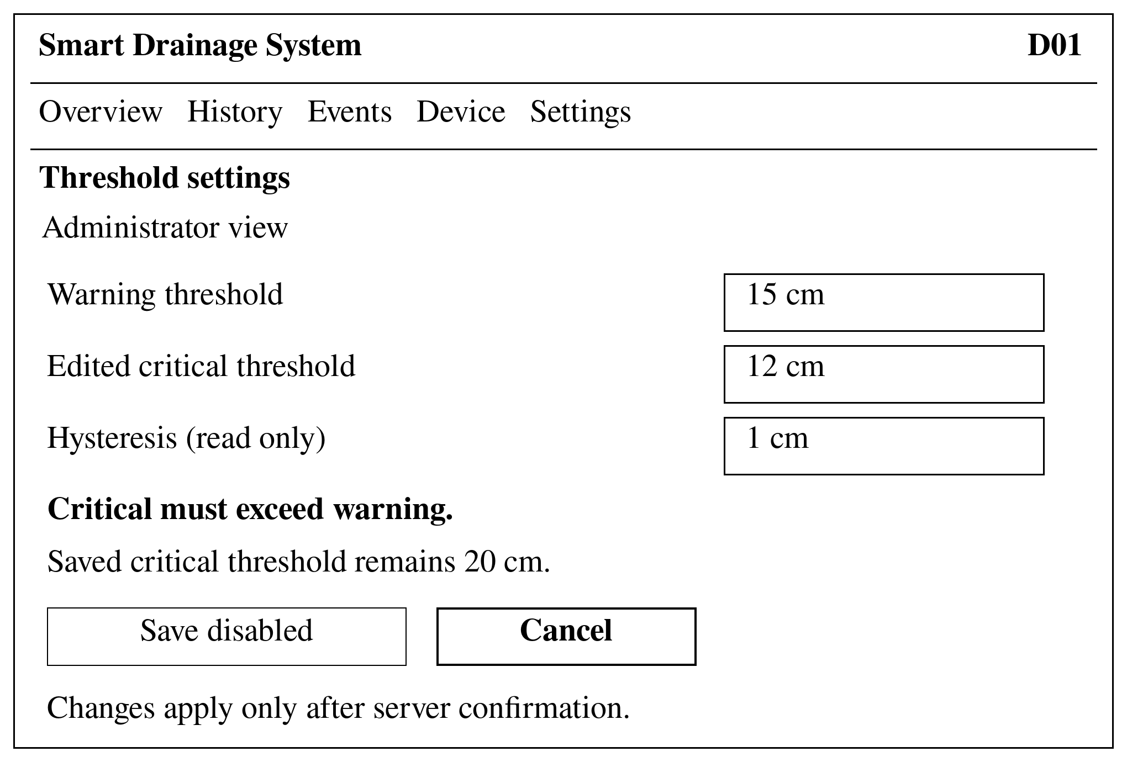
Figure 8.7. Concept of invalid threshold input: warning 15 cm, edited critical 12 cm, saved critical 20 cm.

8.4 REST API contract v1 — proposed, not execution evidence
The team’s draft contract specifies JSON, UTC timestamps and /api/v1. The sample traffic below is illustrative and must not be described as captured from a running server. HTTP 400 denotes malformed or schema-invalid requests, 401 denotes a rejected API key, and 201 denotes a structurally accepted telemetry packet. Well-formed packets with sensor_ok=false may be persisted as invalid diagnostic observations but must not alter the state or trend. Range handling and whether sensor-fault readings can omit level_cm require an implementation decision recorded in OpenAPI [T13].

Measurement submission
POST /api/v1/measurements
Content-Type: application/json
X-API-Key: <local-device-key>
{
"device_id": "esp32-001",
"water_level_cm": 12.4,
"sensor_ok": true,
"seq": 123,
"measured_at": "2026-10-22T10:00:00Z"
}

HTTP/1.1 201 Created
{
"id": 1,
"state": "NORMAL",
"received_at": "2026-10-22T10:00:01Z"
}

Current status and history
GET /api/v1/status?device_id=esp32-001
{
"device_id": "esp32-001",
"level_cm": 12.4,
"state": "NORMAL",
"online": true,
"last_seen_at": "2026-10-22T10:00:01Z",
"thresholds": {"warning_cm": 15, "critical_cm": 20},
"trend": {"rate_cm_per_min": 0.0, "eta_to_critical_sec": null}
}

GET /api/v1/measurements?device_id=esp32-001&limit=2
{
"items": [
{"id": 1, "level_cm": 12.4, "valid": true, "recorded_at": "2026-10-22T10:00:00Z"}
],
"count": 1
}

Other endpoints, validation and access
Endpoint | Purpose and expected behaviour
GET /api/v1/events?device_id=… | Ordered state/online/offline events, with stable ID, time, type and level when valid.
GET /api/v1/thresholds?device_id=… | Read device-specific warning/critical configuration.
PUT /api/v1/thresholds | Authenticated update; reject critical ≤ warning; confirm accepted settings.
GET /api/v1/devices | List available monitoring devices under the current prototype scope.
GET /health | Backend health endpoint for local deployment checks.
Invalid request response | 400: {"error":{"code":"validation_error","message":"device_id is required"}}.
Authentication error | 401 for missing or incorrect device write key; no secret appears in screenshots.

The original v1 status payload does not provide separate timestamps for last contact and last valid reading. That prevents the UI from reliably implementing the precise distinction defined in UI-01. A backward-compatible response extension—last_valid_at, latest_sensor_ok and valid_reading_age_sec—is recommended for the OpenAPI contract; it must be agreed and tested before the UI may claim FR-06 and NFR-09 coverage. These additions are design recommendations, not features verified in the current Go API.

9. Verification and Evaluation Plan

9.1 Metrics and acceptance thresholds
All numbers below are planned acceptance limits. The uploaded files do not include hardware calibration measurements, end-to-end timing logs, message-delivery reconciliation or observed forecast errors. A test result will be reported only with its scenario, build identifier, sample count and raw evidence.
Table 9.1. Measurement plan and evidence status.
Metric | Operational definition | Conditions | Acceptance target | Status
Physical level MAE | MAE = Σ|measured level − ruler reference| / 50 | 5 reference heights × 10 readings; fixed vessel and mounting geometry | ≤1 cm, provisional | Not measured
End-to-end delay | t_visible − t_generated for matched sequence ID | ≥20 local runs; clock synchronisation or shared logging boundary | ≤5 seconds; report mean/max | Not measured
Delivery ratio / PDR | 100% × unique stored sequence IDs / unique generated sequence IDs | One-hour run; planned 2-minute outage and recovery; flushing grace period | ≥99% after recovery | Not measured
Critical detection delay | t_state_change_event − t_reference_crossing | Step/ramp series, N=5 s; controlled thresholds | ≤2 sampling intervals | Not measured
API validation correctness | Expected responses / cases | ≥20 malformed, unauthorised and sensor-invalid packets | 100% match specified policy | Not measured
Time-to-threshold error | |estimated ETA − actual remaining| / actual remaining × 100% | 3 rising series; invalid/non-rising cases test suppression | ≤20% in qualifying cases | Not measured
Interface task success | Completed operator tasks / attempted tasks | 3–5 intended users or representatives; controlled tasks | No numeric improvement claim until study | Not measured

9.2 Test levels and observable outcomes
Test level | Inputs and coverage | Evidence to retain
Unit | Threshold boundary and hysteresis transitions; request validators; regression edge cases; median filter; dedup keys. | Per-case pass/fail logs and deterministic fixtures.
Simulator | Normal, rising, rapid rise, drain, noisy, dropout, invalid and sensor-fail sequences with fixed seeds. | Scenario configuration, emitted sequence IDs and expected state transitions.
Integration | API + real PostgreSQL: migration, write/read, unique sequence, auth, event, status and offline. | Test commands, database snapshot and endpoint responses.
End-to-end | Device/simulator → API → DB → UI for NORMAL/WARNING/CRITICAL and reconnect states. | Video/screenshots with matching sequence and time records.
Fault injection | Unplug network path for 2 min; retry/replay; sensor_ok=false; backend loss and UI retry. | Device/buffer logs; stored uniques; stale-state screenshots.
Load smoke test | A bounded rate above standard five-second cadence with measured HTTP/DB errors. | Requests per second, error rate, resource use and duration.
Usability/accessibility | Identify warning and offline, find history gap, reject invalid threshold, keyboard traversal, contrast. | Task observations, error counts, viewport screenshots and WCAG checklist.

9.3 Baseline comparisons
Manual observation is used only as an illustrative baseline until an actual operator inspection interval is documented. For a simulated manual interval of 30 or 60 minutes, the delay between a threshold crossing and the next visit can approach that interval. Such a synthetic comparison is not a measured operational benefit. For the algorithmic baseline, replay the identical rising sequences with trend estimation disabled and with it enabled, holding the warning/critical rules constant. The comparison should report alert lead time, false confidence and forecast suppression; a trend model cannot count as an earlier threshold crossing unless it is explicitly labelled advisory.

9.4 Reporting and falsification rules
- Fix vessel dimensions, sensor mounting geometry, environment and configured intervals before any physical test.
- Keep raw sensor readings alongside filtered results; report outliers and missing values instead of silently deleting them.
- Use unique sequence numbers in packet-delivery calculations so retries do not inflate successful delivery.
- Use a defensible end-to-end timing method; server received_at by itself is not one-way sensor-to-server delay.
- For each metric, record target, measured result, sample count, software version, pass/fail decision and deviations.
- When hardware is unavailable, report simulator integration only; do not substitute synthetic levels for physical sensor MAE.

10. Project Management and Risks

10.1 Responsibilities and repository conventions
The team allocation follows three principal subsystem owners: Amanzholov Alikhan (IoT, sensing, hardware specification and part of verification), Kenzhebek Bekarys (Go API, database schema, state logic, architecture and integration) and Mukhidinov Nursultan (UX, frontend contract, system comparison and stakeholder materials). Shared literature, review and presentation activities are divided by topic but committed by identifiable contributors.
smart-drainage-system/
├── README.md # project description and available build steps
├── .gitignore / .env.example # no real secrets in version control
├── docker-compose.yml # documented API/database start (when runnable)
├── docs/ # proposal, evidence, literature, ADRs, FR/NFR, tests
├── diagrams/ # editable PlantUML and readable renders
├── iot/ # simulator and ESP32 firmware specification
├── backend/ # Go handlers, services, repository, migrations, tests
├── frontend/ # React + TypeScript interface
├── prototype/ # mockups and UX evidence
└── .github/ # pull-request and review templates

Branch names should contain an issue key, e.g. DIP-18-measurement-api; commits should explain the delivered change, e.g. “DIP-18: validate and persist measurements”. The main branch is reviewed, and each pull request requires a related YouTrack task, a testing note and one team reviewer. The stage tag pre-defense-1 identifies a fixed submission state and must not be moved. These are workflow requirements; no live repository URL or review record was present in the uploaded package.

10.2 DIP issue ownership and evidence scope
The project plan names DIP-1 through DIP-22. To provide a complete thirty-item management map, DIP-23 through DIP-30 below are proposed follow-on work items, not confirmed existing records in YouTrack. Neither numbering nor assignment proves that an issue has been created or closed.
Table 10.1. DIP-1–DIP-30 mapping; only issue descriptions 1–22 are documented in the team plan.
Issue | Work item | Assigned owner | Record standing
DIP-1 | Initial repository, README and ignore rules | Alikhan | Plan-defined
DIP-2 | Create YouTrack project and core tasks | Bekarys | Plan-defined
DIP-3 | Proposal and scope document | Nursultan | Plan-defined
DIP-4 | Coordinate 3–5 real interviews | Nursultan + team | Plan-defined
DIP-5 | Scientific literature collection and analysis | Alikhan | Plan-defined
DIP-6 | Existing-platform comparison | Nursultan | Plan-defined
DIP-7 | Technology and ADR comparison | Bekarys | Plan-defined
DIP-8 | Consolidated FR/NFR specification | Bekarys | Plan-defined
DIP-9 | System context diagram | Alikhan | Plan-defined
DIP-10 | Use case diagram | Nursultan | Plan-defined
DIP-11 | Component diagram | Bekarys | Plan-defined
DIP-12 | Five UX mockups | Nursultan | Plan-defined
DIP-13 | Verification procedure and metrics | Alikhan | Plan-defined
DIP-14 | Risk and milestone register | Alikhan | Plan-defined
DIP-15 | Request supervisor review | Alikhan | Plan-defined
DIP-16 | JSON contract and simulator | Alikhan | Plan-defined
DIP-17 | Database schema and migrations | Bekarys | Plan-defined
DIP-18 | REST measurement and status API | Bekarys | Plan-defined
DIP-19 | Mock-driven React dashboard | Nursultan | Plan-defined
DIP-20 | ESP32 HTTP telemetry firmware | Alikhan | Plan-defined
DIP-21 | Docker Compose integration | Bekarys | Plan-defined
DIP-22 | Presentation and rehearsal | Nursultan + team | Plan-defined
DIP-23 | Data validation and deduplication tests | Bekarys | Proposed, unverified
DIP-24 | Sensor calibration and MAE dataset | Alikhan | Proposed, unverified
DIP-25 | Connectivity retry/buffer test evidence | Alikhan + Bekarys | Proposed, unverified
DIP-26 | API/frontend contract and runtime validation | Bekarys + Nursultan | Proposed, unverified
DIP-27 | UI accessibility and task tests | Nursultan | Proposed, unverified
DIP-28 | State/event integration e2e test | Bekarys + team | Proposed, unverified
DIP-29 | Operator interview confirmation and evidence audit | Nursultan | Proposed, unverified
DIP-30 | Supervisor changes and versioned submission log | Alikhan + team | Proposed, unverified

10.3 Milestones and dependencies
Checkpoint | Expected submission evidence | Dependency / status
21–22 Oct 2026 | Core plan, requirements, architecture, source review and initial simulator/API/UI work. | Task plan exists; completed commits and executable builds are not proven here.
23 Oct 2026 | Integrate where possible; freeze report and preserve evidence; request supervisor remarks. | Requires consistent contract, actual source changes and review records.
24 Oct 2026 | Pre-Defense 1: present problem, prototype design and honest status; demonstrate only verified functions. | Repository access, slides and prepared fallback images/video.
Next stage | Hardware calibration, real API-to-dashboard link, verified tests, operator usability and feedback close-out. | Depends on purchased hardware, approved data contract and reviewer participation.

10.4 Risk matrix
Table 10.2. Qualitative risk register (P = probability; I = impact; L/M/H = low/medium/high).
ID | Risk | P | I | Mitigation | Owner
R-01 | No sensor/board by presentation | M | M | Use labelled simulator, do not claim physical MAE. | Alikhan
R-02 | Sensor blind zone or excessive noise | M | H | Verify chosen datasheet and geometry; retain raw readings. | Alikhan
R-03 | Level signal incompatible with MCU input | M | H | Review exact electrical levels and suitable interface before assembly. | Alikhan
R-04 | Network outage loses or duplicates packets | M | H | Bound queue, retry, deduplicate and run 2-minute interruption. | Alikhan/Bekarys
R-05 | Backend/UI state drift and stale data | H | H | Single authoritative status contract and failure-state e2e tests. | Bekarys/Nursultan
R-06 | Unverified 10 vs 15-second timeout rules | H | M | Set shared 15-second default; test across components. | Bekarys
R-07 | Unreliable trend shown as precise | M | H | Use clear suppression rules and qualify the estimate. | Bekarys/Nursultan
R-08 | Credentials exposed in browser/repository | M | H | Local-only device key; no embedded secrets; audit history. | All
R-09 | Insufficient interview confirmation | H | H | Keep expert statements conditional until respondents approve. | Nursultan
R-10 | Missing supervisor-review records | M | H | Document request and only actual remarks and commit links. | Alikhan
R-11 | UI art mistaken for executed application | H | M | Caption every mockup as static and demonstrate only real builds. | Nursultan
R-12 | Physical actuation from stale input | L | H | No physical pump in scope; block optional simulated action. | All
R-13 | Bibliographic error / unsupported metrics | M | M | Publisher-level verification and per-study limitations. | All
R-14 | Late integration breaks presentation | H | H | Fixed demo scope and content freeze; preserve known evidence. | All

11. Supervisor Feedback

11.1 Review record and attribution
Shyryn Tutkyshbayeva is identified as the project supervisor in every principal team report. The supplied files include proposed feedback-request instructions but do not contain a response from her, dated comments, a marked-up document or a supervisor-linked Git commit. It would be academically inappropriate to attribute unverified editing decisions to the supervisor. The status of the supervisor response therefore remains unconfirmed in this submission package.

11.2 Remark → Action Taken → Commit/PR
Table 11.1. Supervisor-feedback record based on the evidence actually supplied.
Remark | Action Taken | Commit / PR evidence

11.3 Internal consistency corrections, not supervisor feedback
Table 11.2. Changes made during editorial consolidation; these must not be presented as supervisor decisions.
Editorial finding | Action incorporated in this report | Repository status
Earlier versions differed on 10 s versus 15 s offline semantics. | Use 15 s as the documented local demonstration default; separate contact from valid reading. | Documentation change only; code revision not established.
Nursultan UI imagery shows 60/75 cm while contract defaults are 15/20 cm. | Identify 60/75 cm as illustrative UI values and use device API thresholds for runtime behaviour. | Design clarification; implementation not verified.
Interview response wording lacks respondent sign-off. | Present expert themes as confirmation-dependent and split findings from hypotheses. | No interview approval record supplied.
Earlier team report contains incomplete scientific count. | Build a reviewed ten-publication 2021–2025 research table with verifiable DOI links. | Current report only; repository commit not supplied.
Actual Git/YouTrack artefact URLs and build evidence are absent. | Avoid any claim that PR review, integration or tests have already passed. | Pending independent repository verification.

11.4 Deliverable-to-review path
The most useful immediate supervisory review concerns project scope, requirements that cannot yet be demonstrated, the decision to keep actuation simulated, the unresolved v1 status fields and the priority of hardware versus software evidence. After receiving real remarks, the team can associate each comment with a chosen response, a DIP issue, a pull request, and a repeatable check. The record should preserve both accepted remarks and reasoned disagreements rather than substitute generic approval language.

References
Scientific publications (2021–2025). Bibliographic metadata and publisher/index pages were checked during this consolidation. The articles’ results describe their respective study conditions, not outcomes of the Smart Drainage prototype.
[S1] Nageye, A. Y., Jimale, A. D., Abdullahi, M. O., & Addow, M. A. (2025). Enhancing urban resilience: an IoT-based smart drainage system for flood management in Mogadishu, Somalia. Discover Applied Sciences, 7, 515. DOI: 10.1007/s42452-025-07117-8. Source
[S2] Adan, M. A., & Alias, A. (2025). Design and Development of an Early Warning System for Monitoring Rising Water Levels. Enhanced Knowledge in Sciences and Technology, 5(2), 252–258. DOI: 10.30880/ekst.2025.05.02.029. Source
[S3] Zakaria, M. I., Jabbar, W. A., & Sulaiman, N. (2023). Development of a smart sensing unit for LoRaWAN-based IoT flood monitoring and warning system in catchment areas. Internet of Things and Cyber-Physical Systems, 3, 249–261. DOI: 10.1016/j.iotcps.2023.04.005. Source
[S4] Rony, J. H., Karim, N., Rouf, M. A., Islam, M. M., Uddin, J., & Begum, M. (2021). A Cost-Effective IoT Model for a Smart Sewerage Management System Using Sensors. J, 4(3), 356–366. DOI: 10.3390/j4030027. Source
[S5] Siddique, M., Ahmed, T., & Husain, M. S. (2023). Flood Monitoring and Early Warning Systems – An IoT Based Perspective. EAI Endorsed Transactions on Internet of Things, 9(2), e4. DOI: 10.4108/eetiot.v9i2.2968. Source
[S6] Sharafkhani, F., Corns, S., & Holmes, R. (2024). Multi-Step Ahead Water Level Forecasting Using Deep Neural Networks. Water, 16(21), 3153. DOI: 10.3390/w16213153. Source
[S7] Adli Zakaria, M. N., Ahmed, A. N., Abdul Malek, M., Birima, A. H., Hayet Khan, M. M., Sherif, M., & Elshafie, A. (2023). Exploring machine learning algorithms for accurate water level forecasting in Muda river, Malaysia. Heliyon, 9(7), e17689. DOI: 10.1016/j.heliyon.2023.e17689. Source
[S8] Almikaeel, W., Šoltész, A., Čubanová, L., & Baroková, D. (2025). Hydro-informer: a deep learning model for accurate water level and flood predictions. Natural Hazards, 121, 3959–3979. DOI: 10.1007/s11069-024-06949-8. Source
[S9] Tory, M., Bartram, L., Fiore-Gartland, B., & Crisan, A. (2023). Finding Their Data Voice: Practices and Challenges of Dashboard Users. IEEE Computer Graphics and Applications, 43(1), 22–36. DOI: 10.1109/MCG.2021.3136545. Source
[S10] Pimentel Filho, J. A., Neves, C. F., Lopes, W. T. A., & Carvalho, J. C. (2024). Anomaly detection in hydrological network time series via multiresolution analysis. Journal of Hydrology, 640, 131667. DOI: 10.1016/j.jhydrol.2024.131667. Source

Technical standards, software and product documentation
[T1] Espressif Systems. ESP32 Series Datasheet, revision 5.3 (2026). Source
[T2] Arduino. UNO R3 official product/datasheet documentation (accessed 2026). Source
[T3] Raspberry Pi. Pico-series microcontroller technical documentation, Pico W (accessed 2026). Source
[T4] MathWorks. ThingSpeak Licensing FAQ (accessed 2026). Source
[T5] MathWorks. ThingSpeak React App and Visualize Data documentation (accessed 2026). Source · Visualize Data
[T6] Blynk. Connection Lifecycle, Automations and Simple Chart documentation (accessed 2026). Source · Automations · Simple Chart
[T7] Grafana Labs. Data sources and Handle missing data in Grafana Alerting (2026 documentation). Source · Data sources
[T8] Hach. FL900 Flow Logger documentation and September 2024 datasheet / 2024 manuals. Source
[T9] React. Using TypeScript, official documentation (accessed 2026). Source
[T10] Vue. Using Vue with TypeScript, official documentation (accessed 2026). Source
[T11] Angular. What is Angular?, official documentation (accessed 2026). Source
[T12] W3C. Web Content Accessibility Guidelines (WCAG) 2.2, W3C Recommendation (2024). Source
[T13] OpenAPI Initiative. OpenAPI Specification 3.1.2 (2025). Source
[T14] PostgreSQL Global Development Group. PostgreSQL documentation: constraints and foreign keys (2026 edition). Source
[T15] Timescale. Hypertables documentation (accessed 2026). Source
[T16] InfluxData. InfluxDB 3 Core documentation (accessed 2026). Source
[T17] Node.js. Overview of Blocking vs Non-Blocking, official documentation (accessed 2026). Source
[T18] Go Project. Effective Go, official documentation (accessed 2026). Source
[T19] FastAPI. First Steps and automatic OpenAPI documentation (accessed 2026). Source
[T20] MQTT.org. MQTT FAQ and OASIS protocol overview (accessed 2026). Source

Primary project materials
The following internal sources underpin the reported roles, provisional requirements, work allocation, diagrams and mockups. They are deliberately not listed as peer-reviewed scientific literature.
• Project team. Smart Drainage System — pre-defense plan to 24 October 2026 (21 October 2026).
• Project team. Smart Drainage System Team Report, Pre-Defense 1 (22 October 2026).
• Mukhidinov, N. Smart Drainage System — Individual Research and Interface Documentation (23 October 2026), including full-page UI mockups.
• Mukhidinov, N. Revised Research and Interface Documentation (23 October 2026), including interview confirmation status.
• Faculty pre-defense assessment criteria, “До 24 октября” (supplied course document).
• 07-system-context.puml (supplied editable project system-context source).

Appendix A. Editable PlantUML diagram definitions
These sources specify the three required architectural views. The system-context definition is retained from the supplied project file; the use-case and component sources are aligned with the requirements in this report. A PlantUML source is an architecture description, not proof of deployed software.

A1. System context
@startuml system-context
title Smart Drainage System - System Context Diagram
skinparam shadowing false
skinparam defaultFontSize 13
left to right direction
actor "Operator\n(drainage maintenance staff)" as Operator
actor "Administrator" as Admin
rectangle "Water level sensor\n(ultrasonic) + ESP32\n(or Python simulator)" as Device
rectangle "Smart Drainage System\n(API server, PostgreSQL,\nweb dashboard)" as System #LightBlue
cloud "Wi-Fi network" as WiFi
rectangle "Pump\n(optional / simulated)" as Pump #LightGray
Device --> WiFi : water level measurements\n(HTTP REST, JSON)
WiFi --> System : POST /api/v1/measurements
System --> Operator : current level, status,\nhistory, warnings
Operator --> System : view data
Admin --> System : configure thresholds
System ..> Pump : pump command\n(optional, with safety checks)
@enduml

A2. Use case
@startuml smart-drainage-use-cases
title Smart Drainage System — Use Case Diagram
left to right direction
skinparam shadowing false
actor Operator
actor Administrator
actor "ESP32 / Simulator" as Device
rectangle "Smart Drainage System" {
usecase "View current level and freshness" as UC1
usecase "Explore level history" as UC2
usecase "Review warnings and events" as UC3
usecase "Inspect device and sensor health" as UC4
usecase "Configure thresholds" as UC5
usecase "Submit measurement" as UC6
usecase "View trend estimate (optional)" as UC7
}
Operator --> UC1
Operator --> UC2
Operator --> UC3
Operator --> UC4
Operator ..> UC7
Administrator --> UC4
Administrator --> UC5
Device --> UC6
@enduml

A3. Component (design)
@startuml smart-drainage-components
title Smart Drainage System — Component Diagram (design)
skinparam shadowing false
left to right direction
package "Device layer" {
[Water-level sensor / Python scenario] as Sensor
[ESP32 firmware / Simulator] as Device
Sensor --> Device : measured distance or modelled level
}
package "Application layer" {
[HTTP handlers + API-key middleware] as Http
[Telemetry validation + deduplication] as Validate
[Threshold state + event service] as State
[Freshness/status service] as Fresh
[Trend estimator (optional)] as Trend
[Repository] as Repo
Device --> Http : POST /api/v1/measurements
Http --> Validate
Validate --> State : valid readings only
Validate --> Fresh : contact timestamp
State --> Repo
Fresh --> Repo
Trend --> Repo
Validate --> Repo : accepted/invalid diagnostic record
}
database "PostgreSQL
devices | thresholds | measurements | events" as Db
Repo --> Db
package "Interface layer" {
[React + TypeScript dashboard] as UI
}
UI --> Http : GET status / history / events / thresholds
Http --> Fresh
Http --> Repo
Http --> Trend : optional
@enduml

Appendix B. Contract and data semantics

B1. Measurement fields
Field | Type / units | Meaning and intended rule
device_id | string, 1–64 chars | Node identity: alphanumerics, hyphen and underscore under proposed validator.
water_level_cm | finite numeric, cm | Vertical water height in vessel; higher means more water. Source v1 nominal plausibility range 0–400 cm, further constrained by vessel.
sensor_ok | boolean | Whether the node considers the sensor reading valid; false readings are excluded from water-state/trend computation.
seq | non-negative integer | Identifier for retry detection within a device session; reboot-reset policy must be made explicit.
measured_at | optional ISO-8601 UTC | Source time; latency claims require clock synchronisation.
received_at | server UTC | Server receipt time used for connectivity and audit ordering.
recorded_at | UTC | Chosen ordering timestamp for historical query; source and reception semantics documented in OpenAPI.
valid | boolean, server-derived | Whether reading passes accepted plausibility/sensor checks; diagnostic records can remain invalid.
last_valid_at | optional planned extension | Needed by UI to distinguish latest accepted contact from last valid measurement.

B2. Example table and index intent
For a small system, the intended device foreign keys and (device_id, recorded_at DESC) index support recent history retrieval. Unique (device_id, seq) can prevent duplicates if the sequence is stable across a device session. The original design does not define rollover, reboot or out-of-order handling; these are implementation decisions to document before declaring FR-13 complete.

B3. Unresolved design dependencies
The edited interface report requires independent last-contact and last-valid timestamps; the original API v1 contains only last_seen_at. Adding explicit fields is the recommended compatible extension. Similarly, the initial key-based endpoint policy is adequate only for a trusted local demonstration and cannot, on its own, be described as a finished end-user access-control system. These constraints remain visible because suppressing them would make the acceptance criteria unverifiable.

Appendix C Interview records
This appendix reproduces the questions and answers of the three expert interviews held on 21 October 2026. The answers are given as recorded by the team and are not edited. Section 2.2 summarises them, and Section 6.5 shows which requirements each answer informed. Record IDs follow the report (E-01 to E-03).

E-01 — Abdullayev Shynggys
Position: Front-End Developer with Three Years of Experience. Date: 21 October 2026.
Q1. What should an operator understand first when opening the dashboard?
Answer: The operator should immediately understand the current water-level situation without having to search through different screens. I would place the latest valid measurement, its unit, the current status, and the time of the last valid reading together in the main dashboard area. The warning state should be immediately noticeable. A graph can provide additional context, but it should not distract from the most important information.
Q2. What information should be available beyond the current water-level reading?
Answer: I would include a historical chart and an event log. The chart helps the operator understand how the water level changes over time, while the event log shows when warnings appeared and when the device lost communication. It is important to display timestamps and units consistently. If measurements are missing, the chart should show a visible gap instead of connecting the available points and suggesting that data were recorded continuously.
Q3. How should the interface display warning and critical states?
Answer: I would use clear text labels such as WARNING and CRITICAL, supported by distinct visual indicators. Colour can help users recognise the states quickly, but it should not be the only way to communicate them. The interface should remain understandable on smaller screens and for users who have difficulty distinguishing colours. The most important warning information should be visible without requiring the operator to open another page. Q4. What should the dashboard show when the device stops sending data? Answer: It should clearly display an OFFLINE or STALE DATA status, depending on the situation. The system can preserve the last valid measurement, but it must show when that measurement was recorded. For example, if the last reading was low but the device has stopped communicating, the dashboard should not continue presenting that value as proof that the current water level is safe. The interface must distinguish the last known condition from the current device status. Q5. Would a forecast showing the estimated time until a critical water level be useful? Answer: It could be useful because it gives the operator additional context about how quickly the water level is rising. However, I would display it as an approximate estimate rather than a guaranteed prediction. If there are too few measurements, the data are outdated, or the trend is unstable, the interface should explain why the estimate is unavailable. The actual measured level and warning state should always remain the primary information

E-02 — Tungatarov Erzhigit Erbatyrovich
Position: Executive Director of Kokshetau Zhylu. Date: 21 October 2026.
Q1. From an operational perspective, what makes a monitoring system useful?
Answer: The information must be clear, timely, and useful for making decisions. A person responsible for monitoring should be able to see the current measurement, understand whether it requires attention, and know when the data were last updated. It is also important to identify which device provided the information. A system is less useful if employees have to spend extra time figuring out whether its readings can be trusted.
Q2. What limitations should the team consider when developing a small monitoring prototype?
Answer: A prototype tested in a controlled environment is different from a system installed at an actual utility site. In practice, the team would need to consider environmental conditions, power supply, communication reliability, maintenance, sensor suitability, and the procedures followed when an alarm occurs. These factors cannot be fully evaluated through a laboratory demonstration alone. The prototype should therefore have a clearly defined scope and should not be presented as a readyto-use industrial solution.
Q3. How should the system respond when measurements become unavailable or unreliable?
Answer: It should clearly indicate the problem instead of continuing to display an old value as if it were current. The last valid measurement can remain available for reference, but its timestamp and outdated status must be visible. The system should also distinguish between a device that has lost communication and a device that is still connected but producing invalid measurements. These situations require different responses.
Q4. Would you recommend including automatic physical pump control in the first version?
Answer: I would not make automatic pump control part of the initial demonstration. Before controlling physical equipment, the team would need to verify the hardware, define safety mechanisms, and test how the system behaves during communication failures and incorrect measurements. For an educational prototype, a simulated pump state is sufficient to demonstrate the intended workflow without introducing unnecessary operational risks.
Q5. What would be required before considering the system for use at a real facility?
Answer: The system would need repeatable test results demonstrating measurement accuracy, correct warning behaviour, and reliable handling of communication failures and recovery. The sensor and installation method would also need to be assessed for the intended environment. In addition, there should be a clear procedure for responding to warnings and maintaining the equipment. Only after these checks could the team make a more informed assessment of its suitability for practical use.

E-03 — Karim Kazhymukan Baimuratuly
Position: IoT Specialist and STEM Teacher, Judge and Organizer of International STEM Olympiads. Date: 21 October 2026.
Q1. Is ESP32 a suitable choice for a water-level monitoring prototype?
Answer: Yes, I think ESP32 is a good choice for an educational IoT project. It has built-in Wi-Fi, is relatively affordable, and can communicate with a backend server without requiring many additional components. However, before assembling the system, the team should confirm the exact board model, its power requirements, and compatibility with the selected sensor.
Q2. What should the team consider when selecting and connecting a water-level sensor?
Answer: The sensor must match the measurement range and the conditions in which it will operate. If the team chooses an ultrasonic sensor, it should consider the minimum measurement distance, mounting position, and possible interference from the water surface or surrounding objects. Electrical compatibility is also important. ESP32 uses 3.3 V logic, so the sensor's output voltage must be checked before connecting it to the board.
Q3. How can the team make sure that the sensor readings are accurate?
Answer: I would recommend testing the sensor at several known water levels and comparing its readings with reference measurements. Each measurement should be repeated so the team can identify errors and inconsistent results. Filtering can help reduce random fluctuations, but it should not hide a genuine rapid increase in water level. The team should keep the original readings as well, so the results can be checked later.
Q4. What should happen if the Wi-Fi connection is interrupted?
Answer: The device should detect unsuccessful requests and handle reconnection automatically. If the connection returns, the system should be able to identify which measurements are new and which have already been received. Sequence numbers or unique identifiers can help prevent duplicate records. I would also recommend testing both the disconnection and recovery scenarios rather than testing only normal operation.
Q5. Which tests would you consider essential before demonstrating the prototype?
Answer: I would test normal measurements, a rising water level, threshold crossings, invalid sensor readings, Wi-Fi disconnection, backend unavailability, and reconnection. The team should record the expected and actual results for each scenario. It is also important to check what the system displays when measurements are missing, because the interface must not confuse a communication problem with a safe water level.
Q6. Is it necessary to implement water-level forecasting in the first version?
Answer: I would treat forecasting as an additional feature rather than a core requirement. First, the team needs a reliable measurement and data-processing pipeline. After that, it can test a simple calculation based on recent water-level changes. The estimate should be shown only when there are enough valid measurements and the trend is reasonably stable. A machine-learning model would require suitable data and additional evaluation, so I would not make it a priority at this stage.

