Business Template

Subject areas
Logo / Image

Contents
1 Business Description 3
1.1 Business background 3
1.2 Problems. Current Situation 3
1.3 The benefits of implementing a database. Project Vision 3
2 Model description 3
2.1 Definitions & Acronyms 3
2.2 Logical Scheme 4
2.3 Objects 4

Business Description

Business background
Metro management would like to receive detailed information about subway station, lines (routes, schedules, operating frequencies, and required number of trains and employees), information on train arrival and departure times for each station, tickets (types, prices, discounts, promotions). Moreover it's necessary to track the upkeep and repair of subway infrastructure, including tunnels, tracks, trains, and stations.
Additionally, our business analytics contacted customer with previous data logical model that covered their requirements, and gathered new information from them:
- Usually a ticket belongs to a passenger via customer_id. If the customer isnt registered in the system (for example paid with cash or credit card) we can assume them to be assigned to a specific customer with index "-1" and a name idenifying as external customers.
- The ticket should also store the time, date and station it was used on, along with the payment method.
- A registered customer could have a specific amount of money in their account that can be used as a payment method, or they can have a boarding pass (monthly pass, school, pensioner) which can be used as a payment method and also expire.

Problems. Current Situation
We need to develop Data Logical Model from scratch, that will cover all requirements, along with new ones.

the Benefits of implementing a database. Project Vision
The database will centralize all metro-related information—stations, trains, routes, tickets, customers, and maintenance. It will support management in decision-making, enable tracking of operational efficiency, streamline payment and ticketing processes, and allow better forecasting of maintenance needs. The project vision is to create a unified, normalized data model in 3NF for comprehensive metro system management.

Model description

Definitions & Acronyms
PK – Primary Key
FK – Foreign Key

Logical Scheme
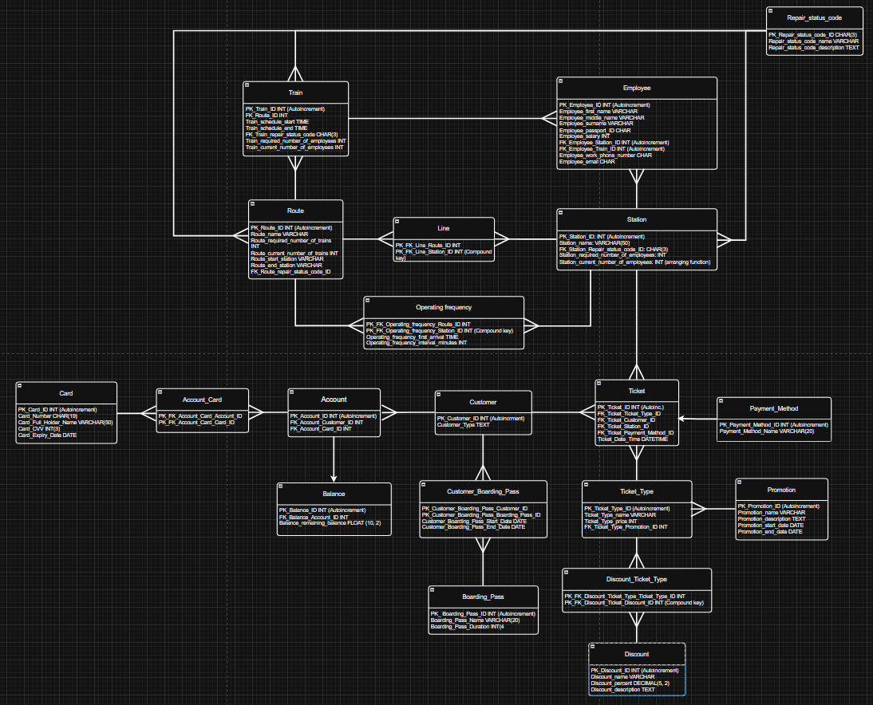

Objects

Table Employee
To store data about employees

Table Name | Field name | Field Description | Data Type
Employee | PK_Employee_ID | Autoincrement, surrogate PK, PK | INT
 | Employee_first_name |  | VARCHAR(20)
 | Employee_middle_name |  | VARCHAR(20)
 | Employee_surname |  | VARCHAR(20)
 | Employee_passport_ID |  | CHAR
 | Employee_salary | In dollars, year salary | FLOAT(10,2)
 | FK_Employee_Station_ID | Can be NaN, employee may work only on 1 station, or/and 1 train | INT
 | FK_Employee_Train_ID | Can be NaN, employee may work only on 1 station, or/and 1 train | INT
 | Employee_work_phone_number | Only 1 work phone number | CHAR
 | Employee_email | Only 1 corporate email | CHAR

Repair Status Code relation exists as dictionary table, that is FK in Route, Station, Train. It depicts current state of the structures mentioned. Relationship with mentioned tables is direct, without bridge tables, but, if our business partner wants to store history of repairs then It can be realized using bridge tables where all info would be stored, about past and current states of infrastructure. I decided to not to do it as need in history is not mentioned

Table Name | Field name | Field Description | Data Type
Repair_status_code | PK_Repair_status_code_ID | Short code, natural ID, can be 003, or 3, depends on usage | CHAR(3)
 | Repair_status_code_name | Name for understanding | VARCHAR
 | Repair_status_code_description | Wide description | TEXT

Train table contains all the information about trains, as well as required number of workers on each

Table Name | Field name | Field Description | Data Type
Train | PK_Train_ID | Surrogate PK | INT
 | FK_Route_ID |  | INT
 | Train_schedule_start | Time when train starts its work | TIME
 | Train_schedule_end | Time when train ends its work | TIME
 | FK_Train_repair_status_code | State of the train | CHAR(3)
 | Train_required_number_of_employees | Required number is what to be stored based on business requirements | INT
 | Train_current_number_of_employees | Can be manually inputted, or can be aggregate function using COUNT employees who work on this train.train_ID | INT

Route – data about route, needed amount of employees

Table Name | Field name | Field Description | Data Type
Route | PK_Route_ID | Primary key ID of the route (auto-incremented) | INT
 | Route_name | Name of the route | VARCHAR
 | Route_required_number_of_trains | Required number of trains assigned to the route | INT
 | Route_current_number_of_trains | Current number of trains currently operating on the route | INT
 | Route_start_station | Starting station of the route | VARCHAR
 | Route_end_station | Ending station of the route | VARCHAR
 | FK_Route_repair_status_code_ID | Foreign key linking to the route repair status code | CHAR(3)

Station - contains information about each station, including its ID, name, employee counts, and repair status reference

Table Name | Field name | Field Description | Data Type
Station | PK_Station_ID | Primary key ID of the station (auto-incremented surrogate key) | INT
 | Station_name | Name of the station | VARCHAR(50)
 | FK_Station_Repair_status_code_ID | Foreign key linking to repair status code | CHAR(3)
 | Station_required_number_of_employees | Required number of employees for the station | INT
 | Station_current_number_of_employees | Current number of employees assigned to the station (arranging function) | INT

Line - represents the relationship between a route and a station (junction table using a compound key). It is necessary to as we want to connect station with several routes, if they lie on it. In most countries there are several routes on 1 station, but each route have more than 1 station, so we need bridge relation

Table Name | Field name | Field Description | Data Type
Line | PK_FK_Line_Route_ID | Primary and foreign key referencing the route associated with the line | INT
 | PK_FK_Line_Station_ID | Primary and foreign key referencing the station included in the route (part of compound key) | INT

Operating_Frequency - defines the schedule characteristics for each route-station pair, including first arrival time and interval between trains

Table Name | Field name | Field Description | Data Type
Operation_Frequency | PK_FK_Operating_frequency_Route_ID | Primary and foreign key referencing the route | INT
 | PK_FK_Operating_frequency_Station_ID | Primary and foreign key referencing the station (part of compound key) | INT
 | Operating_frequency_first_arrival | Time of the first train arrival at the station for the given route | TIME
 | Operating_frequency_interval_minutes | Interval in minutes between consecutive train arrivals | INT

Ticket - stores information about individual tickets, including type, customer, station, payment method, and purchase time

Table Name | Field name | Field Description | Data Type
Ticket | PK_Ticket_ID | Primary key ID of the ticket (auto-incremented) | INT
 | FK_Ticket_Ticket_Type_ID | Foreign key referencing the ticket type | INT
 | FK_Ticket_Customer_ID | Foreign key referencing the customer who purchased the ticket | INT
 | FK_Ticket_Station_ID | Foreign key referencing the station where the ticket is valid or purchased | INT
 | FK_Ticket_Payment_Method_ID | Foreign key referencing the payment method used for the ticket | INT
 | Ticket_Date_Time | Date and time when the ticket was issued or purchased | DATETIME

Payment_Method - contains available payment method types used for ticket transactions

Table Name | Field name | Field Description | Data Type
Payment_Method | PK_Payment_Method_ID | Primary key ID of the payment method (auto-incremented) | INT
 | Payment_Method_Name | Name of the payment method (e.g., cash, card, online via account, or boarding pass) | VARCHAR(20)

Customer - stores basic customer information including unique ID and customer type classification

Table Name | Field name | Field Description | Data Type
Customer | PK_Customer_ID | Primary key ID of the customer (auto-incremented) | INT
 | Customer_Type | Type or category of the customer (e.g. registered, or not, for now text, but can be INT, with indexes-based, like -1 for external) | TEXT

Account - links customer accounts to their assigned cards for ticketing or payment purposes

Table Name | Field name | Field Description | Data Type
Account | PK_Account_ID | Primary key ID of the account (auto-incremented) | INT
 | FK_Account_Customer_ID | Foreign key referencing the customer who owns the account | INT
 | FK_Account_Card_ID | Foreign key referencing the card associated with the account | INT

Account_Card - junction table defining the relationship between accounts and cards (many-to-many link). It exists because, for example, father of the family can use his card to pay for each account, or for users who want to use 2 cards for 1 account, for some reason

Table Name | Field name | Field Description | Data Type
Account_Card | PK_FK_Account_Card_Account_ID | Primary and foreign key referencing the account | INT
 | PK_FK_Account_Card_Card_ID | Primary and foreign key referencing the card (part of compound key) | INT

Card - stores information about payment cards, including card number, holder name, CVV, and expiry date

Table Name | Field name | Field Description | Data Type
Card | PK_Card_ID | Primary key ID of the card (auto-incremented) | INT
 | Card_Number | Unique card number used for transactions | CHAR(19)
 | Card_Full_Holder_Name | Full name of the cardholder as printed on the card | VARCHAR(50)
 | Card_CVV | Card CVV security code (3 digits) | INT(3)
 | Card_Expiry_Date | Card expiration date | DATE

Balance - stores information about account balances, linking each balance record to its corresponding account

Table Name | Field name | Field Description | Data Type
Balance | PK_Balance_ID | Primary key ID of the balance record (auto-incremented) | INT
 | FK_Balance_Account_ID | Foreign key referencing the account associated with this balance | INT
 | Balance_remaining_balance | Remaining balance amount in the account | FLOAT(10,2)

Customer_Boarding_Pass - junction table linking customers to their boarding passes, with start and end validity dates

Table Name | Field name | Field Description | Data Type
Customer_Boarding_Pass | PK_Customer_Boarding_Pass_Customer_ID | Primary and foreign key referencing the customer | INT
 | PK_Customer_Boarding_Pass_Boarding_Pass_ID | Primary and foreign key referencing the boarding pass (part of compound key) | INT
 | Customer_Boarding_Pass_Start_Date | Date when the boarding pass becomes valid for the customer | DATE
 | Customer_Boarding_Pass_End_Date | Date when the boarding pass validity expires | DATE

Ticket_Type - defines available ticket categories, including their names, prices, and associated promotions

Table Name | Field name | Field Description | Data Type
Ticket_Type | PK_Ticket_Type_ID | Primary key ID of the ticket type (auto-incremented) | INT
 | Ticket_Type_name | Name of the ticket type (e.g single with promotion etc) | VARCHAR
 | Ticket_Type_price | Price assigned to the ticket type | INT
 | FK_Ticket_Type_Promotion_ID | Foreign key linking the ticket type to a promotion, if applicable | INT

Promotion - stores information about active and past promotions, including their names, descriptions, and validity dates

Table Name | Field name | Field Description | Data Type
Promotion | PK_Promotion_ID | Primary key ID of the promotion (auto-incremented) | INT
 | Promotion_name | Name of the promotion or discount event | VARCHAR
 | Promotion_description | Detailed description of the promotion | TEXT
 | Promotion_start_date | Start date when the promotion becomes active | DATE
 | Promotion_end_date | End date when the promotion expires | DATE

Boarding_Pass - contains information about types of boarding passes, including their names and duration of validity

Table Name | Field name | Field Description | Data Type
Boarding_Pass | PK_Boarding_Pass_ID | Primary key ID of the boarding pass (auto-incremented) | INT
 | Boarding_Pass_Name | Name of the boarding pass (e.g., student, child, pensioner and etc) | VARCHAR(20)
 | Boarding_Pass_Duration | Duration of the boarding pass validity in days | INT(4)

Discount_Ticket_Type - junction table linking ticket types to applicable discounts (many-to-many relationship)

Table Name | Field name | Field Description | Data Type
Discount_Ticket_Type | PK_FK_Discount_Ticket_Type_Ticket_Type_ID | Primary and foreign key referencing the ticket type | INT
 | PK_FK_Discount_Ticket_Discount_ID | Primary and foreign key referencing the discount (part of compound key) | INT
Discount - stores information about available discounts, including their names, percentage values, and descriptions

Table Name | Field name | Field Description | Data Type
Discount | PK_Discount_ID | Primary key ID of the discount (auto-incremented) | INT
 | Discount_name | Name of the discount (e.g., Student, Senior) | VARCHAR
 | Discount_percent | Discount percentage applied to the ticket price | DECIMAL(5,2)
 | Discount_description | Detailed description of the discount terms | TEXT

